Shafia Bibi 1711966
LECTURER | ERNEST OVIA
MANAGING PROJECTS IN THE ORGANISATION
BMSK5004_BIRM

Contents
INTRODUCTION 2
1. WHAT IS A PROJECT 3
2. WHO IS THE PROJECT BEING DEVELOPED FOR? 4
3. AN ASSESSMENT OF THE RISKS THAT COULD BE INVOLVED 4
4. PROJECT MANAGEMENT TOOLS AND TECHNIQUES 5
5. COMMUNICATING WITH STAKEHOLDERS 8
6. A PEROSNAL REFLECTION OF MANAGING A PROJECT 9
REFERENCES 10

INTRODUCTION

This report will discuss the effectiveness of project management tools and techniques for handling a project within a business. It will also discuss and review a plan to execute the project, taking into great consideration of different skills and knowledge that may be required. Managing projects require a lot of time and planning, therefore project planners are essential in any project. Good leadership is required in order to guide the team. Team members need guidance and demonstration to help them understand their roles better. Without leadership skills, the project will not be run properly. The project becomes at risk of failing. Also, commitment is another essential factor. All stakeholders must be committed to the project, including suppliers. If suppliers cannot deliver products, how will the tasks be carried out? Communication is another essential part of a project. It is the foundation of the project, in which without appropriateness, the team cannot send and receive messages or form a bond with other members.

WHAT IS A PROJECT

A project is a temporary task of which could be big or small, and that has a beginning and an end. Scope and resources are essential in this, as it would aid the efficiency in the project (PMI, 2020). PRINCE 2 is a framework to help develop projects, on time and within the budget. According to Haughey (2015), PRINCE2 is widely used today by many different countries. It was founded in 1975, and both the public and private sector use this method. PRINCE2 is usually used to tackle issues around scope, resources, goals, steps required and stakeholders. The PRINCE2 helps stakeholders to communicate and exchange ideas when plans do not go according to their aims. Having a project framework or cycle would enable an organisation to take precautionary steps when identifying and carrying out a project.
Below is an example of a project life cycle:
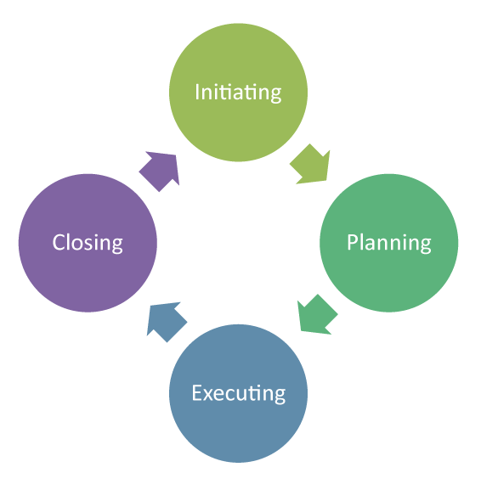

Figure 1: Project Life Cycle (Invensis, 2018).

The initiation period of the cycle is where all discussions take place. Here, stakeholders can identify the project, their aims and goals. The planning period is where the organising would take place. The project manager and stakeholders would prepare to run the project. This is also where scope, time and cost may be considered. Once that has been agreed on and finalised, the work can commence. The project can start, and reviews can take place. Once everything has been dealt with, the project can come to an end. Sometimes, the end result may not be what was discussed. A good or bad service could affect the delivery of the project.

WHO IS THE PROJECT BEING DEVELOPED FOR?

The project is being designed for the Vintners Antique, a family business. They own a traditional high street shop in Shirley, and a warehouse in Sparkhill that is full of stock. The family intend to open a business like the Salvage Hunters but require help in organising the warehouse. Vintners Antique require the support and expertise of project planners to achieve their mission and vision. Their team consists of family members and friends. Doreen Vintner has a background in accounts and runs her own business, abiding by all rules. Denis Vintner is another member of the team who has excellence in finding antiques. It is also something he desires wholeheartedly. Suha Madani who has returned after a year’s break deals with customer services. She is very likable. Omar King who has been working for the Vintners since he was a little boy has general knowledge around the shop. He is very familiar with all items in the shop and can easily locate objects. Lastly, Paul Ranson is a friend of the Vintners family. He always surrounds himself around the Vintners, almost as if he is part of the family. Paul has a lot of knowledge on the Vintners and specialises in graphics, including Smart Art. He pays a lot of attention to detail.

AN ASSESSMENT OF THE RISKS THAT COULD BE INVOLVED

Decision change. Often, the outcome is never predictable. People may change their mind when new knowledge or information is gained. Also, money could play a part in decision change. If the project manager identifies more costs towards furniture, they may want to reduce the cost towards decoration. This will affect the team as everyone may not agree.
Too much people power. This should be limited. Proper management needs to be in place to help people understand their roles and jobs. They need a solid management structure to run the project. Giving people too much authority can sometimes put the project in danger. They should be encouraged to work together to achieve the same goal by a strong leader. “Leadership is the art of getting others to want to do something that you believe should be done”, quoted by Vance Packard (Heagney, n.d., p. 5).
According to Department for Business (2007, p.18), every project must have its own management structure specified at the start and broken up at the end. Identifying the roles, responsibilities and relationships provides a stronger base for the project.
Estimations on Gantt charts may be incorrect, leading to more costs. Estimations could be informed or an educated guess. Using the Delphi method may not always work for everyone. Some may not even understand the method. Also, missed deadlines can cause more costs, not to mention the rushed tasks.
Failure of electrics, planning and building works also puts the project at risk. If planning goes wrong, then the whole plan needs to be reassessed which could incur more time and costs.
In addition, poor communication and commitment from stakeholders could put the project at risk. It would be less effective, and the wrong information could be passed on. Not having enough resources or planned stages being neglected, could delay everything. Plans should be monitored and reviewed regularly to ensure they are appropriate. They should be deliverable to specific designated areas e.g. toilet, partitions and staff room in correct places.

PROJECT MANAGEMENT TOOLS AND TECHNIQUES

The Product Project Technique is a table that describes the job by two categories: size and complexity. The size can range from small to large, and the complexity can range from low to high. This can be included in the Microsoft planner and Gantt chart.
The Delphi Technique is a technique used to guess the price of products and facilities e.g. hiring an electrician and storage equipment. In this technique, the stakeholders make an educated guess of what they assume the price would be. It is then added up and divided by the number of people who participated. If it comes close to their guesses, then they would all agree to it being the final cost.
The Iron Triangle below is a method some may use when running a project. The scope of the project would determine the time and cost, which leads up to quality. If costs were the main priority, the scope and time would have to be adjusted according to the budget available, however a low budget would lower the quality of the project.

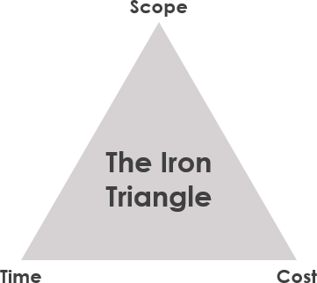

Figure 2: The Iron Triangle (Visual Paradigm, 2020).

Microsoft planner is part of Microsoft Office. According to Cottino (2017), not everyone in the team will be familiar with project planning, therefore Microsoft planner will be beneficial in terms of sharing information, updates and task progressions. Tasks can be grouped by nice, want and must, which is known as The Chevron. This is where a problem is identified and requirements and desires are allocated to must, want and nice. This also includes a mission, which is to deliver the must list. This is a screenshot of Microsoft planner.

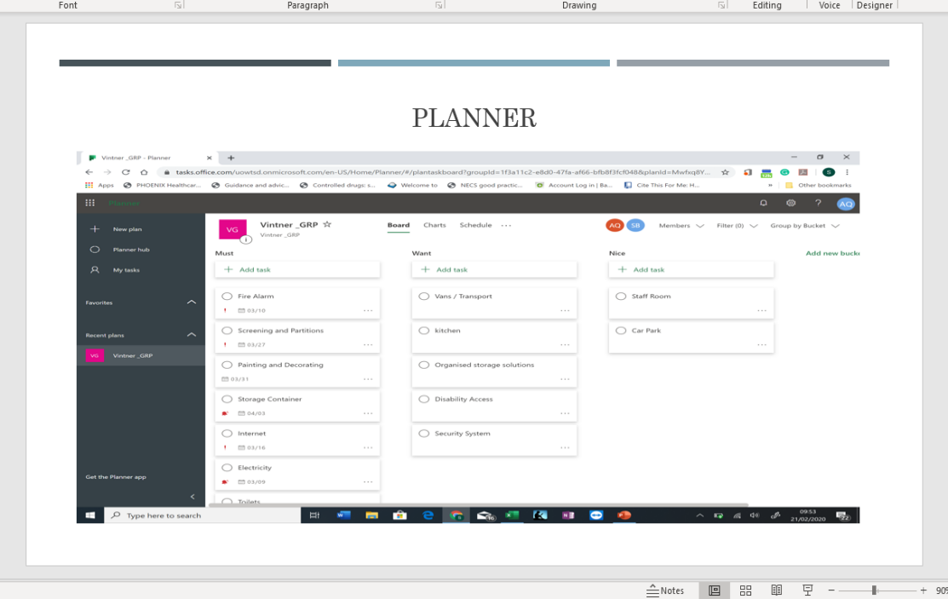
In this screenshot, it can be seen that tasks can be organised by the most prioritised to the least. Due dates can also be added and by whom the task will be completed. This can then be used to transfer onto a Gantt chart, which shows the tasks in great detail. When a task is accomplished, this could be marked off by the percentage of completion. Also, the dates would be presented by bar charts, making it easier to view the remaining time, rather than reading through everything. According to OpenOffice.org (2005, p. 5) managing a project is easier when they are displayed in visual illustration, parallel processes and when time is tracked. Below is an example of a Gantt chart:

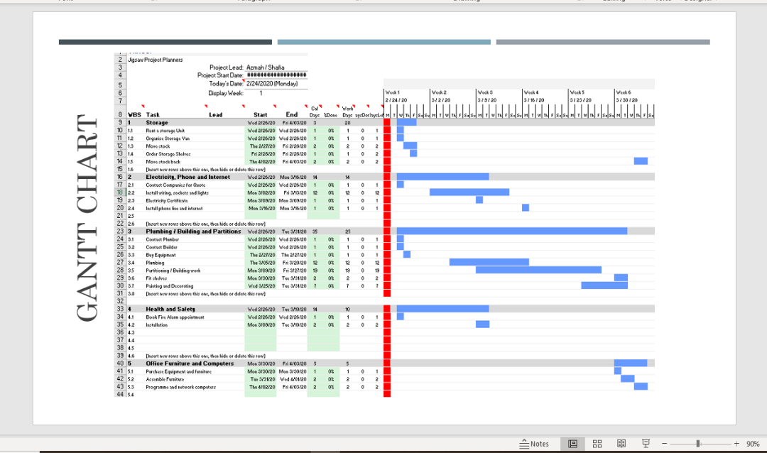

Brown paper plan is a hand drawn Gantt chart, an old method of planning, however the excel version is more efficient as it is more accessible nowadays and does not require pen or paper. The monitoring process is also more time efficient. Microsoft Planner is easily accessible. Stakeholders can view and edit information by using Microsoft planner on their laptops, or even by downloading it on their phones. They can also gain access from wherever they are.
User stories are a collection of stakeholder problems. They are notes on what stakeholders want and for what reason, for example, an office space for privacy. People may have the same issues but worded differently so they should be grouped in terms of same problems. Where there is a lot of people, post it notes are an excellent way of gathering and rearranging notes.

COMMUNICATING WITH STAKEHOLDERS

Information can be communicated through Microsoft planner and User Stories. Notes will be made on the planner so anyone granted assess can see this from anywhere. Stakeholders can also be communicated through skype for business, an online meeting. This is efficient as direct messages can be relayed with immediate responses and facial expressions can be seen. Robinson and Robinson (1982), cited in Quintanilla and Wahl (2017, p. 67), suggests that sometimes messages may not be fully understood and there could be many factors contributing to this. Therefore, having this face-to-face system enables people to reduce barriers to communication. Below is an example of what a Skype call looks like:

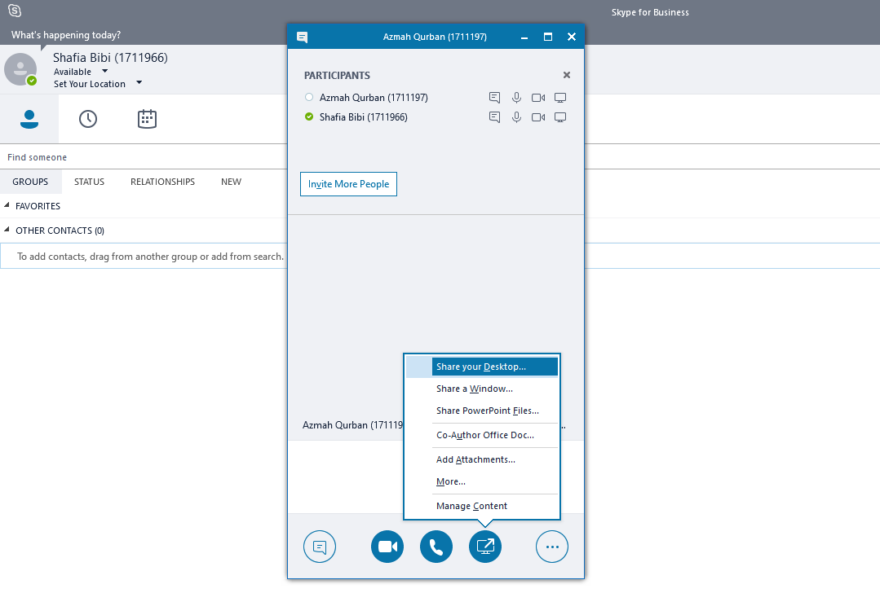

In this screenshot, it can be seen that screen sharing can be done through “share your desktop” so that means whilst on video call, participants can upload Gantt charts or other useful pieces of work. A number of screens can be viewed, and a number of people can be connected. Moreover, the skype call can be recorded for future reference, so if someone forgot a vital message, they could watch back the video. Other methods of communication can include, but not limited to, WhatsApp, Facebook, Twitter and Slack.

A PEROSNAL REFLECTION OF MANAGING A PROJECT

Projects do not always go according to plans. Objectives can be met but it can be at risk of a poor quality. It is important to remember the time, cost and scope of a project.
The team and I had a list of tasks to complete. This included all the project management tools and techniques. After going through the initiation processes, plans had to be changed, but keeping in mind the team’s objectives we stuck to the original ideas. This was because other members were not willing to pull their weight. We discussed the plans but never wrote down exactly who was doing what part. In future, this could be considered to avoid too much pressure on certain individuals and have more people contributing. Perhaps the team did not understand what was expected of them and members did not ask questions. Clarifications and illustrations are generally used to improve understanding, according to Chatfield (2018, p. 31).
We started with the scope of the project, followed by time and cost. In future, we could prioritise the cost so that we know what budget to go by. This may reduce the time and scope of the project.
The team had used the waterfall process for the project. Although people did not make much effort to help achieve the end result, everyone was involved in the planning. According to Heagney (n.d., p. 5), the first rule of project management is that the people who must do the work should help plan it. People need guidance to maintain their roles and responsibilities. This is important to note for future reference, as my communication and leadership skills need expanding for self-development.
When the plan was reviewed, it was noted that plumbing would require more days. This was adjusted by adding a few more days. According to Cobb (2012, pp. 192-193), it helps to revise assumptions and estimates in an early stage of the project. Also, leaders often understand that adjustments need to be made to stay within the budget and time. As we followed the iron triangle, with the scope on top, we did not put much consideration into budget. Therefore, we were able to add the extra days for plumbing. Had we have put time and cost above scope, then budget may have been a barrier to the extra days.

REFERENCES

Chatfield, T. (2018). Critical Thinking. London: Sage Publications Ltd.

Cobb, A. T. (2012) “In Leading Project Teams: The Basics of Project Management and Team Leadership”, in Maund, A. (2018) BA in Leadership and Management: Skills for the Workplace Student Yearbook, 1st Year. London: SAGE Publications Ltd.

Cottino, J. (2017). The Uses of Office 365 Planner for Project Management | MPUG. [online] MPUG. Available at: https://www.mpug.com/articles/the-uses-of-office-365-planner-for-project-management/ (Accessed 28 March 2020).

Department for Business (2007). Enterprise and Regulatory Reform. GUIDELINES FOR MANAGING PROJECTS. [ebook] p.18. Available at: https://moodle.uwtsd.ac.uk/pluginfile.php/350775/mod_resource/content/1/PRINCE2.pdf (Accessed 24 March 2020).

Haughey, D. (2015). What Is PRINCE2? [online] Project Smart. Available at: https://www.projectsmart.co.uk/what-is-prince2.php (Accessed 21 March 2020).

Heagney, J. (n.d). Fundamentals of PROJECT MANAGEMENT. 5th ed. [ebook] New York: American Management Association, p.5. Available at: https://vuthedudotorg.files.wordpress.com/2015/10/fundamentals-of-project-management-0814437362.pdf (Accessed 24 March 2020).

Invensis (2018). What Is Project Life Cycle and Its Main Characteristics? | Invensis Learning. [figure] Invensislearning.com. Available at: https://www.invensislearning.com/resources/pmp/what-is-project-life-cycle-and-its-main-characteristics (Accessed 21 March 2020).

OpenOffice.org (2005). Project-Management with Gantt-Charts. 2nd ed. [ebook] p.5. Available at: https://www.openoffice.org/documentation/HOW_TO/spreadsheet/gantt_pm.pdf (Accessed 27 March 2020).

PMI (2020). What Is Project Management? [online] Pmi.org. Available at: https://www.pmi.org/about/learn-about-pmi/what-is-project-management (Accessed 20 March 2020).

Quintanilla, K.M. and Wahl, S.T. (2017) “In Business and Professional Communication”, in Maund, A., Schriek, M. and Tinkler, P.K. (2017) Certificate in Higher Education: Skills for the Workplace Student Yearbook. London: SAGE Publications Ltd.

Visual Paradigm (2020). Classical Project Management Vs Agile Project Management. [figure] Visual-paradigm.com. Available at: https://www.visual-paradigm.com/scrum/classical-vs-agile-project-management/ (Accessed 28 March 2020).

