

BMHP6009

Name: Sarah Howells
Student Number: 2008448
Date: 03/05/2024
Word count: 2500
Title: Examining the Future Care of Older Persons in the UK

Table of Contents
Abstract | 3
Introduction | 4
Care of the Older Person: Current Initiatives and Policies | 4
Future provisions of services from Statutory, Private, and Voluntary Organisations | 5
ICT and AI Future Implementation in Healthcare for the Elderly | 6
Examining the reasons for change and any expected or perceived challenges | 7
- Reasons for change | 7
- Perceived challenges | 8
Conclusion | 8
Recommendations | 9
Appendices | 10
Glossary of Terms | 11
References | 12

Abstract:
This comprehensive study examines the potential of information and communication technology (ICT) and artificial intelligence (AI) in healthcare systems to enhance the quality of care for elderly people in the United Kingdom. The utilization of digital technologies in the well-being and care of older people has become a focal point in various initiatives. One particular domain that holds much promise for revolutionizing the caregiving process of older people is the integration of artificial intelligence (AI) and information and communication technologies (ICTs). The study will provide policymakers, healthcare providers, technology developers, and other stakeholders with valuable insights into the potential benefits and consequences of utilizing AI and ICT applications in eldercare. The conversation commences by examining the existing efforts and policies that have paved the way for the potential future course of these services. Subsequently, it delves into the rationales behind the need for change, as well as the obstacles and suggestions that healthcare policymakers may adopt.

Introduction:
The provision of healthcare services for the elderly population in the United Kingdom has many problems and prospects. The healthcare and social care sectors have challenges in attending to the needs of the elderly population due to the rise in life expectancy (appendix 1). According to Miles (2023), with the rise in life expectancy, there has been a corresponding decrease in birth rates, resulting in a corresponding rise in the number of elderly people in the population. The current demographic transition necessitates the adoption of novel strategies to effectively tackle the healthcare, social support, and quality of life requirements of the elderly population.
The potential of AI and ICT to change numerous elements of care delivery is immense. These fields include a wide range of healthcare measures, including personalized approaches and remote monitoring. According to Yutong et al. (2023), the use of data analytics, machine learning, and digital communication technologies has the potential to enhance the effectiveness and accessibility of care services. This analysis seeks to explore the prospective use of AI and ICT in the provision of care for elderly people in the United Kingdom. The examination of existing projects, trends, and policies will be followed by a comprehensive analysis of new technologies and policy issues.
Care of the Older Person: Current Initiatives and Policies:
The current state of the health and social care crisis in the UK has far-reaching implications for society as a whole, with older people experiencing the most significant effect. According to the British Geriatrics Society (2023), around 40% of hospital admissions in the UK are for those aged 65 and older, accounting for almost two-thirds of hospital beds. Elderly people are more susceptible to experiencing exceptional waits in emergency rooms. The following section provides an analysis of some ongoing programs and policies.
The long-term strategy of the National Health Service (NHS): The National Health Service (NHS) long-term plan is a governmental strategy initiated in 2019. fixed strategic vision of healthcare delivery methods in England for the next decade is outlined in the NHS initiative (UK Government, 2023). fixed NHS policies have specific measures aimed at enhancing care for elderly people. The fixed strategy encompasses several measures, such as the augmentation of community-based services, the bolstering of support for carers, and the implementation of other projects aimed at promoting healthy ageing (UK Government, 2023).
Social Care, Green Paper: The United Kingdom government has implemented a social care green paper strategy to tackle the difficulties encountered by the social care system, particularly over the provision of care for elderly people (Jarrett, 2019). The primary objective of the Green Paper effort is to suggest changes in the financing and delivery methods of social care, with a specific emphasis on enhancing the dignity, independence, and quality of life for the aged.
Integrated Care Systems (ICS): Are now being implemented across England to facilitate the connection between healthcare providers, local authorities, and other relevant parties. The policies implemented under ICS aim to enhance the quality of care for older people, as well as other patient populations, and promote their well-being (House of Commons, 2023). The ICS program emphasizes improving teamwork, optimizing service delivery, and advocating for preventative care to assist older adults in preserving their health and well-being.
Grand Challenge of an Ageing Society, and the Creation of Dementia-Friendly Communities: The UK government has included concepts to implement innovation and technology as part of the UK's industrial strategy to cater to the requirements of a growing elderly population. This program encompasses financial assistance for the study and development of novel goods and services using technology, with the potential to enhance the provision of care for elderly people. Furthermore, it is worth noting that the United Kingdom government has been actively promoting the establishment of dementia-friendly communities as a means of assisting those who are affected by dementia (Connell & Page, 2019). The primary objective of this program is to mitigate social stigma by enhancing public awareness and enhancing the availability of services and assistance for senior people afflicted with dementia.
Additional significant endeavours include non-profit entities such as Age UK and Independent Age, which provide advocacy, support services, and information to elderly people residing in the United Kingdom. The government provides a wide array of services including health guidance, social welfare, financial assistance, and community-oriented initiatives.
Future provisions of services from Statutory, Private, and Voluntary Organisations:
Probably, the future delivery of support services to the elderly population in the UK will include the integration and consolidation of efforts from statutory, commercial, and volunteer entities in a collaborative fashion. Each sector's contribution is examined in distinct sub-sections.
Statutory Organisations: The NHS is a statutory agency that has a unique role in delivering healthcare services to the elderly. According to the Department of Health and Social Care (2023), the spectrum of services provided includes medical treatment, hospital care, health advocacy, financial help arrangements, and community-based support. The procurement of social care services for elderly adults is also the responsibility of local authorities, including local councils. The services provided include in-home care, residential care, and day-to-day help for older people requiring support.
Private Organisations: In the UK, there are private care homes that function as private enterprises, offering nursing services to elderly people requiring care. Armitage (2024) states that they can provide a variety of services, including lodging, personal assistance, and specialised care for those with dementia and other intricate requirements. Furthermore, home care firms can provide individualised support and aid to elderly people who live independently. The incorporation of technological advancements might prove to be exceedingly advantageous in addressing these circumstances. The breadth of services provided includes healthcare support and assistance, personal care, aid with home activities, medication management, and companionship to mitigate feelings of loneliness.
Volunteer organizations: Include a range of entities, such as charitable organizations, non-profit organizations, and community support networks. Volunteer groups, such as Age UK and Independent Age, as well as local charities, had the potential to assume a crucial function in the next era, serving as a valuable supplement to both government and commercial services. They may provide supplementary assistance and use extra resources to help and care for elderly people and their families (Jentoft, 2023). Advocacy and aid for the elderly in the community may be ensured via the provision of information, guidance, and befriending services. According to Jantoft (2023), the implementation of community support networks may facilitate the establishment of support systems in local communities, thus fostering social inclusion, mitigating feelings of loneliness, and attending to the pragmatic requirements of elderly inhabitants. According to Vibert (2024), support networks can provide social interaction via clubs and fitness courses, as well as initiatives aimed at improving the welfare of older adults. These efforts are organized and executed in collaboration with knowledgeable volunteers.
In the foreseeable future, it will be essential to set up cooperation and partnerships across these three sectors to effectively address the growing demands of an aging population, such as that of the United Kingdom. Further advancements can be achieved through the implementation of initiatives and policies such as the Integrated Care Systems (ICS). These systems rely on the collaboration of various organizations to offer comprehensive and coordinated support to the elderly population. This issue is achieved through the utilization of innovative approaches, including technology-enabled care and community-centered support.
ICT and AI, Future Implementation in Healthcare for the Elderly:
The potential and advantages of integrating Information and Communication Technology (ICT) and Artificial Intelligence (AI) in healthcare for older people are significant. These advancements can have the capacity to enhance the quality of treatment and services, improve operational efficiency, and enhance accessibility to healthcare for older people. The advent of Healthcare 4.0 (Gupta & Singh, 2023) necessitates the widespread use of technology, particularly in the context of data-driven diagnosis and treatment (see Appendix 2). ICT and AI may now be used to assist and reflect vast improvements in healthcare, enabling the examination of crucial aspects of caring for older people.
Remote monitoring and telemedicine: ICT and AI can provide remote health monitoring systems. Currently, there exist several gadgets available on the market; even so, their pricing often poses a disadvantage. Consequently, ongoing research and development efforts are being undertaken to enhance their accessibility for a wider demographic. The majority of gadgets are powered by wearable sensors capable of monitoring vital signs, activity, medication compliance, and essential health indicators in real time. According to Gokalp et al. (2018), telemedicine systems can provide virtual consultations between healthcare experts and elderly people. This will provide substantial assistance to elderly people who have restricted mobility or reside at considerable distances from care facilities.
Electronic Health Records (EHR) and information systems: EHR systems have the potential to be improved to store a more comprehensive account of individuals' medical requirements. This would enable efficient communication and information exchange across various healthcare professionals and different healthcare settings. The use of artificial intelligence (AI) has potential for future applications in data-driven analytics, such as machine learning and integrated care systems. This technology may facilitate the analysis of extensive datasets obtained from electronic health records (EHRs) (Saxena, Meldon, Hashmi, Muir, & Ruwe, 2023). The use of bulk data analysis will facilitate the identification of patterns, trends, and corresponding hazards. The use of AI algorithms enables professionals to access more advanced analytics, hence empowering them to develop personalized care plans via the application of predictive models. This response facilitates early intervention in case of unforeseeable issues affecting older people.
Assistive Technology and Smart Home:
ICT can be utilised to create novel assistive technologies, such as smart home devices, voice-activation-based AI assistants, wearable gadgets, and others. These technologies have the potential to actively improve support for older individuals, while also ensuring their safety and independence. Moreover, they can greatly enhance their quality of life. According to Gupta and Singh (2023), artificial intelligence (AI) has the potential to be used in the future to enhance home systems by acquiring knowledge about users' preferences and daily activities. Hence, these concepts have a substantial role in predicting the requirements of elderly individuals, thereby enabling their adjustment to many environmental contexts and providing necessary support.

Examining the reasons for change and any expected or perceived challenges:
The previous part has addressed the future of AI and ICT applications in healthcare, often referred to as healthcare 4.0. Now, it is necessary to understand the underlying causes and perceived problems associated with these significant changes to the current healthcare systems.

Reasons for Change:
One primary rationale for advocating this move is the use of AI-powered cognitive assessment tools, such as digital neuropsychological exams, to effectively diagnose cognitive impairment and promptly detect the first indications of dementia. This issue is particularly prevalent among the senior population in the UK. By incorporating artificial intelligence into the healthcare sector, significant advantages may be achieved, particularly in the realm of early detection. AI incorporates virtual reality (VR) technology, which may be used to facilitate intricate medical procedures. According to Cornell and Page (2019), reminiscence treatment programs, which monitor the development of illnesses such as dementia over some time, may exhibit a level of complexity comparable to the aforementioned. Artificial intelligence (AI) models provide enhanced analysis and more effective stimulation of cognitive functioning. Social involvement is actively encouraged and has a favourable influence on the emotional well-being of older individuals and those with dementia. Furthermore, AI and ICT play a crucial role in developing digitalized Clinical Decision Support Systems (CDSS), which aid healthcare practitioners in making evidence-based and well-informed choices about the diagnosis and treatment of older patients. Therefore, the use of artificial intelligence fundamentally transforms the healthcare industry, and for valid justifications.

Perceived Challenges:
Here, we address the two primary obstacles:
Digital literacy and accessibility in rural areas: The implementation of digital literacy and accessibility in rural regions poses challenges, despite the potential benefits of training programmes that educate professionals and elderly individuals in metropolitan areas on the functioning of AI and ICT-driven systems. According to the House of Commons (2023), the implementation of accessibility elements such as intuitive user interfaces and a user-friendly design might somewhat alleviate this reaction. Moreover, the issue of trust and trustworthiness is a substantial obstacle, since these endeavours often face opposition stemming from a dearth of confidence among elderly individuals and healthcare practitioners in emerging technology.

Privacy and data security: The second obstacle stems from concerns over privacy and data security. Privacy breaches and data misuse resulting from unauthorised access to private health information has raised substantial concerns. Older individuals may be dissuaded from using AI and ICT solutions for caring due to this concern. To address the situation at hand, it is advisable to adopt a comprehensive data protection strategy that incorporates layered encryption techniques and adheres to centralised security laws to ensure the security of personal information.

Conclusion:
In conclusion, the comprehensive analysis presented herein elucidates the prevailing efforts and policies on the provision of care for elderly individuals within the United Kingdom. Harnessing the potential of ICT and AI in healthcare is a prevalent strategy for achieving healthcare 4.0. The use of sophisticated technology in providing care for the elderly has a significant beneficial effect on promptly identifying issues, and it further enhances caregiving and intervention planning techniques by facilitating well-informed and evidence-based decision-making. Utilising AI algorithms and sophisticated analytics facilitates caring in several domains, as elucidated in the preceding sections. Nevertheless, these technologies must be developed with ethical considerations. The future trajectory indicates that caring may greatly benefit from harnessing technology such as ICT and AI.

Recommendations:
Here is a list of the key recommendations:
The promotion of digital literacy necessitates the development of training programmes by authorities to educate and raise awareness among stakeholders. It is essential to implement appropriate efforts that foster digital literacy for all individuals.
User-centered design and accessibility: The systems have to be crafted with a focus on user-friendliness, ensuring that the tools are accessible to individuals of all abilities.
The UK government should endorse information exchange and promote a collaborative approach among institutions to enhance service provision. Furthermore, it is essential to establish a consistent allocation of resources towards enhancing research and development in the context of healthcare 4.0.
AI-driven healthcare solutions can be customised according to the specific requirements, preferences, and health situations of individual patients, hence enabling continuous monitoring. It is essential to expose the systems to ongoing monitoring to provide updates that aid carers and promote appropriate preventative care throughout treatment and drug administration.

Appendices:

Increase of aging population in the UK:
(Appendix 1)
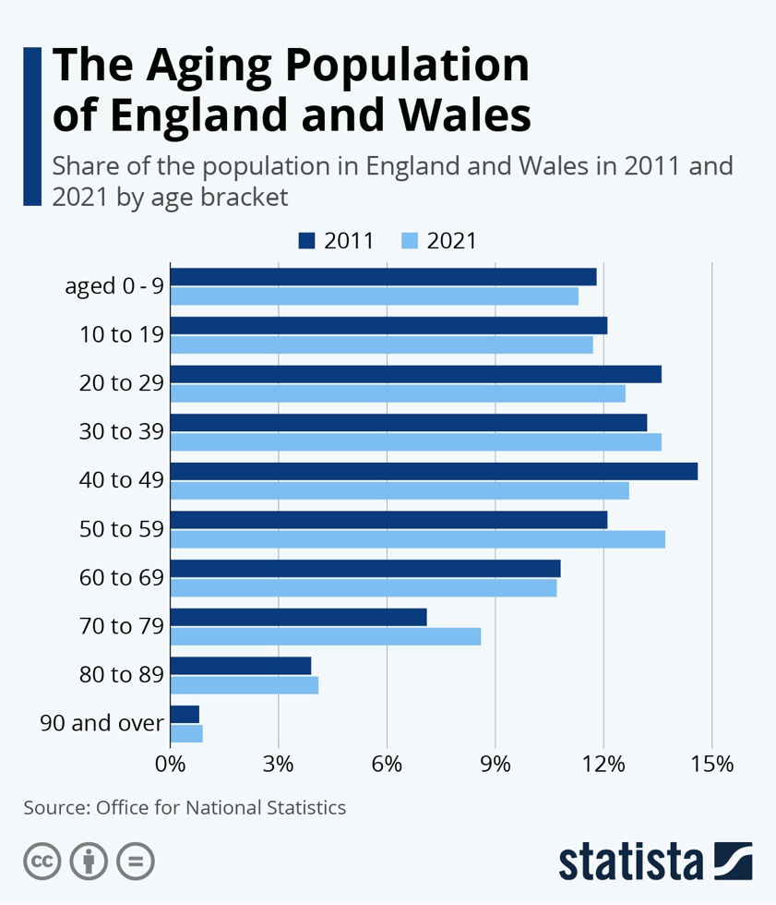
(Fleck, 2022).
Increase in the use of Technology in Healthcare:
(Appendix 2)
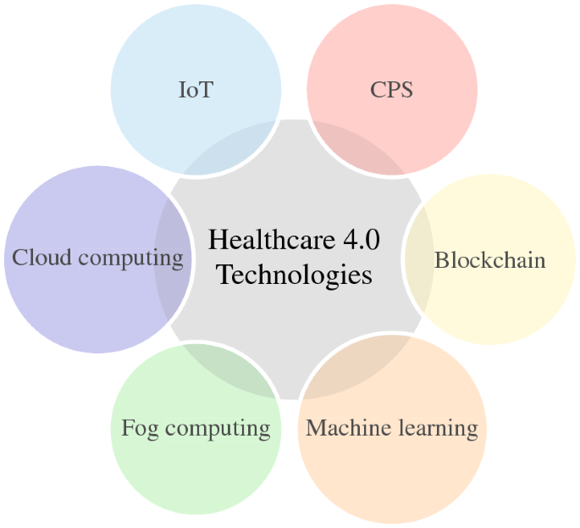
(Gupta & Singh, 2023).
Artificial Intelligence (AI) used in healthcare.
(appendix 3)
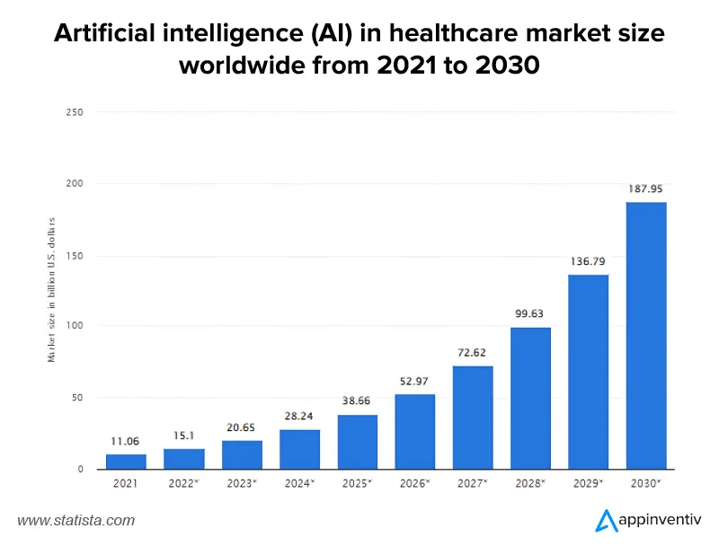
(Srivastava, 2023).

Glossary of Terms:
- UK: United Kingdom
- ICT: Information Communication Technology
- AI: Artificial Intelligence
- NHS: National Health Services
- ICS: Integrated Care Systems
- HER: Electronic Health Records
- CDSS: Clinical Decision Support Systems

Reference List:
Armitage, C. (2024) 5 predictions for health and social care providers in 2024. Available at: 5 predictions for health and social care providers in 2024 - Care England(Accessed on: 22nd March 2024).

British Geriatrics Society (2023). Protecting the rights of older people to health and social care. [online] British Geriatrics Society. Available at: Protecting the rights of older people to health and social care | British Geriatrics Society (bgs.org.uk)(Accessed on: 19th March 2024).

commons, house of (2023). introducing integrated care systems . house of commons. Available at: committees.parliament.uk/publications/33872/documents/185310/default/(Accessed on: 20th March 2024).

Connell, J. and Page, S.J. (2019). An exploratory study of creating dementia-friendly businesses in the visitor economy: evidence from the UK. Heliyon, 5(4), p.e01471. doi:https://doi.org/10.1016/j.heliyon.2019.e01471. Available at: An exploratory study of creating dementia-friendly businesses in the visitor economy: evidence from the UK - PubMed (nih.gov)(Accessed on: 21st March 2024).

Department of Health and Social Care (2023) Next steps to put People at the Heart of Care A plan for adult social care system. Available at: https://assets.publishing.service.gov.uk/media/642b0270ddf8ad000cac0cb5/next-steps-to-put-people-at-the-heart-of-care_a-plan-for-adult-social-care-system-reform-2023-to-2024-and-2024-to-2025.pdf (Accessed on: 21st March 2024).

Fleck, A. (2022). Infographic: The Aging Population of England and Wales. [online] Statista Infographics. Available at: https://www.statista.com/chart/27697/census-shows-population-of-england-and-wales/.(Accessed on: 22nd March 2024).

Gokalp, H., de Folter, J., Verma, V., Fursse, J., Jones, R. and Clarke, M. (2018). Integrated
Telehealth and Telecare for Monitoring Frail Elderly with Chronic Disease. Telemedicine Journal and e-Health, [online] 24(12), pp.940–957. doi:https://doi.org/10.1089/tmj.2017.0322.Available at: Integrated Telehealth and Telecare for Monitoring Frail Elderly with Chronic Disease - PubMed (nih.gov)(Accessed on: 20th March 2024).
GOV.UK. (2023). NHS Improvement: annual report and accounts 2022 to 2023. [online] Available at: Monitor-annual-report-and-accounts-2022-2023-web-accessible.pdf (publishing.service.gov.uk)(Accessed on: 19th March 2024).

Gupta, A. and Singh, A. (2022). Healthcare 4.0: recent advancements and futuristic research directions. Wireless Personal Communications. doi:https://doi.org/10.1007/s11277-022-10164-8. Available at: Healthcare 4.0: recent advancements and futuristic research directions - PubMed (nih.gov)(Accessed on: 19th March 2024).

Jarrett, T. (8002). Adult social care: the Government’s ongoing policy review and anticipated Green Paper (England). [online] Available at: CBP-8002.pdf (parliament.uk)(Accessed on: 20th March 2024).

Jentoft, E.E. (2023). Technology and older adults in British loneliness policy and political discourse. Frontiers in digital health, 5. doi:https://doi.org/10.3389/fdgth.2023.1168413. Available at: Frontiers | Technology and older adults in British loneliness policy and political discourse (frontiersin.org)(Accessed on: 22nd March 2024).

Miles, D (2023) Longer lives, coupled with a trend for richer countries to produce fewer children, has led to panic. But are there really things we should be worrying about? Imperial College Business School. [online] Available at: Ageing populations and declining birth rates: are they really such a catastrophe? | Imperial College Business School(Accessed on: 19th March 2023).

Saxena, S., Meldon, S.W., Hashmi, A.Z., Muir, M. and Ruwe, J. (2023). Use of the electronic medical record to screen for high-risk geriatric patients in the emergency department. JAMIA open, [online] 6(2). doi:https://doi.org/10.1093/jamiaopen/ooad021. Available at: Use of the electronic medical record to screen for high-risk geriatric patients in the emergency department - PubMed (nih.gov)(Accessed on: 21st March 2024).

Srivastava, S. (2018). Artificial Intelligence in Healthcare: Revolutionizing Industry 2023. [online] Appinventiv. Available at: https://appinventiv.com/blog/ai-in-healthcare (Accessed on: 19th March 2024).

Tian, Y., Zhang, Y., Cheng, Q., Meng, L., Gao, M. and Wang, S. (2023). Information and Communication Technology Based Integrated Care for Older Adults: A Scoping Review. International Journal of Integrated Care, 23(2). doi:https://doi.org/10.5334/ijic.6979. Available at: Information and Communication Technology Based Integrated Care for Older Adults: A Scoping Review - PMC (nih.gov)(Accessed on: 19th March 2024).

Vibert, S. (2024) The Road Ahead 2024: Opportunities and challenges for the voluntary sector. [online] Available at: https://www.ncvo.org.uk/news-and-insights/news-index/the-road-ahead-2024-opportunities-challenges-charities-voluntary-sector/ (Accessed on: 19th March 2024).
‌

‌

‌

‌

‌

‌

‌

