University of Wales Trinity Saint David
BA Business Management
Module: Community Engagement
LCBB4002
Lecturer: Efua Adams
Student Name: Raluca Manda
Student id:2127848
Assignment Title: Assessment 2- My future project
Submission deadline: 31st March 2023

Table of contents:
- Introduction
  - Definition and concepts of Community Engagement
  - Reflection on your module Community Engagement
  - Introduce your project
- Body of task
  - Purpose of the project
  - Principle of the Project
  - Legitimacy
  - Feelings
  - Evaluation and compare with the live project
  - Stake holders and participation
  - Consequences
- Conclusion
- Reference list

- Introduction

Definition and concepts of community engagement
“Community engagement, as a concept - has been around for many years but there is no common or widely agreed definition. Many studies and reports provide various definitions and the one used here is taken from the Home Office, which uses Wilcox's model 'ladder of participation', to define community engagement by citizens in relation to those in authority, as;
- Informing - giving a message but don't require feedback or comment
- Consultation - Allows choice between pre-determined options not an opportunity to propose alternatives
- Deciding together - views shared, options generated jointly a course of action agreed upon
- Acting Together - working with others to make decisions and carry through the action agreed
- Supporting local initiatives - supporting groups to develop and implement their own solutions”( Community Engagement-Why is it and why is it important?, 2008)
Reflection on your module
To begin, I could say that I did enjoyed this module , because I have learned something new , useful I could say for the future, concepts and principles that I did had knowledge before.
On this module, I had the opportunity of the free speech and to express my opinion about different project and even to understand better and probably to get involve more in the community.
During the lecture I understood better about the concept and how the council is getting involve , for example sharing on the media different project, getting people involve and heard their opinion, finding founders ,arranging meetings , managerial aspects and contribution.
I believe, being engage in the community has lots of benefits, because is helping you as an individual to take some decisions , important is also mental help were you have full support, interactions , makes you feel confident and a better communicator.
Introduce your project
As a dog lover and actually having one, I came up with the idea of opening an accommodation for pets , that could help the owner who are working full-time or there are going on a holidays and are force to leave the pets with relatives.
During a research I have found that in London are some hotels dedicated for pets ,but they are a bit expensive and far from my city.
I would like to open one od these in my city(Worcester), because I have realise that there are many pets owner and would be something new for this area.

- Body of task

The purpose of the project is to help and get more involve with the people who are owing pets from my community, students who are studying veterinary medicine to get volunteering in our accommodation, find sponsors for food and promote them.
Walking with my dog, I have realised that in the last period here are many dogs owner than before and during a research on internet about cats owner in my town, there are indeed increasing since the past years so therefore this idea on creating an nice ,safe and comfortable environment for them would be in benefits.
Another purpose for this accommodation for pets is for those who are facing hard times and helping them with mental help, also I have to say that as humans, pets can get thru depression and sadness during the period of the family missing for a long or short period .

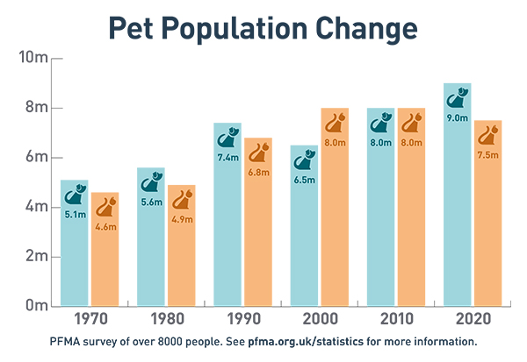
(bing.com,2020)

Principle of the project

The intension of this project to outline clear goals and purpose to the community. This project will be conducted in a Transformational Engagement Strategy therefore full community participation will be promoted.
Initial leaflets will be distributed to the community requesting for community resources such as funding, volunteers, participation, collaboration in the project.
This project will be fully funded through sponsorship, donations, fund raising activities such as gala dinners and community fun days.
The community that will be participating in this project will be considered in term of their culture, diversity, race and community structure the use of communication strategies appropriate to them.
“Transformational leadership is considered one of the main leadership styles that influence organizational and individual outcomes to achieve competitive advantage. This study aims to identify the relationship between some dimensions of transformational leadership namely: Idealized Influence, Inspirational motivation, Intellectual stimulation and empowerment, and change management in Jordanian Insurance companies. “(reserachgate.com, march 2018)

Legitimacy
As is the first project with this idea for the city and the council have to analyse and think about this idea, it will be given three to four months to implement it, as there are a few abandoned houses that they need to rehabilitate and to make safer for people and pets, also to find volunteers to help with cleaning and recondition.

Feelings
I do feel that this project will be a success and we will have support from community answering positive on this initiative , who has not been in town before.
Will be also a good opportunity to talk and organise meetings with the community , regarding our purpose for the town , it will be also a challenge founding sponsors providing food , toys and medical equipment for the pets.
In my point of view, the students and not also they will be excited having pets and taking care of them. This will require an attention on details, patience and last and not least good time and positive attitude with the pets.


(bing.com,2023)

Compare and evaluation within the live

As the live project that I have discussed in the assessment1 , was ideal and dedicated to children and adults , this project is only for pets owner, and the people get involved quickly for their benefits and need , on this one now we are asking if this purpose would like to be on the future in the town .
Following the next period it will be posting on the social media this idea, even we will create fly-poster around the town to get attention of people.
To compare the two projects , it has to be said that the period of developing the project in one case is a few weeks and the other is months, for the other project sponsors ,volunteers and funds were been found easily, but on our projects , we have to wait until people will decide if this project will go on.

Consequences
As this project is something new for this town it might have good view or not and that depends on people, the council and the stakeholders who would like to be involved.

Conclusion
As to conclude this assignment ,as a dog owner , who loves and protect them, I would like that this project to be a success , people to be involved in this project , I would like to hear from them their recommendation about the place , food that has to be provided , special needs, students that would like to volunteer , to be helpful on this project , I would like to see that our community will trust and support this accommodation for pets, I would love to see a performance.

Reference list
1.Bing.com pictures
2. Community Engagement - What is it and why is it important? (2008). Available at: https://www.londoncouncils.gov.uk/node/5871.
3.Alqatawenah, A.S. (2018) TRANSFORMATIONAL LEADERSHIP STYLE AND ITS RELATIONSHIP WITH CHANGE MANAGEMENT. Vilnius Gediminas Technical University. Available at: https://doi.org/10.3846/btp.2018.03.

