Elena Nedelcheva
2112413@student.uwtsd.ac.uk
Lecturer: Dr.Hossein Shokri
University of Walse Trinity Saint David

Strategic management & Sustainability
Unilever PLC

Table of Contents
Introduction 2
Key business and corporate strategies 2
Identification and Analysis of Business Strategies 2
Identification and Analysis of Corporate Strategies 4
Porter’s Generic strategy 5
Ansoff matrix 6
Frameworks Used for Analysis 8
Alignment of resources and capabilities to its current business 8
Value Chain 9
VRIO analysis 10
Evaluation of strategy implementation 11
Competitiveness and sustainability 12
SAF Framework 12
Future strategic directions 13
Recommendations for Future Sustainability Practices 13
Conclusion 14
References 14
Appendix 15

Introduction
In the contemporary world of business sustainability has become the most crucial factor in the development of business at an international level. Sustainable strategies take time in implementation, but it reflects effective progress. Unilever PLC is the chosen organization which is a multinational company and headquarters of the organization is situated in London, United Kingdom. The organization was founded by William lever, 1st Viscount Leverhulme in the year 1929. Unilever is organized into five business groups such beauty &wellbeing, personal care, home care, nutrition, (Unilever PLC, 2024b)and ice cream. The organization offers goods and services in 190 countries across the globe. Unilever contains various brands like Dove, Lipton, Ben & Jerry and Knorr among others. Additionally, the organization is committed towards the maintenance of sustainable business practices with the motive of reducing environmental impacts effectively and efficiently. In the retail industry Unilever is one of the prominent players in the retail industry and fulfilling the demand of the various demographics effectively and efficiently (Unilever PLC, 2024b).
The main purpose of this report is to conduct a strategic review and examination of the corporate and business strategies of the organization. Additionally, this report will critically evaluate the effectiveness implemented strategies of the organization effectively (Iglesias et al., 2023). This analysis will seek to identify the competitive positioning of the organization in the competitive market. Furthermore, this report will identify the key business and corporate strategies of the organization along with the evaluation of strategy. This report will examine competitiveness and sustainability, as well as explore the future strategic directions and conclusion.

Key business and corporate strategies

Identification and Analysis of Business Strategies
In the retail industry Unilever Plc is leading the market by implementing different strategies for maintaining competitive advantage and attaining growth effectively and efficiently. The organization is implementing various strategies for sustaining the growth, but the organization has adapted product diversification as the main strategy (Whittington, et al., 2020). In this the organization is offering a wide range of products and services to the consumers including food, beverages, home care, and personal care. While on the other hand the organization is reducing its dependence on the single market segment by offering different products to the consumers which is differentiating the organization from other businesses and helping the organization in mitigating fluctuations in consumer demand and economic conditions effectively. This approach of the organization is allowing the organization in reducing the dependence on the business as well as it is leading them to capitalize on the opportunities of fulfilling different needs and preferences of the consumers effectively and efficiently.
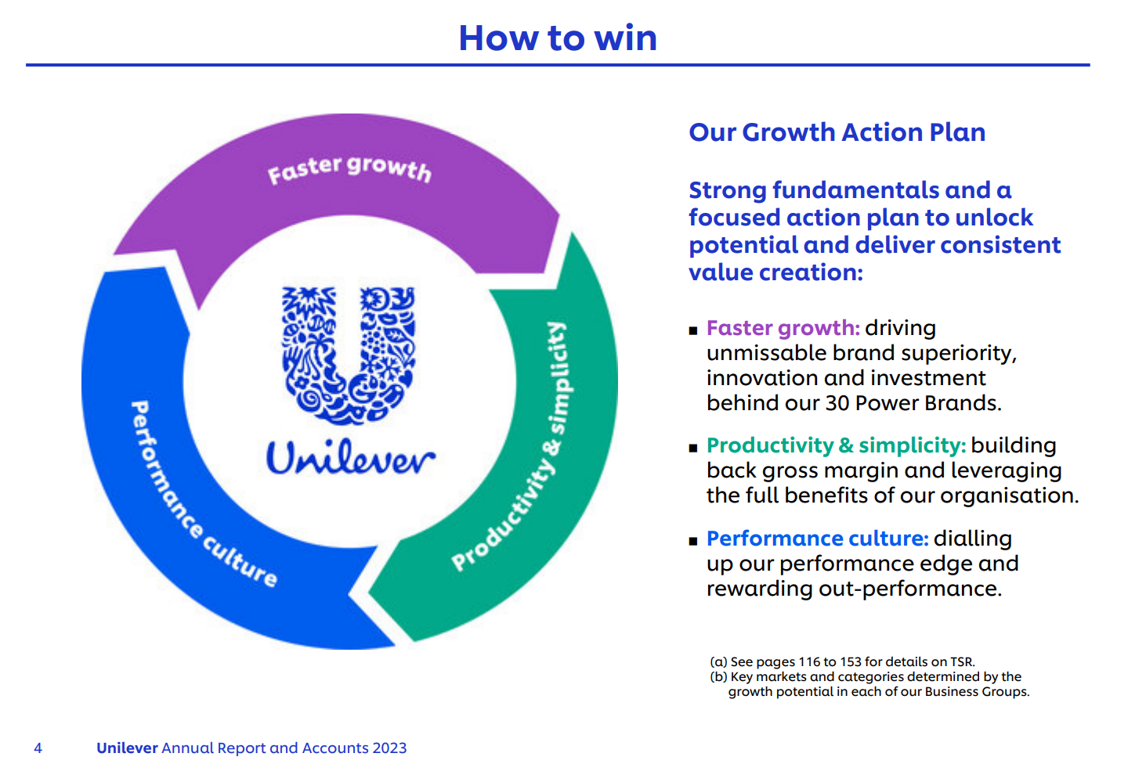
Source: (Unilever PLC, 2023)
Additionally, the organization gives more emphasis on innovations because it is the key driver of the business therefore the organization is continuously investing in the research and development program to manufacture new products and enhance the existing ones (Iglesias et al., 2023). This investment of the organization is helping in gaining the competitive edge of its brand which is deriving the growth by capturing market share which is increasing the customer base of the organization effectively and efficiently. While on the other hand, the commitment of the organization towards sustainability and eco-friendly products is increasing the demand of the consumers regarding conscious choices effectively.

Identification and Analysis of Corporate Strategies
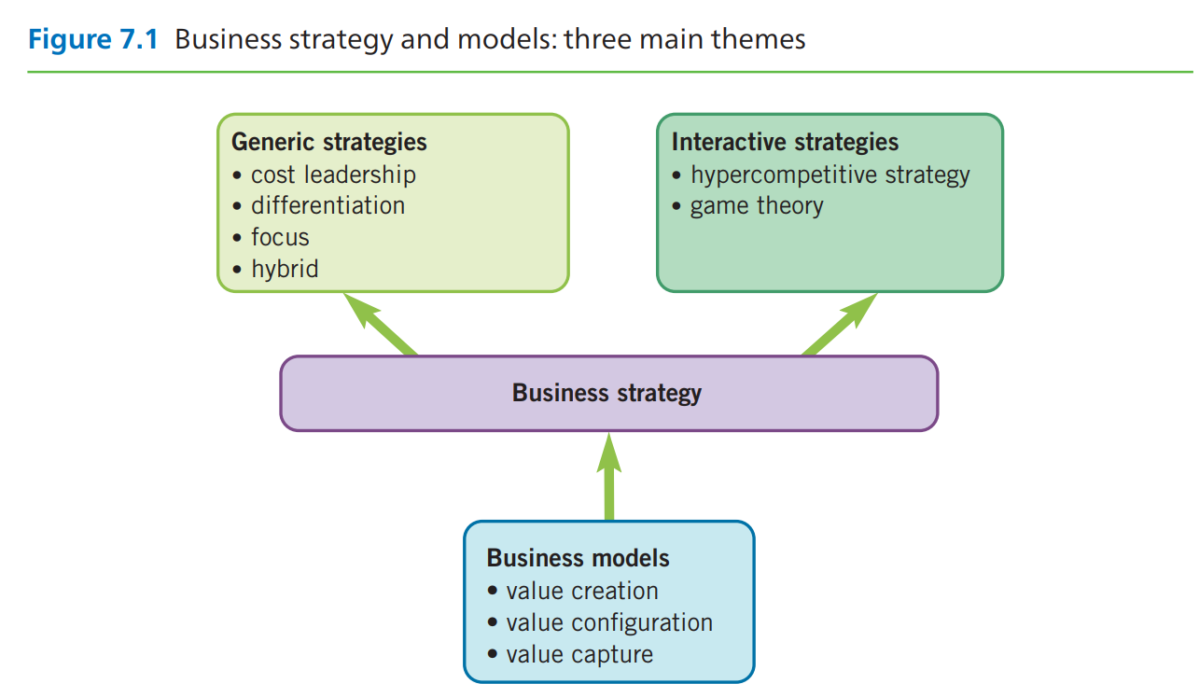
Source: (Whittington, et al., 2020)
Unilever Plc is using various strategies for driving success and sustainable growth at corporate level, which is also improving the value of shareholders (Reza, 2020). The organization is following the stage acquisitions strategy as a key aspect for deriving the success and expanding the business by entering the new markets. It is also helping the organization in attracting more consumers; Stage acquisition strategy is providing strength and the competitive position to Unilever Plc effectively and efficiently. In stage acquisition Unilever take strategic approach by acquiring dollar shave club as seventh generation. This reflects the strategic intent of the organization in diversifying consumer trends like growing demand for natural and sustainable products.
The organization is giving more importance to strategic partnership and alliances for increasing complementary strength and resources. Additionally effective collaboration with the other organization is helping the organization in gaining the access of new market, distribution channels, new suppliers, raw materials, and technologies; this is further leading the organization to enhance business growth effectively and efficiently (Whittington, et al., 2020). Hence, Unilever can improve their competitive strength and advantage, stakeholder value to increase the contribution increase the effectiveness of initiatives and sustainability goals efficiently.
Unilever Plc is giving more emphasis to operational activities and cost management as key components of the implemented corporate strategy. While on the other hand the organization is continuously searching for opportunities to optimize the supply chain, streamlining operations to develop productivity and manufacturing facilities and profitability. Unilever Plc can minimize costs and enhance profitability by reinvesting in strategic initiatives and support as well as aid in the development of long-term growth and sustainability objectives effectively and efficiently.

Porter’s Generic strategy
These strategies were introduced by Michael Porter, they are the ways companies can use to get a competitive advantage over their industry rivals. There are three generic strategies: cost leadership, differentiation, and niche (Whittington, et al., 2020). The cost leadership involves being the lowest cost producer in the market, whereas differentiation means offering products or services that are unique and are appreciated by the consumers.
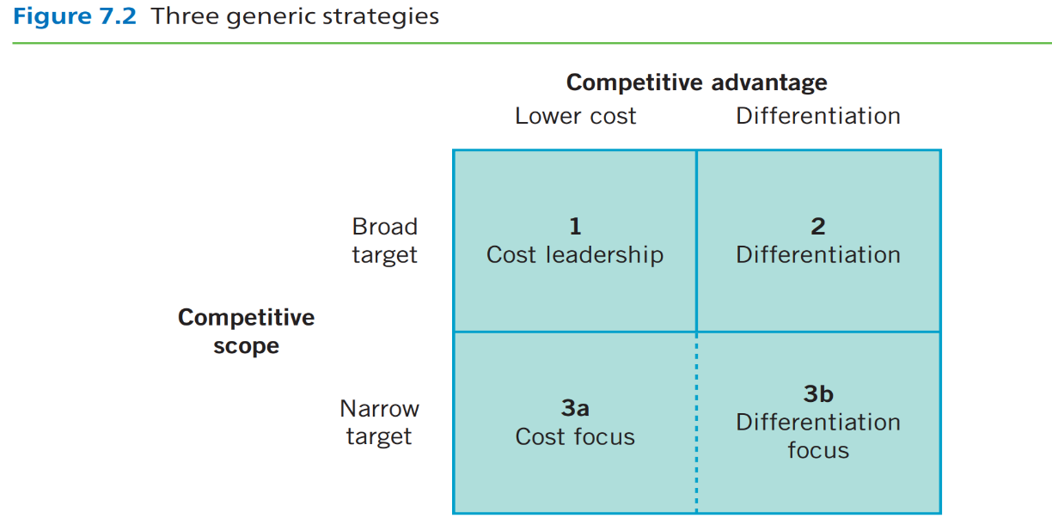
Source: (Whittington, et al., 2020)
Based upon the workings of Porter’s Generic Strategy Framework, the company’s ‘superior’ strategy is based on picking a generic strategy, ‘Differentiation,’ which, in the long run, allows it to pick up profits within the industry. In said strategy, the institution’s currents aim is in line with building a competitive advantage as it meets the needs of consumers. Currently, the company uses broad differentiation where the sole focus of the institution is to build upon it’s attributes and distinctions which makes its products stand out from its competitors (Unilever PLC, 2023).
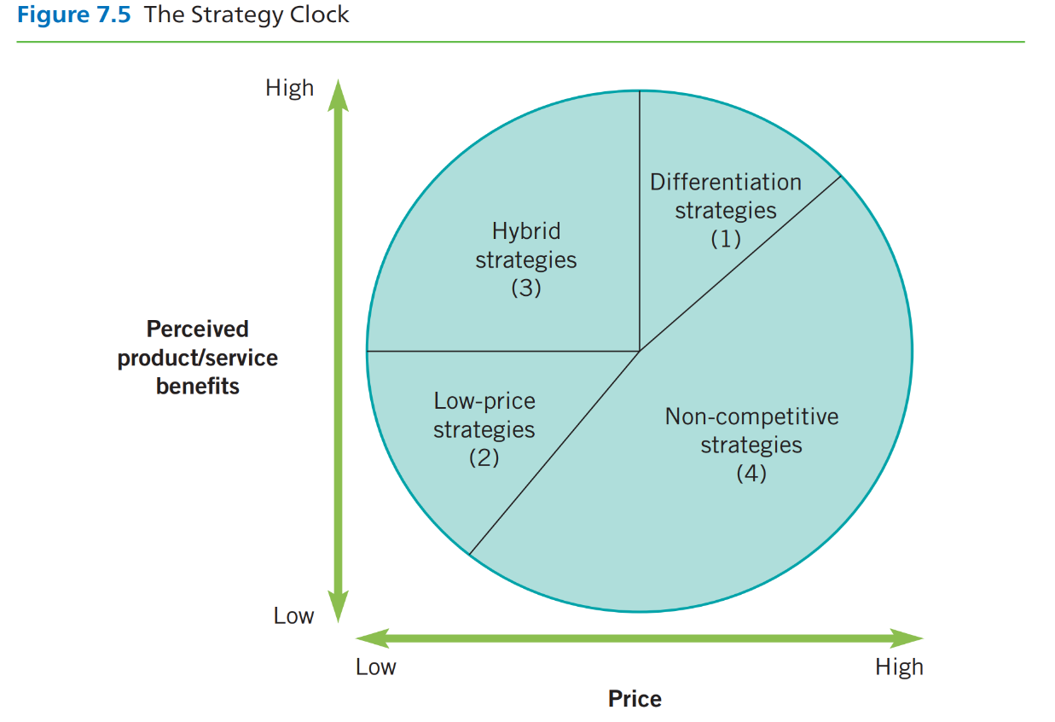
Source: (Whittington, et al., 2020)

Ansoff matrix
Ansoff matrix is named after the renowned Igor Ansoff and its purpose is to assist businesses with deciding their product and market growth strategy plan. It consists of four quadrants: in the marketplace where you have a lot of customers, the main strategy is market penetration (selling more products to the current customers), market development (coming into the new markets with the old products), product development (introducing new products to old markets), and diversification (entering the new markets with new products) (Whittington, et al., 2020).
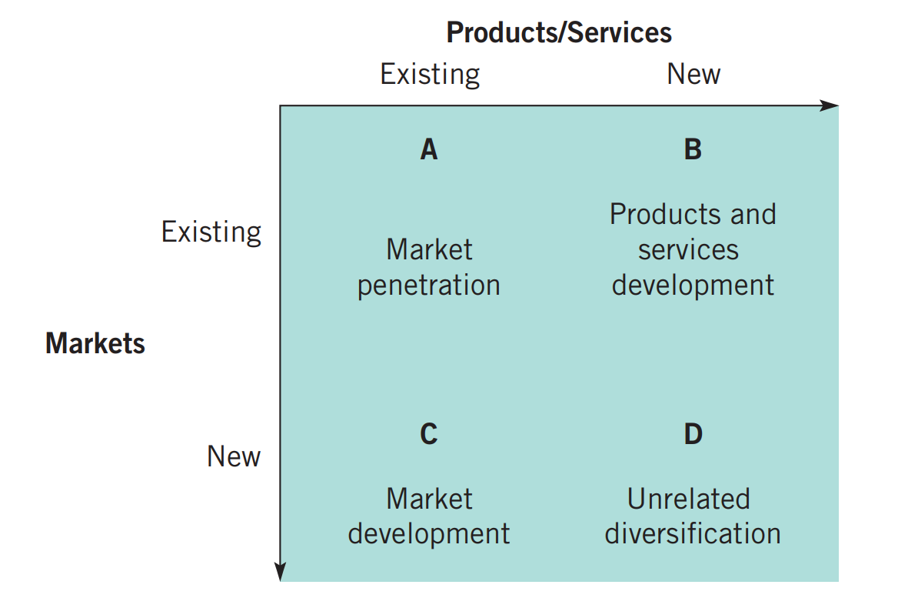
Source: (Whittington, et al., 2020)
Market penetration: the organization has adapted a Market development strategy to cultivate the path for success. The organization launches the products to penetrate the market and it does not only focus on selling the product in one market and then moving on to the other they understand the economies of scale. Currently there are 3.4 billion customers purchasing items from the organization, which reflects its market development strategy (Unilever PLC, 2024a).
Product development: Unilever improves the products or comes with the new product to offer the customers and they effectively understand the product lines. Theo organization keeps on cultivating new products for attracting the customers which is their major strategy (Unilever PLC, 2024a).
Market development: Unilever uses a market development strategy to enter the new geographical markets to extend its business operation across the boundaries.
Diversification: the organization incorporates diversification strategy in every condition. The authority of leadership of different subsidiaries is done with the motive of having disconnected diversification by the organization. For example, Tatcha LLC, Dermologica and seventh generation are the unrelated diversification of the company. The organization is doing consistent diversification in their products (Khankasi, 2020).
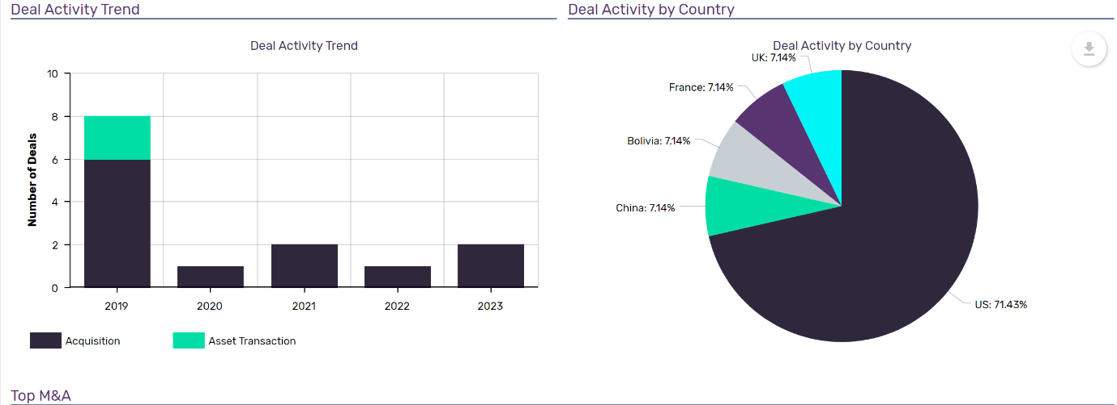

Source: (MarketLine, 2024)

Frameworks Used for Analysis

Alignment of resources and capabilities to its current business
The organization has strategically aligned their strategies and capabilities with the current objectives of their business which is helping them in maintaining the competitive advantage globally. The aligned strategies are helping the organization in attaining the sustainable growth effectively and efficiently. The portfolio of Unilever includes food and beverages, home care and personal care products; the organization is doing regular and effective research and development capabilities which is helping the organization in gaining more consumers by tapping different markets effectively. The organization is utilizing and implementing effective strategies to leverage innovation in product development. This approach provides effective insights about the changing preferences of the customers (Lynch, 2018).
The organization has developed different strategies related to market engagement and brand visibility across the global markets. The organization gives more importance to operational excellence and cost efficiency which is leveraging the improvement in the supply chain and the capabilities to optimize product differentiation (Reza, 2020). Additionally, the commitment of the organization towards sustainability and responsibility is helping them in increasing the demands of the consumers by promoting environmentally friendly products. Ultimately, the alignment of strategies and resources of the organization is enhancing the capabilities in guiding the market dynamics effectively and efficiently. This approach of the organization is deriving the sustainable success and the competitiveness of the organization.

Value Chain
The chain of value explains the grouping of ventures within an organisation which, when put together, create a product or resource. Most institutions are also a part of a larger value system, the inner workings of the links between organisations and the said relationships that are needed to create a product or service. The two are practical in having an understanding on the strategic position of an institution and where important means and capabilities reside.
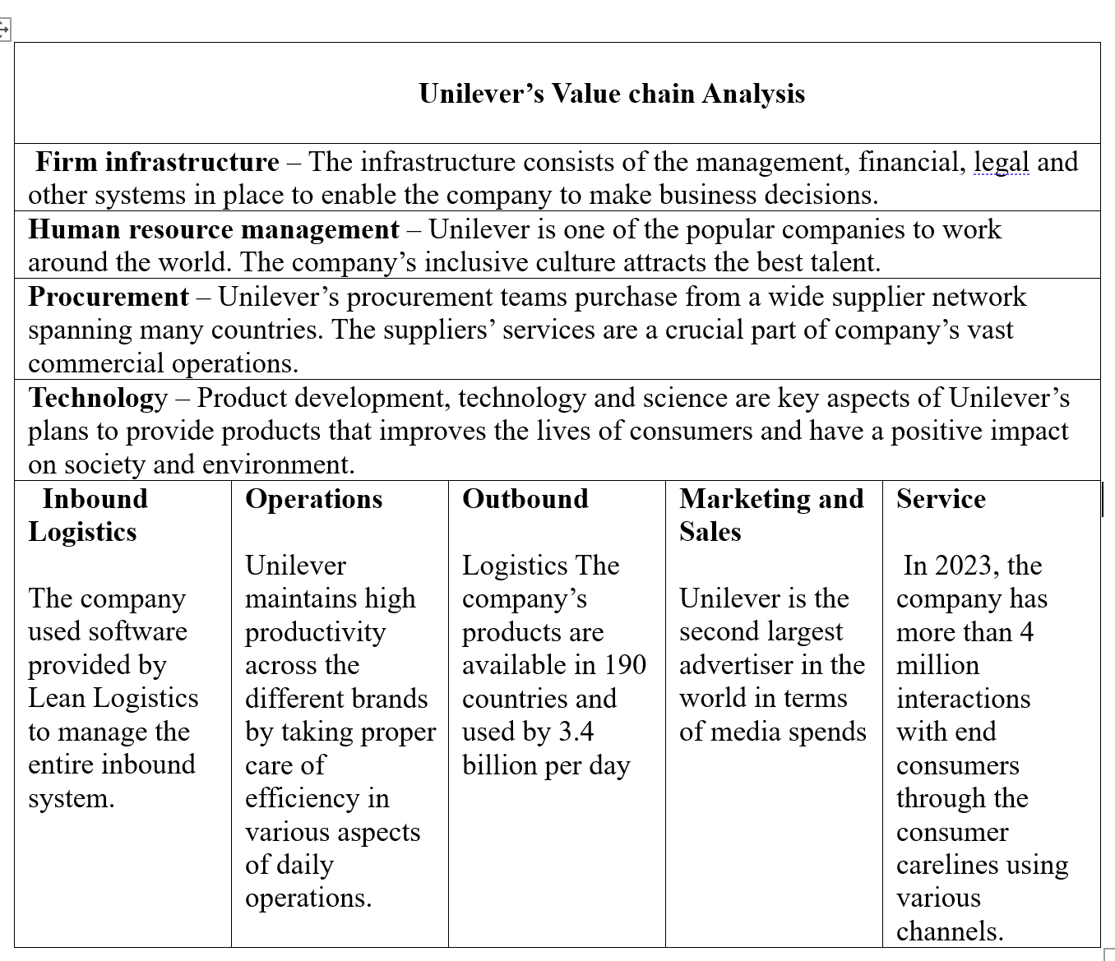
(Unilever PLC, 2023)

VRIO analysis
VRIO stands for the framework that enables the analysis of rivalry of a company’s resources and capabilities. It means Value, Rarity, Imitability, and Organization (Whittington, et al., 2020). Resources and capabilities if aligned around these, can make a sustained competitive advantage.
Valuable: strong brand portfolio, global distribution networks and extensive research and development capabilities are the valuable resources of Unilever. The organization is well known, and the research and development efforts of the organization help to address the evolving preferences of the customers effectively.
Rare: the brand portfolio of the organization including Dove, Lipton and Knorr are considered rare in the industry of goods. The global distribution network and supply chain management strategy of the organization is irreplaceable.
Inimitable: the strong history of the organization is making them strong competitors in the market and the organization the organization concentrates on sustainable and ethical practices which are deeply ingrained in their culture.
Organized to exploit: the organization effectively utilized its resources and maintained competitive advantage. The organization is imposing its strong brand image and global presence for penetrating the diverse markets of different consumer segments.

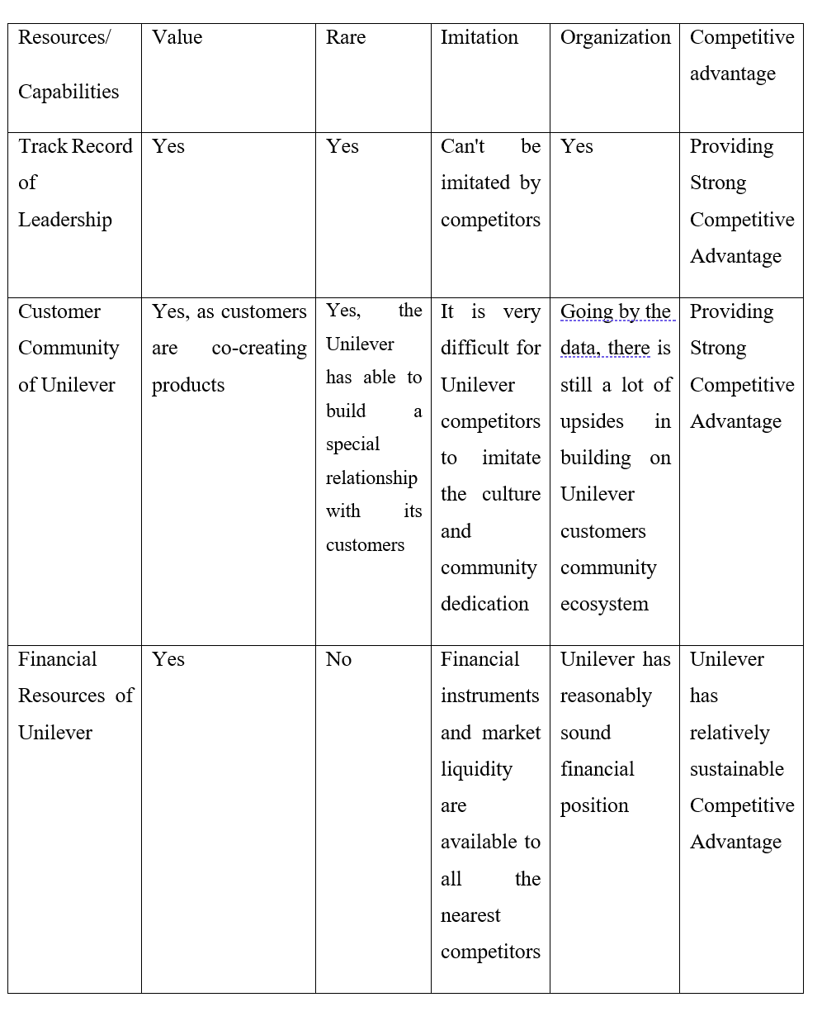

Evaluation of strategy implementation
The organization includes various matrices for the evaluation of strategies the key performance indicator of the organization includes financial metrics like revenue growth and profit margins. The financial analysis of the organization is providing information about revenue growth and profit margins and profitability of the organization. The other major and significant indicators of performance and progress of the organization is market share and brand equity. These indicators help the organization in gaining success and staying ahead of other competitors in the global markets. Furthermore, this strategy aids the organization in gaining the attention of target markets. While on the other hand the customer satisfaction metrics containing the customer retentions rates helps in measuring the rate of meeting the expectation of the consumers effectively and efficiently. Additionally, sustainability metrics helps in measuring carbon reduction level and waste reduction level of the organization (Lynch, 2018).
The organization attained success after the implementation of the strategies in the operations of business. Moreover, the concentration of the organization on innovation and product development helps the organization in launching new products and extending the market effectively and efficiently (Iglesias, et al., 2023). The organization has adapted sustainable strategies like eco-friendly packaging, product formulations and environmental initiatives. It aids the organization in attracting environmental conscious consumers effectively and efficiently. The organization has strong distribution networks and marketing campaigns has promoted its growth and expanded the business of the organization while increasing the brand image and visibility of the organization. The commitment of the organization towards sustainability and corporate social responsibility enhances the brand reputation and stakeholder relationships.

Competitiveness and sustainability
The organization has gained the several competitive advantages because of the sustainable practice’s initiatives. The brand image of the organization in enhanced because of the prioritization of the sustainability practices. it helps the organization in attracting environmental conscious consumers as well as differentiation strategies helps the organization in offering wide range of products and services to the customers (Whittington, et al., 2020). The organization has executed sustainability across its business operations, and it increases the sourcing of raw materials (Uniliver PLC, 2021).

SAF Framework
SAF (Suitability, Acceptability, and Feasibility) Framework: This approach involves appraising the feasibility of the possible strategic alternatives. This principle addresses the question of whether a strategy addresses the key strategic issues of the company. Acceptability implies the fulfillment of requirements from relevant stakeholders. Feasibility studies provide evidence that the organization has enough resources and capabilities to implement the strategy effectively (Lynch, 2018).
Suitability: the organization used a diverse range of products from personal care to home care which blends with the needs of customers effectively. The organization is innovating to meet the demands of the customers as well as the organization has extended its reach by tapping in global markets (Lynch, 2018).
Acceptability: the organization has established a strong brand reputation and commitment towards ethical practices which established a high (Lynch, 2018)level of trust between customer and company. Additionally, the organization incorporated sustainability efforts and initiatives along with boosting CSR. (Lynch, 2018)
Feasibility: the effective production process and supply chain management along with the measures of cost control certified the feasibility of the organization in the market. Effective resources allocation and financial performance is representing the feasibility of the organization effectively (Lynch, 2018).

Future strategic directions
Evaluating Sustainability Efforts includes examining the environmental, social, and economic impacts of the company's activities to establish the depth of its sustainability interventions. The assessment may cover factors such as the carbon footprint, social responsibility initiatives, and financial performance measurement that relate to sustainability objectives.
For the future, Unilever Inc. must make some strategic decisions to secure its position of competitiveness. It ensures its development in an ever-changing consumer goods industry. One of the strategic directions would be the additional market penetration into emerging markets. In this strategic direction, there is an increment in disposable income (Lynch, 2018). The changing consumer preferences offer numerous opportunities for market incision and portfolio diversification. Furthermore, Unilever might diversify the company into the digitalization and e-commerce fields to take advantage of the increasing rate of online shopping and expand interactivity with customers (Lynch, 2018).

Recommendations for Future Sustainability Practices
To strengthen its overall sustainability approach, Unilever PLC should put efforts into activities that help in solving major environmental and societal issues (Uniliver PLC, 2021). Unilever needs to support its sustainable sourcing strategy by scaling up the certified materials and incorporating regenerative agriculture practices. It aids in contributing to soil healthiness and biodiversity conservation. Moreover, Unilever should keep investing in renewable energy sources and energy efficiency measures. It will target a reduction in its carbon footprint and minimize the impacts of climate change. The last thing Unilever can do to be more effective is to use technology and data analysis techniques to increase supply chain transparency and traceability. It allows better management of both environmental and social risks in the extended chain of values.

Conclusion
In essence, Unilever PLC is the chosen organization which is a multinational company and headquarters of the organization is situated in London, United Kingdom. Unilever is organized into five business groups such beauty &wellbeing, personal care, home care, nutrition, and ice cream. In this the organization is offering a wide range of products and services to the consumers including food, beverages, home care, and personal care. The organization is utilizing and implementing effective strategies to leverage innovation in product development. The organization is doing regular and effective research and development capabilities which is helping the organization in gaining more consumers by tapping different markets effectively. The organization is utilizing and implementing effective strategies to leverage innovation in product development. This approach provides effective insights into the changing preferences of the customers. The changing consumer preferences offer numerous opportunities for market incision and portfolio diversification. It promotes sustainability and responsible practices. Adopting the suggested tactics, Unilever can provide further brand differentiation.

References
Iglesias, O., Mingiole, M., Ind, N. & Markovic, S., 2023. How to build a conscientious corporate brand together with business partners: A case study of Unilever. Industrial Marketing Management, 109(1), pp. 1-13.
Khankasi, A., 2020. Ansoff Matrix for Unilever. [Online]
Available at: https://ansoffs.com/ansoff-matrix-for-unilever/
[Accessed 6 4 2024].
Lynch, R., 2018. Strategic management. 8th ed. Harlow: Pearson .
MarketLine, 2024. Unilever Plc. [Online]
Available at: https://advantage-marketline-com.ezproxy.uwtsd.ac.uk/Company/Profile/unilever_plc?swot
[Accessed 11 4 2024].
Reza, M. H., 2020. Marketing Strategy and Sustainable Plan of Unilever. nternational Journal of Scientific Research and Engineering Development, 3(4), pp. 680-692.
Unilever PLC, 2023. Annual report and account, London: Unilever PLC.
Unilever PLC, 2024a. Unilever at a glance. [Online]
Available at: https://www.unilever.com/our-company/at-a-glance/
[Accessed 5 4 2024].
Unilever PLC, 2024b. We are Unilever. [Online]
Available at: https://www.unilever.com/our-company/
[Accessed 15 3 2024].
Uniliver PLC, 2021. Unilever sustainable living plan 2010-2020, London: Uniliver.
Whittington, R. et al., 2020. Exploring Strategy. 12th ed. Harlow: Pearson.
Zou, S., 2021. Analysis on the Recovery of MNEs from the Financial Crisis: A Case Study of Unilever. Advances in Economics, Business and Management Research, 109(1), pp. 121-128.

Appendix
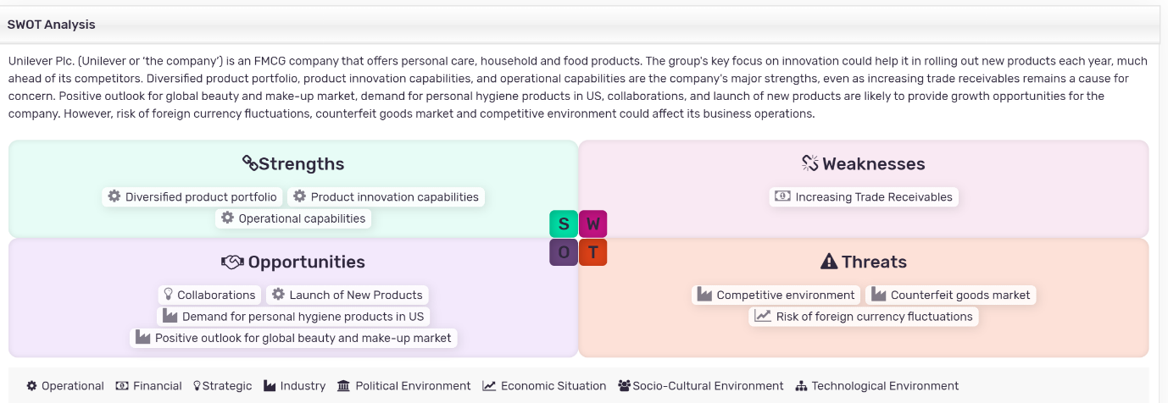
Source: (MarketLine, 2024)

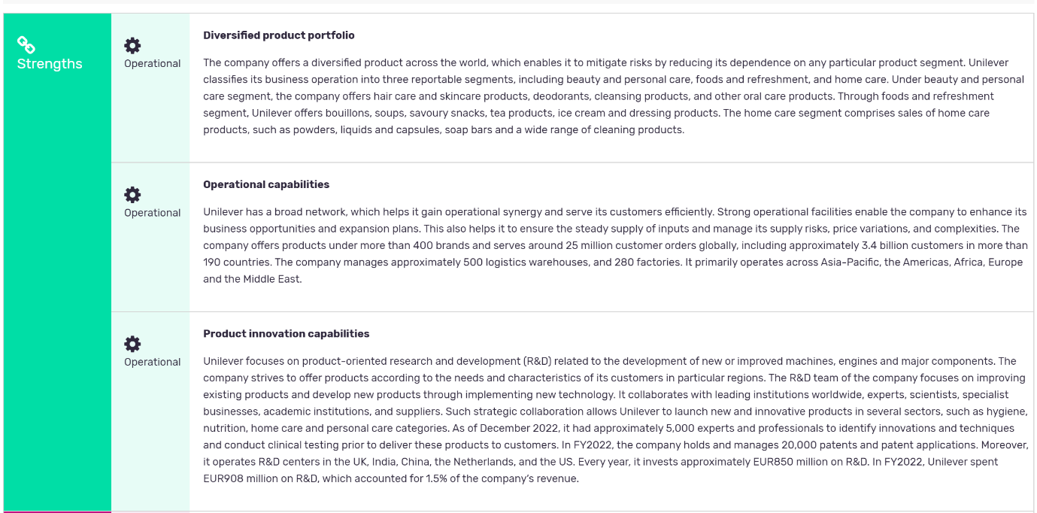
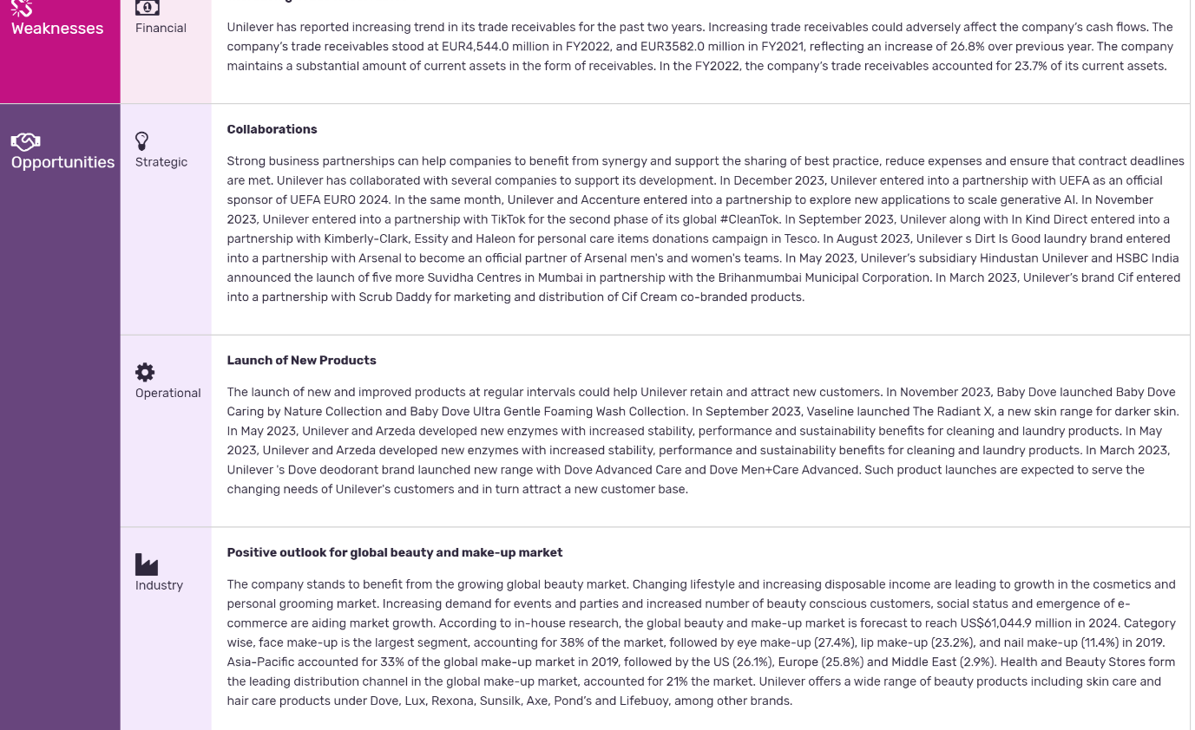
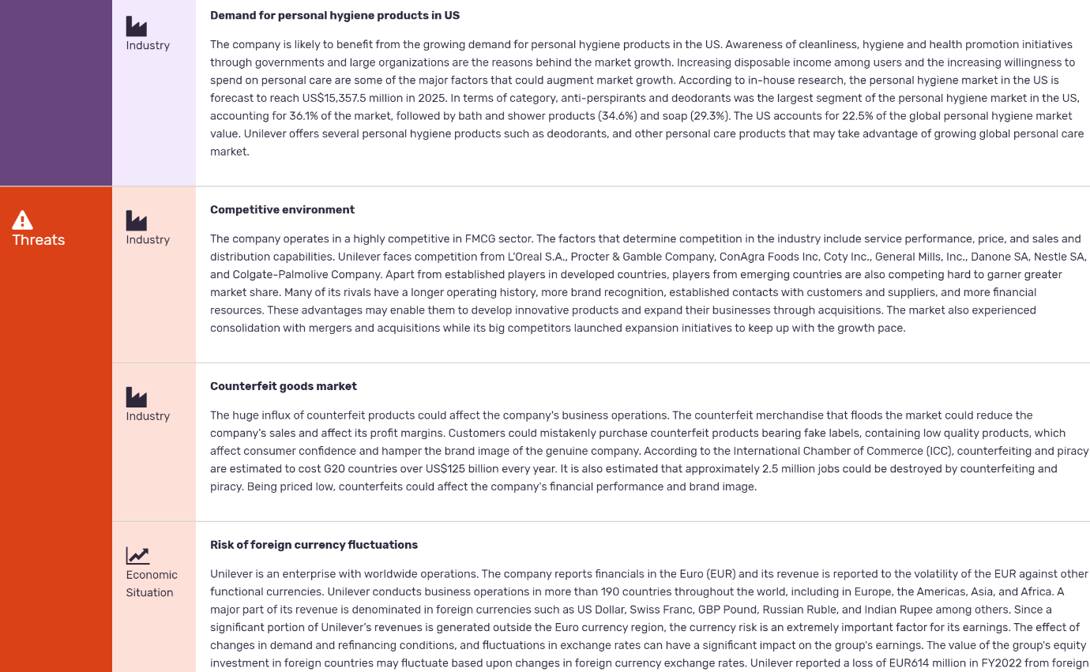
Source: (MarketLine, 2024)

