Student Name: Manikanta Gurram
Student Number:2323354
Lecturer Name: Tushara Balendran
Session: June 2024 term

THE IMPACT OF CELEBRITY ENDORSEMENTS ON CONSUMER BEHAVIOR EMPLOYED BY an analysis of NIKE

Table of Contents
1. Background to the proposed research: 3
Research title: 3
Introduction: 3
Rationale of the study 3
Aims & Objectives: 4
Research Questions: 4
Literature Review: 4
2. Research Methodology: 8
3. Resources and Planning: 13
References: 14

1. Background to the proposed research:

Research title:

The impact of celebrity endorsements on consumer behavior employed by Nike

Introduction:
Celebrity endorsements have grown into an established marketing strategy, with companies using renowned people's popularity and influence to advertise their products and services. Nike, the global market leader in sporting apparel, has made significant use of celebrity endorsements to strengthen its reputation and increase interaction with consumers. The purpose of this study is to delve into how Nike's celebrity endorsements impact consumer behavior, specifically how they influence loyalty and brand perception, especially purchasing choices. Liora and Parmono (2023) argues that celebrity endorsers who are athletes, television stars, film actors, and even people who have passed away and are frequently employed to promote a brand. Nike brought in Portuguese football player Cristiano Ronaldo, who played for Juventus in Italian Serie A, as its main brand ambassador. Ronaldo was signed for life to promote a product brand image that is projected to increase sales. The phenomenon of using celebrities is difficult for manufacturers to consider because prominent individuals will represent the appealing product (Wang, 2023). Kim et al. (2021) define brand image as an individual's collection of opinions, thoughts, and perceptions about a good or service. When making choices about what to buy, brand image development is essential, and a well-managed brand image will pay off. As a result, businesses need to be able to keep customers loyal to their brands.

Rationale of the study
The research offers a clear perspective on how endorsements affect the Nike brand and the buying behavior of consumers which is important for Nike. In addition, this research shows how the effectiveness of the endorsement strategy is calculated so that important aspects of consumer participation and brand loyalty is discovered (Alharbi et al. 2022). Knowing the impact of a celebrity on emotion and psychology enables Nike to spend less on advertising while building trust in the brand and crafting more endorsement campaigns. The research is also useful in understanding the dangers of depending too much on a celebrity or bad media coverage, which can be damaging. Such knowledge assists Nike to plan their marketing strategies effectively so as to not lose competitive edge and market share.

Aims & Objectives:
To analyze the impact of Nike's celebrity endorsement approach in influencing consumer behavior.
- To determine the crucial factors that contribute to a Nike celebrity endorser's effectiveness.
- To evaluate how Nike's brand perception among customers is positively and negatively affected by celebrity endorsements.
- To find out the impact of celebrity endorsements on Nike product-related consumer behavior and intention to purchase.

Research Questions:
- What are the crucial factors that contribute to a Nike celebrity endorser's effectiveness?
- How Nike's brand perception among customers is affected by celebrity endorsements?
- What is the impact of celebrity endorsements on Nike product-related consumer behavior and intention to purchase?

Literature Review:
Definitions
Celebrity Endorsement:
- McCracken (1989) defines celebrity endorsement as “a marketing strategy where a well-known person uses their public recognition to promote a brand or product.”
- Erdogan (1999) describes it as “an advertising technique that leverages the fame, attractiveness, and credibility of a celebrity to influence consumer attitudes and purchase intentions.”
Consumer Behaviour:
- Schiffman and Kanuk (2007) define consumer behaviour as “the study of how individuals select, purchase, use, and dispose of goods and services to satisfy their needs.”
- Kotler (2012) states that it “encompasses the actions and decision-making processes of people involved in buying and using products.”
Brand Perception:
- Keller (1993) defines brand perception as “consumers' interpretations and associations with a brand based on past experiences, advertisements, and word-of-mouth.”
- Aaker (1996) describes it as “the overall impression and reputation a brand holds in consumers' minds, influenced by emotional and functional attributes.”
Addressing research objectives:
Endorsements from celebrities serve as an excellent marketing strategy, but for Nike, it depends on a few critical factors. For Singh, Tripathi, and Kumar (2023), emotional branding and the star’s acclaim are the reasons for the campaign’s achievement, while some argue that success lies in trustworthiness and genuineness. Kang et al. (2023) demonstrate the impact of celebrity personality traits as a double-edged sword. On one edge, they increase consumers’ loyalty and ‘brand advocacy’ on the other, the endorsement needs to meet the consumers’ expectations. Schartel Dunn and Nisbett (2023), on the contrary, showed the other side of the coin by arguing that endorsements succeed when the endorsed action is socially responsible, but can also cause negative perceptions of a brand. Therefore, as much as endorsements raise Nike’s brand awareness and sales, it is not without reason that these endorsements have worked for Nike only because they have been carefully crafted to resonate with the brand's ideology and the public's feelings.
Crucial factors that contribute to a Nike celebrity endorser's effectiveness
Credibility: A celebrity’s expertise, authenticity, and trustworthiness influence consumer trust and brand acceptance (Henry et al. 2023).
Relevance: The alignment between the celebrity’s image, values, and Nike’s brand identity enhances endorsement effectiveness (Tanvir et al. 2024).
Market Reach: A celebrity with a global following expands Nike’s visibility and attracts diverse consumer segments (O’Reilly, 2024).
Emotional Appeal: Inspirational athletes create strong emotional connections, fostering brand loyalty and engagement (Guo, 2023).
Consistency: Long-term partnerships reinforce Nike’s identity and strengthen consumer associations with the brand (Boydstun, 2023).
Social Influence: The ability of a celebrity to shape trends and influence consumer behavior enhances Nike’s market position (Khosasih and Sembel, 2023).

Literature gap what is the weakness/limitation of the current research on celebrity endorsement
Theoretical Framework:
Source Credibility Model:
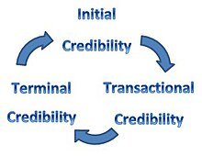
Figure 1: Source Credibility Model
(Source: Leite and Baptista, 2022)
According to the source credibility model, consumers' opinions of a brand endorser's knowledge, trustworthiness, and attractiveness determine how effective the message they express (Leite and Baptista, 2022). An established framework for source credibility that can be applied to predict or explain the effectiveness of communication is the source credibility model. It includes the three most significant source effects on buying intent, perception of a brand, and attitude toward an advertisement.
Advantages of the Source Credibility Model
- Enhances Brand Trust: A credible endorser improves consumer confidence in the brand.
- Influences Purchase Intent: Trustworthiness and expertise positively impact buying decisions (Goldin and Rodhiah, 2025).
- Strengthens Brand Perception: Consumers associate positive attributes with the endorsed brand.
- Increases Engagement: A well-perceived endorser enhances audience interaction (Li and Yu, 2023).
- Effective Across Industries: The model applies to various sectors, from fashion to technology.
Disadvantages of the Source Credibility Model
- Risk of Celebrity Controversy: Scandals can damage brand reputation.
- Short-Term Impact: Effectiveness may decline as trends change (Ramli et al. 2023).
- High Costs: Credible celebrities demand expensive endorsement deals.
- Over-Reliance on Celebrity Image: Brand identity may suffer if the endorser loses popularity (Akoglu and Özbek, 2024).
- Limited Effect on Rational Consumers: Some buyers prioritize product quality over endorsements.

2. Research Methodology:
The approaches and procedures performed to find and examine data associated to a particular study topic are commonly referred to as research methodology. It is a process whereby researchers arrange their study to use their selected research tools to accomplish their goals (Pandey and Pandey, 2021). It incorporates all of the important components of research, such as the overall framework in which the study is carried out, collecting data methods, data analysis techniques, and research design.
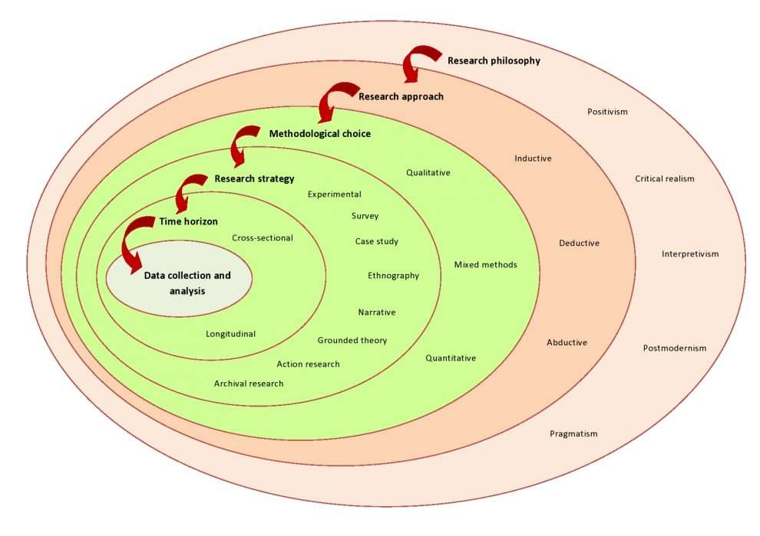
In order to develop a sound research design, Saunders et al. (2012) recommended the research onion framework, which provides a pictorial explanation of each component of the research that must be planned and examined. In other words, the research onion allows the researcher to go through all the steps that are required when developing a research methodology.
Research Philosophy: Positivism
Objectivity and reliability in data collection and analysis will be ensured by adopting a positivist research philosophy for this study (Habu and Henderson, 2023). The study adopts a positivist approach because it strives to analyse brand perception and celebrity endorsement effectiveness using quantifiable data, which relates to established norms of consumer behavior. It will facilitate the statistical examination and generalization of the findings. This philosophy is favorable because it lowers the influence of researcher bias and guarantees that the assumptions made are based on factual evidence rather than an individual's opinion. The study will systematically assess the impact of celebrity endorsements on brand perception and behavior of Nike consumers through the use of surveys (Manivel, 2024).
Research Approach: Deductive
As the study will investigate how the Source Credibility Model would apply to Nike’s endorsement strategies, a deductive method will be used. This approach begins with existing theories and attempts to test their usefulness (Ocaña-Fernández and Fuster-Guillén, 2021). A deductive strategy is optimal when the research focuses on understanding the impact created by credibility, attractiveness, and trust on consumer behavior, as it works from theory through to hypothesis testing. Given that this research will be based on existing literature and theories, a deductive approach will provide an orderly and logical sequence of research. This method is logical because it seeks to measure known marketing concepts within an organization, Nike, allowing for definitive statements to be made regarding the impact of celebrity endorsements (Broussard-Goldsmith, 2024). The analysis will add further value to the debate of brand image and consumer behavior by either supporting or countering the set theories.
Research Strategy: Survey Strategy
For this study, the Survey Strategy will be employed where primary information will be collected from Nike consumers using closed-ended questionnaires. Surveys are an efficient means of collecting quantifiable information regarding attitudes, perceptions, and purchase behaviour (Dubey and Kothari, 2022). The method is selected because it covers a wider scope and ensures that a larger sample of respondents is obtained, which increases the reliability and generalizability of the findings. It also makes statistical analysis possible, which allows for determining the relationships between celebrity endorsements and the consumers’ actions. As Nike's endorsement effect cuts across various socio-economic factors, it is appropriate to use a survey strategy to obtain different consumers' views (Salim, 2024). In addition, surveys allow for systematic collection of data, hence elimination of subjectivity and bias, and the research results become reproducible. The outcome from the survey will enable Nike to understand the effectiveness of the endorsements and the impressions of the consumers which will contribute to future marketing decisions.
Research Choice: Mono Method (Quantitative)
For the current research, a mono-method quantitative approach will be utilized, which indicates that only numerical data will be gathered and analyzed. Quantitative research always has a well-defined structure involving techniques such as surveys and statistical measurement of the variables in question (Mahuika and Mahuika, 2020). On the other hand, qualitative research is concerned with the subjective aspects of experience and insights which are largely open ended in nature. A quantitative approach is chosen in this case because it permits the measurement of the nature and extent of impact of celebrity endorsements on consumer behavior towards Nike. It will permit the researcher to carry out hypothesis testing using statistical tools which leads to objective and replicable outcomes. The mono-method approach avoids variation during the entire research process which enhances consistency in data collection, simplifies the whole complexity, and improves the clarity of the findings (Gupta and Gupta, 2022). This study will help Nike by quantifying their consumers’ purchase intentions, brand perception scores, and endorsement effectiveness ratings, thereby providing actionable results that can be used in real-world marketing campaigns.
Time Horizon: Longitudinal Cross sectional
Data will be collected over a period of time to find trends and changes in consumer behavior toward Nike’s endorsements by celebrities. This is necessary as the effectiveness of endorsements changes with time because of market updates, relevance of a celebrity, and campaign efforts made by the brand. A longitudinal study captures the evolution of a consumer’s perception and purchasing behavior unlike a cross-sectional study which only focuses on one point in time (Zou and Xu, 2023). Endorsement effectiveness is likely to have some sustained impact which this study will aim to uncover, alongside determining whether or not its effectiveness fades over time. Additionally, this study aims to explore external emerging competitors, discerning change in consumer tastes, and the growing role of social media in supporting brand endorsements. Nike will therefore have an in-depth understanding of brand health and the effectiveness of these celebrity endorsements over time.
Sampling Technique
Sampling is about choosing a group of individuals out of a larger population in order to represent the entire population in a research study (Firdaus et al. 2021). This study will collect data from Nike consumers using convenience sampling which is a form of non-probability sampling. Convenience sampling is when participants are selected based on their willingness to participate which is ideal for online surveys. A total of 50 respondents will be selected as a reasonable sample size for the captured data. How are you going to gain access to the respondents
Respondents will be consumers of Nike from different demographic segments such as age 18 to 45 years, gender, and various income levels. From a geography perspective, the research study will concentrate on Nike customers who live in cities where Nike's products are sold abundantly. Where in London? This is valid because it results in rapid data collection without needing advanced sampling methods (Saharan et al. 2020). The use of convenience sampling is typically criticized because the data cannot be generalized. However, in this case, data collected will offer useful information regarding Nike's endorsement celebrity consumer behaviour trends.
Data Collection Method
Google Forms will be used for the online survey, which will enable ease for respondents and facilitate efficient data collection and analysis. The survey will consist of 10 closed-ended questions, designed to capture consumer perceptions, attitudes, and purchasing intentions regarding Nike’s endorsements with celebrities.
To maximize both the speed and the quality of responses, each respondent will be allotted 10 minutes to complete the survey. Closed-ended questions will be employed because they provide a high level of control for the respondent's answers, which subsequently makes the analysis of the endorsement effectiveness much easier (Nayak and Singh, 2021). The online version is preferred due to its low cost, wider coverage, and quicker data collection. Besides, online surveys can be done from anywhere in the world without being restricted by geography. Although there is a tendency of self-reported data to be inaccurate due to response biases, the pre-structure format of the questionnaire will likely guarantee uniformity. This approach allows Nike to understand the impacts of celebrity endorsements on consumers’ behaviors, their perceptions towards the brand, and purchase decisions.
Data Analysis Methods
The study will adopt quantitative approaches to measure how Nike's marketing endorsement by celebrities affect consumer behaviour. The descriptive statistics of consumer answers will be summarized by mean, percentage, and frequency distribution (Islam et al. 2022). Also, inferential statistics like correlation and regression analysis will be used to study endorsement effectiveness and the intent to purchase.
Automatic basic summaries through Google Forms will be produced alongside Microsoft Excel which are used for advanced statistical analyses. In correlation analysis, the relationship between the celebrity's credibility and the attitude of the consumers will be tested for strength, whereas regression analysis will test the strength of purchase behaviour towards endorsements (Dehalwar, 2024). Using this method, Nike will objectively interpret the data, aiding them to make more calculated decisions regarding marketing endeavours. The statistical approach applied will show the impact of celebrity endorsement on brand perception and sales, providing a case study for the effective use of the marketing tool.
Research Ethics
To maintain ethical standards, this study focuses on integrity, transparency, and participant protection. Consent will be sought from all respondents with information regarding the study’s objective and their voluntary participation. No personal information will be revealed, safeguarding anonymity and confidentiality (Kang and Hwang, 2021). Participants are allowed to withdraw at any point of time without suffering from any negative outcomes. The survey will not include any questions that are biased or may elicit misleading answers. Moreover, data will be kept private, secured, and will only be used for research purposes. Ethical approval is anticipated to be granted regarding compliance with researched based policies. With this approach, trustworthiness and credibility is ensured while respecting claimant's rights.

3. Resources and Planning:

Gantt Chart:
Although the complexity and depth of a Gantt chart can vary, it always consists of three primary components: the y-axis, which displays the activities or tasks that need to be completed; the x-axis, which shows the milestones or stages of progress (either at the top or bottom of the chart); and the progress bars, which are horizontal bars that show where each task is at any given point in time.
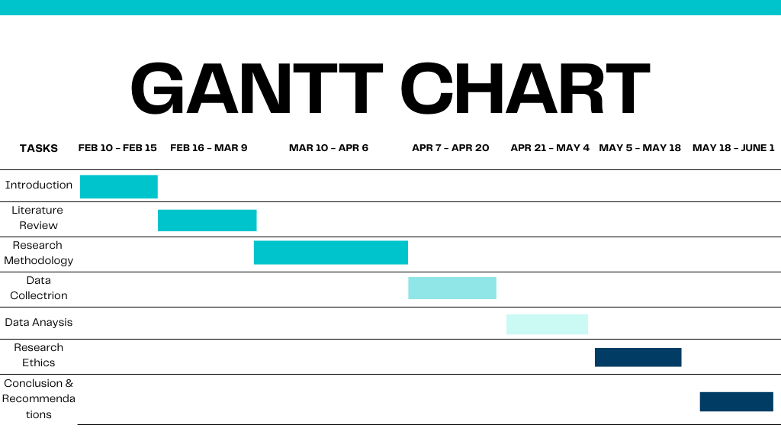Source: Self

References:
Akoglu, H.E. and Özbek, O., 2024. Online purchase behavior of sports consumers: the effect of eWOM and celebrity endorsements. International Journal of Sports Marketing and Sponsorship, (ahead-of-print).
Alharbi, K., Kim, J.K., Noland, C. and Carter, J., 2022. When corporate social advocacy meets controversial celebrity: the role of consumer–brand congruence and consumer-celebrity congruence. Sustainability, 14(3), p.1811.
Boydstun, S., 2023. The Influence of Sports Celebrity Endorsements as Described by Consumers. Grand Canyon University.
Broussard-Goldsmith, A., 2024. Brand Assessment of the Adaptation of Nike to New Consumer Trends. Open Journal of Business and Management, 12(6), pp.4020-4035.
Dehalwar, K. ed., 2024. Basics of research methodology-writing and publication. EduPedia Publications Pvt Ltd.
Dubey, U.K.B. and Kothari, D.P., 2022. Research methodology: Techniques and trends. Chapman and Hall/CRC.
Firdaus, F., Zulfadilla, Z. and Caniago, F., 2021. Research methodology: types in the new perspective. Manazhim, 3(1), pp.1-16.
Goldin, J. and Rodhiah, R., 2025. The Influence of Celebrity Endorsement, Brand Image and Brand Equity on Purchase Intention of Adidas Shoes. International Journal of Management Science and Application, 4(1), pp.11-22.
Guo, S., 2023. Analysis of Nike's Marketing Strategy Based on Adolescent Consumer Psychology. Advances in Economics, Management and Political Sciences, 48, pp.288-295.
Gupta, A. and Gupta, N., 2022. Research methodology. SBPD publications.
Habu, A.A. and Henderson, T., 2023. Data subject rights as a research methodology: A systematic literature review. Journal of Responsible Technology, p.100070.
Henry, M.A.P., Astuti, B. and Dharmmesta, B.S., 2023. The Influence of Kobe Bryant as an Endorser and Subjective Norms on Consumer Purchase Intentions for Nike Basketball Shoes. JDM (Jurnal Dinamika Manajemen), 14(1), pp.137-148.
Islam, M.R., Khan, N.A. and Baikady, R. eds., 2022. Principles of social research methodology. Springer Nature.
Kang, C.Y., Li, G., Au, C.H. and Ho, K.K., 2023. The Role of Celebrities’ Personality Traits & Endorsement on Consumers’ Online Brand Defending and Purchase Behaviour.
Kang, E. and Hwang, H.J., 2021. Ethical conducts in qualitative research methodology: Participant observation and interview process. Journal of Research and Publication Ethics, 2(2), pp.5-10.
Khosasih, R.A. and Sembel, J.S., 2023, December. Online Celebrity Endorsement and Brand Image on Customer Purchase Intention with the Mediating Role of Customer Ideal Self. In Proceeding of International Conference on Entrepreneurship (IConEnt) (Vol. 3, pp. 292-303).
Kim, S., Kim, Y., Lee, S., Lee, Y., Kang, E.Y. and Kim, M.L., 2021. The moderating role of consumers' ad perception in athlete endorsement effectiveness. Sport, Business and Management: An International Journal, 11(5), pp.535-555.
Leite, F.P. and Baptista, P.D.P., 2022. The effects of social media influencers’ self-disclosure on behavioral intentions: The role of source credibility, parasocial relationships, and brand trust. Journal of Marketing Theory and Practice, 30(3), pp.295-311.
Li, Z. and Yu, Y., 2023. The Impact of Nike's Social Media Marketing Strategy on Consumer Demand. Advances in Economics, Management and Political Sciences, 38, pp.172-178.
Liora, H.A. and Parmono, V.R., 2023. INDONESIAN CONSUMERS’ATTITUDE TOWARDS NIKE’S MULTICULTURAL CELEBRITY ENDORSEMENT. TRANSAKSI, 15(1), pp.55-65.
Mahuika, N. and Mahuika, R., 2020. Wānanga as a research methodology. ALTERNATIVE: An international journal of indigenous peoples, 16(4), pp.369-377.
Manivel, R., 2024. Decoding Customer Engagement in the Sports Shoe Industry: A Focus on Brand Loyalty and Customer Satisfaction. Available at SSRN 4824003.
Nayak, J.K. and Singh, P., 2021. Fundamentals of research methodology problems and prospects. SSDN Publishers & Distributors.
O’Reilly, L., 2024. Optics or Ethics? Nike's Strategic Use of Athlete Endorsement in Brand Activism (Doctoral dissertation, Institute of Art, Design+ Technology).
Ocaña-Fernández, Y. and Fuster-Guillén, D., 2021. The bibliographical review as a research methodology. Revista Tempos e Espaços em Educação, 14(33), pp.e15614-e15614.
Pandey, P. and Pandey, M.M., 2021. Research methodology tools and techniques. Bridge Center.
Ramli, N., Abd Latif, Z., Ismail, S.N., Mohd Shukri, N.A. and Mohd Alhadi, M.S., 2023. The influence of celebrity endorsement towards buying decision using online advertisement. ESTEEM Journal of Social Sciences and Humanities, 7(2), pp.12-26.
Saharan, V.A., Kulhari, H., Jadhav, H., Pooja, D., Banerjee, S. and Singh, A., 2020. Introduction to research methodology. In Principles of Research Methodology and Ethics in Pharmaceutical Sciences (pp. 1-46). CRC Press.
Salim, A., 2024. Influencing athletic footwear:“investigating the effects of famous influencer partnerships (Bachelor's thesis, University of Twente).
Schartel Dunn, S. and Nisbett, G.S., 2023. When celebrity endorsements collide with social activism: exploring athlete celebrity endorsements, social issues and brand perception. International Journal of Sports Marketing and Sponsorship, 24(3), pp.558-569.
Singh, A., Tripathi, N. and Kumar, G., 2023. Influence of Celebrity Endorsements and Emotional Branding on the Historical Trajectory of Nike's" Just Do It" Campaign: A Comprehensive Analysis of the Campaign [online]
Tanvir, T., Foroudi, P. and Palazzo, M., 2024. Linking celebrity endorsement and sports apparel: A focus on British customers in sports industry. In Contemporary Marketing and Consumer Behaviour in Sustainable Tourism (pp. 175-191). Routledge.
Wang, J., 2023. The Effect of Celebrity Endorsement on Brands. Communications in Humanities Research, 22, pp.1-6.
Zou, P.X. and Xu, X., 2023. Research methodology and strategy: theory and practice. John Wiley & Sons.

