Cieran Hughes
1800730
Computing

Cloud Based Web Services
Assignment 2

Table of Contents
1. Introduction 1
2. Cloud Computing 1
2.1 What is Cloud Computing? 1
2.1.1 Infrastructure as a Service (IaaS) 1
2.1.2 Platform as a Service (PaaS) 1
2.1.3 Software as a Service (SaaS) 1
2.1.4 Public Cloud 2
2.1.5 Private Cloud 2
2.1.6 Hybrid Cloud 2
2.2 Benefits of Deploying Application to the Cloud 2
2.2.1 Cost 2
2.2.2 Scalability 3
2.2.3 Deployment Speed 3
2.2.4 Reliability 3
2.2.5 Regional Specific Servers 4
2.3 Drawbacks of Deploying Application to the Cloud 4
2.3.1 Cost 4
2.3.2 Reliability 4
2.3.3 Control 4
3. Virtualisation and Containerisation 4
3.1 Virtualisation 4
3.2 Hypervisors 5
3.3 Virtual Machines 5
3.4 Containers 5
3.5 Differences 5
3.6 Adoption of Docker 6
4. Evaluation of Developing Node.JS Application in Docker 6
5. Conclusion 7
6. YouTube Weblink 7
7. References 8

List of Figures
Figure 2 - Containerization Overview 6
Figure 1 - VM Overview 6

1. Introduction
This report will focus on the main aspects of cloud computing. Firstly, defining it with the different cloud computing models and the type of cloud platforms that are offered. Following this there is a explanation of the benefits and drawbacks of deploying applications to the cloud, focusing on cost, scalability, and reliability. After this section, the next section will draw upon virtualisation and containerisation giving details on the aspects of them and looking at the main differences and driving forces. Finally, an evaluation of deploying Node.JS applications using Docker.

2. Cloud Computing
2.1 What is Cloud Computing?
Cloud computing is a way of combating the problem of adding capabilities and increasing capacity when needed without more investment and new infrastructure [1]. The term cloud computing covers any subscription basis or pay as you use service in real-time over the internet.
The way cloud computing works is the companies can rent the use of the hardware the cloud providers own. This can be storage, application, deployment servers and more. There are three main cloud computing models that can be chosen, these are IaaS, PaaS, and SaaS. Following this, there are also different deployment models.

2.1.1 Infrastructure as a Service (IaaS)
The model of cloud computing is the lowest level as the user is renting the fundamental building blocks such as servers, storage, and networking. This type is attractive to companies that want to build the application from the ground up as they can control all the aspects and elements themselves. IaaS requires the users of service to have high technical skills to be able to correctly control and set the system up at that level [2]. One of the main advantages of IaaS over the other models is the scalability, as the model is so low the users can rent more server as they need making the scalability almost unlimited.

2.1.2 Platform as a Service (PaaS)
This cloud computing model is higher up than IaaS as the cloud provider delivers the development platform, such as the infrastructure, OS and the users built on top of this. When a user is using the PaaS, they do not have access to change the OS. The main use of this is a company will build an application and run it on the provided infrastructure that then can be delivered to the client over the internet. Using this, the company does not get the full flexibility of IaaS but combats this with the reliability of predictability and pre-integration [1]. One of the main PaaS providers is the Google App Engine.

2.1.3 Software as a Service (SaaS)
The SaaS type of cloud computing model where the company only have access to the application level of computing and nothing else, as the cloud provider controls this. SaaS is the most popular cloud computing that the end-user is used to as the hardware and OS is irrelevant as the service is accessible by a web browser or app [2]. From the customer's point of view, the investment is low as there is no purchase of servers or licencing, as their cost is often bought on a per user basis. The cloud providers cost is also low with this model as there is only one application being hosted and maintained [1].

2.1.4 Public Cloud
The public cloud platform is the standard cloud computing that is mentioned and uses the main models above. This cloud platform is what the main companies provide, such as Amazon Web Server (AWS), Microsoft Azure, and Google Cloud Platform (GCP). Anything hosted on these servers can be delivered to the public internet or a dedicated network [3]. This type of cloud platform is the most used by companies but also is what the end-users are most used to accessing.

2.1.5 Private Cloud
The second cloud platform is a private cloud. This type of platform is owned by a single company or organisation with all the functionality of cloud coming, but they also own the data centres and hardware at these centres. One of the main uses of the private cloud platform is governments as there is a high level of security as they can control every level of the platform but is very expensive [4].

2.1.6 Hybrid Cloud
The hybrid cloud platform is a mix of both public and private platforms. This is an option for companies or organisations that want the benefits of both of the other cloud platforms. By combining these models, the company can build a specific solution meeting their needs, using the advantages of security and flexibility. A drawback of this solution is the communication could be affected at the networking level between the two cloud types [4].

2.2 Benefits of Deploying Application to the Cloud
2.2.1 Cost
A benefit to a company deploying is cost. This can come in different types of benefits but firstly the hardware cost. When a company is starting and want to deploy, there is a big upfront cost of purchasing the hardware and then keeping that hardware up to date by replacing it every few years. Also, then there is a cost implication with deposing of the used hardware for the company. This is combated by using a cloud provider as the costs are monthly, so the company does not have a high cost of purchasing the hardware and software licencing to set up and to host from.
Linking to the last point is the scalability cost-benefit. When a company is looking to improve and scale up for there is a high cost of hardware and software again, but as the cloud provider costs are spread, this can be easily done by scaling up on the cloud and adding to the monthly payment, not one big lump sum. Also, if a company has this extra hardware for anticipated use, it is expensive to keep it running idle, whereas you would not be paying for it if it were hosted on the cloud.
An example of this is a small start-up company that does not want the upfront cost of buying a large central web hosting and database storage servers for the application that been developed, as this application is expected to store lots of data. Their workaround is to start by hosting the web and starting all the data using AWS, and as the user and data grow, the servers can be scaled up. This will keep the cost down as there is no big initial cost.

2.2.2 Scalability
A big advantage to deploying applications to the cloud is the ease of scalability when there is spike in use and keep the applications full speeds [5]. The scalability can come in different types such as data storage capacity, processing power and networking can all be done with ease to the administrator by a few clicks [6]. Using scalability in the cloud the company can be more flexible with the ability to react to high use of their application therefore resulting in less down time if there is an unexpected spike. AWS uses auto-scaling, and this term refers to the giving the application a consistent performance regardless of the current demand.
Scalability in the cloud allows companies to try out new technologies with a less risk. The company can use different techniques like a new database server with no need to purchase new hardware to run it along sine the existing system [6]. Another advantage to the scalability is the cost of the company running hardware with the expectations for use and scaling up as they will be paying to keep this hardware running.
An example for a company that would benefit from scalability is a tax application, as it will only need to be accessed by the peak users around the end of the tax year. Whereas the rest of the year the user base will be a lot less. Another example is a streaming service, with the recent pandemic streaming services such as Spotify and Netflix needed to scale up without warning as lots of new users joined the platforms as they could not go out [7].

2.2.3 Deployment Speed
One the big benefits of deploying applications to the cloud is the agile nature. The ease of speed for deployment allows for companies to make rapid changes to the software no matter the size with things like bugs, performance upgrades or system updates. This is a major benefit as they can make these changes to keep the users happy.

2.2.4 Reliability
An advantage of cloud computing is the provider has the responsibility of keeping the servers running, not the company that is paying for the service [8]. This has many advantages to using local hardware as these cloud providers have many servers in many regions so the application can roll on to a new server if one goes down seamlessly [9]. Also, the company does not need to look at local technical support teams on standby to look at down servers they can focus all the workforce with the product at hand.

2.2.5 Regional Specific Servers
As the cloud servers can be in different countries, depending on the companies the location of the servers can be important. A reason for this is the latency, as if the server is in the same country that the end user is accessing the content from there is a lowered latency and therefore an improvement in performance [10][11].
An example of a company that this would interest is Netflix. The reason for this as it is their best interest for the users to access and steam the content on the server that are in the local region for improved latency and video quality. But this could lead to a more expensive server as the price differs in different regions [10].

2.3 Drawbacks of Deploying Application to the Cloud
2.3.1 Cost
A drawback of deploying an application to the cloud is cost. Even though this can be a benefit to some companies that do not want to spend lots on new hardware that may not be needed, the monthly cost of hosting applications using cloud providers can be expensive.

2.3.2 Reliability
The reliability of deploying applications on the cloud can be a disadvantage as there is a perceived security. Firstly, the user that rents the servers from the cloud provider does not know the location were their data is being stored causing an insecurity on the protection on the physical data centres that store the systems [8]. Another security risk that is linked to the reusability is the mean of accessing the cloud servers. The ease of accessibility is high, but this can come with security flaws as the ability to access the servers from anywhere allows for bypassing the person connection [12].

2.3.3 Control
A drawback of deploying an application to the cloud is the user does not have control. The reason for this is the company has no control under the cloud computing model that they have paid for, leaving the rest of the decisions on the cloud provider. Whereas if the company local deployed the application they can control every aspect.

3. Virtualisation and Containerisation
3.1 Virtualisation
Virtualisation is the process of allowing multiple technologies to run simultaneously on the same hardware [13]. It creates a virtual platform of the server, OS and storage devices which helps the multiple instances to access the single physical resource [14]. There are different types of virtualisation, Operating System Virtualisation, Hardware Virtualisation, Server Virtualisation and Storage Virtualisation. An example of use for a company running more than one virtual environment for developers to test features on without affecting the main system all on one server [15]. A huge advantage of this is the company does not need more hardware to spin up multiple virtual environments.

3.2 Hypervisors
The virtualisation of multiple technologies running on one system is made possible by hypervisors. A hypervisor is a monitoring tool for all the systems running side-by-side. It has access to all the physical hardware and can allocate the resources such as computing power, power, memory, storage and so on to each portion of the multiple systems [16]. As the hypervisor controls the different systems that are running, they are easy to transfer from server to server using the hypervisor. A hypervisor can also be known as a virtual machine monitor (VMM) [17].

3.3 Virtual Machines
A virtual machine (VM) is made possible by the virtualisation of hardware. It emulates the hardware of a physical computer running any OS that is compatible, allowing for the appearance of multiple computers with different OSs on the hardware of one server [16].
Each VM image is essentially a data folder. This allows the ease of moving, copying, recovery and backing up. Also, all the different workloads can be centralised in house for a company if needed as all the systems will be on one server with the advantage of using different OSs [16]. Another advantage of using VMs is the developers can go beyond the limitations of the hardware as the VMs can be configured in many ways [18].

3.4 Containers
A container is a way of running multiple applications independently from the OS on one machine. All they need is access to the container engine [17]. The containers share the kernel of the OS that it is running on with other containers making them lightweight, giving them the ability to deploy multiple containers from one server. As there is one OS housing, all the containers maintenance is easy, as updating and control can be done from the one OS. Also, this gives the ability for ease of scaling without more servers or space [16].
The container is stored in one executable package of software that stores everything that is needed to run the application. As the container can then be spun up using an engine such as the Docker engine, the software will run the same regardless of the infrastructure. This is the case as the container isolates the software that is being run from the environment to allow for uniformity.
The main advantages of deploying applications using containers are the standard that is delivered by them as they will run the same on each machine. They are lightweight, making it easy to spin multiple containers up and down, and with only one OS, they are very efficient to do so [19].

3.5 Differences
The main difference between containers and VMs is what level they are being run at, as seen in Figure – 1 and Figure – 2. The containers are at the application level and package the code and dependencies together. Whereas the VMs run at the hardware level and can run OSs turning one server into many. The hypervisor allows for the different VMs that store a full copy of the OS, application, and necessary libraries to boot. This makes the VMs slower to boot than a container and are a lot bigger, as a VM can be several GB, whereas a container can be tens of MBs [19].
A main deciding factor between containers and VMs is the lifecycle and access the application needs. Container’s life span is shorter and is designed for more agile applications due to the quick speeds of deployment. Whereas VMs are chosen for an application that is being used for longer periods of time with a long lifecycle. Also, VMs are chosen over containers if the application needs deeper access to the OS and hardware that is it begin run on [16].
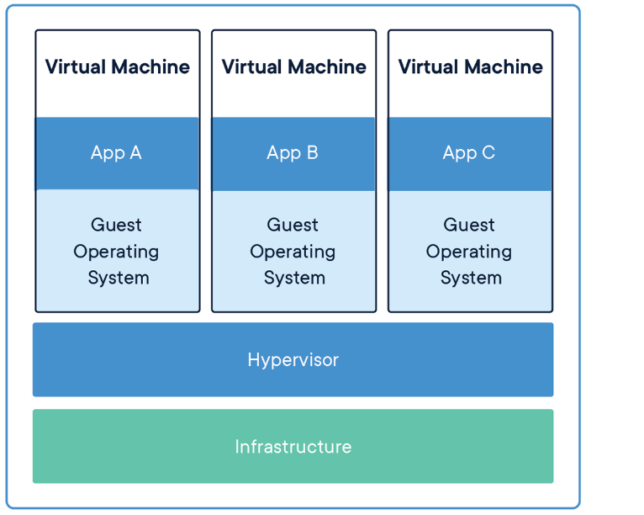
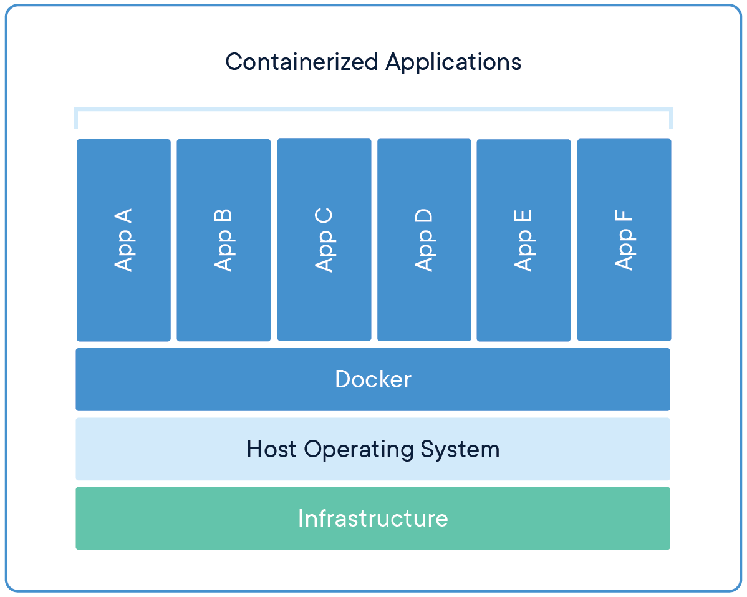
Figure 2 - Containerization Overview
Figure 1 - VM Overview

3.6 Adoption of Docker
It is predicted that by 2023, 70% of organisations will be running three or more containerised applications [20]. By looking at this statistic alone shows how the adoption of docker is going through the roof. The main reason for this is the advantages companies get with the use of containers from the ease of use, speeds to the lowered cost as the application can be spin down and up quickly. Another statistic to back this up is there are over 3.5 million application placed in container using Dockers technology [21].

4. Evaluation of Developing Node.JS Application in Docker
When developing a Node.JS application in docker there are three main containers that are being used. The first one being the database server of the developer’s choice, the web server that the client accesses and the web service that is the communication layer between the database and the client. There is also another container in use for the project and it is a GUI interface for the database server.
The docker compose file is where the containers information is stored. But this links to the Dockerfile that is the set up for the systems of the Node containers. The set-up of the Node.JS environment is done in this section where the ports are stated and the NPM start scripts are run from.
Comparing this to the conventional way of developing Node.JS it goes the developer a higher piece of mind that the system from the database to client side application will work as intended and did on their machine. Also, when developing Node.JS in this way there are more options that are available to be changed such as a deeper configuration of the networking. This can be a good or bad thing as it makes the system more complex to set up but gives the developer more control.

5. Conclusion
This report outlined the main finding of cloud computing and models provide. When looking at the benefits and drawbacks they apply to specific examples so the main use of the types of cloud computing heavily depend on the application at hand.
Virtualisation and containerisation is a key component of allowing flexibility to systems and as talked about giving many advantages. Then finally the report covered the main aspects of Docker and developing an application in Docker using Node.JS.

6. YouTube Weblink
https://www.youtube.com/watch?v=BSSjR9hUz2U

7. References
[1] K. Eric, “What cloud computing really means | InfoWorld,” Infor World, no. April, 2008.
[2] S. Ranger, “What is cloud computing? Everything you need to know about the cloud explained,” 2018. [Online]. Available: https://www.zdnet.com/article/what-is-cloud-computing-everything-you-need-to-know-about-the-cloud/. [Accessed: 13-May-2020].
[3] S. h Neenan, K. Casey, and A. Earls, “What is public cloud? Everything you need to know,” 2020. [Online]. Available: https://searchcloudcomputing.techtarget.com/definition/public-cloud. [Accessed: 13-May-2021].
[4] LeadingEdge, “What are the Types of Cloud Computing?” [Online]. Available: https://www.leadingedgetech.co.uk/it-services/it-consultancy-services/cloud-computing/what-are-the-types-of-cloud-computing/. [Accessed: 13-May-2021].
[5] N. Ram, S. Tirupati, and D. .P.V.S, “Deploying an Application on the Cloud,” Int. J. Adv. Comput. Sci. Appl., vol. 2, no. 5, pp. 119–125, 2011.
[6] VMware, “What is cloud scalability?” [Online]. Available: https://www.vmware.com/topics/glossary/content/cloud-scalability. [Accessed: 13-May-2021].
[7] Y. Sverdlik, “How Zoom, Netflix, and Dropbox are Staying Online During the Pandemic,” 2020. [Online]. Available: https://www.datacenterknowledge.com/uptime/how-zoom-netflix-and-dropbox-are-staying-online-during-pandemic. [Accessed: 13-May-2021].
[8] M. R. Mesbahi, A. M. Rahmani, and M. Hosseinzadeh, “Reliability and high availability in cloud computing environments: a reference roadmap,” Human-centric Comput. Inf. Sci., vol. 8, no. 1, 2018.
[9] LucidContent and Team, “Cloud computing 101: The interrelationship of scalability, reliability, and availability.” [Online]. Available: https://www.lucidchart.com/blog/reliability-availability-in-cloud-computing. [Accessed: 13-May-2021].
[10] R. Hawkes, “Why regional cloud hosting matters,” 2019. [Online]. Available: https://www.techradar.com/news/why-regional-cloud-hosting-matters. [Accessed: 13-May-2021].
[11] D. Blechynden, “Why regional cloud hosting matters,” 2020. [Online]. Available: https://www.itproportal.com/guides/why-regional-cloud-hosting-matters/. [Accessed: 13-May-2021].
[12] McaFee, “What Is Cloud Security?” [Online]. Available: https://www.mcafee.com/enterprise/en-gb/security-awareness/cloud.html. [Accessed: 13-May-2021].
[13] E. Bauer and R. Adams, Reliability and Availability of Cloud Computing. Wiley-IEEE Press, 2005.
[14] VMware, “What is Virtualization?” [Online]. Available: https://www.vmware.com/uk/solutions/virtualization.html. [Accessed: 13-May-2021].
[15] DataFlair, “Virtualization in Cloud Computing.” [Online]. Available: https://data-flair.training/blogs/virtualization-in-cloud-computing/. [Accessed: 13-May-2021].
[16] A. Strong, “Containerization vs. Virtualization: What’s the Difference?” [Online]. Available: https://www.burwood.com/blog-archive/containerization-vs-virtualization. [Accessed: 14-May-2021].
[17] VMware, “Hypervisor.” [Online]. Available: https://www.vmware.com/topics/glossary/content/hypervisor. [Accessed: 14-May-2021].
[18] V. Yfantis, “Virtual Machine and its Benefits | Parallels Insights,” 2020. [Online]. Available: https://www.parallels.com/blogs/ras/virtual-machine/. [Accessed: 14-May-2021].
[19] Docker, “What is a Container?” [Online]. Available: https://www.docker.com/resources/what-container. [Accessed: 14-May-2021].
[20] A. Kohgadai, “6 Container Adoption Trends of 2020,” 2020. [Online]. Available: https://www.stackrox.com/post/2020/03/6-container-adoption-trends-of-2020/. [Accessed: 14-May-2021].
[21] S. J. Vaughan-Nichols, “What is Docker and why is it so darn popular?,” 2018. [Online]. Available: https://www.zdnet.com/article/what-is-docker-and-why-is-it-so-darn-popular/. [Accessed: 14-May-2021].

