

BA (Hons) Leadership and Management
(Stakeholders Engagement)
Student Name: HELGA TIMEA NYERGES
Student Number: 2336465

Course Name: Project Management LCLM5003

Lecturer Name: Dr. Rexon Nting

Executive Summary
Risk analysis is an essential part of the proper project management, because it allows defining, assessing, and eliminating uncertainties that can affect the project results. Within the example of the Worcester transport infrastructure reconstruction, there are a few significant risks involved, each with the need to be handled through proper and systematic management approaches that would reduce its possible effect on the projects performances.
Weather related delays are one of the major risks. Since the project is being pursued as a response to the extreme cases of flooding, chances of new adverse weather conditions impacting on the construction processes are high. The abundance of rain, storms, or unforeseen environmental variations can interfere with the functioning of the site, decrease the efficiency, and pose a threat. To avoid this risk, flexible scheduling will be put in place to ensure that project schedules can be changed where need arises. Moreover, contingency planning will make sure that the critical activities can be re-scheduled without making significant setbacks to the entire project schedule.
The other significant risk is budget overruns that usually occur in large scale infrastructure projects. Financial pressures may arise due to unexpected rises in material costs, the need to repair something more, or the need to delay the execution of the project. To control this, sound financial management practices will be exercised such as constant monitoring of costs and application of stringent financial control practices. Budgetary reviews will be regularly done to monitor expenditure and reserve sum will be kept to meet any unplanned expense without compromising on financial stability.
A fourth risk to the project also includes supply chain disruptions. Delays in delivery or acquisition of the required materials and equipment may have a serious effect on the project timeline and productivity. To avoid this risk, the project will have a proactive procurement policy, which involves use of more than one supplier so as to avoid excessive reliance of one supplier. Procurement planning will also be done early in advance so that materials can be procured in advance and be delivered due to demands of the project.
In order to sustain such strategies, a detailed risk register will be kept throughout all the project life cycles. All the identified risks will be recorded in this register, estimated by their probability and possible effects and provided with the mitigation measures. The reviews and updates will keep the identified emerging risks under control and ensure that the project is flexible, more robust, and focused on the objective.
Table of content
PART A - POSTER 1
PART B - REFLECTION 2
PART C - PROJECT MANAGEMENT PLAN 4
1. Introduction 4
2. Project Description 5
3. Scope 5
4. Work Breakdown Structure (WBS) 6
6. Gantt Chart 7
7. Stakeholder Involvement 8
8. Allocation of Resources 9
9. Risk Analysis 10
10. Conclusion 11
11. References 13

PART A - POSTER
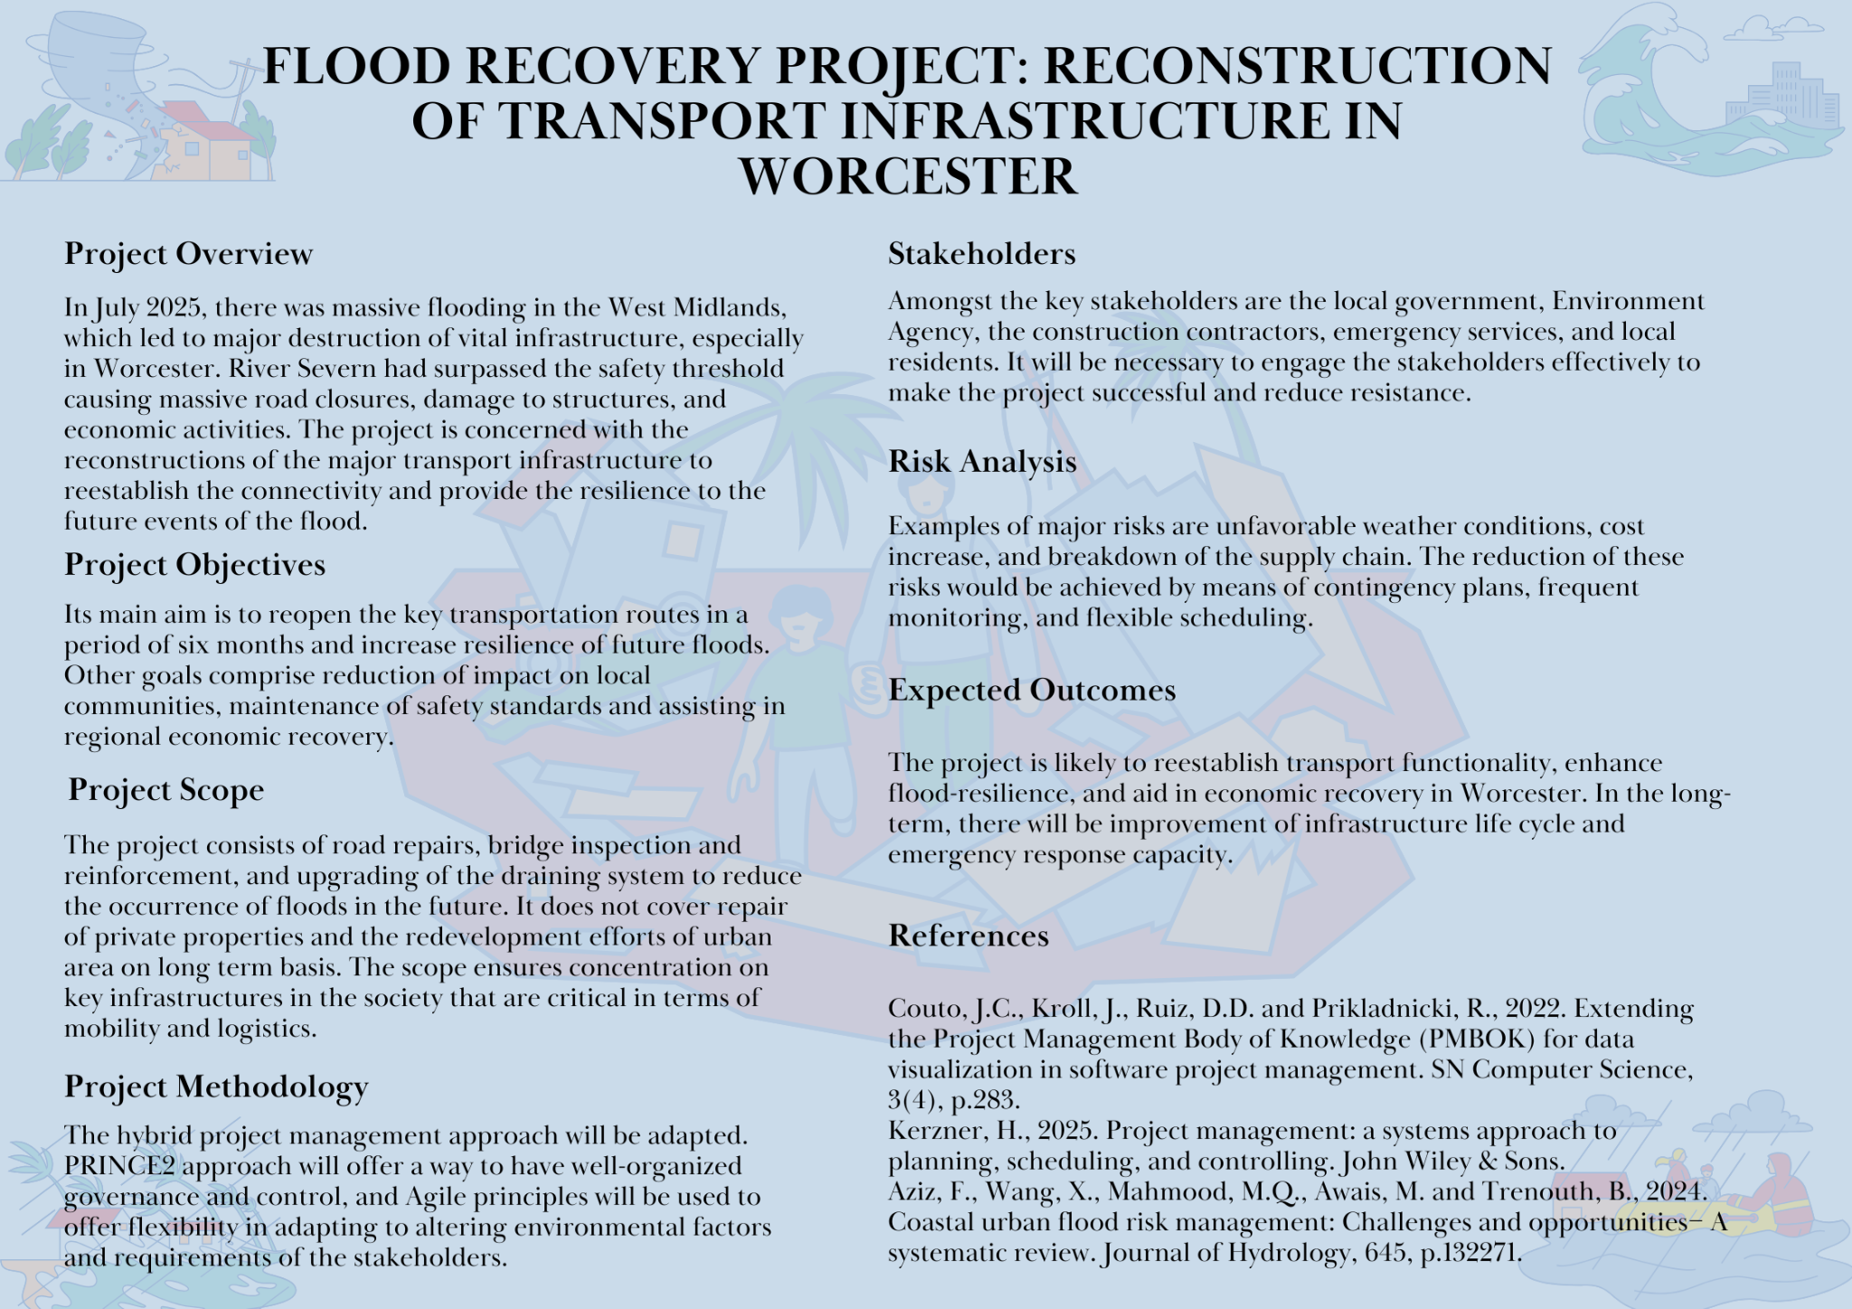

PART B - REFLECTION
This section reflects on the feedback received from the tutor and peers regarding the project proposal poster. The reflection evaluates both strengths and areas for improvement and explains how the feedback informed the final project management plan.
One of the key strengths identified in the feedback was the clarity of the project objectives. The poster clearly outlined the purpose of the project, focusing on infrastructure recovery and resilience. Additionally, the real-world relevance of the project was positively acknowledged, particularly in relation to the recent flooding scenario in the West Midlands. The use of established project management methodologies such as PRINCE2 was also considered appropriate and demonstrated a sound understanding of theoretical concepts.
However, several areas for improvement were highlighted. Firstly, the risk analysis section was considered too brief and lacked depth. Feedback suggested that risks should be categorised and supported with mitigation strategies. Secondly, stakeholder analysis was identified as underdeveloped. While key stakeholders were listed, their roles, interests, and influence were not sufficiently explained. Furthermore, the visual layout of the poster was noted as needing improvement, particularly in terms of structure and readability.
In response to this feedback, several improvements were made in the final project management plan. The risk analysis section was expanded to include a detailed risk register, identifying likelihood, impact, and mitigation strategies for each risk. This aligns with best practices in project management and strengthens the overall plan. Additionally, a stakeholder analysis matrix was introduced, providing a clearer understanding of stakeholder influence and engagement strategies.
The structure and presentation of the project were also improved. Greater emphasis was placed on logical flow, ensuring that each section clearly links to the next. More detailed explanations were included to demonstrate critical understanding rather than simple description.
Overall, the feedback played a crucial role in enhancing the quality of the final project plan. It encouraged deeper analysis, improved structure, and more effective application of project management principles. This reflective process has contributed to the development of both academic and practical skills relevant to project management.

PART C - PROJECT MANAGEMENT PLAN

Introduction
In July 2025, heavy flooding that hit the West Midlands caused widespread destruction of key infrastructure and Worcester was among the most hit regions. The River Severn overflowed its critical level and broke flood defences leading to a lot of havoc. Roads got impassable, bridges were undermined and drainage systems were strained. These situations greatly affected the transportation systems, the emergency response measures and the local economic activities, which shows the susceptibility of the current infrastructures to the extreme weather conditions.
This kind of massive disruption needs to be addressed in an organized and coordinated manner, and here the project management is instrumental. Project management allows planning, carrying out and controlling complex projects in a systematic manner. Utilising the best practices, including PRINCE2 and the ideas in the Project Management Body of Knowledge (PMBOK), organisations may make sure that the resources are distributed efficiently, schedules considered, and risks are detected and addressed accordingly. This is a systematic solution and is vital in case of disaster recovery projects where time, cost and quality parameters have to be well balanced (Nishaant, Sudhakumar and Chellappa, 2025).
This report is presented with the aim of giving a detailed project management plan of rebuilding the transport infrastructure in Worcester after the floods. The project is aimed at recovery of the major road systems, strengthening the damaged bridges and enhancement of drainage systems to boost resiliency in case of future floods. The report identifies the main elements of the project such as project description, defined scope, work breakdown structure, schedule in form of Gantt charts, stakeholder involvement, allocation of resources and analysis of risks.
The purpose of this project management plan is to offer a coherent set of guidelines to facilitate the effective execution of infrastructure recovery and assure sustainability in the long-term, safety enhancement, and resilience elevation in the area (Opabola and Galasso, 2024).

2. Project Description
The project focuses on the reconstruction and improvement of transport infrastructure damaged by flooding. This includes repairing roads, reinforcing bridges, and upgrading drainage systems to enhance resilience.
The project is necessary to restore connectivity, support economic recovery, and ensure public safety. Without intervention, prolonged disruption could negatively impact businesses, emergency services, and daily commuting.
The project will be delivered using a hybrid methodology combining PRINCE2 and Agile principles. This ensures both structured governance and flexibility.

3. Scope
The scope of the given project determines the particular activities and deliverables needed to reconstruction of transport infrastructure in Worcester in the aftermath of flooding that took place in July 2025. Project scope is significantly necessary so that any project objectives could be fulfilled in the most efficient way, resources are distributed and the redundant work could be avoided.
The project has a number of main components which help directly to restore and enhance transport functionality. They involve the repair and resurfacing of roads which were destroyed or made unusable by the floods. Further, the project entails inspection, evaluation, and strengthening of bridges to ascertain their structural integrity and safety to further use. The other important aspect is the modernization of drainage systems to enhance better water control and mitigate the chances of floods in future. It also involves the installation of flood-resistant materials and engineering solutions that will make the infrastructure more resilient and durable to extreme weather conditions.
Meanwhile, some aspects are clearly not in the project to focus on and control resources. The repair or restructuring of residential properties is not part of the project since it is not the role of the development of the infrastructure of the population. The same applies to massive urban redevelopment projects which need planning systems on their own and long-term schedules. This project does not also include non-transport infrastructure including utilities that do not involve roads and bridges (Boakye et al., 2022).
The project scope has helped in making sure that the effort is focused on the most important transport infrastructure because it clearly defines what should and should not be in it. This specialized strategy helps in managing projects well, minimizing scope creep risks, and providing the opportunity to deliver the project goals on time within the stipulated budget and time limits.

4. Work Breakdown Structure (WBS)
One of the essential tools in project management is the Work Breakdown Structure (WBS) which breaks down the entire project into small and manageable pieces. It offers a definite outline of how to systematically arrange work, how to distribute duties as well as how to track the progression during the project life cycle. In the re-construction project of the transport infrastructure in Worcester, the project is planned into a few main stages so as to have a systematic implementation and efficient control.
The initial stage is project initiation that entails setting out of the project objectives, identification of key stakeholders, approval and funding. This stage forms the basis of all the activities that come after it. Planning and design stage is the second phase because it entails the creation of detailed project plans, technical specifications, and engineering design. It also encompasses scheduling, budgeting and risk assessment to make sure that it is ready to be implemented (Wang et al., 2022).
The procurement stage comes next whereby the necessary resources including materials, equipment as well as contractors are obtained. This step will make sure that all the necessary inputs are ready by the time construction starts. The second stage is the construction and repair, which is the main part of the project, and it consists of physical work, which is the resurfacing of roads, strengthening of bridges, and improvement of drainage systems. This stage involves proper coordination to improve quality and time schedules.
The testing and inspection period is followed after construction in order to ensure that all activities are in compliance with the necessary safety and quality standards. Any defects that are detected are rectified prior to acceptance. The last stage is the project closure that consists of formalizing completion, documentation, project performance evaluation, and handing it over to the appropriate authorities.
Every phase is further subdivided into smaller yet detailed tasks in order to enhance clarity and accountability. This systematic method can allow this to be managed efficiently, progress to be tracked and the project fit within the set scope, time and budget limits.
5. Quad Chart
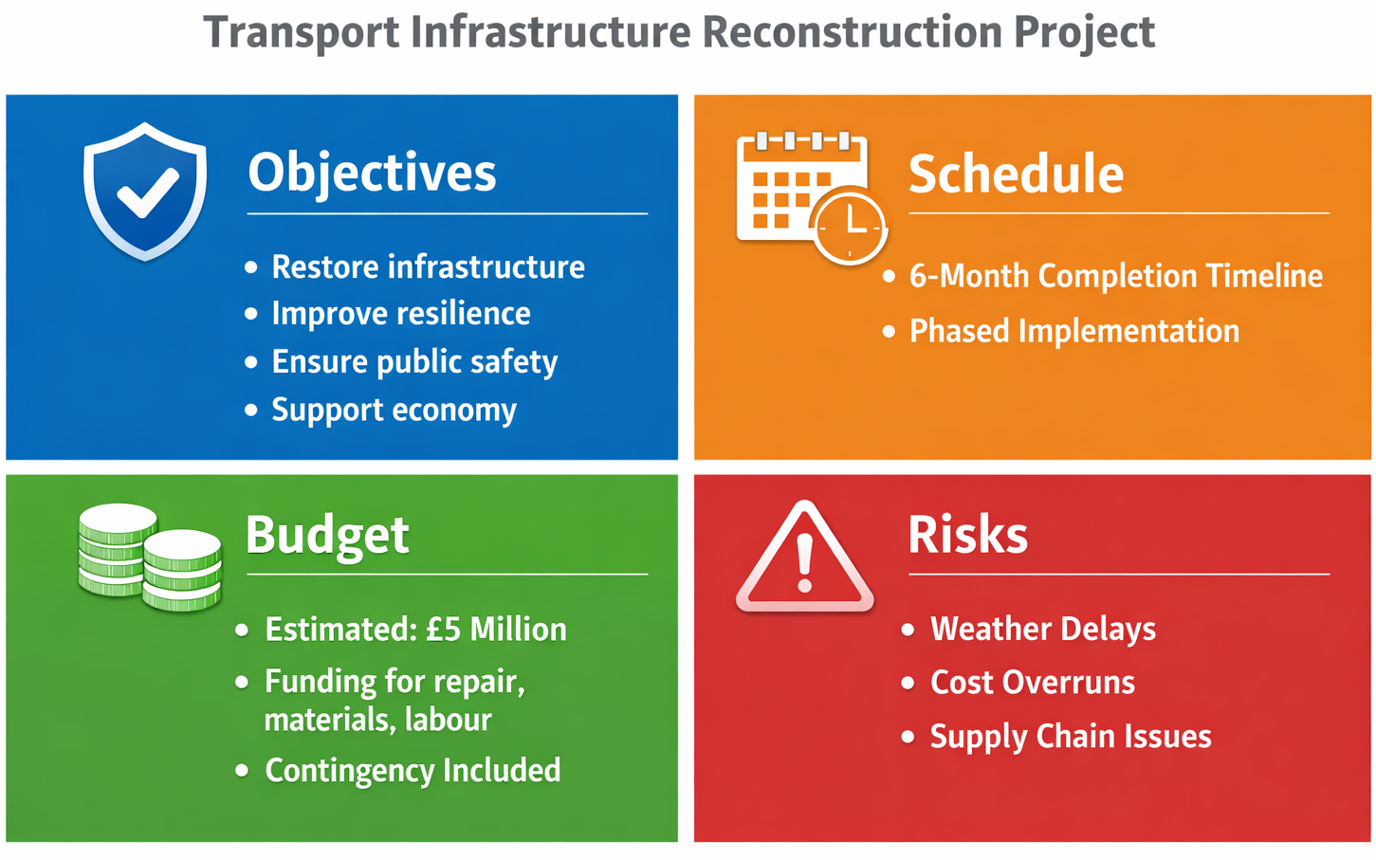
Figure 1: Quad Chart summarising key project elements

6. Gantt Chart

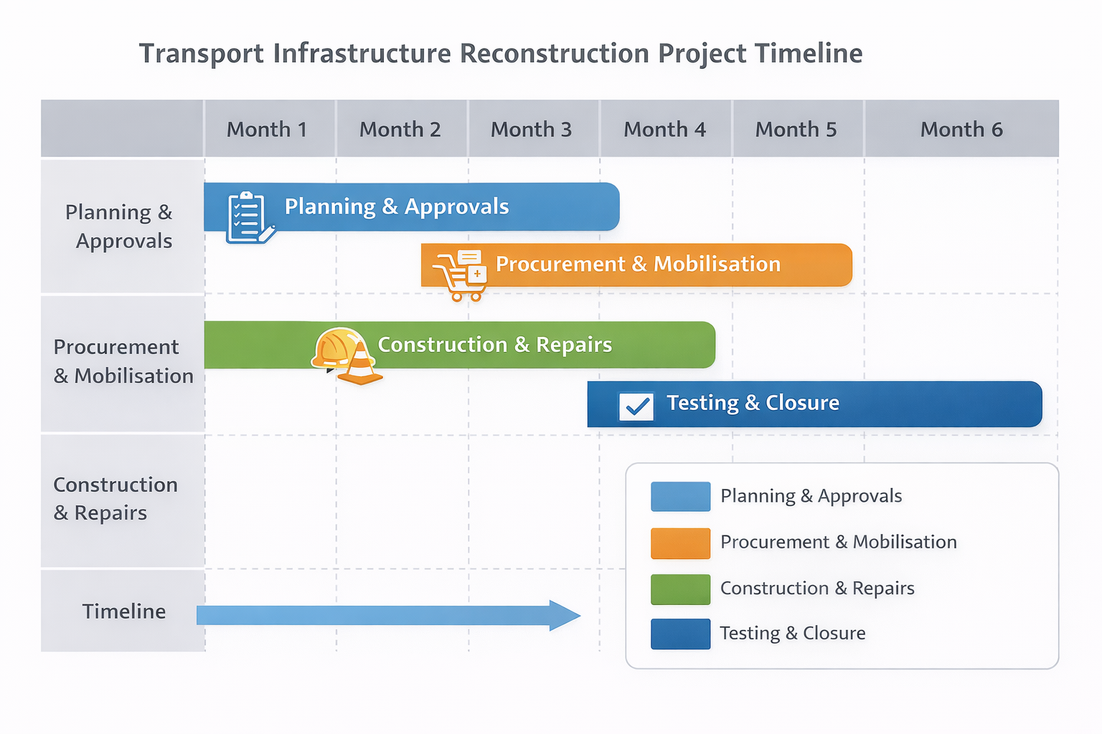
Figure 2: Transport infrastructure project timeline

7. Stakeholder Involvement
Stakeholder engagement is another important aspect of a project management process as it encompasses all the concerned individuals to ensure that they are part of the project and informed and aligned to the objectives of the project. In the scenario of the contract to redesign the transport infrastructure in Worcester, there are a number of critical stakeholders who are involved in the effective implementation of the same.
The local authorities are considered to be one of the first stakeholders as they should give the project approval, ensure funding, and control adherence to the regional development policies. They should be involved to make sure that the project complies with the laws and priorities of the public sector. The other significant stakeholder is the Environment Agency, which provides pro-regulatory advice and skills in the area of flood risk management and environmental protection. Their contribution is imperative in making sure that the project will be sustainable and in line with the environmental standards (Simonaitis, Daukšys and Mockienė, 2023).
The physical side of the project is carried out by contractors and construction firms directly. Their duties involve making repairs, executing engineering solutions and making sure that work is done within the given time and budget limits. There should be effective coordination with the contractors with a view to uphold quality standards and deliver the projects on time. Another stakeholder group that should be noted is the local communities because they are the number one beneficiaries of the infrastructure and directly affected by the disruption by the flooding and the consequential reconstruction efforts. Their needs and concerns should be factored to make sure that the project has significant and valuable results (Ambily, Chithra and Mohammed Firoz, 2024).
Various engagement strategies will be adopted so as to successfully drive the stakeholder relationship. Frequent communication: The frequent communication will be organized in the form of meetings, progress reports, and updates to ensure transparency and develop trust. The consultation with stakeholders will be carried out to receive feedback and eliminate any worries during the project lifecycle. In addition, effective communication channels will be opened that will assist in information sharing and allow taking decisions jointly.
Good stakeholder engagement makes projects more successful through proper management of expectations, minimisation of risks and maintainability of the parties towards the delivery of project objectives. Such a collaborative strategy helps to achieve better results, enhanced responsibility and sustainability of the infrastructure improvements in the long term (Nabawy and Gouda Mohamed, 2024).

8. Allocation of Resources
Resource allocation is a basic element of a successful project management process because it entails the availability of all the required input and efficient utilisation of these resources over the entire lifecycle of the project. When constructing transport infrastructure in Worcester, the resources can be divided into the human, financial and material resources which are important in fulfilling the objectives of the project.
The project implementation involves human resources that consist of various professional and skilled employees and workers. The project managers coordinate, plan and control the activities of an overall project to ensure that the project does not go beyond the schedule and budget. Technical skills are offered by engineers such as designing, evaluating, and executing infrastructure solutions. The physical work done to repair roads, bridge reinforcement and upgrading of drainage systems is done by skilled labourers and construction workers. Management of human resources would entail allocation of roles according to the expertise of the individuals, clear communication during the project and the project being productive.
The financial resources also play a significant role and entail budgeting and control of project budget that is estimated at PS5 million. This budget accounts expenses relating to labour, materials, equipment, and contingency planning. Financial management is done properly to check on expenditures, cost controls and avoid budget overruns. Frequent financial audit and reporting systems shall be deployed in order to achieve transparency and accountability.
The resources that are related to materials include all the physical inputs that will be used in the construction and repair activities. They include construction materials (asphalt, concrete, steel, and specialised flood-resistant materials), equipment (machinery and tools). These materials should be procured in time and delivered to prevent delays and keep the project moving. Supply chain management is used in making sure that we have materials on demand and they conform to quality.
Resource allocation is an efficient activity that entails planning, coordination, and management of all types of resources. With an optimal utilisation of human, financial and material resources, the project can meet its goals within stipulated time and budget allocation. This is a systemic strategy that minimises inefficiencies, minimises wastages, and improves overall performance of the project.

9. Risk Analysis
Risk analysis is an important aspect of project management as it allows defining, evaluating, and reducing possible uncertainties that can influence the project consequences. Within the framework of the Worcester transport infrastructure reconstruction project, a set of major risks have been identified, and each of them has to be managed through the help of proper strategies to reduce the effects of the risks (Waris et al., 2022).
Weather delays are among the main risks that come with the project. Since the project is reactionary to flooding, there is a high probability of additional adverse weather conditions that can interfere with the construction works. Extreme weather or torrential downpours may slow down the process, impact the accessibility of the sites, and undermine the safety. The flexible scheduling will also be adopted to eliminate this risk as there can be adjustments in the schedules when required. Moreover, the contingency plans will be prepared so that the essential activities can be re-scheduled to make sure that the task does not have a significant impact on the overall completion of the project.
Budget overruns are another significant threat. Infrastructure projects can be easily affected by the rising costs because of unpredictable events, like the prices of the materials might be changed, extra repair works may be required, or there may be a delay. Good financial management is therefore needed. Monitoring systems will also be put in place to monitor the amount of money that will be spent in real time and financial management will be observed to the latter to make sure the amount of money being spent is within the budget allocated. An emergency fund will be incorporated as well to meet the unforeseen costs.
Another important risk is supply chain disruptions. The impact of the delay in the delivery of the materials or the lack of necessary resources may take a toll on the project and cause prolonged project timelines. In response to this, the project will implement a proactive procurement approach that will involve obtaining the materials with a number of suppliers in order to minimize the reliance on one. Early planning of procurement will also be adopted to make sure that the materials are ready when they are needed.
A project lifecycle risk register will be kept in order to promote effective risk management. This register will record the risk that has been identified, evaluate the probability and impact of risks and provide mitigation measures that will be undertaken. Frequent reviewing will be done in order to update the risk register and address the arising risks so that the project will remain robust and responsive to the dynamic environment (Padmakusumah et al., 2022).

10. Conclusion
Risk analysis is an essential part of the proper project management, because it allows defining, assessing, and eliminating uncertainties that can affect the project results. Within the example of the Worcester transport infrastructure reconstruction, there are a few significant risks involved, each with the need to be handled through proper and systematic management approaches that would reduce its possible effect on the projects performances.
Weather related delays are one of the major risks. Since the project is being pursued as a response to the extreme cases of flooding, chances of new adverse weather conditions impacting on the construction processes are high. The abundance of rain, storms, or unforeseen environmental variations can interfere with the functioning of the site, decrease the efficiency, and pose a threat. To avoid this risk, flexible scheduling will be put in place to ensure that project schedules can be changed where need arises. Moreover, contingency planning will make sure that the critical activities can be re-scheduled without making significant setbacks to the entire project schedule.
The other significant risk is budget overruns that usually occur in large scale infrastructure projects. Financial pressures may arise due to unexpected rises in material costs, the need to repair something more, or the need to delay the execution of the project. To control this, sound financial management practices will be exercised such as constant monitoring of costs and application of stringent financial control practices. Budgetary reviews will be regularly done to monitor expenditure and reserve sum will be kept to meet any unplanned expense without compromising on financial stability.
A fourth risk to the project also includes supply chain disruptions. Delays in delivery or acquisition of the required materials and equipment may have a serious effect on the project timeline and productivity. To avoid this risk, the project will have a proactive procurement policy, which involves use of more than one supplier so as to avoid excessive reliance of one supplier. Procurement planning will also be done early in advance so that materials can be procured in advance and be delivered due to demands of the project.
In order to sustain such strategies, a detailed risk register will be kept throughout all the project life cycles. All the identified risks will be recorded in this register, estimated by their probability and possible effects and provided with the mitigation measures. The reviews and updates will keep the identified emerging risks under control and ensure that the project is flexible, more robust, and focused on the objective.

11. References
Ambily, P., Chithra, N.R. and Mohammed Firoz, C., 2024. A framework for urban pluvial flood resilient spatial planning through blue-green infrastructure. International Journal of Disaster Risk Reduction, 103, p.104342.
Boakye, J., Guidotti, R., Gardoni, P. and Murphy, C., 2022. The role of transportation infrastructure on the impact of natural hazards on communities. Reliability Engineering & System Safety, 219, p.108184.
Nabawy, M. and Gouda Mohamed, A., 2024. Risks assessment in the construction of infrastructure projects using artificial neural networks. International Journal of Construction Management, 24(4), pp.361-373.
Nishaant, H., Sudhakumar, J.N. and Chellappa, V., 2025. Identifying resource allocation challenges in multiproject environments in the construction industry. Journal of Legal Affairs and Dispute Resolution in Engineering and Construction, 17(3), p.04525024.
Opabola, E.A. and Galasso, C., 2024. Informing disaster-risk management policies for education infrastructure using scenario-based recovery analyses. Nature Communications, 15(1), p.325.
Padmakusumah, R.R., Suraji, E., Umam, M.K. and Saudi, M.H., 2022. Application Of Work Breakdown Structure (WBS) And Gantt Chart On The Project Of Composing Curriculum Merdeka Belajar Kampus Merdeka. Central Asia and The Caucasus, 23(1), pp.5091-5098.
Simonaitis, A., Daukšys, M. and Mockienė, J., 2023. A comparison of the project management methodologies PRINCE2 and PMBOK in managing repetitive construction projects. Buildings, 13(7), p.1796.
Simonaitis, A., Daukšys, M. and Mockienė, J., 2023. A comparison of the project management methodologies PRINCE2 and PMBOK in managing repetitive construction projects. Buildings, 13(7), p.1796.
Wang, L., Cui, S., Li, Y., Huang, H., Manandhar, B., Nitivattananon, V., Fang, X. and Huang, W., 2022. A review of the flood management: from flood control to flood resilience. Heliyon, 8(11).
Waris, M., Khan, A., Abideen, A.Z., Sorooshian, S. and Ullah, M., 2022. Stakeholder Management in Public Sector Infrastructure Projects. Journal of Engineering, Project & Production Management, 12(3).

