My proposed idea for changemakers

Ideas are an interesting thing. Some spark imagination , whilst others seem to fall at the first hurdle.
For this project , I came up with a number of ideas on things I would like to see changed , as per the briefing.
Some of these ideas were big and bold , calling for a project that would have to be undertaken by many, and yet other ideas could be achieved with the help of only a few.
To begin with , I put my ideas through the SCRAM technique;
‘Specific , Collaborative , Relevant , Achievable , Measurable - SCRAM’
I balanced out everyone of my original ideas through this , and eventually emerged only a handful of ideas that could be both collaborative and doable.
My first main idea was proposing better transport from Carmarthen Train Station to Carmarthen University. This was a SCRAM idea.
Idea one is very specific. I propose a university bus to and from the train station that stops at different locations along the way.
I first came up with this idea for personal reasons. I travel into university most days and as I do not yet drive , I need to use public transport. Through this , I have learnt how few buses travel up the steep hill to the campus , and how unreliable buses can be when they are on call. This idea would benefit not only me , but also fellow students and teachers who travel up like I do. It would also improve the lives of people who want to travel around town and the surrounding areas without having to endure the long and tiring walk.
Idea one is very collaborative , as it involves the bus company , the university itself and the students. If I were to move forward with this idea , I would need to contact all the relevant people to get the go ahead and to form connections. As I am already a UWTSD student , I have formed connections I would definitely need for this idea already.
Idea one is very relevant as everyone , whether they live on campus or not , needs to go to town at some point for either shopping or travel. Having a bus service every fifteen minutes or so would be very helpful.
In terms of it being potentially achievable I would need to contact quite a lot of people regarding this new service , and it would cost a lot of money to put on , so it may be a project too big to take on. However , if the bus service and affiliated companies agreed this service was needed , a lot of the pressure would be taken out of my hands and given to somebody with more power and money to make it a reality.
I decided I would measure idea 1 in a survey , which would reach out to a wide , student-based audience and would calculate my results which would hopefully be as informative as possible.

My second idea
was to have better roles and representation for neurodivergent actors on stage and screen by creating a specific theatre group in the local community.
I would measure idea 2 in how many neurodivergent people see themselves represented on stage and screen. On a personal note , I never saw myself accurately portrayed on screen for many years , and it's only recently autism with its many wonderful strands has been seen in the mainstream. Shows that have been released recently , like A Kind of Spark and musicals like How to Dance In Ohio portray autism as something that is beautiful and normal , and being alive at the same time the world is allowing productions like this to grow and thrive is a wonderful thing. If my idea was pursued , I would love to create a safe space where neurodivergent actors could succeed in the same way many of their peers are right now.
I put this through the SCRAM format , and decided this would be an idea I could develop more.
Idea 2 is very relevant , as neurodivergence is hardly ever portrayed accurately on screen and stage , and seeing someone either in front or behind the camera would be a step in the right direction.
Idea two is not very specific as it could mean a lot of different avenues to go down. I would need to make it more specific if it were my final idea.
Idea 2 is very collaborative as I would need to find and get in contact with theatre companies and programming companies to try to achieve a better rep on screen and stage. I would also need to contact theatre spaces if I were to set up a theatre company for specific needs. This would need a lot of time, dedication and potentially rejection. I would also need to find someone to teach this class , although I do have experience in teaching theatre to young adults , so potentially I could be the teacher of this class. I would also need to factor in what exactly this class would teach , and why it would differ from other amateur groups in the area.
Idea 2 isn’t all that achievable quickly, and would take months to even register a new business , let alone getting it on its feet.
To achieve idea two I would need to write and complete a survey designed for a neurodivergent audience. This would then be sent out to my autistic friends and acquaintances , and posted onto specific sites and online groups with permission. From here , I would review the data. However , once I’ve collected my data it would be difficult to arrange a specific date and time for this theorised theatre group , and pay for a venue , which would of course be expensive. That is if any of my survey responders would want to participate in a group like the one I was proposing. Whilst reviewing this idea , I was alerted to the fact that renting out a space in a rehearsal hall is more expensive than I had previously thought. A friend of mine was told it would be £200 for two hours at a hall in Swansea , and if I were to carry out this idea I would have to fund this company with money I do not have. This idea quickly deteriorated , as I balanced the very specific survey with the price of hiring a hall.
As I began to set up both ideas , I began to realise quite quickly that idea one would prosper more successfully then idea two , as it was a smaller scale idea and therefore I could utilise my resources better.

Once I had decided to focus on idea one , I would need to create a pilot survey. For a survey on this scale , I would need to include many different types of questions for my audience , such as open questions/multiple choice/ short answer questions and a box for the responders to ask any questions. I would need to open up the survey to different types of questions as I needed certain responses that I would struggle to get in a simple ‘yes’ or ‘no’. This would help me get specific answers on things such as prince ranges and travel needs , and would create a more expansive result.
I then began to decide on how I would formulate and send out this survey. I considered email , then printing out flyers and posters with QR codes and hand these out on the streets of Carmarthen , but both these ideas seemed too small scale for the response I needed. I decided that I would complete my survey on the website SurveyMonkey , and then send this out via social media.
I got nineteen responses in the end , which gave me a good generalisation of people’s opinion on my idea, although it would have been beneficial to have collected more as it would have given me a better idea of the thoughts surrounding this issue in the local area.

My pilot survey;
https://uk.surveymonkey.com/create/preview/?sm=bu27TvvNLy8IWti2zWrQy7D4JwcYRVdS_2FDMXLAqncH4_3D?ut_source=lihp

Interestingly , my pilot survey didn’t turn out as I anticipated. I originally assumed the results would all be similar , as I knew many of my target audience had the same take on my ideas. In the next segment , I will break down the results on my survey I found most interesting.

My survey

Question #3, ‘Would you use a bus service to Carmarthen town from UWTSD?’ had a 33% answer on ‘No’. I found this rather surprising as I had the idea that most people would benefit from using a bus that goes to town and back. If I was to continue this survey and focus on more specifics , I would ask why people wouldn’t take advantage of a constantly running bus. Currently , the timetable from the town centre to the university runs only sporadically , and that is not all that helpful when you want to make multiple journeys. I have linked onto this portfolio a copy of the timetable as it now stands , and how inaccessible the bus route is for most people. 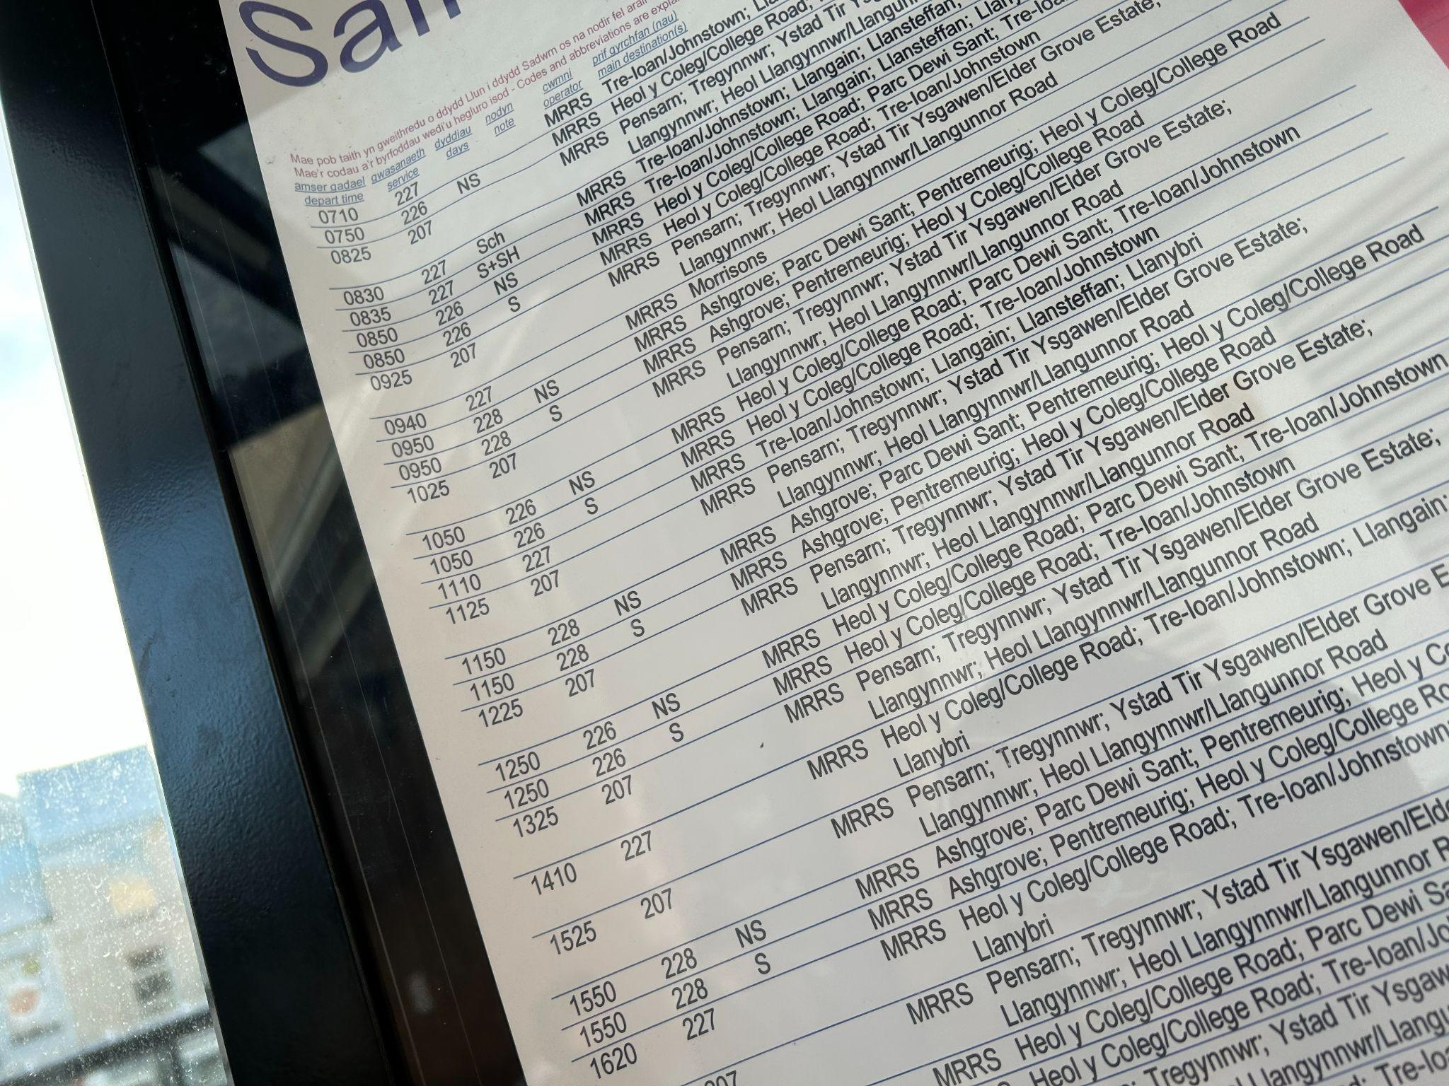

The second question response that struck me was the answers to Question #7, ‘How much would you pay for this service?’ The results were surprisingly different. This was an open question , and the answers began at £2, and ended at £5. This shows that different people would be willing to pay different rates for a bus service , so if this service did become a reality the prices would have to be a good balance in the middle of those two answers. A regular ticket from Carmarthen Train Station to the University is £1.50 , and whether or not my responders realise how much a regular ticket costs , it is interesting that people would be willing to pay over the usual threshold for this service.

Going forward

My chosen idea , my proposed bus service , is something I would hope to continue with as I feel it would benefit the community greatly. When reviewing my survey , I found one person had commented that they would like this proposed bus service ‘To help with access to other venues and facilities in the local area’. To me , this is a clear indication that this service is much needed by the students of UWTSD. Going forward , I would extend this survey to the wider community in Carmarthen , as I feel getting a balance in age ranges and locations would add a new dimension to my proposed plan. If I were to continue with this proposed plan , I would carry on my survey in the local area , and then once I had retrieved the data I would make routes to contact people in Carmarthan’s authority , such as the council and the bus company with my completed survey. I would set up a potential plan for a timetable and route , and with the data I’d set out what the ideal price for such a service would be. It would then be up to the people in charge as to whether they took up my idea or not. This is a proposed plan that would be impossible on my own , so its downfall would be in the hands of those with more power than me. However , I do trust that the data I have collected so far would show them that this service is much needed , and they would take on my profilo when making their informed decision.
This project has been incredibly interesting , and it’s been very rewarding to explore a number of topics that I feel passionate about, but ultimately I believe the idea that i’ve chosen is the most necessary to not just me but our community , and a change in the unsatisfactory bus service is a change we all need to see.

Bibliography;
My survey; https://uk.surveymonkey.com/create/preview/?sm=bu27TvvNLy8IWti2zWrQy7D4JwcYRVdS_2FDMXLAqncH4_3D?ut_source=lihp

https://www.bbc.co.uk/iplayer/episodes/p0f7q3rv/a-kind-of-spark- A Kind of Spark

https://howtodanceinohiomusical.com/- How to Dance in Ohio

https://bustimes.org/services/226-carmarthen-carmarthen-2- Bus Timetable

