BMHP6030 Written Report
Programme: BSc (Hons) Health and Social Care
Module: Health, Wellbeing and Sustainable Development (BMHP6030)
Student: Naila Waheed
Student number: 2246132

Executive Summary
This report critically reviews how SDG 3 -Good Health and Wellbeing and SDG 13 -Climate Action affects the health, wellbeing, and sustainability of citizens at the global, national, and local levels. The SDG 3 targets to decrease maternal and child mortality, eradicate epidemics, attain universal health coverage, and enhance access to basic medicines and vaccination. It has been analysed that the global policies, such as WHO vaccination and Global Action Plan, have enhanced population health, whereas the UK and Welsh national and local policies, such as the NHS Long-Term Plan and community health initiatives have enhanced preventive care and mental health services. Unrelenting inequalities, lack of funds, and accessibility are some of the major obstacles.
SDG 13 is concerned with mitigation, adaptation, and resilience in climate with direct health implications in air quality, heat diseases, and food security. The adaptation and mitigation depend on global models such as the Paris Agreement and WHO climate-health programs, whereas national policies such as the Climate Change Act and NHS sustainability plans, and local climate action plans, advance the co-benefits of the environment and health. Examples are translation of policy into practice, resource limitations, and inconsistent engagement of the population.
The report points out the interdependence between health, wellbeing and sustainability and the importance of multi-level integrated approaches. The recommendations that have been made based on evidence are improvement of preventive health services, encouraging health infrastructure that is resilient to climate conditions, and empowering communities, which would ensure sustainable changes in population health and wellbeing.

Title: Critical Analysis of Health, Wellbeing, and Sustainable Development Policies: Focusing on SDG 3 and SDG 13
Table of Contents
BMHP6030 Written Report 1
Executive Summary 2
Title : Critical Analysis of Health, Wellbeing, and Sustainable Development Policies: Focusing on SDG 3 and SDG 13 3
Introduction 4
Section 1: SDG 3 - Good Health and Wellbeing 4
Overview of SDG 3 4
Critical Analysis of International Policies/Programs 6
National and Local Policies/Initiatives Critical Evaluation 6
Recommendations 7
Section 2: Chosen SDG 3: Climate Action 8
Overview of Chosen SDG 8
Critical Analysis of International Policies/Programs 8
Critical Analysis of National/Local Policies/Initiatives 9
Recommendations 11
Conclusion 11
References 13

Introduction
The concept of health, wellbeing and sustainable development is becoming a recognised interdependent priority in the 21st century, determining the quality of life and resilience of society in various parts of the world (Kickbusch et al., 2021). Health is simply defined as the physical, mental, and social well-being of people, not just the absence of disease, whereas wellbeing refers to satisfaction with your life, mental and social performance (World Health Organization, 2022). Sustainable development can be defined as a way of achieving the current needs without undermining the ability of the future generation to achieve their needs in terms of economy, social, and environment.
This report will be based on SDG 3 Good Health and Wellbeing and SDG 13 Climate Action, discussing how it will affect the health of the citizens at the global, national (UK) and local level. The aim is to critically analyse the existing relevant policies and initiatives, assess the effectiveness, and give evidence-based recommendations to improve them. The report will be divided into two key parts that examine each SDG, and then a conclusion that has implications of policy interconnections and overall implications.

Section 1: SDG 3 - Good Health and Wellbeing
Overview of SDG 3
Good Health and Wellbeing (SDG 3) is a goal that will guarantee healthy lifestyles and wellbeing of all people of all ages. It has such priority areas as maternal and child mortality, the elimination of communicable diseases (HIV/AIDS, tuberculosis, and malaria), universal health coverage (UHC), and access to essential medicines and vaccines (United Nations, 2023). The objective is highly consistent with the priorities of the World Health Organization, especially the Global Health Strategy, which focuses on equity, prevention, and health system empowerment on global levels (WHO, 2022).
SDG 3 has direct effect on the physical, mental, and social health of the citizens. Physical health benefits entail access to immunisation, maternal care, and chronic and infectious diseases treatment. Policies aimed at mental health care, elimination of stigma, and community support services are used to boost mental wellbeing (Patel et al., 2018). Fair access to health services and community health programs that decrease inequalities across the populations have a social wellbeing impact (Marmot et al., 2020). The global, national, and local efforts must go together to achieve SDG 3 with a realization that health determinants are interconnected, and one cannot thrive where there are poor economic conditions, lack of education and environmental factors (Solar & Irwin, 2010).

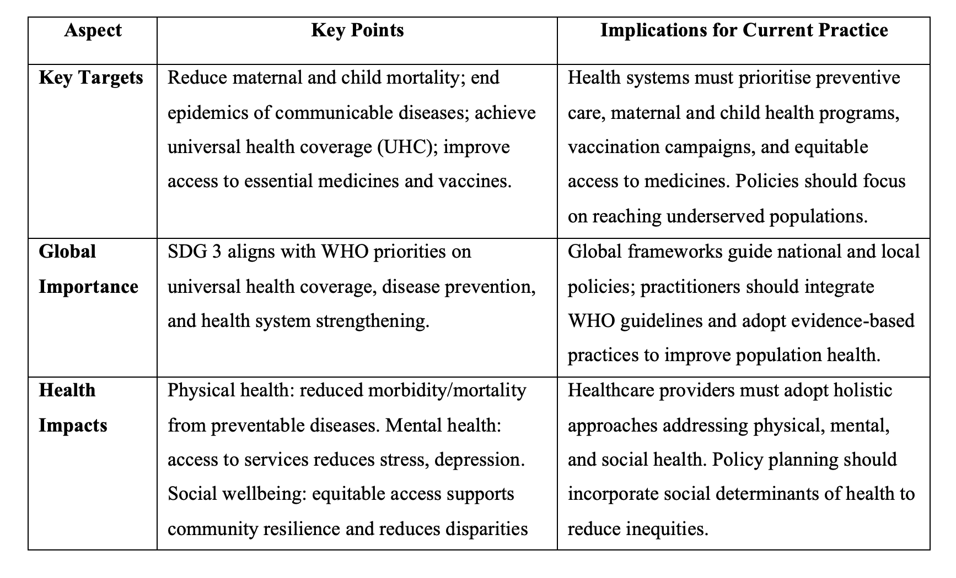
Summary table for SDG 3 – Good Health and Wellbeing(self-created).

Critical Analysis of International Policies/Programs
Various projects around the world are trying to attain SDG 3, such as the WHO Global Action Plan to Healthy Lives and Wellbeing, world vaccination, such as Gavi, the Vaccine Alliance, and mental health initiatives by the WHO and other agencies. The WHO Global Action Plan is an extensive framework model to organize multi-sectoral initiatives, with UHC, disease prevention and health system strengthening as its priorities (WHO, 2021). The international vaccination programmes have been effective in lowering child deaths caused by vaccine-preventable diseases; an example is the decreasing mortality caused by measles, whose rate of child mortality decreased by 73% among the global population in the time 2000-2018 (World Bank, 2021).
Although these were successful, there are still challenges. Inequality in access to vaccines and other important medicines around the globe emphasize the differences between high- and low-income nations. Poor infrastructure, political instability, and shortage of resources tend to widen the gaps in implementation (Bump et al., 2019). Social Determinants of Health (SDH) model also states that socioeconomic, environmental, and political determinants influence health outcomes, which implies that the interventions in policies should be focused on these determinants to be effective (Solar & Irwin, 2010). More so, the Health Belief Model implies that the social involvement and self-efficacy are the main determinants of preventive behaviour adoption, and most global interventions are insufficient to positively impact the cultural and behavioural obstacles (Glanz et al., 2015).

National and Local Policies/Initiatives Critical Evaluation
On a national scale, the UK NHS Long-Term Plan (2019) offers a plan of enhancing health and wellbeing with the focus on prevention, mental health, and integrated care. The programs of the Public Health England (2020) focus on smoking cessation, the decrease in obesity, and the increase of vaccination, to minimize inequalities within socioeconomic groups. Accessibility, early intervention, and mental and physical integration of health services are the subjects of mental health frameworks like The Five-Year Forward View on Mental Health.
In the case of community-based programmes, locally these strengthen national policies. As an illustration, urban-based vaccination schemes, and health promotion activities in such cities as Birmingham and Cardiff aim at vulnerable groups, offering them easy access to screening, nutrition education, and physical activity programmes (Public Health Wales, 2021). Such interventions have shown quantifiable positive outcomes such as higher levels of immunisation and lowering of lifestyle-related diseases.
Nevertheless, there are still limitations. The gaps in fund access tend to limit the access and sustainability of programmes especially in impoverished districts, which increases health inequalities (Marmot et al., 2020). The barrier to uptake of services is accessibility, like transport challenges and cultural diversity. The effectiveness of local initiatives as well differs about coordination, staffing, and resources. The use of the SDH framework brings to focus the necessity of combating social, economic, and environmental determinants in addition to clinical ones, whereas such behavioural models as the Health Belief Model indicate that both the level of public awareness and motivation to practice preventive behaviour should be enhanced (Glanz et al., 2015; Patel et al., 2018).

Recommendations
The SDG 3 policy needs to be implemented in a multi-level evidence-based strategy to increase its effectiveness. Internationally, efforts must focus on fair availability of vital drugs and vaccines by enhancing coordination and financial aid to the low-income nations (Bump et al., 2019). At the national level, gaps in the system will be filled through the upgrading of primary care and preventive care, as well as integration of mental and physical health programmes (Public Health England, 2020). At the local level, there should be an increase in community engagement and culturally sensitive interventions that enhance visibility and use of health services. The implementation of the SDH model will guarantee that the policies consider both social and environmental determinants, whereas implementation of behaviour framework will help the population engage in preventive health behaviours (Solar and Irwin, 2010; Glanz et al., 2015).

Section 2: Chosen SDG 3: Climate Action

Overview of Chosen SDG
Climate Action SDG 13 is concerned with immediate action to address climate change and its effects. Its major objectives are the mitigation of climate change, adaptation plans, and improving resilience of societies and minimizing environmental risks like extreme weather events, rising sea levels, and air pollution (United Nations, 2023a). The effects of climate change on health and wellbeing are immense: higher temperatures worsen heat-related illnesses, change the patterns of vectors-borne diseases, decrease food security, and worsen mental health due to stress and displacement (Watts et al., 2018). Connected to the burning of fossil fuels, air pollution causes respiratory and cardiovascular diseases, with higher rates in the vulnerable population groups (Landrigan et al., 2018).

SDG 13 is also at the core of IPCC documents and UN climate agendas globally, which emphasize the interdependence of environmental sustainability and human health outcomes (IPCC, 2021). Climate targets are necessary to support the health of the population, lower health disparities, and defend social and economic prosperity. The eco-social theory helps to recognize the associations between environmental exposures and health consequences, and systems theory underlines the interdependence of ecological, social, and health systems (Krieger, 2012; Meadows, 2008).

Critical Analysis of International Policies/Programs
In the international arena, numerous undertakings focus on SDG 13, among which are Paris Agreement, United Nations Framework Convention on Climate Change (UNFCCC) and WHO programs on climate and health. The Paris Agreement binds states to reduce the increase in global temperature to less than 2C, and the national efforts and adaptation plans to make the states more resilient to climate change (UNFCCC, 2015). WHO efforts are placed on adaptation in the health sector, promoting climate resilient health systems and incorporation of climate risk assessment in the plans of the public health (WHO, 2021a).
The international mitigation measures have resulted in a slow rise in the use of renewable energy and establishment of international climate finance facilities. Nevertheless, there are still gaps: many low- and middle-income countries have inadequate technical and financial resources that slow down the process of adaptation measures (Hsu et al., 2019). Climate-related events are more likely to affect the vulnerable population disproportionately, presenting global inequalities (Watts et al., 2019).
Using the eco-social theory, climate hazards are not only environmental processes, but are mediated by social factors including income, education, and health services access which enhance health inequities (Krieger, 2012). In the same way, systems theory puts a focus on the changing interaction between human, ecological, and health systems whereby uncoordinated climate policies may cause unintended health impacts (Meadows, 2008). An example is that urban development to curb the heat islands can be poorly planned and this would result in more exposure to pollution in case the energy sources are not clean.

Critical Analysis of National/Local Policies/Initiatives
The Climate Change Act of 2008 is a law in the UK that establishes legally binding carbon reduction targets and encourages adaptation planning within the sectors (HM Government, 2008). The NHS has implemented the sustainability measures that are expected to decrease the carbon footprint of health services, encourage the low-emission transport, and incorporate environmental sustainability within the healthcare provision (NHS England, 2020). The guidance on climate resilience has been developed by Public Health England which correlates with population health with heatwave planning and air quality monitoring (Public Health England, 2019).

At the local level, national committees are reinforced at the city level. As an illustration, the Climate Action Plan of London encourages the use of sustainable transport, green infrastructure, and urban cooling, and the community-level initiatives of Wales are directed towards the local flood management, adoption of renewable energy sources, and climate education (Greater London Authority, 2020; Welsh Government, 2021). These measures have proven to be effective to mitigate greenhouse gas emissions and local environment quality, which directly affects health as a co-benefit, such as respiratory illness and subsequent physical activity due to active travel (Haines et al., 2020).

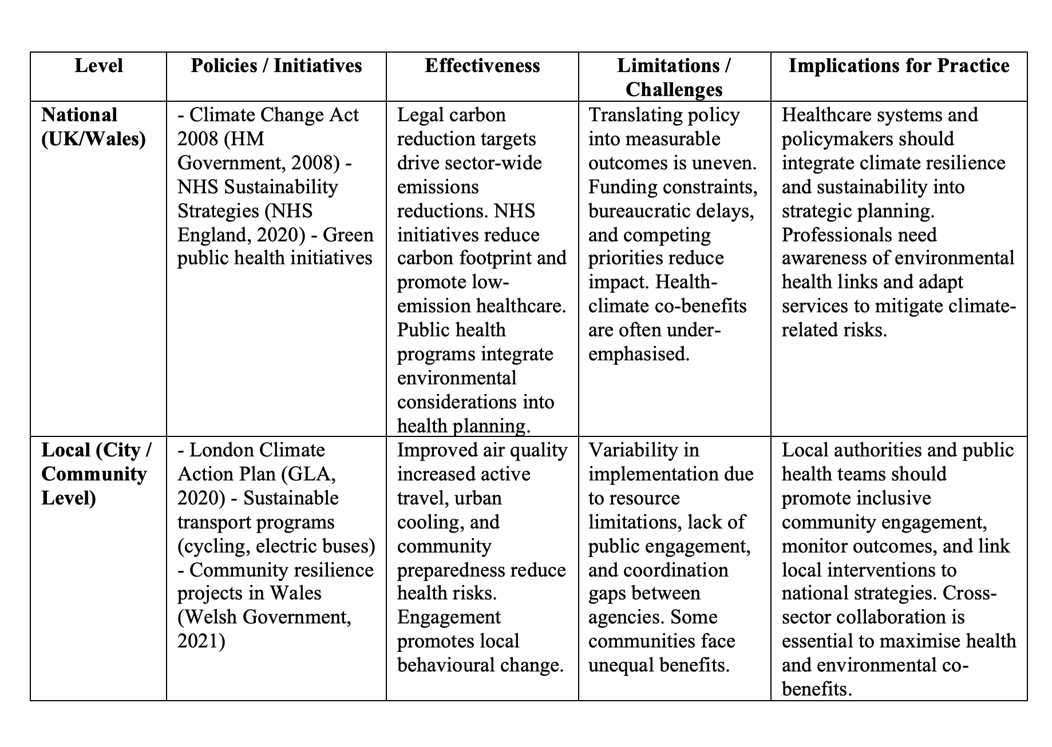
Summary table: critical analysis of National/ local policy (self-created).

Recommendations
The climate action should be incorporated in the public health planning across all levels to enhance SDG 13 initiatives. At the national level, the implementation of climate resilience in healthcare infrastructure, such as low-carbon hospital operation and climate-adaptive facilities can mitigate the impact of the health sector on the environment and enhance patient safety (NHS England, 2020). The local governments are encouraged to make more engagement with people by educating about the connection between climate change and health and promoting sustainable transportation, parks and green areas, neighbourhood-based resilience initiatives (Haines et al., 2020). Financial and technical assistance to vulnerable nations is needed all around the world to guarantee fair adaptation and mitigation steps (Hsu et al., 2019).
Notably, the policies must clearly identify the co-benefits of climate action to SDG 3: cleaner air, better respiratory and cardiovascular health, urban green cover, better mental health, and heat-reducing measures will reduce death rates caused by heat (Watts et al., 2018). Applying the eco-social theory can also provide an opportunity to use the social determinants in the design of the interventions, whereas the systems theory can be used to facilitate a multi-sectoral approach to the optimization of positive health outcomes of the environmental, social, and healthcare systems.

Conclusion
The report has discussed critically SDG 3 (Good Health and Wellbeing) and SDG 13 (Climate Action) on a global, national, and local basis, showing the interdependence of health, wellbeing, and sustainable development. SDG 3 analysis revealed that the activities like WHO Global Action Plan, vaccination programs, and national strategies on public health can enhance the physical, mental, and social health outcomes. Despite these achievements, these policies have not been able to reach their full potential due to unrelenting inequities, scarcity of resources, and gaps in implementation. On the same note, SDG 13 agendas, such as the Paris Agreement, the UK Climate Change Act, and local climate action plans, lead to environmental resiliency in addition to generating considerable health co-benefits, such as the improvement of air quality, the mitigation of heat-related illness, and the improvement of mental wellbeing.
The interconnections amongst these SDGs underline that the health and environmental politics cannot work alone. Climate resilience is directly affected by sufficient healthcare systems, whereas population health is affected by environmental sustainability. These complex issues need to be tackled using a multi-level approach that bridges international systems with national policies and inter-community efforts. To enhance health equity, promote adaptive capacity and guarantee long-term, sustainable wellbeing, evidence-based and socially inclusive approaches are required. The results highlight the significance of the connection between theory and practice, whereby policies must be enacted to further societal health as well as environmental sustainability.

References
- Bump, J.B., Sparkes, S.P., Topp, S.M. and Rajan, D., 2019. Global health governance and the Sustainable Development Goals: who is accountable? Global Health, 15(1), pp.1-12.
- Glanz, K., Rimer, B.K. and Viswanath, K., 2015. Health behavior: Theory, research, and practice. 5th ed. San Francisco: Jossey-Bass. Availbel via https://www.google.co.uk/books/edition/Health_Behavior/0j4LCgAAQBAJ?hl=en&gbpv=1&dq=Glanz,+K.,+Rimer,+B.K.+and+Viswanath,+K.,+2015.+Health+behavior:+Theory,+research,+and+practice.+5th+ed.+San+Francisco:+Jossey-Bass.&pg=PR11&printsec=frontcover (Accessed on 8th March 2026).
- Greater London Authority, 2020. London Environment Strategy. London: GLA. Available via https://www.london.gov.uk/programmes-and-strategies/environment-and-climate-change/london-environment-strategy (Acccessed on
- Haines, A., Kovats, R.S., Campbell-Lendrum, D. and Corvalan, C., 2020. Climate change and human health: Impacts, vulnerability and public health. Public Health, 174, pp.23–28.
- HM Government, 2008. Climate Change Act 2008. London: HMSO. Available via https://www.legislation.gov.uk/ukpga/2008/27/pdfs/ukpga_20080027_en.pdf (Accessed on 10th March 2026).
- Hsu, A., Setzer, J. and Rennkamp, B., 2019. Closing the adaptation gap: A global assessment of climate adaptation finance flows. New York: UN Environment Programme.
- IPCC, 2021. Climate Change 2021: The Physical Science Basis. Geneva: Intergovernmental Panel on Climate Change. AVailabel via https://www.ipcc.ch/report/ar6/wg1/downloads/report/IPCC_AR6_WGI_SPM_final.pdf (Accessed on 9th March 2026)
- Kickbusch, I., Gleicher, D. and World Health Organization, 2021. Governance for Health in the 21st Century. Geneva: WHO.
- Krieger, N., 2012. Methods for the Scientific Study of Discrimination and Health: An Ecosocial Approach. American Journal of Public Health, 102(5), pp.936–945.
- Marmot, M., Allen, J., Boyce, T., Goldblatt, P. and Morrison, J., 2020. Health Equity in England: The Marmot Review 10 Years On. London: Institute of Health Equity.
- Meadows, D.H., 2008. Thinking in Systems: A Primer. White River Junction, VT: Chelsea Green Publishing.
- NHS England, 2020. For a Greener NHS: Delivering a Net Zero National Health Service. London: NHS England. Available via https://www.england.nhs.uk/greenernhs/wp-content/uploads/sites/51/2020/10/delivering-a-net-zero-national-health-service.pdf (Accesed on 5th March 2026).
- Patel, V., Saxena, S., Lund, C., Thornicroft, G., Baingana, F., Bolton, P., Chisholm, D., Collins, P.Y., Cooper, J.L., Eaton, J. and Herrman, H., 2018. The Lancet Commission on global mental health and sustainable development. The Lancet, 392(10157), pp.1553-1598.
- Public Health England, 2019. Health Effects of Climate Change: Adaptation Guidance for Local Authorities. London: PHE.
- Public Health England, 2020. Health Profile for England 2020. London: PHE. Available via https://www.gov.uk/government/organisations/public-health-england (Accessed on 9th March 2026).
- Public Health Wales, 2021. Annual Report on Community Health Initiatives. Cardiff: PHW. Available via https://phw.nhs.wales/about-us/annual-report/ (Accessed on 10th March 2026).
- Solar, O. and Irwin, A., 2010. A conceptual framework for action on the social determinants of health. Geneva: World Health Organization.
- UNFCCC, 2015. Paris Agreement. New York: UNFCCC.
- United Nations, 2023a. Sustainable Development Goals Report 2023. New York: UN.
- Watts, N., Amann, M., Arnell, N., Ayeb-Karlsson, S., Belesova, K., Boykoff, M., Byass, P., Cai, W., Campbell-Lendrum, D., Chambers, J. and Cox, P., 2018. The 2018 report of the Lancet Countdown on health and climate change: shaping the health of nations for centuries to come. The Lancet, 392(10163), pp.2479–2514.
- Watts, N., Amann, M., Ayeb-Karlsson, S., Belesova, K., Bouley, T., Boykoff, M., Byass, P., Cai, W., Campbell-Lendrum, D., Chambers, J. and Cox, P., 2019. The 2019 report of the Lancet Countdown on health and climate change: ensuring that the health of a child born today is not defined by a changing climate. The Lancet, 394(10211), pp.1836–1878.
- Welsh Government, 2021. Prosperity for All: A Climate Conscious Wales. Cardiff: Welsh Government.
- World Bank, 2021. Vaccination Coverage Data. Washington DC: World Bank. available via https://immunizationdata.who.int/ (Accessed on 5th March 2026)
- World Health Organization, 2021. Global Action Plan for Healthy Lives and Wellbeing. Geneva: WHO.
- World Health Organization, 2022. Constitution of the World Health Organization – Basic Documents. Geneva: WHO.
- World Health Organization, 2022. Constitution of the World Health Organization – Basic Documents. Geneva: WHO.

