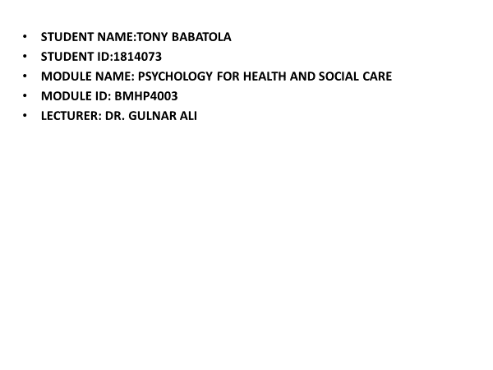

TACKLING OBESITY IN UNITED KINGDOM

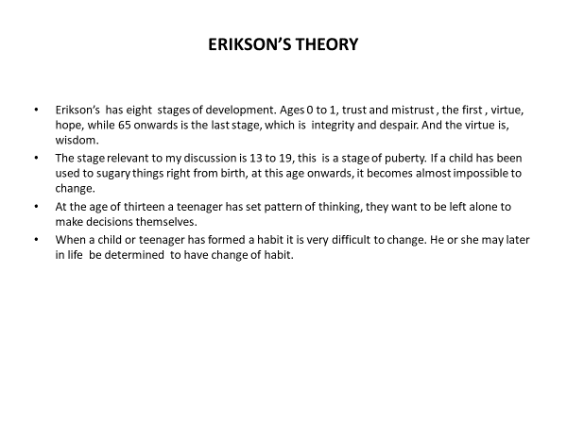

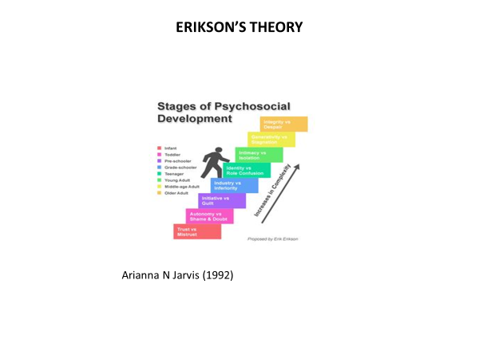

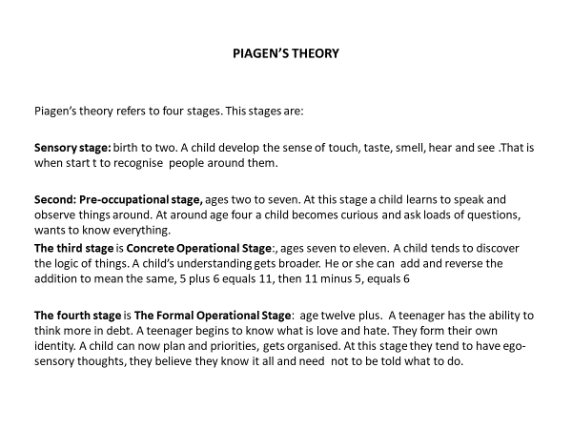

INTRODUCTION
I will be writing about lifespan stage from age twelve onwards. In doing this, I will be applying the theory of the development stages.
I will be writing one thousand words for my slides. This is will be based on Obesity in United Kingdom, applying theories of models of psychology.
Obesity is a rising problem in United Kingdom over two decades ago. Statistics shows that right from tender age, children start getting obese and if it is neglected can lead to a serious problem. It is costly when left till late before tackling it.
So, it is not only for the person but also for NHS. It cost NHS an average of #4.1 billion a year and it has been predicted that by 2020 the figures will rise to 9.7 billion pounds. According to Biro F. and Wien M. predicted that ‘children the sever obesity, the chance they will no longer be obese at the age of thirty five fell from 21.0 per cent (95%Ul, 7.3 to 47.3),at the age of 2 years to 6.1 per cent (95% Ul, 2.1 to 9.9) at the age of 19 years’.
(Third National Health and Nutrition Examination Survey, 2004)

‘The prevalence and severity of obesity have increased in recent years, likely the result of complex interactions between genes, dietary intake, physical activity, and the environment’

Childhood Obesity and Adult Morbidities
(Biro F. Wien M. 2010).

One of the consequences of childhood and teenage obesity is
getting into puberty too early as well as menarche.

ERIKSON’S THEORY
According to Erikson’s theory, from the age of twelve onwards a child has a set pattern of any wrong doing or behavioral pattern in general. So, from this age upwards it become very difficult to correct any wrong doing they are addicted to.
As a child grows up in life they believe they can do things by themselves, make their own decisions, and does not want to be told what to do. During this age they tend to form their own identity and pattern in life.

So, if a child has bad eating habit it is more or less very difficult to correct at this stage, hence it is the duty of the parent to do their best to correct any bad habit before it gets out of hand. Parents should encourage their kids to eat lots of fruit and vegetable as they grow up and possibly do some exercise. McDonalds, Ken Turkey or chocolates should be taken occasionally not on daily routine.

When a child has a set pattern for their lives it becomes very difficult to correct, unless later on life they realise they are setting to dangerous part of life they make a conscious decision to change or correct.
They can then go for dietary classes in order to correct the past mistakes.

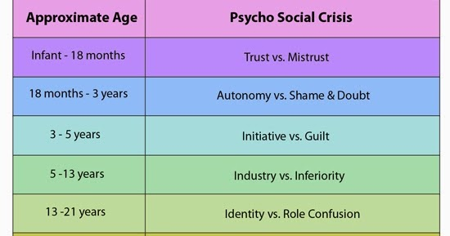

PIAGETS THEORY
Piaget’s Theory suggests that from the age of eleven onwards children has a set pattern of their thinking ways. The emotions is set, so if a child has a bad eating pattern it more or less quite difficult, almost impossible to change.

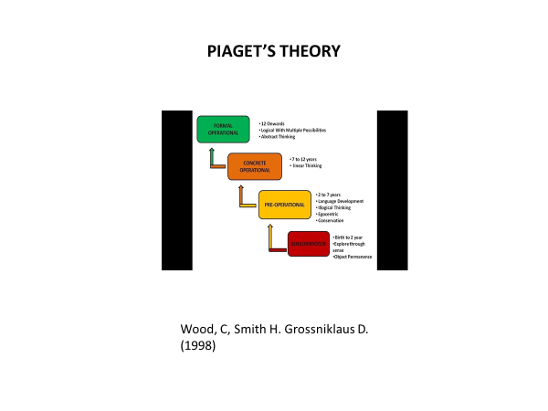

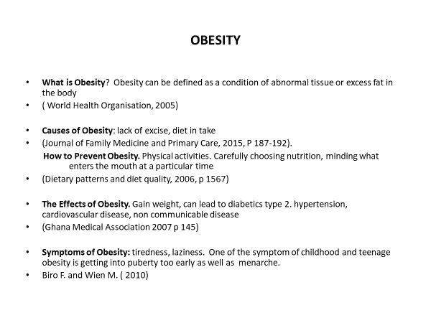

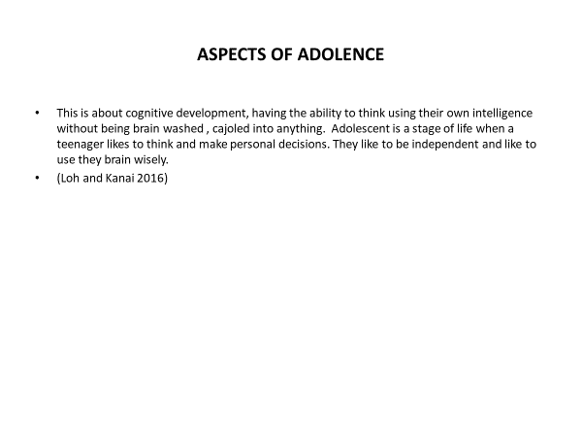

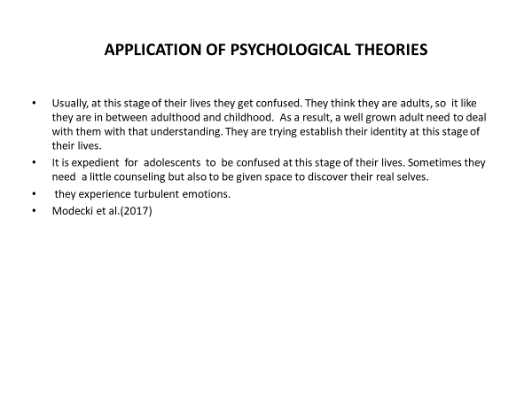

ASPECTS OF ADOLENCE
This is about cognitive development. This is about having the ability to think using their own intelligence without being brain- washed, cajoled into anything. Indolence is a stage of life when a teenager likes to think and make their personal decision.
Loh and Kanai, (2016)

APPLICATION OF PSYCHOLOGICAL THEORIES
Usually, at this stage of their lives, they get confused. They think they are adults, so it is like they are in between adulthood and childhood. As a result, a well grown adult need to deal with them with patience and understanding. They are trying to establish their identity at this stage of their lives. This can lead to psychosocial growth and development.

RATIONAL
The reason why I decided to choose this life stage is because I have related with of them in the pass, both at a religious gathering also when I was a cab driver. I remember a particular day I took a lady and her friend in my car, I actually thought one of them was the mother. She also went to McDonald’s and bought so many sugary food stuffs that was extremely dangerous to her health.
It is important for teenager, adolescent to take care of their health, because there are consequences for being obese. When someone is obese he she attracts more disease, heart problem, breathing problem and so on.
It is worse now because so many of the food are fatty and chemically based. In the past it was less dangerous. Nowadays, youth do not like to cook, take prepare fast food which is very bad for the health.

Why is obese dangerous:
It causes;
1 High blood pleasure
2 heart disease
3 Stroke
4 Cancer
5 Fatty liver disease
6 Kidney disease
7 Pregnancy problems
8 Kidney disease
9 Osteoarthritis
10 Sleep Apnea
As we can see, it is not a light thing, so it really touches my heart and really.
NIDDK, (2015)

CONCLUSION
As I conclude, it is of necessity to tackle obesity earlier than leaving it late. Obesity is not something to handle lightly, or with contempt, if ignored could lead to something very serious. Premature death is the worst-case scenario that can happen, if neglected. NHS handle it as serious and essential. If NHS should deem it as serious and it is should be neglected. It is essential do daily exercise and manage what one eats daily.
It is essential for any teenager to seek help at an early stage before it gets out of hand. They should go for counselling sections, neglecting it will not make it go but rather get worse.

REFERENCES
Biro F. and Wien M. (Match 2010)
‘The American Journal of Clinical Nutrition’
Childhood Obesity and Adult Morbidities

Brian G C. (2019) ‘Erik Erikson’s Theory of Psychosocial Development Explained’, video Available at//www.simplypsychology.org/Erik-Erikson.html
(Accessed 3 December 2019).

Zachary J. ward, Long W. etc. (2017) ‘The New England Journal of Medicine’ Stimulation of Growth Trajectories of Childhood Obesity into Adulthood

National Institute for Diabetes and Digestive and Kidney Information Centre
Health Risks of Being Over weight
(2015)
(Accessed: December, 2019)

Wood C, Smith H., Grossniklaus D
(1998) ‘ Department of Educational Psychology and Instructional Technology, University of Georgia’
Piaget’s Stages of Cognitive Development

