Major Project Research
My project story revolves around the usage of a varied amount of firearms and the equipment that goes along with them. This document will contain my personal investigation into this equipment with works best with my written choice of an altered past future in which technology is more advanced but we are in the past.
Section 1 Probably
When writing the story for my major project I knew I wanted to start with a basic simple shaped rifle and as I went on I settled on my character being an American army veteran. So the most obvious gun to start would be the American ‘AR-15’ platform which is one of the most commonly known weapon which even the most unknowledgeable of people could describe the shape of. The task I had now given myself was to decide which. The weapon platform has many, many different variants some of which are very minor and others major.
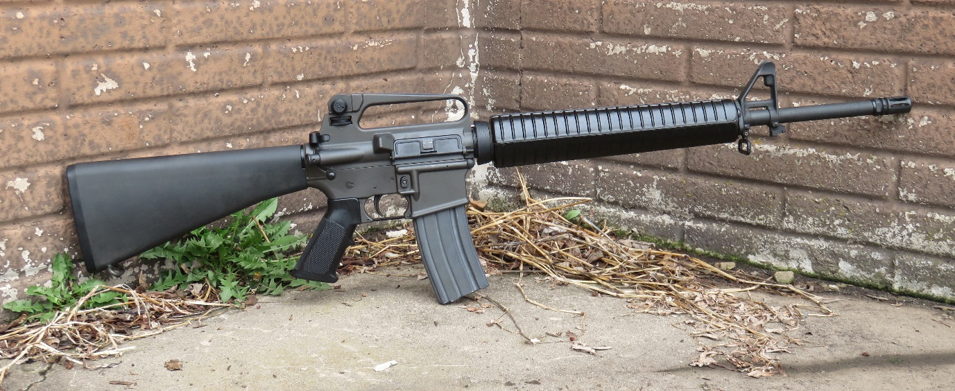
The first rifle I am looking at was the standard issue of the era, the M16A2 was the standard issue service rifle for the American military during the 80’s and 90’s which has the simple look to it with its round hand grip. It has a simplistic design and I quite like the round handgrip.
Continuing with the previously established M16A2, I decided to look at additional weapons like it.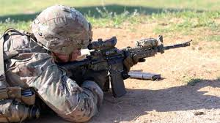
Next on my list is this M4A1 which has a shorter barrel which I prefer over the M16A2’s as for the animation the assault course it takes place is would be considered an indoor area where shorter barrels are considered to be better. However with the inclusion of the standard commonly named ‘pica tinny rail’ which allows the easy attachment of a varied amount of things on the weapon that includes things like scopes, flashlights and lasers, fore grips and grenade launchers. I feel that with the inclusion of the rail makes the weapon appear more complex and modular which I feel takes away from a simple look to it.
Taking into consideration the smaller barrel of the M4A1 and the round ribbed handguard of the M16A2 I began looking at similar ones and found the CAR15.

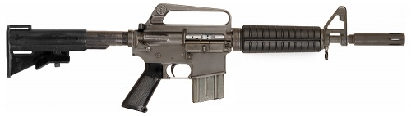
This rifle has the short barrel that I am looking for and features the round ribbed handguard that I liked on the M16A2. The absence of any pica tinny rails is a welcome sight as I feel the weapon looks simple to use while also maintaining a professional piece of equipment. The adjustable stock is a welcome addition as this would make sense for small environments such as the one my animation takes place in.
The next weapon I took a look at was the ‘M16 LSW’ due to its rather unusual and uncommon look.
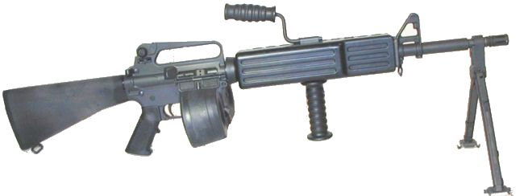
It featured no pica tinny rails like which immediately caught my attention but the length of the weapon personally caused me to not consider the weapon. However because of its unusual looking handguard I felt it be a more interesting addition.
Continuing with the unusual looks I found the Colt ACR pictured below.
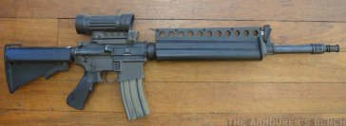
The weapon is the most unusual looking one that I have looked at thus far. Its visual design takes a drastic change in comparison to the others and looks more like a weapon found in a weird SCI-FI space battle series other than a real world production for considered military use. However once again I found the rifle to be too long despite its title literally meaning ‘compact.’
The second weapon I wanted to feature was a shotgun. I wanted something which looked like it would pack a punch while also having an aggressive usage. I needed something that fit with the scene where after loading the shotgun he’d use a pump in an aggressive manner like a few cinematic movies do but have it so when he does it he would lose a shell which impacts him later on when he’s a shell down for the reactive target that knocks him off his feet.
The first shotgun I found was the M26 MASS which is a standard issue shotgun which can be used as an under barrel attachment similar to grenade launchers. The issue with this however is the earlier mentioned pica tinny rails.
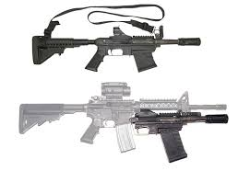
This shotgun functions like a pump shotgun which I like the idea of more however this one in particular does it in an unusual way with a lever on the side. The use of a magazine fed shotgun however does not allow me to do my missing shotgun shell scene unless the character has the weapon already be loaded from the start which also removed part of the scene where he loads it.
The next shotgun I considered was the well-known SPAS 12.
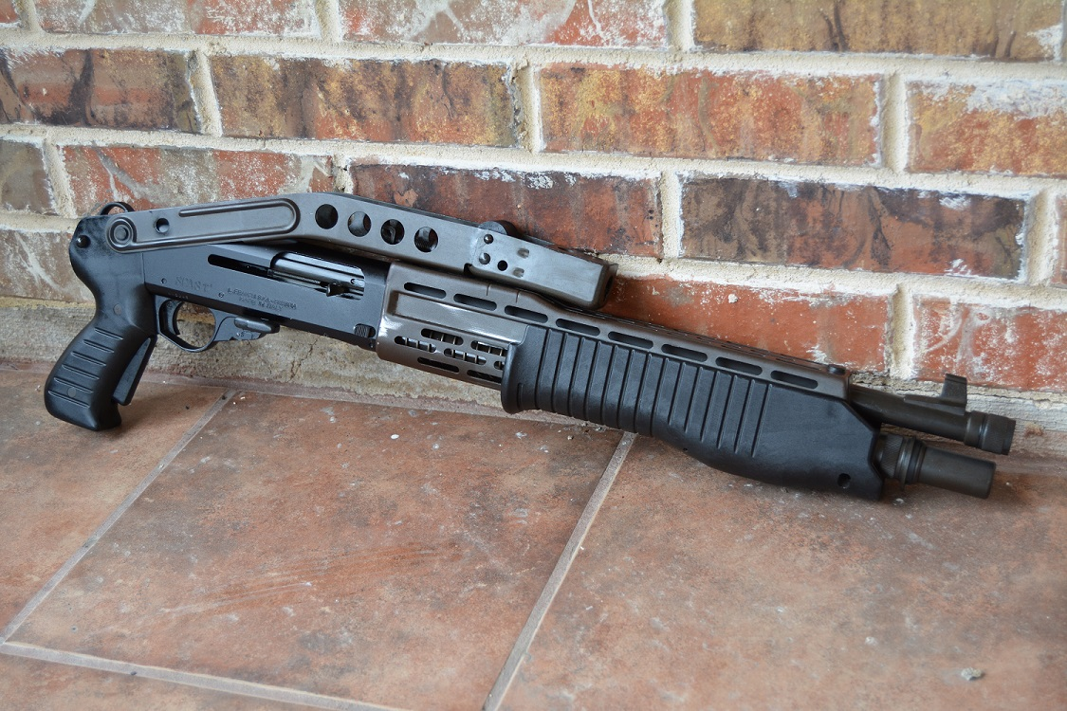
This shotgun can be used in both pump and semi-auto which means I could have the pump for the missing shell scene and have him show inexperience with the weapon as having it semi-auto would allow him to use it to shoot the targets faster. While it does have the uncommon look about it I find the shotgun to have a complicated look to it.

The next shotgun I dug up is the Remington 870 which is the standard issue for American military units.
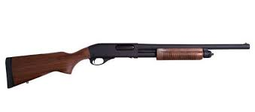
While the picture above shows it with wooden furniture which I personally prefer it can also come with synthetic plastic pieces. While the wooden would give it an older look the plastic makes it lighter which would make sense for the scene. It operates via a pump which means it could be used for my missing shell scene and it is also loaded from the bottom which allows for the missing shell scene to make more sense.
Next on the search was the AA12.
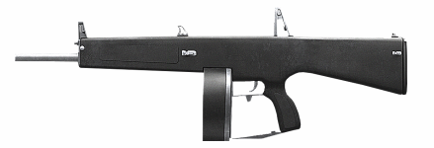
This one in particular has also got an unusual look to it and has been seen in many action movies. The weapon itself wouldn’t work well with the written scene but I felt that due to how it looks I could probably consider it with a few self-designed modification that would have made it more useable. I’ve kept this as a consideration because of its simple but unusual look.
The M1014 shotgun was the next one I have considered.
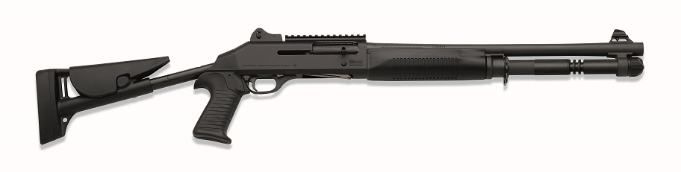
Unlike the other shotguns which have a similar look to this, this one is specifically semi-auto but is loaded in the usual shell by shell basis from the bottom. Once again it would be unsuitable in the scene due to the semi auto nature but would be more practical due to its shorter barrel and adjustable stock. This particular one pictured above does have a pica tinny rail but it doesn’t need one and some do not feature it.

The third weapon I wanted was a handgun that the character would use in emergencies such as the one where he is knocked down by the reactive target and must use said handgun to shoot it.
The first handgun I looked at is one of the more famous handguns known as the M1911.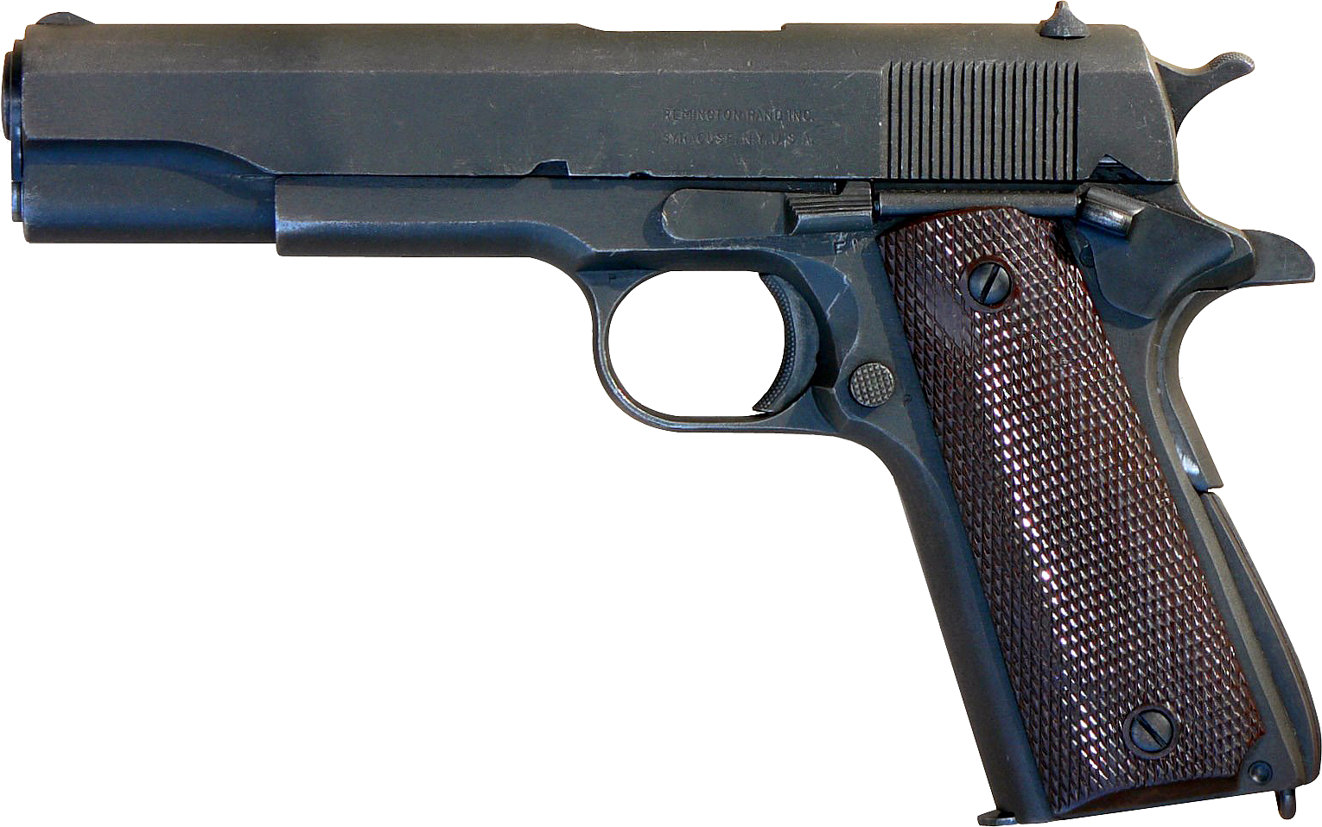
I initially chose this handgun due to how common it is in America and for its significance as one of the more famous handguns in the world. It has a simple look to it and due to its common usage with the American military and even in their homes it would make the most sense. It does have a heavier frame.
The second handgun I took a look at is the Berretta M9.
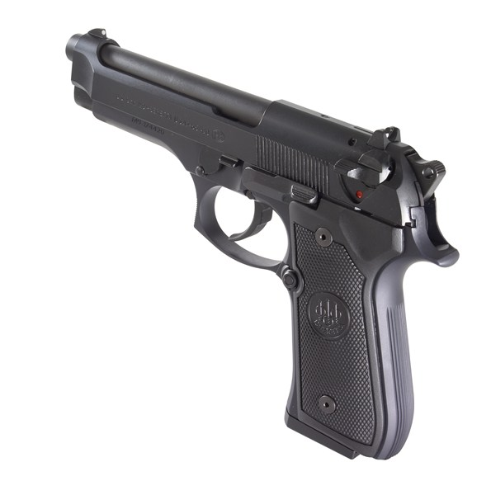
This handgun is a smaller in both size and calibre. It also had more bullets in a magazine which is better in this close quarter scenario. This handgun was also a standard military issue for the Americans around the time.
Another handgun I wanted to look at was the Glock 20.
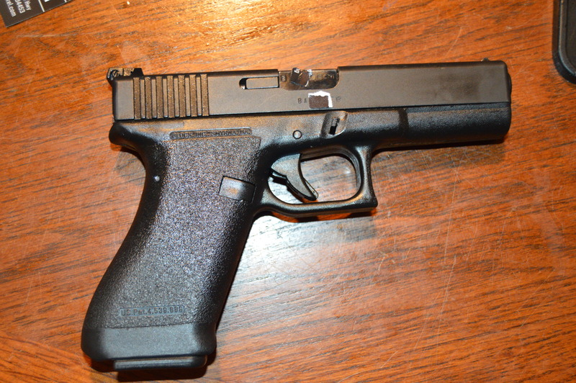
I considered this handgun for my character due to its distinct look. It was designed at the time for the growing law enforcement market. The handgun has the same calibre as the previous M9 but the Glock has been made to be more lightweight which means it would be easier to shoot in theory.
While completely inconvenient for the setting. I also looked at the renowned Desert Eagle.
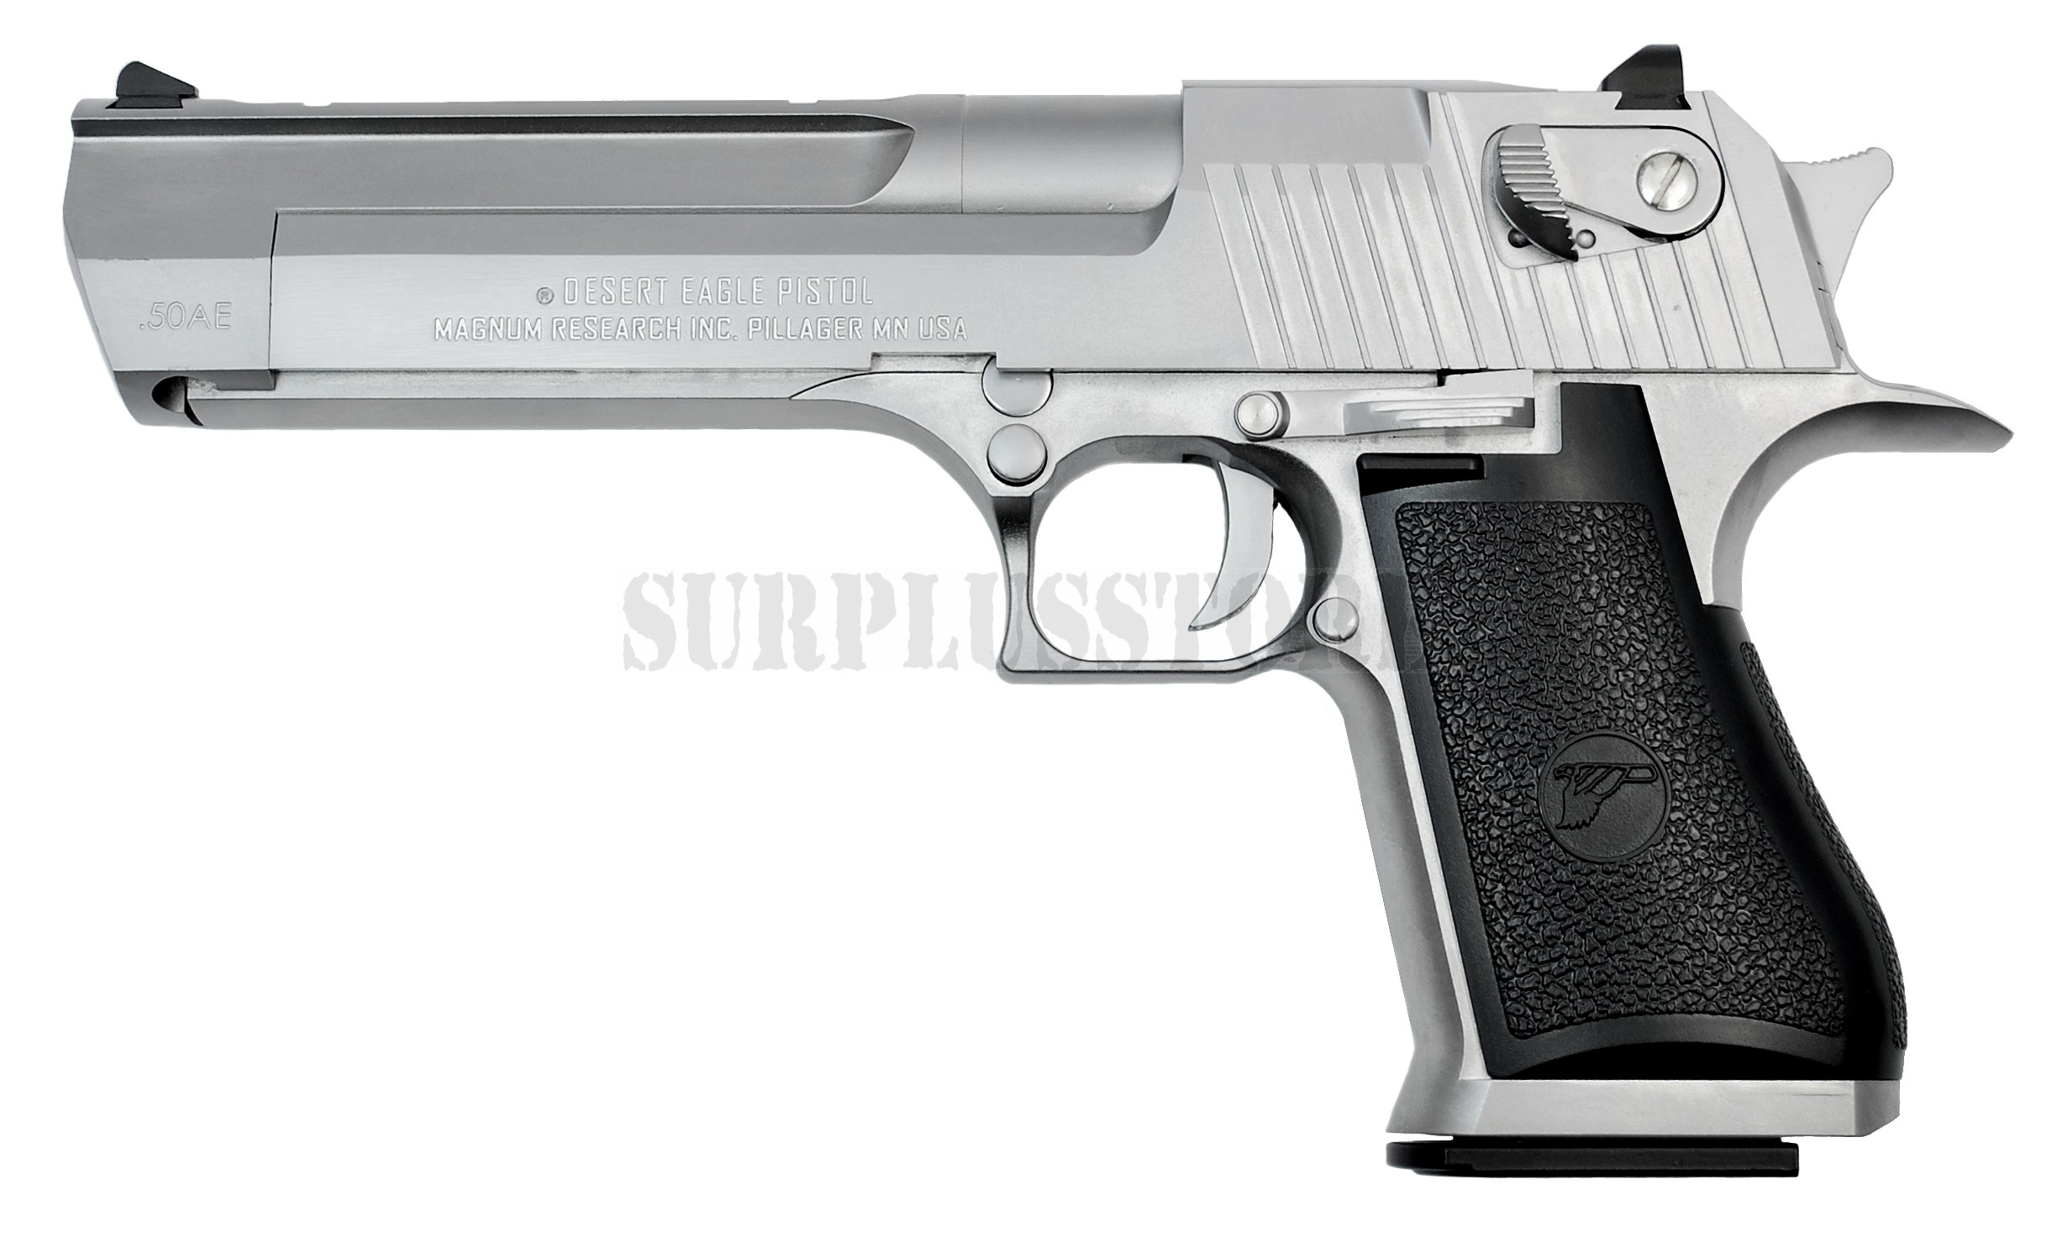
The handgun itself has one of the larger bullets to be fired from a small weapon and would be completely inconvenient for the scene but due its unique look I felt I could possibly consider a smaller design of my own which could fit the scene more practically while also sticking with its large menacing look.

The next handgun I considered was the Walther P99.
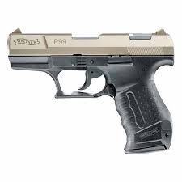
I considered this handgun due to its more futuristic design despite being made in 1996. The handgun uses the same 9mm round as the M9 which would make it on par in its performance meaning that in the small area that would be my assault course it will perform just as well as the M9 while also looking quite futuristic, its design visually assists the ‘future-past’ aesthetic.
The fourth weapon would be the complete opposite of the starting ‘AR-15’ and intended to be completely different in design and use which means the character will have little to no experience with the firearm and will encounter issues trying to operate it correctly. Obvious signs of inexperience would be the recoil handling and standard reloading procedure. These could range from higher calibre battle rifles, smaller more compact sub machine guns and bullpup rifles. I’ve chosen to avoid anything sniper rifle related due to no reasoning for range in this close quarter environment. The same applied to light machine guns also due to the size of them on average.
To start the first gun I looked at was the British SA80 or L85.
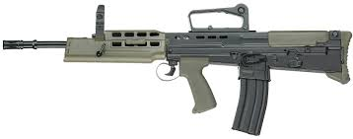
I’ve chosen the A1 designation due to the issues it had during its deployment which could play into the inexperience as they won’t know how to directly sort it which helps establish the characters inexperience. Its design is of a bullpup fire arm which there are none of in the American military, however it was present during the Gulf war so one could argue that the character may have had some experience with it by co-ordinating with British troops.

The second weapon I considered is the MP5 SMG.
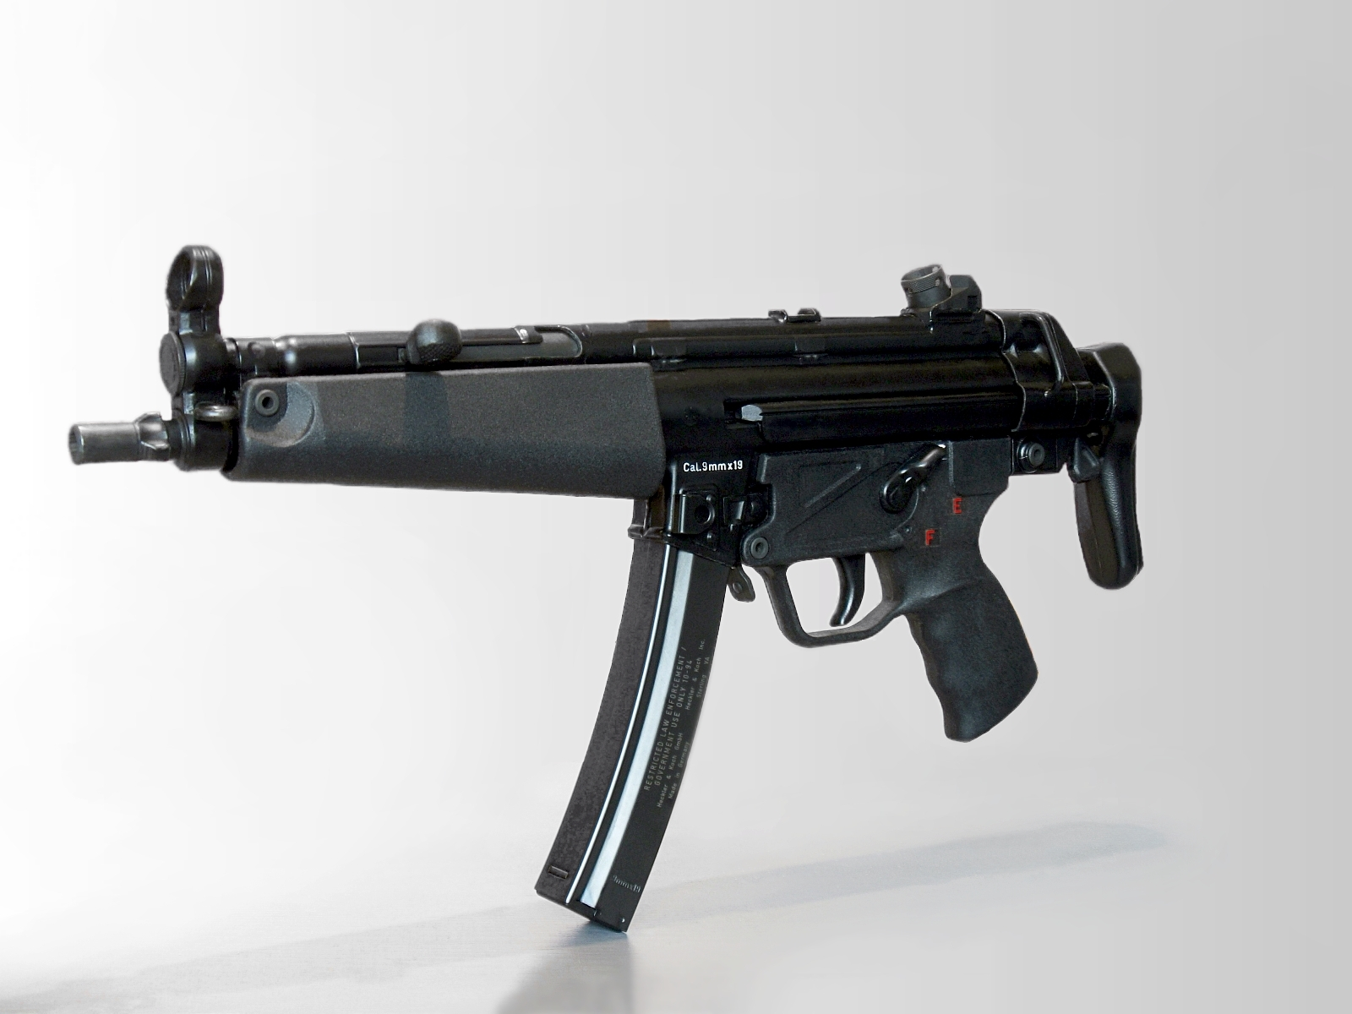
For the course itself the weapon is a perfect choice due to the close quarter’s scenario but the MP5 was issued to certain American military personnel so there is a chance that the character could have had the training to use it. The weapon itself is a smaller calibre so despite inexperience it could still be shot easily. The only issue that the user would have issues with is the reloading mechanism as it is completely different from most firearms that the Americans have.
The third weapon I considered was the FAL.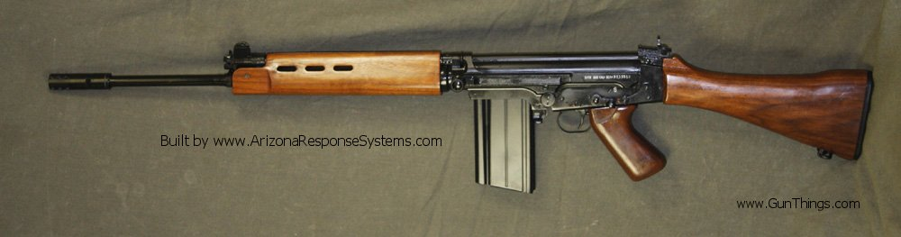
The FAL falls into the battle rifle category which means a big round from a long gun which would be somewhat unhelpful in a close quarter area due to the weapons length but the power of it will balance out the situation. Due to the location of the magazine release this weapon would be considered rather difficult to an inexperienced user such as my character which would make it a good contender for the ending scenes of my animation.

The fourth weapon I had chosen to consider is the MP7.
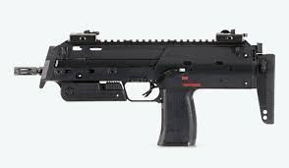
Designed for close quarter battles this SMG is would be perfect for the ending scenes but as a fairly new to the era firearm it is likely that the user being my character would be very inexperienced when handling this weapon properly. Additionally the weapon comes with pica tinny rails by default which I feel gives the weapon a more future look while I would prefer something more smoother.
The fifth weapon I have considered is the Steyr AUG.
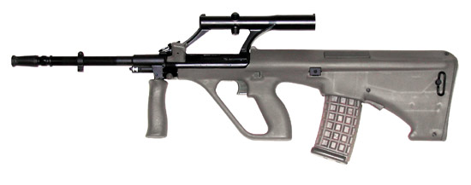
An outlandish choice due to no American usage I considered it for its main design of being a fairly futuristic looking rifle while actually being fairly old by most standards. The rifle appears fairly simplistic despite it being of bullpup design to use so the user may have a fairly simple time realistically when just picking up the rifle from fresh with exception of the magazine release which doesn’t seem obvious from the get go.
Section 2
For various military pieces of equipment usually camouflage is applied to it. For this section I want to look at different types of camouflage from the era and era surrounding it to decide what would look best and make sense for my scene.

The first camouflage considered is the one commonly called ‘Chocolate Chip.’
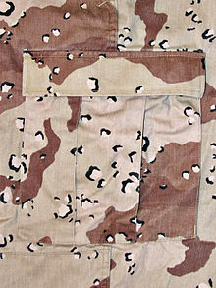
This camouflage was an early 80’s designed and used for a small amount of time by the Americans. I like this camouflage as it has a unique look to it over some of the others available. However this would be considered slightly inaccurate as stated it is a 80s one and saw less use.
The next camouflage I decided to check out was ‘Desert Night’ camouflage.
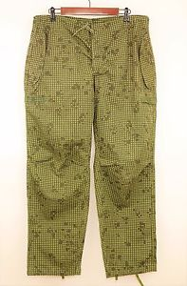
This camouflage was designed for night time use that would go over the previously shown ‘chocolate chip’ but it was found to be ineffective. However out of all of the ones around the era the design is quite outlandish and unusual which could work to a futuristic type of approach.

The third camouflage I decided to take a look at was the ‘tri-colour’ or Desert Camouflage uniform.
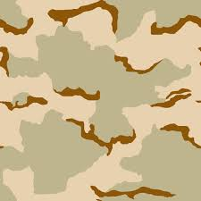
This was the most notable camouflage used in the Gulf war and would be the one which would be most commonly found and used by my character. It’s also fairly simplistic compared to the others on offer.
The fourth camouflage I considered was the standard woodland issue camouflage.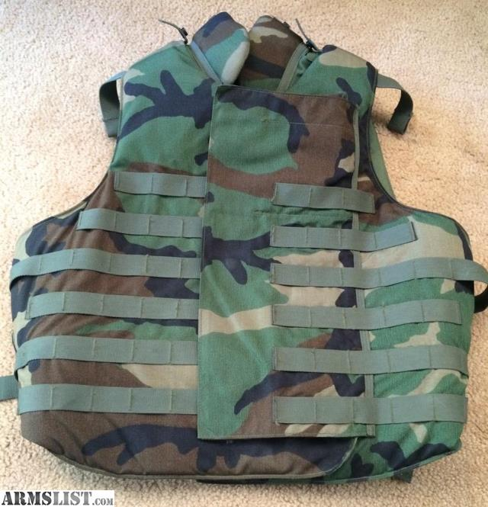
This camouflage was widely used in the Gulf war despite the area being completely desert and this appeared to be a funding issue as most of the American gear apart from the battle dress uniforms and helmets were tri-colour. This would work well alongside the tri-colour for use on the character design.

