Women in Westerns.
It appears that especially in early westerns women were perceived as the weak ones. As if they were being kept down and should know their place in society. They were never or very rarely given any real power over men, in these early westerns. However, this was a myth, the myth of the Western. The one that the Hollywood filmmakers wanted to portray, and indeed the only one the very male-dominated industry and society was prepared to accept. Lehman and Luhr (2008) explain that ‘…the western has constructed reality as a masculine enterprise. Women are impeding to it or peripheral.’
Women always were the teachers, the spinster, prostitute or the saloon girl. More often than not the teacher, spinster or even prostitute were making their way from the east to the west, Cook (1988:294) suggests they were going to try and tame the west, it was seen as a challenge or even a threat to the Cowboy’s way of life.

The view proposed by Cook (1988:294) suggests that,
“It is unusual for the woman who starts out wearing pants, carrying a gun and riding a horse to be still doing so at the end of the movie. Suitably re-clad in dress or skirt, she prepares to take her place in the family, leaving adventure to the men.”

Very rarely you would see a woman in a position of power if ever. If they did start in a position of power, you could guarantee by the end of the film, the hero would re-establish his dominance over her, and this usually concludes with him marrying her.

Women were always the ones being rescued or saved by the hero from the savage Indians, desperadoes or sometimes themselves. Women were very rarely portrayed in a position of power in early westerns. Male dominance was never challenged, and if it was, it was dealt with. By the seventy’s things were starting to change. The genre was starting to change in the way women were being portrayed.

What I would like to do is to look at two conflicting ways in which women are portrayed. The first film I'd like to look at is For A Few Dollars More (Sergio Leone, 1965).

This spaghetti Western draws on all the myths of the Western film in that the women we do see are being portrayed as weak, needy or even lustful. Never in a positive of light, or in any way dominate the hero or even the villain of the film. Again, in these films women play the parts of the mother, wife, or the saloon girl. Women could also be seen as the Achilles heel of the heroes of this genre. They can stop him from achieving his goal or quest and the way in which they achieve this comes in many guises such as wealth, power, dominance or even justice, it’s a theme which runs through this genre of film.
According to Lehman and Luhr (2008) “All of recent westerns… clearly respond to both the formula of previous westerns and to the times in which they were made.”

Here is an example of the female being portrayed in a negative light. Lehman and Luhr (2008) explain that these westerns do not ‘respond to contemporary awareness of cultural diversity in the form of the women’s movement.’ The American culture was drenched in conservative values, but these had started to fall apart by 1970’s. They were being confronted by the rise of feminism. ‘The values of the strong, righteous men of the 1950’s now came under question, and the [cowboy] was no exception.’ (Lehman and Luhr, 2008)

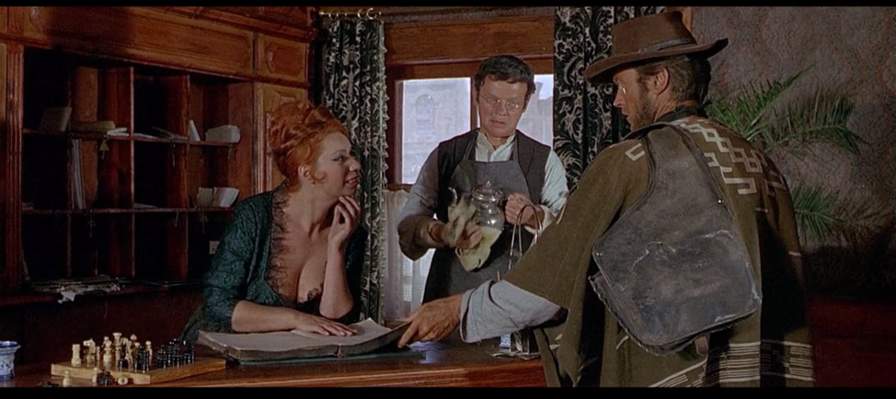

So, let’s take a look at this short scene which demonstrates the inequality, it’s from For A Few Dollars More (Leone 1965,32.50)

The second film I’d like to look at is Two Mules for Sister Sara (Siegel, 1970).

He believed that he was rescuing her, and his mission was to keep her safe on the journey, but they are actually equals. As she is using him to achieve her goal to rid the town of the French garrison.

He is oblivious to her true identity and finds himself in a difficult potion when she reveals her true identity. It is at this point that he realises that he has been used, emasculating him to a degree by using her femininity and presumed purity on order to make him carry out her plan.

According to Lucas (1998) ‘…the impulse to love, which typically feels so natural to the characters in a western’ is turned on its head in this film, because of the role reversal and the experience and knowledge of her true profession.

Ebert (1970) states that ’The respect turns out to be misplaced when Eastwood discovers Miss Shirley MacLaine isn't exactly a nun…’

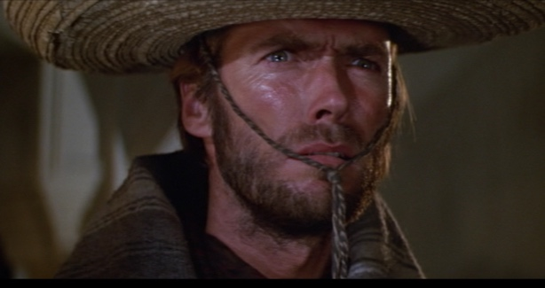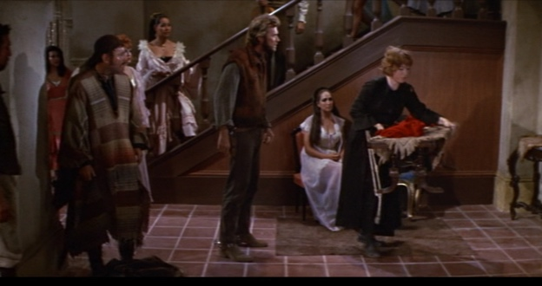
Two Mules For Sister Sara (Siegel, 1970, 1:27.10)

Internet Movie Database (1990-2018) states that, the film's title is actually a pun. Sara's initial transportation is a mule, that becomes lame, and she trades it for a younger and smaller donkey - which is not technically a mule. So, the second "mule" of the title may be Hogan, whom Sara says, "You're as stubborn as my mule." Later, she calls Hogan, "Mr. Mule".

Reference List

Cook, P. (1988) ‘Women and the Western’, in Kites, J. and Rickman, G. (eds)
The Western Reader. New York: Limelight Editions.

Ebert, R. (1970) Two Mules for Sister Sara. Available at:
http://www.rogerebert.com/reviews/two-mules-for-sister-sara-1970 (Accessed: 31 October 2018).

Internet Movie Database (1990-2018) Two Mules for Sister Sara. Available at: http://www.imdb.com/title/tt0065134/trivia?ref_=tt_trv_trv (Accessed: 30 October 2018).

Lehman, P. and Luhr, W. (2008) Thinking about Movies. Oxford: Blackwell Publishing.

Lucas, B. (1998) ‘Saloon Girls and Ranchers’ Daughters’, in Kites, J and Rickman, G (ed)
The Western Reader. New York: Limelight Editions.

Film Reference List

For A Few Dollars More (Sergio Leone, 1965).

Two Mules for Sister Sara (Don Siegel, 1970).

