University of Wales Trinity Saint David

Wales Institute of Science & Art



Application of Computer Aided Engineering Processes

Structural Design & Fluid Analysis, ACHA6010

Ella Chaves

1802962

05/01/2024

Table of Contents
1 Introduction 2
2 Literature Review 3
2.1 Use of CAE 3
2.2 Advantages and Limitations 4
2.3 Principles of Stress and Strain Calculations 4
2.4 Concepts of Iterative Design 5
2.5 Benefits of CAE for Iterative Designing and Mass Reduction 5
2.6 Poisson’s Ratio and Young’s Modulus 6
3 Methodology 6
3.1 Validation Testing 6
3.2 CAD Modelling 7
3.3 Kinematic Simulation 7
3.4 Thermal Influence 8
3.5 Static Structural Analysis 8
3.6 Iterative Improvement 12
4 Combined Results and Analysis 13
5 Conclusions 18
6 Evaluation 20
7 References 21

Introduction
Computer-Aided Engineering (CAE) tools play a pivotal role in modern engineering, offering a virtual platform for simulating and analysing complex systems. These tools optimise designs, reduce development time and costs, and identify potential issues early in the design process, mitigating risks. CAE supports interdisciplinary integration, handling intricate geometries, and facilitating innovation through iterative testing. Its significance lies in accelerating product development, improving reliability, and encouraging innovation across various engineering disciplines. This report aims to gauge comprehension of the CAE process and its limitations, as well as practical implementation skills. Through simulating the testing of a real-world system in a computational environment, the report models an assembly, conducts a kinematics analysis, and performs a static structural assessment of a chosen component. The objective, utilising an iterative approach, is to enhance the structural performance of the selected component, considering structural loadings, fatigue life, and optimising mass. The incorporation of thermal conditions adds a realistic dimension, acknowledging material property degradation. The report emphasises the application of CAE tools in the engineering design process while acknowledging their limitations.

Literature Review
To provide a comprehensive foundation for comprehending the realm of Computer-Aided Engineering (CAE) tools and their practical applications, this section explores the relevant literature. Investigating the development of CAE in engineering, the review details the progression of its development and widespread integration within the discipline. Additionally, it offers an insightful overview of CAE applications, spanning design, analysis, and testing. By examining the progression and modern applications, the literature review forms the basis of a detailed analysis of the advantages, drawbacks, and underlying principles that underpin the effective use of CAE tools in the engineering domain.

Use of CAE
The historical evolution of CAE in engineering highlights its transformative journey within the discipline. Initially emerging as specialised software solutions in the 1970s, with a predominant focus on finite element analysis (FEA), CAE revolutionised the industry by enabling engineers to simulate and analyse structures and materials comprehensively., ((22) The Evolution of CAD and CAE Software in Engineering | LinkedIn, no date). The introduction of this mathematical technique, employed to address intricate structural and mechanical engineering challenges, brought about a revolution in the industry. Engineers gained the capability to simulate and analyse the performance of structures and materials across diverse conditions, resulting in the development of more resilient and dependable designs (Marcin Frąckiewicz, 2023). Subsequent advancements, including parametric and feature-based design, enhanced the flexibility and efficiency of the design process (Zalzala, 1998). Over time, CAE has become indispensable in engineering design and analysis, reflecting continuous efforts to improve efficiency, accuracy, and innovation. Its historical development underscores the dynamic relationship between technology and engineering, facilitating iterative improvements in design and comprehensive evaluations in analysis. (Computer-Aided Engineering (CAE) | Siemens Software, no date). Additionally, in the realm of testing, CAE provides a virtual environment for simulating real-world conditions, reducing the reliance on physical prototypes, and accelerating the product development cycle (What is Computer Aided Engineering (CAE)? - TWI, no date).

Advantages and Limitations
Exploring CAE tools involves assessing their advantages and limitations in engineering. On the positive side, CAE tools empower engineers with capabilities to virtually simulate, analyse, and optimise designs, reducing reliance on physical prototypes and accelerating the product development cycle (The advantages of Computer-Aided Engineering - CAE | Dassault Systèmes, no date). They facilitate the assessment of complex system interactions, contributing to robust and innovative solutions. However, inherent limitations include the need for specialised training, potential inaccuracies in simulations, and the complexity of model creation (CAE - CEOpedia | Management online, no date). CAE significantly enhances efficiency by streamlining the design process through rapid prototyping, virtual testing, and iterative optimisation, accelerating time-to-market (Computer Aided Engineering - an overview | ScienceDirect Topics, no date). Its cost-effectiveness is evident in decreased reliance on physical prototypes, minimising material, and testing expenses (Ramakrishnan, 2012). Early issue identification in the design phase reduces costly modifications later on. CAE fosters innovation by providing a platform for exploring and fine-tuning design concepts, pushing the boundaries of traditional approaches. Its integral role in enhancing efficiency, reducing costs, and encouraging innovation has become crucial in modern engineering practices, ensuring the delivery of high-quality products in a competitive and dynamic landscape. (Bahman and Iannuzzo, 2018)

Principles of Stress and Strain Calculations
The fundamental concepts of stress and strain entails exploring the foundational principles that dictate the mechanical behaviour of materials. Stress is a measure of the internal forces within a material, typically expressed as force per unit area (Stress vs. Strain: What are the Key Differences? | Xometry, no date). It signifies the material's resistance to deformation or failure under external loads. Strain, on the other hand, represents the deformation or elongation of a material relative to its original dimensions (Stress And Strain - What Are They And What Is Their Relationship, no date). It is calculated as the change in length divided by the original length. Young's Modulus and Poisson's Ratio interrelate stress and strain. In CAE, stress analysis simulates internal forces to understand potential failure points, while strain analysis assesses material response to external loads, optimising designs for durability and performance (‘FEA Concepts: SW Simulation Overview, Concepts of Stress Analysis ’, 2009). (Housari and Yang, 2005). These principles play a foundational role in the accurate modelling and simulation of structural components, ensuring that CAE tools provide valuable insights into the mechanical integrity of engineered systems (Beňo et al., no date).

Concepts of Iterative Design
The iterative design process in engineering involves a dynamic and systematic approach, emphasising repeated cycles of design, testing, and refinement for continuous improvement. Acknowledging that initial designs may require adjustments, this methodology promotes adaptability, creativity, and problem-solving. It plays a vital role in achieving innovative and optimised solutions, encouraging learning and improvement throughout the design lifecycle (All about the Iterative Design Process | Smartsheet, no date). The focus on improving resistance to thermal load, reducing mass, and optimising structural performance through iterative design aims to achieve efficient, reliable, and lightweight solutions. Thermal load resistance ensures components withstand varying temperatures, preventing deformations or failures. Mass reduction enhances system efficiency, lowers material costs, and improves energy consumption, particularly in weight-critical applications. Optimising structural performance ensures meeting criteria such as strength, durability, and reliability. The iterative design process enables systematic refinement, incorporating insights from testing and analysis for a well-balanced and high-performing engineering solution. (Thermal Loads in Structural Design - Enterfea, no date).

Benefits of CAE for Iterative Designing and Mass Reduction
CAE achieves mass reduction while maintaining structural integrity through comprehensive analysis and optimisations. By iteratively simulating and analysing alternative materials, configurations, and geometries, CAE enables optimal weight reduction while meeting performance criteria. This ensures structurally sound final designs, minimising excess material usage for lightweight and efficient engineering solutions. This balance is crucial for industries aiming to enhance fuel efficiency, reduce costs, and improve sustainability. (‘Cranktrain Design Optimized for Reducing Weight and Friction Supported by Coupled CAE Tools’, no date) (Benefits of optimization with parametric mesh morphing: ANSA and META integration in pSeven. Use Case, no date)

Poisson’s Ratio and Young’s Modulus
Explanation of Poisson's Ratio and Young's Modulus involves understanding two fundamental material properties in engineering. Poisson's Ratio is a dimensionless parameter that describes the ratio of lateral contraction to longitudinal extension when a material is stretched or compressed (Poisson’s Ratio, no date). It is expressed as the negative of the ratio of transverse strain to axial strain. Young's Modulus, on the other hand, is a measure of a material's stiffness, indicating how much it deforms under axial (tensile or compressive) stress. It represents the ratio of stress to strain within the elastic limit of the material (Young’s Modulus - an overview | ScienceDirect Topics, no date). Both parameters are crucial for characterising material behaviours, utilised in structural analysis and design. They play a paramount role in predicting material responses to external forces, guiding engineers in designing components that meet performance requirements while considering factors like elasticity and deformation (Mechanical Properties of Materials | MechaniCalc, no date) The consideration of Poisson's Ratio and Young's Modulus ensures the structural integrity and optimal performance of materials in engineering applications. (Mechanics of Materials: Strain » Mechanics of Slender Structures | Boston University, no date)

Methodology
ANSYS provides a comprehensive set of features for structural, thermal, and dynamic analysis, making it well-suited for the diverse range of tests required.

Validation Testing
The selected tests included a Bi-Metallic Strip study to determine mesh size independence, two Cantilever tests (uniform and axial loading), a Gravity Loading test, and a comprehensive Iterative Design test. The latter focused on a piston geometry, utilising 6061-T6 Aluminium and Structural steel in rigid dynamics, steady-state thermal, and static structural analysis. These tests collectively assessed ANSYS's effectiveness across diverse loading scenarios, materials, and analysis types, providing a comprehensive evaluation of the modelled assembly. The mesh sizing assessment is crucial in CAE investigations, influencing result accuracy and guiding parameter selection for improved efficiency and reliable simulations.

CAD Modelling
In the CAD modelling and assembly section, a realistic assembly, consisting of components such as a piston, connecting rod, gudgeon pin, and crankshaft, was utilised as the basis for subsequent analysis. This assembly aimed to demonstrate the versatility of CAE tools in simulating real-world engineering scenarios. The section emphasises the critical role of precise CAD geometry in influencing the accuracy of structural analyses, particularly in assemblies with intricate components. Meticulous CAD modelling is essential to maintain the reliability of structural assessments by minimising discrepancies in stress distribution and deformation predictions (Allen, 2009).

Kinematic Simulation
In the next assessment phase, ANSYS is employed for a kinematics analysis, scrutinising the dynamic behaviour of the assembly. This simulation, conducted under realistic operating conditions, offers insights into the intricate motions, velocities, and accelerations among the components. Crucial for understanding dynamic interactions, this analysis lays the foundation for subsequent static structural assessments. The integration of kinematic simulation within the broader CAE framework demonstrates its significance in comprehensively evaluating the performance and behaviour of complex engineering assemblies. To ensure an accurate representation of real-world scenarios, realistic loading conditions and appropriate boundary conditions are determined and applied in the ANSYS simulation. This involves identifying external forces, pressures, or thermal conditions the assembly would encounter and establishing constraints that mimic the physical limitations. Meticulous consideration of these conditions is paramount for obtaining reliable simulation results closely mirroring the assembly's actual performance under authentic operating scenarios, enhancing the subsequent analyses reliability and applicability.

Thermal Influence
In this assessment, particular focus is placed on the thermal conditions affecting the assembly's chosen component, specifically the piston. ANSYS will be utilised to simulate the thermal conditions that the piston may encounter during operation. This involves analysing heat dissipation, thermal expansion, and assessing how the piston responds to varying temperatures The study aims to comprehensively understand how temperature fluctuations specifically impact the piston's structural integrity and performance within the assembly. This focused thermal analysis is pivotal to optimise the piston's design not only for mechanical loading but also for the thermal conditions it may experience in real-world applications. Realistic material properties, derived from technical papers and specific to 6061 T6 Aluminium, were incorporated throughout the study. Adjustments to Young's Modulus and Poisson's Ratio were made based on provided technical specifications, ensuring a true representation of the material's real-world behaviour under varying thermal conditions. By integrating precise material properties and thermal results, the study aims to enhance the accuracy and reliability of simulations, aligning the virtual model closely with the expected physical behaviour of the materials in practical applications.

Static Structural Analysis
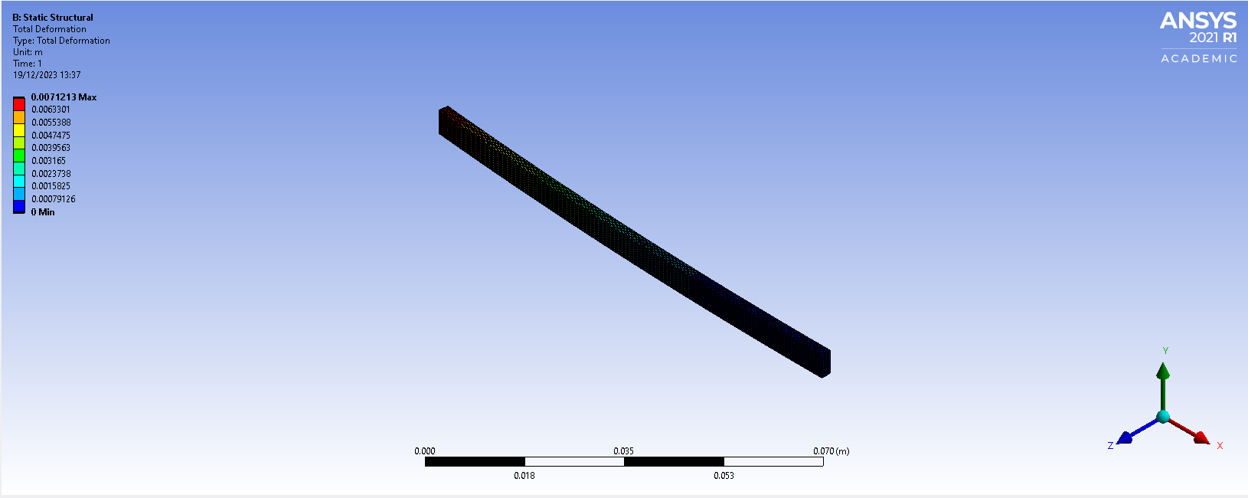
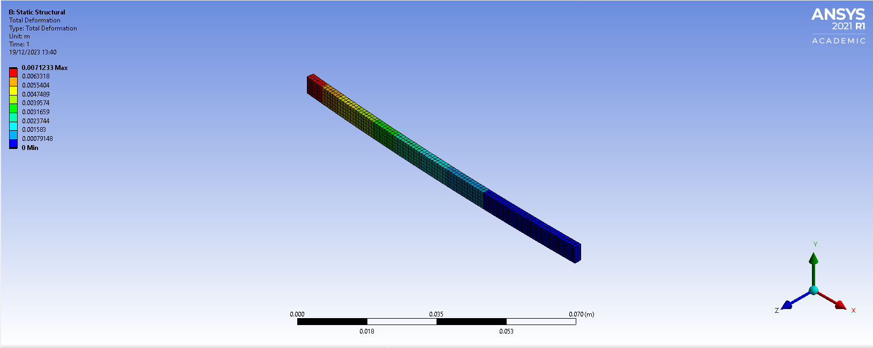
Building on kinematics insights, the study advances to a static structural analysis in ANSYS, integrating dynamic behaviours from the kinematics study. This integrated approach considers both static forces and dynamic effects, enhancing the understanding of assembly components under steady-state conditions. Preliminary tests, such as the Bimetallic Strip, Cantilever with Axial Loading, Cantilever with Uniform Loading, and Gravity Loading, precede the targeted examination of the piston. These tests provide a foundation for systematically assessing structural performance under diverse loading scenarios, identifying stress points, deformations, and weaknesses. The Bimetallic Strip test investigates mesh size impact on analysis precision, aiming to establish mesh independence. Figures 1 and 2 depict two mesh sizes (0.001mm and 0.00025mm), revealing variations in total deformation results. Notably, smaller mesh sizes align more closely with expected values, which according to the technical paper is -7.049mm, emphasising that reducing mesh size enhances accuracy in static structural outcomes. The cantilever with axial loading tests, serves as a crucial step in understanding how the component responds to specific loading conditions. The cantilever with axial loading tests are pivotal for understanding the component's response to specific loading conditions. These tests offer insights into the assembly's behaviours under forces parallel to its axis, exploring stress distribution, deformations, and potential failure points. By subjecting the assembly to axial loading, the study identifies areas of potential compromise in structural integrity, informing design refinements to ensure the assembly withstands practical axial forces. Following a methodology similar to the Bimetallic strip, the analysis involved testing multiple mesh sizes, starting with the cantilever's width, and iteratively halving to determine optimal accuracy.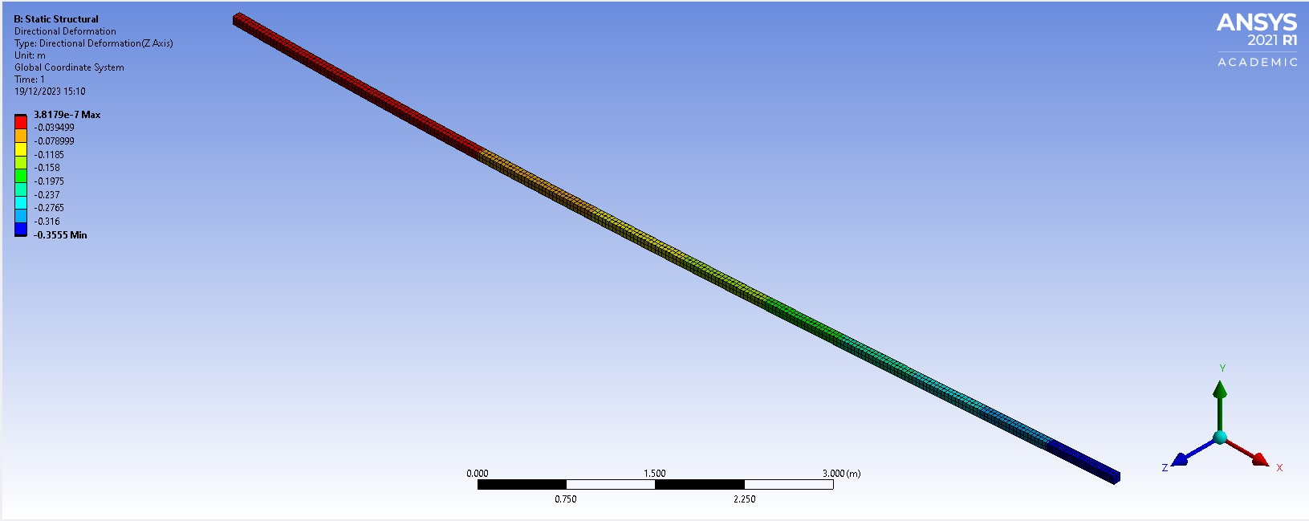
Figure 2 - Bimetallic Strip mesh size 0.00025mm
Figure 1 - Bimetallic Strip Mesh size 0.001mm
Figure 3 - Cantilever with Axial Loading - mesh size 0.04mm
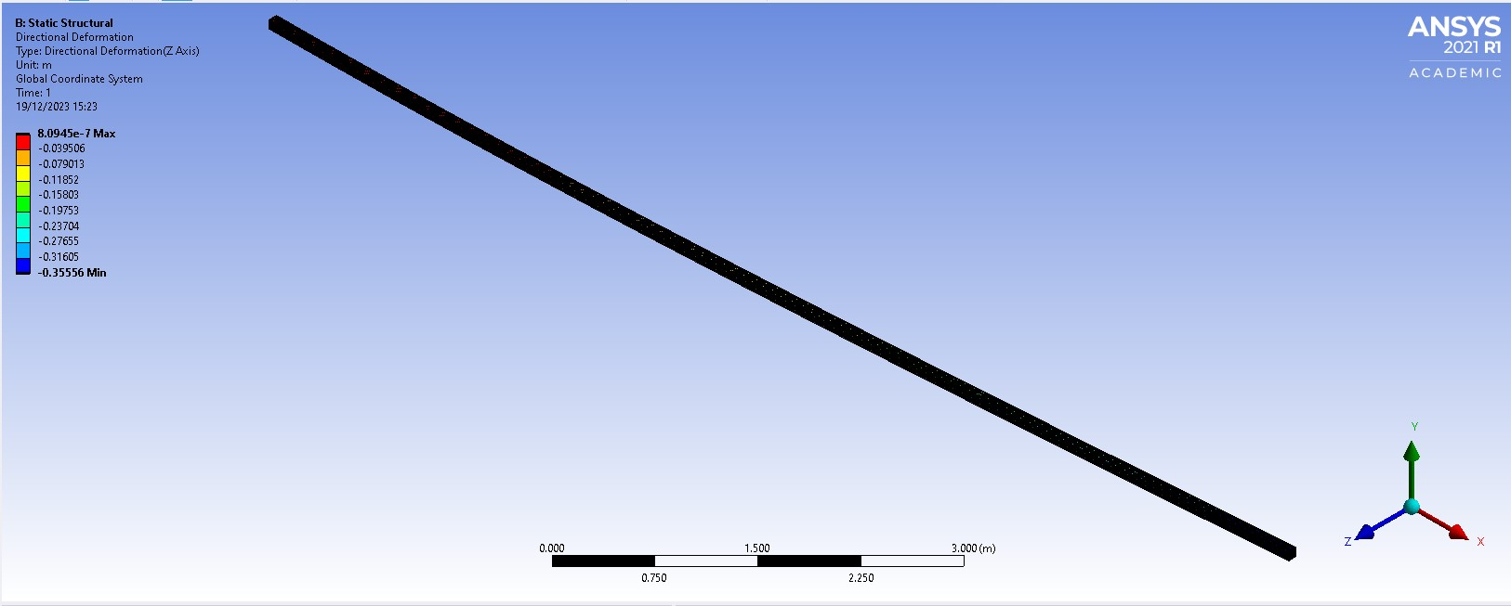
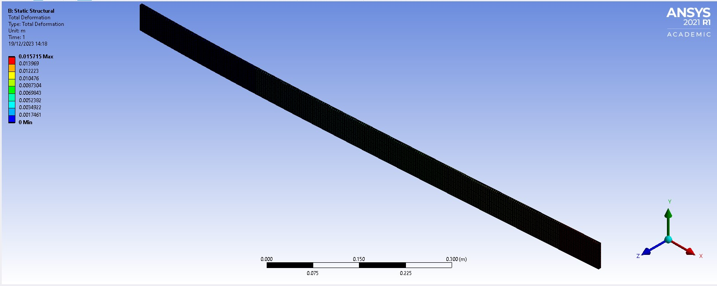
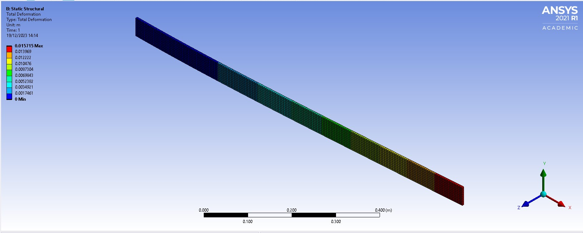
Figures 3 and 4 depict the largest and smallest mesh sizes, showing a notable increase in total deflection for the smaller mesh. This is attributed to the finer mesh capturing subtle variations in stress distribution and deformation, leading to heightened sensitivity to localised effects. While reducing the mesh size enhances accuracy by representing intricate structural features, a careful balance is crucial to avoid excessive computational demands. The cantilever with uniform loading test, is essential for understanding how the component responds to evenly distributed forces. The cantilever with uniform loading test is essential for understanding the component's response to evenly distributed forces, exploring critical aspects of stress distribution, deformations, and potential weak points in the structure. Figures 5 and 6 show two mesh sizes, progressively halved, yet the total deformation scale remains consistently unchanged. This stability in total deformation values can be attributed to the uniform load distribution along the cantilever's length, resulting in a uniform stress distribution. In scenarios with such uniform loading, variations in mesh size may have less impact on result accuracy compared to cases with more complex loading patterns. The uniformity of the load contributes to numerical stability, ensuring relatively consistent total deformation outcomes across different mesh configurations. The gravity loading test, plays a crucial role in understanding how the component responds to the influence of gravitational forces. The gravity loading test simulates the effect of gravity on the assembly, providing insights into its behaviour under this constant force.
Figure 4 - Cantilever with Axial Loading - Mesh size 0.01mm
Figure 6 - Cantilever with Uniform load - mesh size 0.00125
Figure 5 - Cantilever with Unform Load - Mesh size 0.005mm
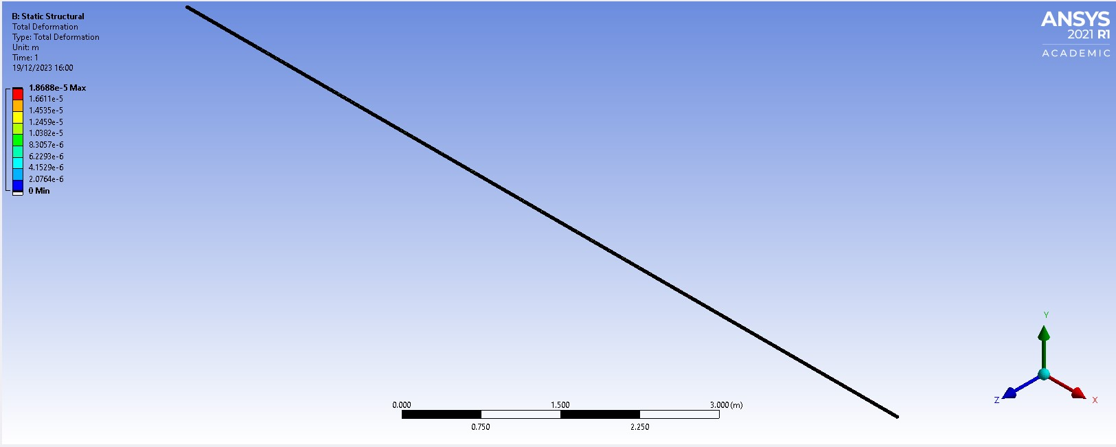
Figure 7 - Gravity Loading - mesh size 0.01mm
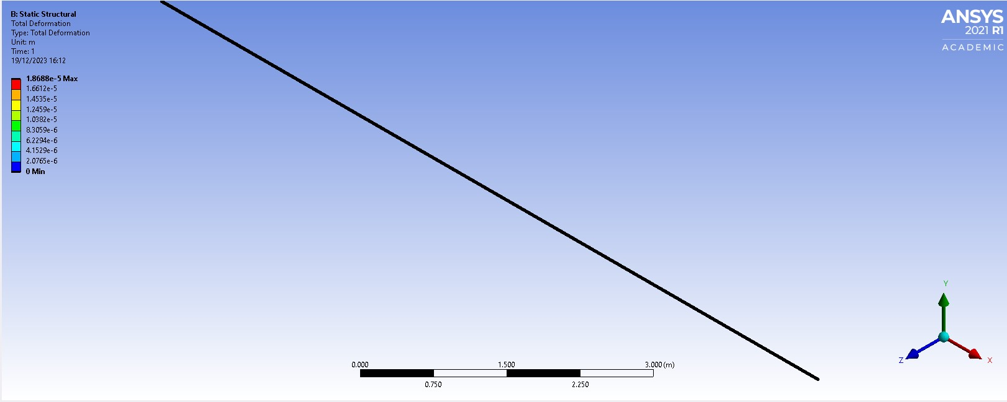
Similar to the Cantilever with uniform loading, the Gravity Loading test may exhibit consistent total deformation values across different mesh configurations, reflecting the stability introduced by the uniformity of the applied forces. This consistency underscores the robustness of the simulation results under these specific loading conditions.
Figure 8 - Gravity Loading - mesh size 0.0025mm

Iterative Improvement
The iterative design test focused on refining the performance of the piston within the provided assembly. Contrary to the initial material choice of 6061 T6 Aluminium, structural steel and its corresponding material properties were employed in this iterative design study. This intentional shift in materials aimed to explore alternative options for optimising the piston's structural performance. The iterative process involved analysing the FEA study outcomes and identifying areas for enhancement. This approach showcases the effectiveness of iterative design in leveraging FEA insights to iteratively enhance the structural integrity and overall performance of a critical component within the assembly.
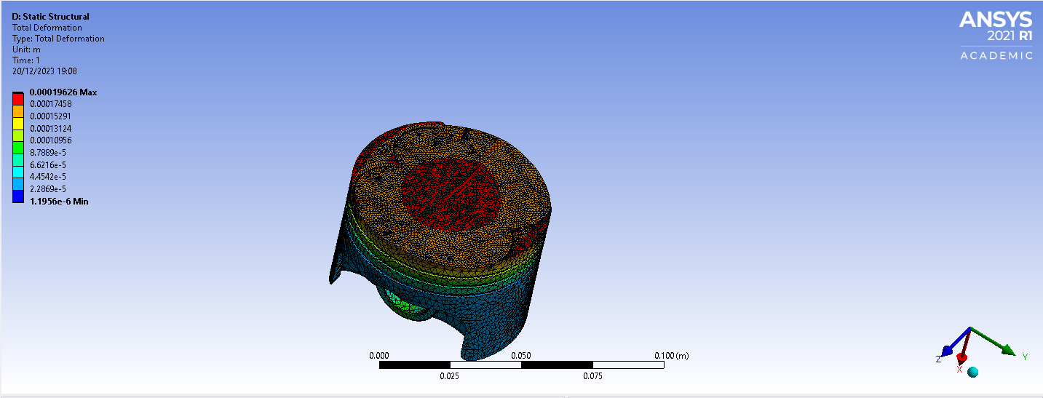
In this study, the exploration of total deformation goes beyond a straightforward static structural analysis. This assessment includes dynamic considerations, integrating rigid dynamics to analyse how the piston responds to dynamic forces. Additionally, the study delves into steady-state thermal analysis, exploring the thermal behaviour of the piston under varying temperature conditions. Furthermore, stress analysis is integrated to gain a holistic understanding of how the structural steel piston performs under different loading scenarios. By incorporating multiple analyses, including rigid dynamics, steady-state thermal, and stress analysis, the study aims to provide a thorough understanding of the structural integrity and performance of the structural steel piston across diverse operating conditions.
Figure 9 - Structural Steel Piston Study

Combined Results and Analysis
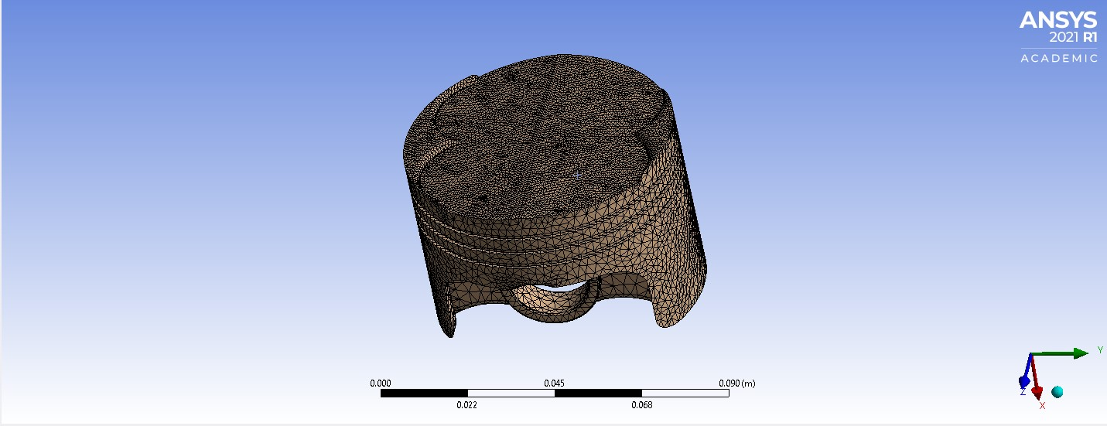
The kinematics analysis explores the system's motion and response under realistic conditions, establishing a foundation for the subsequent static structural study. This assessment delves into the structural behaviours of assembly components, providing insights into stress distribution, deformations, and potential areas for improvement. Combining these analyses offers a comprehensive understanding of the assembly's performance, addressing both kinematic and structural aspects. After mesh sizing studies, the mesh for the piston study with 6061-T6 Aluminium properties was adjusted to multiple sizes in different areas to enhance accuracy. This strategic approach, utilising finer mesh sizes in critical areas and coarser sizes in less critical regions, captures localised effects more accurately. Figure 9 illustrates a mesh size of 0.005 for the majority of the piston, while the piston crown, prone to higher stress concentrations and varied material behaviours, employs a finer mesh size of 0.001 for accurate representation of stress distribution and deformation. The findings for the total deformation of the piston after creating the refined mesh sizing is as somewhat expected. The results suggest that the deformation is higher at the centre of the piston crown (Figure 10) than that of the underside of the piston (Figure 11), this is due to the mechanical and thermal demands of this region during engine operation.
Figure 9 - Piston Mesh
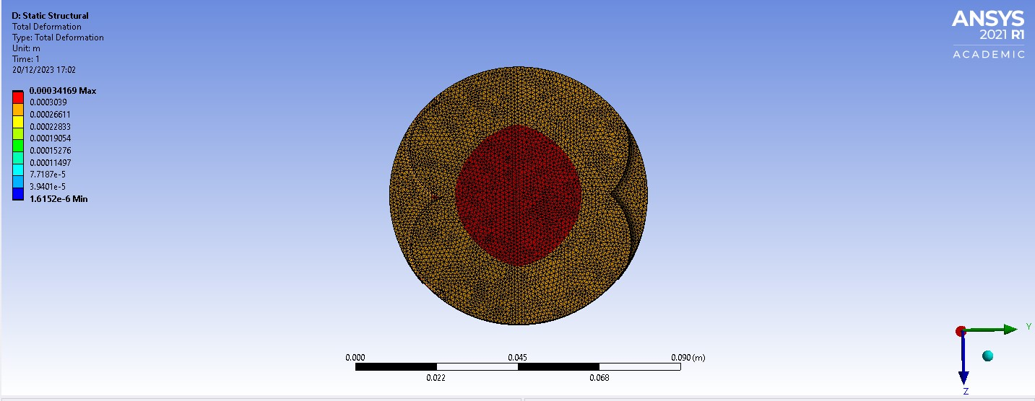
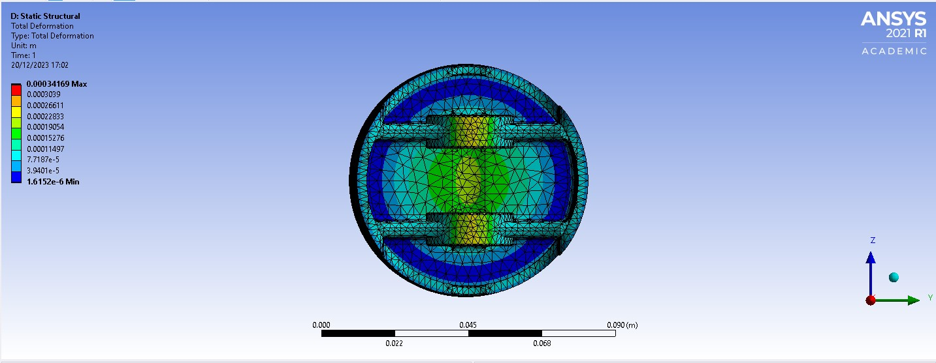
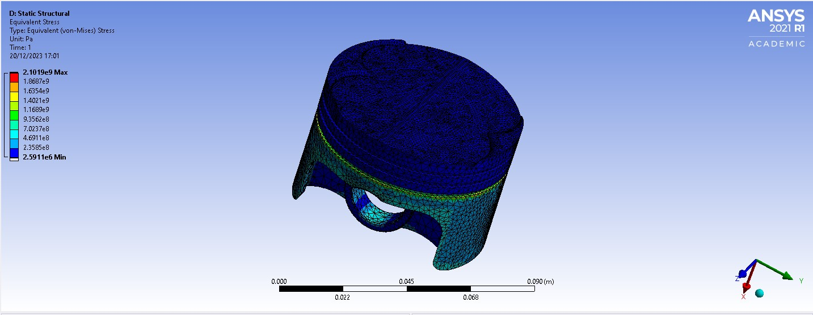
The piston crown, subjected to high temperatures and combustion pressure, experiences increased stress concentrations and thermal expansion, leading to significant deformations. A finer mesh size in this critical area provides a more accurate representation, resulting in higher total deformation compared to the underside with lower stresses. In equivalent stress analysis, variations are anticipated across piston regions, with high-pressure areas like the crown potentially exhibiting elevated equivalent stress due to intense mechanical loading. Conversely, ring grooves and skirt regions may experience lower equivalent stress. Examining this distribution helps identify potential failure points or areas for design optimisation, with an even stress distribution indicating robust design for structural integrity under operational conditions.
Figure 10 - Piston Crown Deformation
Figure 11 - Piston Underside Deformation
Figure 12 - Piston Equivalent Stress
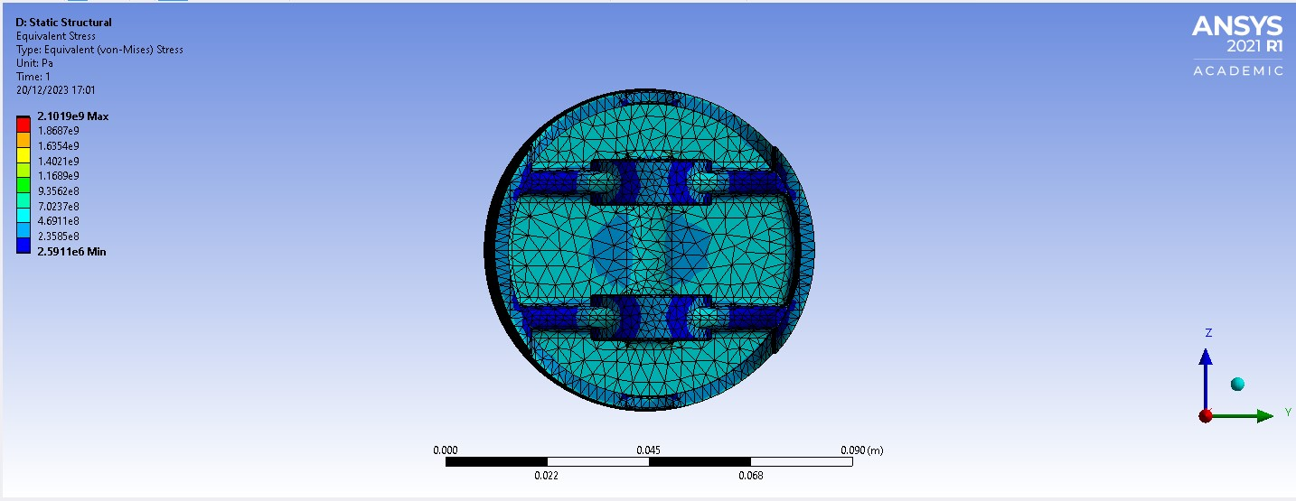
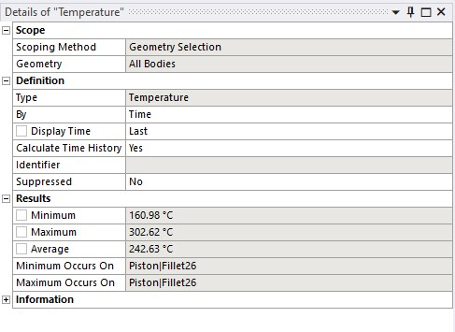
As shown in Figure 12, certain regions of the piston skirt, grooves, and underside exhibit higher stress rates than the crown. The underside often faces varying stress concentrations from thermal gradients, mechanical loading, and combustion effects. Areas with minimal stress, including the crown, suggest effective design and material usage, indicating resilience to operational conditions. Despite potential concerns about high equivalent stress in specific regions, the overall minimum stress in critical sections signifies a robust design, aligning with expected stress distribution in engine components. Steady-state thermal analysis is crucial for understanding the piston's thermal behaviour, assessing its ability to dissipate or absorb heat and preventing structural compromise from overheating or thermal fatigue. Expected results include temperature distribution across the piston surface, identifying areas prone to excessive heating or cooling.
Figure 13 - Piston Underside Stresses
Figure 15 - Temperature Data
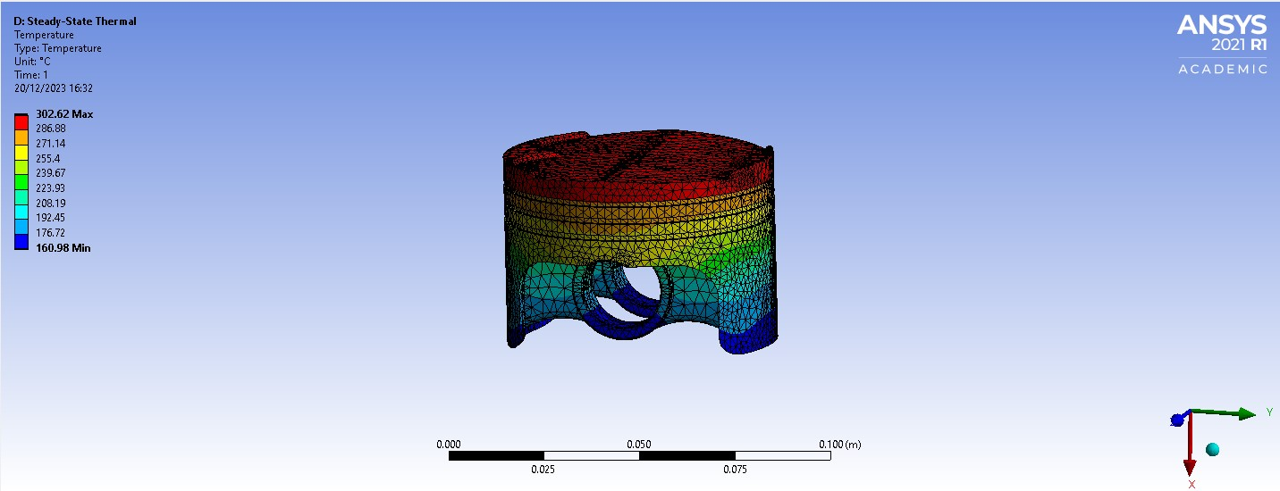
A benefit that is included in ANSYS is the data section that is provided for an easier view of the outcomes, shown in Figure 15, is the data provided from the temperature analysis. The obtained results for the steady-state thermal analysis of the piston are within a reasonable range and align with expectations. The maximum temperature of 302.62°C suggests that specific areas near the combustion chamber or regions exposed to high heat sources, experience elevated temperatures. The minimum temperature of 160.98°C indicates cooler regions, located farther from the combustion chamber. The average temperature of 242.63°C falls within the expected range, reflecting an overall assessment of the piston's thermal behaviour. Lastly, the rigid dynamics forces test for the piston is essential for understanding its response to dynamic forces during engine operation. The rigid dynamics analysis simulates these dynamic conditions, considering factors such as acceleration, deceleration, and inertial effects. This test helps evaluate the piston's ability to withstand dynamic loads. The test was carried out at 4000RPM, this is because it represents a realistic and commonly encountered engine speed. Testing at this speed allows for the assessment of the piston's performance under typical operating conditions, providing insights into potential issues such as vibration, resonance, or dynamic stress concentrations.
Figure 14 – Temperatures
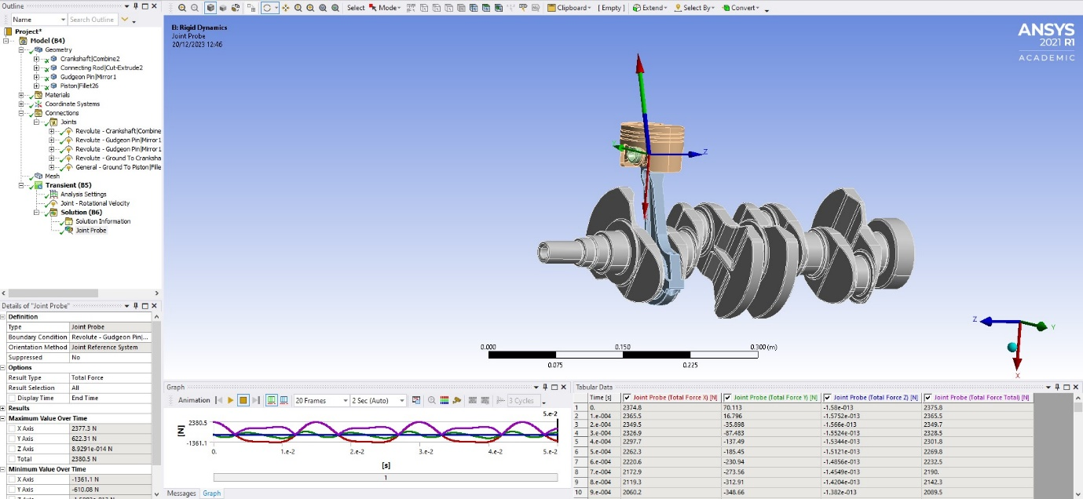
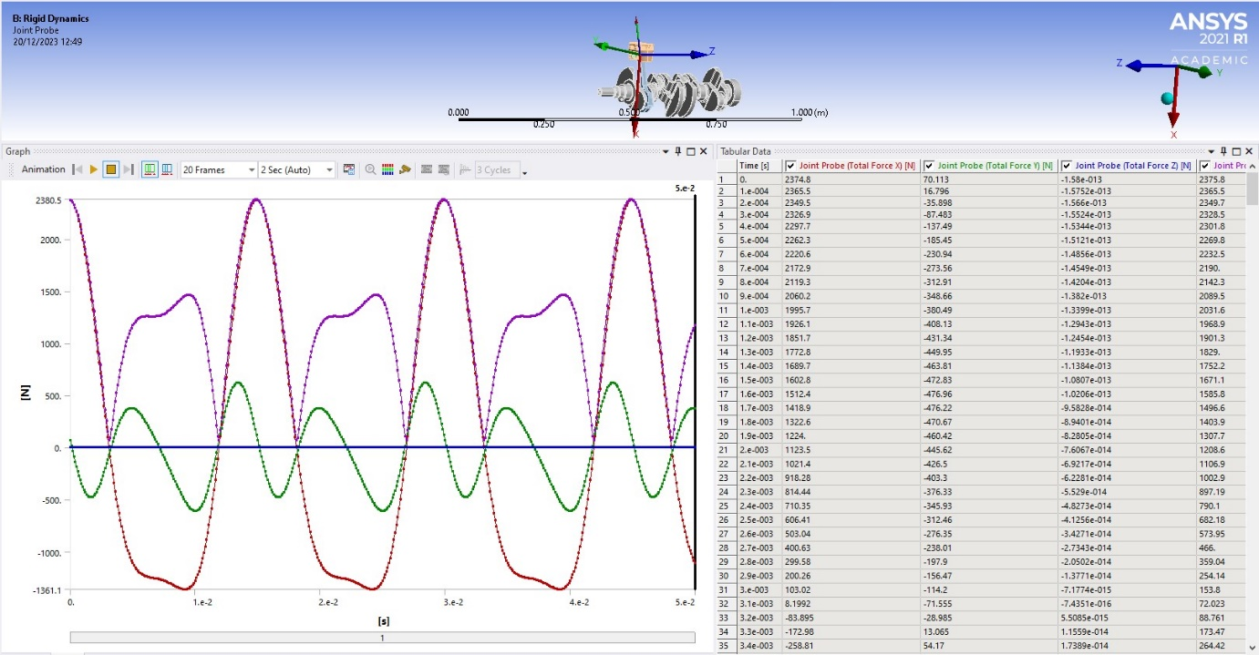
Visible in figure 16, the graphs and tables from the rigid dynamics’ forces test illustrate the dynamic response of the piston to forces encountered during engine operation, particularly at 4000 rpm. Figure 17 offers a more distinct perspective of the graph and table from the test, revealing that the maximum force recorded is approximately 2380.5 Newtons, while the minimum force is around -1361.5 Newtons. The positive maximum force reflects the peak force exerted on the piston during acceleration or power strokes, which is typical in an internal combustion engine. The negative minimum force indicates forces during deceleration or compression strokes. These results are consistent with the cyclic nature of engine operation, demonstrating the piston's response to the dynamic forces encountered in a real-world engine scenario. The comparison of CAE results, encompassing the rigid dynamics forces test at 4000 rpm, steady-state thermal temperatures, equivalent stress, and total deformation, with real-world scenarios reveals a promising alignment. The rigid dynamics test yielded forces of approximately 2380.5 Newtons (maximum) and -1361.5 Newtons (minimum), consistent with expectations for dynamic conditions in an internal combustion engine. Furthermore, the steady-state thermal analysis produced temperatures within the range of 160.98°C to 302.62°C, providing insights into the piston's thermal behaviour. Equivalent stress and total deformation analyses contributed valuable information on the structural integrity under dynamic and thermal loading. While these results demonstrate the effectiveness of CAE simulations, it's crucial to acknowledge inherent limitations, such as assumptions in material properties and transient effects. Validation through physical testing remains essential for a comprehensive understanding and optimisation of the piston's design for real-world scenarios.
Figure 16 - Rigid Dynamics, Forces on the piston
Figure 17 - Forces Graph and Table

Conclusions
The comprehensive CAE analysis, incorporating various tests, yielded crucial insights into the performance of the assembly components. The Bi-Metallic strip study, Cantilever tests under axial and uniform loading, gravity loading, and the iterative design study provided valuable information. The mesh size test, a key evaluation, offered insights into simulation accuracy, indicating that a smaller mesh size is effective for intricate geometry areas, while a slightly larger mesh size is efficient for less complex regions. This study showcases CAE's role in enhancing efficiency, structural integrity, and performance in real-world engineering design processes. Insights from various tests inform decisions and optimisations, emphasising CAE's value in guiding the design process. Acknowledging inherent limitations, the study underscores CAE's potential as a tool, complemented by a comprehensive iterative design approach.

Evaluation
The chosen CAE software, ANSYS, underwent a thorough evaluation for analysis tasks. Results from various tests, including validation and mesh independence, assessed the software's accuracy. ANSYS demonstrated reliability in replicating real-world scenarios, with the mesh size study optimising parameters for accurate simulations. Comparison with analytical solutions affirmed ANSYS' accuracy. The mesh independence study provided essential insights into the impact of mesh sizing on result accuracy, ensuring that simulation outcomes were reliable and not overly influenced by the mesh parameters. A critical evaluation of the overall methodology reveals its effectiveness in simulating and analysing the assembly components under diverse conditions. The iterative design approach, coupled with thorough FEA studies, facilitated significant improvements in structural performance. While the methodology demonstrated success in addressing thermal and dynamic challenges, it is essential to acknowledge its limitations, such as assumptions in material properties and simplifications in geometry. Despite these constraints, the methodology remains highly applicable to real-world engineering challenges, providing a valuable framework for systematic design optimisation and performance enhancement.

References
(22) The Evolution of CAD and CAE Software in Engineering | LinkedIn (no date). Available at: https://www.linkedin.com/pulse/evolution-cad-cae-software-engineering-eleation/ (Accessed: 18 December 2023).
All about the Iterative Design Process | Smartsheet (no date). Available at: https://www.smartsheet.com/iterative-process-guide (Accessed: 20 December 2023).
Allen, G. (2009) ‘Geometric Modeling Problems in Industrial CAD / CAM / CAE’.
Bahman, A.S. and Iannuzzo, F. (2018) ‘Computer-aided engineering simulations’, Wide Bandgap Power Semiconductor Packaging: Materials, Components, and Reliability, pp. 199–223. Available at: https://doi.org/10.1016/B978-0-08-102094-4.00010-4.
Benefits of optimization with parametric mesh morphing: ANSA and META integration in pSeven. Use Case (no date). Available at: https://www.pseven.io/blog/use-cases/benefits-of-optimization-with-parametric-mesh-morphing-ansa-and-meta-integration-in-pseven.html (Accessed: 5 January 2024).
Beňo, P et al. (no date) ‘OPTIMIZATION OF THIN-WALLED CONSTRUCTIONS IN CAE SYSTEM ANSYS’.
CAE - CEOpedia | Management online (no date). Available at: https://ceopedia.org/index.php/CAE (Accessed: 19 December 2023).
Computer Aided Engineering - an overview | ScienceDirect Topics (no date). Available at: https://www.sciencedirect.com/topics/engineering/computer-aided-engineering (Accessed: 20 December 2023).
Computer-Aided Engineering (CAE) | Siemens Software (no date). Available at: https://www.plm.automation.siemens.com/global/en/our-story/glossary/computer-aided-engineering-cae/13112 (Accessed: 18 December 2023).
‘Cranktrain Design Optimized for Reducing Weight and Friction Supported by Coupled CAE Tools’ (no date).
‘FEA Concepts: SW Simulation Overview, Concepts of Stress Analysis ’ (2009). Available at: https://www.clear.rice.edu/mech403/HelpFiles/FEM_stress_concepts.pdf (Accessed: 20 December 2023).
Housari, B. and Yang, L.X. (2005) ‘Experimental Techniques for Strain Measurement and Validation of CAE Model’, SAE Technical Papers [Preprint]. Available at: https://doi.org/10.4271/2005-01-0587.
Marcin Frąckiewicz (2023) The Evolution of Computer-aided Engineering: A Historical Perspective, https://ts2.space/en/the-evolution-of-computer-aided-engineering-a-historical-perspective/#gsc.tab=0.
Mechanical Properties of Materials | MechaniCalc (no date). Available at: https://mechanicalc.com/reference/mechanical-properties-of-materials (Accessed: 21 December 2023).
Mechanics of Materials: Strain » Mechanics of Slender Structures | Boston University (no date). Available at: https://www.bu.edu/moss/mechanics-of-materials-strain/ (Accessed: 21 December 2023).
Poisson’s Ratio (no date). Available at: https://www.engineeringtoolbox.com/poissons-ratio-d_1224.html (Accessed: 21 December 2023).
Ramakrishnan, K. (2012) ‘Cost benefit analysis of computer aided engineering implementation in bespoke engineering business.’
Stress And Strain - What Are They And What Is Their Relationship (no date). Available at: https://www.fidelisfea.com/post/stress-and-strain-what-are-they-and-what-is-their-relationship (Accessed: 20 December 2023).
Stress vs. Strain: What are the Key Differences? | Xometry (no date). Available at: https://www.xometry.com/resources/materials/stress-vs-strain/ (Accessed: 20 December 2023).
The advantages of Computer-Aided Engineering - CAE | Dassault Systèmes (no date). Available at: https://www.3ds.com/store/cad/computer-aided-engineering (Accessed: 19 December 2023).
Thermal Loads in Structural Design - Enterfea (no date). Available at: https://enterfea.com/thermal-loads/ (Accessed: 21 December 2023).
What is Computer Aided Engineering (CAE)? - TWI (no date). Available at: https://www.twi-global.com/technical-knowledge/faqs/what-is-computer-aided-engineering (Accessed: 18 December 2023).
Young’s Modulus - an overview | ScienceDirect Topics (no date). Available at: https://www.sciencedirect.com/topics/engineering/youngs-modulus (Accessed: 21 December 2023).
Zalzala, A.N.S. (1998) ‘PARAMETRIC AND FEATURE-BASED CAD/CAM CONCEPTS, TECHNIQUES, APPLICATIONS by J.J. Shah and M. Mäntylä, Wiley, Chichester, 1995, 619 pp., ISBN 0–471–00214–3 (£55; HBK)’, Robotica, 16(6), pp. 701–702. Available at: https://doi.org/10.1017/S0263574798230852.

