Atterberg Experiment
Liquid Limit and Plastic Limit
Craig Jowitt - 2113158
2113158@student.uwtsd.ac.uk

Table of Contents
1. Introduction 2
2. Methodology 3
a) The Plastic Limit Procedure 4
b) Liquid Limit Procedure 5
3. Results 8
4. Analysis 9
5. Conclusion 10
6. References 11
7. Bibliography 11

Introduction

The aim of this report is to review the Atterberg Limits Test. The Atterberg test is used by engineers to better understand the soil and its properties from the sampled area. It is important to know how soil will behave especially when planning to construct on that soil. The Atterberg test will give an indication of the plastic limit of the soil and the liquid limit. Fine grained soils such as clay can be in four different states, Liquid, Plastic, Semi Solid and Solid. (Haig 2013)

Methodology

Equipment:

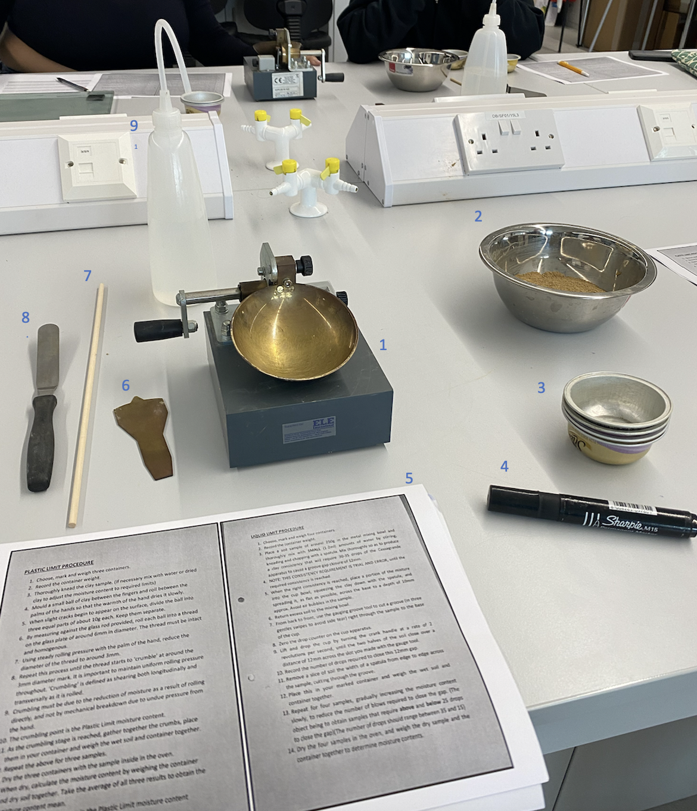
Equipment needed for the Atterberg test:
- Casagrande's liquid limit device
- Mixing bowl
- Fireproof sample pots for drying out the sample.
- Pen
- Methodology printed off.
- Grooving tool
- 3mm stick to check the plastic sample size.
- Spatula
- Water bottle

The Plastic Limit Procedure
- The containers were selected then weighed, ensuring to select containers which are heat proof.
- the containers weight was written down and each container marked with a number.
- a sample of clay was mixed with a small amount of water until it was of the correct consistency the sample needs to be malleable and not too wet.
- Once the sample is of the correct consistency roll it on a glass chopping board in a 6mm pencil like shape without it breaking up and homogenous.
- Using gentle pressure and the palm of the hand roll out the sample to approximately 3mm in diameter.
- The process should be continued until at close to 3mm the sample starts to crack and break away.
- This needs to be from uniform consistent pressure and not from being forced to crack.
- At the point at which the sample crumbles this is the plastic limit moisture content
- Once this point is reached collect the pieces and place them in one of the containers then weigh that sample and make a note of the weight, this is the wet soil weight.
- Carry out the above three more times.
- The three samples then need to be dried in an oven to remove all the moisture.
- Once the oven has removed the all the moisture weigh each container and note the dry weight take an average of the three samples.
- The average number is the Plastic Limit moisture content indicator.

Liquid Limit Procedure

- First select four containers, mark them on the outside to identify each container/sample.
- Weigh each container and make a note of their weight.
- Put a sample of soil weighing approximately 250g into a clean mixing bowl, then combine with a small amount of water until a clay like consistency is achieved. 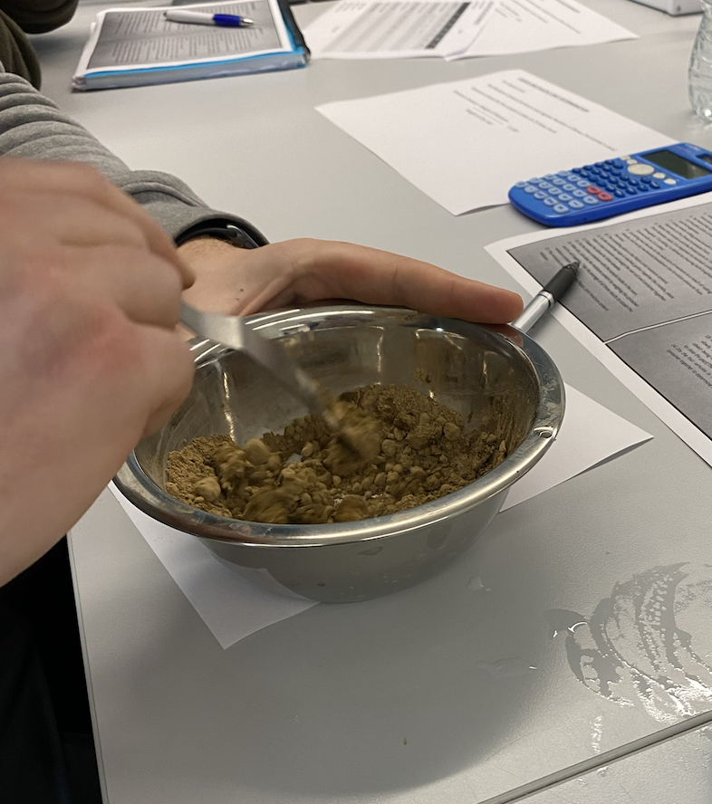
- This can take several attempts and is easier to add more water than it is to take it away.
- Once the soil is at a clay consistency place a portion into the dish of the Casagrande apparatus and spread it to a smooth flat finish the sample should be around 10mm in depth.
- From top to bottom bring the gauging tool towards you down the center of the sample taking time and making multiple passes until you can see the dish. 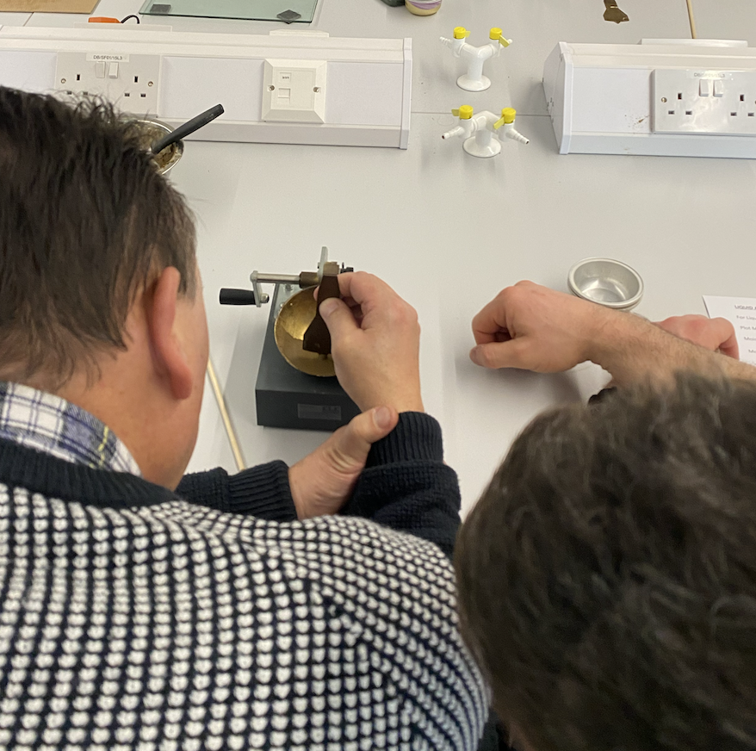
- The drop counter then needs to be zeroed.
- Using the crank handle wind at a rate of two revolutions per second, until either side of the soil sample begin to touch. 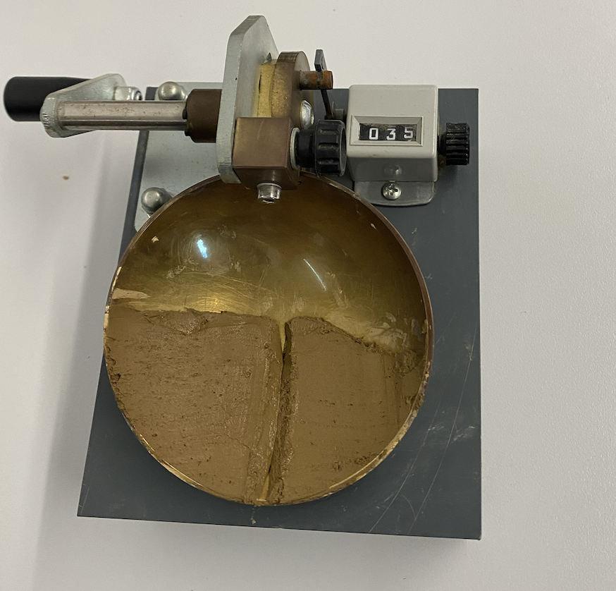
- Make a note of how many blows it took to close the gap made by the gauge tool.
- Take a portion of the sample using the spatula used to spread it. Take the sample from one edge to the other.
- Put into one of the marked containers then weigh with the sample in the container.
- Make a note of the weight and container number.
- Carry out the procedure three more times to get a total of 4 samples. With each consecutive sample gradually increase the water content which will decrease the number of blows required to close the 12mm gap. the aim is to produce samples that range from 35 blows to 15 to close the 12mm gap.
- Place the samples in an oven until all moisture has gone.
- Weigh the dried samples in their containers. This will show the water content of each sample.

Results

names | 1 | 2 | 3 | 4 | 5 | 6 | 7
type of test | LL | LL | LL | LL | PL | PL | PL
container number | C1 | C2 | C3 | C4 | P1 | P2 | P3
weight of wet soil +container | 13.56 | 11.58 | 13.35 | 15.05 | 7.99 | 8.67 | 9.39
weight of dry soil + container | 11.08 | 9.62 | 10.76 | 11.82 | 7.35 | 7.90 | 8.41
weight of container | 4.67 | 4.70 | 4.75 | 4.76 | 4.66 | 4.69 | 4.76
weight of moisture | 2.48 | 1.96 | 2.59 | 3.23 | 0.64 | 0.77 | 0.98
weight of dry soil | 6.41 | 4.92 | 6.01 | 7.06 | 2.69 | 3.21 | 3.65
moisture content % | 38.69 | 39.84 | 43.09 | 45.75 | 23.79 | 23.99 | 26.85
number of blows | 35.00 | 23.00 | 12.00 | 6.00
plastic limit | 24.88
liquid limit | 40
plastic index | 15.12
Table 1 – Results of test
The Table above shows the results from the Liquid Limit (LL) test and the Plastic Limit (PL) test.

Table 2 – shows the number of blows plotted against moisture content.
The above table shows the correlation of moisture content to blows, displayed this way makes it easy to see at what point the soil passes into a liquid state, when the gap closes below 25 blows.

Analysis

The Liquid Limit was calculated to be 40% moisture content. The gap created by the grooving tool came together before reaching 25 blows when the moisture content was 40% therefore, indicating at which point the soil sampled would reach its liquid limit.

For the Plastic Limit of this soil sample, the experiment was repeated three times and the results mean was used to give the plastic limit of 24.88% moisture content. As per the BS EN ISO 17892-12:2018

This experiment is essential for civil engineers to predict how a soil will behave in various conditions. The importance of this can be highlighted when looking at the Aberfan Disaster. The coal heaps which had been built up for several decades, some being place on a water course moved due to reaching its liquid limit after heavy rain. Had engineers taken samples and carried out an Atterberg test the disaster could have been avoided as it would have highlighted the disaster waiting to happen.

Conclusion

Recommendations:
The results of the Liquid Limit test gave a linear trend line this shows the results of the test are all following the correct trend with no anomalies. For this sample of soil, it gives a clear indication at which point the Liquid Limit of the soil would be reached. Therefore, and excellent indication to anyone wanting to build on the area where this sample was taken. (Hossain 2021)
The Plastic Limit test was difficult to get the correct amount of liquid into the dry sample to then roll out the pencil like shape. If you were to recreate this experiment time should be taken to add water gradually and not to rush this step. Carrying out the experiment again it would be prudent to weigh the water and the soil sample before adding together then the correct percentage or very close to the correct could be added getting you very close to the desired levels.

Limitations:
One limitation for the experiment our group carried out, would be that we did not put the sample into the oven to dry out therefore, were reliant on someone else tell us that the sample had been put in there and correctly dried out. For continuity purposes and more reliable results, placing the sample in an oven myself would have been a way to improve the experiment.

References

Haig H Ã, S., Vardanega, P. and Olton, M. (2013). The plastic limit of clays. [online] 63(6), pp.435–440. doi:https://doi.org/10.1680/geot.11.P.123].

Hossain, M.S., Ph.D, P.E, Islam, M.A., Badhon, F.F. and Imtiaz, T. (2021). Atterberg Limit Test. [online] uta.pressbooks.pub. Available at: https://uta.pressbooks.pub/soilmechanics/chapter/atterberg-limit-test/.

Bibliography

Andrade, Al-Qureshi, H. A., & Hotza, D. (2011). Measuring the plasticity of clays: A review. Applied Clay Science, 51(1-2), 1–7. https://doi.org/10.1016/j.clay.2010.10.028

British Standards Publication (2014). British Standards Publication geotechnical investigation and testing : laboratory testing of soil. Milton Keynes England: British Standards Institution.
‌

