

LCMB7034: International Business Concepts

Student Name : Aniket Rajvansh
Student ID : 2505472
Lecturer’s Name : S Mansoob Mureshed
Table of Contents
SECTION I: Industry and Business Report 3
1. Introduction 3
2. China’s Electric Vehicle Industry Overview 4
2.1 Development of the EV Industry in China 4
2.2 Market Size, Growth and Economic Importance 4
2.3 Key Firms and Competitive Landscape 6
3. Global Competitiveness Using Porter’s Diamond Model 6
3.1 Factor Conditions 7
3.2 Demand Conditions 8
3.3 Related and Supporting Industries 8
3.4 Firm Strategy, Structure and Rivalry 9
3.5 Additional Factors: Role of Government 9
3.6 Additional Factors: Role of Chance 10
4. Tesla’s Operations in China 10
4.1 Overview of Tesla 10
4.2 Market Attractiveness Analysis (PESTLE) 11
4.3 Tesla’s Market Entry Strategy 14
4.4 Opportunities for Tesla in China 15
4.5 Challenges and Risks 16
4.6 Strategic Evaluation 16
5. Conclusion 17
Section II: Reflection Analysis 18
6. Reflective Analysis Using Gibbs Cycle 18
6.1 Description 18
6.2 Feelings 18
6.3 Evaluation 19
6.4 Analysis 19
6.5 Conclusion 20
6.6 Action Plan 20
7. References 22

SECTION I: Industry and Business Report

1. Introduction
The world automotive sector is going through significant change where governments and producers are switching to electric cars (EVs) more to cut down on carbon emissions and promoting sustainable mobility. The rise in the adoption of EV technology is evident with over 17 million electric cars sold in the global market in 2024, which is approximately 20-22 percent of new car sales (Virta, 2024). EVs have been perceived as a major way of minimizing transportation-related emissions and enhancing energy efficiency as opposed to conventional vehicles powered by internal combustion engines (U.S. Department of Energy, 2024).
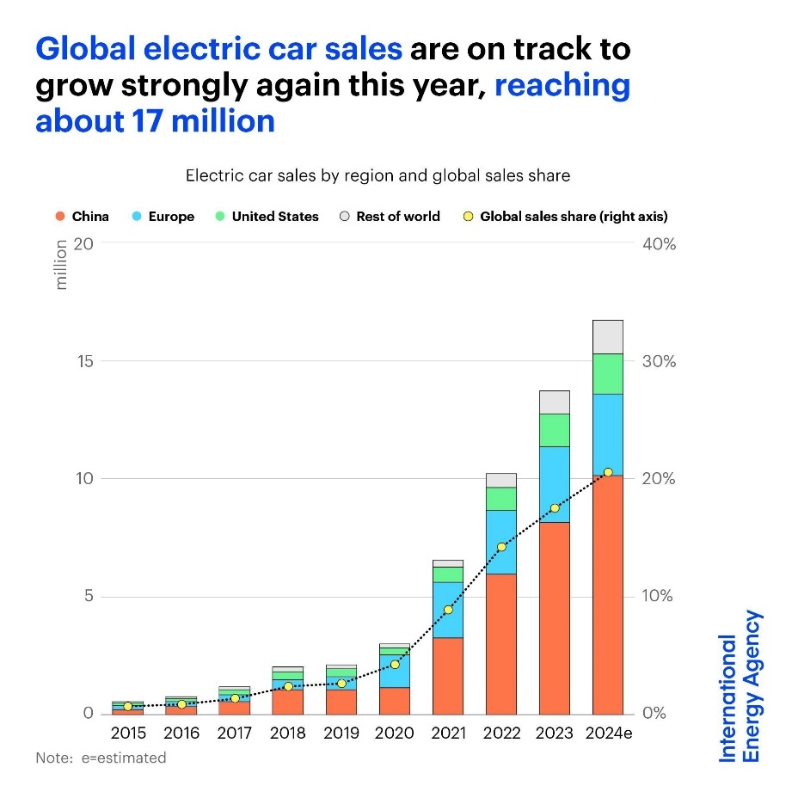
Figure 1 Electric Vehicles Sales
(Source: IEA, 2025)

With robust government policies, industrial investment and a fast expanding consumer base, China has become the largest electric vehicle market in the world with close to two-thirds of the global EV sales in 2024 (IEA, 2025). Tesla is one of the foreign multinational companies that are involved in this industry, and China constitutes its second-largest market and a huge manufacturing hub with the Shanghai Gigafactory (Reuters, 2025).
This report compares the competitiveness of the China EV industry by the Porters Diamond Model and conducts the PESTLE analysis of the Tesla business operations in China to evaluate the opportunities and threats Tesla encounters in this fast-changing market.

2. China’s Electric Vehicle Industry Overview

2.1 Development of the EV Industry in China
The electric vehicle (EV) sector in China has emerged in the last twenty years as the Chinese market has become the largest EV market in the world. The industry started picking up steam in the late 2000s as the Chinese government unveiled the New Energy Vehicle (NEV) policy framework in 2009 with a view to achieve electric mobility via subsidies, tax reliefs and research investments. Among these policies were purchase subsidies, tax exemptions and funding to manufacturers so as to promote the production as well as the uptake of EVs by consumers (Tian, Wang and Zhu, 2024). China spent over 200 billion yuan (about 28 billion dollars) in EV subsidies and incentives between 2009 and 2022, which shows the amount of government interest in the sector (Yu, 2023).
The environmental issues have also contributed significantly to the growth of the EV industry in China. The transport industry ranks among the greatest contributors to air pollution and greenhouse gases, especially in big cities. China, to counter it, has set such ambitious environmental aims as carbon neutrality by 2060 and peaking carbon emissions before 2030, which has boosted the shift to more environment-friendly transportation technologies (Chinese Climate Policy, 2023). To these efforts, the government also came up with regulations that forced automakers to manufacture a specified percentage of electric vehicles into the market via the NEV credit system, which incrementally raised EV production requirements across the automotive sector.
The sector has also expanded at high rates due to technological innovation. The Chinese companies have concentrated a lot on battery technology, digital platforms and smart mobility systems that enabled the domestic companies to introduce EV models into the market at a faster rate than many foreign companies did. Indeed, Chinese automakers of EVs are able to produce new models within a period of approximately 20 months in contrast to an average of 40 months of traditional companies, which is indicative of the high level of innovation in the country (Lo, 2025). Due to powerful governmental backing, environmental focus, and technological advancement, China has become a world leader in the production and adoption of electric vehicles

2.2 Market Size, Growth and Economic Importance
The country is now the largest electric vehicle market globally, with almost two-thirds of the EV sales in the world in 2024 (IEA, 2025).
China is the world leader in both production and consumption of electric vehicles. In 2024 Chinese electric cars sold more than 11 million vehicles, more than half of all EVs in the world, and far outpacing the United States (approximately 1.5 million) (IEA, 2025) and Germany (around 380000) (Bekker, 2025). China leads the production in addition to being the largest EV market: approximately 72% of all EVs are produced in China and much of the battery supply chain is controlled there. In China, almost 80% of EV battery cells are manufactured, which makes the industry much cheaper and competitive to domestic companies (Scott, 2025). All these benefits make China to be the leader in EV industry compared to the United States and Germany.
Chinese market has undergone incredible growth in the last ten years and the sales of EVs are rising tremendously every year as consumers are adopting them more. The market has continued to grow, with nearly 40% more electric vehicles being sold in China in 2024 than in the past year (IEA, 2025).
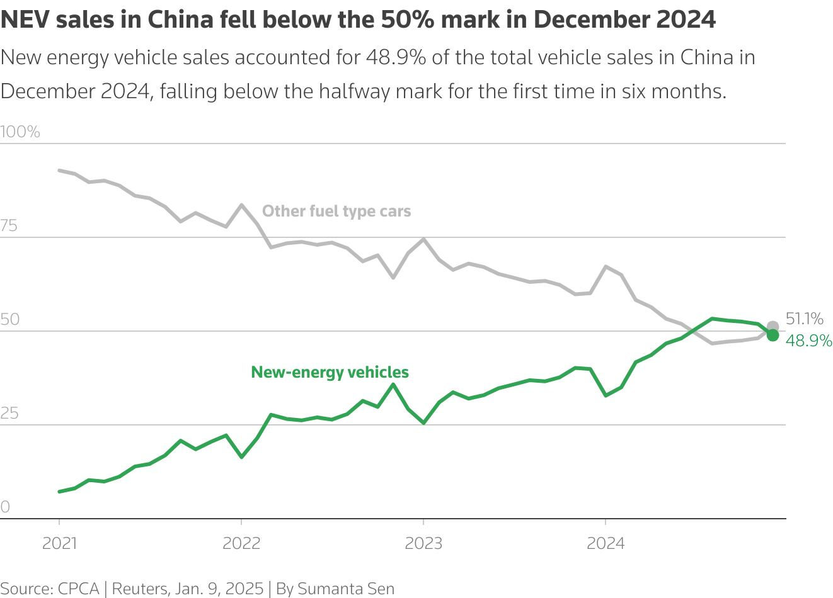
Figure 2 China EV Sales
(Source: Reuters , 2025)

The industry size is also measured by general market penetration. In China, electric vehicles had a market share of about 48.9% of the new vehicles in 2024, which means that almost half of the cars sold in the country are electric or hybrids (Reuters, 2025). This faster adoption has transformed China into the world centre of EV manufacturing and innovation. The nation also monopolizes the world EV battery supply network, holding almost 69% of the world EV battery market, and much of this is due to several leading battery producers like CATL and BYD (Saptakee , 2025).
The EV industry has turned into an important part of the industrial policy and economic growth of China. The industry provides millions of jobs in the vehicle manufacturing, battery manufacturing, software development and charging infrastructure. Moreover, the production of EVs has boosted the export performance of China where Chinese manufacturers are growing to other international markets like Europe and South America (Honcharov, 2025). With the electrification of the world automotive industry, the EV industry in China is set to continue to be a major economic growth factor, technology and global competitiveness factor.

2.3 Key Firms and Competitive Landscape
The Chinese electric vehicle market is marked by high competition amongst the local automobile companies as well as foreign multinationals. The market is now dominated by domestic firms, with BYD becoming the market leader in the EV production in China, with a national EV market share estimated to 27.2 percent in 2025, having sold over 3.48 million vehicles (Zhang, 2026). NIO and XPeng are other key Chinese EV makers that are specialized in technologically advanced and high-end electric vehicles. The companies distinguish themselves by highly developed battery systems, autonomous driving technologies and intelligent vehicle software.
Chinese EV market also is dominated by foreign multinational companies. One of the most active international rivals is Tesla, which also manufactures vehicles in China in its Gigafactory Shanghai and sells approximately 97,100 EVs in China in 2025, which comprise about 4.9% of the national EV market (Tong and Mingyang, 2026). Similar to Volkswagen and BMW, other international car manufacturers have been able to venture into EV business in China by forming joint ventures with local companies.
Company | Origin | Market Position | Key Strength
BYD | China | Market leader | Battery technology & scale
NIO | China | Premium EV segment | Smart technology & brand innovation
XPeng | China | Technology-focused EV | Autonomous driving systems
Tesla | USA | Global EV leader | Advanced battery and software technology
Volkswagen | Germany | Traditional automaker transitioning to EVs | Global manufacturing scale
BMW | Germany | Premium EV segment | Strong luxury brand reputation
The Chinese EV market is among the most competitive in the world as domestic Chinese EV companies lead through economies of scale, powerful supply chains and fast innovation.

3. Global Competitiveness Using Porter’s Diamond Model
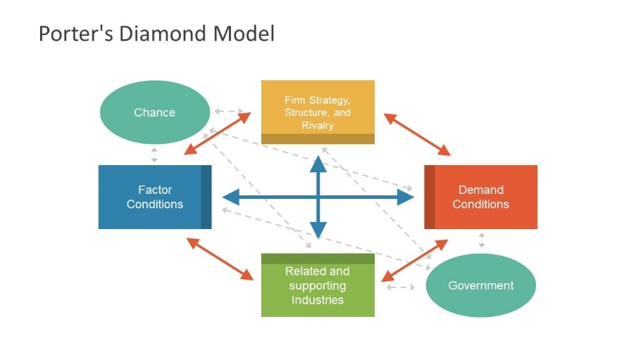
Figure 3 Porter’s Diamond Model
(Source: Vlados, 2019)

3.1 Factor Conditions
Favourable factor conditions such as modern manufacturing facilities, high number of skilled labour and high battery manufacturing power largely drive the global competitiveness of China in the electric vehicle (EV) industry. China has emerged as the largest EV manufacturing center in the world, as of 2024 it had created 12.4 million EVs, a figure that constituted more than 70 percent of the world EV (IFM Correspondent, 2025).
One of the biggest opportunities is that China is a leader in the production of batteries. The Chinese companies are leaders in EV battery industry worldwide, with companies like CATL and BYD, having large market share (Zheng et al., 2025). By 2025, approximately 38.1 of global EV battery equipment had been installed by CATL and 16.9 by BYD, putting Chinese manufacturers at over half of the world battery installations (Kang, 2025).
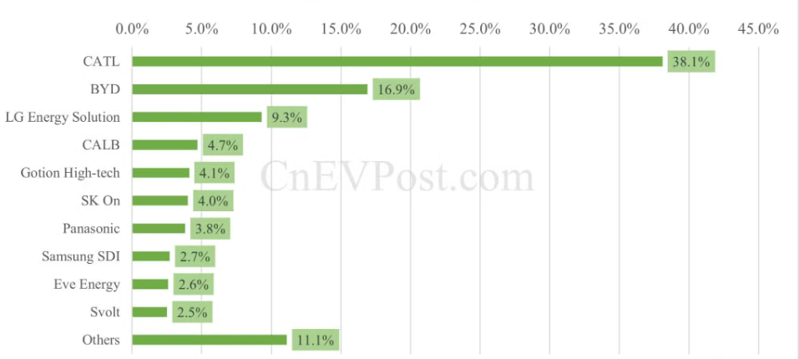
Figure 4 Market Share
(Source: Kang, 2025)

Another advantage that China enjoys is the availability of source materials and the availability of huge supply chains of battery components. These benefits allow Chinese manufacturers to lower costs of production and enhance efficiency. Consequently, Chinese-made EV batteries are usually far more affordable than their counterparts in Europe or North America, which allows Chinese EV manufacturers to stay at high competitiveness levels across the globe (IEA, 2025a).

3.2 Demand Conditions
The high level of domestic demand is an important factor in promoting the EV industry in China. China has the largest EV market in the world, and over 11 million electric vehicles were sold in 2024, which is almost half of all new auto sales in the country (IEA, 2025a).
The increasing EV demand has been prompted by the increased environmental awareness, concerns about air pollution in urban areas and conducive government policies that support electric mobility. Most large cities in China limit the registration of internal combustion engine vehicles and provide incentives to the owners of EVs, including simplified license plate registration. Such policies will make consumers switch to electric vehicles much faster.
Moreover, EV sales in China grew nearly 40 percent in 2024 and it reflects notable growth in the domestic market (IEA, 2025c).
A high domestic market presents businesses with the opportunity to scale up the production process in a short time and experiment new technologies more effectively. The availability of millions of EV consumers gives the valuable feedback of the market and fosters the constant improvement of the product. As a result, high domestic demand has enhanced the innovation in technology and improved the competitive advantage of China in the EV sector worldwide.

3.3 Related and Supporting Industries
The sector of EVs in China is blessed with a well-developed network of relevant and supporting industries. The nation has established a solid supply chain that involves battery makers, semiconductor companies, charging infrastructure companies, and technology companies. Such a powerful industrial community promotes productivity and innovation in the EV industry.
China controls the world EV battery supply chain, manufacturing more than three-quarters of the EV batteries in the world (IEA, 2025b). Battery makers like CATL and BYD provide batteries to numerous automobile manufacturers worldwide including Tesla, BMW and Volkswagen.
Besides building batteries, China has made huge investment in EV charging infrastructure to facilitate electric mobility. Large charging systems in urban areas and on highways remove range anxiety and promote consumer adoption of EVs. Economies of scale, fast technological evolution and efficient supply chain can be enjoyed by EV manufacturers due to the existence of the developed supporting industries.

3.4 Firm Strategy, Structure and Rivalry
The rivalry between the the EV producers in China is high, which made it one of the major engines of the innovation and development of the industry. The competition among domestic brands like BYD, NIO and XPeng is very intense with foreign brands like Tesla, Volkswagen and BMW. This stiff competition compels firms to spend a lot of money in research, development, and technological innovation and product differentiation.
For example, BYD is one of the largest manufacturers of EVs globally and has supplied more than 3.5 million electric vehicles all over China in 2024 which proves the power of local corporations in the industry (Autovista, 2025).
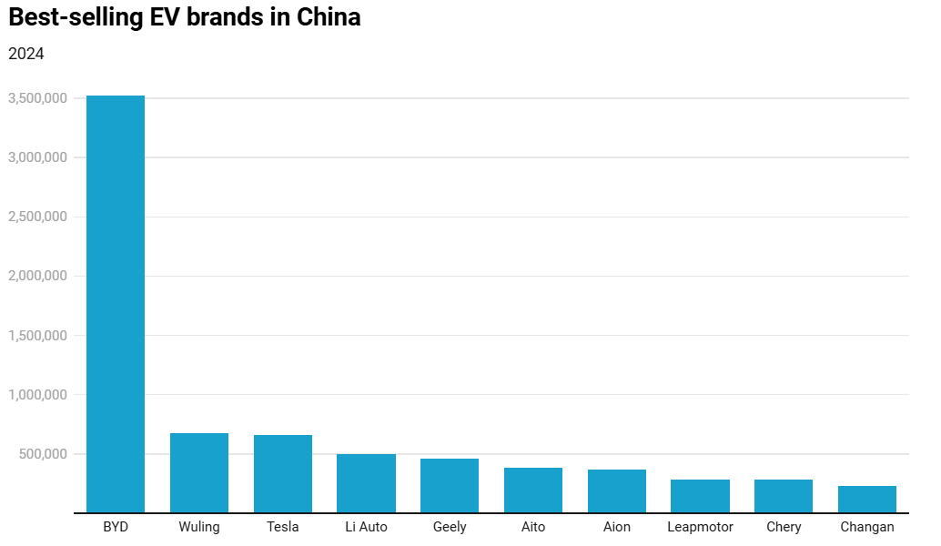
Figure 5 Best-selling EV brands in China
(Source: Autovista, 2025)

Chinese EV firms are also faster in innovations, research shows that Chinese car manufacturers can come up with new models of cars in less than 30 percent of the time that many conventional Western manufacturers (Ezell, 2024).
This stiff competition enhances product quality, faster development of technology and lower costs of production, further enhancing the competitiveness of China in the EV industry globally.

3.5 Additional Factors: Role of Government
One of the key drivers of the evolution of the EV industry in China has been government policy. Chinese government has also introduced subsidies, tax incentive and industrial policies to encourage EV production and adoption (Liu et al., 2023). They have helped to create the biggest EV market in the world and helped local manufacturers to scale production at a high rate. The long-term environmental aspirations of China and commitment to reducing carbon emission have also led to increased uptake of electric mobility, which increased the sector and competitiveness at the global level.

3.6 Additional Factors: Role of Chance
External events have also influenced the development of the EV industry in China. The COVID-19 pandemic disrupted a global network of automotive supply chains, but it showed the importance of the local production potential. Due to the well-developed industrial base, China managed to resume production in the nearest future (Wen et al., 2021). Increased need to transport clean energy throughout the globe and technological advancement in battery technology have also increased the number of people who have adopted EVs. Nevertheless, there is a possibility of uncertainty in world EV supply chains due to geopolitical tensions and trade conflicts.

4. Tesla’s Operations in China

4.1 Overview of Tesla
Tesla Inc. is one of the most powerful manufacturers of electric vehicles (EVs) in the world and a major pioneer behind the shift towards sustainable transportation. Martin Eberhard and Marc Tarpenning started the company in 2003, and Elon Musk, who subsequently became a key investor and the chief executive officer, joined. Tesla has a mission of hastening the global adoption of sustainable power by electric cars, battery storage as well as renewable energy technologies (Ozsevim, 2024).
Tesla has established itself as a powerful international brand in the last 20 years with electric vehicles being sold in key markets such as the United States, China and Europe. The company has been well known in the area of technological leadership in the design of EVs, battery systems, autonomous driving software and software updates over the air. The Model Y and the Model 3, the flagship models of Tesla, are now being sold in large numbers around the world.
China is already one of the most significant foreign markets of Tesla. China took up approximately 36.7 percent of Tesla worldwide sales revenue in 2024 making it the second-largest market of the company just after the United States (Reuters, 2025). One of the strongest sources of Tesla presence in China is its Gigafactory Shanghai that came to operation in 2019 and has made Tesla its largest manufacturing facility outside of the United States. The factory produces up to one million vehicles annually and supplies almost half of the world deliveries made by Tesla (Kang, 2025b).
Consequently, the operations of Tesla in China are a major strategic element in the global manufacturing chain and international expansion strategy of Tesla.

4.2 Market Attractiveness Analysis (PESTLE)
China is among the most promising markets in the world to electric vehicle manufacturers because of its favourable government policies, huge consumer base and fast technological advancement. PESTLE analysis will emphasize the political, economic, legal and cultural forces that impact Tesla in the Chinese EV market.
PESTLE | Description
Political Factors | One of the most significant sources of EV development in China is the government policy. Chinese government has implemented many policies that promote the use of electric vehicles such as subsidies, tax reductions and investment in electric vehicle charging infrastructure. These had been set to curb the emission of carbon and encourage local technological development in the automobile industry.  There are also long-term climate objectives in China, such as carbon neutrality by 2060, which also contributes to switching to electric mobility (Hepburn et al., 2021). These policies provide favourable environments to EV manufacturers, such as Tesla, to increase their business in China.  Nevertheless, the uncertainties faced by foreign companies doing business in China may arise because of geopolitical tensions between the United States and China. Future investment by Tesla and supply chain strategies could be affected by trade issues, technological limitations and regulation dissimilarities.
Economic Factors | Economically, China is a great opportunity to Tesla because it has a huge and fast-evolving EV market. China is now the biggest EV market in the globe, and its sales surpass 11 million electric cars in 2024. This can be viewed as a substantial portion of EV demand in the world (IEA, 2025a).  The rising middle-income population in the country has also helped to boost the purchasing power and demand of the electric cars. The higher the income level, the higher the purchase of technologically advanced vehicles with smart features and high performance by Chinese consumers are willing to buy.  This has improved Tesla because of this increasing demand. In China, the company registered over 657, 000 sales in 2024, which is its highest sales volume in the market (Zhang, 2025).  Simultaneously, the Chinese EV market is very competitive. Foreign competitors like BYD, NIO and XPeng have also grown in fast numbers and provide a diverse variety of EVs at attractive prices. This has increased the competition in the market and compelled Tesla to keep advancing its technology as well as its pricing strategy.
Social and Consumer Factors | The performance of Tesla in the Chinese market is also affected by culture and consumer preferences. Chinese buyers are more focused on technological advances, intelligence in cars and internet connectivity (Lei et al., 2024). Consequently, the sophisticated software programs, autonomous pilot and remote upgrades of Tesla products are attractive to numerous Chinese consumers. Nevertheless, the local preferences among consumers in China also incline towards the local brands of the country, which provide competitive price and personalised features. The Chinese EV manufacturers like BYD and NIO have managed to localize their vehicles to align them to local consumer demands, forming a stiff competition to Tesla.
Technological Factors | The powerful technological ecosystem in China favors the operations of Tesla. The nation is the largest producer of EV batteries in the world, and its firms like CATL are the major producers of many batteries globally. China is also building modern EV charging systems, and over 1.3 million public charging points were added to the international stock (IEA, 2025a).
Legal and Regulatory Factors | The Chinese regulatory environment is also a significant factor that influences the operations of Tesla. The foreign firms in Chinese automotive industry are forced to abide by a rigorous policy regarding the safety of vehicles, and their emissions and industrial policy. The investment in the Gigafactory Shanghai was especially relevant to Tesla since it became the first completely foreign-owned automobile manufacturing plant in China as a result of which Tesla could operate without the classical joint-venture cooperation with a Chinese car manufacturer (Yiyi, 2025).  In spite of these benefits, there are regulatory hazards. The protection of intellectual property, the laws on data security, and the changing standards of the EV industry have the potential to impact Tesla business in China. Organizations that are in the Chinese technology industry are also obliged to adhere to data storage regulations and cybersecurity.
Environmental Factors | In China, the growth of EV is heavily dependent on the policies of the environment. The government is directing to achieve carbon neutrality in 2060 that will stimulate investment of electric mobility and clean transportation. Such policies provide favourable environments to the long-term growth of Tesla.

4.3 Tesla’s Market Entry Strategy
The move of Tesla to the Chinese market is a major case of foreign direct investment (FDI) and international growth strategy. In 2019, Tesla opened Gigafactory Shanghai, the first production plant to be located outside of the United States. The factory was built in Lingang Free Trade Zone and started to produce vehicles the same year, exhibiting one of the most accelerated timelines in the creation of an automotive factory in history (Ozsevim, 2024).
Gigafactory Shanghai allowed Tesla to localise its operations in China and minimise its reliance on the imported products of the United States. The local production of vehicles enabled Tesla to save on import tariffs as well as transportation expenses, which made its vehicles comparatively cheaper in the Chinese market.
It was also through localisation that Tesla was able to incorporate Chinese suppliers into its production network. Nowadays, over 95 percent of materials employed in the construction of cars in the Shanghai factory are locally sourced, and that lowers the cost of manufacturing and enhances the efficiency of the supply chain (Reuters , 2025).
Theoretically, the move to invest in China by Tesla can be described as an operation of the Eclectic Paradigm of Dunning (OLI framework). This theory argues that the expansion of firms overseas occurs when they enjoy ownership advantages, location advantages as well as internalisation advantages. The high level of EV technology, brand recognition and software capabilities are the ownership benefits of Tesla. China has good location benefits as it has a big EV market with well established supply chain and favorable government policies. These benefits of internalisation are because Tesla chose to own and manage production by means of the wholly owned manufacturing company instead of licensing its technology to the local partners.

4.4 Opportunities for Tesla in China
Tesla has considerable growth opportunities in China since it is the biggest electric vehicles (EV) market on Earth. In 2024, China is expected to sell about 11 million electric cars, which is nearly two-thirds of the total EV sales worldwide. This level of demand gives Tesla a huge pool of consumers and gives the company the ability to enjoy the economies of scale in manufacturing and distribution (IEA, 2025d).
The other significant opportunity Tesla has is the accelerated EV infrastructure. China has spent a lot of money in charging systems and urban mobility to promote the growth of electric cars. The existence of the extensive charging networks makes people less worried about the vehicle range and makes more people adopt EVs.. The development of electric mobility in China is also supported by government policies on carbon reduction and the development of clean energy.
Increasing income rates and urbanisation are another cause of EV demand. The rising middleclass in China is also demanding more technologically advanced automobiles that are digitally upgraded and high performance automobiles. Chinese people are interested in Tesla cars, especially the Model 3 and Model Y, due to their good battery life, software features, and autonomous driving.
Gigafactory Shanghai also offers a strategic benefit to Tesla. The factory is capable of assembling over 750,000 vehicles every year and is a major export center servicing Asian and European markets (EVBoosters, 2024). This will enable Tesla to lower the costs of production and improve efficiency in the supply chain. Altogether, China offers Tesla a high growth potential with market size, development of infrastructure, and favorable environmental policies.

4.5 Challenges and Risks
Nevertheless, Tesla has some major challenges in the Chinese EV market despite great growth potential. The greatest threat is the stiff competition among manufacturers of electric vehicles in the country. Chinese manufacturers BYD, NIO and XPeng have been fast growing in terms of technological power and market share. To show how Chinese competitors are growing in strength, BYD sold around 2.26 million battery electric vehicles internationally in 2025, exceeding 1.63 million EVs delivered by Tesla (Jolly, 2026).
The competitive position of Tesla is also not spared within the Chinese market per se. In 2025, Tesla had sold an estimated 625,698 cars in China, or about 4.9% of the EV market, whilst BYD controlled the market with a greater market share of more than 27%. These values show the high competitive edge possessed by local manufacturers (Zhang, 2026).
Another possible risk to Tesla is regulatory uncertainty. Government policies on EV subsidies and industry regulations and data security requirements are subject to change at a fast rate, which impacts foreign firms in China. Adherence to data localisation laws and vehicle software regulations can make Tesla operations more complex.
Geopolitical risks also exist between US and China. Trade disputes have an influence on technology, logistics and many other aspects. In addition, prices in the Chinese EV market have been in fierce battle with some domestic manufacturers reducing the prices of cars to increase market share. Such price competition can reduce the profitability and burden Tesla financially.

4.6 Strategic Evaluation
The interest of Tesla in China is still strategic because of its size, technology environment, and the prospects of long-term evolution. The good presence of supply chains, advanced battery manufacturers and the broad availability of charging infrastructure have great location advantages to Tesla. However, fierce competition and rapid technological change is also characteristic of the Chinese EV market. Domestic manufacturers have challenged Tesla that have developed strong battery technology and cost-effective production such as BYD and NIO (Micucci, 2025).
However, China is also a significant part of the Tesla global strategy that defeats such challenges. The strong demand of EV in the country, positive environmental policies and the new technological ecosystem provide sufficient reasons to continue growth. The success of Tesla in China over the long term will depend on its ability to stay abreast of the technology and adapt its strategy accordingly to compete with the rapidly emerging domestic manufacturers.

5. Conclusion
This report assessed the competitiveness of Chinese electric vehicles industry, and strategic positioning of Tesla in the Chinese market. The Diamond Model of Porter raises the significance of the strong manufacturing force, local and state support that has made China a world leader in terms of EV production. The Chinese opportunities available to Tesla are a vast market, extensive EV systems, and the Shanghai Gigafactory.

Section II: Reflection Analysis

6. Reflective Analysis Using Gibbs Cycle


Figure 6 Gibbs Reflective Cycle
(Source: Adeani, Febriani and Syafryadin, 2020)

6.1 Description
This assignment evaluated the competitiveness of the Chinese electric vehicle (EV) sector in the global context and assessed the strategic placement of Tesla in the Chinese market. The starting point of my research was to find the academic literature, industry reports on the topic of EV industry, international business strategy, and automotive industry in China. I found information in different sources such as academic journals, international energy reports, government publications and industry analysis reports. These publications made me become aware of the dynamism of the EV industry and how different manufacturers worldwide and in their country compete against each other (Adeani, Febriani and Syafryadin, 2020).
To organize my analysis, I used some theoretical frameworks discussed in the module. I have applied the Diamond Model developed by Porter to analyze those factors that make China competitive in the EV industry. I also used PESTLE analysis to assess the appeal of the Chinese market to Tesla based on political, economic, legal and cultural factors. These frameworks assisted me in structuring the information in a systematic manner and form a stronger idea of the international business environment.

6.2 Feelings
At first, when I began working on this assignment, I was interested and a little bit overwhelmed by the intricacy of the subject. The market of electric vehicles is evolving, and numerous sources of information can be found about the development of the market, technological progress and policies of the government. The initial part of the research process was very difficult because I needed to identify the most reliable and relevant data sources to use in my analysis.
I also realised that international markets have to be analysed with more regard to political, economic and cultural issues. In the first place, I was not sure how to use theoretical frameworks like the Porters Diamond Model in practical business scenarios. There was however increased confidence in terms of application of these models to explain industry trends as I went on with the research. I also discovered that the use of theoretical frameworks enabled me to simplify the entire information and made my analysis easier to organize. This slowly boosted my self-confidence in the analysis of international business environments.

6.3 Evaluation
In reflection of the research process, I think that there were a number of strengths in my approach to this assignment. The capacity to obtain information through a considerable number of sources was one of my primary strengths. With the help of academic journals, reports of international energy, publications of the industry, news articles, I have created a comprehensive picture of the market of EV and the strategy of Tesla in China. This assisted me in backing my arguments with actual information and examples which enhanced the general quality of my analysis.
The other strength was that I used theoretical frameworks to lead the analysis. Using the Diamond Model and PESTLE analysis, I managed to organize my research in a logical and critical way and analyze the factors that affect the EV industry and operations of Tesla (Anton, 2020). Such frameworks will assist me in the transition of merely describing the industry; rather, they will enable me to analyse why China has established a strong competitive edge in the manufacture of electric vehicles.
Nevertheless, there are also some limitations I faced in the course of the research. A challenge that I had to deal with was the abundance of data about the EV industry. In some instances, I could not distinguish the most relevant statistics to use in supporting my analysis. Moreover, the EV market evolves very fast, so information within the industry may alter fast, and that is why I had to check several sources before using some figure.

6.4 Analysis
By doing this assignment, I have gained a stronger insight into international competitiveness and the forces that affect the global industries. Among the most important lessons I could get was that government policy combined with the industrial infrastructure and the domestic demand could make or break a national industry in terms of competitiveness. Using the Diamond Model by Porter, I could observe the way in which the high production capacities of China, huge domestic market, and embedded supply chains have contributed to the country becoming a world leader in the production of electric vehicles.
I learned useful information on multinational business strategy as well. The investigation of Tesla activities in China allowed me to realise the reason behind the multinational corporations entering foreign markets and how they change their approaches to fit the local market. For example, the case of Tesla, with the establishment of the Shanghai Gigafactory, shows how foreign direct investment can assist companies in minimizing production costs, and accessibility to local supply chains and cater to mass consumer markets in a more cost-effective way. I also learned that for ensuring competitive advantage, companies need to be innovation in terms of technology. I also understood that companies should keep on being innovative in order to be competitive in these fast changing markets.
6.5 Conclusion
Considering this assignment, I think that my knowledge about international business strategy and global industry competition has been enhanced significantly. By examining the market of EV in China and the strategic placement of Tesla in this market, I have come to better understand how the economic, political and technological conditions of the world have impacted global industries.
It is also through this assignment that I was able to enhance my research and analytical skills. I got acquainted with the ways of collecting information using various sources, assessing the credibility of information and implementing the theoretical concepts to the practice of business. Such capabilities are critical in the analysis of foreign markets and effective strategic business decision-making.
Above all, the assignment has made me realize that multinational companies need to adjust their strategies in order to enter the foreign markets. The experience of Tesla in China shows that localisation, innovation and strategic investment are important in making businesses stay competitive in the global markets.

6.6 Action Plan
Development Area | Action | Purpose | Timeline
Research Skills | Use more peer-reviewed journals and industry databases (e.g., Scopus, Statista). | Improve reliability and depth of research evidence. | Next assignments
Critical Analysis | Compare multiple academic viewpoints when analysing industries. | Strengthen analytical and evaluation skills. | Ongoing
Framework Application | Practise using models like PESTLE and Porter’s Diamond in case studies. | Enhance strategic analysis ability. | Throughout M

7. References
Adeani, I.S., Febriani, R.B. and Syafryadin, S. (2020). USING GIBBS� REFLECTIVE CYCLE IN MAKING REFLECTIONS OF LITERARY ANALYSIS. Indonesian EFL Journal, 6(2), p.139. Doi: HTTPs://doi.org/10.25134/ieflj.v6i2.3382.
Anton, R. (2020). An Integrated Strategy Framework (ISF) for Combining Porter’s 5-Forces, Diamond, PESTEL, and SWOT Analysis. [online] mpra.ub.uni-muenchen.de. Available at: https://mpra.ub.uni-muenchen.de/72507/.
Autovista (2025). Which brand won the battle for China’s EV market? [online] Autovista24. Available at: https://autovista24.autovistagroup.com/news/which-brand-won-the-battle-for-chinas-ev-market [Accessed 5 Mar. 2026].
Bekker, H. (2025). 2024 (Full Year) Germany: Best-Selling Electric Cars by Brand and Model - Car Sales Statistics. [online] Best-selling-cars.com. Available at: https://www.best-selling-cars.com/germany/2024-full-year-germany-best-selling-electric-cars-by-brand-and-model [Accessed 14 Mar. 2026].
Chinese Climate Policy (2023). C: Electric Vehicles. [online] Guide to Chinese Climate Policy. Available at: https://chineseclimatepolicy.oxfordenergy.org/book-content/domestic-policies/vehicles/electric-vehicles [Accessed 5 Mar. 2026].
EVBoosters (2024). Tesla vs BYD: A battle of global production capacity. [online] EVBoosters. Available at: https://evboosters.com/ev-charging-news/tesla-vs-byd-a-battle-of-global-production-capacity [Accessed 5 Mar. 2026].
Ezell, S. (2024). How Innovative Is China in the Electric Vehicle and Battery Industries? [online] Itif.org. Available at: https://itif.org/publications/2024/07/29/how-innovative-is-china-in-the-electric-vehicle-and-battery-industries [Accessed 5 Mar. 2026].
Hepburn, C., Qi, Y., Stern, N., Ward, B., Xie, C. and Zenghelis, D. (2021). Towards Carbon Neutrality and China’s 14th Five-Year Plan: Clean Energy transition, Sustainable Urban development, and Investment Priorities. Environmental Science and Ecotechnology, [online] 8(1), p.100130. Doi: HTTPs://doi.org/10.1016/j.ese.2021.100130.
Honcharov, O. (2025). CHINA’S GOVERNMENT PROGRAMS SUPPORTING ELECTRIC VEHICLE PRODUCTION: IMPACT ON SECTOR DEVELOPMENT AND GLOBAL TRENDS IN SUSTAINABLE TRANSPORTATION. Green Blue and Digital Economy Journal, 6(1), pp.21–28. Doi: HTTPs://doi.org/10.30525/2661-5169/2025-1-4.
IEA (2025). Trends in electric car markets – Global EV Outlook 2025 – Analysis - IEA. [online] IEA. Available at: https://www.iea.org/reports/global-ev-outlook-2025/trends-in-electric-car-markets-2
IEA (2025a). Electric vehicle charging – Global EV Outlook 2025 – Analysis - IEA. [online] IEA. Available at: https://www.iea.org/reports/global-ev-outlook-2025/electric-vehicle-charging [Accessed 5 Mar. 2026].
IEA (2025b). Executive summary – Global EV Outlook 2025 – Analysis - IEA. [online] IEA. Available at: https://www.iea.org/reports/global-ev-outlook-2025/executive-summary [Accessed 5 Mar. 2026].
IEA (2025c). The Battery Industry Has Entered a New Phase – Analysis - IEA. [online] IEA. Available at: https://www.iea.org/commentaries/the-battery-industry-has-entered-a-new-phase [Accessed 5 Mar. 2026].
IEA (2025d). Trends in electric car markets – Global EV Outlook 2025. [online] IEA. Available at: https://www.iea.org/reports/global-ev-outlook-2025/trends-in-electric-car-markets-2 [Accessed 5 Mar. 2026].
IFM Correspondent (2025). China’s EV surge shakes the world. [online] International Finance. Available at: https://internationalfinance.com/magazine/industry-magazine/chinas-ev-surge-shakes-the-world [Accessed 5 Mar. 2026].
Jolly, J. (2026). China’s BYD overtakes Tesla as world’s biggest electric car seller. [online] the Guardian. Available at: https://www.theguardian.com/business/2026/jan/02/china-byd-tesla-worlds-biggest-electric-car-seller-elon-musk-donald-trump-ev [Accessed 5 Mar. 2026].
Kang, L. (2025a). Global EV battery market share in Jan-Oct 2025: CATL 38.1%, BYD 16.9%. [online] CnEVPost. Available at: https://cnevpost.com/2025/12/02/global-ev-battery-market-share-jan-oct-2025/ [Accessed 5 Mar. 2026].
Kang, L. (2025b). Tesla hits milestone of 4 million cars produced in China. [online] CnEVPost. Available at: https://cnevpost.com/2025/12/08/tesla-4-million-cars-produced-china [Accessed 5 Mar. 2026].
Lei, J., Indiran, L., Kohar, A. and Liu, H. (2024). Unveiling Consumer Perceptions and Preferences in the Era of Disruptive Innovation of New Energy Vehicles Market in China. PaperAsia, [online] 40(4b), pp.178–192. Doi: HTTPs://doi.org/10.59953/paperasia.v40i4b.210.
Liu, Y., Zhao, X., Lu, D. and Li, X. (2023). Impact of policy incentives on the adoption of electric vehicle in China. Transportation Research Part A: Policy and Practice, [online] 176(1), p.103801. Doi: HTTPs://doi.org/10.1016/j.tra.2023.103801 .
Lo, K. (2025). China is setting the pace in the EV race, and the West can’t keep up. [online] Rest of World. Available at: https://restofworld.org/2025/china-us-ev-race [Accessed 5 Mar. 2026].
Micucci, L. (2025). Electric vehicles: Actual market and future prospects , with a focus on battery technology - Webthesis. Polito.it. [online] Available at: https://webthesis.biblio.polito.it/35717/.
Ozsevim, I. (2024). Tesla’s EV battery production and global gigafactory network | Article | Automotive Manufacturing Solutions. [online] Automotivemanufacturingsolutions.com. Available at: https://www.automotivemanufacturingsolutions.com/electrification/electric-dreams-teslas-gigafactory-network-and-ev-battery-production-blueprint/545858 [Accessed 5 Mar. 2026].
Reuters (2025). China’s EV exports seen stalling in 2025. Reuters. [online] 9 Jan. Available at: https://www.reuters.com/business/autos-transportation/chinas-car-sales-extend-gains-dec-2025-01-09/.
Reuters (2025). Tesla’s China sales rise to record high in 2024, bucking global decline. Reuters. [online] 3 Jan. Available at: https://www.reuters.com/business/autos-transportation/teslas-china-sales-rise-record-high-83000-december-2025-01-03/.
Saptakee , S. (2025). China Now Controls 69% of the Global EV Battery Market as CATL and BYD Surge in 2025. [online] Carbon Credits. Available at: https://carboncredits.com/china-now-controls-69-of-the-global-ev-battery-market-as-catl-and-byd-surge-in-2025 [Accessed 5 Mar. 2026].
Scott, D. (2025). Global Race for Clean Transportation Leadership Still Open as EV Sales Reach 23% Market Share - International Council on Clean Transportation. [online] International Council on Clean Transportation. Available at: https://theicct.org/pr-global-race-for-clean-transportation-leadership-still-open-sept25/ [Accessed 14 Mar. 2026].
Tian, J., Wang, P. and Zhu, D. (2024). Overview of Chinese New Energy Vehicle Industry and Policy Development. Green energy and resources, 2(2), pp.100075–100075. Doi: HTTPs://doi.org/10.1016/j.gerr.2024.100075.
Tong , M. and Mingyang, T. (2026). Tesla’s Shanghai gigafactory hits monthly delivery high in December, supplies over half of global deliveries for the year - Global Times. [online] Globaltimes.cn. Available at: https://www.globaltimes.cn/page/202601/1352343.shtml.
U.S. Department of Energy (2024). Alternative Fuels Data Center: Electric Vehicle Benefits and Considerations. [online] afdc.energy.gov. Available at: https://afdc.energy.gov/fuels/electricity-benefits [Accessed 5 Mar. 2026].
Virta (2024). The Global Electric Vehicle Market In 2024. [online] Virta Global. Available at: https://www.virta.global/global-electric-vehicle-market [Accessed 5 Mar. 2026].
Vlados, C. (2019). Porter’s Diamond Approaches and the Competitiveness Web. [online] International Journal of Business Administration. Available at: https://papers.ssrn.com/sol3/papers.cfm?abstract_id=3452402 [Accessed 5 Mar. 2026].
Wen, W., Yang, S., Zhou, P. and Gao, S.Z. (2021). Impacts of COVID-19 on the electric vehicle industry: Evidence from China. Renewable and Sustainable Energy Reviews, 144(1), p.111024. Available at: https://doi.org/10.1016/j.rser.2021.111024
Yiyi, Z. (2025). Tesla’s Shanghai Gigafactory exports over 35,000 vehicles in October, marking highest monthly level in two years - Global Times. [online] Globaltimes.cn. Available at: https://www.globaltimes.cn/page/202511/1348097.shtml [Accessed 5 Mar. 2026].
Yu, B. (2023). Life after subsidies for China’s EVs. [online] Dialogue Earth. Available at: https://dialogue.earth/en/business/life-after-subsidies-for-chinas-evs/ [Accessed 5 Mar. 2026].
Zhang, P. (2025). Tesla sells all-time high of about 83,000 cars in China in Dec. [online] CnEVPost. Available at: https://cnevpost.com/2025/01/03/tesla-sales-china-dec-2024/ [Accessed 5 Mar. 2026].
Zhang, P. (2026). Automakers’ share in China NEV market in 2025: BYD leads with 27.2%, Tesla 5th with 4.9%. [online] CnEVPost. Available at: https://cnevpost.com/2026/01/12/automakers-share-china-nev-market-2025 [Accessed 5 Mar. 2026].
Zheng, L., Chen, G., Wen, B. and Bao, W. (2025). Analysis of lithium demand for electric vehicles from supply and demand perspectives under China’s carbon peak and neutrality goals. Waste Management, 202, p.114822. doi:https://doi.org/10.1016/j.wasman.2025.114822

