

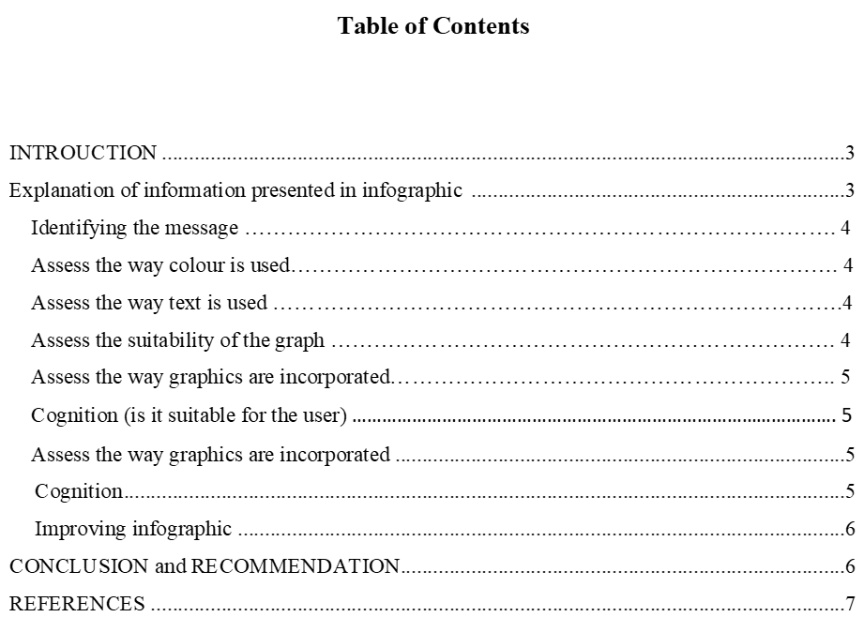

Data visualization is all about graphical representation of information of data where graphs, charts and maps can be used to summarize the data. The present study also provides in-depth information related to impact of Covid-19 upon business performance through an infographic presentation. In this, study will also highlight the message and way colour, text and graphics used by suggesting the ways to improve the infographic.
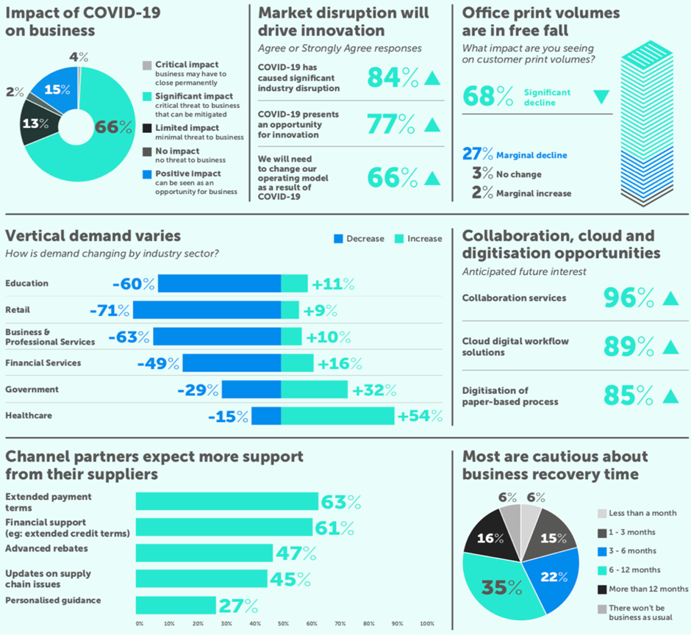
The infographic helps to examine the impact of pandemic upon business and determine that there is about 84% disruption identified within market due to Covid-19. Apart from this, vertical demand varies negatively and to combat from such situation, collaboration with cloud and digitalization opportunities have been developed that enhance the performance of businesses. Further, with the help of graphical representation, it has been also identified that most of the people are cautious about the business recovery time around 6 to 12 months. Therefore, to evaluate the layout of infographic, seven points has been considered which are as mentioned below:
The infographic clearly represents the message by using visualization of data. Such that the message provided by infographic is such that there are many negative impacts identified due to Covid-19 upon market situation such that 66% of a business highly affected and to minimize he negative disruption, businesses start collaborating with cloud services and that is why, 85% digitalization of paper- based process increases that help to revive back in market [1]. Apart from this, channels partners also expect more support from their suppliers in term of payment, financial support, personalized guidance. At last, to recover from current situation, it has been examined that business took at least 6 to 12 months as per the defined graphs.
In the present infographic data, light background colour has used which highlight the data presented in a form of graph, text [2]. Therefore, the choice of a colour appropriate because it assist to capture the reader’s attention. Apart from this, the way colour used also allow to highlight different data sets and their relationship with other so that it makes the visual representation more attractive.
The text used within an infographic is not easily readable, however the heading highlighted in bold and large font size as compared to text [3]. Though the text used in infographic must be easier to understand and implement. This lack within an infographic which needs to be improved. Apart from this, the text is not justified and same size which needs to be focused so that it represents the data in effective manner.
The graph used are suitable as compared to text because the number clearly represent the preference and relevant labels. Further, due to having large data, it is better to use graphs in order to understand the complex data in effective manner. Similarly, in the context of present infographic, suitable graphs (bar graph, pie-chart) have used that helps to reflect the views of respondents of covid-19 impact over business.
Graphics are always a significant part of the poster. Especially increase of infographic poster graphics become a crucial part of the entire presentation made. There are many ways to incorporate the graphics in the poster. This involves draw the graph over the excel with support of data. In context to the infographic poster data and information become a crucial and significant part of the presentation process [4]. Based on the specific needs and requirements of the academic write up graphs are presented in the poster so that reader of the graph can grab the best possible information and knowledge about the topic. Every time graphics are used in the poster this involves only relevance information that must be shown with support of graphs. This is required for the professional to involve not only the basic information rather the graphics must provide or reflect the maximum possible information in the poster.
Cognition is denoted as a practice that involve mental actions taken to acquire and adopt the information and knowledge in the best way possible. This involves various steps that are taken at a mental level so that best form of information could been collected and grab by the academic. Cognition is always a crucial part of grabbing the best form of learning experience. Every topic require strong mental ability to understand and get used too with the study area [5]. This is an important part of the learning practice where the academics require to think at a mental level about the study area and topic of study. When it corms to acquire knowledge and understanding cognition always play a key role and support mentally to the learner for adopting the best suitable knowledge and understanding about the topic of study that is conducted.
Infographic can be improved with support of different ways that would allow the academic to discover and project the best form of information and knowledge. The infographic can improved with support of different other ways such as tracking the information. Searching reliable sources, updating the information on a regular basis, attach reliable image to present the information in more attractive manner and all these techniques that would allow the scholar to approach the poster in a more attractive manner [6]. Another key approach can be taken is that infographic poster must reflect the recent and latest information so that reliability could have been improved of the poster. Inclusion of graphs and pie chart will establish better connection and relationship in between the academic material and learning tactics that are adopted. It can state that all these techniques stated above would allow the academic to make a better use of infographics.

Infographic poster are one of the most attractive way and technique to reflect and present the information in front of the reader. This can be approached with support of graphs and such like tools to make it more presentable.
- Tools like excel can be used to make the infographic more presentable.
- This is recommended that information should depict the latest figure in the infographics.

[1] M. Dick, “Midland History Autumn 2020,” Midland History, vol. 45, no. 3, pp. 275–276, Sep. 2020, doi: 10.1080/0047729x.2020.1814647.
[2] Y. Hrabovskyi, N. Brynza, and O. Vilkhivska, “DEVELOPMENT OF INFORMATION VISUALIZATION METHODS FOR USE IN MULTIMEDIA APPLICATIONS,” EUREKA: Physics and Engineering, vol. 1, pp. 3–17, Jan. 2020, doi: 10.21303/2461-4262.2020.001103.
[3] R. Akhmad, D. Sugandi, N. Nandi, and Rahmawati, “Infographic Design as Visualization of Geography Learning Media,” IOP Conference Series: Earth and Environmental Science, vol. 145, p. 012011, Apr. 2018, doi: 10.1088/1755-1315/145/1/012011.
[4] Burling, A., 2018. Exploring Journal Writing Through Science Research Projects. The Rosen Publishing Group, Inc.
[5] Nemchinova, E. E. and Vasiliev, A. A., 2020. FONT POSTER ARTISTIC LANGUAGE. PalArch's Journal of Archaeology of Egypt/Egyptology. 17(6). pp.682-688.
[6] Gibson, R. and et.al., 2017. Unsafe opioid replacement therapy in England and Wales: a mixed-methods study. The Lancet. 389. p.S38.

