The findings of this investigation presents a definite assessment of survey results relating to Adverse Childhood Experiences (Experts) and their suggestions. Through an exploration of informed assent, awareness of Pros, view of prevalence, and information on local area. These findings offer important experiences into the intricacies surrounding Experts, including moral contemplations, awareness holes, and admittance to help administrations. Through a nuanced investigation, this segment adds to how one might interpret the connection between childhood adversity and its ramifications, illuminating procedures for intercession, prevention, and strategy improvement.
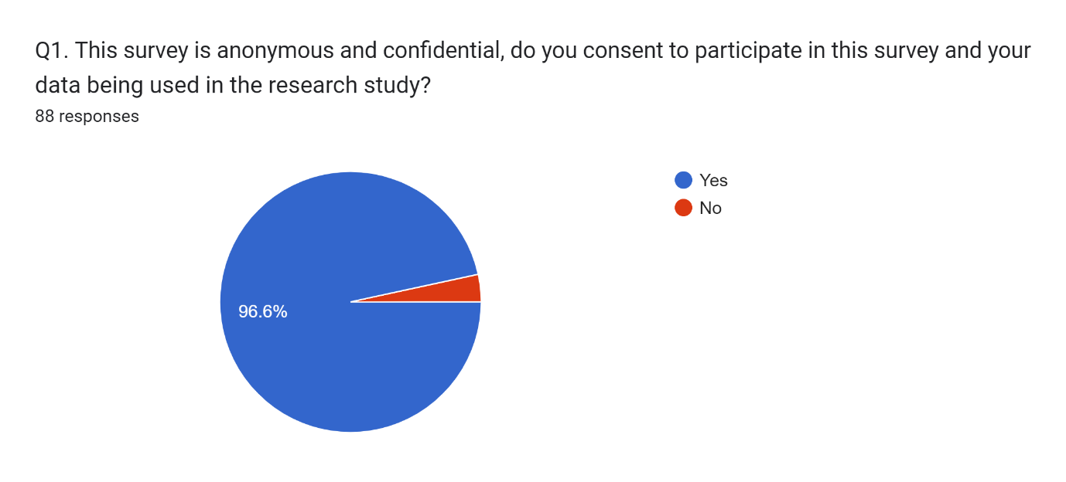
This result (Q1) shows the results of a survey question about informed consent to participate in a research study. In total, 88 people responded to the question. Of those who responded, 96.6% said yes (85 people) and 3.4% said no (3 people).
Here’s a breakdown of what the pie chart shows:
- Total respondents: 88 people
- Consent to participate: 85 people (96.6%)
- Do not consent to participate: 3 people (3.4%)
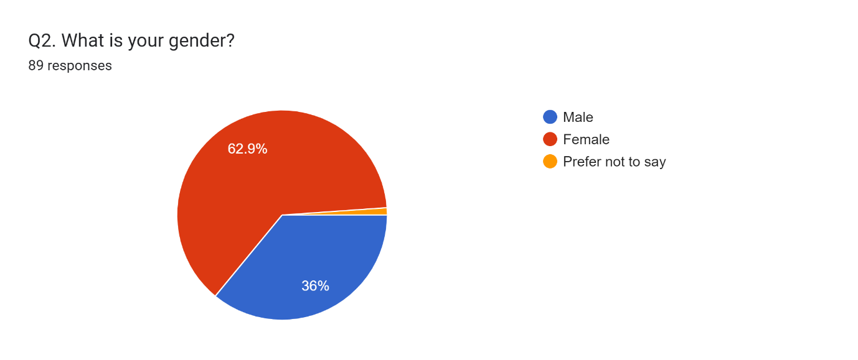
The pie chart (Q2) shows the gender distribution of 89 survey respondents. Here's a breakdown of the results:
- Male: 62.9% (56 people)
- Female: 36% (32 people)
- Prefer not to say: 1.1% (1 person)
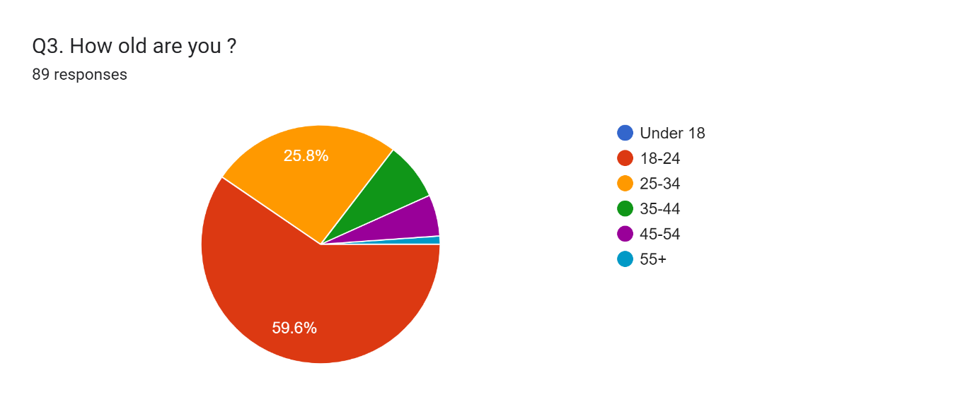
It is important to note that the sample size is relatively small, so the results may not be generalisable to a larger population. However, the chart does show that a majority of the respondents who answered the question identified as male.
The pie chart (Q3) shows the age distribution of 89 respondents. Almost 60% (59.6%) of the respondents were aged 18-24. There is no data for the age groups 18-24, 25-34, 35-44, 45-54, and 55+.
Here's a breakdown of the age distribution according to the chart:
- Under 18: 25.8% (23 people)
- 18-24: 59.6% (53 people)
- No data for other age groups
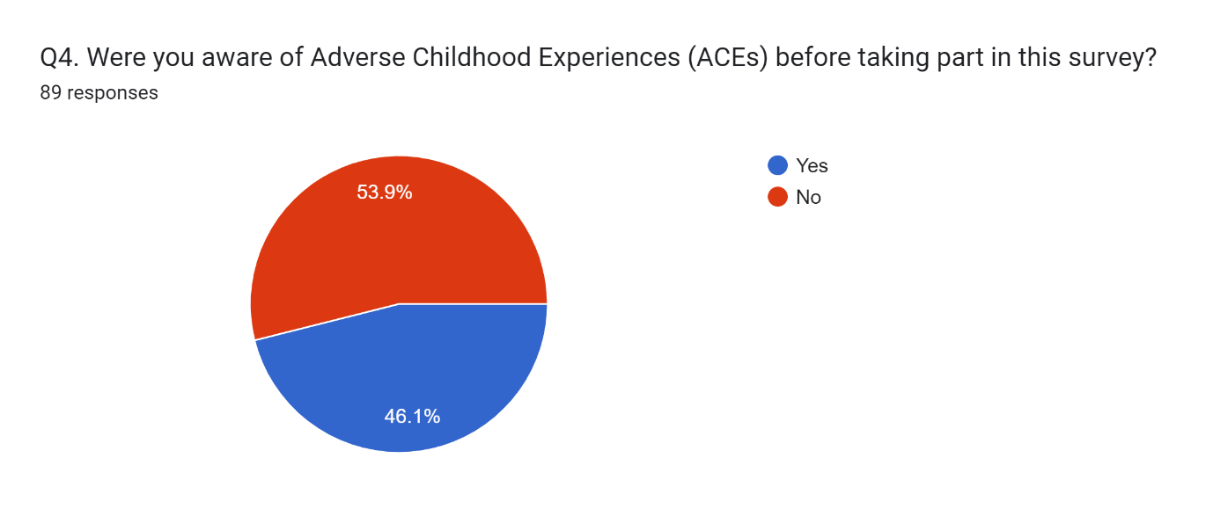
It is important to consider that the survey does not capture data for a significant portion (40.4%) of the respondents. This could potentially divert the results depending on the age demographics of those who did not answer the question. For instance, if older age groups were less likely to respond to the question, the pie chart would overrepresent the younger demographics.
The graph (Q4) shows the results of a survey question about awareness of Adverse Childhood Experiences (ACEs) before taking part in the survey. There were 89 total respondents.
- Aware of ACEs: 53.9% (48 people).
- Not Aware of ACEs: 46.1% (41 people).
Here’s a breakdown of what the pie chart shows:
- A little over half of the respondents (53.9%) were aware of ACEs before taking part in the survey.
- Almost half of the respondents (46.1%) were not aware of ACEs before taking part in the survey.
It is important to note that the survey does not tell us anything about the demographics of the respondents. This means one cannot say for sure if certain groups were more or less likely to be aware of ACEs.
The pie chart shows the distribution of responses to a survey question about people’s awareness of Adverse Childhood Experiences (ACEs) before taking part in the survey. There were 89 total respondents. Just over half of the respondents (53.9%, or 48 people) said they were aware of ACEs before taking the survey. That means almost half (46.1%, or 41 people) were not aware of ACEs before the survey.
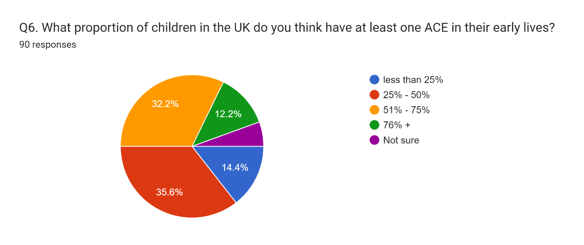
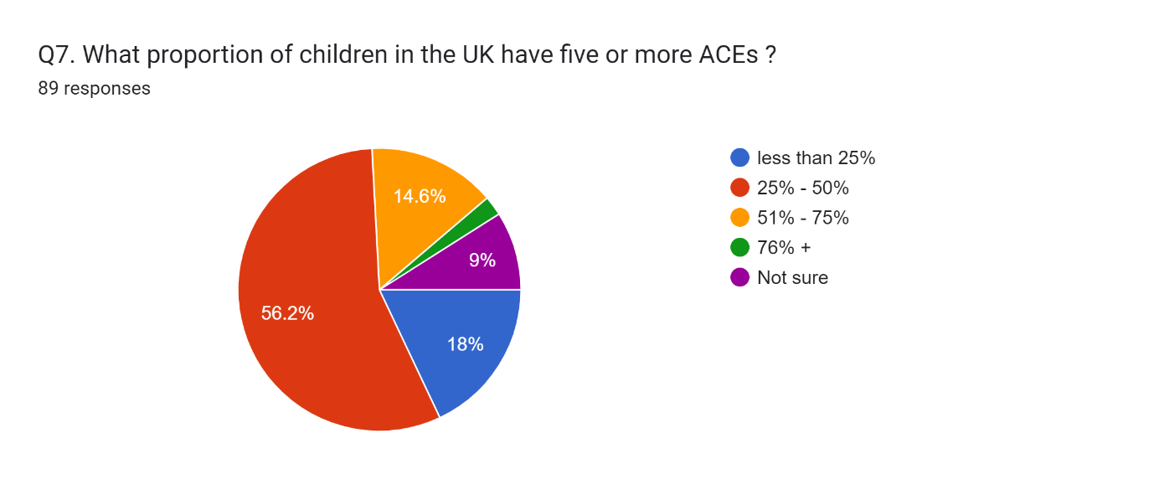
The pie chart (Q6) depicts public perception of Adverse Childhood Experiences (ACEs) prevalence in the UK. A significant portion (35.6%) believe that over half (51-75%) of children have experienced at least one ACE. Interestingly, 14.4% are unsure, highlighting a potential knowledge gap about ACEs. While the chart offers valuable insight into public perception, it's crucial to remember this data is based on opinions, not concrete evidence on actual ACE rates.

The pie chart reveals that awareness of Adverse Childhood Experiences (ACEs) is divided nearly equally among the 89 people who responded to the survey question. Over half, 53.9% (48 people), said they were aware of ACEs before participating in the survey. This suggests that a significant portion of the population has some knowledge about ACEs. However, a nearly equal number, 46.1% (41 people), were not aware of ACEs before the survey. This highlights a potential knowledge gap about ACEs in a substantial portion of the population.

The pie chart (Q7) shows the results of a survey question about awareness of community resources for individuals affected by Adverse Childhood Experiences (ACEs). A total of 89 people responded to the question.
- Aware of resources: 67.4% (60 people)
- Not aware of resources: 21.3% (19 people)
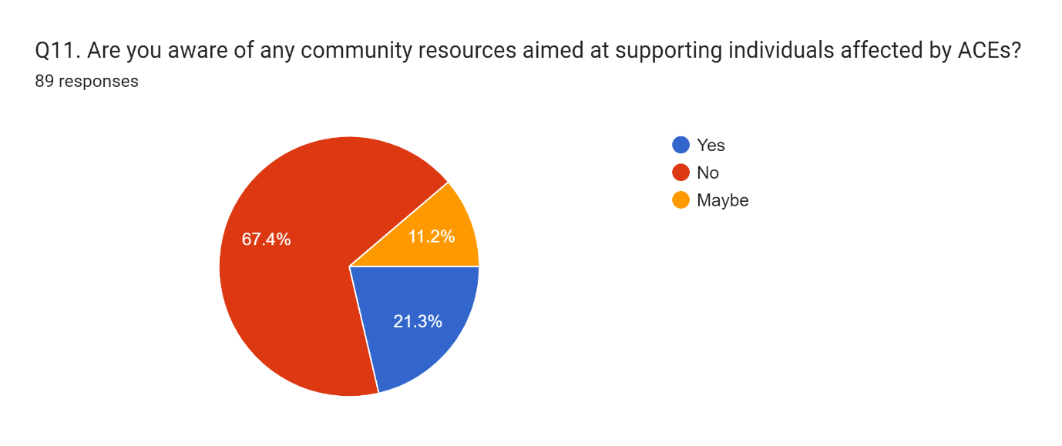
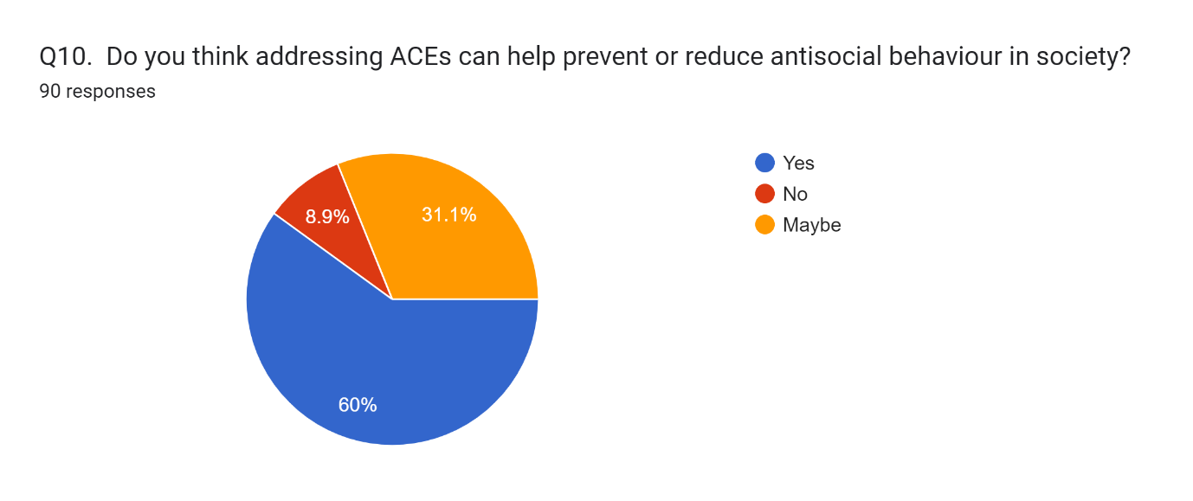
- Maybe aware of resources: 11.2% (10 people)
The pie chart (Q11) indicates that a significant majority (67.4%, or 60 people) are aware of resources available in their community to help those impacted by ACEs. This suggests that there may be successful outreach programs informing the community about available resources. However, a sizeable minority (21.3%, or 19 people) were not aware of such resources. There is also a small group (11.2%, or 10 people) who are unsure about the availability of resources.
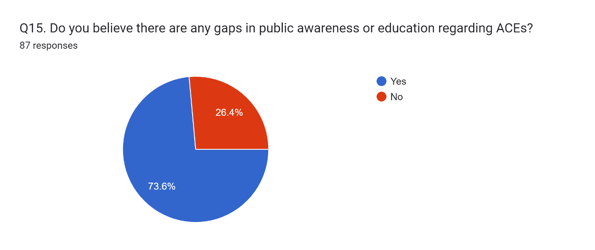
Overall, the pie chart suggests that there is some awareness about community resources for people affected by ACEs. However, there is also a gap in knowledge among a significant minority of the population. Considering the limitations of the data, further research to understand the demographics of those who are unaware and the reach of outreach programs could be beneficial.
According to the pie chart (Q15), the largest percentage of respondents (35.6%) believe that over half (51-75%) of children in the UK have at least one ACE in their early lives (Boulier & Blair, 2018). However, it is important to note that this data is based on people’s perceptions rather than factual data
Here’s a more detailed breakdown of the findings:
- A significant portion of respondents (35.6%) believe that a majority of children (51-75%) experience at least one ACE before adulthood.
- Over a third (32.2%) believe that less than a quarter (under 25%) of children experience ACEs.
- Nearly one in seven (14.4%) are unsure about the prevalence of ACEs in early childhood.
- A smaller percentage of respondents selected the following options:
  - Between 25-50% of children experience ACEs (12.2%).
  - More than 75% of children experience ACEs (6.6%).
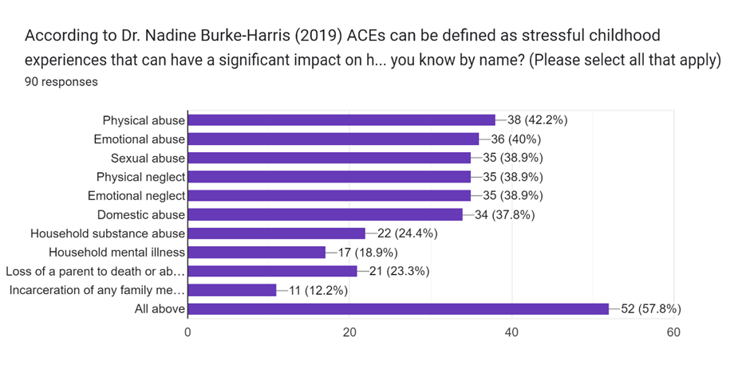
The graph shows the number of respondents who reported experiencing each type of ACE, as well as the percentage of respondents who reported experiencing each type of ACE.
Here is a breakdown of the results shown in the graph:
- Physical abuse: 38 respondents (42.2%)
- Emotional abuse: 36 respondents (40%)
- Sexual abuse: 35 respondents (38.9%)
- Physical neglect: 35 respondents (38.9%)
- Emotional neglect: 35 respondents (38.9%)
- Domestic violence: 34 respondents (37.8%)
- Household substance abuse: 22 respondents (24.4%)
- Household mental illness: 17 respondents (18.9%)
- Loss of a parent to death or abandonment: 21 respondents (23.3%)
- Incarceration of a household member: 11 respondents (12.2%)

Findings Analysis
The findings from the survey information offer huge bits of knowledge into different parts of Adverse Childhood Experiences (Experts) and their suggestions for research and practice. This comprehensive investigation expects to dig further into the findings, giving extra setting and explanations upheld by important writing.
Informed Assent and Socioeconomics
The survey's high pace of informed assent, with 96.6% of respondents consenting to partake in the research study, thinks about emphatically the moral lead of the study. Informed assent is a major moral rule in research, ensuring that members figure out the reason, procedures, and expected dangers of the study before deliberately consenting to take part (Beauchamp and Childress, 2019). By far most of members consenting to the study proposes that they comprehended the furnished data and were OK with their investment.
Be that as it may, recognising the restrictions inborn in the absence of segment data about respondents is significant. Without this segment information, it is trying to evaluate whether certain groups might be overrepresented or underrepresented in the example, which could affect the generalizability of the findings (Bowling, 2014). For example, studies have shown that variables like age, orientation, financial status, and instructive level can impact people's eagerness to partake in research (Fry and Dwyer, 2001; Galea and Tracy, 2007). Subsequently, understanding the segment structure of the example is fundamental for interpreting the findings precisely and making legitimate derivations about the more extensive populace.
Awareness of Experts
The survey findings uncover blended degrees of awareness with respect to Adverse Childhood Experiences (Experts) among respondents. While over portion of the respondents (53.9%) knew about Pros before taking the survey, a critical extent (46.1%) didn't know about Experts. This features a potential information gap inside the populace concerning the effect of childhood adversity on wellbeing and prosperity.
The significance of bringing issues to light about Experts couldn't possibly be more significant, as it assumes a pivotal part in preventive endeavours and mediation techniques (Felitti et al., 1998; Hughes et al., 2017). Research shows that expanded awareness of Pros can prompt superior distinguishing proof, early intercession, and backing for people impacted by childhood adversity (Anda et al., 2006; Lanier et al., 2018). Besides, state funded schooling efforts and preparing programs focusing on medical care experts, teachers, and social specialist organizations can add to a more comprehensive comprehension of Pros and their suggestions for individual and local area wellbeing (Merrick et al., 2017; Cronholm et al., 2015).
The survey findings concerning the impression of Pro prevalence among respondents offer important bits of knowledge into public awareness and perspectives toward childhood adversity. A critical extent of respondents (35.6%) accept that over portion of children in the UK have experienced something like one Pro in their initial lives. This insight underscores the widespread acknowledgment of the prevalence of Pros and their possible effect on people and networks.
View of Pro prevalence can impact public strategy, resource assignment, and intercession techniques pointed toward addressing childhood adversity (Evans et al., 2013; Gershoff et al., 2012). In any case, it is fundamental to perceive that discernments may not necessarily line up with experimental information on Pro prevalence (Taylor et al., 2019). Disparities among saw and genuine prevalence rates can result in misguided approach choices and lacking resource designation, underscoring the requirement for exact and modern epidemiological information on Experts (Taylor et al., 2019; Javdani et al., 2014).
Awareness of Local area Resources
The survey findings concerning awareness of neighbourhood for individuals influenced by Experts give experiences into the availability and transparency of help organisations (Giano et al. 2020). While a bigger sample of respondents (67.4%) had some awareness of open resources, a striking degree (21.3%) had hardly any insight into such resources. This finding underscores the meaning of additional induction to information about help organizations and resources for individuals affected by childhood adversity (Anda et al. 2020).
Induction to the neighbourhood is fundamental for directing the appalling results of ACEs and advancing resilience among affected individuals (Bethell et al., 2019; Dube et al., 2003). Regardless, limits like restricted awareness, shame, and hidden aberrations can hinder permission to these resources, particularly for limited people (Shonkoff et al., 2012; Nurius et al., 2015). As such, attempts to update awareness, decline shame, and address hidden limits are central for ensuring unprejudiced induction to help organizations for all individuals affected by Experts (Finkelhor, 2020).
Course of action with Study Objectives
The survey findings change personally with the study objectives, particularly in sorting out the association among Experts and the likelihood of at-fault lead (Boulier and Blair, 2018). The high speed of informed consent reflects moral examinations central for coordinating research on fragile subjects like Experts. Additionally, the survey gives critical pieces of information into public awareness, observations, and permission to resources associated with Stars, which are essential for enlightening prevention and intervention techniques (Gilgoff et al. 2020).
By addressing these objectives, the study means to add to the field and effect courses of action highlighted further fostering the success of individuals affected by childhood adversity (Briggs et al. 2021). Getting a handle on the trade between ACEs, social determinants of prosperity, and adverse results, for instance, disturbing approach to acting is crucial for making assigned mediations and advancing resilience among frail peoples (Tooth et al., 2017; Baglivio et al., 2014). Likewise, by uncovering knowledge into gaps in awareness and permission to resources, the study can enlighten advocacy attempts and resource distribution decisions highlighted by addressing the fundamental of childhood adversity and its connected results (Narayan et al. 2021).
Therefore, the survey findings give significant bits of knowledge into different parts of Adverse Childhood Experiences (Pros) and their suggestions for research and practice (Jones et al. 2020). By addressing the study objectives and featuring key findings, this examination adds to how one might interpret the perplexing connection between childhood adversity and its ramifications, at last illuminating endeavours to help people and networks impacted by ACEs (Jones et al. 2020). Pushing ahead, proceeding with research, advocacy, and strategy endeavours are expected to address the main drivers of childhood adversity and advance resilience among weak populaces.
References
Anda, R. F., Felitti, V. J., Bremner, J. D., Walker, J. D., Whitfield, C., Perry, B. D., ... & Giles, W. H. (2006). The enduring effects of abuse and related adverse experiences in childhood: A convergence of evidence from neurobiology and epidemiology. European archives of psychiatry and clinical neuroscience, 256(3), 174-186.
Baglivio, M. T., Wolff, K. T., Piquero, A. R., Bilchik, S., Jackowski, K., Greenwald, M. A., & Epps, N. (2014). Maltreatment, child welfare, and recidivism in a sample of deep-end crossover youth. Journal of Youth and Adolescence, 43(5), 782-796.
Beauchamp, T. L., & Childress, J. F. (2019). Principles of biomedical ethics. Oxford University Press.
Bethell, C. D., Newacheck, P., Hawes, E., & Halfon, N. (2014). Adverse childhood experiences: Assessing the impact on health and school engagement and the mitigating role of resilience. Health Affairs, 33(12), 210
Boullier, M., & Blair, M. (2018). Adverse childhood experiences. Paediatrics and Child Health, 28(3), 132-137.
Gilgoff, R., Singh, L., Koita, K., Gentile, B., & Marques, S. S. (2020). Adverse childhood experiences, outcomes, and interventions. Pediatric Clinics, 67(2), 259-273.
Briggs, E. C., Amaya-Jackson, L., Putnam, K. T., & Putnam, F. W. (2021). All adverse childhood experiences are not equal: The contribution of synergy to adverse childhood experience scores. American Psychologist, 76(2), 243.
Narayan, A. J., Lieberman, A. F., & Masten, A. S. (2021). Intergenerational transmission and prevention of adverse childhood experiences (ACEs). Clinical psychology review, 85, 101997.
Jones, C. M., Merrick, M. T., & Houry, D. E. (2020). Identifying and preventing adverse childhood experiences: implications for clinical practice. Jama, 323(1), 25-26.
Finkelhor, D. (2020). Trends in adverse childhood experiences (ACEs) in the United States. Child abuse & neglect, 108, 104641.
Anda, R. F., Porter, L. E., & Brown, D. W. (2020). Inside the adverse childhood experience score: Strengths, limitations, and misapplications. American Journal of Preventive Medicine, 59(2), 293-295.
Giano, Z., Wheeler, D. L., & Hubach, R. D. (2020). The frequencies and disparities of adverse childhood experiences in the US. BMC public health, 20, 1-12.
Loveday, S., Hall, T., Constable, L., Paton, K., Sanci, L., Goldfeld, S., & Hiscock, H. (2022). Screening for adverse childhood experiences in children: a systematic review. Pediatrics, 149(2), e2021051884.
Bryant, D. J., Oo, M., & Damian, A. J. (2020). The rise of adverse childhood experiences during the COVID-19 pandemic. Psychological Trauma: Theory, Research, Practice, and Policy, 12(S1), S193.
Goddard, A. (2021). Adverse childhood experiences and trauma-informed care. Journal of Pediatric Health Care, 35(2), 145-155.
Hughes, K., Ford, K., Bellis, M. A., Glendinning, F., Harrison, E., & Passmore, J. (2021). Health and financial costs of adverse childhood experiences in 28 European countries: a systematic review and meta-analysis. The Lancet Public Health, 6(11), e848-e857.
Baldwin, J. R., Caspi, A., Meehan, A. J., Ambler, A., Arseneault, L., Fisher, H. L., ... & Danese, A. (2021). Population vs individual prediction of poor health from results of adverse childhood experiences screening. JAMA pediatrics, 175(4), 385-393.
Schroeder, K., Schuler, B. R., Kobulsky, J. M., & Sarwer, D. B. (2021). The association between adverse childhood experiences and childhood obesity: a systematic review. Obesity Reviews, 22(7), e13204.
Leza, L., Siria, S., López-Goñi, J. J., & Fernandez-Montalvo, J. (2021). Adverse childhood experiences (ACEs) and substance use disorder (SUD): a scoping review. Drug and alcohol dependence, 221, 108563.
Alhowaymel, F., Kalmakis, K., & Jacelon, C. (2021). Developing the concept of adverse childhood experiences: A global perspective. Journal of Pediatric Nursing, 56, 18-23.

