

LCLM4005 Assignment – Employability and Career Development

Name:Teodora Gogonea
Lecturer: Dr. Lizeta Demetriou

Submitted on: 26/04/2026

Task 1: Comparison of Job Adverts

For this analysis, two real-world job roles were selected: a Marketing Assistant at Unilever and a Business Development Executive at Salesforce. These organisations operate globally and represent competitive graduate-level opportunities within the business sector.

Key Skills and Knowledge Identified

The Marketing Assistant role at Unilever highlights:

* Digital marketing and social media knowledge
* Content creation and brand awareness
* Analytical skills (e.g., campaign performance tracking)
* Communication and teamwork

In contrast, the Business Development Executive role at Salesforce focuses on:

* Sales and negotiation techniques
* Customer relationship management (CRM systems)
* Commercial awareness
* Target-driven performance

Despite the differences, several core transferable skills are common across both roles:

* Communication skills
* Teamwork and collaboration
* Problem-solving ability
* Time management
* Digital literacy

This reflects the increasing demand for hybrid skill sets, where both technical and soft skills are required in modern workplaces (CIPD, 2023).

Critical Evaluation of Communication Skills

Among these, communication is arguably the most significant. Communication is not simply the exchange of information, but the ability to influence, persuade, and build relationships effectively. In both marketing and business development roles, communication directly impacts performance outcomes.

For example, in marketing, professionals must communicate brand messages clearly to target audiences. In business development, persuasive communication is essential for closing deals and maintaining client relationships. According to Robbins and Judge (2017), ineffective communication can lead to misunderstandings, reduced productivity, and organisational failure.

Furthermore, communication underpins other employability skills such as teamwork and leadership. As noted by the CBI (2021), employers consistently rank communication as one of the top skills required from graduates. Therefore, its importance extends beyond individual roles and is critical for long-term career success.

⸻

Task 2: Self-Assessment and Employability Readiness
SWOT Analysis

To evaluate my readiness for employment, I conducted a SWOT analysis:

Strengths

One of my key strengths is strong communication skills, which I have developed through academic presentations and group work. I am also highly organised, allowing me to meet deadlines effectively. Additionally, I have demonstrated the ability to work collaboratively in team settings, which is essential in business environments.

Weaknesses

A major weakness is my limited professional work experience, particularly in corporate environments. I also lack advanced digital skills, such as proficiency in Excel analytics or CRM tools. Additionally, I sometimes lack confidence when faced with unfamiliar or high-pressure situations.

Opportunities

There are several opportunities available to me, including access to university career services, internships, and online learning platforms. These resources can help me develop both technical skills and practical experience. The growth of digital learning platforms also allows me to gain certifications independently.

Threats

External threats include high competition from graduates with more experience, as well as rapid technological changes in the workplace. Economic uncertainty may also reduce job availability, increasing competition further.

⸻

Critical Reflection on Personal Development

This SWOT analysis highlights that while I possess strong foundational skills, I must enhance my technical and practical competencies to remain competitive. Reflection is a key component of professional development, as it allows individuals to evaluate their performance and identify areas for improvement (Gibbs, 1988).

For example, my communication skills have been consistently recognised through positive feedback from tutors, particularly in presentations. However, my limited exposure to real-world business environments means I may struggle to apply these skills in professional contexts. This demonstrates a gap between academic capability and workplace readiness.

⸻

Evidence of Employability Readiness

Despite these weaknesses, I have demonstrated readiness for employment in several areas:

Academic Experience

My academic work has equipped me with a strong understanding of business principles, including marketing, teamwork, and problem-solving. Successfully completing assignments under strict deadlines has improved my time management and organisational skills.

Teamwork and Collaboration

Group projects have allowed me to develop interpersonal skills and learn how to manage conflicts effectively. This aligns with employer expectations for collaborative working environments.

Skill Development Activities

Through workshops and self-directed learning, I have begun improving my digital skills. For example, I have started learning Excel and basic data analysis, which are essential for modern business roles.

Feedback and Self-Improvement

Feedback from tutors has highlighted strengths in communication and structure, while also identifying the need for deeper critical analysis. I have actively used this feedback to improve my academic performance.

⸻

Evaluation of Employability Skills

Employability is defined as a set of achievements, skills, and personal attributes that make graduates more likely to gain employment (Yorke, 2006). Based on my self-assessment, I demonstrate several key employability skills, particularly in communication, teamwork, and organisation.

However, to achieve a higher level of employability, I must:

* Gain practical work experience
* Improve technical/digital competencies
* Build confidence in professional environments

This aligns with the view that employability is not static but requires continuous development (CIPD, 2020).

⸻

Task 3: Employment Goals and Personal Development Plan

Employment Goals

Short-Term Goals (0–12 months)

My primary short-term goal is to gain relevant work experience through internships or part-time roles in marketing or business development. I also aim to improve my digital skills, particularly in Excel and CRM systems, and to build confidence in professional communication.

Long-Term Goals (3–5 years)

In the long term, I aim to secure a full-time role in a reputable organisation such as Unilever or Salesforce, and progress into a managerial or specialist position. Ultimately, I aspire to develop expertise in business strategy and leadership.

These goals are important because they align with my career aspirations and address the weaknesses identified in my SWOT analysis.

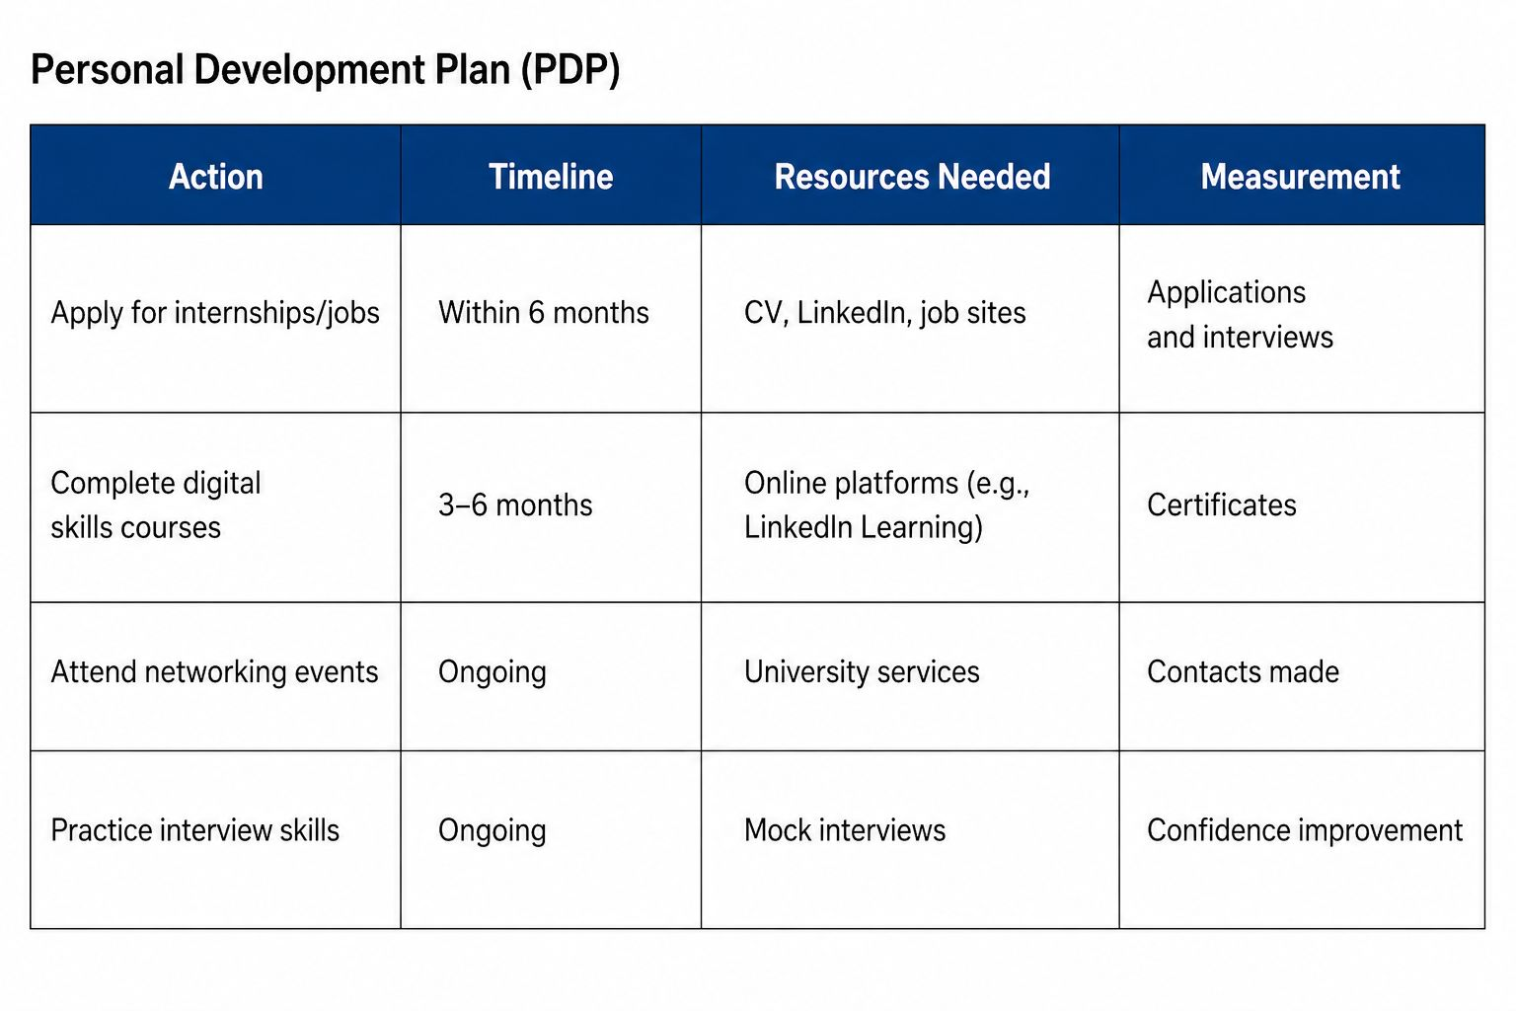

Evaluation of the Plan

This plan is achievable and structured, with clear timelines and measurable outcomes. Continuous professional development is essential in adapting to changing workplace demands (CIPD, 2020). By following this plan, I will improve my weaknesses and enhance my employability.

⸻

References

CBI (2021) Education and Skills Survey. London: Confederation of British Industry.

CIPD (2020) Continuing Professional Development. London: Chartered Institute of Personnel and Development.

CIPD (2023) Workplace Skills Report. London: CIPD.

Gibbs, G. (1988) Learning by Doing: A Guide to Teaching and Learning Methods. Oxford: Oxford Polytechnic.

Robbins, S.P. and Judge, T.A. (2017) Organizational Behaviour. 17th edn. Harlow: Pearson.

Yorke, M. (2006) Employability in Higher Education. York: Higher Education Academy.

