University of Wales Trinity Saint David
Wales Institute of Science and Art


Project Planning
ACHA5012
George Hall
2404493
23/11/25

Contents
Table of Contents
Contents 2
1.0 Introduction 3
2.0 General Team Rolls and Skills 3
2.1 Team Rolls 3
2.2 Skills and Personality (Belbin’s) 4
3.0 Group Tasks and Timing 5
4.0 Individual Tasks 6
4.1 Task List 6
4.2 Bill of Materials 10
5.0 Milestones and Gateways 10
5.1 Significant Group Milestones 10
5.2 Gateway Objective 10
6.0 Risk Management 11
6.1 Risk One 11
6.2 Risk Two 11
7.0 Gantt Chart 12
7.1 Group Summary 12
7.2 Individual Plan 13
8.0 Reference List 14

Introduction
In this assignment I am going to talk about project planning skill relating to my group project. My group project is to develop a prototype car; the car is a formula 750 race car which we will be converting from internal combustion drive to a fully electric drive. The end goal is to get it as close to regulations as it can be apart from the combustion engine and make it a competitive car. The team is made of 8 people whose roles will be broken down in the assignment and what plans we have as a team and individually.

2.0 General Team Rolls and Skills

2.1 Team Rolls
Name | Role | Responsibility
George | Group Leader | The team leader oversees the whole project, making sure deadlines are met and that every part of the team is working as it should. Helping and supporting team members when needed and overviewing the whole project making important decisions on the direction of the project.
Dan | Weight + Suspension | The weight + suspension team member is in charge of making sure the suspension is at the right settings to support the car, they are also part in charge of the positioning of heavy internal components of the car so that the car handles right and the centre of gravity is not too high or back so that the car is unstable.
Jac | CAD | The CAD team member is in charge of the computer modelling and development of the car. They get a base of the car that all team members can look at and work and then helps design and test new parts that will go in the car and see where that can be placed.
Alex | Motor + Drivetrain | The motor team member investigates how the motor works and how it connects to the drivetrain and how it gets power to the wheels. They look at the cooling and electrical requirements for the motor. They also are responsible for testing of the motor. They work very closely with the controller as that is what governs the motor.
Lily | Controller | The controller team member looks at the software the controller uses and programs it to get the right drive for the car. They also look at the cooling and electrical requirements of the controller. They work closely with the motor team member, so the final drive of the car is correct and work with the driver team member so that the drive is acceptable for the driver.
Ellis | Driver + Safety | The driver + safety team member is responsible for driver health, comfort and safety, they investigate the firewalls, safety gear and lap details so the driver is safe and can drive the car. They are also responsible for the driveability of the car, so it is nice to drive.
Tristan | Packaging + Wiring | The packaging team member is in charge of the position of components in the car with the direction form the weight + suspension team member, they also look into the bodywork and wiring harness of the car and how it will all look together.
Tasha | Battery | The battery team member research into the storage of power in the batteries, how much each component needs, the cooling of the battery and the recovery of energy in braking.

2.2 Skills and Personality (Belbin’s)
Belbin’s Category | Implementer | Coordinator | Shaper | Plant | Resource Investigator | Monitor Evaluator | Team Worker | Completer Finisher
Score | 13 | 9 | 8 | 10 | 9 | 6 | 7 | 8
Best fit for role | 6 | 17 | 15 | 7 | 4 | 10 | 8 | 3
Variation | 7 | 8 | 7 | 3 | 5 | 4 | 1 | 5

As seen, I have quite a big variation for a typical project leader which means I will need to learn, adapt and research how to fulfil my role to the best ability. Teams without clear goals and tasks are more likely to fail this is why a good project leader should have a high shaper and coordinator score (Meredith Belbin, 2010). Shapers challenge people to move forward and push for progress. Coordinators are great at getting others to focus on their tasks. These are good qualities for a leader, and I will have to challenge myself to be more assertive and not shy away from decision making. I will also need to be less of an implementer for my role, as project leader I need to focus on the overall outcome of the project and not focus on one task and making sure it works, that is for the other specialised team members to do.

3.0 Group Tasks and Timing

Task | Description | Est. Completion Date | Hours
Researching Regulations | Reading the general Formula 750 and MSUK regulations on race and electric track vehicles. | 19/10/25 | 4
Design Battery Box | Using CAD to create a design for the casing for the batteries and using it to produce technical drawing ready for manufacture. | 30/11/26 | 8
Manufacture Battery Box | Following technical drawings produce the physical battery boxes. | 25/01/26 | 10
Part List and Purchasing | Working out and filing a purchase request form for the university so we can order the parts needed for the project. | 31/01/26 | 2
Radiator Instillation | Once cooling requirements have been calculated, installing the required radiators onto the chassis in place for use. | 30/01/26 | 5
Cooling Installation | Installing the water pumps, pipes and connecting to all the water cooled components and radiators so everything runs at required temperature ratings. | 30/01/26 | 4
Assembling Drivetrain | Installing motor, belt, differential and driveshafts, connecting to the wheels and chassis. | 6/02/26 | 3
Bodywork Modifications | Shaping, cutting or adding to the bodywork to help with performance and cooling of the car so the right values are achieved. | 20/02/26 | 10
Fitting the Floor | Attaching the designed floor to chassis so internal parts are protected ready for racing. | 28/11/25 | 4
Project Prestation Work | Producing the PowerPoints and speeches for the project presentation to project supervisor and other lectures to assess the progress and effectiveness of the project. | 22/03/26 | 10
Testing Car | Evaluating the performance of the car against expected results and original ICE formula 750 to assess the success of the project and the improvements that need to be made. | 13/03/26 | 25

4.0 Individual Tasks
As group leader my job is to overlook all areas of the project and give a hand when needed. It is also my responsibility to make sure deadline are hit and that the project is heading in the right direction this mean my task are a lot of research, setup, preparations and helping out other team members when required.

4.1 Task List
Task | Description | Time | Duration | Specialist Equipment
Weekly Group Meetings | Attending and leading both Monday and Wednesday group meetings guiding the direction of the project and taking feedback from group members | 42Hrs | 6/10/25-22/03/26 | N/A
Project Presentation PowerPoints and Preparation | As leader preparing the PowerPoint for the presentations and handing out to team members to fill in their specific areas then going back over the whole thing adjusting. Then leading running through the presentation as group. | 20Hrs | 23/11/25-9/12/25 and 14/03/26- 22/03/26 | N/A
Overall Project Overview for Team Members | Creating and updating the shared access excel workbook with all relevant data for the project so it’s all in one easy to access place. | 6Hrs | 12/11/25-22/11/25 | N/A
Researching Regulations | Reading the MSUK and Formula 750 regulations so that we can produce a compliant and safe car. | 5Hrs | 6/10/25-19/10/25 | N/A
Researching Batteries | Looking into battery information to be able to support battery group member and better understand project. | 2Hrs | 17/10/25-22/10/25 | N/A
Researching Motor + Controller | Looking into Emrax motor and Sevcon controller manuals to be able to support motor + controller group members and better understand project. | 3Hrs | 18/10/25-23/10/25 | Sevcon Gen 4 and Emrax Motor Manuals.
Researching Required Components | After looking at regulations, searching for the required and optimal components needed to complete the car. | 4Hrs | 27/10/25-05/11/25 | N/A
Sourcing Differential for Car | Finding a differential for the car that we can use that is within the regulations. | 4Hrs | 06/11/25-11/11/25 | N/A
Setup DVT Software for the Project | Downloading and getting licence organised for use of BorgWarner DVT software that the Sevcon controller uses. | 3Hrs | 14/11/25-18/11/25 | BorgWarner DVT 2025.b Software
Motor Testing | Running DVT on controller and testing motor output to optimise car. | 5Hrs | 24/11/25-30/11/25 | 4 x 12V Lithium-Ion Batteries
Chassis Development | Looking at the chassis and making the required modifications as to suit our car best. | 3Hrs | 24/11/25-30/11/25 | N/A
Purchasing List and Budgeting + Purchasing | Talking to team members and filling in purchasing request forms for the parts they require for their specific areas. This is spread over a long time due to different team | 10Hrs | 26/11/25-31/1/26 | N/A
Workshop Hours | Helping with assembling the components of the car after optimisation from team members. This includes the floor, driver safety, wiring harness, cooling system, bodywork modifications, drivetrain installation, battery instillation and chassis changes. | 50Hrs | 19/11/25-20/02/26 | N/A
Sourcing Driveshaft for Car | Once differential found getting the relevant driveshafts for the diff along with the driveshaft for the wheels so that they can be combined. | 4Hrs | 5/01/26-9/01/26 | N/A
Talking to Formula 750 | Once we have a good base for the car and performance communicate with the Formula 750 leaders to see if we can get a chance to drive with other Formula 750 cars or get data to compare with. | 3Hrs | 01/2/26-08/2/26 | N/A
Testing the Car | After completion of the car putting it through dynamometer tests and track days to check performance of the car and adjust if necessary. | 25Hrs | 21/02/26-13/03/26 | Dynamometer, Trailer, Driver, Vehicle Passport.

4.2 Bill of Materials
As project leader my bill of material will consist of overall things need for the car as a whole when going racing and not individual components like the other team members as they included all the components for their areas in their bill of materials.
Bill of Materials
Material | Cost | Lead Time
4 x 12V Lithium Ion Batteries | £418 | 3 Days
BorgWarner DVT Licence | £100 | 1 Day
Formula Registration | £100 | 1 Day
Transponder | £140 | 4 Days
750 Membership | £95 | 1 Day
Motorsport UK ‘Club’ Race Licence | £99 | 1 Day
Motorsport UK ‘Go Racing’ Pack | £104 | 1 Day

5.0 Milestones and Gateways

5.1 Significant Group Milestones
- Completed CAD model
- Optimised Controller Software
- Complete motor testing
- Project Presentation 1 Complete
- Purchasing request
- Chassis Adjustments
- Battery Casing Manufactured
- Floor Manufactured
- Cooling and wiring harness installed
- Suspension Optimised
- Brake lines and pedal box connected
- Power train completion
- Car Completed
- Successful Testing
- Project Presentation 2 Complete

5.2 Gateway Objective
A gateway is a milestone on the project that will delay the project if not completed on time or to the standard required (Stratton, 2003). One important gateway for my area of the project is that the car is completed for testing and performs as expected. As project leader it is my job that the project is kept on schedule and is meeting performance requirements. If the car isn’t completed in time to take the car testing, then we cannot get a final value for the success of the project. Those values being if it produces a minimum of within 10% of 90hp so it is competitive with the rest of the competition, if it is within regulations as much as possible and if it has the power to complete a 20min race.

6.0 Risk Management
A risk is an unplanned circumstance that if does occur can have a positive or negative effect on a project’s tasks (Project Management Institute, 2000). Risks need to try to be avoided at all costs in projects as it can set the project off track. Below I will talk about two possible areas of concern in my section of the project for risks to occur and how they could be prevented.

6.1 Risk One
Risk: Group Members not completing their tasks.
If a group member is not completing their part of the project, it can prevent the rest of the group from progressing and therefore hold up the project as it could be a gateway task. It is important that everyone in the group does their part as everyone is reliant on one another. This would throw the whole project of the deadline date and could leave us without a completed car in time for testing. To prevent this from happening as group leader I will give set dates for tasks to be completed by to keep everyone on track, I will also check in on group members making sure they understand the task set, give a hand if need be and keep motivation and moral high. As project leader I have a significant influence on moral and low moral can damage the progression of a team member (Dye, 2011).

6.2 Risk Two
Risk: Components Breaking.
If the correct procedures are not followed important components could be broken when testing them or installing them on the car. This would set the project back on both time and budget as most components on the car are expensive. To best try avoid damage, all components will be handled with care when moving or installing them into the car with supervision. To help prevent this risk further testing plans should be written so that parts are safety checked for the user and components health. When parts are being tested or operated pre-use checks should be completed as outlined in our testing plans. These plans will be instrumental in preventing damage and helping everyone follow safety procedures therefore reducing the chance of this risk having a negative effect on the project.

7.0 Gantt Chart
Gantt charts are a great way to visualise the planning out a project; they break down the individual milestone and/or tasks of a project and give a dedicated time frame in which they should be to keep a project on track and to hit deadlines. Due to being group leader my tasks are very similar to he group tasks.

7.1 Group Summary
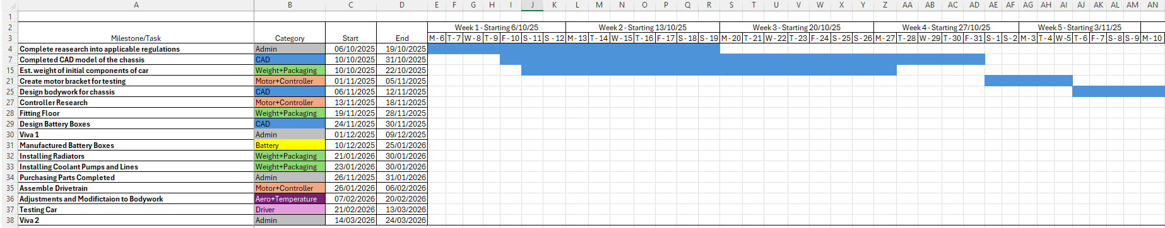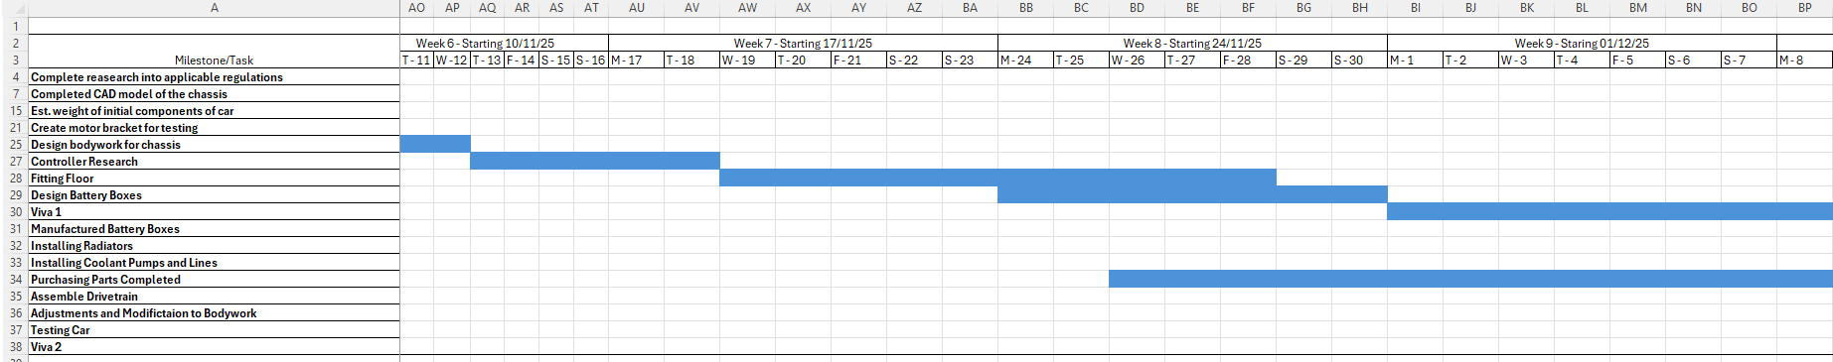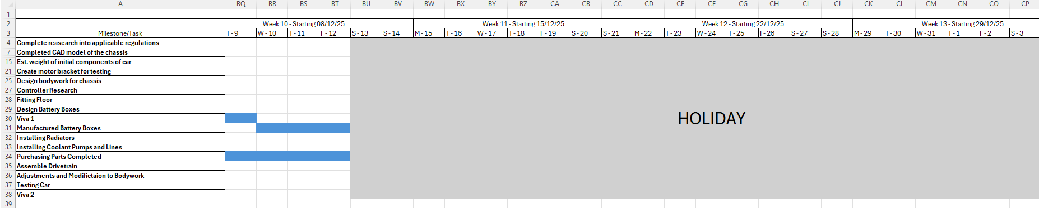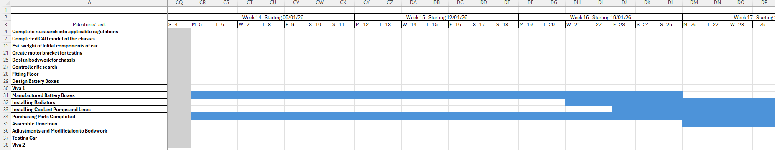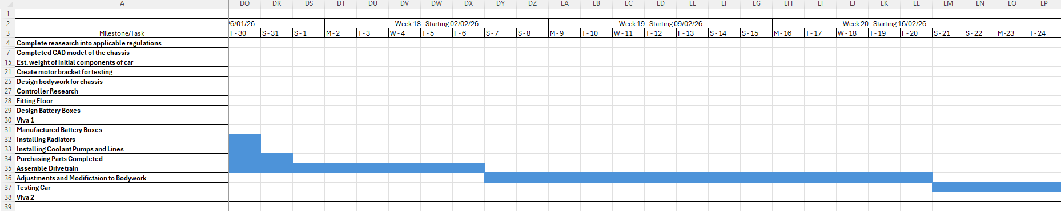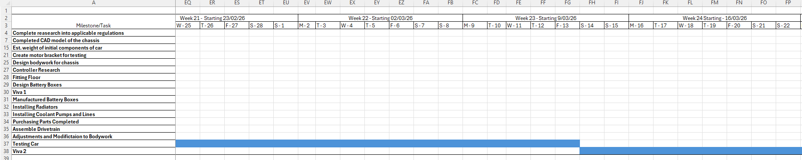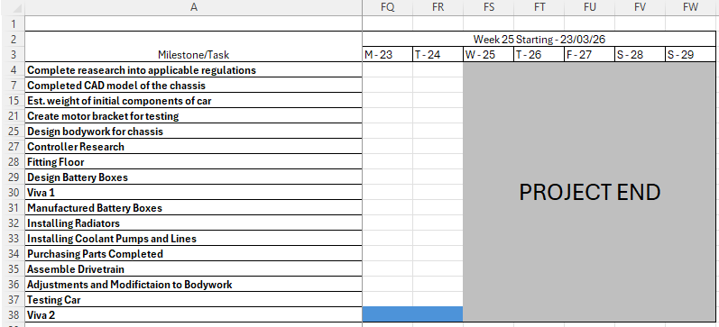

7.2 Individual Plan
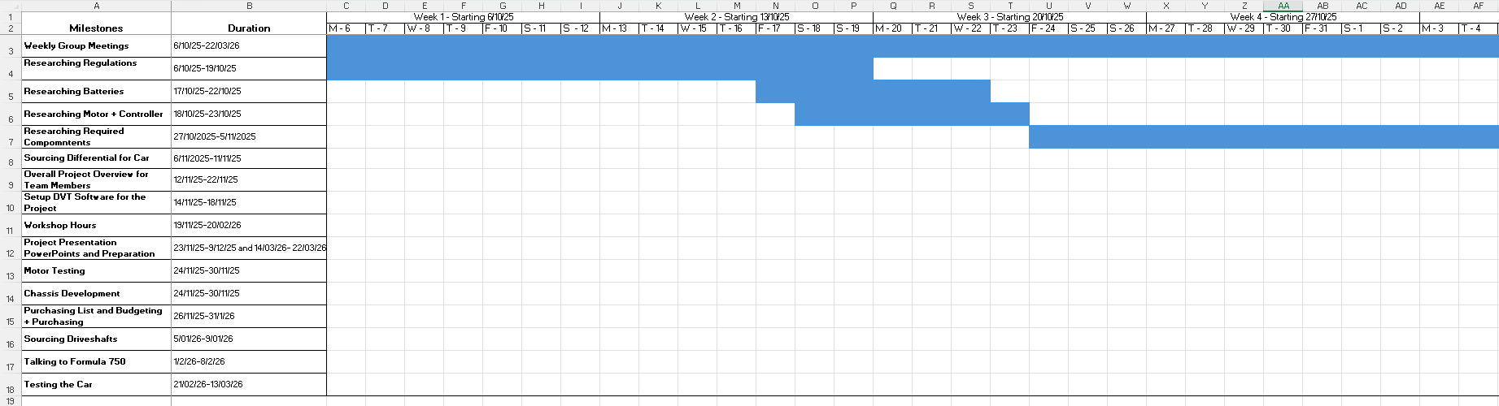
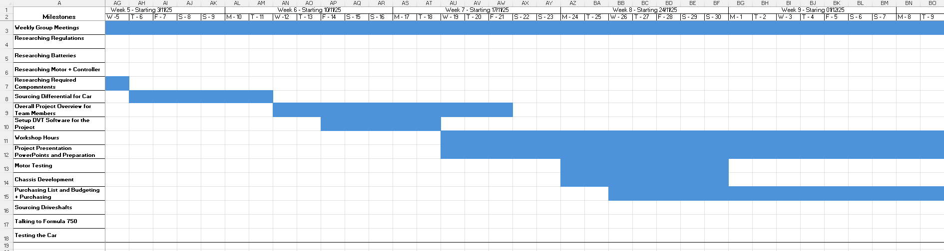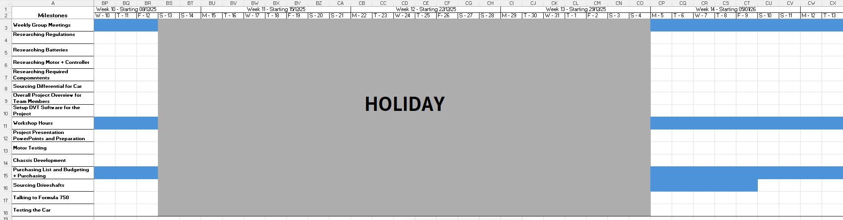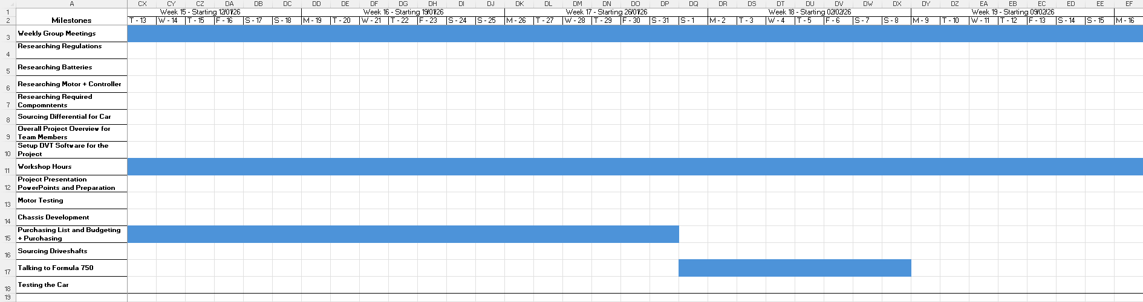
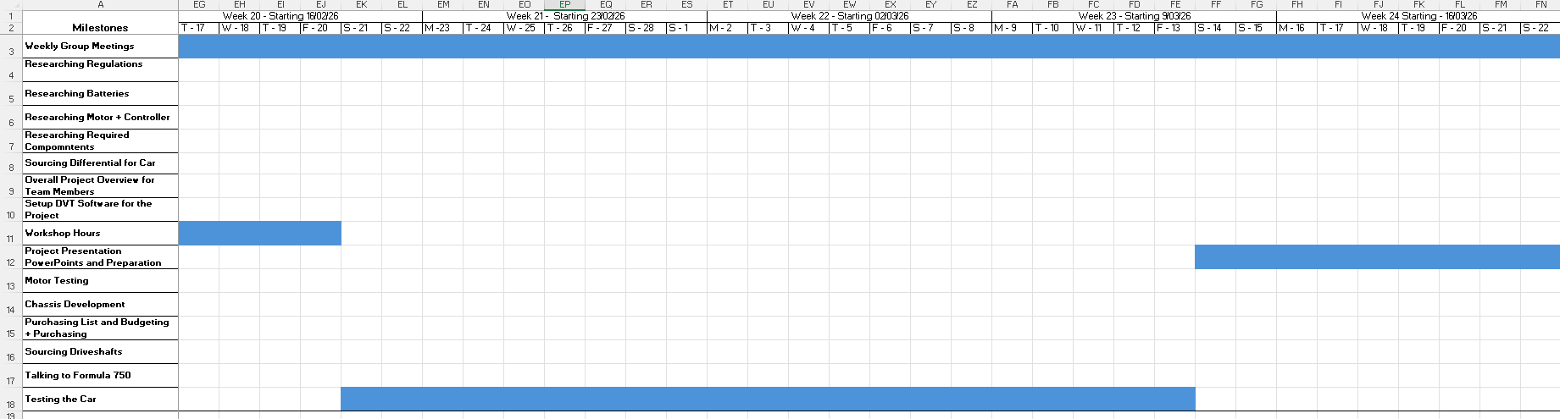

8.0 Reference List
Dye, L.D. (2011) The significant role of the project manager in establishing and maintaining team morale. Paper presented at PMI® Global Congress 2011—North America, Dallas, TX. Newtown Square, PA: Project Management Institute.
Meredith Belbin, R. (2010) Team Roles at Work - EBSCO. Available at: https://research-ebsco-com.ezproxy.uwtsd.ac.uk/c/onvpsy/ebook-viewer/pdf/up7dqkjwkr/page/pp_104?location=https%25253A%25252F%25252Fresearch-ebsco-com.ezproxy.uwtsd.ac.uk%25252Fc%25252Fonvpsy%25252Fsearch%25252Fdetails%25252Fup7dqkjwkr%25253Fdb%25253Dnlebk&auth-callid=d171b0ea-61c5-4304-ab0d-a8750e80fd34 (Accessed: November 11, 2025).
Project Management Institute (2000) “A Guide to the Project Management Body of Knowledge PMBOK ® Guide 2000 Edition.”
Stratton, R.W. (2003) Project gates: "Chutes and Ladders®" for project managers. Paper presented at PMI® Global Congress 2003—EMEA, The Hague, South Holland, The Netherlands. Newtown Square, PA: Project Management Institute.

