GreenLeaf Organics: PART A

Student Name:yasir azad
ID:2332328
ACCA5026 Databases and Application Development

Table of Contents
1. Introduction 4
2. Database Design 4
2.1 Entity identification 4
2.2 Entity Relationship and explanation 5
2.3 ERD and Explanation 6
2.4 Normalization 7
3. Implementation Documentations 11
3.1 Table Creation 11
3.2 Constraint Implementation 17
3.2.1 Primary Key Implementation 19
3.2.2 Foreign Key Implementation 19
3.2.3 Not Null constraints 19
3.2.4 Data Types and their Relevance 20
3.2.5 Structural Integrity for Tables 20
3.2.6 Evaluation 21
3.3 Sample Data Insertion 21
3.3.1 Purpose 22
3.3.2 Data Volume 23
3.3.3 Data Quality 23
3.3.4 Evaluation 23
3.4 Stored Procedures 23
3.4.1 Purpose 24
3.4.2 Add Product 24
3.4.3 Update Product 25
3.4.4 Delete Product 25
3.4.5 Execution and Testing 26
3.5 Trigger Implementation 26
3.5.1 Trigger Type 27
3.5.2 Audit Table 27
4. Stored Procedure and Transactional Scenario 28
4.1 Understanding the concept of Transactions 29
4.2 Transaction Design in GreenLeaf Database 30
4.3 Implementation of transaction 30
4.4 Rollback and Commit Operation 31
4.4.1 Commit Operations 31
4.4.2 Practical Demonstration 31
4.4.3 Rollback Operation 32
4.4.4 Practical Demonstration 32
4.4.5 Error Handling 32
5. Performance Tuning Enhancement 33
5.1 Index Implementation 33
5.2 Benefits and impact 33
5.3 Improvement in terms of speed and efficiency 33
5.4 Evidence Using EXPLAIN 34
5.4.1 Interpreting EXPLAIN operation 34
6. Conclusion and Reflection 34
References 36

Introduction
GreenLeaf Organics is a UK-based sustainable and eco-conscious brand specializing in organic and lifestyle products. It has become imperative for brands to promote a healthy, sustainable lifestyle by offering consumers sustainable options. With growing consumer demand for online options, GreenLeaf intends to expand its business by going online. The online store needs to enable consumers to make purchase decisions smoothly, with ease and convenience. However, the major problem is that of scalability and optimization, for which a relational database is needed. Microsoft explains a relational database as one that clearly stores and organizes data to define the relationship between data [1], enabling admins and customers to access the services with ease.

2. Database Design
The first step in database design is to develop an entity relationship diagram, which also means identifying the different business processes and entities involved. There are usually eight steps to develop a model using ERD that include understanding business rules, identifying the main entities, defining relationship between entities, and defining constraints for each entity, among others [2].

2.1 Entity identification
The following entities are identified based on the GreenLeaf Organics business processes and requirements:
Suppliers: It is an entity that only stores information about key suppliers that supply all the products to the brand. For example, a locally-produced organic dairy product. This information can be enriched with the addition of key attributes like the supplier ID, name, email, contact, addresses, and especially certification to establish their authenticity and credibility.

Product: The next entity is the product, which is the core component for the functioning of the online store. It stores all relevant data about each kind of product sold by GreenLeaf. It has key attributes like the ID, price, quantity, manufacturing and expiry date, the supplier ID who supplies a specific product, and stock quantity.

Category: it is the entity associated with types of products sold at an online store. For example, a sustainable accessory category, an organic dairy category, and a sustainable clothing category, having such categorization is essential to help customers make an easy choice. It includes key attributes like ID and name.

Customer: These entities are the ones interacting in the system, choosing products, putting them in the cart, buying, and changing. Their personal contact information, like name, address, contact details, and addresses are relevant.

Orders: this entity comes in the last few stages of the transaction, which are critical as they are evidence of a purchase needed for other functionalities like accounting and financial reasons. In that case, the order date, the order ID with a special numeric and alphanumeric amount, and the customer's unique ID are critical.

Order Items: It helps connect a customer order with a particular product, where its total quantity and prices become relevant. Key attributes include both order item ID, Order, and product ID, price, and quantity.

2.2 Entity Relationship and explanation
The relationships are arranged in the following manner between the entities and their attributes:
- A supplier can supply more than one product.
- A customer is also involved in purchasing more than one product.
- A single order can contain more than one product, which is shown via order items.
- A single product belongs to different categories.
- A single customer can write multiple reviews.
- A single product can have multiple reviews.

2.3 ERD and Explanation
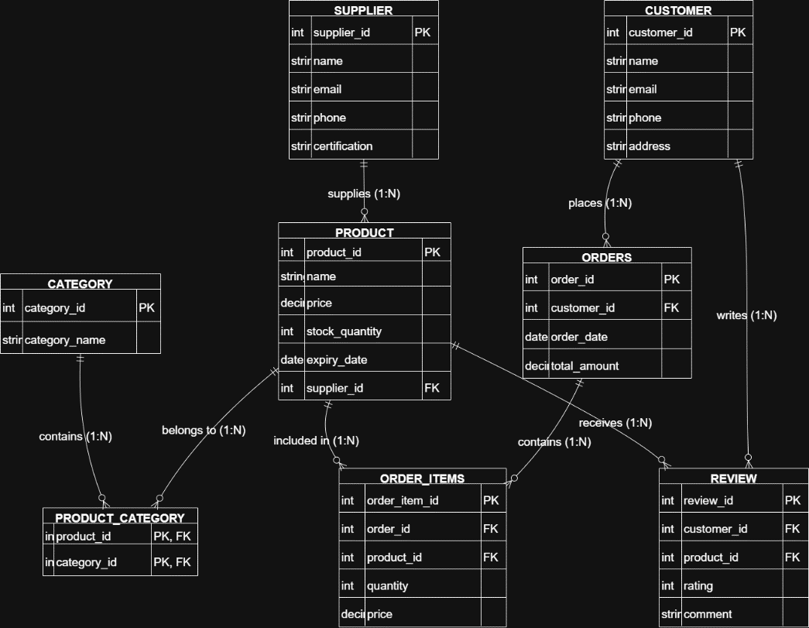
Figure 1: ERD for establishing a relationship
Figure 1 illustrates the entities and their relationship with each other. One important thing about each of the entities is that they have primary keys, which are their unique ID, different from each other. On the other hand, the foreign key is used to draw a relationship between entities. For example, there is a relationship between the product ID and the supplier ID supplying that specific product. Similarly, in terms of review, if review ID is a primary key, the customer and product ID uses foreign key to determine the relationship with the review ID.
There is also a use of relationship cardinality where relationship such as one-to-one and one-to-many exists. In the case of GreenLeaf Organics, the relationship is mainly one-to-many, identified using 1:N. For example, there is a relationship between the customer entity and the review entity showing 1: N, which means that a customer can write many reviews for many products at a time. that is why the figure also has junction tables.

2.4 Normalization
Normalization in database creation and management is the process of avoiding any duplication of data, thereby improving data integrity and reliability. Using the existing knowledge, the database for the brand is normalized to Third Normal Form, which means it is the highest normal form that can be applied in the table to reduce any vulnerabilities owing to the dependencies among entities, also helping to reduce abnormalities of data [3].
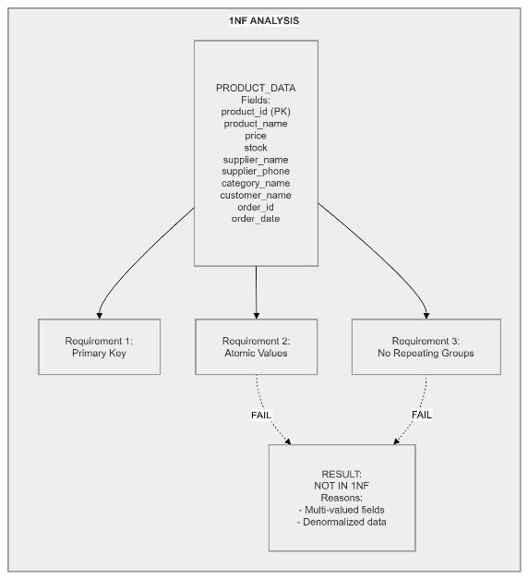
First Normal Form (1NF)

Figure 2: 1NF
The first normal form has data that is stored in a single table, which creates dependencies and makes the data vulnerable to misinterpretation or error. The different entities have differing values and outcomes, which cannot be placed together, thereby needing changes.
As shown in Figure 2, data is normally stored in a single table, thereby creating data integrity issues. For example, the product data has multiple attributes such as customer ID and supplier ID.
Second Normal Form
The second normal form is a more standardized form where there are separate tables for each entity. However, the major problem here is that a few are overlapping, such as in the product entity, where the category name is added. This will create confusion because products are created out of a specific category, and they cannot be placed together.
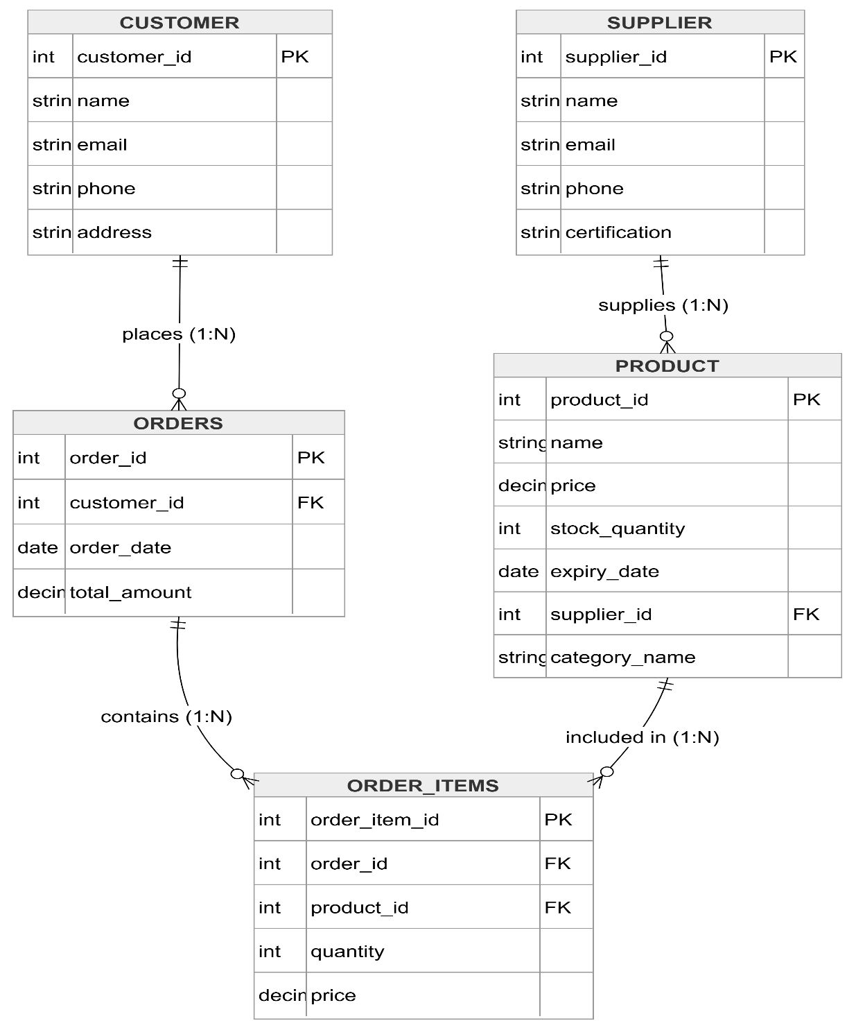

Figure 3: 2NF
As illustrated in Figure 3, the attributes are now arranged in different tables. For example, now the customer ID is made available in the customer-related table.

Third Normal Form
Finally, the third normal form will help in normalizing data. In this case, the focus has been on removing dependencies and separating data systemically. For example, previously the category attribute was in the order entity, which is now removed and placed in a separate category.
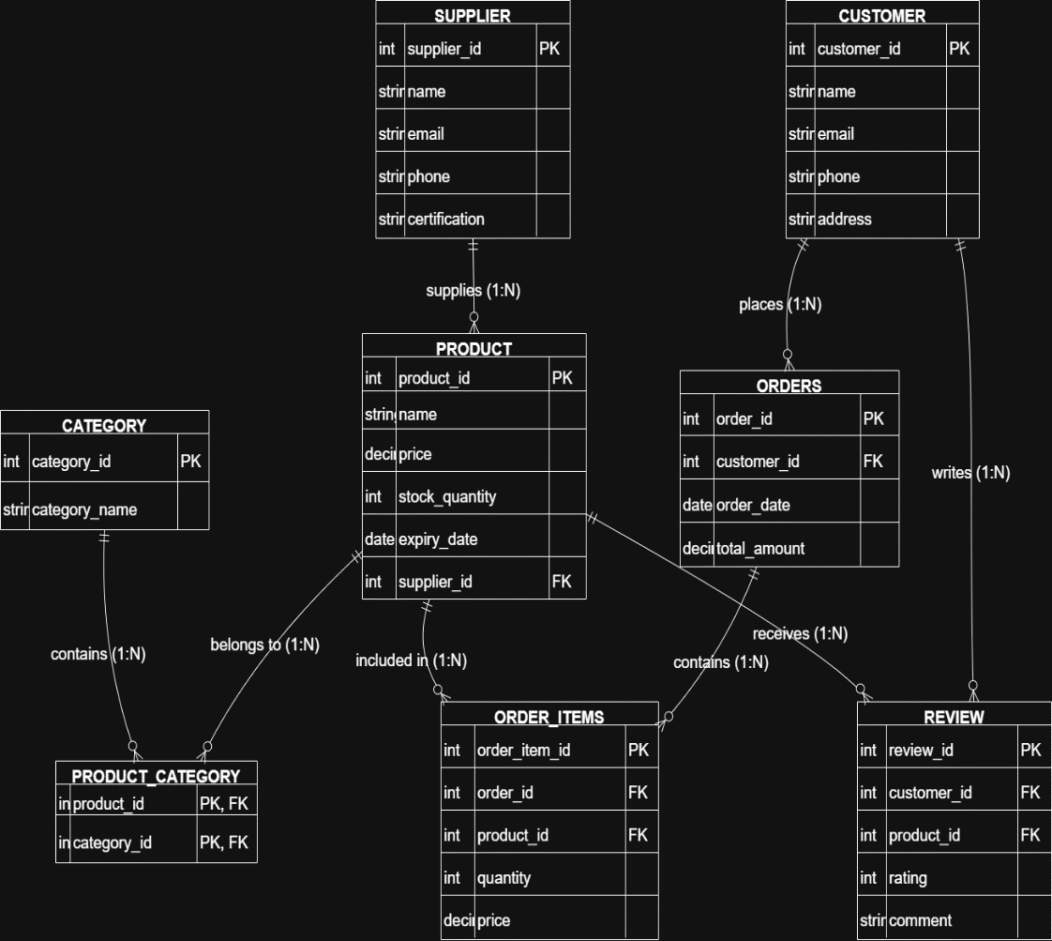
Figure 4: 3NF
As illustrated in Figure 4, now there is a more simplified table crated for each entity. There is also the use of primary and foreign key to show the relationship. For example, the customer ID is part of customer table as well as a foreign key in the review table.
Thus, by choosing the third normal form, the existing transitive dependencies are removed, and each information set is credibly established, as well as its relationship.

3. Implementation Documentations
Now, the focus needs to be on explaining how each of the important elements of the database was prepared and the outcomes. Since the theories and concepts were used to design a system using SQL, it is imperative to also showcase the practical side of the elements together to make a wholesome database. The focus is on demonstrating a few important elements that include the rationale and explanation for the table creation process, with the outcome. It is followed by showcasing the use of different constraints and how they are currently implemented. Further, this section also showcases the data types used for identifying each of the chosen attributes, followed by an explanation of the structural integrity of tables and an evaluation of the overall design.

3.1 Table Creation
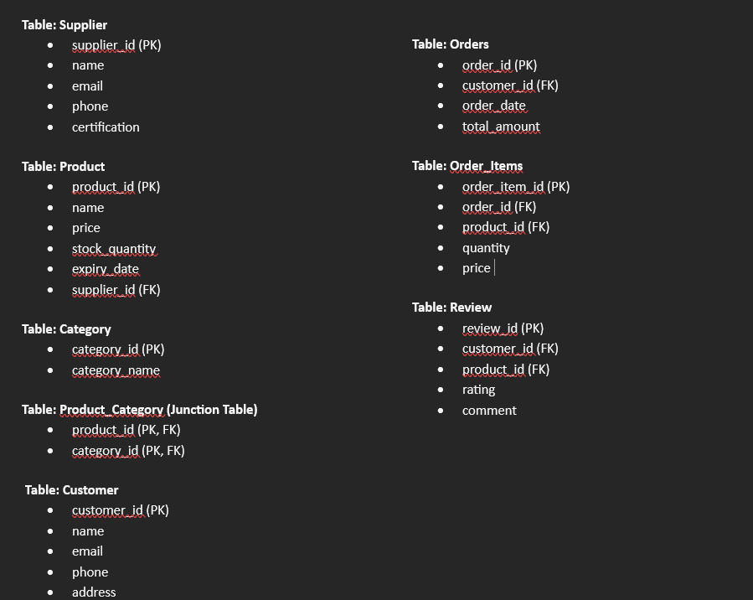
Figure 5: Tables for each entity
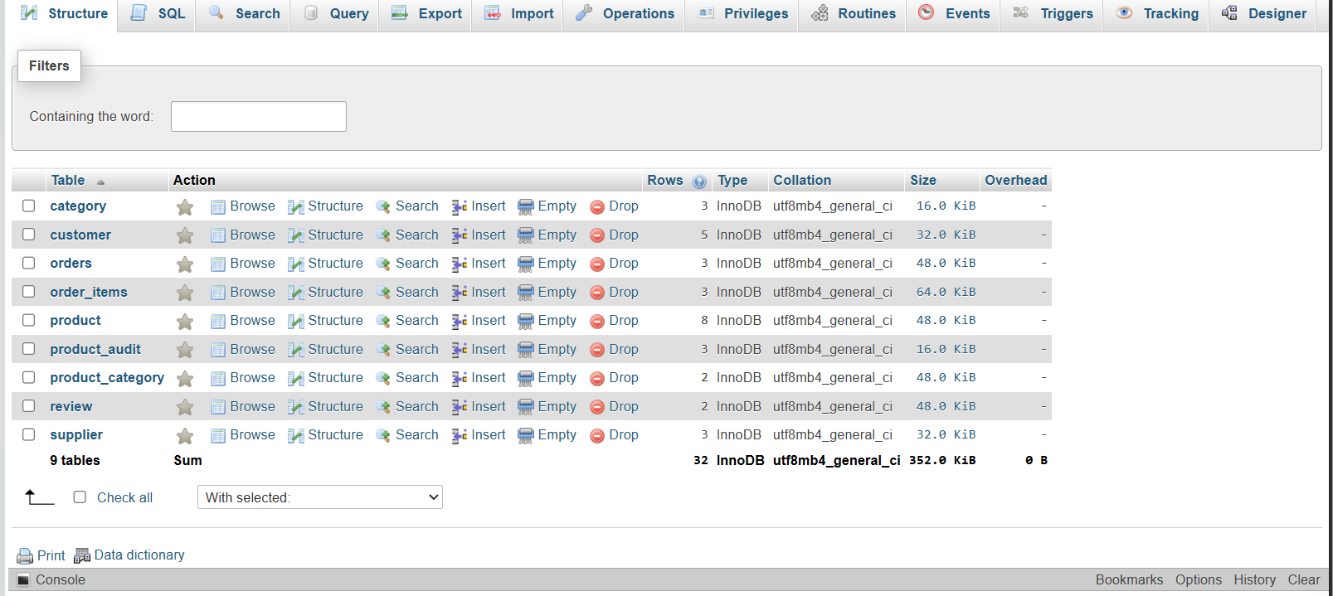
Table List from Database
There were requirements for different tables with different entities and attributes. As such, the SQL Create Table statements have been used [4]. The table, as shown in Figure 5, is based on the inputs of the ERD that help in maintaining the relationship of each of the entities as it is. The table includes those relating to customer, product, supplier, category, product category, and review. The most important thing in table creation is the use of different constraints to identify the entity and its relationship. There are eight (8) tables assigned for each business process, starting from the product and ending with review. Each tables have 3 rows and columns, where each has data types and attributes associated with the main entity. It is important to note that the junction table is also added to establish a meaningful relationship between the product and the category to which they belong.
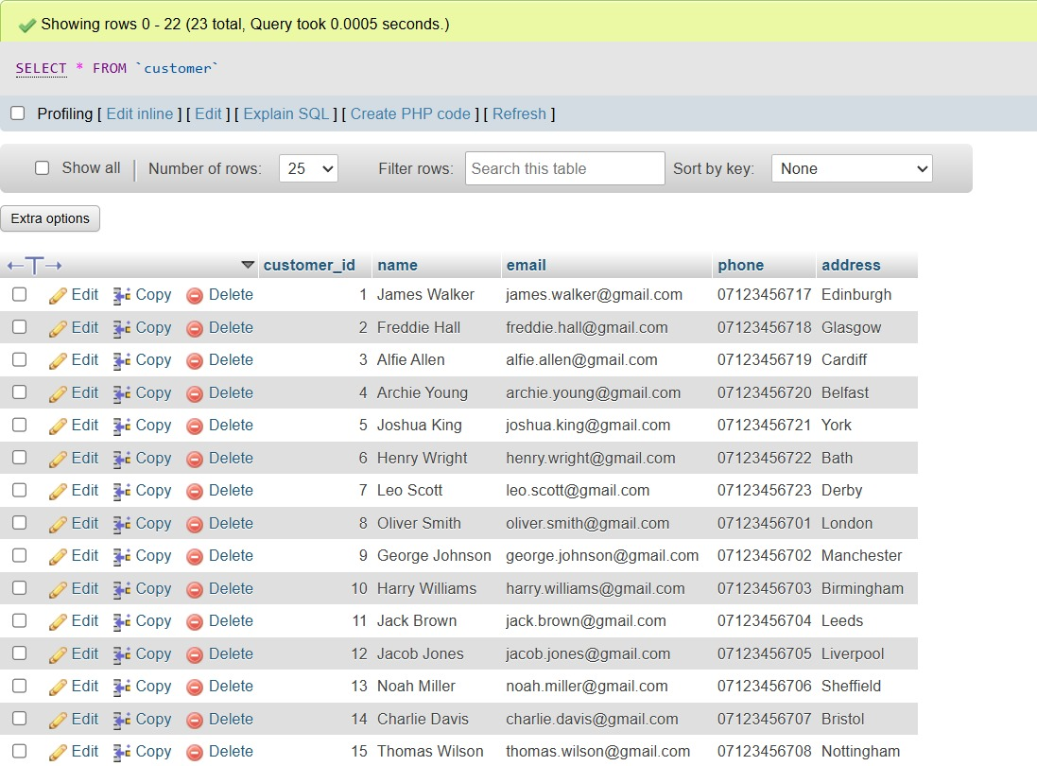
Figure 6: Customer Table
As illustrated in Figure 6, a customer table has inputs like customer ID, name, email addresses, contact details, and addresses. The customer table, as shown in the figure, helps to store all relevant data and information relating to customers. Each customer is identified using a unique customer ID. The customer ID is the primary key here, and it helps in maintaining informational integrity throughout. The table also includes essential information like the email address, phone number, and address of each of the customers. If the customer table has to be linked with other entities, a foreign key can be used. Through the use of foreign keys, individual customer transactions and purchases can be easily tracked in the online store.
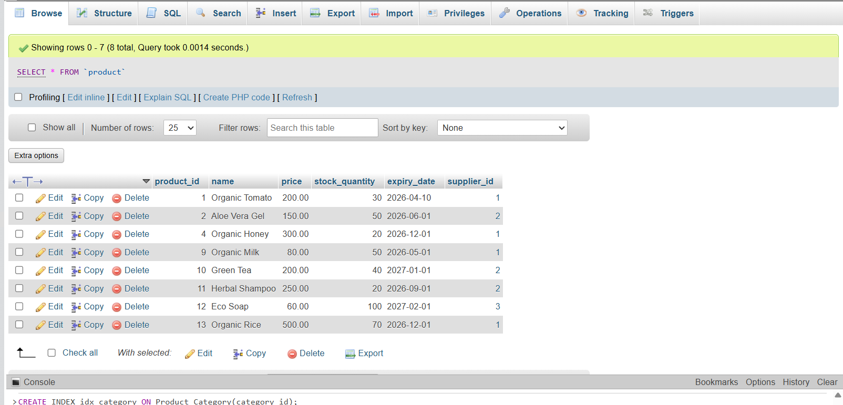
Figure 7: Product Table
The Product table stores information about all available items in the system, including attributes such as product_id, name, price, stock_quantity, and expiry_date. It also includes a foreign key (supplier_id) to establish a relationship with the Supplier table.
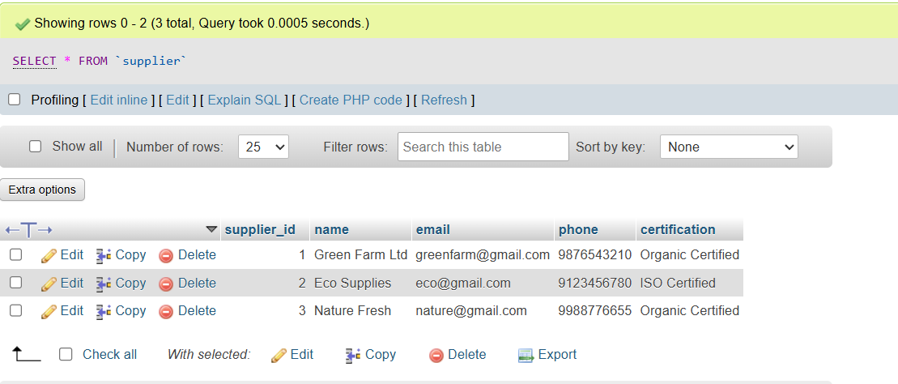
Figure 8: Supplier table
The Supplier table contains details of suppliers, including supplier_id, name, contact information, and certification. Each supplier can provide multiple products, establishing a one-to-many relationship with the Product table.
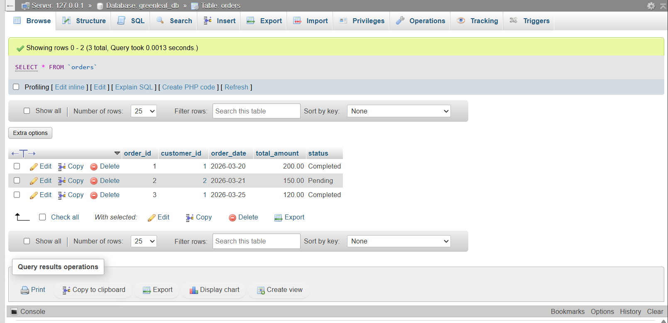
Figure 9: Order table
The Orders table records transaction details for each purchase, including order_id, customer_id, order_date, and total_amount. It links customers to their respective orders through a foreign key.
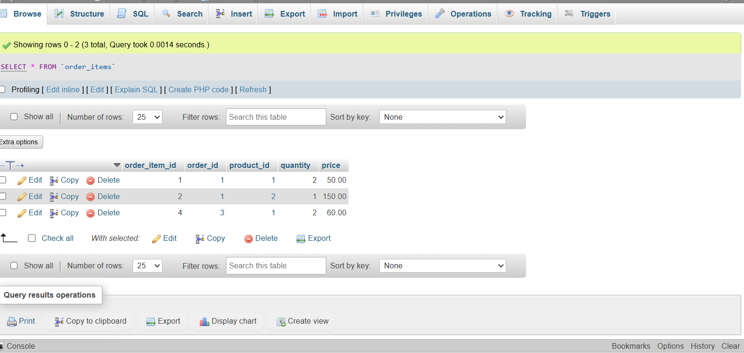
Figure 10: Order_items table
The Order_Items table represents the relationship between orders and products. It includes attributes such as order_item_id, order_id, product_id, quantity, and price, allowing multiple products to be included in a single order.
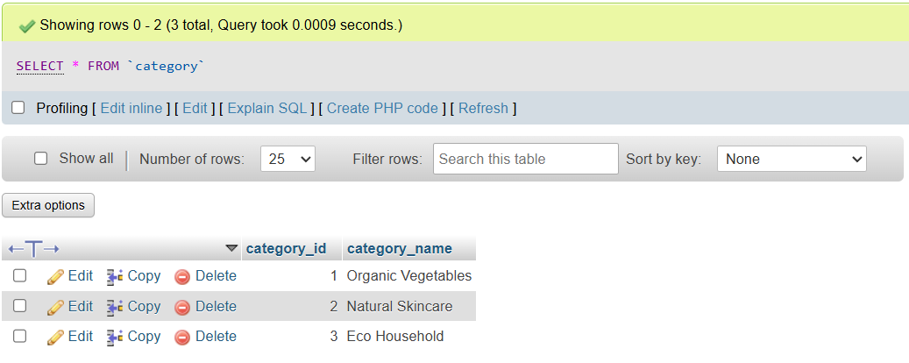
Figure 11: Category table
The Category table stores different product categories such as organic food and skincare. It includes category_id and category_name, enabling classification of products.
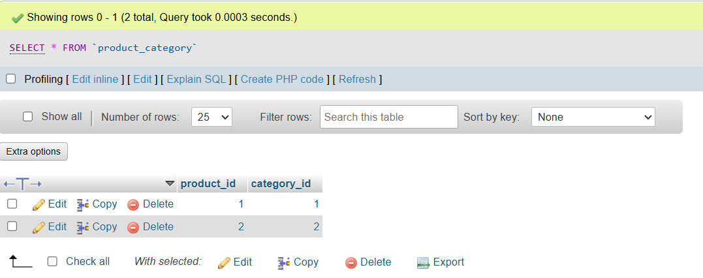
Figure 12: The Product Category table
The Product_Category table is a junction table used to manage the many-to-many relationship between products and categories. It links product_id and category_id to allow products to belong to multiple categories.
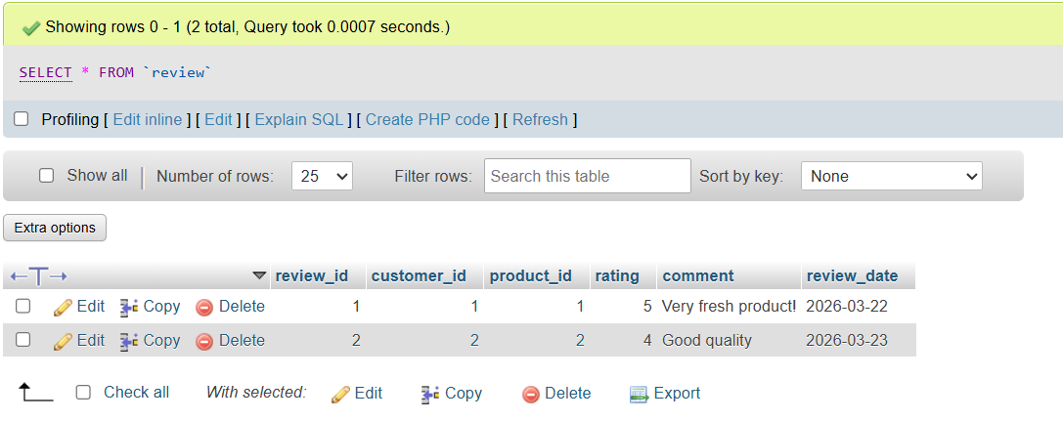
Figure 13: Review table
The Review table stores customer feedback on products, including review_id, product_id, customer_id, rating, and comments. This supports user engagement and quality assessment of products.

3.2 Constraint Implementation
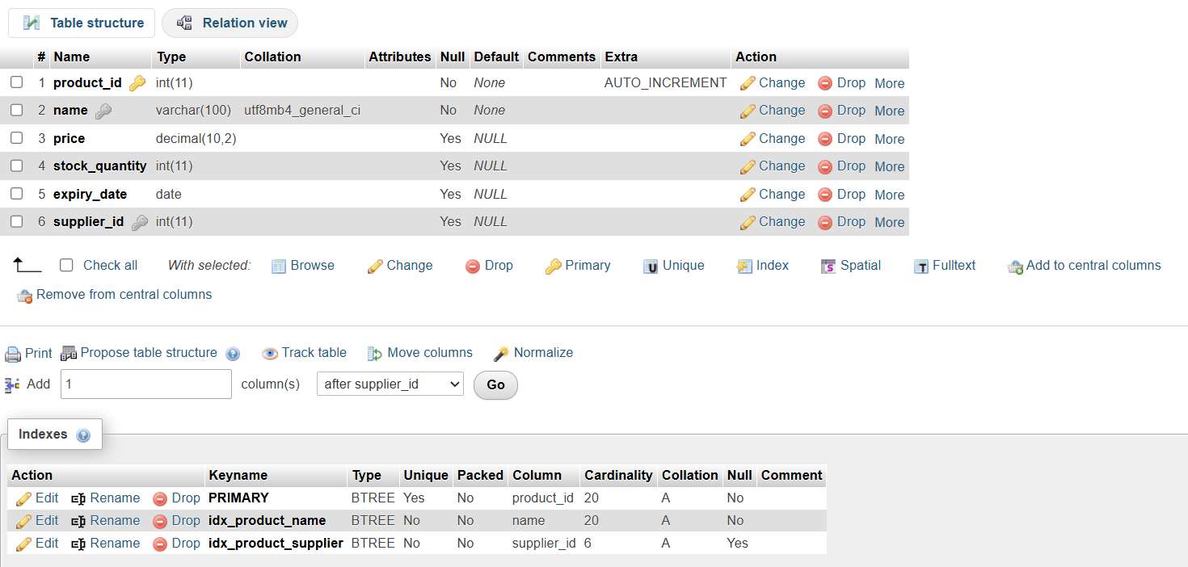
Figure 14: constraint implementation using different keys
To enable the table to be free from integrity issues, duplication, or anomalies, three key constraints are used: primary, foreign, and Not Null key. While the primary keys are defined for all the entities as shown in the figure 2 in the above sections, the foreign keys are only relevant if a relationship exists between different entities. However, one thing that needs to be considered is that the same primary key can be used as a foreign key depending on the relationship it shares with other entities. For example, customer ID is found in entities, mainly the customer table, and supplier ID can be used both as a primary and a foreign key. Further, using the Not Null Key is relevant to showcase mandatory attributes under each entity. For example, in Figure 14, there are attributes where ‘No’ Null is mentioned, and some attributes have null components. To be more specific, the figure shows that product ID and product name are always essential and cannot be left empty. On the other hand, attributes like price, stock quantity, and expiry data can be left empty and will have no major impact.

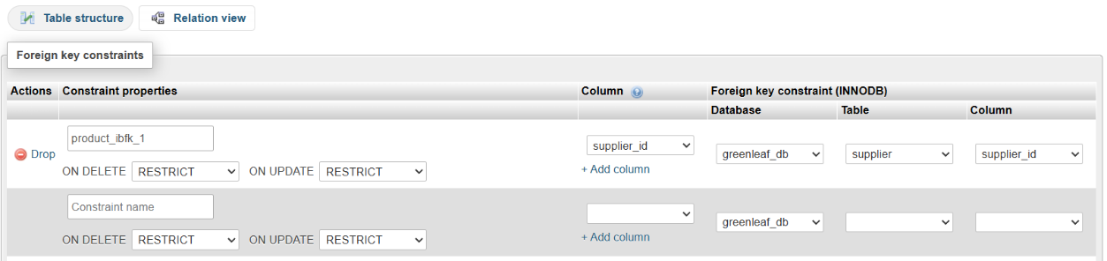
Figure 14(a): Foreign Key Constraint for Product Table
As shown in Figure 14(a), the supplier_id column in the Product table is defined as a foreign key referencing the supplier table. This ensures that each product is associated with a valid supplier, maintaining referential integrity.
Figure 15: Example of constraints used in the table, like PK, FK.

3.2.1 Primary Key Implementation
It is denoted as (PK) for all the entities, as shown in Figure 15, which helps in giving a unique identity to each entity. For example, if the admin has to check records for any product, I can use a uniquely assigned ID as the primary key to review them.

3.2.2 Foreign Key Implementation
It is a constraint key that helps to establish a relationship between entities. It is again based on the entity relationship diagram, and the same has been implemented without alteration. One simple example is the inclusion of the supplier ID in the product entity, as shown in Figure 5. Similarly, in the order entity, customer ID is a foreign key establishing the relationship, as shown in Figure 5.
Handling foreign key constraints is a critical part of the implementation process. There is a uniquely designed method to resolve that. In terms of GreenLeaf Organics, focus was given to the use of deletion operations. The major problem exists with the deletion process if the admin has to delete data from the parent table, thereby causing deletion errors [5]. For example, the parent table in this case can be the customer table that has a unique customer ID, while the order table can be construed as a child table. Thus, the following methods were used to handle the deletion process:
- The records or data in the child tables, like the order and product table were first deleted.
- After that, the parent table was removed completely.
- The referential integrity, therefore, remains maintained throughout.

3.2.3 Not Null constraints
It is applied mainly to ensure that no records are left empty to ensure data integrity, and most importantly reserve the importance of relational database management systems [6]. Its usage has ensured that mandatory data is used everywhere in the parent as well as the child table. In this case, critical attributes like product name, price, quantity, and customer contact information are always provided for every table.

3.2.4 Data Types and their Relevance
Data type can be defined as specific data designed to illustrate the type of data entered for a specific entity [7]. For example, in this case, the four different data types used are INT, VARCHAR, DECIMAL, STRING, and DATE. INT is an identifier or an integer that represents a numerical value assigned to one of the attributes of an entity.
Figure 16: Use of data types in the Product table
For example, product ID comes with a numeric value, and INT is assigned to its column as shown in Figure 16. This applies to every such column where a numeric value is assigned or used. The use of such data types helps in defining a data set more accurately, ensuring ease of administration by users of such data.

3.2.5 Structural Integrity for Tables
Maintaining the overall integrity of tables is relevant to ensuring data reliability. To that end, junction tables have also been implemented. Accordingly, the table uses keys and constraints adequately to maintain consistency between the data. For example, in the product table, there is the use of a primary key, which is the product ID, as well as the foreign key, which is the supplier ID. Each product must have a supplier to ensure that the product actually exists. Similarly, for every order made by customers, there are unique ID ensuring that the order was actually placed via the online store.
Figure 17: Table Structure Showing Constraints
As shown in the figure 17, the table has the most important component- the product ID. Under it, there are different attributes such as the name of the product, its price, and the quantity ordered. Also, in the same table, the supplier ID is used as a foreign key, making a reference to the supplier table. So if an admin needs to link a particular supplier for a particular order, they can use the Supplier ID to trace them.

3.2.6 Evaluation
The development of the table using ERD and the SQL statement has helped to ensure that each entities, parent, child table, and attributes corresponds to each other. The issues like duplication, replication, and deletion errors have been resolved using different methods. The most important method used is the constraint keys, which have mainly helped in establishing a relationship between data and making the mandatory data available at all times.

3.3 Sample Data Insertion
Sample data is needed to have physical evidence of how each entity has the relevant data recorded. For example, using the product table, there can be different attributes, including name, price, quantity, supplier ID, and product ID for multiple customers in a single table. This will help the admin to test the efficacy of managing such bulky data tables at a time, especially when processing orders.
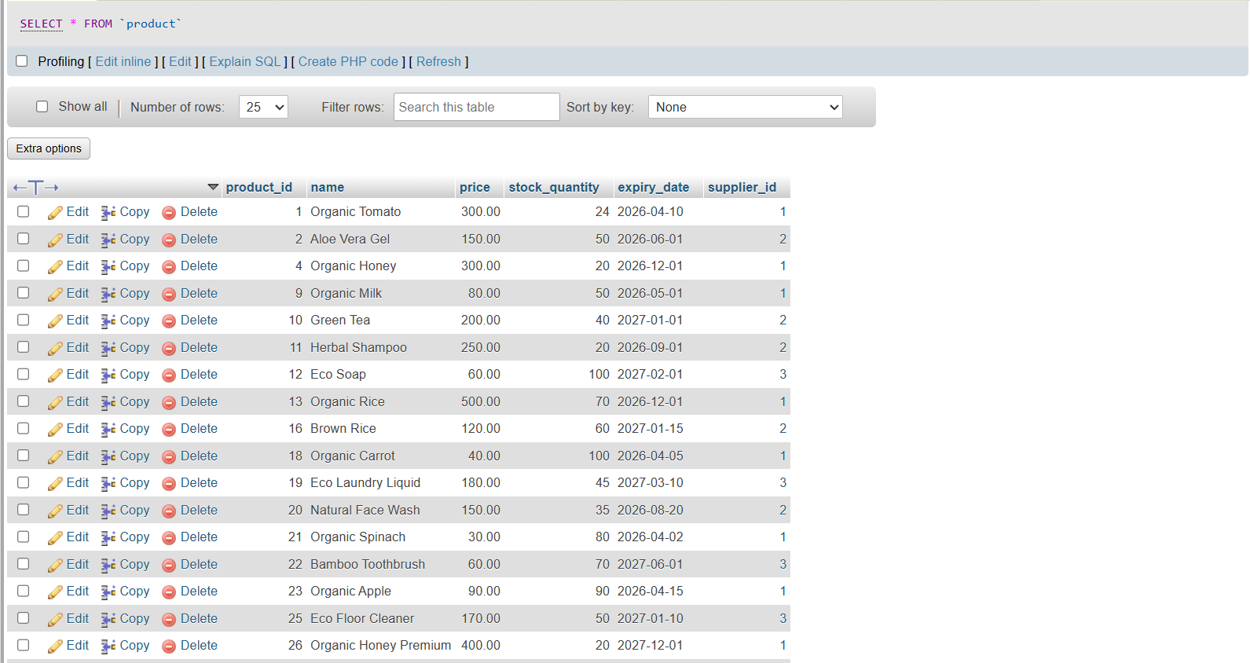
Figure 18: Sample Insertion for product entity
As shown in the figure 18, the product table contains the data, which is a normal procedure of the insertion part. One important element that has to be considered is isolating data, which means differentiating the order history or data of one customer from another bearing a different ID [8].
One of the important things to consider was ensuring the validity of the inserted data. To that end, queries were used. The queries involved the use of SELECT and FROM prompts for a product.

3.3.1 Purpose
The major purpose is to ensure that the datasbe operations can be tested successfully. It also helps to ensure that the existing relationship between entities in the table is explained thoroughly and is maintained. Further, it helps to validate the constraint implementation.

3.3.2 Data Volume
There are approximately 5-10 records used to create a sample. The tables are adequately populated to ensure effective and reliable testing. These records are used across all major tables, such as customer, product, and order tables.

3.3.3 Data Quality
To ensure that the datasbe contains records that look more like real-life business terms, like ‘organic’ and ' vegetables’ have been used. Also, the prices and stock quantities use numbers that appear more real. The customer name, ID, and addresses are synonymous; however, they are based on real-life information.

3.3.4 Evaluation
The use of relevant, more like a business sample data has helped in conducting the operations successfully. The key constraints have also been duly implemented throughout the sample data.

3.4 Stored Procedures
It can be defined as a predefined set of tables or information that can execute on its own once it is created. It is much like a code that only requires a specific prompt to run on its own. It is needed for the GreenLeaf online store because the admins with such a feature only have to use a particular name or ID to automatically retrieve or use information associated with a particular business process.
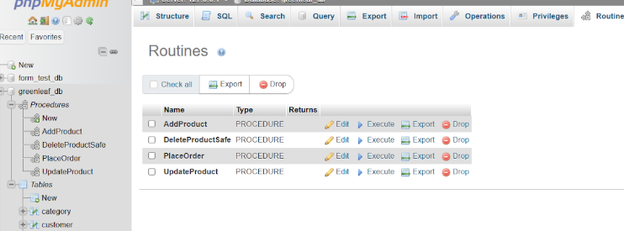
Figure 19: Stored Procedure
There are multiple types of procedures to be used, including Add Product, Update Product, and Delete Product procedures, as shown in Figure 19. Each of the procedure have distinct function, enabling easy updates without having to enter all the data and details.

3.4.1 Purpose
Its primary purpose is to ensure that there is a logical flow of data whenever any changes are made. It also ensures that there is no requirement for repeated use of SQL code whenever any query is to be made.

3.4.2 Add Product
This is a procedure where a new product will be added to the product table. For its implementation, different criteria are used that are considered acceptable within the system. They include name, price, quantity of the stock, and expiry date, among others.

CALL AddProduct ('Organic Honey', 320.50, 25, '2026-12-15', 1);
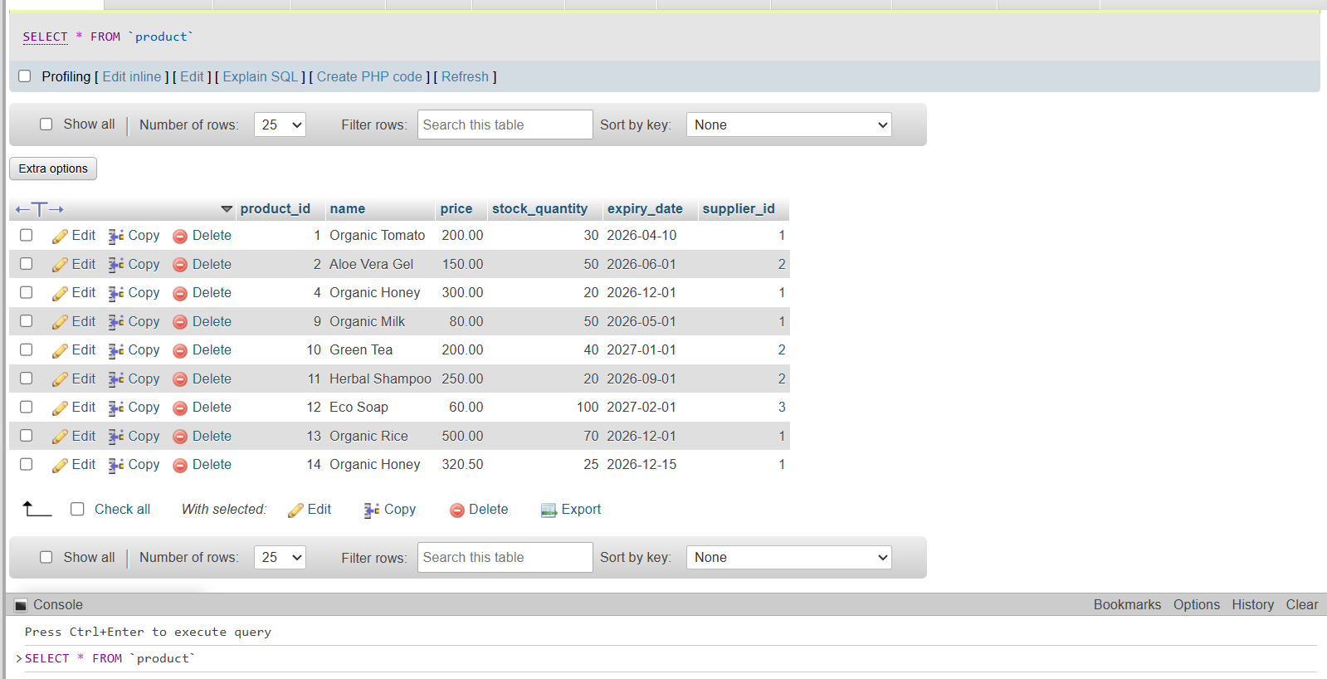
Figure 20: Add Product
As illustrated in Figure 20, the update transaction relies on the product ID as a primary key to ensure precise modification. When the admin updates a product like Honey, only the targeted record is accessed. This guarantees that changes are applied to the correct entry without affecting other products. Using a unique identifier maintains data integrity and ensures that the transaction remains isolated, consistent, and accurate within the database system.

3.4.3 Update Product
CALL UpdateProduct (14, 350.00, 30);
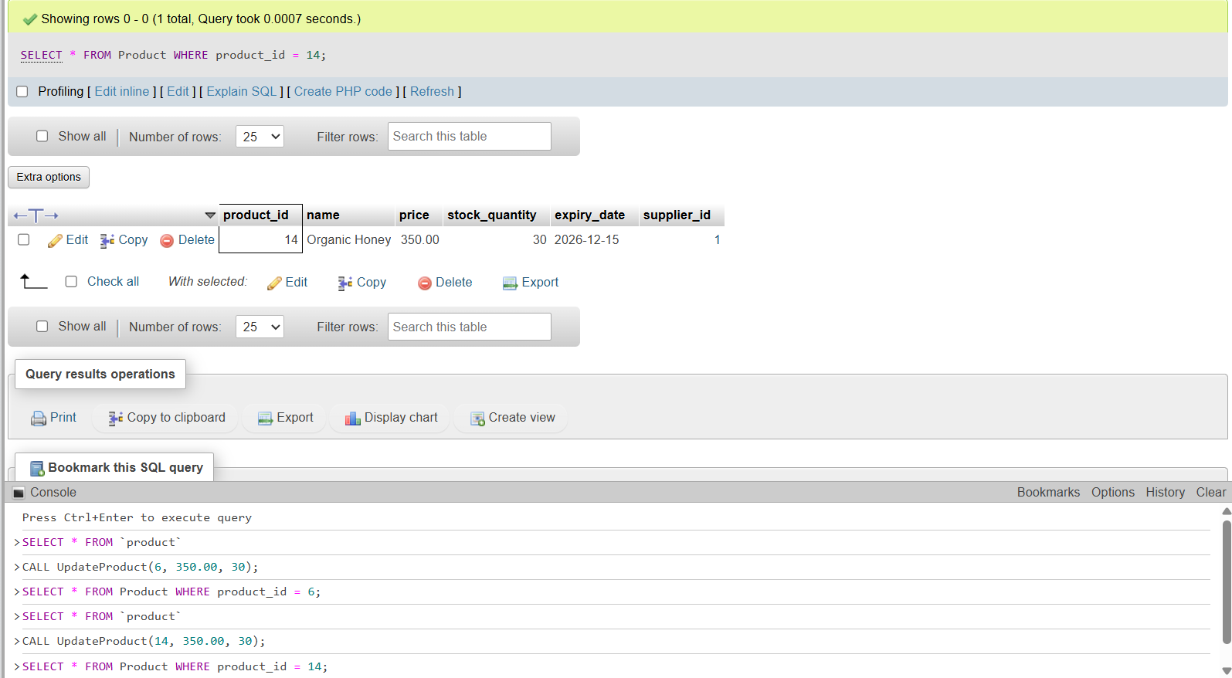
Figure 21: Update Product
Figure 21 demonstrates how the admin updates specific attributes, such as stock quantity. After identifying the product through its ID, the system allows controlled modification of selected fields only. This ensures that unrelated data like price or supplier details, remain unchanged. The procedure validates inputs before applying updates, preventing incorrect entries. Such selective updating improves efficiency and preserves database consistency while allowing flexibility in managing inventory records.

3.4.4 Delete Product
DELETE FROM Product WHERE product_id = 14;
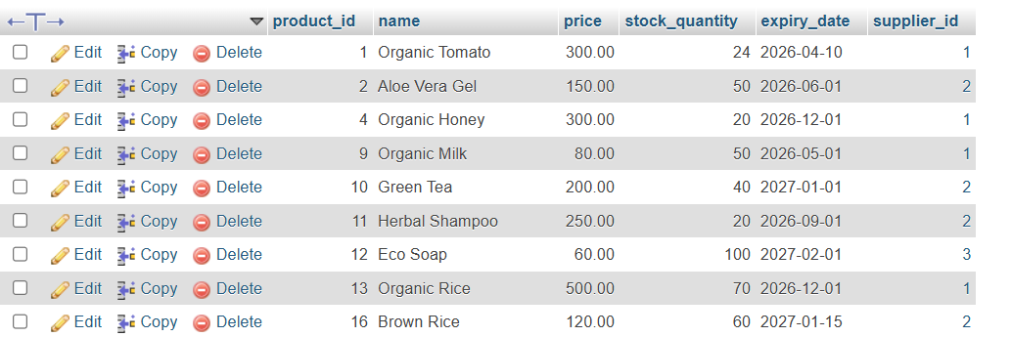
Figure 22: Delete Procedure
To remove a product, the admin uses a delete procedure based on the product ID:
DELETE FROM Product WHERE product_id = 14;
This query ensures that only the specified product is deleted from the database. The use of a primary key prevents accidental deletion of multiple records. Before execution, validation checks confirm the existence of the product. This controlled deletion process maintains database integrity and avoids unintended data loss while ensuring that obsolete or unwanted records are safely removed.
This procedure help admin to move the product from the database. However, to ensure that the references are adequately maintained, the procedure involves removing related records from any dependent table. For example, to delete the customer data, all related orders must first be deleted to ensure referential integrity.

3.4.5 Execution and Testing
The procedure uses a SELECT statement to ensure that the operations and data are stored successfully. To take an example, once a new product was added, the product table was scanned and queried to check if a new record was maintained.

3.5 Trigger Implementation
Trigger helps the admin to track changes made to the product table or any other table. While in the case of stored procedures, major actions are needed, triggers are automated. For example, if an admin selects or clicks on ‘Update,’ it will automatically get updated. Different forms of triggers are suitable for GreenLeaf online operations. They include after and before triggers applicable for updates, deletion, or insertion. In the case of GreenLeaf Organics, the After Update trigger is used.

3.5.1 Trigger Type
This data set uses an AFTER trigger to ensure that once an update is made, the trigger operation automatically makes and saves changes to the tables.

3.5.2 Audit Table
It is used in the product table for the audit system, as shown in Figure 13, which can help the admin to monitor historical values and compare them back and forth. As such, when an admin enters any keys like update or insert, modifications are automated. For example, if on the product table an email address needs to be changed, the stored procedure is used, and after that, the email gets updated using triggers, but ensures that the old attribute is retained for future references.
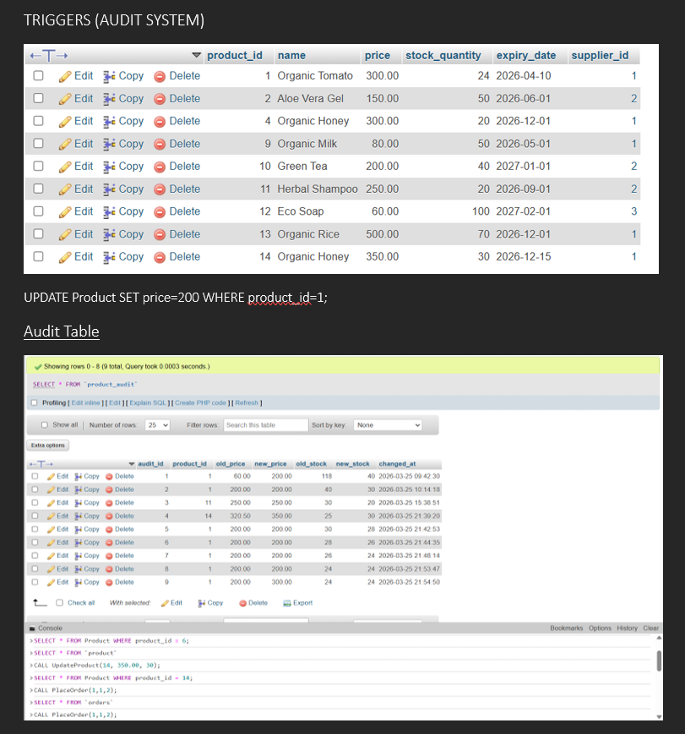
Figure 23: trigger procedure used for the audit system

4. Stored Procedure and Transactional Scenario

The stored procedures are critical and were implemented in the database mainly with the intention of creating business logic enabling its simplification. A stored procedure helps in reducing the time taken to make an SQL query in the database. Transactions are critical for GreenLeaf's online operation as it ensures execution of multiple functions in a given time. It is important to ensure that each step that makes an order successful is maintained.
The very purpose of the procedure is to provide a structural support for admins to execute any predefined operations at a given point in time. For example, if a customer has to place an order, they have to go through multiple stages, right from choosing the product, adding it to the cart, and including the necessary contact details. The customer likely faces issues while going through such transactions. As such, there is also a need to have mechanisms such as Commit and Rollback, which will be described in the later sections. Such a mechanism enables users of any system to go back and forth unless the transaction becomes entirely successful.

4.1 Understanding the concept of Transactions
Further, there are certain theoretical considerations which where required to be included for implementation. Since a transaction is considered an individual work or action taken or done at a time, it is important to ensure its stability throughout. As such, every transaction in a given online setup has to undergo the following process effectively:
Completion of all processes: also referred to as atomicity, where every part of a single transaction needs to be completed. Any failure in one of the steps leads to failure, for which mechanisms like Commit and Rollback are deployed.
Regularity or consistency: it is also important to ensure that the transaction at each stage has complete information, relationships, and constraints are adequately implemented. If any of the aspects, such as the constraint key, are missing, it leads to failure again.
Isolation: this is a very important stage where each customer making an order should be differentiated from another customer, even if the same orders are made. This is where the role of the primary key comes into play. Each primary key, which is the ID, ensures that duplication as well as replication of data is avoided.
Durability: this ensure permanence of data stored in the datasbe which protects it from overall system failure. This is where the role of Commit comes into picture even after adding or deleting things from the database.

4.2 Transaction Design in GreenLeaf Database
For the GreenLeaf database, the Place Order transaction was used to conduct tests and analysis. The following steps were considered:
- Assessment of existing stock, availability, as well as non-availability
- Creating a new record based on the assessment
- Insert a new record into the order items table
- Finally, make an update.

4.3 Implementation of transaction
For GreenLeaf, a transaction trial was performed using the procedure of Placing Order, where the important steps were performed. Other than that, a set of steps were used to ensure that each transaction could go successfully. It has been briefly explained in the following section:
- Once the order comes, check if the stock is available. This is done to validate stock existence. Here, the SELECT query is used, which helps in retrieving current stock information.
- Then, the second step is to insert a new record for that particular order with a new ID, order data, and the amount. This will help customer and the users to take the next step successfully.
- Then the next step is to insert order items into the database. This is done using the Order ID, product ID, its quantity, and current prices. As this process ends, the record for ordered products is stored.
- It is followed by making necessary updates to the existing stock so it becomes visible for users as well as the customers.

4.4 Rollback and Commit Operation
The role of commit and rollback operations comes into play once the transactional logic is implemented as described in the above-mentioned sections.

4.4.1 Commit Operations
Commit operation is used when all the transactions are succesufl leading to the final stage. It helps to save all major updates or changes and is saved permanently. It is mainly used to enable the database to save any changes made using the transaction logic. It could be for any attributes like stock, product, or customer information. The use of such operations ensures that once the order comes, the information needed from the backend is successfully stored, and the customer can take necessary actions, such as making a purchase successfully.

4.4.2 Practical Demonstration
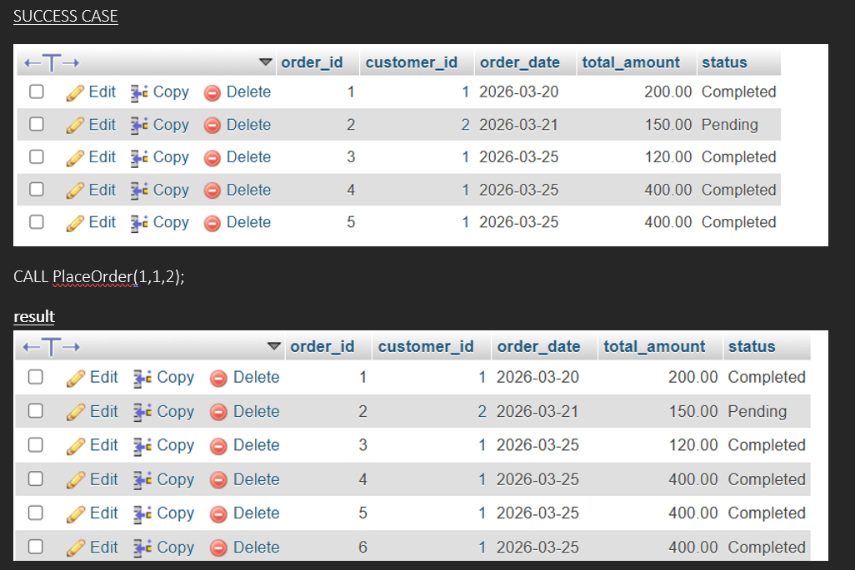
Figure 24: Successful use of the COMMIT operation
As shown in Figure 24, a successful transaction scenario where, before executing the order, it has five order IDs, and after the execution, it successfully saves six order IDs, thereby ensuring that there are enough stocks to support the order.

4.4.3 Rollback Operation
However, if there are any issues, such as the lack of stock for a particular order, a rollback operation is initiated, which will undo all the previous stages, thereby taking the database to the prior state. It helps to ensure that the incomplete data is not stored or sanitized in the database. The system automatically helps in detecting such insufficiencies, creating a prompt that enables the database to restore the information to its original state.

4.4.4 Practical Demonstration

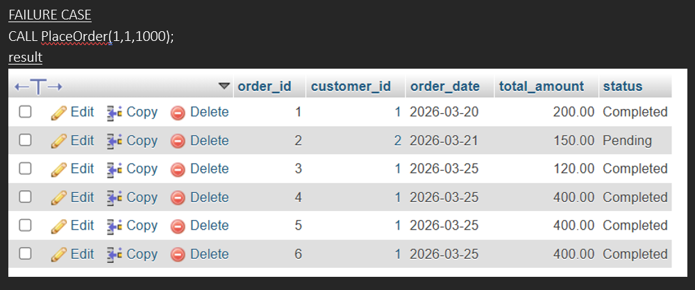
Figure 25: Example of a failed transaction
On the other hand, the failure case figure 25, illustrates the lack of availability of stocks of a particular product against the quantity demanded. The rollback operation is used if the non-availability of stock is detected in the system. As shown in the figure, even before and after the operations, the order items are six in number with no changes to be saved. It is in this case that Rollback takes the system back to the original state without making any material or economic loss to the user or the customers.

4.4.5 Error Handling
Error handling is mainly supported by rollback operations. However, considering the overall scenario, every time the stock availability is negative, the transactions will stop immediately for the system. Also, if the insertion into order leads to failure, it will not execute any subsequent actions.

5. Performance Tuning Enhancement
It is mainly used in a database to confront issues related to the data and queries. If any query is made by the customer or even the admin, the indexing helps to locate or access the needed information quickly. It is more like indexing the page number of a book for reference.

5.1 Index Implementation
In terms of implementation, the first thing that was addressed was to create indexes based on the search history. The focus was given to the product name as most user’s makes product related queries. The statement provided below is the actual example of indexing used for a product-related query:
For example, CREATE INDEX idx_product_name ON Product (name);
Every statement is used to enable easy searching for information related to a product. The query helps in filtering information based on product name, and there is no requirement for the system to search the entire product table, where there are multiple attributes and relationships. However, it is important to note that the given statement example applies only to a specific product and not a category. If category inputs are provided in similar codes, then the query can do the work in the same manner. Without the use of such indexing, a customer would end up mixing all the filters and not be able to find the true category of product, such as for sustainable lifestyle products or organic dairy products.

5.2 Benefits and impact
It mainly helps in retrieving required data and information within a time-bound manner. It also helps to reduce the complexity in searching for the needed file or information. For example, using indexes helps in reducing the requirement for processing multiple rows and columns, making the result more accessible in a time-bound manner. Further, it helps in optimizing the overall transactions, even with the increase in the number of data and information used in the database.

5.3 Improvement in terms of speed and efficiency
Query optimization was possible using the EXPLAIN command, which helps in understanding what information criteria, columns, or rows are used to make a search query fast and reliable.
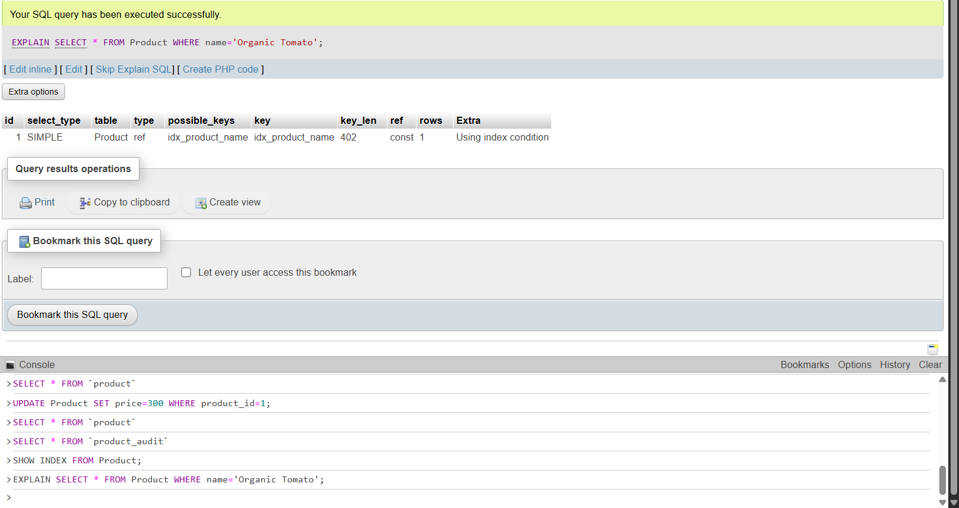
Figure 26: Index optimization
As shown in the figure 26, the use of the index idx_product_name reduces the number of scans and the time needed to make a search.

5.4 Evidence Using EXPLAIN
The database uses the EXPLAIN Statement, which provides complete details on how the query is executed by the system. It actually ensures that the index is in use or is affected by some error.

5.4.1 Interpreting EXPLAIN operation
The key column used is the idx_product_name, ensuring that the index is actually in use. Also, the value attributed to rows is limited, which ensures that the system can easily access the existing rows faster and more efficiently. Furthermore, there is an additional column indicating ‘using index condition’, which illustrates that the performance is optimized.

6. Conclusion and Reflection
The creation of a SQL-based database caters to the existing requirements of developing an online store. The key business processes are carefully integrated, focusing on all spheres, right from product, customer, and their reviews. Careful consideration is also given to factors that can affect the overall integrity, reliability, and credibility of the data. Different measures have been used that use practical experiences as well as theories.
Considering the challenges, the creation of the datasheet was the most critical challenge. Before that, the creation of ERD was more difficult because every other table and the relationship are to be entirely based on it. ERD was revised multiple times before finalizing it. Many interrelated aspects of database creation led to confusion. A few of the things had to be reconstructed multiple times before finalization. There is still room for making improvements based on the learnings from this project, as well as from existing theories, and real-time databases developed by similar brands and businesses.

References
[1] Microsoft, “What is a relational database?” Microsoft Azure, [Online]. Available: https://azure.microsoft.com/en-ca/resources/cloud-computing-dictionary/what-is-a-relational-database
[2] N. Amran, F. D. S. Bahry, A. H. A. Razak, M. S. Muksin, and N. A. A. Rahaman,
“Database conceptual diagram using ERD and data dictionary metadata for SME construction business,” International Journal of Academic Research in Business and Social Sciences, vol. 12, no. 10, pp. 2985–2999, Oct. 2022. [Online]. Available: https://www.researchgate.net/publication/365851456_Database_Conceptual_Diagram_Using_ERD_and_Data_Dictionary_Metadata_for_SME_Construction_Business
[3] “Third Normal Form (3NF),” GeeksforGeeks, Jul. 25, 2025. [Online]. Available: https://www.geeksforgeeks.org/dbms/third-normal-form-3nf/
[4] M. Demba, “Algorithm for relational database normalization up to 3NF,” International Journal of Database Management Systems (IJDMS), vol. 5, no. 3, pp. 39–51, June 2013, https://doi.org/10.5121/ijdms.2013.5303
[5] S. Kanwal, N. R. Chaudhry, R. Choudhary, Y. A. Shaik, P. Yadav, and A. Rashid, “Foreign Key Constraints to Maintain Referential Integrity in Distributed Database in Microservices Architecture,” International Journal of Advanced Computer Science and Applications (IJACSA), vol. 16, no. 6, 2025. [Online]. Available: https://thesai.org/Downloads/Volume16No6/Paper_96-Foreign_Key_Constraints_to_Maintain_Referential_Integrity.pdf
[6] C. Mancas, “On the Paramount Importance of Database Constraints,” Journal of Information Technology & Software Engineering, vol. 5, no. 3, 2015. [Online]. Available: https://www.researchgate.net/publication/292672966_On_the_Paramount_Importance_of_Database_Constraints
[7] M. S. Raisinghani, “3.1 Data Types, Database Management Systems, and Tools for Managing Data,” in Foundations of Information Systems. Houston, TX, USA: OpenStax, Mar. 5, 2025. [Online]. Available: https://openstax.org/books/foundations-information-systems/pages/3-1-data-types-database-management-systems-and-tools-for-managing-data
[8] B. Marandi, “A study on the role of database systems in the field of education,” International Journal of Cloud Computing and Database Management, vol. 5, no. 2, pp. 109–113, 2024. [Online]. Available: https://www.computersciencejournals.com/ijccdm/article/78/6-1-5-529.pdf

