12/2/2022
BA Business Management
Assignment 1-B
Student id: 2133455 Catalin I Marin

Table of Contents
Introduction: 2
EXPANDED KNOWLEDGE - Community Knowledge 3
HEALTHCARE PROGRAMS & POLICIES 3
THE IMPACT - Explicit Action 3
THRIVING COMMUNITIES 3
What could have been done differently and why? 4
BULLY-Free Communities 4
BIGGER PICTURE 4
BIG NAMES AND BIGGER PROMISES 4
BIGGER PROMISES, LARGER HURDLES 5
Conducting Research 6
Conducting community mapping? 6
Social engagement through social media platforms 6
Impact analysis and evaluation 6
Conclusion 7
References 9

Introduction:
Although the Birmingham 2022 Commonwealth Games will be remembered for some incredible sporting moments, its lasting impact is likely to be in other areas. At the root of this for Birmingham is the 2020 Legacy Strategy, which calls for the city to become a 'world-leading catalyst for social change by building on the work done by the Commonwealth Games. We will also need to harness the progress made at the 2017 Homelessness and Rough Sleeping Summit (launched with Prime Minister Theresa May in July 2017). Whilst the fight against rough sleeping in the city is still ongoing, several practical initiatives are beginning to address the issue.
Rough sleeping refers to sleeping rough or sleeping in temporary accommodation outside of a dwelling – whether it is a tent, makeshift shelter, or under a bridge. Rough sleeping also includes those sleeping temporarily in a place like a police cell, hostel, or for an extended period in a cold weather shelter.
Intentional interactions between communities and elected officials are necessary for community engagement. A top-down approach to public decision-making is challenged by the emphasis on the lived experience of community members taking a front seat and local knowledge inflecting decision-making processes (Clark and Kearns, 2021).
The project is firmly focused on utilizing Birmingham 2022 as inspiration and a platform to address inequalities and provide young people with a positive experience.
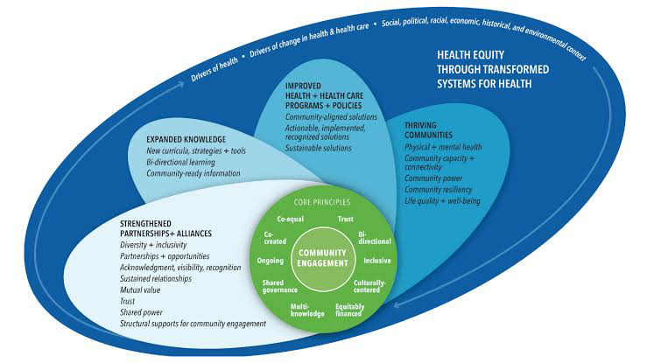
Best practices are of course essential, but one must also go beyond and ensure that the current system does not oppress those with 'alternative' perspectives.

EXPANDED KNOWLEDGE - Community Knowledge
Community knowledge is the power of creating space for dialogue between a community and those with power. A broad definition of 'knowledge' is needed, including institutional knowledge such as access to health care, legal systems, etc. The difference between the two projects can be described on health-related policies and actions that were a part of Birmingham Commonwealth Games.

HEALTHCARE PROGRAMS & POLICIES
Programs and policies must be built on high-quality evidence of success. More information is needed on what constitutes a well-rounded system that prioritizes community health, rather than private, corporate interests. Removal of carbon footprint was one of the main projects of this event. The goal of leaving a carbon-neutral legacy is a top strategic focus for the Games' sustainability initiative. For this endeavor, this means integrating the effect on the environment caused by the Games into every aspect of the operation in a genuine and comprehensive way. Together with our regional partners, suppliers, and other stakeholders, we will work to lessen our impact on the environment and the community at large. The strategy relies on the tried-and-true technique for measuring and controlling carbon footprint created by the International Olympic Committee after reviewing data from previous Commonwealth Games. The effects of all greenhouse gases, not simply carbon dioxide, are included in the CO₂e measurement of the Games' carbon footprint. The firm has relied on outside specialists throughout the process of measuring and managing its carbon footprint to ensure its accuracy and reliability.

THE IMPACT - Explicit Action
A local knowledge approach within a reflective strategic framework can help:
- Residents create and shape the processes and policies through which their communities are formed and safeguarded, ensuring that local power is co-decided.
- These processes enable a diverse and participatory learning process to determine how a community best reaches out and includes individuals and communities.
- This knowledge ultimately informs the policies and processes which are required to maintain and build a vibrant, well-connected, and resilient community, and ensures that the impacts of growth are inclusive and shared.

THRIVING COMMUNITIES
Community connecting - a key tenet of well-functioning communities. This allows participants to gain practical skills and take pride in the work they are doing. Working together allows for new social and economic networks to form, as well as the sharing of knowledge, skills, and resources (Helsinki, 2021).
Community engagement - connecting those who already have the power to make the change, and encouraging people who are new to a community to get involved. The project will assist people to leverage their resources to engage people in the projects they are working on.
Community power - each person plays a part in shaping their community, and the project encourages its participants to build up their strength. Participants are equipped with the knowledge and skills needed to not only participate in public decision-making processes but to be involved and carry out the work in the community and beyond (Johnston et al., 2021).

What could have been done differently and why?
In Birmingham 2022 Commonwealth Games: Living Legacy, the focus was on how various practices developed by local actors could be adapted and taken back to their communities, and how the impact of the process could be amplified. A critical aspect of this was the need to involve residents in each phase of the process.
BULLY-Free Communities - Provide safe spaces to debate tough issues; engage people on difficult issues by clarifying the limits of free speech, respecting differences, and providing context.
BIGGER PICTURE - Enabling people to connect in meaningful and productive ways and to take ownership and ownership of their communities

BIG NAMES AND BIGGER PROMISES
As a host city for the 2022 Commonwealth Games, Birmingham has a powerful platform to shape the community's participation, and what could have made a big difference was not realized. One of the most visible projects was Birmingham 2022: Living Legacy, which sought to create a community-led legacy from the games. However, there was little community involvement, the impact on marginalized communities was restricted and the risks of segregation as well as segregation at the games were well documented. This project has revealed potential missed opportunities.
The Living Legacy team undertook two key things in terms of design. First, they introduced a range of direct and indirect ways for people to get involved. The project ran "meet the team" sessions, where people were encouraged to join in with a short activity, for instance creating mascots, or what the team called "creative out-of-work democracy" activities, which gave people a chance to get involved by choosing an event to organize, and then giving out leaflets, completing an activity, or doing some other kind of work. The project also facilitated social media pages and groups. The second element of the design was to offer training to key public service workers. These included the Birmingham police, the Birmingham public health team, the road safety group, local politicians, and Birmingham 2022 itself.
In terms of delivery, the teams spoke with key actors in Birmingham, including the police, the mayor, and representatives of Birmingham 2022, and carried out interviews, and they also visited 20 of the city's largest parks and public spaces, taking the findings back to the partners and stakeholders. It then helped create a series of publications and two films that helped deepen the understanding of the issues and a toolkit for local people to get involved.

BIGGER PROMISES, LARGER HURDLES
As a result of the projects in Birmingham, the study identified issues with the way communities interact and communicate with the public service, the knowledge and skills gap around the event, and the impacts on marginalized communities. Some community representatives told us that they were unaware of the purpose of the work on the stadium, for example, and were skeptical about the uses of the facilities and the opportunities they offered the community. Birmingham 2022 also faced multiple obstacles. The research and advocacy groups in Birmingham highlighted that their role was neither conceived of nor discussed in the design process and several factors worked against them.
The Birmingham teams admitted that the projects were low-budget and had not been designed for integration or community engagement, which impacted the outcome. The high level of secrecy around the project meant that the teams were often isolated from their communities. On the other hand, the local players did not have the experience of engaging with communities and there was a lack of community awareness of the projects. The projects were based on assumptions that were not consistent with the community's knowledge or needs and there was a lack of regard for the effects of segregation on marginalized communities. The fact that the staff was only given a few weeks to produce activities meant that they were not subject to accountability and scrutiny and several important issues were not addressed. Given these findings, it is possible that Birmingham 2022 could have benefited from partnering with more organizations with a collective perspective (PennState College of Agricultural Sciences, 2022).
Discuss the impact of active consultation, communication, stakeholders’ participation, and inclusion? In terms of the impact of the project in Birmingham, there was clear evidence of a lack of engagement with the community on the projects, which meant the space felt empty. It had also experienced delays and the lack of adequate assessment meant that there were growing concerns that it did not deliver the outcomes they were looking for. Despite the clear and often negative effects of race, which are well documented, the research also found evidence of the communities’ concerns being ignored. This raised questions about the public service’s capabilities and their ability to learn from past mistakes.
Despite the shortcomings, there was also a clear recognition that Birmingham 2022 had had positive effects. Some community representatives described a greater interest from local people in the projects, and engagement with children as young as 12. There were positive reactions to the processes and the project, which showed that Birmingham 2022 was producing content that was valuable to the communities. Community groups described that they felt empowered to continue their work with the active involvement of the public service, and a general atmosphere of engagement.

Conducting Research
Birmingham 2022 Commonwealth Games gave priority to the development of the social capital they thought the games would bring to the city and were very focused on communication.

Conducting community mapping?
First, pre-mapping. the creation of a task force to direct the process. Establishing a Vision.
Next is mapping. Locating Resources Creating Mapping Tools and Techniques.
Third Step: Acting. creating a plan of action.
Step 4: Keeping up, continuing, and assessing mapping efforts Monitoring Progress

Social engagement through social media platforms
Birmingham 2022 was the first to commission research that integrates community engagement as a fundamental part of the process and to make public programming accessible to residents. Furthermore, they created an internal reporting structure to develop relationships with stakeholders and ensure active engagement (Naidoo and Grevemberg, 2022).

Impact analysis and evaluation
A determination of the impact of an intervention, whether intended or not, on results is known as an impact evaluation. However, the outcome data available from Birmingham 2022 was not sufficient to adequately address any challenges the researchers might face. The researchers’ findings were also affected by some of the questions being asked, which might have included engagement with other partners who also had plans for activities on the Commonwealth Games.

The interviews with project partners revealed that the leadership team understood the community’s questions about the project and that there were conversations that were either in progress or at an early stage regarding community engagement.
Justifying best practices - The public sector's willingness to adopt and assess best practices has a critical role to play in overcoming the issues highlighted by this investigation. It does not reflect a ‘business as usual attitude in terms of intellectual energy and resources, but one of common purpose and a common challenge.
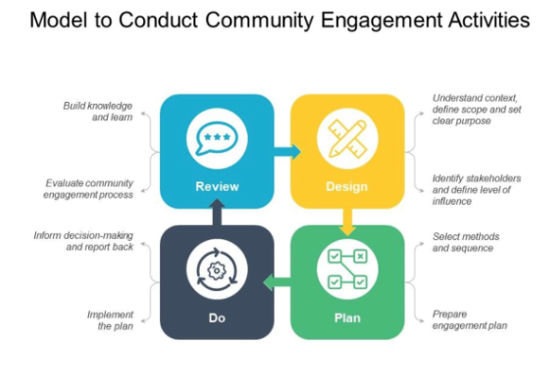

Conclusion
To address issues affecting those people's well-being, community engagement is the practice of working with and through groups of people who are connected by proximity to one another, common interests, or similar circumstances. It works well for affecting behavioral and environmental changes. The community engagement strategy for the [Commonwealth Games] Games in Birmingham (and the wider context) is based around three axes: culture, communications, and community planning, which form the basis of the thinking that underpins the participatory approach Is employed to identify communities that are interested in participating in the process, to consider what they want from participation, and to develop the mechanisms for collecting that information and actioning it to drive decision making.
However, if that planning is not part of a process that is public and public policy led, then we risk that development being driven by a corporate culture, which has little regard for the interests of those communities it would seek to affect.
The problem that has arisen in Birmingham is that the planning process has been co-ordinated and supported by a range of third-sector partners rather than a central government department and, as a consequence, has fallen victim to, at best, insufficient accountability and transparency.
The ‘Commonwealth Games’ brand has been designed and developed by a range of corporate partners, who have been invited into the process through various means. However, this led to some of the problems identified by the investigator with the loss of an important role for a central government department and a view that the process was driven by, rather than for, communities. It also meant that not all engagement processes were focused on getting those individuals and communities who had significant experience in participation and community campaigning into the process and that there was a tendency to bring in partners and ‘spin doctors’ rather than people who would add to the community contribution and community buy-in. - The community engagement process for the [Commonwealth Games] has taken place over a long period of time, often taking place over a number of years. For many community groups this has meant that they have not been involved in the process on an ongoing basis and that they have missed the opportunity to engage with those who have been consulted on decisions and processes.

References

Clark, Julie, and Ade Kearns. “Achieving a Sustainable Mixed Community: Report of a Survey of Residents of the Commonwealth Games Athletes’ Village in Glasgow.” Research-Portal.uws.ac.uk, 1 Aug. 2021, research-portal.uws.ac.uk/en/publications/achieving-a-sustainable-mixed-community-report-of-a-survey-of-res. Accessed 24 Oct. 2022.
Helsinki. Key Practices of Community Engagement – Communitybenefitconnect.org. 2021, www.communitybenefitconnect.org/cb-process/engage/introduction-engage/key-practices-of-community-engagement/. Accessed 1 Dec. 2022.
Johnston, Mel, et al. “Local Resident Support for Hosting a Major Sport Event: The Role of Perceived Personal and Community Impacts.” European Sport Management Quarterly, 18 June 2021, pp. 1–20, 10.1080/16184742.2021.1937263.
Meghan, R. “Steps to Successful Community Engagement | Outreach and Engagement | Office of the Provost | TTU.” Ttu.edu, 2019, www.depts.ttu.edu/provost/outreach-engagement/faculty/steps-to-successful-community-engagement/. Accessed 30 Nov. 2022.
Misener, Laura, et al. “Leveraging Parasport Events for Sustainable Community Participation: The Glasgow 2014 Commonwealth Games.” Annals of Leisure Research, vol. 18, no. 4, Sept. 2020, pp. 450–469, 10.1080/11745398.2015.1045913.
Naidoo, Urvasi, and David Grevemberg. “The Role of Athlete Commissions in Addressing Sport-Related Human Rights Abuses: A Case Study of the Commonwealth Games Federation Athletes Advisory Commission.” The International Sports Law Journal, 17 Jan. 2022, 10.1007/s40318-021-00208-9. Accessed 1 Dec. 2022.
PennState College of Agricultural Sciences. “What Is Community Engagement? (Center for Economic and Community Development).” Center for Economic and Community Development (Penn State University), 2021, aese.psu.edu/research/centers/cecd/engagement-toolbox/engagement/what-is-community-engagement.
Robertson. “What Is Community Engagement? Definitions, Examples & More.” Darzin Stakeholder Management App, 14 Dec. 2020, www.darzin.com/blog/what-is-community-engagement/.
Rogerson, Robert J. “Re-Defining Temporal Notions of Event Legacy: Lessons from Glasgow’s Commonwealth Games.” Annals of Leisure Research, vol. 19, no. 4, 26 Feb. 2019, pp. 497–518, 10.1080/11745398.2016.1151367.

