Student ID:2030517
Student Name:Claudia Georgiana Macarie

DATA ANALYSIS AND VISUALIZATION

Table of Contents
Part 1 3
Analyzing of the decline in sales along with profits over these years 3
Explanation of the utilization of Excel for doing data analyzing, data pre-processing and data visualization 4
Determining the decline in sales or profit by Pivot tables and IF 5
Part 2 9
2.1 Number of students those are interested in ice-cream which is vanilla om flavor 9
2.2 Number of female and male students 10
2.3 Median and mean of students 11
2.4 Exemplar of clustering 12
2.5 Illustration of common text mining and data mining methods 13
2.6 Discussion of the disadvantages and advantages of utilizing Excel and SPSS 13
Reference List 15

Part 1

Analyzing of the decline in sales along with profits over these years
In the dataset of Superstore sales, the rate of profit, discount, sales over the years effectively have been highlighted and it can be illustrated that, the profit has increased, side by side decline in profit over some years have also happened (Karakoc, 2022). It can also be stated from the data set that the decline in profit as well as sales have happened from the year of 2009 up to 2012. In August of 2009, the rate of sales was 261.54 and the profit was -213.25 and from this it can be highlighted that the decline in profit is much higher than the rate of sales.
In the same year, another profit was 642.8 and the decline in sales rate was -253.11 including that in this year also the rate of sales was 942.42 and the decline in sales was -634.87 (Zhang et al. 2019). On the other hand, in the month of December from the year, the rate of sales was 549.92 and the decline in sales was -210.97. From this it can be illustrated that, though sales have increased still side by side, the decline in the range of profit has also happened in the whole year. On the contrary, in December 2009, the rate of sales was 5572.92 and the profit range had slightly declined up to -639.47 in this case. In May 2009, the rate of sales was 3213.87 and the decline in sales had happened up to -1069.72 and from this illustration it can be highlighted that the decline in profit is higher than the sales rate.
In the June month of 2010, the rate of sales was 436.17 and the rate of decline in profit was -141.27 and from this it can be highlighted that profit did not happen in this month. On the other hand, in February of 2010, the rate of sales was just 669.02 and the decrease in profit was -1274.02 and from this it can be mentioned that the decline in profit was much higher than the previous year. In addition, in March, 2020, the rate of sales was 1168.15 and the decrease in rate of profit was -743.96 and from this it can be seen that in March this decrease in profit has also increased. In December 2010, the rate of sales was 1280.34 and the decrease in profit was -1048.25 and in this scenario the profit was much lower than the sales rate (Wahyuni et al. 2019). In 2011, the decrease in sales has also been shown in the dataset of Superstore Sales effectively.
In addition, in July 2011, the rate of sales was 663.784 and decrease in profit was -481.04 therefore, it can be illustrated that the profit rate was not much higher in this year also. In April, 2011, the rate of sales was 1837.44 and this had increased more in this month though the decrease in sales was -1414.41 and this was much less than the rate of sales. In October 2011, the rate of sales was 1326.04 and this was much higher in the sales range though the profit had declined up to -1129.96. Apart from this year, the decrease in profit had also occurred in the year of 2012 apart from the previous three years. In February, 2012, the rate of sales was 538.22 and decrease in sales was -154.66 and from this it can be shown that the sales are not much higher. In April 2012, the much higher decrease in sales happened as the rate of sales was 2728.65 and the decrease in sales was -5572.39 and in this case the decrease in profit was higher than the sales (Giovanni et al. 2022). In September, 2012 the sales were 281.546 and the decrease in profit was -434.56 that was higher than the sales.

Explanation of the utilization of Excel for doing data analyzing, data pre-processing and data visualization
In terms of crafting a data visualization within Excel, it is necessary to start through making an organized spreadsheet. Through the support of MS-Excel the data visualization, data analysis and data preprocessing can be conducted easily. There are several functions with MS-Excel that can support data pre-processing and these functions are RIGHT, COUNTIF, IF, MID, LEFT, IFERROR, ISTEXT and FIND. MS-Excel can be recognized as the most effective tool for managing and preprocessing the structured dataset for those who are non-programmers (Abdul-Rahman et al. 2021). A useful spreadsheet in Excel will help an individual to organize raw data into a format which can be readable and this supports in making this simpler to extract some actionable insights. In addition, in terms of handling the difficult data set, Excel gives a better chance to customize the fields and functions that support in making the calculations.
Data analysis in Excel supports in empowering one to gain a better understanding about the data through “natural language enquiries” that provides a better allowance to ask questions regarding the data instead of writing complicated formulas (Cleff, 2019). Moreover, analyzing the data gives a higher level of visual trends, patterns along with summaries. Analyzing data can be recognized as the most crucial part as it supports business firms in knowing their consumers better, enhances sales, increases sales, reduces costs and enhances customer targeting and gives a better chance in creating some “problem solving strategies” (Moriarty et al. 2022). There are several features within Excel to analyze the data and these features are XLOOKUP, COUNTBLANK, pivot charts, conditional formatting including pivot tables as well as MATCH. Apart from that, there are some more patterns of data analysis that are there within Excel mainly as sorting, filters along with charts. In addition, the VLOOKUP function can be recognized as a mostly used and renown function in MS-Excel and half of the people are utilizing this function. It is suitable for amalgamating data from several lists within one and also making a comparison of other 2 lists in order to match a few missing items (Liang and Liu, 2018). In this section it can be illustrated that there are some recent trends in Business Intelligence and these trends are Connected Cloud, Data Security, and Data Governance.
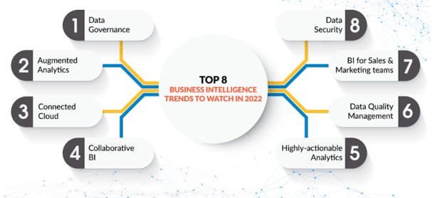
Figure 1: Trends in BI
(Source: Liang and Liu, 2018)
Graphs along with charts are mostly utilized in MS-Excel to make the graphical presentation for any specific data spreadsheet. Moreover, any chart in Excel can be considered as the visual presentation of any particular information, and in this chart the data labels are shown by some symbols and in Line Chart this shows in lines and in Bar Chart this shows in bar (Evergreen, 2019). The prime goal of visualizing the data is to create this in a much simpler way to identify the patterns, outliers and trends in any large dataset. In this data visualization study, IF function for data pre-processing, Pivot Table to analyze the data along with that some charts and graphs to visualize the data have been used. Any person can gain the capability to effectively manage data in the Excel datasheet in a more accessible and organized format through the support of Gantt chart, Line chart and Bar graph. Visualizing data gives a clearer concept of what accurately the data means through giving visual representation by maps and graphs (Becker and Gould, 2019).

Determining the decline in sales or profit by Pivot tables and IF
It has been shown in the previous section that Excel can be utilized for visualizing data, pre-processing of data and data analysis in a systematic way. In this work, two functions mainly as IF and Pivot Table in Excel have been utilized and graphs along with charts have also been formulated in Excel (Yan and He, 2020). The utilization of Pivot Table in Excel has been executed to make the large Superstore dataset more accessible and systematic in order. Any person can be capable of using this Pivot Table for scrutinizing numerical data in a detailed way as well as answering some of the unanticipated questions about the data.
This Pivot Table is known as an effective way to summarize the large dataset more easily. In addition, a Pivot Table has been effectively created to query large amounts of data in various patterns of user-friendly paths. In the Superstore Sales, the decrease in profits than the sales rate had occurred from 2009 up to 2012 and to highlight this this decrease in profits as well as sales for these four years have been shown by Pivot Table (Selwyn, 2022).
In January, 2009, the sum of sales was 1443.32 and in this sales rate the decrease in profit rate was -288.15 and in this case the decline is not much higher than sales rate. In addition, in October 2009, the rate of sales was quite higher which was 23347.67 in comparison to that the profit rate was -13261.64 and it can be illustrated that the profit was much lower (Jelen and Alexander, 2018). In addition, the grand total of sales was 4209896.846 and the grand total of profit was 434096.02 in 2009 and it can be illustrated that the profit was too low that the sales rate.
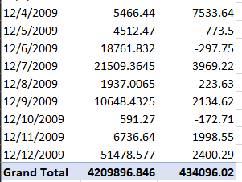
Figure 2: Total of sales along with profit in 2009
(Source: MS-Excel)
In February, 2010, the total of sales was 301.44 and the profit range was -213.03, therefore, in this scenario, it can be illustrated that the profit was much lower than the sales range. In March, 2010, the total sale was 5006.4595 and the profit range was much lower that was -2117.68 and it can be highlighted that, the profit has not increased in 2009 and 2010 also (McKee, 2021). The grand sum of the entire sale was 3560087.045 and the overall profit range in 2010 was 3644917.33 and from this it can be illustrated that the profit was much less than that sale.
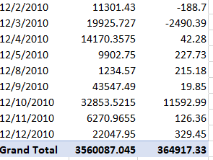
Figure 3: Total of sale as well as profit in 2010
(Source: MS-Excel)
During the year of 2011, the grand sum of sales was nearly 34429944.981 and on the other hand, the overall profit was 380310.5 and from this it can be mentioned that the profit has decreased much more than the entire sales rate (Cosma, 2019). In terms of showing this, the Pivot Table has been formulated and some graphs have also been generated in Excel.
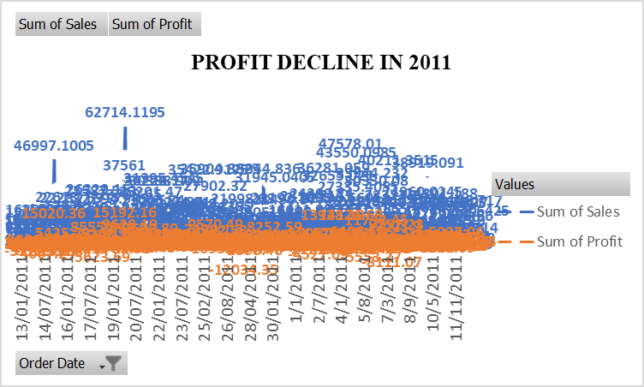
Figure 4: Profit decline in the year of 2011
(Source: MS-Excel)
In the year of 2012, the total sales related sum was 3715671.953 in comparison to that the total profit was approximately 342444.13 and from this result it can be shown that the profit range was much lower than the sales rate. In terms of visualizing this the below graph of profit decline in 2012 have been shown.
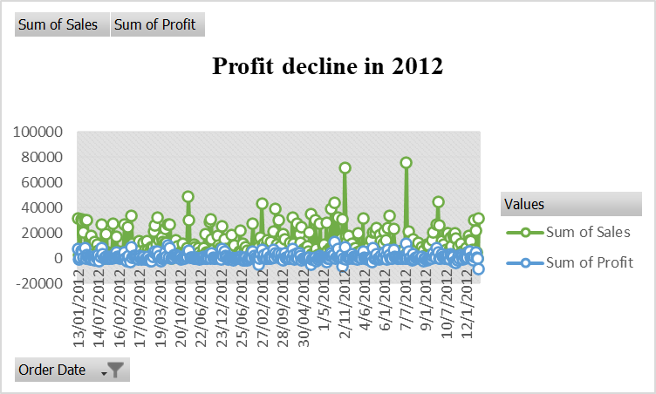
Figure 5: Profit decline in 2012
(Source: MS-Excel)
In terms of showing the profit decline over these four years, the line chart in the below has been shown through the Pivot Table. In these four years, the sales range was quite higher though in comparison to that the estimation of profit was way lower.
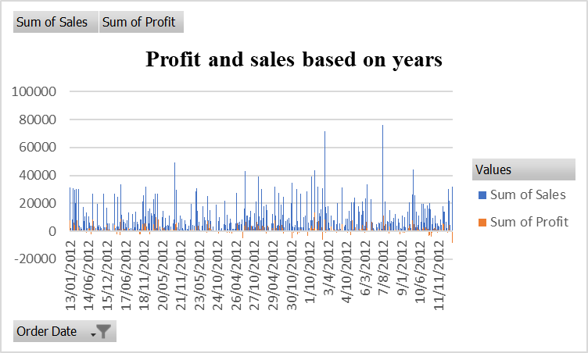
Figure 6: Line chart of profits and sales over the years
(Source: MS-Excel)
In the given dataset, the function of IF has effectively been used to highlight the increase in sales and decline in profit in 2009, 2010, 2011, and 2012. In 2011, the profit range was 30.94 along with that the rate of sales was 394.27 along with as per to the function it shows that the profit has declined. In 2012, the profit range was 1198.97 and the rate of sales was 4965.76 and as per this function again the profit has declined (Zhou, 2020). On the contrary, in 2009, the rate of sales was 191.67 and the profit range was -236.27 along with as per to IF the profit has declined. Thus, it can be concluded that the function of IF has been used effectively in Excel in order to do data processing.

Part 2

2.1 Number of students those are interested in ice-cream which is vanilla om flavor
As a data analyst, a survey of 200 high school students has been conducted and their data has been collected on several tests such as a puzzle and a video game. A report work has been generated by evaluating these findings by the support of Bar, Histogram and Pie depending on the dataset of Ice cream.xls and Ice cream_csv (Aziz and Aftab, 2021). From the survey how many students are liking ice cream which is vanilla flavored have been highlighted in this area using SPSS software.

ice_cream
 |  | Frequency | Percent | Valid Percent | Cumulative Percent
Valid | 1 | 95 | 47.5 | 47.5 | 47.5
Valid | 2 | 47 | 23.5 | 23.5 | 71.0
Valid | 3 | 58 | 29.0 | 29.0 | 100.0
Valid | Total | 200 | 100.0 | 100.0

Figure 7: Percentage of ice cream flavor
(Source: SPSS)
It can be illustrated that, 1 is representing vanilla flavor and in the above figure it is showing that the percentage of 1 is 47.5. On the contrary, 2 represents chocolate and the percentage of chocolate is 23.5 and 3 means Strawberry and it has 29.0 and thus 1 has the higher percentage. In thee below the percentage between the ice cream flavor is clearer (Hosseini and Sardo, 2021).
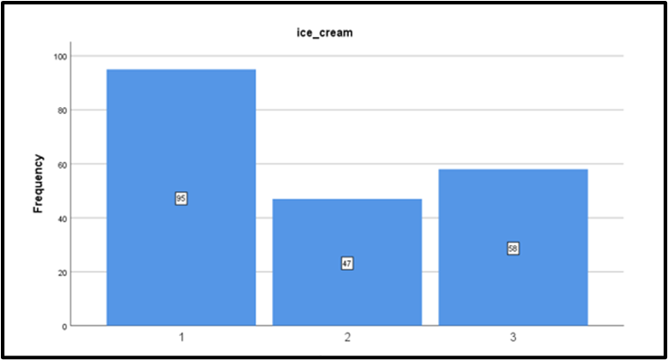
Figure 8: Histogram
(Source: SPSS)

2.2 Number of female and male students

female
 |  | Frequency | Percent | Valid Percent | Cumulative Percent
Valid | 0 | 91 | 45.5 | 45.5 | 45.5
Valid | 1 | 109 | 54.5 | 54.5 | 100.0
Valid | Total | 200 | 100.0 | 100.0
Figure 9: Percentage of female and male
(Source: SPSS)
In the survey how many students were female and male have been estimated through the support of SPSS software. It can be shown that, 1 represents female and 0 represents male, and thus, from the above figure, it can be highlighted that, the percentage of females is higher as percentage of 1 is 54.5 and on the other hand, percentage of 0 is 45.5 (Denis, 2018). In order to highlight this, the percentage of females and male more clearly, the below pie chart has been given. From the pie chart, it can be illustrated that, the estimation of female is higher than the male students. From this it can be known that females are more into ice cream than the male students.
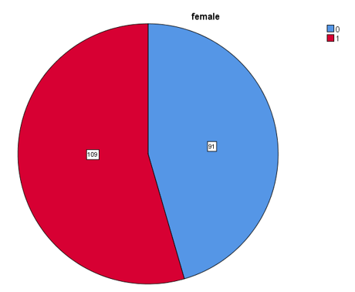
Figure 10: Pie chart
(Source: SPSS)

2.3 Median and mean of students
The median and mode of the respondents who are liking strawberry and chocolate ice cream effectively have been highlighted by using SPSS software. The number of high school students is 200 and the mean statistics of students who are interested in strawberry and chocolate ice cream is 1.82 including that this value is positive as it is higher than 1. Moreover, the minimum statistics estimation is 1 and maximum statistics estimation is 3 including that these values are positive as all are above 1 (Lemenkova, 2019). In the end, it can be concluded that half of the respondents are liking chocolate along with strawberry flavors.
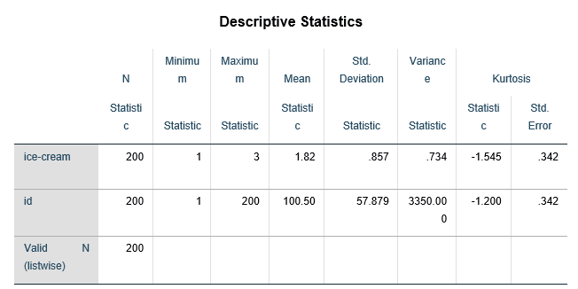
Figure 11: Descriptive statistics
(Source: SPSS)

2.4 Exemplar of clustering
“K-means clustering” can be recognized as the basic unsupervised learning related algorithm that is utilized in terms of resolving clustering problems (Yuan and Yang, 2019). It focuses on the simple process of classifying a provided data set into an estimation of clusters, illustrated through the letter “k” that is effectively fixed beforehand.
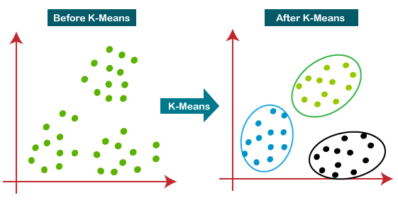
Figure 12: “K-means clustering”
(Source: Yuan and Yang, 2019)

2.5 Illustration of common text mining and data mining methods
The major basic and renowned data mining methods that can be used in business is Machine Learning along with some of the business firms are utilizing machine learning in their business operation. Facebook, IBM, Google, Apple, Intel, Microsoft, Amazon, Pinterest and Twitter are utilizing machine learning. It can be specified that, “increasing automation in data mining” can be recognized as the current trend within data mining. Information extraction can be recognized as a suitable method for text mining that can simply be used for business purposes and in order to highlight examples, it can be definited that this method is effectively utilized for legal documents, presentations as well as for scientific papers (Wang et al. 2021). In this section, it can also be highlighted that AI operations, higher utilization of SaaS are examples of present trends in data warehousing. It can be quantified that, in the present times, data mining, data warehousing and BI are utilized more effectively. Side by side, the data mining along with “text mining methods” utilization are also increased in companies in the present days.

2.6 Illustration of the disadvantages along with advantages of using Excel and SPSS
Advantages of using Excel | Disadvantages of using Excel
1. Utilizing MS-Excel can be recognized as the most useful way for visualizing data by the support of graphs and charts. | 1. Excel sometimes becomes more complex to do troubleshooting or testing. In terms of showcasing practical examples, it can be detailed that this becomes more difficult to use as it sometimes hangs or stops working.
2. Excel has all the necessary tools to analyze the data and thus, analysis of data can simply be executed in Excel. | 2. MS-Excel usage has already been criticized for bringing mistakes in the papers of academic gene (BBC News, 2016).
Table 1: Disadvantages and advantages of MS-Excel
(Source: Self-made)
Advantages of using SPSS | Disadvantages of using SPSS
1. Through the support of SPSS beneficial data management can be done. For instance, SPSS gives data analysis for predictions, descriptive statistics and bivariate statistics to analyze groups. | 1. The attributes of graphs of this software are not easy though, on the contrary using MS Excel is much simpler.
2. It is not requiring additional effort to start to utilize this software. In terms of giving practical examples, in the software’s interface it highlights open data along with a spreadsheet in its prime view (Ibarra-Cisneros et al. 2020). | It needs training to properly exploit various of the already available attributes.
3. It is useful for doing quantitative and qualitative data analysis. For instance, it can be illustrated that this software is used through various researchers to perform quantitative analysis. | 4. It can be itemized that, SPSS is more costly to purchase and as an impact of this most students are not able to purchase this for their tuition purpose.
Table 2: Disadvantages and advantages of utilizing SPSS
(Source: Self-made)

Reference List
Abdul-Rahman, M., Chan, E.H., Wong, M.S., Irekponor, V.E. and Abdul-Rahman, M.O., 2021. A framework to simplify pre-processing location-based social media big data for sustainable urban planning and management. Cities, 109, p.102986.
Aziz, N. and Aftab, S., 2021. Data Mining Framework for Nutrition Ranking: Methodology: SPSS Modeller. International Journal of Technology, Innovation and Management (IJTIM), 1(1), pp.85-95.
BBC News, 2016. Microsoft Excel blamed for gene study errors. [Online]. Available athttps://www.bbc.com/news/technology-37176926 [Accessed on: 15 November, 2022]
Becker, L.T. and Gould, E.M., 2019. Microsoft power BI: extending excel to manipulate, analyze, and visualize diverse data. Serials Review, 45(3), pp.184-188.
Cleff, T., 2019. Applied statistics and multivariate data analysis for business and economics: A modern approach using SPSS, Stata, and Excel. Springer.
Cosma, E., 2019. Pivot Table: A Tool to Calculate, Summarize, and Analyze Data. Ovidius University Annals, Economic Sciences Series, 19(1), pp.161-166.
Denis, D.J., 2018. SPSS data analysis for univariate, bivariate, and multivariate statistics. John Wiley & Sons.
Evergreen, S.D., 2019. Effective data visualization: The right chart for the right data. Sage Publications.
Giovanni, A., Sijabat, Y.P., Hirawati, H. and Jauzaa, A., 2022. QUALITY OF INVESTMENT DECISION, BUSINESS RISK, EFFICIENCY AND PROFIT GROWTH. Jurnal Riset Bisnis dan Manajemen, 15(2), pp.67-74.
Hosseini, S. and Sardo, S.R., 2021. Data mining tools-a case study for network intrusion detection. Multimedia Tools and Applications, 80(4), pp.4999-5019.
Ibarra-Cisneros, M.A., Hernández-Perlines, F. and Rodríguez-García, M., 2020. Intellectual capital, organisational performance and competitive advantage. European Journal of International Management, 14(6), pp.976-998.
Jelen, B. and Alexander, M., 2018. Microsoft Excel 2019 Pivot Table Data Crunching. Microsoft Press.
Karakoc, B., 2022. Information Asymmetry, Shortage of Liquidity and Evidence on the Role of Credit Sales in Business-to-Business Marketing. Global Business Review, p.09721509221116690.
Lemenkova, P., 2019. Numerical data modelling and classification in marine geology by the SPSS statistics. International Journal of Engineering Technologies IJET, 5(2), pp.90-99.
Liang, T.P. and Liu, Y.H., 2018. Research landscape of business intelligence and big data analytics: A bibliometrics study. Expert Systems with Applications, 111, pp.2-10.
McKee, T.E., 2021. Analyzing An Audit Population Via Either Excel Pivot Tables and/or R Language Cluster Analysis. Current Issues in Auditing, 15(1), pp.I1-I14.
Moriarty, B., Held, B. and Richardson, T., 2022. Microsoft Excel Functions and Formulas: With Excel 2021/Microsoft 365. Stylus Publishing, LLC.
Selwyn, N., 2022. ‘Just playing around with Excel and pivot tables’-the realities of data-driven schooling. Research Papers in Education, 37(1), pp.95-114.
Wahyuni, L., Fahada, R. and Atmaja, B., 2019. The effect of business strategy, leverage, profitability and sales growth on tax avoidance. Indonesian Management and Accounting Research, 16(2), pp.66-80.
Wang, L., Huang, Y. and Omar, M., 2021. Analysis of blended learning model application using text mining method. International Journal of Emerging Technologies in Learning (iJET), 16(1), pp.172-187.
Yan, C. and He, Y., 2020, June. Auto-suggest: Learning-to-recommend data preparation steps using data science notebooks. In Proceedings of the 2020 ACM SIGMOD International Conference on Management of Data (pp. 1539-1554).
Yuan, C. and Yang, H., 2019. Research on K-value selection method of K-means clustering algorithm. J, 2(2), pp.226-235.
Zhang, S., Pauwels, K. and Peng, C., 2019. The impact of adding online-to-offline service platform channels on firms' offline and total sales and profits. Journal of Interactive Marketing, 47, pp.115-128.
Zhou, H., 2020. Learn Data Mining Through Excel. Apress.

