Single Sign-on capabilities to MobileEPR application

Introduction
Access to patient information is now more streamlined and efficient. In addition to electronic patient records (EPR) being accessible through desktops and workstations on wheels (WoWs), mobile devices now support EPR system, offering lightweight, on-the-go data access (Ventola, 2014). Mobile applications enhance healthcare delivery by improving health record management, patient monitoring, and decision-making, leading to better patient outcomes (Alkhuzaimi et al., 2024). Healthcare professionals can now complete essential tasks safer and faster.
Milton Keynes University Hospital (MKUH) is a medium-sized acute district hospital under NHS England, serving the growing population of Milton Keynes and surrounding areas. With a capacity of 550 beds and a workforce of 4,000 staff, MKUH provides care to approximately 400,000 patients annually, including outpatient and emergency attendances (About Us-MKUH, 2025). MKUH has undergone digital transformation, utilising electronic health records for the past six years. Nursing workflows such as drug administration and clinical documentation, are now conducted digitally on their EPRs desktop version. This information system has now been extended to mobile devices through a software application called MobileEPR.
MobileEPR also aids in positive patient identification through wristband scanning, using its built-in scanners and clinical photo documentation with its camera functionality. However, adoption among nurses has been limited due to the complex login process and strict password requirements, leading to underutilisation of the product and a low return on investment (Gabutero, 2025). To improve adoption rates and maximise the benefits of the app, digital solutions and initiatives are being explored to further streamline the login process. One proposed solution is the integration of Single Sign-On (SSO) to improve user experience and adoption.
Single Sign-On is a service that enables users to access multiple platforms and applications with a single set of credentials via a secure session and authentication process (Pandey and Nisha, 2021). SSO simplifies user authentication and access management, enhances the user experience, and saves time when accessing healthcare applications (James et al., 2020). This essay will outline the SSO project proposal, using the Information Technology Infrastructure Library (ITIL) framework to ensure a more structured, efficient, and organised approach to planning and implementation.
The aims of this project are:
- Enable staff to access MobileEPR through a single, simple, and secure login.
- Increase adoption and optimise the use of MobileEPR.
- Reduce password-related issues, freeing up IT (Information Technology) support and back-office resources.

Scope
This project will focus on inpatient wards where mobile devices are already available. The primary target users are nurses, who rely on mobile technology for patient care and documentation. By implementing SSO, MobileEPR will be more accessible, efficient, and user-friendly, ultimately enhancing workflow efficiency and improving patient care in MKUH.

Methods
The upcoming changes in this SSO project will replace the current login process for nurses accessing their MobileEPR accounts. The new system will align with the existing login process used for the EPR on WoWs, creating a more seamless user-friendly authentication experience. The following sections will discuss SSO project planning.
Current State
Mapping the current state of the service in need of improvement is a critical first step in identifying its strengths and areas for improvement (Hanks, 2024). Laying out the service's existing processes results in valuable insights into what aspects are working well, and which ones require attention. Below are the steps in MobileEPR login.
- Nurses log in to the device using their work email and password, which may require multi-factor authentication (MFA) via Microsoft Authenticator.
- They set a session PIN, allowing quick access to the device when the screen locks.
- To access MobileEPR, nurses must log in separately using their Smart Card credentials, different from their email credentials. The application will only allow 3 failed password attempts before the account is locked and needs resetting by the Back-office team.
- Once authenticated, they can use the app.
- After their session, they log out of the app manually.
- Log out of the device, making it ready for the next user.

Future state
Below is the desired login process after SSO integration.
- Nurses will log in to the device and all installed apps (including MobileEPR) using their Smart Card credentials in a single step.
- They will scan their SmartCard identification
- Users enter the same password they use for WoWs. This will authenticate them across all apps on the device.
Note: When the screen locks (after 3 minutes of inactivity), they simply: Tap their smartcard. Enter their PIN to regain access instantly.
- To log out, nurses tap their smartcard on the device, and they will be fully logged out.

Baseline measurement and Key data points
The baseline measurements of this project proposal are reflected in the results of the MobileEPR assessment where the top three issues for low adoption of MobileEPR are login and password challenges, accessibility issues, and perceived necessity (Gabutero, 2025). Among these, the complexity of login and password requirements stands out as the most significant barrier. After implementation, SSO will aim to improve the data on:
- Password reset request to IT
- Number of MobileEPR launches and usage per month
- Staff feedback regarding the use of MobileEPR

Return of Investment
The estimated return on investment (ROI) will be used to assess the net financial gains of the project by considering all resources invested and the benefits realised (Ingram, 2025). This includes costs related to procuring mobile devices for housing MobileEPR, along with accessories such as docking stations, as well as capital investment in MobileEPR. Additionally, expenses incurred during the go-live and optimisation phases will be factored in. The ROI calculation will also account for financial gains through increased revenue and cost reductions. As this is not an area of expertise, collaborating with the finance team and other relevant staff will be essential in accurately analysing the financial impact.

Project Team and Stakeholders
The SSO integration will be implemented in designated wards with mobile devices, involving multiple teams to ensure a seamless rollout. The back-office and software development teams will handle the integration, while the engineering team will ensure network connectivity, device security, and software updates. The training and project teams will oversee communication with nurses, and the clinical informatics team will act as a bridge between IT and clinical staff. On the user side, nurses will be the primary stakeholders, with senior clinical teams providing oversight to ensure clinical safety and compliance in using these devices.
Roadmap
Implementing the SSO system requires a structured approach to ensure seamless integration, stakeholder alignment, and long-term success. The following timeline in Figure 1 outlines key phases of the project, from initial planning to post-implementation evaluation.
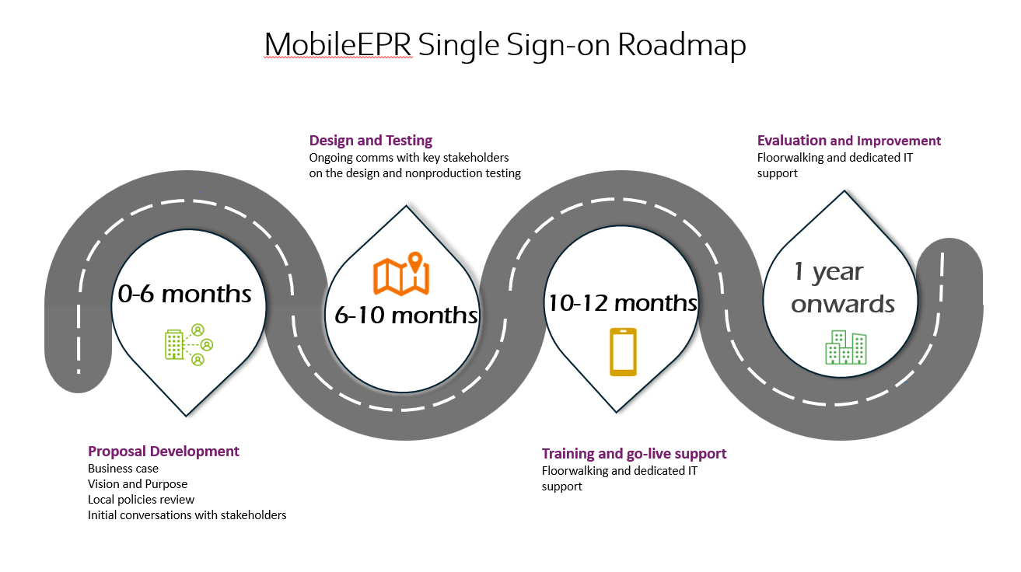
Figure 1. Single Sign-on Roadmap from planning phase to post implementation evaluation.

0-6 Months: The business case and vision for the proposal are developed and shared with relevant stakeholders. Local policies are reviewed to ensure the project aligns with tech and care standards. Once approved, benchmarking is conducted, and a suitable product is selected for integration with the current software and data policies.
6-10 Months: SSO software integration is designed and tested. Ongoing discussions, demos, and testing with stakeholders are conducted.
10-12 Months: Training is provided, and go-live support is offered.
1.5 Years Onwards: Product evaluation begins by comparing data points to baseline measurements to assess improvements.
Strategy
The SSO integration will be implemented in two phases. The first phase, the non-live phase, will focus on planning, design, and testing. During the planning stage, key stakeholders and relevant IT teams will hold a series of meetings to assess the current state, define key objectives, and establish desired workflows. These discussions will continue regularly until the design and process receive stakeholder approval. The SSO will then be integrated into a non-production domain, allowing flexibility for design adjustments and thorough testing. Once fully tested, final approval from stakeholders will be obtained before deployment in the live domain. If necessary, training can be provided to nurses, though general communications and relevant quick reference guides. A go-live support phase will address any issues encountered, followed by an evaluation of the implementation months after deployment. The strategies and planning outlined in this essay will be structured and guided by the Information Technology Infrastructure Library (ITIL) framework, a best practice methodology for IT service management that ensures IT services are effectively aligned with business needs (Vivianto, 2024).

ITIL
ITIL is a structured framework of concepts and best practices designed to standardise the selection, planning, delivery, maintenance, and overall management of IT services throughout their lifecycle within a business (Susnjara and Smalley, 2024). Its primary goal is to enhance efficiency and ensure predictable service delivery on best practice approaches and guidelines (Vivianto, 2024). This framework aligns IT operations and expenditures with business needs, allowing for adaptability as the organisation evolves or shifts direction (Hashemi-Pour, Bigelow and Montgomery, 2024). Figure 2 shows the ITIL framework as a continual service improvement alongside its related processes (ITIL Logo – LogoDix, 2025).

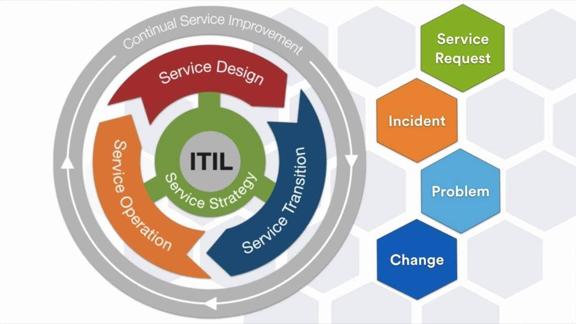
Figure 2 The ITIL Framework Continual Service Improvement (ITIL Logo – LogoDix, 2025)
ITIL requires a shift in mindset from a technology-focused approach to a customer-focused approach (Susnjara and Smalley, 2024). In healthcare, where services continuously revolve around patient needs, IT services must align to support patient care and safety in a consistent manner (Edgman-Levitan and Schoenbaum, 2021). ITIL helps ensure these critical IT services are delivered in a way that is not only efficient but also focused on the needs of patients and healthcare providers (Vivantio, 2024).
There are project management methodologies which can be used to successfully implement a project, including IBM Service Management, the Microsoft Operating Framework, and IT Service Management (ITSM), which encompasses ITIL (Susnjara and Smalley, 2024). However, ITIL has been chosen for this project integration because it emphasises collaboration with people and continuous service improvement, the key factors in addressing the gaps identified in MobileEPR adoption. The following sections will discuss the implementation of SSO following ITIL guidelines.
To initiate a project based on ITIL standards, several key functions must be in place. First, an IT interface or service desk must be established for issue logging and monitoring. The trust involved in this project has a dedicated service desk team responsible for handling IT issues and overseeing operational services. Additionally, IT technical and application management play crucial roles in infrastructure planning and software support, functions that are reflected within the project team and stakeholders. Lastly, operations management includes service agreement plans and a disaster recovery plan, which serve as essential guidelines for addressing potential issues. These key functions must be in place before launching an ITIL-based project.
Discussion
Several risks have been identified that could impact the successful implementation of this project. First, there is the potential for developmental delays caused by unforeseen challenges, such as integration or testing failures. Since SSO software differs from MobileEPR, ensuring smooth integration not only with the EPR but also with device logins is critical. Failure in this area would undermine the entire project's purpose and be considered a hard stop in implementation. Another common risk is budget overruns, as unexpected resource needs may arise during the design and testing phases. Budget overruns can result from several factors, such as the need for additional software licenses, extended development time due to integration challenges, or the hiring of specialised personnel to address technical complexities (Acquaint Sofitech, 2024). Unexpected costs may also occur from security enhancements, compliance requirements, or modifications needed to align the system with existing infrastructure. Additionally, stakeholder pushback is a concern, potentially hindering the adoption of the SSO system (Eastgate Software, 2024). For clinical staff, the introduction of SSO might be perceived as an additional complexity rather than a solution, especially if previous IT changes have been met with frustration and still see MobileEPR as an unnecessary option to access EPR. Moreover, security breaches pose a significant risk, with the potential to compromise sensitive user or patient data, leading to more severe data breaches. These risks must be regularly reviewed and addressed throughout both the design and production phases to ensure that healthcare service delivery remains uncompromised.
In terms of downstream improvements, several efforts can be made to further enhance the efficiency, security and user experience of SSO. After implementation, some users may still experience inefficiencies related to access control that may need manual adjustments on user permissions, leading to more delays and security risks. Automating this process would be a great benefit. For example, synchronise automation with user directory to automatically grant or revoke access especially role changes reduce IT workload by safely replacing manual interventions (Niedringhaus, 2020). Furthermore, addressing display issues identified by users in the MobileEPR assessment (Gabutero, 2025), such as auto-rotation and font display problems, will enhance navigation and provide a more seamless experience when accessing the application. An improved user interface improves completion of tasks and promotes accurate documentation (HealthManagement, 2023). This improvement can also be done pre going live if resources allow. Lastly, regular audits and compliance reporting such as real time analytics and dashboards enables the organisation to track progress and promptly investigate identified issues (Alhmoud et al., 2022). Data dashboards showcasing the benefits of MobileEPR such as improved clinical photo documentation and increased patient scanning for drug administration can help stakeholders recognise MobileEPR’s value and use the app more effectively. These improvements ensure that SSO remains a scalable and effective authentication solution while supporting evolving organisational needs.
With managed risks and downstream improvements, IT project implementations become more seamless and successful (Kelemba, 2020). However, sustained stakeholder engagement is crucial for ensuring long-term adoption and effectiveness (Kujala et al., 2022). Stakeholders, in this context, the nurses, IT teams, trust operational and clinical management, and ultimately, patients are directly impacted by this project's outcome. One strategy is engaging stakeholders early and consistently which helps projects run more smoothly by anticipating potential challenges and fostering strong working relationships (Miller and Oliver, 2015). Additionally, choosing the right communication strategy such as tailored meetings between clinical and technical teams ensures that all stakeholders understand project updates and expectations (McLaney et al., 2022). Effective communication and collaboration, especially in decision-making from the outset, play a key role in securing stakeholder support (Kujala et al., 2022). Moreover, celebrating milestones and recognising key achievements help stakeholders feel more valued and appreciated, fostering motivation and a sense of ownership in the project’s overall success (Watterson, 2025).

Disclaimer and Limitations
The author acknowledges potential biases in presenting the findings. As the study focuses on a specific NHS trust and product, their names have been anonymised. The views expressed are the author’s own and do not necessarily reflect those of the trust or its users.

Conclusion
In conclusion, while MobileEPR offers significant potential, its adoption remains low, primarily due to the complexity of the login process. To address this issue, the implementation of Single Sign-On is proposed to streamline authentication, enhance user experience, and encourage greater MobileEPR usage. The project proposal outlines key aspects, including the current state, future state, return on investment, and the application of the ITIL framework for successful implementation. Additionally, potential risks and downstream improvements have been identified, emphasising the critical role of stakeholder engagement in ensuring the project's success

References
5 Benefits of Automated User Provisioning - JumpCloud (no date). Available at: https://jumpcloud.com/blog/automated-user-provisioning-benefits (Accessed: 20 February 2025).
About Us - Milton Keynes University Hospital (no date). Available at: https://www.mkuh.nhs.uk/about-us (Accessed: 20 February 2025).
Alhmoud, B. et al. (2022) ‘Evaluating a novel, integrative dashboard for health professionals’ performance in managing deteriorating patients: a quality improvement project’, BMJ Open Quality, 11(4), p. e002033. Available at: https://doi.org/10.1136/BMJOQ-2022-002033.
Alkhuzaimi, F. et al. (2024) ‘The impact of mobile health interventions on service users’ health outcomes and the role of health professions: a systematic review of systematic reviews—protocol’, Systematic Reviews, 13(1), p. 199. Available at: https://doi.org/10.1186/S13643-024-02624-Y.
Calculating project ROI: Why it matters and how to do it (no date). Available at: https://www.hellobonsai.com/blog/roi-project (Accessed: 20 February 2025).
Council Post: The Importance Of Celebrating Milestones At Your Company (no date). Available at: https://www.forbes.com/councils/forbesbusinesscouncil/2025/01/31/the-importance-of-celebrating-milestones-at-your-company/ (Accessed: 20 February 2025).
Edgman-Levitan, S. and Schoenbaum, S.C. (2021) ‘Patient-centered care: achieving higher quality by designing care through the patient’s eyes’, Israel Journal of Health Policy Research, 10(1), p. 21. Available at: https://doi.org/10.1186/S13584-021-00459-9.
Eliminate Software Budget Overrun - Observing Budget Patterns (no date). Available at: https://acquaintsoft.com/blog/software-development-budget-overruns-budget-patterns (Accessed: 20 February 2025).
Engaging Stakeholders for Project Success (no date). Available at: https://www.pmi.org/learning/library/engaging-stakeholders-project-success-11199 (Accessed: 20 February 2025).
How To Reduce Costs And Risks In Application Modernization? - Eastgate Software (no date). Available at: https://eastgate-software.com/how-to-reduce-costs-and-risks-in-application-modernization/ (Accessed: 20 February 2025).
IT project risk management: risk examples, categories, prevention, mitigation | TSH.io (no date). Available at: https://tsh.io/blog/it-project-risk-management/ (Accessed: 20 February 2025).
ITIL Framework: Best Practices for IT Service Management (ITSM) (no date). Available at: https://www.vivantio.com/blog/itil-framework-can-be-described-the-best-as/ (Accessed: 20 February 2025).
ITIL Logo (no date). Available at: https://logodix.com/logos/495357 (Accessed: 1 February 2025).
James, N. et al. (2020) ‘Impact of Single Sign-on Adoption in an Assessment Triage Unit: A Hospital’s Journey to Higher Efficiency’, The Journal of nursing administration, 50(3), pp. 159–164. Available at: https://doi.org/10.1097/NNA.0000000000000860.
Kujala, J. et al. (2022) ‘Stakeholder Engagement: Past, Present, and Future’, Business and Society, 61(5), pp. 1136–1196. Available at: https://doi.org/10.1177/00076503211066595/ASSET/IMAGES/LARGE/10.1177_00076503211066595-FIG2.JPEG.
Lee Ventola, C. (2014) ‘Mobile devices and apps for health care professionals: uses and benefits.’, P & T : a Peer-reviewed Journal for Formulary Management, 39(5), pp. 356–364. Available at: https://europepmc.org/articles/PMC4029126 (Accessed: 20 February 2025).
McLaney, E. et al. (2022) ‘A framework for interprofessional team collaboration in a hospital setting: Advancing team competencies and behaviours’, Healthcare Management Forum, 35(2), pp. 112–117. Available at: https://doi.org/10.1177/08404704211063584/ASSET/IMAGES/LARGE/10.1177_08404704211063584-FIG1.JPEG.
Our Digital Strategy - MK View (no date). Available at: https://www.mkuh.nhs.uk/mkview/our-journey/our-digital-strategy (Accessed: 20 February 2025).
Pandey, P. and Nisha, T.N. (2021) ‘Challenges in Single Sign-On’, Journal of Physics: Conference Series, 1964(4), p. 042016. Available at: https://doi.org/10.1088/1742-6596/1964/4/042016.
Part 4: Mapping the Current State: Value Stream Mapping (no date). Available at: https://sarahanks.substack.com/p/part-4-mapping-the-current-state (Accessed: 20 February 2025).
What Is IT Infrastructure Library (ITIL)? | IBM (no date). Available at: https://www.ibm.com/think/topics/it-infrastructure-library (Accessed: 20 February 2025).
What is ITIL | Learn about best practices for IT management (no date). Available at: https://www.opservices.com/o-que-e-o-itil/ (Accessed: 20 February 2025).
What is ITIL? A Guide to the IT Infrastructure Library | TechTarget (no date). Available at: https://www.techtarget.com/searchdatacenter/definition/ITIL? (Accessed: 20 February 2025).
What Is Single Sign-On (SSO)? Definition, Process, and Best Practices - Spiceworks (no date). Available at: https://www.spiceworks.com/it-security/vulnerability-management/articles/what-is-single-sign-on/#_001 (Accessed: 20 February 2025).

