Module: Critical Review
Module Code: ADFM6001
Course: BA Computer Games Design
Student number: 1902571
Student name: Lewis Duggan

Personal Development Plan
During my time studying Computer Games Design I have most certainly been developing major key skills to know and learn ready for when I will enter employability. Over the course of these 5 years, I can pinpoint some of the software’s and skills I excel at and some which I will need to improve on. Most importantly I noticed how much I have developed within the last year. Whether this is to do with personal development with mental health or learning and enhancing my knowledge about the software I use, or even learning completely new software’s.
Strengths and weaknesses
Some of the skills I can comfortably say that I can do with great confidence are modelling and texturing inside of Maya 2019/2020 and Substance Painter. After looking into online tutorials, asking tutors and peers, reading the complete Maya 2019 software booklet. There are a few ways I was able to increase my modelling and UV texturing skills. This helped me for future projects whilst undergoing assignments in my university. Another asset of mine which stands out is the ability to create a real scale landscape using world machine. This is an extremely recent skill I have picked up on within my last project. Being able to understand this and learn how to use this software and export height maps and textures allowed me to create a landscape in unreal extremely quickly. I am also extremely efficient when it comes to work. I have always met deadlines and haven’t handed in many projects late. I am formal and very work orientated when in the given environments.
On the other hand, I believe there are a lot more weaknesses to myself than I first realise. The first thing I need to improve on is my communication skills within a group. This could be using social media to communicate such as discord or even email to send over work, have team meetings and have a review on my work from the team and how it can be improved further. Having communication in a group is essential for the successful outcome. It allows the team to not finish or be set the same tasks accidentally and even possibly have an overlap in work. It helps the efficiency. One other thing i insist on improving is my time management skills. I severely lacked this within my last project of university which affected the outcome of my work. Gantt charts, production management is one of the biggest parts towards a deadline or a due date for something. This ensures that everything is on track and scheduled to be completed by said date. Therefore, industries and gaming companies have launch dates for their games. I do need to focus more upon punctually. Attendance differed through out my academic year from COVID-19, and I needed to prioritise my studies and will continue to do so forever more when starting in my field. It will not just become my education but my lifetime job to enjoy learning and developing bettering myself as a game’s designer.

Setting goals
One of the main goals I would like to achieve within the next year is to be able to develop learning my skills within Maya and Substance Painter to create top grade assets to implement into games. Following with this goal, I would like to be able to manage my projects to ensure I keep on track with given tasks when entering this industry.

SMART TARGETS
SMART:
Specific- these stands for what do I exactly want to achieve. To peruse a solid and clear goal. The goal above needs to be done independently at home using software and secondary resources on my computer. I work and teach myself better when I am alone compared to when I am in a crowded environment. I want to reach this goal because I believe once I can master this subject, I would be able to get noticed a lot more easily when I can produce industry standard work even before I start working there. Alternative ways of achieving this could be using primary resources such as tutors to guide me in lessons, professional assistance/ guidance too to gain information from a much more experienced individual.
Measurable- this represents what I will see, hear, or feel when I end up reaching my goal. I know for certain gaining the knowledge and mastering the given software’s will give me a more positive outlook upon my career choice and will also aid my mental health too. Having the comfort of knowing I am good at what I do would be a huge bonus for my confidence and not be afraid to showcase and produce work. Evidently it will have a good impact upon my lifestyle and physical health too.
Achievable- ‘That means investigating whether the goal really is acceptable to you. You weigh the effort, time, and other costs your goal will take against the profits and the other obligations and priorities you have in life.’ I know this goal would attenable with some hard work. I believe the time and effort I put into this goal would be necessary towards the outcome. No one can be the best at something without hard work or determination. Therefore, if I had a negative outlook and questioned if it was worth it for the future, I would not provide this goal for myself.
Relevant – this goal is linked within the industry I want to be in and more importantly what area of study I want to go into in games design. Becoming an environmental artist and level designer relies upon knowing the software’s inside and out to produce ultra-realistic landscapes for AAA games. I want to pursue into creating photorealism in games. It has always caught my attention when playing games and it’s been a dream ever since I started playing which was over 15 years ago.
Time Bound- I must make sure when giving myself a time schedule for this realistic and to keep it flexible.’ Being too stringent on the timely aspect of my goal setting can have the perverse effect of making the learning path’ of achieving my goals and objectives into a ‘hellish race against time.’
Finalising I need to take time to update and reflect upon my Personal Development Plan to ensure it is working and for me to follow it correctly to have the outcome I want.

To conclude my PDP, I have a list of people which would be able to help along my progression to improve my skills using software’s such as my colleagues, friends tutors and professionals.

cv
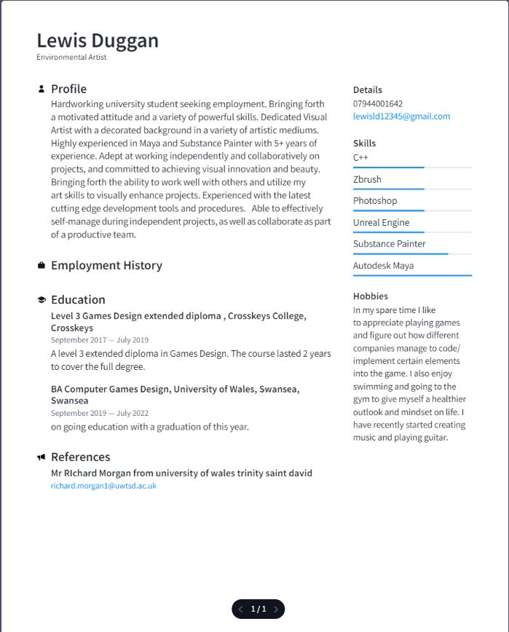

Speculative Application Letter
09/05/2022
Activision Blizzard Inc. Santa Monica
Hiringmanager@gmail.com
Dear Mr/Ms/Mrs [hiring mangers name]
This letter is regarding my interest in applying for the post of Games Designer/ Environmental Artist at your company. With my advanced qualifications and over 5 years’ experience using key developing software’s in the field of game designing, in addition to my communication, time management and analytical skills I am more than certain that I could benefit your company significantly.
Jeff Negus is one of the most known and experienced games designers in the country which help made the infamous games Call of Duty. Your company has never failed to amaze me with breath taking scenery in Campaign modes and the impeccable gameplay of the intense mode of online multiplayer. The company has made traditional idea from war and transferred them into a simulation on the screen flawlessly. With unique ideas and game modes to keep players immersed and creating different assets to make the game breath takingly accurate to real life, I would be honoured to be part of such an ambitious and creative gaming firm which never fails to please their audience.
I have a level 3 extended diploma in Games design along with in progress of graduating my last year of BA Computer Games Design with Honours. Providing a sold foundation int eh complexities of coding, modelling, and texturing and level creation. I have a list of positive assets I can bring into the working environment and duties which I can undertake.
- Establishing innovative gaming vision for projects on gaming platforms such as PC, consoles, and VR.
- Created a solo asset pack and an entire landscape using world machine and applied height maps and textures for it.
- Expertise in modelling and sculpting software’s such as Maya, Zbrush and Substance Painter.
- Assisting lead designer in university projects and being the lead asset creator for levels in Unreal Engine.
- Prototyped gameplay whilst working in groups in both college and university for final projects.
I bring strong expertise from education into the field of games design. I have interpersonal skills allowing me to work with clients and professionals making me flexible. I have strong project planning skills and can meet deadlines without fail. My attention to detail in unmatchable. Becoming an asset to your company wont just benefit you.
Thank you for your time and consideration
Sincerely
Lewis Duggan

