

Programme: Master of Business Administration

Module: Marketing Management
Module code: LCMB7024
Lecturer: Laila Maazouz Taonga Kaonga Sobere-Snithers
Assignment Title: Marketing Environment Analysis

Student Name: Zalak Patel
Student ID Number: 2526278
Word Count: 2646

Table of Contents
1.0 Task 1: Natural Environment Actor 2
1.1 Climate Pressure as a Market Challenge 2
1.2 Government and Regulatory Actor 6
2.0 Task 2: Strategic Growth and Competitive Positioning of BHP 8
2.1 Recommended Ansoff Strategy: Product Development 8
2.2 Supporting Strategy: Market Penetration 8
2.3 Supporting Strategy: Market Development 10
2.4 Limited Use of Diversification 10
2.5 Competitive Advantage as a Lower-Carbon Business Model 10
3.0 Task 3: Critical Reflection on AI Usage 12
3.1 Tool Disclosure 12
3.2 Critical Evaluation of AI Support 12
3.3 Contribution Analysis 12
3.4 Ethical and professional Reflection 13
References 14

1.0 Task 1: Natural Environment Actor

1.1 Climate Pressure as a Market Challenge
The top external marketing environment actor impacting BHP's progress towards lower carbon products is The Natural Environment. Mining is associated with GHGs, land disturbance, water use, biodiversity pressure and community concern. So BHP cannot sell anything but on scale, price and reliability.
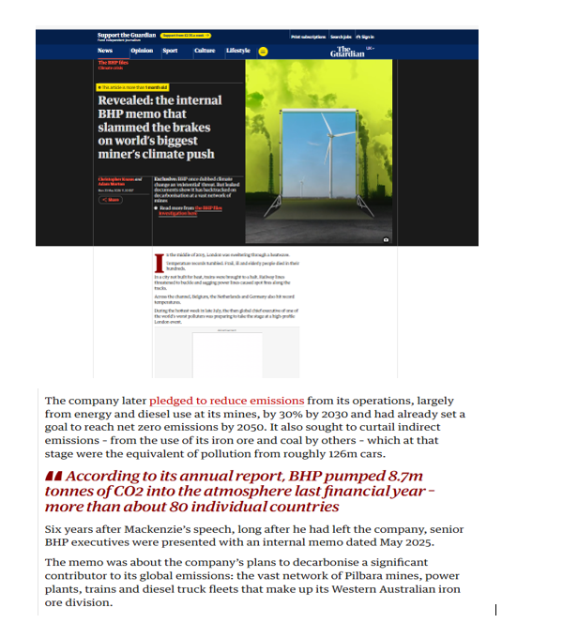
Figure 01: Climate Pressure Related marketing News Upholding Pathway Towards Carbon Neutralisation
Source: (The Guardian, 2026b)
According to the report of the Guardian (2026b), it has been clarified that VHP pumped 8.7 million terms of co2 into the atmosphere in the last financial year that is needed to be mitigated by the company. The news clearly helped in understanding that it is helping BHP to limit their carbon intensive footprints with better carbon neutralisation programmes.
It will have to show how its activities and products are aligned with the global climate expectations.The coal that BHP uses to make iron ore and iron and steelmaking is used to make steel and is very carbon-intensive. Thus, not only are emissions from the company's mines assessed, but also emissions generated by the company's customers while using the company's products.
This is a challenging marketing scenario. BHP will have to raise the visibility of its contribution to the energy transition, and acknowledge that some of its assets are still tied to high-emission industries.
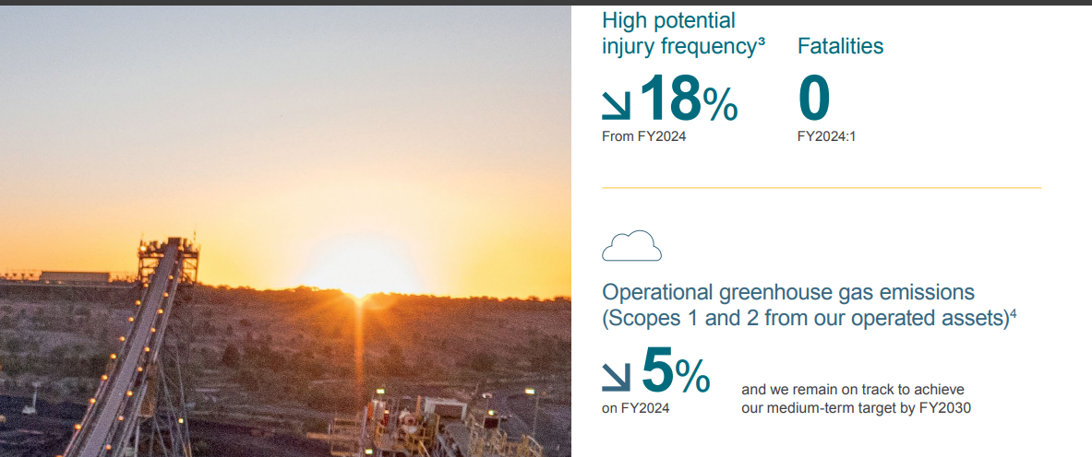
Figure 02: Operational Greenhouse Gas Emissions Decreased in BHP
Source: (BHP, 2025)
However, the previous financial reports of the company also helped to know that the company's total GHGs have decreased by 5% in FY2025 from the previous year, FY2024, as revealed in BHP's latest full sustainability disclosure (BHP, 2025). It also helped to know that the company is trying to lower their carbon footprints but they are still not getting the expected results. This helps with the sustainability message, but does not eliminate the bigger challenge. If it exaggerates environmental gains, it could be suspected of being greenwashing. Hence, BHP's environmental marketing should demonstrate tangible emission improvements, attainable goals and transparent consideration of remaining challenges.

Low-Carbon Demand as a Market Opportunity
The Natural Environment also presents opportunity, driven by the growth in demand for transition-critical minerals as a result of the decarbonisation. Electric power and transmission systems, renewable energy, electric vehicles, data centres and digital infrastructure require copper. It enables BHP to market copper as a transition product, rather than just a traditional industrial product (Enemuo and Ogunmodimu, 2025).
This is evident in the latest BHP statistics. Copper was the highest earner for the company and took up 51% of BHP's underlying EBITDA for the half year to 31 December 2025. BHP also raised its group copper production target for FY26, to 1.9–2.0 million tonnes. By March 2026, BHP was still anticipating copper production to be in the upper half of this range, with the backups of Escondida and Antamina. This demonstrates the importance of copper in BHP's growth plan (Joshua, 2026).
This provides a marketing opportunity for BHP as they are able to align their products with electrification, renewable energy and digital growth.
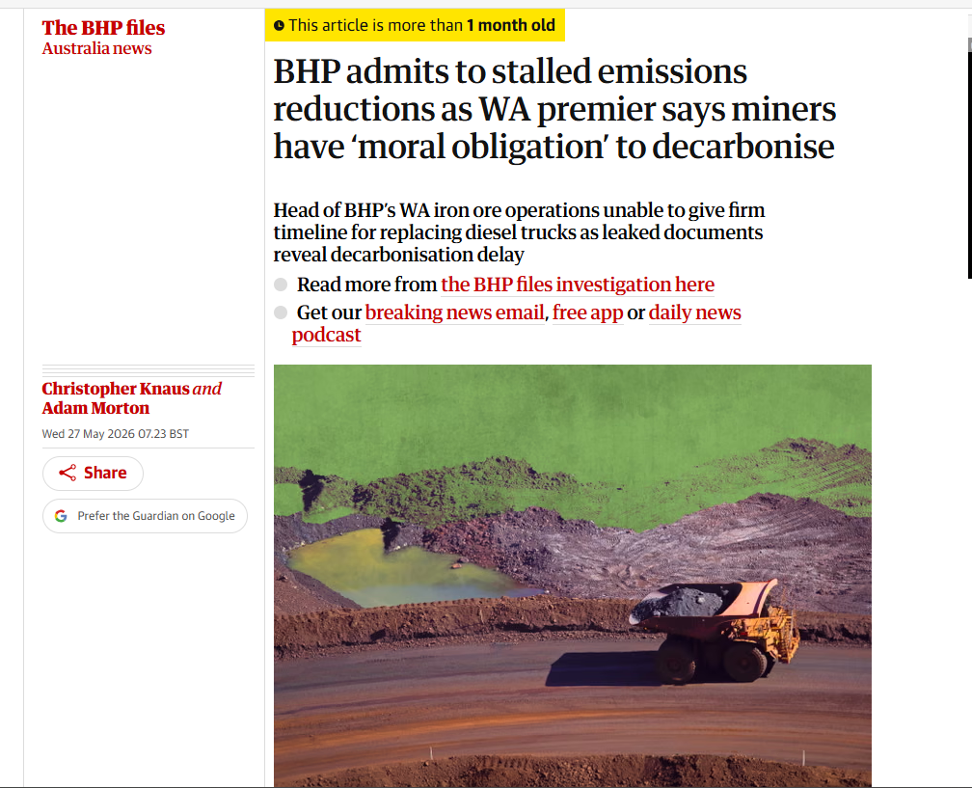
Figure 3: BHP STalled Emissions because full decarbonisation claims increase Moral obligations
Source: (The Guardian, 2026a)
However, BHP continues to mine iron ore and coal, which leaves them unable to claim to be a 100% low carbon company. Instead, it's better to market BHP as a provider of valuable resources to the transition as well as a communication of how BHP is minimizing operational impacts.
Value-Chain Collaboration as BHP’s Route to Lower-Carbon Products
The lower carbon transition is the primary pillar of BHP's project, and relies primarily on value-chain collaboration. This is playing an important role in steelmaking, where BHP's customers are being pressured to cut down emissions (BHP, 2023). BHP can assist with this by engaging with steel producers, technology partners and shipping suppliers to minimize emissions throughout the steel product lifecycle (Islami et al., 2025).
This alters the marketing value proposition of BHP. Companies may compete on the commodity market in terms of price, quality, size, and dependability. Another source of differentiation is credible support for customer decarbonisation, in the context of environmental pressure. By assisting customers to lower emissions, BHP can enhance business-to-business relations and prevent them from relying on it solely as a raw material supplier (Sharma et al., 2023).
The message is backed up with the financial position of BHP.
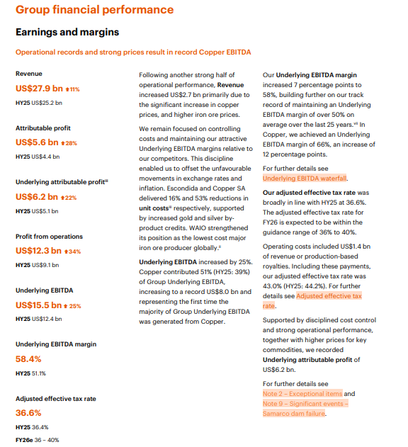
Figure 04: Group Financial Performance
Source: (BHP, 2026)
BHP achieved US$15.5 billion underlying EBITDA, a 58% EBITDA margin and US$6.2 billion underlying attributable profit for the half year to 31 December 2025 (BHP, 2026). This is important because transition is an investment in renewable electricity and in the trial of cleaner equipment and technology. But while many of the technologies used to reduce carbon emissions from mining and steelmaking are not yet commercially available, BHP needs to not show future targets as having been achieved (BHP, 2023).

1.2 Government and Regulatory Actor
Negotiating Change: Pressure from others
Government and regulation is the other critical external influence impacting BHP's lower-carbon transition. New, more stringent emissions regulations, reporting requirements and public disclosure requirements for mining companies. The Safeguard Mechanism is effective for facilities in Australia that emit over 100,000 tonnes of CO₂-e per year (DCCEEW, 2025). It applies to the big industrial sites such as oil and gas, waste, transport, manufacturing and mining.
This poses a direct threat to BHP as covered facilities need to meet emissions limits that tend to decrease by 4.9% annually until 2030 (CRU Group, 2024). Reducing emissions is not just about doing what's voluntary for BHP. It is emerging as an operating cost, investment planning and risk management requirement.
Regulation is more challenging from a marketing point of view. BHP will need to demonstrate that its operations will meet formal expectations, and that lower carbon claims are backed by measurable action.
Regulation as a Credibility Opportunity
Regulation also provides a credibility opportunity. The Safeguard Mechanism for Australia covered 208 facilities and total covered emissions were 132.8 million tonnes of CO₂-e, which was a 2.3% decrease from 2023–24. The rate of compliance was good, with 205 of 208 facilities compliant by the deadline (CER.GOV, 2025). This gives a public indicator to high emission industries.
Good performance within regulatory systems can help to build stakeholder confidence for BHP. When environmental claims are associated with external monitoring and official data, customers and investors will be more likely to trust the claims (Noor, 2026). This is relevant, since there is a lot of doubt about the sustainability marketing that is done in the mining sector. Regulation can support BHP's lower-carbon strategy to be linked to accountability, rather than just promotion.
However, there is also higher oversight when it comes to regulation. The availability of public emissions data enables stakeholders to put BHP's marketing claims into perspective with actual emissions (Roemer et al., 2026). BHP's environmental credibility could be called into question if it too heavily relies on offsets, if it delays decarbonisation projects or if it does not cut direct emissions. Thus, the company should be transparent in explaining the direct reductions, value chain partnership and carbon credits.

2.0 Task 2: Strategic Growth and Competitive Positioning of BHP

2.1 Recommended Ansoff Strategy: Product Development
Using product development, BHP can make its existing mineral products more environmentally friendly and sell them to its existing industrial customers, in a lower carbon form. BHP is not going to move away from its primary market, but is going to improve its product mix for a market under climate pressure, meaning copper, iron ore and potash will generate a higher value for customers. The approach should not be about more production, but rather on achieving lower carbon product solutions.
BHP can create copper that is responsible, provides greater traceability, and has more information on emissions levels at the product level. Copper is already a significant contributor to BHP's business as it accounted for 51% of the underlying EBITDA in the half year ended 31 December 2025 (BHP, 2026). BHP can sell copper as a transition-critical commodity as it is needed in electric vehicles, renewable energy, power grids and data centres. The product development part, however, is the result of the improvement of Copper production, verification and communication to customers (Beatriz Calzada Olvera and Iizuka, 2023).
Secondly, BHP can enhance its iron ore offer for steelmaking customers through the promotion of lower emissions in steelmaking. This may involve access to premium iron ore, carbon accounting assistance and working with steel manufacturers on emissions reduction plans (BHP, 2023). This adds value to BHP's product as customers are getting raw material as well as BHP's support in their own decarbonisation goals.
Thirdly, BHP can produce augmented product service, for example, emissions portray, cleaner transportation choices, evidence of responsible origin and long-term product service agreements. These new additions make basic commodities lower-carbon business solutions (Jai et al., 2020). This will give BHP a competitive edge as customers will not only be assessing the price and the reliability of the supply, but the environmental credibility as well.

2.2 Supporting Strategy: Market Penetration
BHP has opportunities to improve the existing mineral products into a lower carbon, traceable and customer focused solution for its existing industrial customers through product development. This would not mean BHP would cease trading copper, iron ore and potash, but the products would still be upgraded with emissions information, responsible sourcing information, cleaner logistics solutions and technical support for customers seeking to lower their carbon footprints.
The best prospects are copper. The copper demand today is 28 million metric tonnes and is projected to grow to 42 million metric tonnes by 2040, primarily driven by electrification, AI infrastructure, renewable energy, grid expansion and electric vehicle growth (S&P Global, 2026). This benefits product development as BHP can develop a more valuable copper offering for current customers within the renewable energy, EV, power networks and data centres sectors.
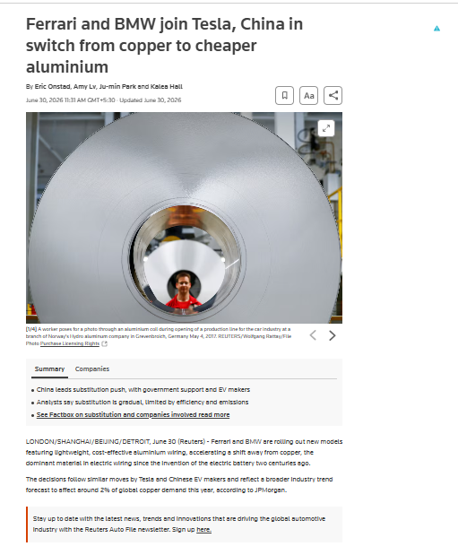
Figure 05: Automobile Companies are More Focusing on Aluminium Based Products
Source: (Reuters, 2026)
But BHP will have to face market difficulties. In the automotive industry, in the case of copper, some automakers like Ferrari, BMW and Chinese EV makers are transitioning to aluminium wiring, which would impact about 2% of global copper consumption by 2026 and as much as 6% by 2030 (Reuters, 2026). But BHP cannot depend solely on copper demand growth. It must become more reliable, sustainable, have better quality assurance and customer support to make its copper more attractive.

2.3 Supporting Strategy: Market Development
BHP has the opportunity to expand its current and enhanced product portfolio to new market segments and growth markets, associated with the lower carbon transition. In Ansoff's terms, this is the sale of existing products to new markets. This should include copper for renewable energy, EVs, power grids, data centres and AI infrastructure, and the creation of potash markets to support food security and sustainable agriculture for BHP (Ferreira and Marques, 2024).
The best market opportunity for developing the market is in copper. Demand for electricity has been rising rapidly with the introduction of AI data centres, the expansion and electrification of the grid.The demand for electricity and digital infrastructure is increasing rapidly, particularly due to the advent of AI data centres, grid expansion, and electrification (Brousse, 2026). The projected electricity consumption in the data centres is more than doubled and will peak at approximately 945 TWh by 2030 (IEA, 2025). It can help the company to be more carbon-neutral.

2.4 Limited Use of Diversification
Diversification must be used sparingly and judiciously by BHP. According to Ansoff's Matrix, diversification is entering new products and new markets, and is therefore the most risky growth strategy. So, BHP should not stray too far from core businesses like battery manufacturing, retailing in renewable energy or finished steel (Chau, 2025). These areas may contribute to the low-carbon economy but are not where BHP has the best expertise of mining, large scale operations and commodities supply in the world.
A more sensible approach is to diversify relatively into areas where BHP's lower carbon business model will thrive. Recycling and circular metal partnerships are one possibility that can help the company to achive the carbon-based targets. The global recycled copper market will increase with strong growth in the next five years, and by 2050 battery recycling may provide 20-30% of the lithium, nickel and cobalt demand IEA (2025b).

2.5 Competitive Advantage as a Lower-Carbon Business Model
BHP will be able to gain a competitive edge by leveraging product development and responsible supply. This is backed up by its financial strength. Over the next six months (31 December 2025), BHP is to report underlying EBITDA of US$15.5 billion, with an underlying EBITDA margin of 58%, and underlying attributable profit of US$6.2 billion (BHP, 2026). This allows the company to invest in cleaner technology, renewable power and trials of new technology and partnerships with customers (The Great Reserve, 2025).

3.0 Task 3: Critical Reflection on AI Usage

3.1 Tool Disclosure
This report was prepared using Artificial Intelligence as an “academic tool”. The function of this was primarily to plan, improve sentence flow, to check sentence structure and to ensure that the discussion remained on track with the assessment requirements. It also helped to structure the ideas for the marketing environment, external actors, the Ansoff Matrix and the lower-carbon transition for BHP. Because of the use of AI in support, the AI use acknowledgement is relevant. I made the final choice of BHP, and also picked the two external actors, the Natural Environment and the Government and Regulation, and the main strategic approach, of product development.

3.2 Critical Evaluation of AI Support
The use of AI support was carefully considered as AI can sometimes provide information that may seem correct but could be outdated, too broad or not fully connected to the given task. To mitigate this risk I have cross-checked information with BHP company reports, most recent market data, government and other business reputable sources. I also looked to verify the statistics are up to date and directly linked to BHP's lower carbon transition.
Some of the weaknesses were identified and remedied during this process. An example of this type of error was the early inclusion of a section on product development that attempted to overemphasize copper demand and failed to explain how BHP would leverage product development as a strategy. I rectified this by making product development more closely connected to better mineral products, better emissions data, better traceability, better support for customer decarbonisation and better support for cleaner logistics. This facilitated the relevance of the analysis to Ansoff's Matrix and facilitated a brief assessment.

3.3 Contribution Analysis
The most common use of AI was to aid in the presentation, words and structure of the report. It assisted me to organize headings, enhance business expression and link theory to business practice. The big challenge and direction from the report was however, the work that I did. Picked some pertinent points, removed the generic arguments, revised evidence and reworked the discussion to fit report requirements.
Balanced analysis was a special product especially of my own contribution. I realised that there was no need to portray BHP as being completely low carbon as it does have an iron ore and coal business. In addition, I wondered about how growing demand on transition minerals is in conflict with the environmental impact of mining expansion. This enabled the report to be more realistic and critical.

3.4 Ethical and professional Reflection
Ethical and professional dilemmas are rampant in the use of AI in marketing analysis. Although AI can be an efficiency and clarity tool, human control remains essential in the pursuit of accuracy, evidences, and originality. This is especially applicable in the framework of sustainability marketing as misleading or unsupported marketing claims can be used to facilitate the development of greenwashing. Therefore, an evidence-based, transparent and scholarly final report must be prepared despite the assistance of AI.

References
Beatriz Calzada Olvera and Iizuka, M. (2023). The mining sector: Profit-seeking strategies, innovation patterns, and commodity prices. Industrial and Corporate Change, 33(4). doi:10.1093/icc/dtad020.
BHP (2023). Value chain GHG emission reductions | BHP. [online] Bhp.com. Available at: https://www.bhp.com/sustainability/climate-change/value-chain-ghg-emission-reductions.
BHP (2025). Climate Transition Action Plan | BHP. [online] Bhp.com. Available at: https://www.bhp.com/sustainability/climate-change/climate-transition-action-plan.
BHP (2026). Financial results for the half year ended 31 December 2025.
Brousse, C. (2026). AI and the growth of data centres: Challenges for the copper market Chart 1: Forecast of annual demand for copper by data centres located in North America Artificial intelligence: Driving the demand for copper. [online] Available at: https://www.banque-france.fr/system/files/2025-04/Billet_402_VE.pdf.
CER.GOV (2025). 2024-25 Safeguard Mechanism data insights. [online] Available at: https://cer.gov.au/document/2024-25-safeguard-mechanism-data-insights.
Chau, A. (2025). Andy Chau. [online] Andy Chau. Available at: https://www.andy-chaukl.com/publication-articles/ansoff-matrix-strategic-roadmap-to-sustainable-business-growth.
CRU Group (2024). Australian industry to face tighter emissions caps. [online] CRU Group Website. Available at: https://www.crugroup.com/en/communities/thought-leadership/sustainability/australian-industry-to-face-tighter-emissions-caps/.
DCCEEW (2025). Safeguard Mechanism. [online] Dcceew.gov.au. Available at: https://www.dcceew.gov.au/climate-change/emissions-reporting/national-greenhouse-energy-reporting-scheme/safeguard-mechanism.
Enemuo, M. and Ogunmodimu, O. (2025). Transitioning the mining sector: A review of renewable energy integration and carbon footprint reduction strategies. Applied Energy, [online] 384, p.125484. doi:10.1016/j.apenergy.2025.125484.
Ferreira, A. and Marques, M.B. (2024). The Importance of the Ansoff Matrix for the Study of the Information Services Market. [online] Canadian Journal of Information and Library Science. Available at: https://www.researchgate.net/publication/382141729_The_Importance_of_the_Ansoff_Matrix_for_the_Study_of_the_Information_Services_Market.
IEA (2025a). Energy demand from AI – Energy and AI – Analysis - IEA. [online] IEA. Available at: https://www.iea.org/reports/energy-and-ai/energy-demand-from-ai.
IEA (2025b). Overview of Outlook for Key Minerals – Global Critical Minerals Outlook 2025 – Analysis - IEA. [online] IEA. Available at: https://www.iea.org/reports/global-critical-minerals-outlook-2025/overview-of-outlook-for-key-minerals.
Islami, M.S., Urmee, T., Lund, C., Bahri, P.A. and Anisuzzaman, M. (2025). Decarbonisation strategies for critical mineral supply chain: State-of-Art in mining and refining industries. Renewable and Sustainable Energy Reviews, [online] 218, p.115811. doi:10.1016/j.rser.2025.115811.
Jai, D., Pandit, K., Watson, M. and Qader, A. (2020). Reduction of Greenhouse Gas Emissions in Steel Production Final Report. [online] Available at: https://www.resources.nsw.gov.au/sites/default/files/2022-11/report-reduction-of-ghg-emissions-in-steel-industries.pdf.
Joshua (2026). BHP Hits Milestone as Copper Becomes Largest Earnings Driver, Posts Strong H1 Results. [online] Joshua Thompson. Available at: https://joshthompson.co.uk/investing/bhp-h1-2026-results-copper-ebitda-milestone/ [Accessed 6 July 2026].
Noor, R. (2026). Decarbonization Performance of the Australian Extractive Industry: A Cross-State Comparative Analysis. The Extractive Industries and Society, 26, p.101883. doi:10.1016/j.exis.2026.101883.
Reuters (2026). Ferrari and BMW join Tesla, China in switch from copper to cheaper aluminium. Reuters. [online] 30 June. Available at: https://www.reuters.com/business/autos-transportation/ferrari-bmw-join-tesla-china-switch-copper-cheaper-aluminium-2026-06-30/.
Roemer, J., Mungyeko Bisulandu, B.-J.R., Rousse, D.R., Pellerin, M., Bozorg, M. and Ilinca, A. (2026). Energy Consumption, Decarbonization Pathways, and Renewable Energy Integration in the Mining Industry: A System-Level Review. Energies, 19(8), p.1890. doi:10.3390/en19081890.
S&P Global (2026). Copper in the Age of AI | S&P Global. [online] S&P Global. Available at: https://www.spglobal.com/en/research-insights/special-reports/copper-in-the-age-of-ai.
Sharma, S., Rajesh Kumar, S., Mishra, R. and Nachi, S.N. (2023). Developing climate neutrality among supply chain members in metal and mining industry: Natural resource-based view perspective. The International Journal of Logistics Management, [online] 35(3), pp.804–832. doi:10.1108/IJLM-03-2023-0108.
The Great Reserve (2025). The Great Reserve. [online] THE GREAT RESERVE. Available at: https://www.thegreatreserve.org/news/how-carbon-reduction-is-becoming-a-competitive-advantage.
The Guardian (2026a). BHP admits to stalled emissions reductions as WA premier says miners have ‘moral obligation’ to decarbonise. [online] The Guardian. Available at: https://www.theguardian.com/world/2026/may/27/bhp-files-stalled-emissions-reductions-mining-company-moral-obligation-decarbonise.
The Guardian (2026b). Revealed: The internal BHP memo that slammed the brakes on world’s biggest miner’s climate push. [online] The Guardian. Available at: https://www.theguardian.com/world/ng-interactive/2026/may/25/bhp-files-internal-memo-revealed.
Voronets, D., Garafonova, O., Verezomska, I. and Oliinyk, O. (2019). Diversification Strategy and Sustainable Development of Mining Companies in the Eurasian Mining Region. E3S Web of Conferences, 134, p.03012. doi:10.1051/e3sconf/201913403012.

