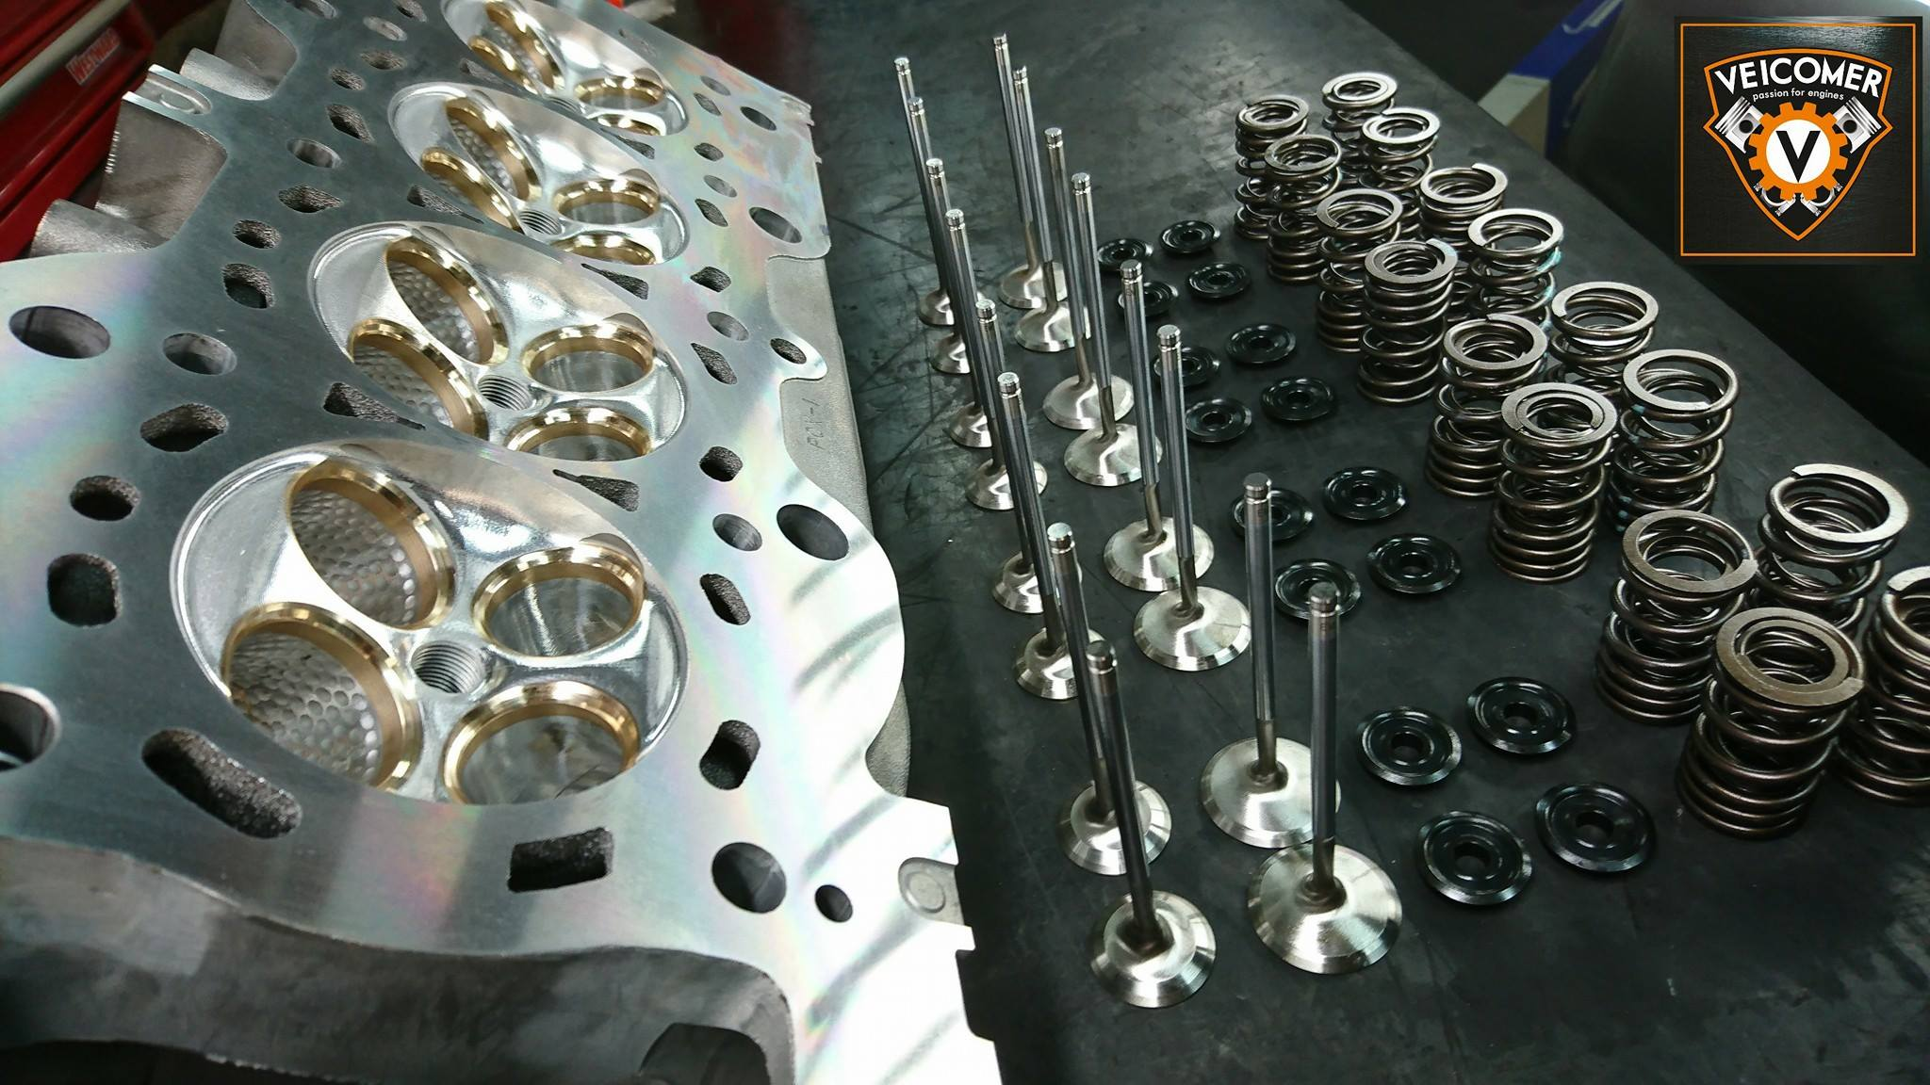
Image 1 https://veicomer.com/wpcontent/uploads/2018/10/26220328_1561238777259124_4501479184551657647_o.jpg

Cylinder Head Data Analyses
POWERtrain design and efficiency
João Moura

2019
Table of Contents
1.0 Introduction 2
2.0 Background Research 3
2.1 Induction Systems 3
2.1.1 Carburettor 3
2.1.2 Electronic fuel Injection 4
3.0 Cylinder Heads 5
4.0 Air Flow 6
5.0 Flowbench 6
5.1 Air Flow Test 7
6.0 Methodology 7
7.0 Results 8
8.0 Analyses 12
9.0 Conclusion 14
References 15

1.0 Introduction

A cylinder head is a fundamental part of an engine. There are different induction systems in the market and different cylinder head shapes, but they all have the same purpose – to efficiently guide airflow or air fuel mixture to the combustion chamber and expel exhaust gases after combustion has taken place, as quickly as possible. A cylinder head also houses other engine components such as camshafts, valves, valve lifters and valve springs and as the name suggests it sits on the top of the engine block.
Porting is the name given to effectively increase the performance of a cylinder head. Intake and exhaust runners can be enlarged or polished the obtain a higher airflow and thus increasing the engine power output and efficiency. (Pratte, 2015)
This assignment will show detailed data of two distinctive cylinder heads and how air flows differently in the two cylinder heads. The cylinder heads used were a Rover K series cylinder head and a Ford 1.6L cylinder head. Using a flow bench, the heads were put to test to measure the volumetric air flow ratio in both intake and exhaust runners/ports. After the data was gathered, further discussion and analyses of the results obtained will be discussed as well as possible improvements to the cylinder heads.

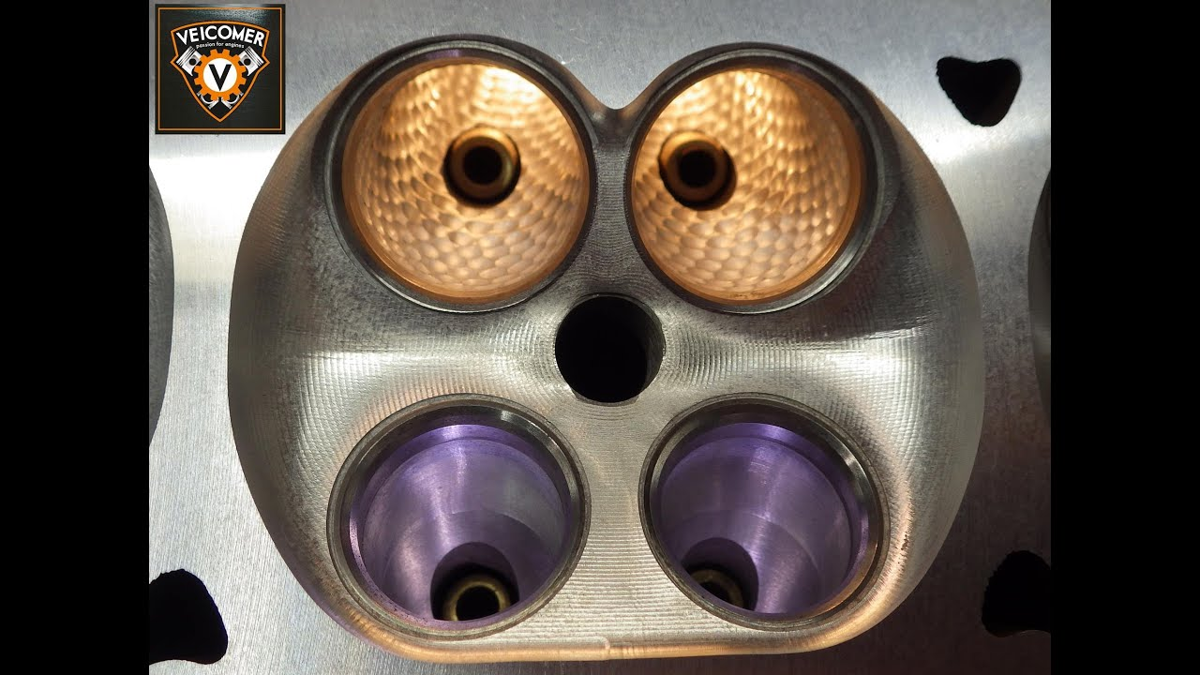
Image 1 Intake and exhaust ports https://i.ytimg.com/vi/cP_8PzZN5iQ/maxresdefault.jpg

2.0 Background Research

2.1 Induction Systems
Since the first combustion engine was invented, different types of induction systems were invented.
Carburettors were the first systems to be invented and worked quite well until emissions and fuel consumption became a problem. Double carburettors are almost as old as single carburettors and were invented as an attempt to increase the air flow and fuel an engine could essentially take. More recently, single point injection was invented, and multi-point injection followed quickly afterwards.
Each of the systems above required different cylinder heads and different intake and exhaust ports and runners. The differences are obvious when we look at an engine using a carburettor vs an engine using an electronic fuel injection system.

2.1.1 Carburettor

Carburettors are fully mechanical devices that pre-mix air and fuel and rely on so called Venturi effect to accelerate and increase the speed at which this mixture is delivered to the combustion chamber.
Venturi effect (Image 2) is achieved when a portion of an intake runner is narrowed down and sub consequently the air flow rate increases and thus, dropping the air pressure. At this point, fuel is drawn out of the storage tank, mixed with the fuel, and taken into the combustion chamber. The more air flow the more fuel is drawn, the less air flow, the less fuel is drawn. A dual carburettor has its advantages. Such system can be used in order to share the induction of certain engines, for example in a four-cylinder configuration, one carburettor feeds cylinder 1 and 2 and the second carburettor cylinder 3 and 4, thus increasing engine efficiency and power.
Carburettors are good and efficient in a very narrow band and are the reason why they are still used in NASCAR where engine speeds are usually constant with little oscillations. These systems are not adaptive, meaning they don’t cope well with different atmospheric pressures and different engine speeds. (HowCarWorks, 2019)
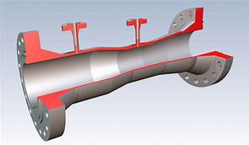 Image 2 http://www.emco.dk/files/emcobilleder/flow/kvrsnit2.jpg

2.1.2 Electronic fuel Injection
EFI was first invented to respond to the demands of lower emissions and engine efficiencies.
Single point injection uses a single injector which is controlled by the ECU. Fuel is sprayed just before the throttle body where it mixes with the air and then taken into the cylinders through different intake runners (Image 3). This system is an improvement over the carburettor, but it presents the same issue as a single carburettor – feeding all cylinders by itself. Multi point fuel injection follows the same principle as single point with the main difference being that there is one injector feeding each cylinder and placed on the intake runners, thus increasing efficiency and reducing fuel consumption due to the system being fully adaptive to different engine speeds and different air pressures. This also means that the intake runners are now even more important than before, as they are the highways where air and fuel travel at high speeds, manipulated by its surfaces and bends to achieve maximum efficiency.
Multi-point injection is by far better than carburettor when it comes to daily driven cars and certain vehicles used for motorsport due to it’s adaptive capacity and reliability in all conditions. (DifferenceBetween, 2012)
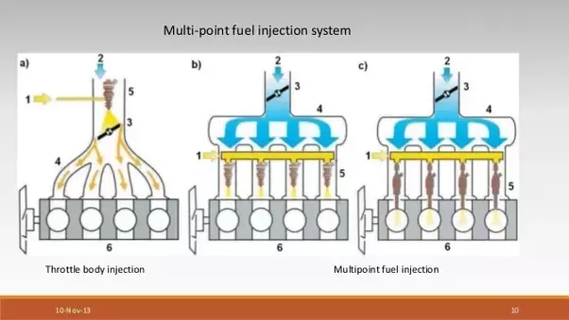
Image 3 https://qph.fs.quoracdn.net/main-qimg-5a39fbc88124719a49fcc623ec4eebdd

3.0 Cylinder Heads

There are various cylinder head designs on the market. Cylinder heads can be made of cast iron or aluminium. Most cylinder heads have their valves located above the combustion chamber. These are denominated OHV. It is an ingenious design as it allows the engine itself being smaller than its predecessors, it also allows for the camshafts to be mounted virtually above the combustion chambers allowing more space for dual camshafts as known as Dual Overhead High Cams (DOCH) (Image 4).
Cylinder heads are a complex engine component, apart from intake and exhaust ports, they also hold space for the injectors, exhaust and intake valves, camshafts and oil and coolant passages. Regardless of the shape and form, either it’s a Hemi cylinder head design or an inline design, every cylinder head on the market is looking to increase air flow into the combustion chamber.
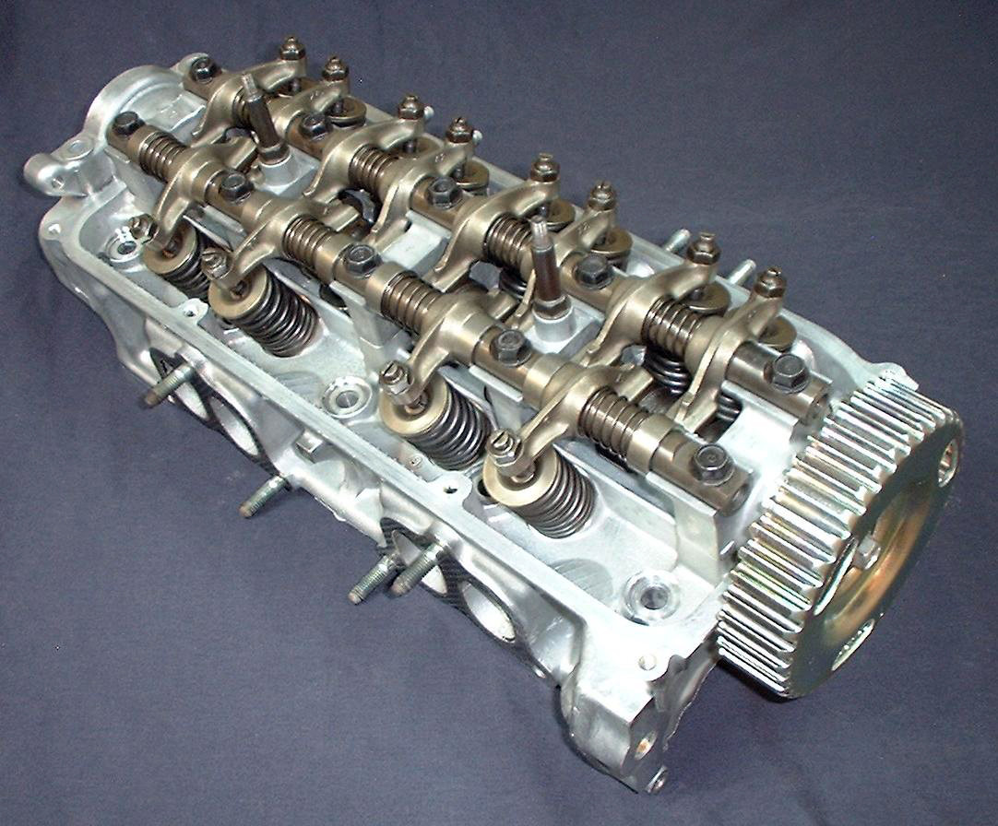
Image 4 https://i.stack.imgur.com/AdKJw.jpg

4.0 Air Flow

Air flow is the most important thing when it comes to cylinder heads. The basic concept is simple, the more air the combustion chamber can be provided with, the more power a vehicle can make. For this reason, engineers have spent thousands of hours understanding and studying how air behaves when accelerated, compressed and forced to change direction. Engineers learnt how to manipulate the air inside the cylinder head to aid air turbulence.
Air turbulence is a key element when it comes to internal combustion engines. The more turbulent the air is, the faster it travels. The faster this air travels, the more fuel can be injected, thus increasing power. A turbulent flow will also aid flame propagation because it has different fronts from which detonation can occur.
Squish is also very important when it comes to combustion. Squish is the name given to the phenomena that happens when the piston is near TDC on the power stroke and compresses the air and fuel mixture at very high velocity, increasing its turbulence and aiding combustion. Even though is not directly related to the shape of the cylinder head runners, understanding squish also helps showing how important it is for the air flow to be turbulent.
Finally there is Swirl, which as the name indicates it is a rotational flow of air about its own axis.
Swirl is important because as the charge enters the combustion chamber, it is forced to the walls of the cylinder, increasing its speed and propagating inside the chamber in a more homogenised way. The relationship between turbulence, squish, swirl and the shape of the runners is that a cylinder head will always one way or another be built to increase all these behavioural aspects of air flow.

5.0 Flowbench

A flowbench (Image 5) is a device that can be used to measure the efficiency of cylinder heads or intake manifolds, it acts as a big powerful vacuum cleaner sucking in air and measuring it as it passes through the cylinder head runners and ports. This consequently gives the tester an idea of how efficient the components are and where improvements can be made. (SuperFlow, 1995)

5.1 Air Flow Test

An air flow test as briefly described before consists of sucking or blowing air through the component to be tested at a constant pressure.
When it comes to cylinder heads: the flow rate is measure at different valve lifts, thus indicating the capacity of the cylinder head at different lifts. Changes can be made to the ports for example and then the head can be re tested to confirm positive results or not. Further calculations can also be done to verify valve efficiency, determine runner lengths and air flow speed.
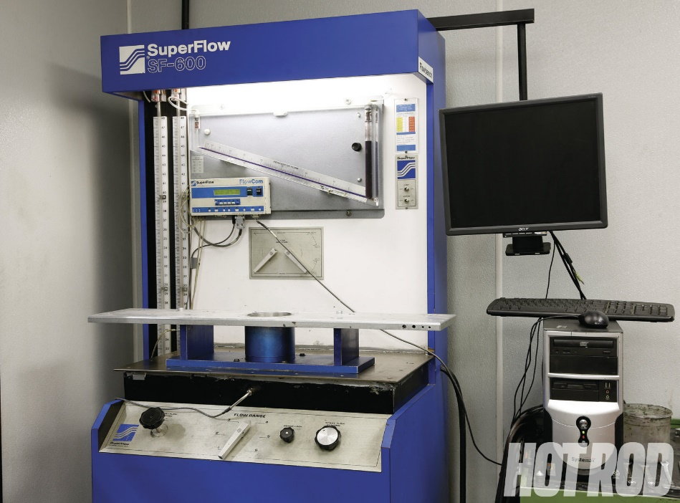
Image 5 http://image.hotrod.com/f/techarticles/general/1308_dyno_flow_numbers/47062840/flow-bench.jpg

6.0 Methodology

The flow bench utilised for this test was the Super Flow model 110.
Before the start of the test the two-cylinder heads were brought in and visually checked.
The first head to be tested was the Rover K series. The head was mounted on the flow bench with the aid of a 4-inch tube adapter. One side of the tube was attached to the cylinder head on cylinder number 1 and the other end attaches to the flow bench. The head was also held fixed with C-clamps. It is very important to note that the 4-inch adaptor must be sealed in both ends to prevent air leaks. Blue tac was used to seal the surfaces. (SuperFlow, 1995)
The next step was to attach a threaded mount to the rocker harm to the bolt touches the valve stem. When the bolt is rotated it opens the valve. A DTI was also installed in order to accurately measure the increments of valve opening. The direction of flow was turned to intake as the first valves being tested were the intake valves.
The flow bench was then turned on and the leakage percentage recorded 0 and it will be corrected later. The pressure flow nob can now be open until it reaches 25 inches of water, at this point the valve diameter was multiplied by the L/D at 0.05 increments to obtain the valve lift. The threaded mount rotated to the specified lift points and the flow percentage recorded. Using the correct calibration with the right rubber stoppers for different flow rates ensures that the readings are as correct as possible. This test was performed 8 times for the intake valves and 8 times for the exhaust valves for each cylinder head. Note that to test the exhaust valves the air flow direction had to be switched to exhaust mode. (SuperFlow, 1995)

7.0 Results
Rover 1.8
 | Valve Diameter (mm) | Valve stem diameter (mm) | Valve head diameter (mm) | Valve stem diameter (inches) | Effective Valve Area
Intake | 27.7 | 6.47 | 1.091 | 0.255 | 0.884
Exhaust | 24 | 5.98 | 0.946 | 0.235 | 0.657

(L/D) | 0.05 | 0.10 | 0.15 | 0.20 | 0.25 | 0.30 | 0.35 | 0.40
Intake valve lift (mm) | 1.39 | 2.23 | 4.16 | 5.55 | 6.93 | 8.31 | 9.69 | 11.08
Exhaust valve lift (mm) | 1.20 | 2.40 | 3.60 | 4.80 | 6.00 | 7.20 | 8.40 | 9.60

Range | 1 | 2 | 3 | 4 | 5 | 6
Intake | 34.98 | 70.98 | 147.76 | 292.98 | 440.53 | 595.54
Exhaust | 41.43 | 78.652 | 159 | 314.82 | 465.55 | 603.35

Intake Valves
Test | 1 | 2 | 3 | 4 | 5 | 6 | 7 | 8
Pressure | 25 | 25 | 25 | 25 | 25 | 25 | 25 | 25
Lift | 1.39 | 2.23 | 4.16 | 5.554 | 6.93 | 8.31 | 9.69 | 11.08
Flow Range | 1 | 2 | 3 | 3 | 3 | 4 | 4 | 4
Flow scale (1/1) | 0.935 | 0.89 | 0.61 | 0.748 | 0.841 | 0.9 | 0.455 | 0.47
Fow Test (Raw) | 32.706 | 63.172 | 90.133 | 110.524 | 124.266 | 132.984 | 133.305 | 137.7
Leakage % | 0 | 0 | 0 | 0 | 0 | 0 | 0 | 0
CFM | 32.706 | 63.172 | 90.133 | 110.524 | 124.266 | 132.984 | 133.305 | 137.7
CFM (sq/in) | 37.03964 | 71.54247 | 102.0759 | 125.1687 | 140.7316 | 150.6048 | 150.9683 | 155.9456
Potential Flow | 25.3 | 47.3 | 65.7 | 74.2 | 79.5 | 82.6 | 82.6 | 82.6
Potential Flow % | 1.464 | 1.512 | 1.553 | 1.686 | 1.770 | 1.823 | 1.827 | 1.887

Exhaust Valves
Test | 1 | 2 | 3 | 4 | 5 | 6 | 7 | 8
Pressure | 25 | 25 | 25 | 25 | 25 | 25 | 25 | 25
Lift | 1.2 | 2.4 | 3.6 | 4.8 | 6 | 7.2 | 8.4 | 9.6
Flow Range | 1 | 1 | 2 | 2 | 2 | 3 | 3 | 3
Flowscale (1/1) | 0.5 | 0.965 | 0.74 | 0.88 | 0.96 | 0.57 | 0.615 | 0.65
Fow Test (Raw) | 20.715 | 39.979 | 58.202 | 69.213 | 75.505 | 90.63 | 97.785 | 103.35
Leakage % | 0 | 0 | 0 | 0 | 0 | 0 | 0 | 0
CFM | 20.715 | 39.979 | 58.202 | 69.213 | 75.505 | 90.63 | 97.785 | 103.35
CFM (sq/in) | 31.52968 | 60.85084 | 88.58752 | 105.347 | 114.9239 | 137.9452 | 148.8356 | 157.3059
Potential Flow | 25.3 | 47.3 | 65.7 | 74.2 | 79.5 | 82.6 | 82.6 | 82.6
Potential Flow % | 1.246 | 1.286 | 1.348 | 1.419 | 1.445 | 1.670 | 1.801 | 1.904

Ford 1.6
 | Valve Diameter (mm) | Valve stem diameter (mm) | Valve head diameter (mm) | Valve stem diameter (inches) | Effective Valve Area
Intake | 30.05 | 5.95 | 1.185 | 0.256 | 1.05
Exhaust | 24.14 | 5.98 | 0.95 | 0.243 | 0.66

(L/D) | 0.05 | 0.10 | 0.15 | 0.20 | 0.25 | 0.30 | 0.35 | 0.40
Intake valve lift (mm) | 1.5 | 3 | 4.5 | 6 | 7.50 | 9.00 | 10.50 | 12.00
Exhaust valve lift (mm) | 1.2 | 2.40 | 3.60 | 4.85 | 6.00 | 7.22 | 8.45 | 9.65

Range | 1 | 2 | 3 | 4 | 5 | 6
Intake | 34.98 | 70.98 | 147.76 | 292.98 | 440.53 | 595.54
Exhaust | 41.43 | 78.652 | 159 | 314.82 | 465.55 | 603.35

Intake Valves
Test | 1 | 2 | 3 | 4 | 5 | 6 | 7 | 8
Pressure | 25 | 25 | 25 | 25 | 25 | 25 | 25 | 25
Lift | 1.5 | 3 | 4.5 | 6 | 7.50 | 9.00 | 10.50 | 12.00
Flow Range | 2 | 3 | 3 | 3 | 4 | 4 | 4 | 4
Flow scale (1/1) | 0.565 | 0.567 | 0.81 | 0.95 | 0.48 | 0.485 | 0.49 | 0.495
Fow Test (Raw) | 40.12 | 83.80 | 120.00 | 140.37 | 140.64 | 142.10 | 143.47 | 145.02
Leakage % | 0 | 0 | 0 | 0 | 0 | 0 | 0 | 0
CFM | 40.12 | 83.80 | 120.00 | 140.37 | 140.64 | 142.10 | 143.47 | 145.02
CFM (sq/in) | 38.20952 | 79.809523 | 114.285714 | 133.685714 | 133.9429 | 135.333 | 136.6381 | 138.1143
Potential Flow | 25.3 | 47.3 | 65.7 | 74.2 | 79.5 | 82.6 | 82.6 | 82.6
Potential Flow % | 1.51 | 1.69 | 1.73 | 1.80 | 1.68 | 1.63 | 1.65 | 1.67

Exhaust Valves
Test | 1 | 2 | 3 | 4 | 5 | 6 | 7 | 8
Pressure | 25 | 25 | 25 | 25 | 25 | 25 | 25 | 25
Lift | 1.2 | 2.40 | 3.60 | 4.85 | 6.00 | 7.22 | 8.45 | 9.65
Flow Range | 1 | 2 | 2 | 3 | 2 | 3 | 3 | 3
Flow scale (1/1) | 0.66 | 0.605 | 0.845 | 0.53 | 0.57 | 0.605 | 0.625 | 0.645
Fow Test (Raw) | 27.35 | 47.59 | 66.47 | 84.30 | 90.67 | 96.21 | 99.55 | 102.65
Leakage % | 0 | 0 | 0 | 0 | 0 | 0 | 0 | 0
CFM | 27.36 | 47.65 | 66.50 | 84.29 | 90.67 | 96.200 | 99.450 | 102.615
CFM (sq/in) | 41.45455 | 72.19697 | 100.7576 | 127.7121 | 137.3788 | 145.7576 | 150.6818 | 155.4773
Potential Flow | 25.3 | 47.3 | 65.7 | 74.2 | 79.5 | 82.6 | 82.6 | 82.6
Potential Flow % | 1.64 | 1.525 | 1.53 | 1.720 | 1.723 | 1.76 | 1.82 | 1.88

8.0 Analyses
The graphics below compare both intake and exhaust flow on both cylinder heads.
Graph 1 clearly shows that both heads perform virtually the same at the lowest lift, but as soon as the lift increases the Ford cylinder head takes the lead and reaches its maximum volumetric efficiency faster than the Rover cylinder head. Note that the Ford head maintains a CFM of 140 for a long time despite the increase in lift, suggesting that improvements could be made to this head in order to increase its volumetric efficiency.
The Exhaust valves shown on Graph 2 below, show us that the Rover head is inferior to the Ford at expelling exhaust gases at any valve lift. Overall in both cylinder heads the volume of air being expelled is less than the volume being charged in by the intake, due to the size of the exhaust valves being smaller than the intake valves.

Graph 1 Intake Air Flow CFM vs Valve lift

Graph 2 Exhaust Air Flow CFM vs Valve lift

The Graphic 3 below show us the relationship between the air flow in the inlet manifold over the effective valve area at different lifts. It is interesting to see the Rover cylinder head tops the Ford in this particular area. Since the effective valve area of the rover is smaller than the Ford and the air flow accelerates faster than the ford at higher lifts, filling up the combustion chamber faster. Note that the Rover engine capacity is higher than the ford producing a higher vacuum and thus aiding the aspirating power forcing the air to be drawn in faster.

Graph 3 Air flow/inches sq vs Valve lift
Graphic 4 below shows the same relationship as graphic 3 above but regarding the exhaust valves.
In this case both cylinder heads perform similarly, and since the effective valve area is nearly the samein both engines the rate at which the exhaust gases are expelled is similar in both engines.
The Ford engine wins, as the lift is slightly higher than the Rover.

9.0 Conclusion

Cylinder heads are a very complex engine component and over the years great improvements were made. The Rover K series engine is an old example and when put to the test against the newer Ford 1.6L it lacked performance. The Ford head managed to flow better than the rover both in the intake and exhaust side, only lacking behind when the air flow was measured in function of effective valve area and lift.
By looking at the data and graphics on this report, it seems to be obvious that by smoothing out the ports also known as porting, further improvements could be achieved in terms of air speed, especially in the ford engine. The rover engine could see similar improvements, especially if bigger intake valves could be fitted to match the larger engine capacity at 1.8L vs 1.6L of the Ford.
Such results can be credited to the fact that technology has come a long way and porting cylinder heads can nowadays be precisely done using CNC machines to achieve the desired results. (Pratte, 2015)
Porting cylinder heads is an old art, and for those looking for true performance is worth the effort and money to make engines as efficient as possible.

References
DifferenceBetween, 2012. Difference Between. [Online]
Available at: https://www.differencebetween.com/difference-between-carburetor-and-vs-fuel-injection/
HowCarWorks, 2019. How car Works. [Online]
Available at: https://www.howacarworks.com/basics/how-a-fuel-injection-system-works
Pratte, D., 2015. Speed Academy. [Online]
Available at: https://speed.academy/cylinder-head-porting-explained-gains-worth-it/
[Accessed 2019].
SuperFlow, C., 1995. SF-110 Flowbench Operator's Manual, s.l.: s.n.

