Student Name: Joseph Lloyd
P Number: 1803656
Programme of Study: Graphic Design
Tutor: Scott Smith
Word Count: 1517 words

Honesty of Reflection
In our world today we are ever polluting out planet in ways we could not imagine, we are finding ourselves in a space where things are taken for granted, we are unmindful to the world we live in as we continue to destroy what we have via pollution such as plastic, thermal, radioactive and many other environmental emergencies.
The introduction of new technologies has blinded us from the real world. We live behind our screens instead of in the ‘here and now’ (Barthes, 1980). We are clouded with information on the topic of climate change but yet we do not have enough meaning to make a difference or a change in our world, Jean Baudrillard stated that, ‘we live in a world where there is more and more information, and less and less meaning.’ The statement speaks truth in some ways as there is so much false information in the world that the way we perceive it differs with all of us.
This exhibition displays the effects of climate change and why we need to act now so that we can work towards helping the planet grow not plummet. The artworks show the reality of the world we live in and shows the impact of which we have and have made to our planet. The chosen artists in this exhibition show how we can perceive climate change differently so we can make a change. The exhibition explores the effects of climate change such as, Ice caps melting, deforestation, extinction, and also includes plastic pollution.
The exhibition would be located in Port Talbot close to the factories so that the effects of pollution can be seen even before entering the space. The area will demonstrate what the exhibition is about, as well as educate us on the issue due to being able to see first-hand and be reminded about the pollution of fossil fuels upon entering and leaving. Everyone who lives a ‘modern life is directly or indirectly using large amounts of fossil fuel energy-it is that ubiquitous.’ (Epstein, 2014). We have to make a change, ‘We must and can replace fossil fuels with renewable… climate friendly energy from solar, wind and biomass.’ (Epstein, 2014).
There are different categories that people are placed in when it comes to climate change, these are the Alarmed, Concerned, Cautious, Disengaged, Doubtful and the Dismissive.

- The Alarmed are people within the public that believe that global warming is happening and that it is a serious threat
- The Concerned are less engaged in the issue but still believe that global warming is serious
- The Cautious are less certain that global warming is happening and do not have any urgency about it
- The Disengaged don’t know or think about the issue
- The Doubtful are split between believing and disbelieving in the issue
- The Dismissive are engaged with the issue but do not believe that global warming is happening.
(Hackett et al. 2017)
This exhibition hopes to attract all people in these categories as people can be more informed on the issue and possibly change people’s feelings towards climate change.
As global temperature rises our planet starts to suffer. Our ice caps are melting an important part of our planet is disappearing, ‘A prime example is sea ice in summer: it is melting.’ (Wadhams, 2017). When ice caps melt it causes sea levels to increase which can cause catastrophic problems for certain parts of the world. The topic is of many importance which is why it is included in the exhibition. The exhibition begins with Olafur Eliasson’s, Ice Watch (2018), which consists of melting blocks of ice aiming to show the urgency of tackling climate change. ‘If countries fail to act, the world will face catastrophic change…sea levels will rise, ocean temperatures and acidity will increase.’ (BBC, 2019a) 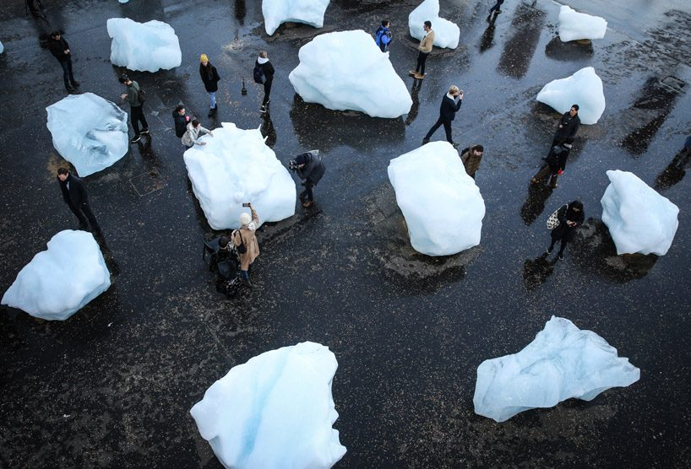
People will be able to interact with the ice blocks and will be able to see the impact that the increase of global temperature has on the planet. People will be able to touch each block of ice hopefully inspiring change. These ice blocks are visible upon entry, in an open room with seating around the walls. The room is white to create a sense of emptiness, this is because without the ice caps the world would collapse.
As the exhibition continues, we enter a space that is divided into four rooms, the first containing the second piece in the exhibition, Alexis Rockman’s, Cascade, (2015), which is an oil and alkyd painting on wood panel. 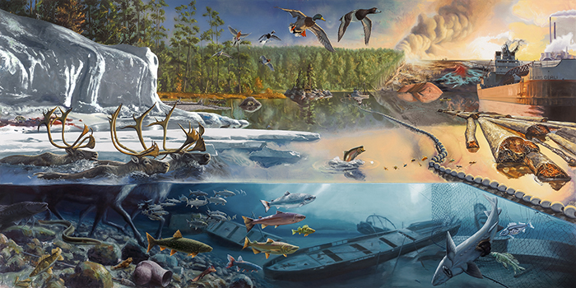
The story of the painting is told from left to right. The shift of colour goes from bright blues to warm oranges and reds, showing the impacts we have on our planets. The painting demonstrates the effects that we have on wildlife as it also shows the pollution from our industrial factories and shipping industry. In addition, deforestation is included within the image which further displays the impacts that we have on our environment. ‘Around 12 million hectares of forests in the world’s tropical regions were lost in 2018, equivalent to 30 football fields per minute.’ (BBC, 2019b). An aim for this exhibition is to help educate people on the different effects that we have on the planet and try to further inform the impact of climate change. This room will have a cool feel on one side with pale blue walls while the other will warm with cracked red walls representing the calmness as well as the destruction in the painting by Alexis Rockman.
Another growing issue that has risen in recent years is forest fires, the global temperature is rising therefore, having an impact on our forests, ‘The global average temperature has risen 1.6˚F.’ (Climate Central, 2015). This is linked to the third piece in the exhibition, this next piece is from Jill Pelto, using scientific data on drought in past years the artist created a piece that demonstrates what is happening in places that are having more and more seasons of drought. 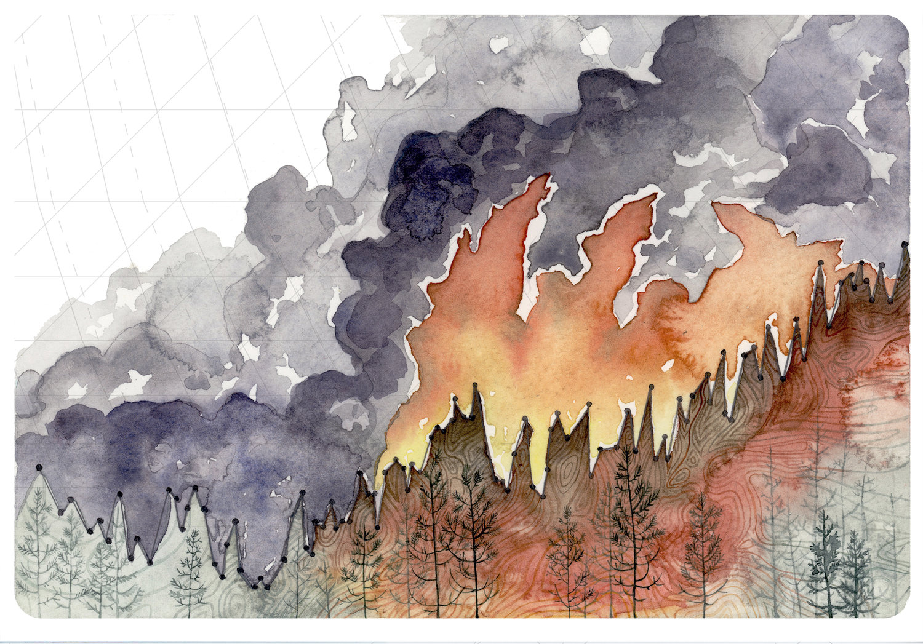
The piece has been created using pens and water colours. This shows the devastation of what drought can bring, forest fire becomes a threat for plants, animals and us humans who live in these areas.
The piece will be placed in the centre of the wall in the room next to the previous piece. The room will have bright red and orange walls to give the feeling of warmth as people enter, Moreover the room will be at a higher temperature to play with our senses. As we walk into the room, we would be with warmth representing the flames from a forest fire. Furthermore, burned branches and bark will be placed around the edges of the room, whist dark wood chip mulch will be spread across the floor bringing the smell of the forest to the room.
As we move on the exhibition opens up and we are faced with three Under the Skin posters 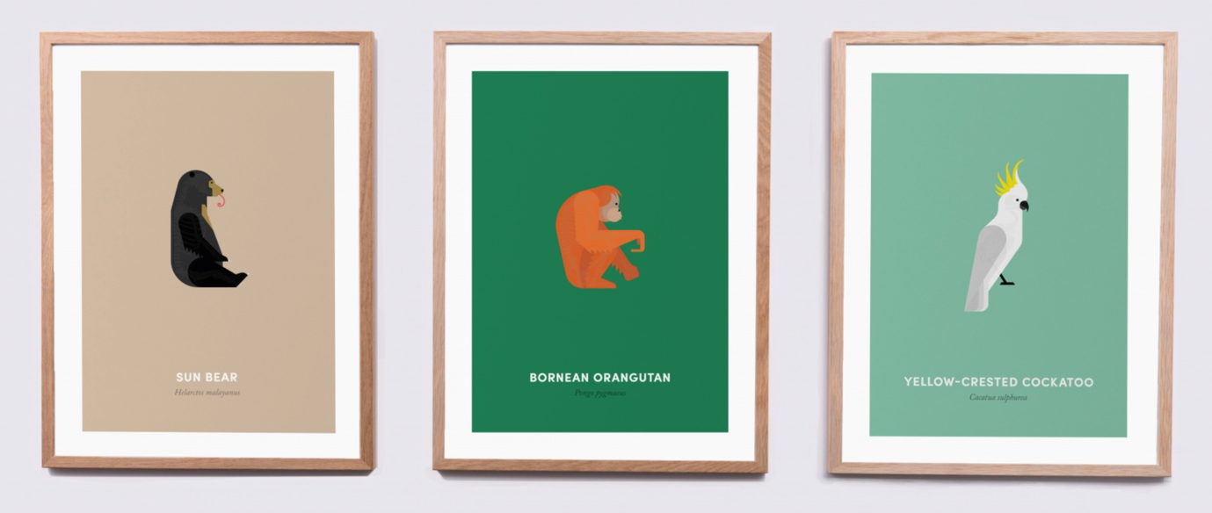
These posters are interactive and have been created by brothers; James Harrison and Ed Harrison they are created to raised awareness on animals that are on the brink of extinction, each poster reveals the skeletons of the animals when put under a UV light. Next to each poster on the wall of exhibition there will be a UV torch, so that people can reveal its deeper meaning. The lights above the posters can be dimmed so that the posters have the full effect within the exhibition.
The purpose of these posters is to help bring extinction of these animals to an end.
Animals are becoming extinct from our own doing, ‘Nature everywhere is declining at a speed never previously seen and our need for ever more food and energy are the main drivers.’ (BBC, 2019c). These posters demonstrate what will happen if we carry on the way we are. More and more animals will become extinct.
Lastly, plastic pollution is one of the biggest environmental topics at this time, plastic has been one of the most sort after materials in term of convenience. It is used everywhere, from bottles to bags. But the ‘problem is that the items do not ever go away from the planet, they pollute it.’ (Knight,2013). The last piece in the exhibition is Tan Zi Xi, Plastic Ocean, (2017). The artwork contains hundreds of plastic items that are known to be found in the sea such as, plastic bottles and bags. The items are attached to the ceiling and gives the viewer the perspective of what it looks like for marine life below the surface.
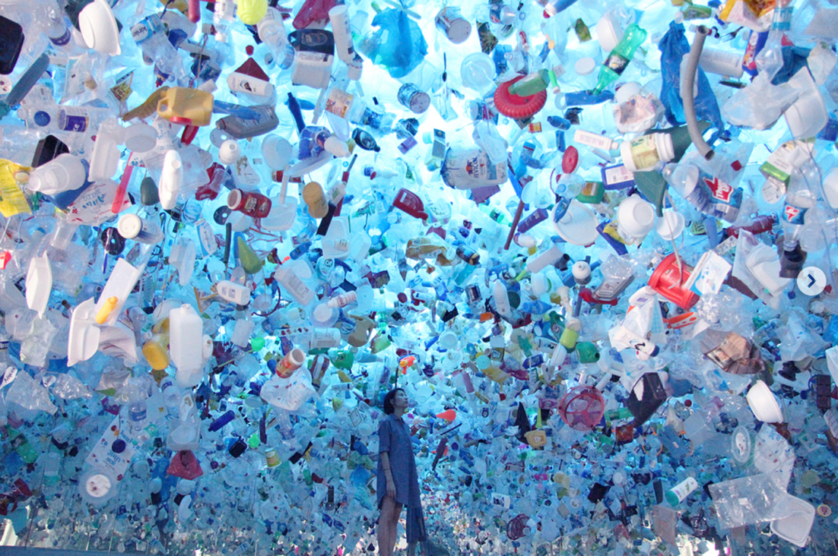

This piece will be placed in its own room where viewers can have a full emissive experience, all the walls and floor will be coloured a deep blue to mimic the ocean and give the feeling of being under water.

My Final Exhibition space:

Overall, I believe the space that I have created flows well and the separate rooms work well as the viewer is able to immerse themselves into each artwork. However, I do believe that the room could be connected via separate corridors to go straight from one to the next. On the whole I am satisfied with the exhibition space that I have curated.

Bibliography
Epstein, A. (2014) The Moral Case for Fossil Fuels, New York: Penguin

Hackett, R.A. et.al (2017) Journalism and Climate Crisis: Public Engagement, Media Alternatives.
New York: Routledge

Wadhams, P. (2017) A Farewell to Ice: A Report from the Arctic. Great Britain: Oxford University Press

Knight, G. (2013) Plastic Pollution. London: Raintree

Baudrillard, J. (1980) Simulacra and Simulation. United States of America: The University of Michigan

BBC. (2019a). Climate change: Where we are in seven charts and what you can do to help. Available at: https://www.bbc.co.uk/news/science-environment-46384067

BBC. (2019b). Deforestation: Tropical tree losses persist at high levels. Available at: https://www.bbc.co.uk/news/science-environment-48037913

BBC. (2019c). Nature crisis: Humans ‘threaten 1m species with extinction. Available at:
https://www.bbc.co.uk/news/science-environment-48169783

Climate Central. (2015). Rise in Global Temps Since 1880. Available at:
https://www.climatecentral.org/gallery/graphics/rise-in-global-temperatures-since-1880

