UWTSD
Name - Judith Churcher
Course – Business and Management (BA)
Module – Technological Change and Innovation (BMSP5001)
Assignment 1 – ‘The Internet, like the steam engine, is a technological breakthrough that changed the world.’ Peter Singer, Australian Philosopher
Considering this quotation, critically evaluate the impact that technology and innovation has had on the development of economies and societies.
Your work should be presented in essay style of 2,000 words (+/- 10% acceptable). Within your work you should discuss a range of theory, drawing from the work discussed within the module as well as your own additional research.

Introduction
In this paper I want to look at how far we have come with technology and how technology for language has helped expand communities and the economy. Pre 19th century, Webster, 2022, says that the book was once the height of technology. The ‘Gutenburg printing press’ was a revolution which had a short term impact and helped the new generation of the time expand their knowledge.
“The internet, like the steam engine, is a technological breakthrough that changed the world” (Peter Singer, Australian Philosopher).
The technological advancement that is the Internet, has had a huge impact on the world and has led to millions of further technological advancements. Such developments and advancements have contributed to the modernization of daily life, business prosperity, economic growth and the expansion of global social communities.
Within the last decade alone, the advancement of the Internet has provided us with opportunities to conduct global and virtual business via e-commerce and virtual networking tools. The internet has also opened up new business ventures and prospects including the development of local organisations into international chains.
“Technology is not something isolated from economies and societies; it co-evolves with social, political and economic systems.” (Defelipe, 2019). The impact of technology and innovation on economies and societies has been studied by many including Carlota Perez, Nikolai Kondratiev and Marshall McLuhan.

Social Impact
Technological change is continuous and has a variety of social impacts. It is fair to say, that over the years, people’s lives have changed as the digital era has developed around them. Giannelis, 2010, tells us that societies will change for those who are willing to accept the advancements. The impact from technological advancements will continue to grow as people embrace its benefits by sharing online and creating global villages.
Technological advancements have had a very positive impact on society as they have improved the way in which people can communicate. Communication has developed from pigeons to transfer messages to email and social media platforms that can reach somebody within seconds even if they are halfway around the world.
Geek, 2022, argues that there are downsides and negative impacts that technological change can have on society. Many people have replaced regular face-to-face contact with piers with digital contact for convenience reasons. While this can be beneficial to people in regards to busy routines and work schedules, staying ‘behind the screen’ also reduces physical activity and has been noted to contribute to mental health problems.

Business Impact
The use of technology in businesses significantly evolved during the Covid-19 global pandemic. The pandemic took a significant impact on businesses in a variety of fields and as a result, businesses needed a quick method to adapt how everyday business was conducted.
While tools such as Skype and FaceTime were commonly used social media tools within the community, the global pandemic drastically changed the impact these platforms effects on people’s lives. Social media is a great way for people to communicate and for communities to come together and share information and ideas. Tools such as Microsoft Teams, Zoom and Skype are now the front running networking tools within businesses and are utilised alongside the use of e-mail. Using such platforms now will reduce overhead costs for many businesses.
Moritz, 2017, says that a study over a million patients published over the past 100 years has revealed that technological advancements have not only had a positive impact, but they have expanded the economy. Technological innovations through the eras have made the industries produce more which effectively has grown and improved the country’s financial health.
Geek, 2022, argues that there are downsides and negative impacts that technological change can have on business. With the digitalisation of the world comes a threat of information governance and information security breaches; such threats have identified the requirement for specialised training and job roles to mitigate against such threats.

Educational Impact
The technology advancements have changed how students learn. Technology allows for flexibility. They are not limited to the classroom and this has taken off since the COVID-19 pandemic. People have had to learn how to use all the different forms of technology in able to continue their learning curriculum. Not only this, but by being able to have access to these technologies they can research subjects, share ideas and learn any specific skills. (ET, 2016) It allows students to be able to work together and helps them find new ways to approaching problems. As technology is always progressing, nearly all will have access to such devices, it is important that they still use textbooks to expand their knowledge. It helps students with all kinds of learning styles, encourages collaboration and most importantly prepares them for the future as this is something that will keep advancing which they need to be ready for.

The Kondratieff Wave Cycle
Nikolai Kondratiev, who developed the Kondratieff Wave Cycle, says that it is a long-term economic cycle that comes from innovative change that makes success (Ganti, 2021).
Kondratieff found that the major periods (also known as ‘K Waves’) of technological evolution were all part of a repetitive cycle consisting of 3 phases:
- Expansion
- Stagnation
- Recession
Trading View, 2022 tells us that such cycles cause changes in mood and social shifts and will impact the world economy.
They also tell us there are six ‘K Waves’ within the cycle; five of which have already occurred and the sixth which is currently in progress. Each ‘K Wave’ represents a period of time, between 45-60 years, where enormous industry change occurs and old mediums are replaced with new.
- Development of the Steam Engine (1780-1830)
- Birth of the Steel and Rail Industry (1830-1880)
- Electrification of the Chemical Industry (1880-1930)
- Growth of the Petrochemical Industry (1930-1970)
- Global Village- Computer Technology (1970-current day)
- Health Care and Biotechnology (There is debate around when the sixth K Wave began; it is believed to be somewhere between 2005-2010).
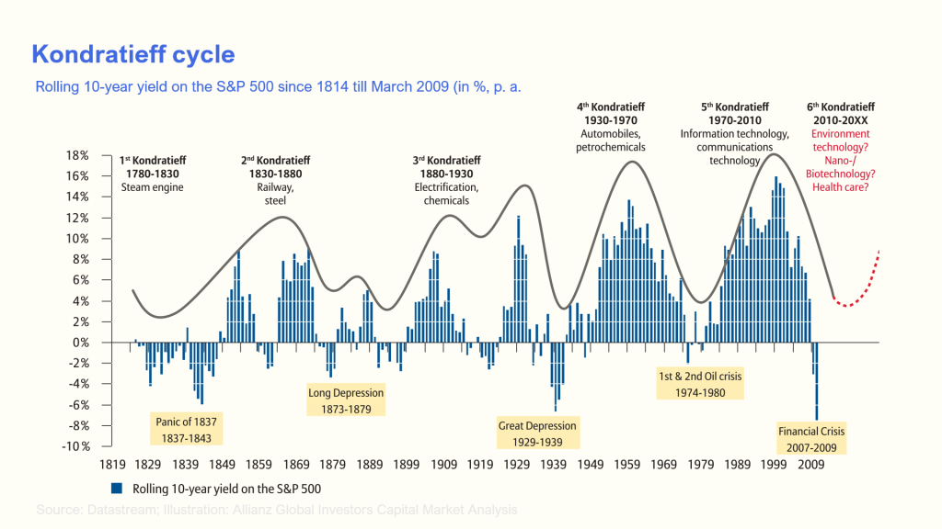
( Kondratieff Cycle: Meaning, Details of the Cycle and Criticism (penpoin.com) )
The sixth stage of the Kondratieff cycle, as said by the CFI Team, 2021, will make change through the technological advancement of healthcare. Theorists believe that the sixth ‘K Wave’ has begun as the world recovers from the impacts and effects of the Covid-19 global pandemic.

The Perez Framework
Carlota Perez undertook studies on each major technological revolution since the industrial revolution to assess the impact of such revolutions on the capital market.
According to Perez, there are two main phases to a technological revolution:
- Installation- technology is introduced and an infrastructure is built.
- Deployment- technology is adopted within society.
AVC, 2015, says that the turning point between the installation and the deployment is marked by a financial crash and recovery as seen in the table below.
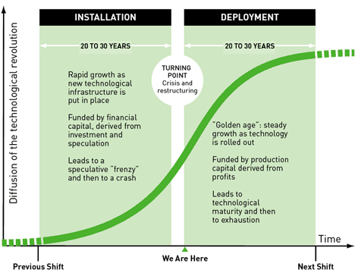
(Carlota Perez, Technological Revolutions and Financial Capital: The Dynamics of Bubbles and Golden Ages, Edward Elgar Publications, 2003)

The Marshall McLuhan Theory
According to Marshall McLuhan, the medium being used to show a message (i.e. - social media, email, posters) is more important that the actual message as the medium significantly influences how a message is understood.
In order to tackle this, McLuhan utilised a ‘tetrad’ of questions, in order to ensure a consistent method of evaluation when considering how each medium will affect the message. The four stages of the tetrad are:
- Enhancement
- Retrieval
- Obsolescence
- Reversal
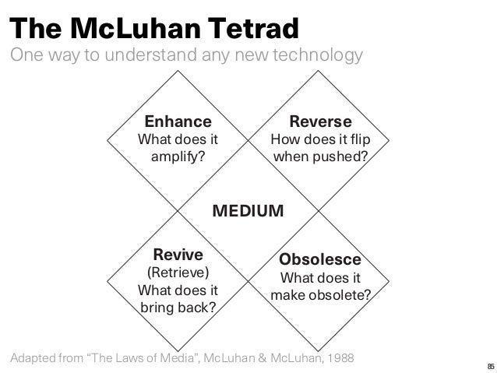
(McLuhan, 1988)
The McLuhan tetrad provides a new perspective for businesses when developing marketing tools. With the tetrad, businesses can consider how their advertisements will be interpreted by their audiences. This allows businesses to adapt their advertisements for different mediums to meet maximum customer outputs.
The tetrad can also be utilised within society when introducing new products, ideas and prospects. For example, Skype, they would use this method when creating their software and it will act as a tool to help find problems and ideas that may need examining. It will enhance the distance from which people can connect and retrieve information and communicate directly. It helps obsolete written letters and memos but can reverse into bulling or miscommunication.
Its important for them to use this tool as it will help businesses see how they convey a message. They can filter their marketing to have different impacts on different people. The tetrad would be used to find out the best way to introduce a message to society.

The Fourth Industrial Revolution.
As we are on the brink of a technological revolution, business and shareholders need to be ready and many may not know how it will affect them. Just like the other eras, this change will given an opportunity to help and change peoples quality of life and increase global income. Schwab, 2016, says that companies are already seeing changes in the supply, through the access of mobile and other devices can see the change in customer behaviours. Customers are adding to the economy and it is important that businesses are serving them correctly.
It will have mass impact on the government, all these platforms will help people engage and express opinions and voices. They need to be able to adapt to the changes to be ready for any change. So far they are under pressure to keep up with legislations and regulations.
Finally, it will affect the people. The constant change will impact on our privacy and identity. It will change our habits, consumption patterns and the time we may spend on other activities outside of the technology world.
Its important that we come together we need to have the same views on technology, how it affects us and out future. To be able to make a success in the way we shape the future, we need to consider people and their values.

Conclusion.
It appears from the evidence that technology advancement has changed the world. Its not something that will disappear as it has created such a large ‘global village’. It has allowed people to expand on knowledge and contact people with ease. It would be fair to say that there are very few today that do not have some sort of technological device. You can look at both sides of the argument and can agree that there are some disadvantages too. The K wave and the Perez Framework theories link by the fact that they both state the cycles of proven through the financial impact the technologies have had. McLuhan’s theory is of one which is used today in many companies and business when marketing. From this, the technologies have supported online economies giving people a wider target audience range. This has opened up more pathways for the now. Its hard to say what will come next, could there be an expansion on the metaverse? A world where you can connect with people in from but are not there physically? The Meta, 2022, hope that by the next decade, a million people will be using this technology. Will you be one of them?

References.
CFI Team. (2021). Economic cycles that alternate between periods of high and low growth rates. What is the Kondratieff Wave? https://corporatefinanceinstitute.com/resources/economics/kondratieff-wave/ Accessed: 14/12/2022
Carlota Perez, Technological Revolutions and Financial Capital: The Dynamics of Bubbles and Golden Ages, Edward Elgar Publications, 2003 [Image] Accessed 14/12/2022
Defelipe, S. (2019). Impactotic. The impact of technology on the development of societies is a matter of choice. https://impactotic.co/en/idh2019-impact-technology-human-development/ Accessed: 14/12/2022
Educational Technology. (2016). The trusted voice in ICT in education. Five ways technology has changed teaching and learning. Five ways technology has changed teaching and learning - Education Technology (edtechnology.co.uk) Accessed: 16/12/2022
Favour, A. (2015). Van Guard. How social media makes the world ‘global village’. How social media makes the world ‘global village’ - Vanguard News (vanguardngr.com) Accessed: 16/12/2022
Giannelis, M. (2010). Tech News. The Social Impact Of Technology. https://www.techbusinessnews.com.au/the-social-impact-of-technology/#:~:text=Impact%20On%20Society,-Technological%20change%20is&text=As%20technologies%20continue%20to%20improve,pathways%20of%20communication%20and%20interaction. Accessed: 16/12/2022
Ganti, A. (2021). Investopedia. Kontradieff Waves: Definition, Past Cycles, How They Work. Kontradieff Waves: Definition, Past Cycles, How They Work (investopedia.com) Accessed: 14/12/2022
Moritz, K. (2017). Rewire. How Does Technology Affect the Economy? How Does Technology Affect the Economy? | Rewire Accessed 14/12/2022
Nasrudin, A. (2022). Penpoin. Kondratieff Cycle: Meaning, Details of the Cycle and Criticism. Kondratieff Cycle: Meaning, Details of the Cycle and Criticism (penpoin.com) [Image] Accessed:14/12/2022
Trading View. (2022). Wave analysis. Konfratieff Wave – predictions and analysis. https://www.tradingview.com/ideas/kondratieff/ Accessed: 14/12/2022
View Sonic. (2022) Education. 5 Benefits of Technology in the Classroom. 5 Benefits of Technology in the Classroom - ViewSonic Library Accessed: 16/12/2022
Meta. (2022) About Meta. What is the metaverse? What is the Metaverse? | Meta Accessed: 16/12/2022
Kelly, O. (2011) Mc Luhans’s tetrads. McLuhan’s tetrads: what they are and how they work. McLuhan’s tetrads: what they are and how they work – owenkelly.net Accessed: 16/12/2022
Naughton, J. (2008) The Observer. Thanks, Gutenberg – but were too pressed for time to read
World Economic System. (2016) Fourth industrial revolution. What it means and how to respond. https://www.weforum.org/agenda/2016/01/the-fourth-industrial-revolution-what-it-means-and-how-to-respond/ Accessed; 16/12/2022

