
Student name-Badmus Adeshola OMOTOSHO
Student ID-1914925
Module code-BMHP5013
Lecturer Name Dr Evelyn Callahan

Public Health Policy

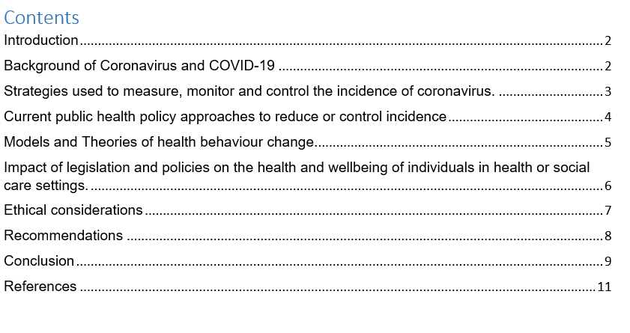

Introduction

General wellbeing strategy is characterized because the laws, guidelines, activities, and choices dispensed inside society to advance wellbeing and guarantee that individual wellbeing objectives are met. The Covid-19 pandemic has been an uncommon circumstance that has tried nearby general wellbeing frameworks to the limit for over a year. Specifically, they need had a completely unique perspective and are at the bleeding fringe of selecting complex choices about their neighbourhood populaces.

Background of Coronavirus and COVID-19

COVIDs are a group of linked RNA diseases that infect warm-blooded animals and birds, causing illness. They produce respiratory contaminations in individuals and birds which variety from mild to fatal. People can contract mild illnesses such as the usual cold (which is also occured by other diseases, most notably rhinoviruses), while more dangerous strains could cause SARS, MERS, and COVID-19. They decrease bowel looseness in cows and pigs, as well as hepatitis and encephalomyelitis in mice. The first documented cases of COVID illness in animals were in the late 1920s, when a severe respiratory infection of domesticated hens seemed in North America. In 1931, Arthur Schalk and M.C. Hawn issued the most definitive report of another respiratory ailment in hens in the United States. Heaving and lethargy were signs of contamination in new-born chicks, as were significant death rates of 40–90 percent. The illness that caused the contamination in 1933 was contained by Leland Bushnell and Carl Alfred Brandly. COVID's hazard factor changes dramatically. Some, such as MERS-CoV, can end up to 30% of those diseased, while others, such as the common cold, are relatively harmless. Coronaviruses might induce colds with life- threatening indications such as fever and a sore throat due to swollen adenoids. SARS-CoV, a human COVID discovered in 2003 that reasons severe acute respiratory syndrome (SARS), has a new pathophysiology subsequently it affects both upper and lower respiratory tract disorders. COVID sickness 2019 (COVID-19) is a disease caused by a unique COVID recognised as major intense respiratory disease COVID 2 (SARS-CoV-2; also known as 2019-nCoV), which was originally identified during a respiratory illness outbreak in Wuhan, Hubei Province, China. On the first day of 2019, it was responded to by the WHO. The WHO declared the COVID-19 flare-up a worldwide health concern on January 30, 2020. The WHO acknowledged COVID-19 a universal epidemic on March 11, 2020, the initial period it has done so meanwhile announcing H1N1 flu a plague in 2009. (Jimmy, 2019).
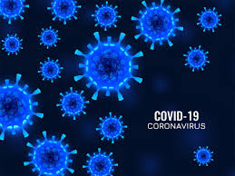
Measure: In nations extensively testing speculated cases for COVID-19, the foremost accurate marks of power are irrefutably the amount of recently affirmed cases and their notice rate per 100,000 populaces. they offer a robust premise to observing patterns over the long term and for intra-country (probably to a lesser degree: between country) correlation. Nations just testing serious cases for COVID-19 could utilize the amount and spot pace of maximum cases as an intermediary of power for pattern checking, taking under consideration changes in testing strategy after our time of individual and social entities (Iren, 2019).
Monitor: because the infection that causes COVID-19 began to spread from one individual to a different in networks (local area transmission), researchers expected to follow the sickness and try and slow its spread. to try to per se, they necessary a representative description for an instance of COVID-19. Consuming a case description supports with guaranteeing cases are counted the identical way everywhere. within the uk, an affirmed illustration of COVID-19 is categorised as a positive individual for the infection that causes COVID-19. COVID-19 changed into a broadly notifiable illness, implying that wellbeing offices are needed to report instances of COVID-19. Frameworks just like the National Notifiable Diseases closed-circuit television (NNDSS) gather and send information on instances of COVID-19 to CDC (Henry, 2018). These aides the organization screen patterns in cases inside states and also the nation over. Gathering information from clinical records (outline deliberations) can enlighten us really regarding COVID-19 patients and therefore the course of their illness. This information may incorporate segment data (age, race/nationality, sex), even as side effects, medicines, and wellbeing results. Researchers can utilize graph deliberations to comprehend who is certain to end up to be seriously sick, what clinical consideration patients have gotten, and within the event that patients have recuperated.
Control: Screening, regulation (or concealment), and relief are procedures used to keep an episode under control. The screening is completed with a device, such as a thermometer, to detect the increased internal heat level associated with fevers produced by the Covid. Control is adopted in the early stages of the flare-up, and preparations are made to follow. and detach individuals who have been exposed, as well as familiarize yourself with various ways to avoid the virus from scattering. When it is no longer possible to anticipate to control the illness, efforts shift to the alleviation stage, in which steps are sought to reduce the spread and mitigate the repercussions for the medical aid system and society. It's possible that a combination of regulatory and alleviation measures will be implemented at the same time. Concealment necessitates more serious measures to halt the epidemic by lowering the elemental generation number to less than one (Graham, 2017).

Current public health policy approaches to reduce or control incidence

Worldwide, immunization programs have ended up being protected and powerful and save lives. However, most antibodies don't present 100% security, and it is not recognized how immunizations will forestall upcoming broadcast of SARS-CoV-2,6 given arising variations. The extent of the populace that ought to be inoculated against Coronavirus to make crowd resistance relies significantly upon current and future variants. This immunization limit fluctuates as per the state and populace's reaction, sorts of antibodies, bunches focused on for inoculation, and viral changes, among different elements. Until crowd insusceptibility to Coronavirus is reached, paying little heed to the widely demonstrated high immunization rates, general wellbeing preventive procedures are likely to remain as best choice measures in illness anticipation, especially in places with a coffee take-up of Coronavirus inoculation. Measures like lockdown (neighbourhood and public variation), physical removing, obligatory utilization of facial coverings, and hand cleanliness are disbursed as essential preventive techniques to test the Coronavirus pandemic (Bob, 2020). Past orderly surveys on the viability of general wellbeing measures to treat Coronavirus didn't have the incorporation of logical investigations, an exhaustive thanks to accommodate information amalgamation (zeroing in precisely on one measure), a radical appraisal of adequacy of general wellbeing measures, an evaluation of the reassurance of the proof, and powerful techniques for relative examination. To handle these holes, we played out an orderly survey of the proof on the viability of equally discrete and various general wellbeing events in lessening the occurrence of Coronavirus, SARS-CoV-2 transmission, and Coronavirus transience. At the purpose when attainable we additionally did a basic examination of the proof and meta-investigation.
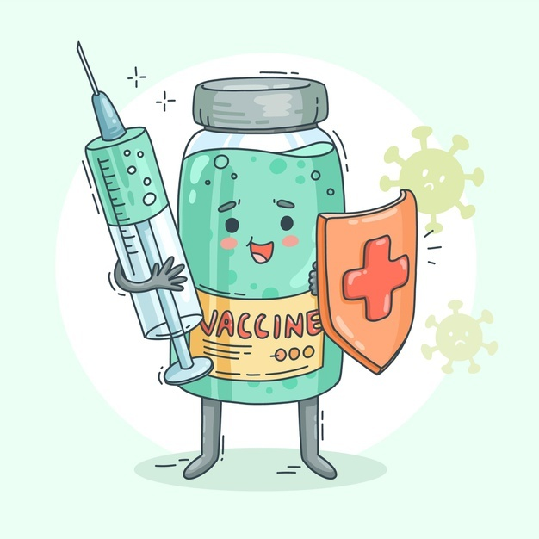

Models and Theories of health behaviour change.

The turn of events and evaluation of models and hypotheses aimed at understanding or potentially impacting wellbeing behavior has gotten a lot of attention from social researchers. Researchers have accepted increasing explicitness within the theoretical definition and estimate of constructs as hypothesis has evolved, sprouting up to be more focused on behavior transformation over comprehending the reasons why individuals participate especially in wellness activities (Eric, 2016). Models include:
Health belief model (HBM)
The HBM foremost acted in the 1950s as a guidebook for TB screening studies. It polished concepts from a diverse range of mental and practical explorations and laid the groundwork for the speculations that followed. HBM stands for expectation esteem model.
Social cognitive theory (SCT)
As an additional thanks to cater to representations/speculations of wellbeing conduct, we emphasis on Bandura's SCT.5 like HBM, SCT hypothesises people as normal entertainers. While there's proceeded with accentuation on the thought of anticipation esteem, a main headway of SCT is its emphasis on near home organization and therefore the significance of setting as an element of wellbeing conduct. Additionally, while SCT has remained helpful in considerate the rationale why individuals play out a selected comfort conduct, it's similarly majorly pretentious interventions for conduct change (Darcy, 2018).
Relapse prevention (RP)
The third model of well-being behavior that we choose to explore is RP, which stands for habit-forming performance. 10 RP might be a paradigm that is specifically designed to manage change. The goal of RP, which sprang from SCT, was to portray the trajectory of habit-forming behavior's backslide while accentuating the significance of premature interference. They saw backslide as a common and transient interaction, with the essential idea being to steer away from or figure out how to adjust to high-risk situations.
Self-determination theory (SDT)
Humans are driven by three primary wants, according to SDT: the urge to feel competent, social communication, and Independent. SDT's fundamental needs are positioned to be inherently valued, and Deci and Ryan, like other theories, emphasize the significance of connecting the substance of one's objectives with one's essential needs.
The fundamental justification behind wellbeing and security enactment is to confirm individuals at work and therefore the folks that are impacted by work exercises. Enactment (that is, laws) is created so everybody within the public arena knows which practices are satisfactory and which aren't (Ven, 2019). Enactment and code of coaching work together with my organization's goal to ensure that people are looked for in accordance with the plan and strategy that reflect the wellness and social consideration area. Most health and social consideration settings will be on the lookout for new laws and enactments to see if they have been updated or changed, because if they do not know that the arrangement has changed, they may be in violation of the enactment that governs their industry, which could have a serious impact on their business. In each workplace, the coaching code ensures that expert activity follows the organization's requirements. This aids in identifying and monitoring threats to assure security. A code of conduct also aids in ensuring that clients receive high-quality services. Abusing a code of coaching in any profession might result in legal consequences for both the organization and the individual doing the demonstration. As we add this section, we are reminded that it is our obligation to support and focus on our clients, protecting them from harm and misuse. The Code of Conduct outlines how laborers should conduct themselves. It specifies the lead standard for all treatment support workers and adult friendly consideration workers in England. The code outlines the behaviors and attitudes that people who receive care and support can expect from those who work in the field. Although the Code of Conduct is voluntary, it is seen as a sign of top practice. The Code of Conduct establishes the standard of conduct required of medical aid workers and adult friendly consideration workers. It records the behaviors and mindsets that you should expect from folks who have signed on to the code. It enables them to provide secure, dependable care and support (Drake, 2019).

Ethical considerations

Moral believe is a collection of values and makings that should to be adhered to while burden human undertakings. The moral observations safeguard that nonentity acts so that is hurtful to society or a person. It avoids persons and associations enjoying awful conduct. Nurses are advocates for patients and should track down an equilibrium while conveying patient consideration. There are four fundamental standards of morals: independence, helpfulness, equity, and non-perniciousness. Every individual has the freedom to make their own decisions based on their own convictions and characteristics. Medical treatment necessitates high moral standards. These standards are part of the subject of applied morals known as wellness or clinical morals, which is concerned with moral navigation in clinical treatments and methods. Abusing a patient's secrecy can have legitimate and moral ramifications for medical care suppliers, as per the Health Insurance Portability and Accountability Act (HIPPA). Doctors are expected to maintain the safety and security of a patient's medical information as part of the demonstration (Ceilo, 2021). HIPPA further specifies who has access to personal information and who does not. Despite the law's clarity, there are still scenarios that are unclear. Clinicians should be aware that CPR might sometimes worsen pre-existing conditions. In such scenarios, evaluating whether the amount of suffering warrants the benefits might aid specialists in examining extreme conditions such as dire situations. The high-risk nature of the medical services environment may increase the likelihood of misconduct. The essential duties of patient concern should be covered by overseers, just as they should be covered by doctors and medical attendants. Conventional carelessness in clinics might be due to a lack of clinical equipment, a misdiagnosis, or a delayed decision (Fedrick, 2019).

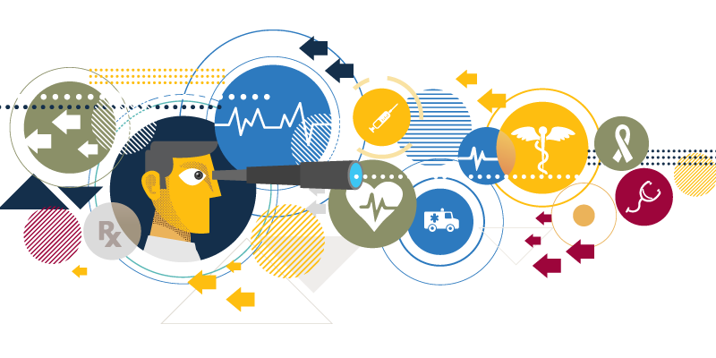

Recommendations

The UK Health Security Agency (UKHSA) has suggested 3 realistic changes that medical clinics can make to the current administration of (COVID-19) Infection Prevention and Control (IPC) events, with an attention on elective care. This exhortation comes as a greater amount of the populace is inoculated and thusly ensured against COVID-19 and we see more with regards to how the disease is communicated and can be contained (Ruston, 2020). This counsel ought to be utilized by nearby intense consideration suppliers to permit them to begin to roll out additional protected improvements to their administrations, in accordance with a neighborhood appraisal of risk. It is trusted that while reacting to changing logical information, these proposals in beginning to lessen upgraded COVID-19 explicit IPC estimates will likewise assist with facilitating the strain made by the pandemic on NHS limit over the course of the following not many months, adjusting the distinctive wellbeing needs of the populace as we figure out how to live with the infection. Such as:
- A decrease of physical contact from 2 meters to 1 meter with suitable alleviations where patient access can be controlled (for instance, not in crisis offices). This is in agreement with the World Health Organization (WHO) which as of now exhorts 1-meter physical separating in medical care facilities.
- Removing the requirement for a negative PCR and 3 days’ self-segregation before chose elective methods. Chosen patients in okay gatherings who are completely immunized, asymptomatic, with a negative parallel stream test upon the arrival of their system will presently don't have to have a negative PCR and separate for 3 days (Strasburg, 2020).
- Re-taking on standard rather than upgraded cleaning methodology. Upgraded cleaning can be suspended in concurred generally safe regions, for example, arranged or booked elective consideration and suppliers can return to standard cleaning methods between patients.
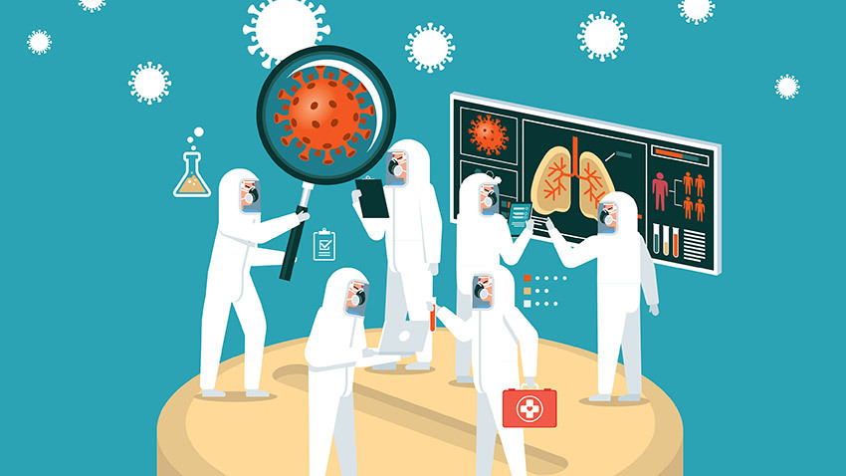

Conclusion
While COVID-19 disease rates remain somewhat low in a considerable lot of the spaces where we work, this is what else is going on. Violence has ejected all over the planet in implementing new rules set up to shield individuals from the infection. Beatings are going on in the business sectors, burglaries and plundering are a steady danger. The emergency is grasping its clench hand, fixing the pressure and agony felt across the world. Connection Projects need us right now. Food and medication supply lines have been cut, and we should buy food soon. To securely ship this food and get earnestly required medication, locking vans or transports are an absolute necessity.

References
- Centres for Disease Control and Prevention. 2021. Coronavirus Disease 2019 (COVID-19). [online] Available at: <https://www.cdc.gov/coronavirus/2019-ncov/science/about-epidemiology/monitoring-and-tracking.html>
- Cortés Manuel, E., 2020. Coronavirus disease 2019 (COVID-19): The importance of the One Health approach. Compendia de Cadencies Veterinaries, 10(1), pp.46-47.
- Feasibility of controlling COVID-19 outbreaks by isolation of cases and contacts. Lancet Glob Health2020;8: e488-96. doi:10.1016/S2214-109X (20)30074-7 pmid:32119825.
- Guzzetta, G., Riccardo, F., Marziano, V., Poletti, P., Trentini, F., Bella, A., Andrianou, X., Del Manso, M., Fabiani, M., Bellino, S. and Boros, S., 2021. Impact of a nationwide lockdown on SARS-CoV-2 transmissibility, Italy. Emerging infectious diseases, 27(1), p.267.
- Hellewell J, Abbott S, Gimma A, et al., Centre for the Mathematical Modelling of Infectious Diseases COVID-19 Working Group.
- Henry DA, Jones MA, Stehlik P, Glasziou PP. Effectiveness of COVID-19 vaccines: findings from real world studies. Med J Aust 2021; 215:149-151.e1. doi:10.5694/mja2.51182. pmid:34296443.
- Holmdahl, I. and Buckee, C., 2020. Wrong but useful—what covid-19 epidemiologic models can and cannot tell us. New England Journal of Medicine, 383(4), pp.303-305.
- Marteau TM, Ogilvie D, Roland M, Suhrcke M, Kelly MP. Judging nudging: can nudging improve population health? Bmj-Brit Med J. 2011;342: d228–d228. doi:10.1136/bmj. d228.
- Parodi SM, Liu VX. From Containment to Mitigation of COVID-19 in the US. JAMA 2020; 323:1441-2. doi:10.1001/jama.2020.3882. pmid:32167525.
- Rochaska JO, Redding CA, Evers KE. The transtheoretical model and stages of change. In: Glanz K, Rimmer BK, Viswanath K, editors. Health Behavior and Health Education: Theory, Research & Practice. 4th ed. San Francisco, CA: Jossey-Bass; 2008:97–117.
- Sterne, J.A., Savović, J., Page, M.J., Elbers, R.G., Blencowe, N.S., Boutron, I., Cates, C.J., Cheng, H.Y., Corbett, M.S., Eldridge, S.M. and Emberson, J.R., 2019. Rob 2: a revised tool for assessing risk of bias in randomised trials. bmj, 366.
- Stuckler D. If the world fails to protect the economy, COVID-19 will damage health not just now but also in the future. Nat Med 2020; 26:640-2. doi:10.1038/s41591-020-0863-y. pmid:32273610.
- Tobías, A., 2020. Evaluation of the lockdowns for the SARS-CoV-2 epidemic in Italy and Spain after one month follow up. Science of the Total Environment, 725, p.138539.
- UKEssays. November 2018. Impact of Policies on Health and Social Care Setting. [online]. Available from: https://www.ukessays.com/essays/health-and-social-care/impact-policies-health-social-care-5778.php?vref=1
- Van den Berg, P., Schechter-Perkins, E.M., Jack, R.S., Epshtein, I., Nelson, R., Oster, E. and Branch-Elliman, W., 2021. Effectiveness of three versus six feet of physical distancing for controlling spread of COVID-19 among primary and secondary students and staff: A retrospective, state-wide cohort study. Clinical infectious diseases: an official publication of the Infectious Diseases Society of America.

