
School of Engineering
Degree being studied: - Mechanical Engineering

Module Name: -Computational Methods
Module Code: - ACMA6012
Student Name: - Jason Evans
Student Number: -1706645

Contents
1 Introduction 3
2 The governing equation of the problem 4
3 A full description of the numerical method chosen to discretise the governing equation 5
4 The initial, boundary conditions and analytical solution 8
5 Codes’ details and explanations 9
6 Analysis of the code results. 15
7 A discussion as to the limitations of the model. 19
8 Suggested improvements to the model and future developments 20
9 A conclusion. 21
10 References 22
11 Appendix 23

List of tables
Table 1 Thermal Equilibrium Versus Grid Spacing 17
Table 2 Thermal Equilibrium Versus Time Step Change 18
Table 3 Tolerance versus Therma Equilibium 19

List of figures
Figure 1 Summary of boundary conditions 9
Figure 2 First part of the code 10
Figure 3 Setting the dimensions of the plate 10
Figure 4 User defines spacing dimension 11
Figure 5 Setting up the time step 11
Figure 6 Initializing the conditions of the plate 11
Figure 7 Initial temperature distribution 12
Figure 8 Main iteration part of the simulation 13
Figure 9 Visualization of the main part of the simulation 13
Figure 10 How long the simulation took with conditional statements showing seconds, minutes, hours and days accordingly. 14
Figure 11 The analytical solution 14
Figure 12 Visualization of the analytical solution 15
Figure 13 Calculating and displaying the difference between the simulation and the analytical code 15
Figure 14 Temperature map of the heat equation on the aluminium plate. 16
Figure 15 Graph displaying grid spacing versus thermal equilibrium 17
Figure 16 Thermal Equilibrium Versus Time Step. 18
Figure 17 Thermal Equilibrium versus Tolerance 19

Introduction
This technical report is designed to briefly describe and show the calculation of the heat equation. Within the report there is a full description of the governing equation, numerical method chosen to discretise the governing equation as well as a section displaying the different sections of the code with a brief explanation of each.
Following this there will be a section analysing the different iterations of code that have altered variables to see what affect they may have on the final outcome.
There will also be a section discussing the limitations of a model like this and some suggestions for improving the model and future development flowed by a conclusion.
At the end of the report is an appendix which contains the analytical code in its entirety which would then be possible for an alternate user to use the same cod to see if results are repeatable.

The governing equation of the problem
The Fourier equation, a partial differential equation developed by Jean Baptiste Joseph Fourier (1768-1830) (Morales-Castillo and Morales-Rodriguez, 2023). At the time that the equation was presented in 1822 there was no reliable way to determine the heat conduction through a solid object (Narasimhan, 1999). Fourier established the partial differential equation that is the Fourier equation and solved it using an infinite amount of trigonometric functions and it describes how the heat in a given region changes over time (Monks, 2022). There had been many attempts by many well renowned scientists to understand heat transfer including such names as Gabriel Daniel Fahrenheit. He created the first temperature scale and mercury thermometer (Qiu et al., 2023). Joseph Black coined the terms latent heat and specific heat after observing ice was absorbing more heat without changing its temperature and noting that different materials of the same mass needed varying amounts of heat to raise their temperature by the same amount (da Fonseca Moraes Batista and Silva, 2019). These are just two examples of other scientists working towards a similar goal of understanding the phenomenon of heat transfer through a solid object.
Through solving the equation engineers can determine how heat travels through different types of systems and is crucial in the creation of heat exchangers (Shah and Sekulić, 2003). With this in mind the modern world could suffer greatly without the use of this equation as the efficient transfer of heat from things like the central processing unit of a computer could end up being a lot more difficult due to being unable to accurately calculate the diffusivity of the heat sink and could cause no end of problems and its possible that the technology available today may not have been possible without the heat equation (Nakayama, 2014).
Engineering uses are not the limits of this equation however, there are many more uses that have been found for the equation including meteorological uses, where the equation is used to create climate models for weather patterns. Also, geological uses and various other disciplines also use the same equation in various forms to create models to represent the data that they have collated (Helwig et al., 2023).
Below is a mathematical definition for a two-dimensional geometry with ideal assumptions of uniform density, specific heat and thermal conductivity. with no heat source assuming Cartesian coordinates: -
$$\frac{d^{2}T}{{dx}^{2}}+\frac{d^{2}T}{{dy}^{2}}=\frac{ρ∙c_{p}}{k}∙\frac{dT}{dt}$$
Where $“T$” is Temperature and “$x$” and “$y”$ are spatial coordinates along the two-dimensional plane. $"ρ"$ is the density ${"c}_{p}"$ is specific heat and “$k"$ is the thermal conductivity, finally “$d"$is the change in these variables ( for example $dx$= change in $x )$.

A full description of the numerical method chosen to discretise the governing equation.
To discretise the governing equation the first step was to use the Taylor series to generate a difference approximation to the first derivative of the equation then followed by a second derivative.
The Taylor series or the Taylor expansion as it is also known is way to express a function as an infinite number of sums of terms at a particular point as a function of “$x$”. This is based on derivatives of the functions at this given point. This allows the user to approximate functions with what are known as polynomial terms. A polynomial is a mathematical expression that literally means many terms for example: -
$$P\left(x\right)=5x^{3}+2x^{2}+3x+1$$
As this shows using the Taylor series to solve the Fourier equation gives a much simpler equation to solve as opposed to the initial equation.
To begin this there is a forward, backward and central derivation from the Taylor series that allows a greater approximation of the final answer.
Forward derivation: -
Focusing on 2 points “$x"$ point “$x+h"$ where “$h"$ is a spacing dimension chosen by the user: -
$$f\left(x+h\right)=f\left(x\right)+f^{'}\left(x\right)h+\frac{f''(x)}{2!}h^{2}+\frac{f'''(x)}{3!}h^{3}+…\frac{f^{∞}(x)}{∞!}h^{∞}$$
Thus, approximating the function $f^{'}\left(x\right),$ the result is
$$f^{'}(x)≈\frac{f\left(x+h\right)-f\left(x\right)}{h}$$
Which can be truncated to prevent it being too long of a solution.
This is then the forward difference formula, a similar result can be achieved for the backward derivative again by considering two points, in this case “$x"$ and $"x-h"$
$$f\left(x+h\right)=f\left(x\right)+f^{'}\left(x\right)h+\frac{f''(x)}{2!}h^{2}-\frac{f'''(x)}{3!}h^{3}+…\frac{f^{∞}(x)}{∞!}h^{∞}$$
Again this allows the approximation of the derivative $f'(x)$ which, again allows the truncation after this term: -

$$f'(x)≈\frac{f\left(x\right)-f(x-h)}{h}$$
This is the solution.

To get the central difference formula, again looking at two points this time $"x+h"$ and “$x-h$”. As previously seen the Taylor series around these points are as follows: -
For $"x+h"$: -
$$f\left(x+h\right)=f\left(x\right)+f^{'}\left(x\right)h+\frac{f''(x)}{2!}h^{2}+\frac{f'''(x)}{3!}h^{3}+…\frac{f^{∞}(x)}{∞!}h^{∞}$$
For $"x-h"$: -
$$f\left(x+h\right)=f\left(x\right)+f^{'}\left(x\right)h+\frac{f''(x)}{2!}h^{2}-\frac{f'''(x)}{3!}h^{3}+…\frac{f^{∞}(x)}{∞!}h^{∞}$$
Subtracting the second from the first gives this: -
$$f\left(x+h\right)-f\left(x-h\right)=2f^{'\left(x\right)}h+\frac{2f^{'''}\left(x\right)}{3!}h^{3}+…$$
And finally, if this is solved for $f'(x)$ the result is: -
$$f'(x)≈\frac{f\left(x+h\right)-f(x-h)}{2h}$$
Which is the central difference formula.
Using the explicit finite difference scheme: -
Using the heat equation: -
$$\frac{dT}{dt}=a\frac{d^{2}T}{{dx}^{2}}$$
Replacing the time derivative with an approximation of the forward derivative and the second derivation (the spatial one) with the approximation of the central difference which then gives: -
$$\frac{dT}{dt}≈\frac{T\left(x,t+Δt\right)-T(x,t)}{Δt}$$
And,
$$\frac{d^{2}T}{{dx}^{2}}≈\frac{T\left(x+Δx,t\right)-2T\left(x,t\right)+u(x-Δx,t)}{{Δx}^{2}}$$
Substituting this into the heat equation: -
$$\frac{T(x,t+Δt)-T(x,t)}{Δt}=a\frac{T\left(x+Δx,t\right)-2T\left(x,t\right)+T(x-Δx,t)}{{Δx}^{2}}$$

Applying the finite difference scheme often means solving for $u(x,t+Δt)$ or $T(x,t+Δt)$in this instance, since $T(x,t)$ at the current time step is known, the previous equation is then rearranged to the following: -
$$T\left(x,t+Δt\right)=T\left(x,t\right)+a\frac{Δt}{Δx^{2}}(T\left(x+Δx,t\right)-2T\left(x,t\right)+u\left(x-Δx,t\right))$$
This equation gives us the finite difference method for the heat equation, where the spatial or “x” derivative is substituted with the central difference approximation and the temporal “t” derivative is substituted with the forward difference method. This is then used to solve the heat equation by using the values of $T(x,t)$ independently through each spatial point giving an approximate example of the temperature there at a given point.
The next step is dividing the spatial domain so that each given point or node on the grid is spaced small enough that an accurate picture can emerge of the plate to show as accurate representation as possible.
Dividing the spatial domain (a, b) into “$n$” number of grid points $x_{a}$ where $a=0,1,2,3…n$ and using uniform grid spacing $Δx$ between nearby grid points calculated as $Δx=\frac{b-a}{n}$.
Where $"a"$ represents the left boundary of the domain and the “$b"$ represents the right boundary of the domain in this instance it represents the temperature at these boundaries.
What must be completed then is the breakdown of the temporal domain essentially breaking the time interval into discreet steps allowing for the most accurate representation of this point.
Breaking down the time interval $(t_{0},t_{f})$ into numerous time steps “m” in this instance $t_{0}$is the initial time step and $t_{f}$ is the end or final one.
What is needed then is choosing an appropriate time step, choosing a size small enough that the solution is numerically stable. While choosing the timestep, stability considerations need to be considered which means that for a differential equation to be stable the solution to the equations, or the output must be under control. This ensures that the information that the simulation creates is as accurate as possible.
Initialization of the time step $t=t_{0}$ this is the start time and then at each time step of $t$ the spatial derivatives are then computed using the central difference method mentioned above then the temperature is updated at each node in the grid using the explicit finite difference method. Following this it is necessary to move onto the next time step and repeat the process until reaching the final time of “$t_{f}$”.
To calculate the Fourier number: -
$$F_{0}=\frac{aΔt}{(Δx)^{2}}$$

The initial, boundary conditions and analytical solution
The initial boundary conditions are set up as follows: -
Initial domain condition: 𝑇(𝑥, 𝑦, 0) = 0 0 < 𝑥 < 6 0 < 𝑦 < 6
Constant boundary conditions:
- 𝑇(0, 𝑦,𝑡) = 0
- 𝑇(6, 𝑦,𝑡) = 0
(a,b) for 0 ≤ 𝑦 ≤ 6 𝑎𝑛𝑑 0 ≤ 𝑡 ≤ 𝑡ℎ𝑒𝑟𝑚𝑎𝑙 𝑒𝑞𝑢𝑖𝑙𝑖𝑏𝑟𝑖𝑢𝑚
- 𝑇(𝑥, 0,𝑡) = 𝑓(𝑥)
- 𝑇(𝑥, 6,𝑡) = 0
(c,d) for 0 ≤ 𝑥 ≤ 6 𝑎𝑛𝑑 0 ≤ 𝑡 ≤ 𝑡ℎ𝑒𝑟𝑚𝑎𝑙 𝑒𝑞𝑢𝑖𝑙𝑖𝑏𝑟𝑖𝑢𝑚
Below is a figure displaying these boundary conditions: -
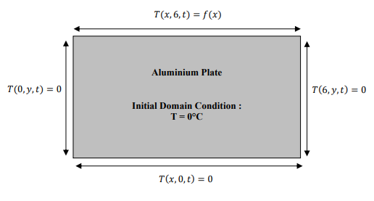
Figure 1 Summary of boundary conditions.
Below is the analytical code that will be used for the analytical section of the code given in the assignment brief (Daileda, 2012):-
$T\left(x,y\right)=\frac{450}{π^{2}}∙\sum_{n=1}^{∞}{(}\frac{\sin\left(\frac{2∙n∙π}{3}\right)}{n^{2}∙\sinh\left(n∙π\right)}∙sin⁡(\frac{n∙π∙x}{6})∙sinh⁡(\frac{n∙π∙y}{6})$)

Codes’ details and explanations
This part should provide snapshots of each section of the codes with some explanations underneath.
In this section there will be a snapshot of each section of the code and a brief explanation oof what each part of the code does.
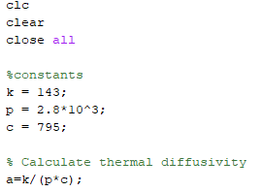
Figure 2 First part of the code.
The first three lines (figure 1), (clc, clear and close all) ensures that the workspace is clear of any conflicting variables that may otherwise cause issues with the script like unwanted side effects etc. It also clears any output messages from previous scripts allowing anything from the current script to be easily viewed without any confusion or clutter. Finally, “close all” ensures that any open image windows are closed, this ensures that there aren’t any conflicts with current windows when a new one opens, as well as resource management within the computer, the greater amount of windows are open could cause the computer to run slower.
The first section of the actual code where the constants required for the simulation are set up, including the thermal conductivity (k), density (p), and the specific heat capacity (c). These are specific to the material in use for the simulation which is aluminium and was given as part of the assignment brief.
Using these constants the thermal diffusivity (a) is calculated.
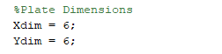
Figure 3 Setting the dimensions of the plate.
This section of the code (figure 2) sets the dimensions of the plate with the “Xdim” being the dimensions of the aluminium plate in the horizontal axis and “Ydim” being the dimensions in the vertical axis.

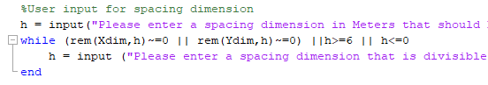
Figure 4 User defines spacing dimension.
Here the user defined spacing dimension is set, it also does not allow the user to input a number that cannot be accommodated by the code (must be greater than zero, less than six and wholly divisible by six), if the number does not meet these requirements the code asks the user to input another number following these parameters.
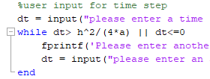
Figure 5 Setting up the time step.
The time step for the analysis is also user defined and in the above figure the part of the code is shown that controls this.
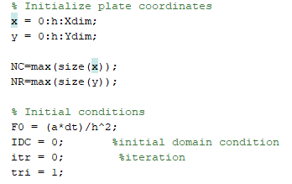
Figure 6 Initializing the conditions of the plate.
This section essentially initiates the conditions of the plate’s coordinates (x and y) as well as the setting up of variables for the initial domain conditions, iteration count, convergence criterion as well as other variables.

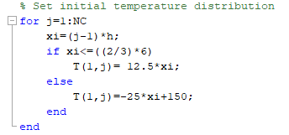
Figure 7 Initial temperature distribution.
In this part of the code the initial temperature distribution across the plate is created. At each point across the plate, defined by the code above, the temperature is calculated on the surface of the plate and a temperature matrix (T) is initialized.

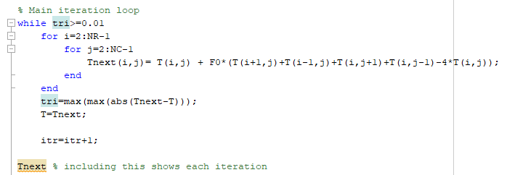
Figure 8 Main iteration part of the simulation.

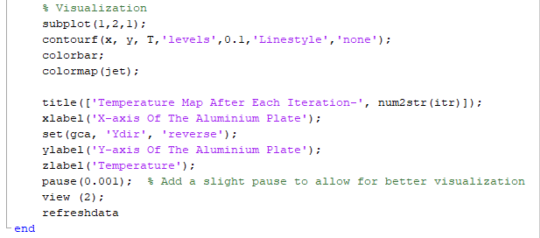
Figure 9 Visualization of the main part of the simulation.
This is what may be considered the main part of the simulation. This part of the code repeats until the temperature distribution throughout the plate aligns to what is defined as thermal equilibrium (tri<0.01).
The temperature matrix (T), initialized in the previous section, is updated in each iteration using the heat equation and forward differencing to calculate the temperatures at each coordinate in the matrix.

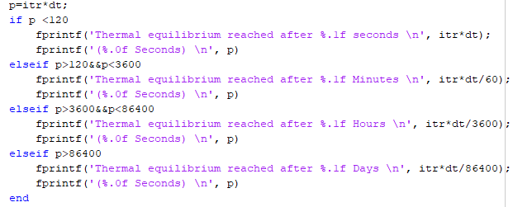
Figure 10 How long the simulation took with conditional statements showing seconds, minutes, hours, and days accordingly.
The code shown above is set up to display the length of time it took the simulation to reach thermal equilibrium. It is set up to display the timeframe suitable for the length it took as well as in seconds.

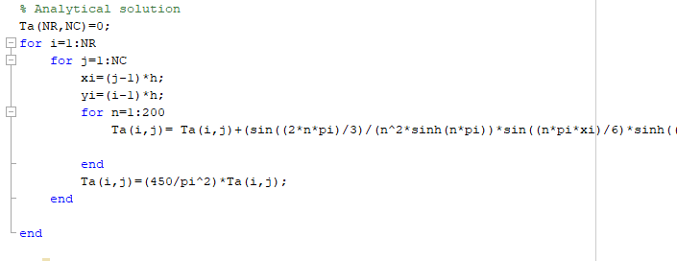
Figure 11 The analytical solution.
Here is where a mathematical formula for the Explicit Finite Difference Method is used to calculate the analytical solution for the temperature distribution through the plate. It’s calculated at each point across the plate (the same as in section 7). Using the analytical expression the temperature is computed across the plate.

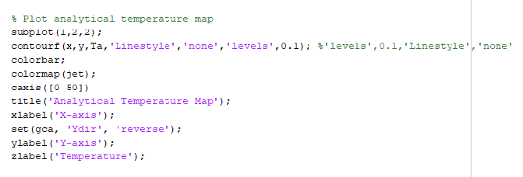
Figure 12 Visualization of the analytical solution.
Here is where the visualisation of the analytical solution is created this can then be used as a comparison between the analytical solution and the simulation code as both images’ windows will appear next to each other.
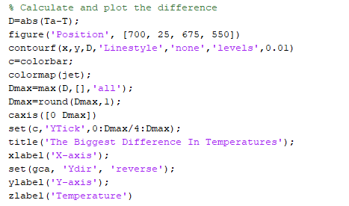
Figure 13 Calculating and displaying the difference between the simulation and the analytical code.
The final section of code helps evaluate how accurate the simulation is versus the analytical solution. It does this by calculating and visualising the difference between the two temperature distributions.

Analysis of the code results.
Initially running the code created through MATLAB with a spatial dimension of 1 and a time step of 3600 seconds gives results as follows: -
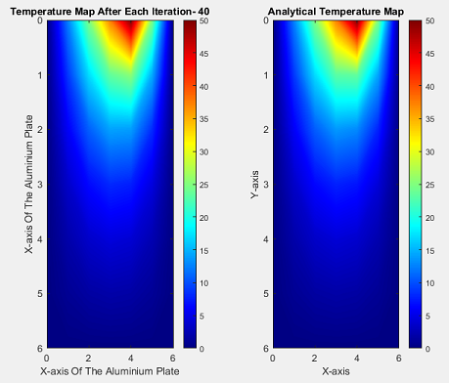
Figure 14 Temperature map of the heat equation on the aluminium plate.
These initial results show the similarities between the MATLAB code and the analytical solution the code on the left and the analytical solution on the right the MATLAB code reaching thermal equilibrium in 1.7 days (144,000 seconds).

Firstly changing only the grid spacing the result is a follows: -
Grid Spacing | Time Step | Tolerance | Thermal Equilibrium Time in Seconds
3 | 150 | 0.01 | 48750
2 | 150 | 0.01 | 53850
1.5 | 150 | 0.01 | 52500
1.2 | 150 | 0.01 | 53250
1 | 150 | 0.01 | 54300
0.75 | 150 | 0.01 | 54000
0.5 | 150 | 0.01 | 54600
0.25 | 150 | 0.01 | 54450
0.2 | 150 | 0.01 | 54450
Table 1 Thermal Equilibrium Versus Grid Spacing

Figure 15 Graph displaying grid spacing versus thermal equilibrium.
This graph shows that with the decrease in spatial dimensions increasing the resolution there is an increase in accuracy for the solution (Faragó and Horváth, 1999). This does directly affect the computational strain as there are more nodes or grid points that need to be analysed taking up more computing power (Huang et al., 2012). Conversely increasing the grid spacing decreases the resolution and gives a less accurate solution as an output although it does cause less strain on computational resources but can lead to large inaccuracies especially when considering how quickly the temperature can change in certain areas (Wei, Jian and Guangxuan, 2006). In this numerical model that uses the finite difference method there is also the ability of having too coarse of a “mesh” or grid spacing resulting in dissipation or dispersion which may lead to inaccuracies although refining the mesh would minimise any issues that may arise in this instance (Stolk, 2016).

Secondly changing only the time step results as follows: -
Grid Spacing | Time Step | Tolerance | Thermal Equilibrium Time in Seconds
0.75 | 2000 | 0.01 | 126000
0.75 | 1500 | 0.01 | 118500
0.75 | 1000 | 0.01 | 108000
0.75 | 800 | 0.01 | 101600
0.75 | 600 | 0.01 | 93600
0.75 | 400 | 0.01 | 82000
0.75 | 200 | 0.01 | 62000
0.75 | 100 | 0.01 | 43900
0.75 | 50 | 0.01 | 27900
0.75 | 25 | 0.01 | 17150
Table 2 Thermal Equilibrium Versus Time Step Change

Figure 16 Thermal Equilibrium Versus Time Step.
Starting at a time step of 2000 seconds it can be seen that the thermal equilibrium has a much shorter time frame as the time step decreases (Salama, Ali and Ali, 2022). This is because there is less of a time between each calculation thus allowing for a more accurate calculation of the temperature at a given time step. The smaller the time step the greater the drain on computational resources as more calculations would need to be completed (Salama and Ali, 2020). The larger the time step the less drain on resources although this does mean a sacrifice to accuracy and possibly cause destabilising of the calculations.

Finally changing only the tolerance gives these results: -
Grid spacing | Time Step | Tolerance | Thermal Equilibrium Time in Seconds
1 | 500 | 0.1 | 29000
1 | 500 | 0.01 | 89500
1 | 500 | 0.001 | 155500
1 | 500 | 0.0001 | 222000
1 | 500 | 0.00001 | 288000
1 | 500 | 0.000001 | 354500
Table 3 Tolerance versus Therma Equilibium

Figure 17 Thermal Equilibrium versus Tolerance

As it shows in the graph above lowering the tolerance increases the precision of the solution which may be ideal in certain uses and may be required. Adjusting the tolerance also gives the ability to monitor the convergence criterion which is what controls the speed at which the solver completes. A smaller tolerance gives the ability to have a more accurate solution and a larger tolerance would give a slower converging solution therefore giving a potentially less accurate solution. By monitoring the variations in the tolerance in different iterations it is possible to see any numerical errors that may occur (Salama et al., 2022).
The alteration of the grid spacing, time step and tolerance of model can lead to the computations being very intensive and may need a computer with a high processing capability to ensure the accuracy of the solution (Troy, Dutta and Stroscio, 2021).

A discussion as to the limitations of the model.
There are limitations to this model when considering the numerical method with regards to several things for instance round off error. Due to limitations of computer models, there is a rounding error that can occur in the calculations that computers can do that accumulates and can cause severe degradation the accuracy of the solution (Karris, 2008).
Truncation errors could be commonplace in a coarser mesh size due to the approximation of derivatives through the finite difference method. This can be mitigated but not eliminated completely by using a much finer degree of precision for instance a finer mesh size or shorter time step (Abdul Hamid et al., 2019).
The use of this model with more complex geometries can be much more complex to represent, as there may be issues with irregular boundaries like corners or sharp edges. This can be combatted somewhat with a finer mesh and time step however this may lead to excessive computational modelling and difficulties in having the appropriate mesh around the difficult geometry (Wang, Jiang and Wang, 2019).
Stability issues may arise if the numerical method is unstable that could cause divergence issues. With these issues there may be limitations on what stepping could be used for the discretisation of the model (Lemarié et al., 2015).

Suggested improvements to the model and future developments
As an alternative to the EFDM there is the Implicit Finite Difference Method which is able to compute complex geometries and as a direct comparison, better accuracy than the EFDM (Liu and Sen, 2009). The same can be said for the Finite Element Method (FEM) and Finite Volume Method (FVM) which offer increases in accuracy and the ability to handle complex geometries (Wang et al., 2011). There are even options for using a meshless method which would allow a lot of flexibility in mesh generation allowing more complex geometries to be handled in a more accurate manner (Ahmad et al., 2023).

Conclusion.
This report has introduced and successfully explained the Fourier equation and the governing equation of the problem. The numerical method chosen was fully described and all the initial boundary conditions were shown.
The code was broken down and explained in a way that would be easily understandable and able to replicate if needed.
The section showing limitations of the model were researched from numerous sources as well as the suggested improvements and the sources show that they appear to be potentially viable options.

References
Abdul Hamid, S. a. et al. (2019) ‘Impact of truncation error and numerical scheme on the simulation of the early time growth of viscous fingering’, International Journal for Numerical Methods in Fluids, 89(1–2), pp. 1–15. Available at: https://doi.org/10.1002/fld.4680.
Ahmad, H. et al. (2023) ‘A meshless method for numerical solutions of linear and nonlinear time-fractional Black-Scholes models’, AIMS Mathematics, 8, pp. 19677–19698. Available at: https://doi.org/10.3934/math.20231003.
Daileda, R.C. (2012) ‘The two dimensional heat equation’, UWTSD [Preprint].
Faragó, I. and Horváth, R. (1999) ‘An optimal mesh choice in the numerical solution of the heat equation’, Computers & Mathematics with Applications, 38(9–10), pp. 79–85. Available at: https://doi.org/10.1016/S0898-1221(99)00263-1.
da Fonseca Moraes Batista, R. and Silva, C.C. (2019) ‘When Things Go Wrong: Implementing Historical-Investigative Activities in the Classroom’, Science & Education, 28(9/10), pp. 1135–1151. Available at: https://doi.org/10.1007/s11191-019-00071-z.
Helwig, J. et al. (2023) ‘Group Equivariant Fourier Neural Operators for Partial Differential Equations’. arXiv. Available at: https://doi.org/10.48550/arXiv.2306.05697.
Huang, S. et al. (2012) ‘Simplified MFE with power-change adaption strategy for the dynamic optimization of HTR-PM *’, in I.A. Karimi and R. Srinivasan (eds) Computer Aided Chemical Engineering. Elsevier (11 International Symposium on Process Systems Engineering), pp. 1301–1305. Available at: https://doi.org/10.1016/B978-0-444-59506-5.50091-2.
Karris, S.T. (2008) ‘Introduction to numerical analysis using MATLAB’, Choice, 45(8), pp. 1373–1374.
Lemarié, F. et al. (2015) ‘Stability constraints for oceanic numerical models: implications for the formulation of time and space discretizations’, Ocean Modelling, 92, pp. 124–148. Available at: https://doi.org/10.1016/j.ocemod.2015.06.006.
Liu, Y. and Sen, M.K. (2009) ‘A practical implicit finite-difference method: examples from seismic modelling’, Journal of Geophysics and Engineering, 6(3), pp. 231–249. Available at: https://doi.org/10.1088/1742-2132/6/3/003.
Monks, K.M. (no date) ‘Fourier’s Heat Equation and the Birth of Fourier Series’.
Morales-Castillo, J. and Morales-Rodriguez, E.M. (2023) ‘A formula to solve Laplace and Fourier Transforms’, Journal of Computational and Applied Mathematics, 431, p. 115235. Available at: https://doi.org/10.1016/j.cam.2023.115235.
Nakayama, W. (2014) ‘Heat in Computers: Applied Heat Transfer in Information Technology’, Journal of Heat Transfer, 136(1), p. 013001. Available at: https://doi.org/10.1115/1.4025377.
Narasimhan, T.N. (no date) ‘Fourier’s Heat Conduction Equation: History, Influences and Connections’.
Qiu, Y. et al. (2023) ‘A systematic approach to optimization of ANN model parameters to predict flow boiling heat transfer coefficient in mini/micro-channel heatsinks’, International Journal of Heat and Mass Transfer, 202, p. 123728. Available at: https://doi.org/10.1016/j.ijheatmasstransfer.2022.123728.
Salama, F.M. et al. (2022) ‘An efficient modified hybrid explicit group iterative method for the time-fractional diffusion equation in two space dimensions’, AIMS Mathematics, 7(2), pp. 2370–2392. Available at: https://doi.org/10.3934/math.2022134.
Salama, F.M. and Ali, N.Hj.M. (2020) ‘Computationally Efficient Hybrid Method for the Numerical Solution of the 2D Time Fractional Advection-Diffusion Equation’, International Journal of Mathematical, Engineering and Management Sciences, 5(3), pp. 432–446. Available at: https://doi.org/10.33889/IJMEMS.2020.5.3.036.
Salama, F.M., Ali, U. and Ali, A. (2022) ‘Numerical Solution of Two-Dimensional Time Fractional Mobile/Immobile Equation Using Explicit Group Methods’, International Journal of Applied and Computational Mathematics, 8(4), p. 188. Available at: https://doi.org/10.1007/s40819-022-01408-z.
Shah, R.K. and Sekulić, D.P. (2003) Fundamentals of heat exchanger design. Hoboken, NJ: Wiley.
Stolk, C.C. (2016) ‘A dispersion minimizing scheme for the 3-D Helmholtz equation based on ray theory’, Journal of Computational Physics, 314, pp. 618–646. Available at: https://doi.org/10.1016/j.jcp.2016.03.023.
Troy, W., Dutta, M. and Stroscio, M. (2021) ‘Numerical modeling of laser photothermal heating in organic and inorganic structures’, Thermal Science and Engineering Progress, 26, p. 101136. Available at: https://doi.org/10.1016/j.tsep.2021.101136.
Wang, J.J. et al. (2011) ‘An experimental study and finite element analysis of weatherstrip’, International Journal of Precision Engineering and Manufacturing, 12(1), pp. 97–104. Available at: https://doi.org/10.1007/s12541-011-0012-0.
Wang, S., Jiang, S. and Wang, J. (2019) ‘Fast High-Order Integral Equation Methods for Solving Boundary Value Problems of Two Dimensional Heat Equation in Complex Geometry’, Journal of Scientific Computing, 79(2), pp. 787–808. Available at: https://doi.org/10.1007/s10915-018-0872-x.
Wei, Y., Jian, W. and Guangxuan, L. (no date) ‘Grid-independent Issue in Numerical Heat Transfer’.

Appendix
Below is a copy of the MATLAB script used to create the heat map of the aluminium plate.
clc
clear
close all

%constants
k = 143;
p = 2.8*10^3;
c = 795;

% Calculate thermal diffusivity
a=k/(p*c);

%Plate Dimensions
Xdim = 6;
Ydim = 6;

%User input for spacing dimension
h = input("Please enter a spacing dimension in Meters that should be smaller than the 6*6 Meter plate:- ");
while (rem(Xdim,h)~=0 || rem(Ydim,h)~=0) ||h>=6 || h<=0
h = input ("Please enter a spacing dimension that is divisible by six and should be smaller than the plate:- ");
end

%user input for time step
dt = input("please enter a time step for analysis in seconds:- ");
while dt> h^2/(4*a) || dt<=0
fprintf('Please enter another time step larger than 0 and smaller than %.0f seconds \n',h^2/(4*a))
dt = input("please enter an appropriate time step for analysis:- ");
end
% Initialize plate coordinates
x = 0:h:Xdim;
y = 0:h:Ydim;

NC=max(size(x));
NR=max(size(y));

% Initial conditions
F0 = (a*dt)/h^2;

IDC = 0; %initial domain condition

itr = 0; %iteration

tri = 1;

T(1:NR,1:NC)=0;

% Set initial temperature distribution
for j=1:NC
xi=(j-1)*h;
if xi<=((2/3)*6)
T(1,j)= 12.5*xi;
else
T(1,j)=-25*xi+150;
end
end

Tnext = T;
figure('Position', [00, 25, 700, 550])

% Main iteration loop
while tri>=0.01
for i=2:NR-1
for j=2:NC-1
Tnext(i,j)= T(i,j) + F0*(T(i+1,j)+T(i-1,j)+T(i,j+1)+T(i,j-1)-4*T(i,j));
end
end
tri=max(max(abs(Tnext-T)));
T=Tnext;

itr=itr+1;

Tnext % including this shows each iteration
%
% end
% Visualization
subplot(1,2,1);
contourf(x, y, T,'levels',0.1,'Linestyle','none');
colorbar;
colormap(jet);

title(['Temperature Map After Each Iteration-', num2str(itr)]);
xlabel('X-axis Of The Aluminium Plate');
set(gca, 'Ydir', 'reverse');
ylabel('Y-axis Of The Aluminium Plate');
zlabel('Temperature');
pause(0.001); % Add a slight pause to allow for better visualization
view (2);
refreshdata
end

% Output thermal equilibrium time
p=itr*dt;
if p <120
fprintf('Thermal equilibrium reached after %.1f seconds \n', itr*dt);
fprintf('(%.0f Seconds) \n', p)
elseif p>120&&p<3600
fprintf('Thermal equilibrium reached after %.1f Minutes \n', itr*dt/60);
fprintf('(%.0f Seconds) \n', p)
elseif p>3600&&p<86400
fprintf('Thermal equilibrium reached after %.1f Hours \n', itr*dt/3600);
fprintf('(%.0f Seconds) \n', p)
elseif p>86400
fprintf('Thermal equilibrium reached after %.1f Days \n', itr*dt/86400);
fprintf('(%.0f Seconds) \n', p)
end

% Analytical solution
Ta(NR,NC)=0;
for i=1:NR
for j=1:NC
xi=(j-1)*h;
yi=(i-1)*h;
for n=1:200
Ta(i,j)= Ta(i,j)+(sin((2*n*pi)/3)/(n^2*sinh(n*pi))*sin((n*pi*xi)/6)*sinh((n*pi*yi)/6));

end
Ta(i,j)=(450/pi^2)*Ta(i,j);
end

end

Ta = flip(Ta)

% Initialize Ta matrix for analytical solution
Ta(NR, NC) = 0;

% Plot analytical temperature map
subplot(1,2,2);
contourf(x,y,Ta,'Linestyle','none','levels',0.1); %'levels',0.1,'Linestyle','none'
colorbar;
colormap(jet);
caxis([0 50])
title('Analytical Temperature Map');
xlabel('X-axis');
set(gca, 'Ydir', 'reverse');
ylabel('Y-axis');
zlabel('Temperature');

% Calculate and plot the difference
D=abs(Ta-T);
figure('Position', [700, 25, 675, 550])
contourf(x,y,D,'Linestyle','none','levels',0.01)
c=colorbar;
colormap(jet);
Dmax=max(D,[],'all');
Dmax=round(Dmax,1);
caxis([0 Dmax])
set(c,'YTick',0:Dmax/4:Dmax);
title('The Biggest Difference In Temperatures');
xlabel('X-axis');
set(gca, 'Ydir', 'reverse');
ylabel('Y-axis');
zlabel('Temperature')

