Dragos Carbunaru
11/17/2020
University of Wales Trinity Saint David

Professional Career Development
Module No. BMSW4005
Contents
0
1.0 Introduction 2
2.0 Self Awareness 3
2.1 COVID-19 Pandemic impact 3
2.2 Learning Styles and Reflection on week 1 4
2.3 7 Habits of Highly Effective People Summary 4
2.3 VARK Questionnaire 5
2.4 Big 5 Personality Test 6
2.5 Myers Briggs MTBI Personality Test 7
2.6 SWOT Analysis 8
3.0 Employment Skills 14
4.0 Personal Development Plan PDP 16
5.0 SMART Analysis 17
6.0 Conclusion 18
7.0 References 19
8.0 Appendies 20
8.1 Appendices A 20
8.2 Appendices B 22
24
8.3 Appendices C 26
8.4 Appendices D 26
8.5 Appendices E 26
8.6 Appendices F 26

1.0 Introduction

This report will present a personal point of view, a reflection of my strengths and weaknesses and what I’ve learn so far at the University and what challenges I’ve faced. I will present a guide and learning process to aim and develop specific skills for my personal development and career goals by understanding and applying a personal action plan in order to achieve one’s full potential for a professional career.
This assessment will also illustrate the steps and the importance of a high Professional Career Development in more details to point out and follow a SWOT, SMART, and Gap analysis which are the most important in my opinion, however I also explore more options to have a deep understanding of my choices, to take action, to discover myself in order to work more effectively, to be more productive and have a spectacular future especially on digital technology, to make the world a better place to live in.

2.0 Self Awareness

2.1 COVID-19 Pandemic impact

Because of the corona virus situation our way of life, study and work have changed drastically. On a long term working from home remotely it may affect our productivity and effectiveness in a negative or positive way depending in what market or industry we work. For a proper and real data about this situation we need more time to come up with a conclusion. Fundamentally I think is not wise to mix the personal home zone with office work for a long term because it will be obvious that can affect us badly as in our personal home clearly we have a different mood and mind set, we have many major personal distractions that can interfere and hijack our attention. That could be children, family and friends, pets, the comfort zone, which is the bed, food, a relaxing sofa or how we like to call it “Me time” where it can easily escalate to lazy zone. This can be a disaster for some people out there that they cannot make the difference to balance the situation and control it. This is a great challenge for all of us which we have no choice then just to adapt, improvise and overcome any situation that were going to face.

2.2 Learning Styles and Reflection on week 1

The study experience started from home remotely, I had the opportunity to view the reading list books and to get familiar using student Hub Hwb, MyDay, Outlook, how to use the online library and all the tools I found on MyDay. For me it was easy to use these new tools because of my background experience I am familiar with these technologies as I am a web developer myself at a medium level, I learned quite fast. I’ve learned how to develop an assignment and to identify what relevant skills I require to perform such a report. I learned how to reference in Harvard style which I will demonstrate in this report, I learn about Gibs and Kolb learning styles which I will reflect on them shortly.

2.3 7 Habits of Highly Effective People Summary

On my first week I started to study and improve my self-awareness by taking different tests which are VARK Questionnaire, Big 5 Personality test, Myers Briggs Personality test, and as a result I was ready to reflect and consider my plans for future by implementing a gap analysis for my new career as a web developer and software engineer. I’ve read the 7 habits of highly effective people by Stephen Covey and I understand and agree with what Anum Hussain suggests in her report posted on her blog (https://blog.hubspot.com/sales/habits-of-highly-effective-people-summary) , and I found myself exited that I do have and use most of these habits. It is fascinating to be able to control your own feelings, and to maintain this to 100%, you need to meditate daily for at least 20 minutes and concentrate on breathing in and out and try to clear the mind of any self-doubt.
“It’s incredibly easy to get caught up in an activity trap, in the busyness of life, to work harder and harder at climbing the ladder of success only to discover that it’s leaning against the wrong wall” (Stephen R. Covey, 1989, The 7 Habits of Highly Effective People, 1st, New York, London, Sydney, Utah, G. K. Hall).
I do agree with what Stephen Covey point of view and I could add more because in my opinion to have success in the right direction with achieved goals will influence our future, will impact and make a huge difference for human species evolution towards exploring the galaxy’s and universe because the way technology evolve, humanity will create a real Star Trek experience (small rabbit hole but possible and probable is likely to happen some day).
The question “What are we trying to accomplish?” needs to be answered with a clear mind and have a strategic vision it’s essential, however in order to be a true leader I need to have and develop wisdom, power, guidance which I can develop, for instance wisdom through my life and journey experience, guidance through university, lectures, teachers, books and different resources from the internet and library, and power is in my virtue because I am confident and believe in myself because I have quality courage that is growing in me and I believe I am on the right track and I really have a strong future vision to my organisation which I plan to build with my new career journey. I am a proactive person, I do think Win-Win, seek first to understand, then to be understood, I do begin with the end in mind, put first things first, and I am full of energy because I have martial arts background.

2.3 VARK Questionnaire

According to VARK test results I learn best in a kinaesthetic and aural way with calculated score of 12 for both then I had 11 points for reading /writing, and last and not least 9 points for visual learning style. I find this information very useful and to consider to learn more in ARK mode however I think I am learning quite good with visual side too, because I use my eyes 100% and there fore my brain is processing the image information much faster according to human anatomy and biology and could result in a very long memory storage if I will prioritise to my brain as important information. The experience of this test is handy and help me realise my best learning styles. I will use all my learning styles to develop any new skill that I will encounter in my life and to my new career as web developer/software engineer (Appendices B).

2.4 Big 5 Personality Test

On my personality test it help me determine how I act among different people and understood how my personality is behaving. This completed test it demonstrates and confirms my strengths through previous test that I am on the right track. It proves that I have an honest and hardworking skills, I tend to follow rules therefore I’ve score 38 points for C which is Conscientiousness personality. I am open and seeking to new experience, with 32 points for O Openness to Experience. 31 Points for letter N that is Neuroticism I can get emotional sometimes because I am a shy person to be honest. I had 29 points for Agreeableness letter A which reflects as a polite and like people personality, and I can confirm with my previous test that is true. I got 22 points for Extroversion personality. On this side of the test it can change and improve day by day to develop an extrovert personality, this is a skill that I must develop more and achieve (Appendices A).

2.5 Myers Briggs MTBI Personality Test

I’ve completed the test and I demonstrated the good score for extrovert, Intuitive, Thinking, Judging and Feeling, and there for Myers Briggs Personality Test proves that all my previous tests are 86% accurate and confirms the same strengths. I can use these skills for employability for a specific job and career or organisation to be more productive and efficient as soon possible.

2.6 SWOT Analysis

Strengths:
- An honest person;
- I am confident;
- I am organised;
- I can learn tech fast;
- Good time management;
- I have a creative thinking;
- I can perform critical analysis and critical reading;
- A loyal person;
- Hard working;
- I have problem solving skills;
- Focused on professional priorities;
- Keep myself fit with a vegan healthy diet with intermittent fasting;
- A calm and friendly person;
- Have a positive mind set;
- Open mind to new things;
- Welding certificate in MIG, MAG, MMA;
- Locksmith certificate on SNC;
- Driving skills License since 2003;
- Sales skills from Big Issue magazine;
- Black belt certificate in Martial Arts;
- Security Agent certificate;
- Certificate of Achievement form SITEL;
- Certificate of Achievement from TUI Travel;
- Top 10 employability skills;
- IT skills;

Weaknesses:
- Poor sleep;
- Coffee addiction;
- Poor presentation skills;
- Not a 100% extrovert person yet;
- English not my native language;
- Public speaking in front of hundreds of people;
- Do not have a certificate in High Skills for Workplace;
- Do not have advance experience in web development and software engineer;
- Social Networks could distract my attention to long;
- Lose time to much on social networks without doing productive work;
- Pandemic isolation for a long term;
- Unused potential;

Opportunities:
- Improve on my English accent and skills every day;
- Improve on my presentation skills through university and practicing home on a mirror;
- Achieve certificate for High Skills for the Workplace;
- Achieving a certificate in web development and software engineer;
- Building a Personal Development Plan and follow it;
- Develop a Business Plan;
- Using IT skills and develop new IT skills going forward;
- Apply for British citizenship;
- Invest in my image;
- Apply for business grants and loans;
- Build websites and applications on iOS and Android;
- Apply for web development job;
- Studying remotely from home using IT technology, Microsoft Teams, Word, PowerPoint, PDF, Outlook, Google, IoT, PC, My Day, Office365, Windows 7,8, 10, Chrome and Firefox browser, OneDrive cloud server etc;
- Access to information form internet for free for research and study purposes;
- Learning from YouTube, Vimeo, Twitch, Reddit, tutorials about web development;
- Learning and using platforms FreeCodeCamp.com, W3shools.com and Udemy.com;

Threats:
- Corona virus threat;
- Lock downs leads to losing your job and be out of business;
- Coffee addiction can damage my health for a long term;
- Poor sleeping can lead to health problems;
- Concerned about failing to graduate for certificate of High Skills for the Workplace;
- Worries about not passing the web development and software engineer exams;
- Too much time on social media could lead to wasting time;
- Could accident on sport and martial arts activities;
- Working to much time remotely could lead to anxiety or depression;
- Future lockdowns and isolation;
- COVID-19 Mutations concerns;
- Fail to have a job in web development and software engineer;

2.7 Gibbs Reflective Cycle

Graham Gibbs develop he’s cycle in 1988 and is truly remarkable how right he was. I believe is one of the most famous cyclical models of reflection taking you through six stages of honest feedback I can say: description, feelings, evaluation, analysis, conclusion, and plan.

I will give you my latest experience from presenting a product for Academic and Employability skills and use Gibbs Cycle.

Description:

I had to do a share presentation in Microsoft Teams where all students from my class was watching LIVE about a smart TV that I choose to present.

Feelings:

At beginning when I heard I felt nervous and frustrated because my presentation skills are not very good.

Evaluation:

I started to think about it how to resolve the problem and put together all the information that I need to prepare the presentation. I changed my attitude to a positive attitude and said to myself, this will be a great opportunity for me to improve my presentation skills in real time.

Analysis:

After I assemble all information from a draft, I started to create PowerPoint slides for my presentation. After I finish it, I’ve practiced in from of a mirror many times.

Conclusion:

My teacher said I did great and I can improve even more. I learned that I can overcome this public speaking skill if I will practise more and more in front of a mirror and have more projects to present in future.

Action Plan:

I will use Gibbs Cycle from now one, also SWOT and SMART analysis to overcome, improve and develop this presentation skill because as a leader I must master it professionally. I will speak my mind when I have concerns, by remembering it can benefit the outcome.

2.8 Kolb Reflective Model

I think Kolb’s model is similar at some point with Gibb’s model. Kolb’s reflective model is referred to as “experiential learning”. The basis for this model is our own experience, which is then reviewed, analysed and evaluated systematically in different stages. Once this process has been undergone completely, the new experiences will form the starting point for another cycle.

Concrete experience:

It presents an experience from a situation, which causes you to understand that you must reflect deliberately to discover some new information or develop your current expertise and practice. However, at the end you still systematically had to reflect on how you feel what you think as Gibbs Cycle too.

Reflective observation:

On this stage you dig deeply on what has happened in that situation. By answering important questions like, what worked? What failed? Why did the situation arise? Why did others and I behave that way and the way we did? A deep reflection and understanding of the situation in order to solve it and avoid repeating it in the future.

Abstract conceptualisation:

Understanding the situation in order to solve it and avoid repeating it in the future. What could I have done better or differently? How can I improve? On this stage is when you apply good strategies for when you experience a similar event again to make sure it will not happen again.

Active experimentation:

Is when at this final stage is when all the ideas and theories or practising are put to the test to find out which one will be more efficient then the other, and then activate this experiment.

2.9 Johari Window

The Johari window model or tool was created in 1955 by Joseph Luft and Harry Ingram. A very useful psychological tool for understanding and training an organisation personnel but also for personal individual. It also can be used to discover your strengths, blind spots and areas to explore and it works best in a high trust environment. The concept Johari window helps the employee and employer to develop and improve employability skills such us: self-awareness, personal development, communications skills, interpersonal relationships, group dynamics, team development and the list may go one.

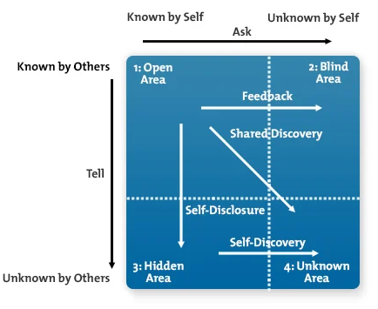

3.0 Employment Skills

(https://www.pexels.com/photo/photo-of-people-doing-handshakes-3183197/)
There are several employability skills attributes required by employees in entering the workplace. Communication skills, problem-solving and decision-making skills, teamwork skills, enterprise skills, planning and organising, self-management and time-management, learning skills and technology skills are the attributes of employability skills with highest importance level. Employees are also expected to have several personal attributes included: resilience, digital competency, self-awareness, self-confidence, independence, emotional intelligence, flexibility and adaptability, stress tolerance, creativity and initiative, willingness to learn, reflectiveness, lifelong learning, and professional behaviour. I think I have these skills and I did demonstrate on this report that I do. The tests completed shows all my skills and abilities. Most of my employment skills comes from experience, first grade school, college, university, academy school, certificates from different organisations, work experience and life experience as I mention on my SWOT analysis strengths and I will used them to get a job for my new career in IT digital technology, going forward I intend grow and develop more skills to be updated with new technologies yet to come as future foresee.

4.0 Personal Development Plan PDP

I choose to build a career in web development and software engineer because I have some ideas and projects to build new applications and websites.

GAP ANALYSIS for Web developer/Software Engineer
Job Description: Oscar Technology, Vacancy: Full Stack Developer
Qualifications required: ASP.Net, C# knowledge is essential with full stack development awareness across the Microsoft Stack, HTML5, CSS3 and JavaScript

Current Situation-No Qualification |  | Skill Level
Study  Complete Udemy course  2020 Web Development Bootcamp | 1 year  It provides 480 lectures resources with video explanations and PDF material with 35 sections | I have a medium Level of understanding HTML5, CSS, Java Scrip, C# and Python programming language.
Desired Situation- Graduate and achieve certificate from Udemy Platform in
Full-stack web developer on HTML, CSS, Java script, Node, React, MongoDB

On Udemy Platform I will learn:

What you'll learn
- Be able to build ANY website you want.
- Craft a portfolio of websites to apply for junior developer jobs.
- Build fully-fledged websites and web apps for your startup or business.
- Work as a freelance web developer.
- Master backend development with Node
- Master frontend development with React
- Learn the latest frameworks and technologies, including Javascript ES6, Bootstrap 4, MongoDB.
- Learn professional developer best practices.

5.0 SMART Analysis

Specific:
I created a daily program that I follow and 3h to max 4h per day where I study video tutorials and test in real time IDE Visual Studio all the codes on Udemy Platform.

Measurable:
Yes, I will get a certificate after I will pass the tests and exams and build websites and applications that Udemy provides us to do.

Achievable:
Yes, I put daily hours to study until I will graduate.

Realistic:
Yes, as I am very dedicated and exited every time when I study because to code is also fun.

Time Line:
1 Year to maximum 2 years

6.0 Conclusion

For my conclusion I use and identify the system KISS which stands for Keep it Small and Simple a very handy module. Going forward I learned about Kolb’s, Gibb’s, Johari Window, PDP, SWOT, SMART, which I intend to deliver, maintain and follow in order to work effectively, efficient and be productive on professional and personal career. I will reflect and I will speak my mind when I have concerns, by remembering it can benefit the outcome, improve my skills and develop them.

7.0 References

1) Cottrell, Stella., 2013, The study skills handbook, 4th ed., Basingstoke: Palgrave Macmillan.
2) Pears, Richard., 2016, Cite them right, 10th ed. And expanded edition, London: Palgrave.
3) Van Emden, Joan., 2010, Presentation skills for students, 2nd ed, New York, Hampshire, Basinstoke, Houndmills: Palgrave Macmillan.
4) Cottrell, Stella., 2010, Skills for success: The Personal Development Planning handbook, (ebook on Google Books: https://books.google.co.uk/books?id=cbscBQAAQBAJ&printsec=frontcover&dq=The+Personal+Development+Planning+Handbook+by+Cottrell+Stella&hl=en&sa=X&ved=2ahUKEwjm5syNsNLsAhWailwKHfMyAvgQ6AEwAHoECAIQAg#v=onepage&q=The%20Personal%20Development%20Planning%20Handbook%20by%20Cottrell%20Stella&f=false) 2nd ed., Basingstoke: Palgrave Macmillan.
5) Levin, Perer., 2009, Write great essays, 2nd ed., Maidenhead, England: Open University Press.
6) Seely, John., 2013, The Oxford guide to effective writing and speaking: how to communicate clearly,(ebook: https://ebookcentral.proquest.com) Oxford, England: Oxford University Press.
7) Dale Carnegie, Stuart R. Levine, Michael A. Crom, 1995, The Leader in You, Associated, INC., New York, Toronto, London, Sydney: Pocket Books.
8) Youth Central, 2018, 8 Job skills you should have, (online available at: https://www.youthcentral.vic.gov.au/jobs-and-careers/plan-your-career/8-job-skills-you-should-have), (Accessed 27/10/2020).
9) John, Adair, Brian Bowles(Narrator), 2011, Decision Making Problem Solving and Creative Thinking, Audiobook by The Sunday Times and Audible Ltd.

10) Andrew Bradbury, Daniel Philpott (Narrator), 2010, Successful Presentation Skills, 4th ed., (Audio book) The Sunday Times, Audible Ltd.
11) Posted by: Sarah Bowden, Official blog of the University of Surrey’s Employability and Careers Centre, Surrey Careers blog, 2017, Resilience-an attractive skill for employers, (online available at: https://blogs.surrey.ac.uk/careers/2017/08/17/resilience/ ), (Accessed 12/11/2020)

8.0 Appendies

8.1 Appendices A
Please see my Big 5 Personality Test in images from original PDF file as bellow.
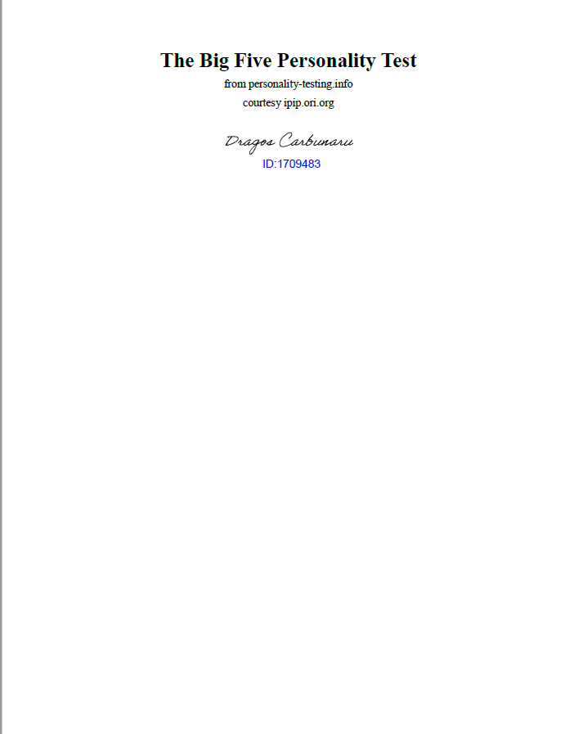
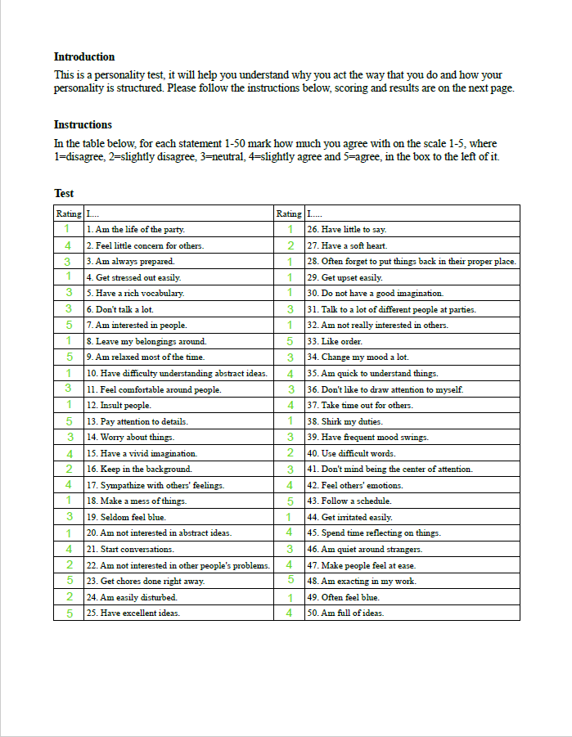
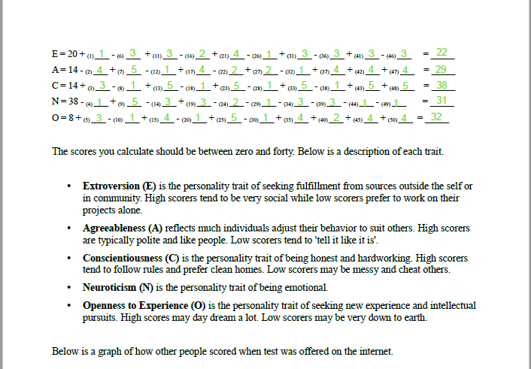

8.2 Appendices B
My VARK Questionnaire results in images from original PDF file.
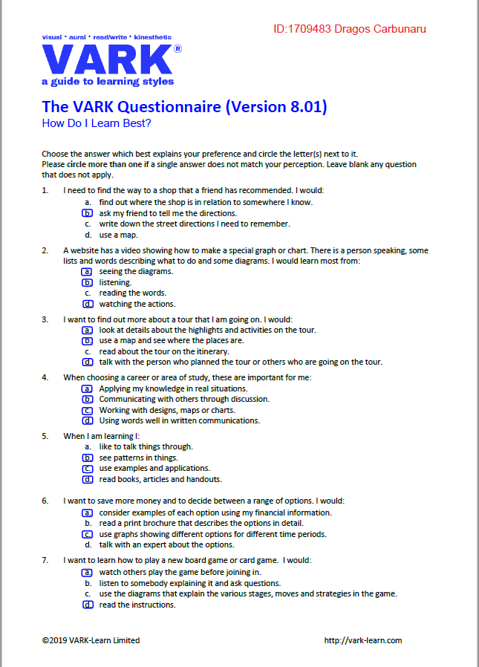

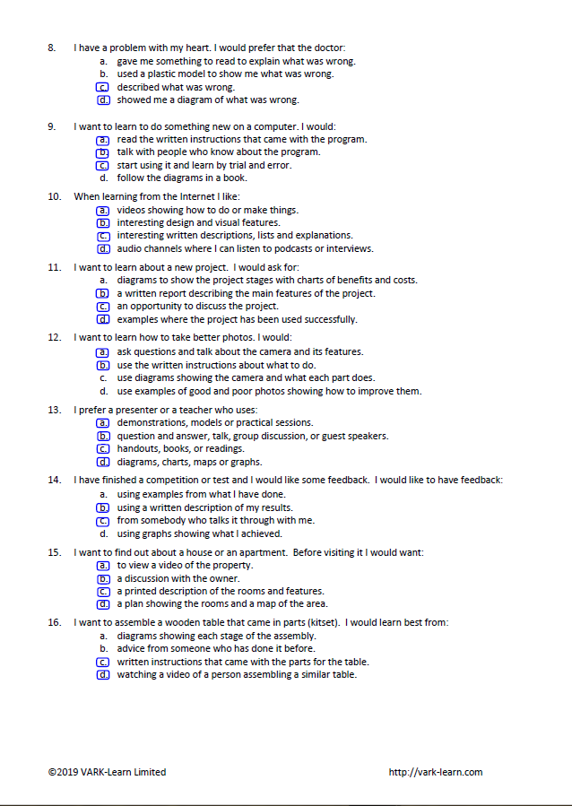

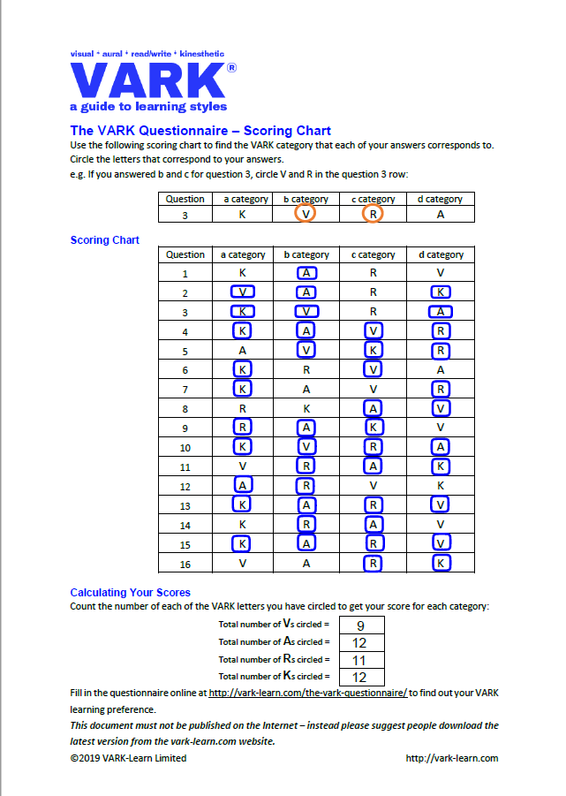

8.3 Appendices C

