
Further Counselling Skills
Dr. Beverly Cole

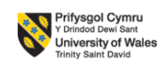

AI acknowledgement:
I acknowledge that I have not used AI for my report.
-I confirm that all interpretation findings are my own work
- I have not presented any AI generated context as my work.
-I confirm that I have drafts notes and other resources I used
I confirm that I have used AI for spelling mistakes and to correct punctuations.

Content table:

Description………………………………………………..3
Feelings…………………………………………………….4
Evaluation………………………………………………….4
Analysis……………………………………………………..5
Conclusion…………………………………………………6
Action plan………………………………………………….7
References…………………………………………………..9
Appendices………………………………………………….10-17

DESCRIPTION
I have volunteered in an organisation called Congolese Development Project (CDP) based in Swansea I have been volunteering there for nearly 3 years now, every Saturday , the organisation supports vulnerable local community mainly focusing on asylum seekers and refugees through cultural integration, social inclusion, awareness, and practical assistance. My main role as a volunteer was to teach basic IT classes for asylum and refugee women whose first language is not English and they have little to no digital literacy, it involved delivering basic digital skills such as using smartphones and laptops, sending/receiving emails, searching online websites, using navigation and completing forms which reflected broader problem of digital exclusion seen commonly by newly arrived migrants.
My role expanded naturally as I got more familiar with women and built a rapport alongside IT my role was also to encourage them to speak in English in order to improve their English by using simple conversations about how they spent their week. This helped them reduce their anxiety around English language and created a supportive learning environment.
During Dyslexia awareness week I delivered a little presentation with main speaker Sandra Wolo (CEO) of Adult Dyslexia United Organisation from which many ladies came out with their stories where they or someone they know experienced dyslexia but was misunderstood in schools, institutes, and by their own parents some also said they never heard of dyslexia in their life and was labelled negatively due to their learning difficulties. I listened to their stories patiently and explained what dyslexia is, how it can cause learning difficulties and where they can seek support.
Eventually deepened trust women began sharing their issues, these conversations overtime expanded into discussions about rights in UK which includes housing support, education, transport, and other community support. Basic mental health awareness was also shared due to which many women shared their difficult experiences of their day to day issues, stress, loneliness, anxiety. I reassured them that these emotions are quite common and encouraged them to seek support. I listened to them empathetically while maintaining clear boundaries and guided them to my project manager and signposted them to appropriate services.
Racism, verbal abuse and hate crimes are very commonly experienced especially with migrants and when we discussed it several ladies experienced feeling unsafe, discriminated and humiliated in public places, I read and translated what constitutes hate crime with the help of official south Wales Police website and how cam someone report it online and what services exits. I Continuously teach practical life skills such as drafting emails to council, schools, solicitors, using government official websites, GP online system, googling local food or leisure activities, use of AI to translation to tackle language barriers, checking bus timings online, alone with different type of awareness.
Over the period of 3 years we build strong bond. To support their wellbeing and increase their social connections, once in few months we have a bonding session where we call it beauty session where ladies show their talent they have by threading, fake nails, hair cuts and dress up in their traditional costume, have music and celebrate a little despite all problems each of us have. This informal activity create more comfortable environment built trust reduce stress and reinforce sense of support, community and belonging.
Feeling
At the start of my volunteering I had mixed feelings of I am able to fulfil what the organisation and women expect me to be, with vast cultural, language barriers and emotional challenges, I recall while delivering dyslexia and rights awareness presentation I felt huge responsibility especially when brave ladies stood up and shared their experiences of being misunderstood or negatively labelled this often evoked sadness and empathy in me and now when I look back I feel honoured they trusted me enough and share their experiences.
Teaching practical skills to women’s make me feel proud of myself as I was able to see their growth in short period of time as a confident individual. While discussing and have session about mental health I felt compassionate and cautioned. I did support them emotionally, but I was very much aware of my boundaries and the important of not getting involved beyond my role as volunteer. The beauty sessions brings sense of belonging in me. I feel content, joyful and grateful for friendship and trust I built over the years. And I feel doing my volunteering was good decision it brought meaningful, personally rewarding and emotionally rich experience.
Evaluation
I consider my volunteering experiences as positive. Essential skill like IT classes help women to use technology, communication in English improved their language which help them in reducing loneliness. Dyslexia, mental health, rights in UK and hate crime sessions helped them in increasing their knowledge which they never received before. Beauty session had powerful impact in strengthening trust, sense of community and belonging
However, there were definitely challenges like cultural, language barriers which became hurdle in communication sometimes where I had to repeat multiple times or using google images to explain my point. Some of the ladies shared their problem I listened with empathy. And was very caution of my boundaries and information provide was accurate and double checking every signpost mentioned and backing up everything with my project manager, never I have stepped out of my role, at times I had hard time emotionally by their stories. Despite challenges I faced my volunteering experience I consider as positive and help me grow professionally and personally by active listening and showing real empathy.

Analysis
Through Gibbs cycle reflecting on my experience helps me understand how my overall skills evolved and how they relate to the BACP counselling skills Competence Framework (BACP,2021). I have never provided counselling, yet I have used skills like active listening, non-judgmental, confidentiality and empathy when women shared their bad experiences. I felt these skills helped me create a save, respectful and trustworthy space which BACP framework recognise as necessary in supporting, helping relationships.
I have also experienced cultural sensitivity, identifies women’s experiences are due to being migrant, trauma and new country system. Cultural differences are crucial when it come to supporting asylum and refugees. Keeping boundaries was curtail part. I Empathetically and actively listened but avoided giving advice instead signposted. This reflects ethical practice and being with in one’s competence.
Delivering practical skill acquired good communication, problem solving, and patience. Whereas beauty session showcase importance of rapport, trust and emotional. Refugees mental health is improved by social communications. My overall experience revealed my ability to adapt diverse needs, build trust and support through awareness and education.

Conclusion
My experience volunteering at CDP has been very meaningful. I have learned interpersonal skills, including empathy, listening, and communication skills, cultural sensitivity. I developed many transferrable skills like confidence in teaching, leadership, giving presentations, facilitating discussions, communication skills, problem solving, boundary setting, and supporting through challenges. The nature of my role from teaching IT along with language encouragement, awareness session and well being activities allowed me to see how community support can grow into strongly trusted, safe and respectful environment.

Action plan
I am eager to learn more in future to develop me communication and facilitation skills. I want to attend training on practice to support individuals who experience adversity. To provide signposting I want to keep myself informed up to date with support available. To manage my emotional wellbeing I will be seeking guidance from my project manager and keep my self-reflecting on my experiences. I want to put more efforts towards empowering women trough education, awareness and built safe community space for women.

References
University of Edinburgh. (n.d.). Gibbs’ reflective cycle. Reflection Toolkit. https://www.ed.ac.uk/reflection/reflectors-toolkit/reflecting-on-experience/gibbs-reflective-cycle
British Association for Counselling and Psychotherapy. (2021). Counselling skills competence framework. https://www.bacp.co.uk/media/6811/bacp-counselling-skills-competence-framework.pdf

Appendices
Appendix A:
Detailed banner of organisation.
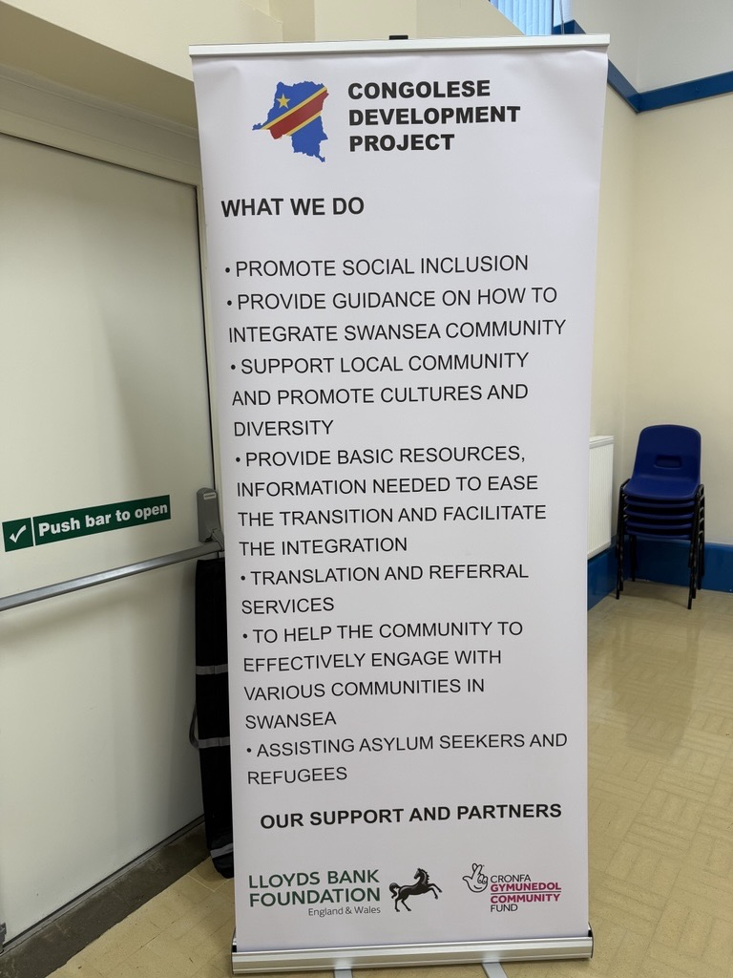

Appendix B:
Letter confirming my volunteering, skills, and achievement.

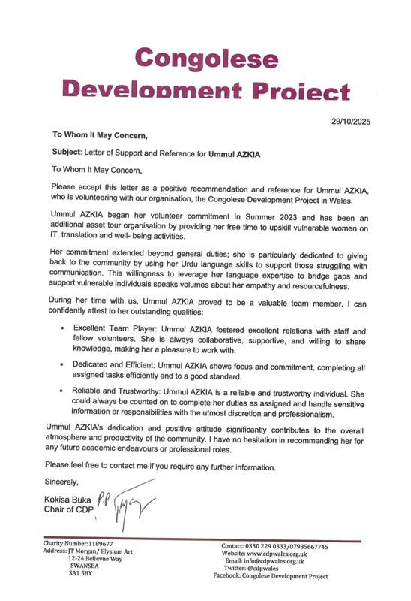

Appendix C:
Below is the picture of Me and Sandra Wolo from the day dyslexia was discussed
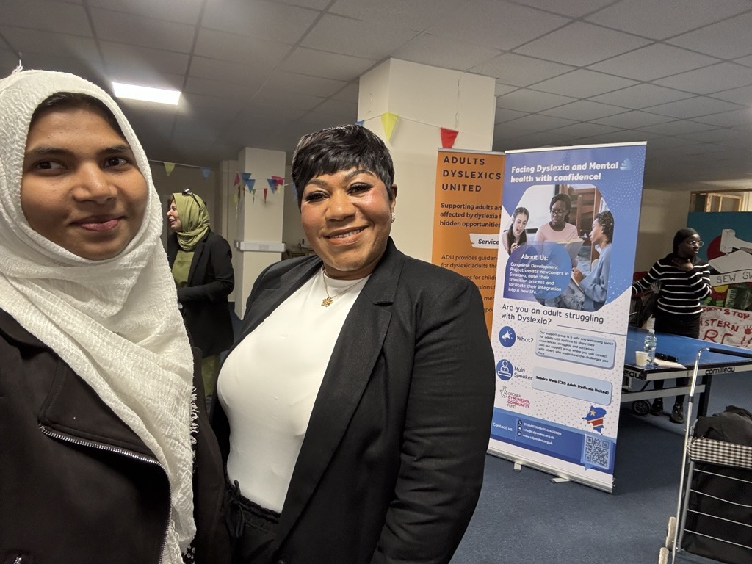

Appendix D:
Me actively listening to women’s about their weeks routine.
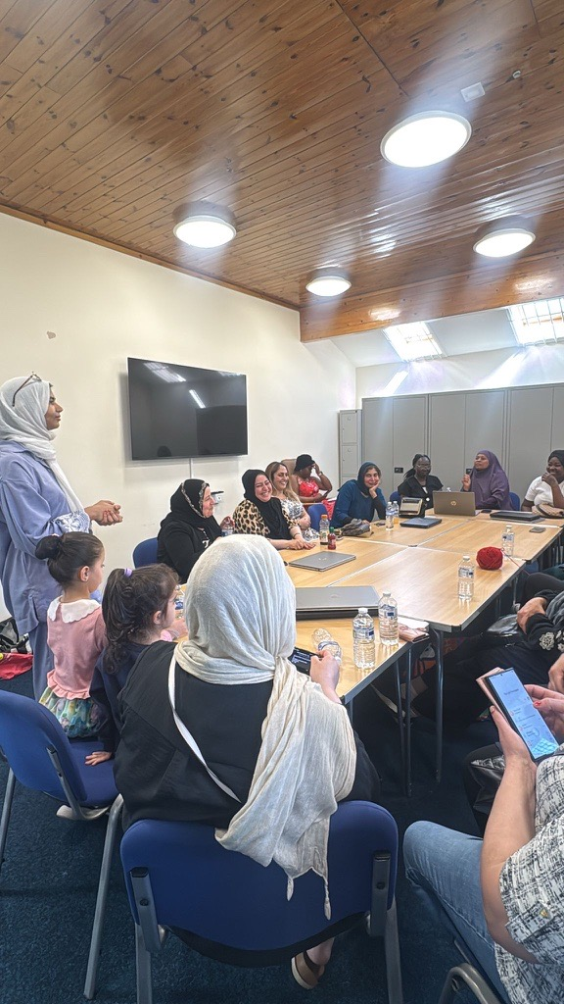
Appendix E:
Me Emphatically listening to the hate crime women experience.
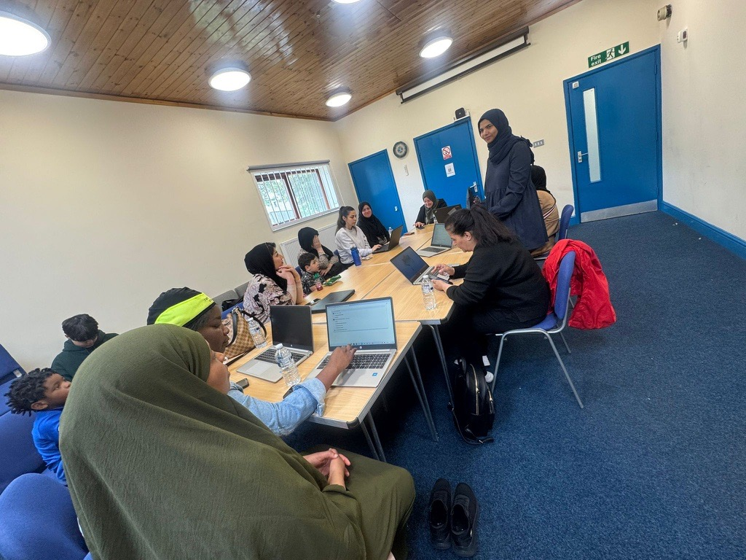

Appendix F:
Me signposting them to appropriate places.
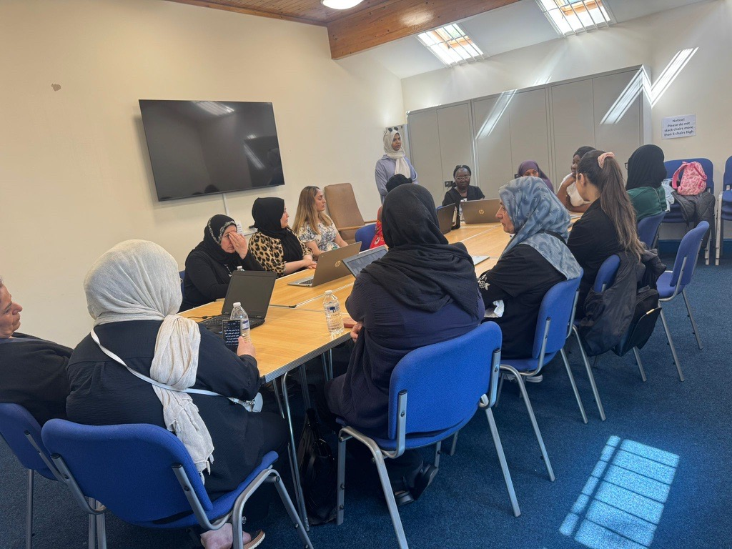

Appendix G:
Women’s enjoying party.


