REFERENCE SHEET FOR ACDB4011 CHEMISTRY QUIZ #2
ANSWERS
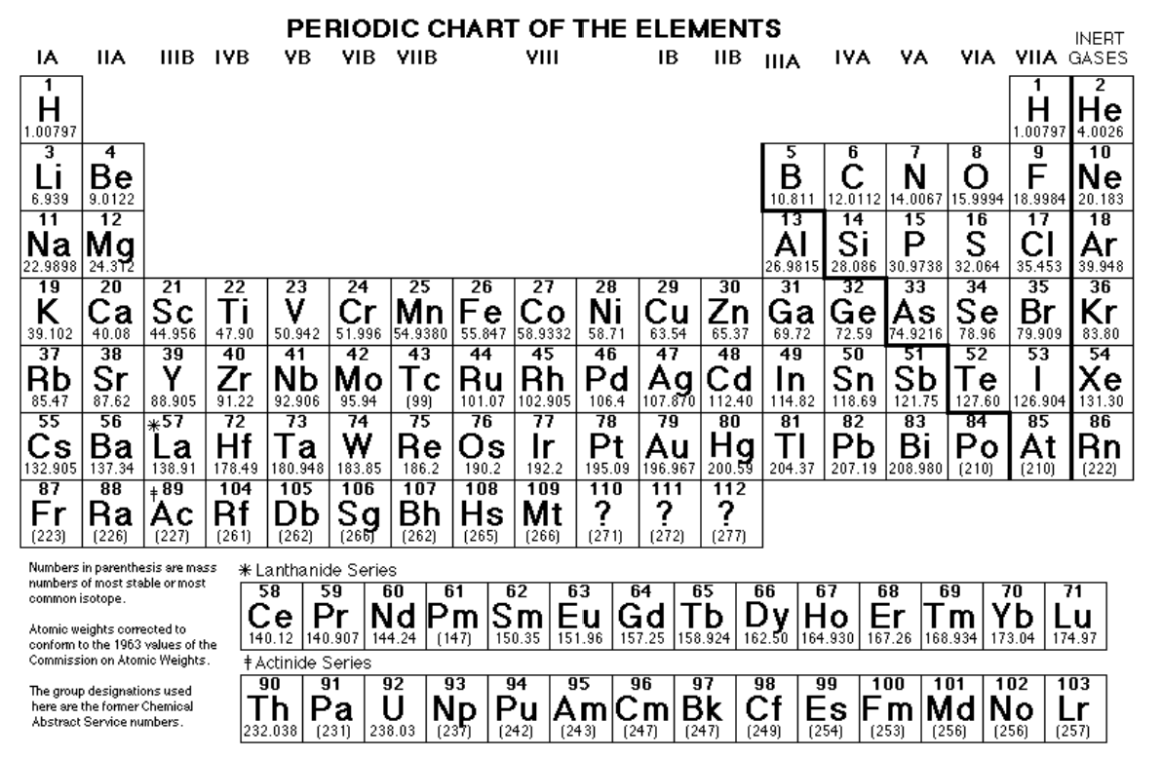
PHYSICAL CONSTANTS:
C = 3.0 x 10⁸ m/s (speed of light)
R_{H} = 3.29 x 10¹⁵ s⁻¹ (Rydberg constant)
h = 6.6 x 10⁻³⁴ Js (Plank’s constant)
e = 1.602 x 10⁻¹⁹ C (charge of electron)
1 amu = 1.66 x 10⁻²⁴ kg (atomic mass unit)
6.02 x 10²³ Avogadro’s number
R = 0.0821 L-atm/mol-K

ACDB4011 CHEMISTRY QUIZ 2

NAME_____________________________________ DATE: November 02, 2022

- (6 points) Indicate whether each of the following statements is true or false:

T F
__ _X_ A C-C single bond is generally shorter than a C=C double bond.
__ _ X _ One mole of magnesium has the same number of atoms as one mole of hydrogen gas.
_ X _ __ Covalent bond forms when the atom shares an electron with another atom.
_ X _ __ Among elements in a Main Group those with the largest radii have the smallest electronegativity.
_ X _ __ Angstrom, Å, is the unit of the length of a chemical bond.
_ X _ __ The C₂H₄ molecule has six bonding electron pairs and no lone pairs.
2. (8 points) How many nitrogen atoms are there in 30.0 g of N₂O₄. Give your answer in individual atoms, not moles.
In 1 mol of N₂O₄ molecules, there are 2 moles of N atoms and in each mole of N atoms there is Avogadro number of N atoms (6.02 x 10²³)
Convert the mass of N₂O₄ to moles using the molar mass of N₂O₄, 92.0 g/mol
30.0 g N₂O₄ / 92.0 g/mol = 0.326 mol N₂O₄
From the stoichiometry of this reaction: 0.326 mol N₂O₄ x (2 mol N / 1 mol N₂O₄) x (6.02 x 10²³ atoms N / 1 mol N atoms) = 3.925 x 10²³ N atoms

- (6 points) Balance the following equations. Do not leave spaces blank. If needed, write “1” to indicate a single unit of a species.

- _6_ K (s) + _1_ N₂ (g) _2_ K₃N (s)

- _1_ C₅H₁₂ (g) + _8_ O₂ (g) _6_ H₂O (g) + _5_ CO₂ (g)

4. (7 points) Using the Lewis structures to support your answer, determine which molecule contains only TWO unshared pairs of electrons, H₂O or NH₃.

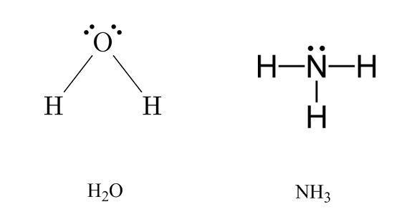
Only H2O has two unshared (non-bonding) electron pairs

- (8 points) Potassium chlorate decomposes when heated to potassium chloride and oxygen, according to the following chemical equation: 2 KClO₃ (s) 2 KCl (s) + 3 O₂ (g). How many grams of oxygen gas can be obtained from 24.5 g of potassium chlorate?

molar mass of KClO₃ is 122.5 g/mol and 24.5 g is the mass of 0.2 mol of KClO₃ (24.5 g / 122.5 g/mol = 0.2 mol)

(mol O₂ / mol KClO₃) = (coefficient O₂ / coefficient KClO₃)
(mol O₂ / 0.2 mol KClO₃) = 3/2
mol O₂ = 0.3
molar mass of O₂ is 32.0 g/mol, so the mass of 0.3 mol O₂ is 9.6 g (0.3 mol x 32.0 g/mol)

