Name:_Liam Jenkins

Student Number: 2502497
__________________________________________________________

WORKSHEET 3 – TESTING (Lap Times)

- Original code:
lapTime = []
for counter in range(5):
flag = 0
while flag == 0:
try:
time = float(input("Please enter the lap times "))
if time == 0:
print("Give a realistic time")
else:
lapTime.append(time)
flag = 1
except ValueError:
print("Please enter an appropriate time in seconds")
flag = 0
while flag == 0:
try:
targetTime = float(input("What is your target lap time"))
if targetTime == 0:
print("Give a realistic lap time") #don't know the length of the track so cannot give a realistic limit apart from non-zero
else:
flag = 1
except ValueError:
print("Please enter a valid time in seconds")
overallTime = sum(lapTime)
averageTime = overallTime / len(lapTime)
fastestTime = max(lapTime)
fastestLap = lapTime.index(fastestTime) + 1
slowestTime = min(lapTime)
slowestLap = lapTime.index(slowestTime) + 1
fasterTime = 0
for counter in range(len(lapTime)):
if lapTime[counter] >= targetTime:
fasterTime = fasterTime + 1
print("Your statistics .... \n")
print(f"1. The overall lap time is: {overallTime} seconds \n")
print(f"2. The average lap time is: {averageTime} seconds\n")
print(f"3. Your fastest lap was lap {fastestLap} in {fastestTime} seconds \n")
print(f"4. Your slowest lap was lap {slowestLap} in {slowestTime} seconds \n")
print(f"5. {fasterTime} of your laptimes were better than or equal to your target \n")
print("6.")
for counter in range(0,5):
if counter == 0:
print(f"Lap {counter + 1} was {lapTime[counter]} seconds")
elif lapTime[counter] > lapTime[counter - 1]:
print(f"Lap {counter + 1} was {lapTime[counter]} seconds, which was faster than the previous lap")
elif lapTime[counter] < lapTime[counter - 1] :
print(f"Lap {counter + 1} was {lapTime[counter]} seconds, which was slower than the previous lap")
elif lapTime[counter] == lapTime[counter - 1]:
print(f"Lap {counter + 1} was {lapTime[counter]} seconds, which was equal to the previous lap")

- Code Testing
For each test below, run your code and show the results of the scenarios below. Present a screenshot of what happened when the programme ran. Did the programme behave correctly or did it do something unexpected, and if so, why?

- Test a lap time for your programme:
- 42 seconds
- 2 seconds
- -4 seconds
- 53444 seconds
- Test the target lap time – show that the values entered are reasonable

- Using the same five lap times as the sample output ie

Lap 1: 42.3
Lap 2: 42.1
Lap 3: 44
Lap 4: 44
Lap 5: 39.4

Examine each statistic (1-6) and comment on whether the correct answer(s) are displayed or not. (If any statistics were incomplete after Phase 1 (code completed in class) simply write “Unfinished”)

- Test two further sets of lap times of your own choice.

Template for tests:
Test: enter 42 seconds

Screenshot(s) of output:
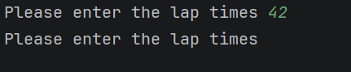
Result: Did the programme behave as expected ie syntactically and logically correct?
YES
If YES, comment on what happened.
Allowed 42 seconds a reasonable lap time and then prompts for the second lap time

Test:
Enter 2 seconds

Screenshot(s) of output:
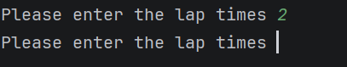
Result: Did the programme behave as expected ie syntactically and logically correct?
NO
If NO, what went wrong and why? Suggest how things could be improved
Allowed 2 seconds to be entered, which is not realistic should use if statements to validate for realistic times

Test: enter -4 seconds

Screenshot(s) of output:
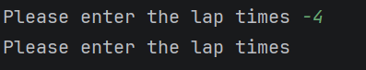
Result: Did the programme behave as expected ie syntactically and logically correct?
NO
If NO, what went wrong and why? Suggest how things could be improved
Whilst validation was in place to stop a 0 input, nothing prevented a below 0 input, should change from ==0 to <= a realistic time

Test:
Enter 53444 seconds

Screenshot(s) of output:
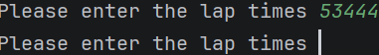
Result: Did the programme behave as expected ie syntactically and logically correct?
NO
If NO, what went wrong and why? Suggest how things could be improved
Validation only prevented a 0 value and nothing prevented an unrealistically large value

Test: Test target lap time – show that values entered are reasonable

Screenshot(s) of output:
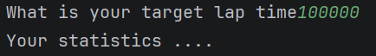
Result: Did the programme behave as expected ie syntactically and logically correct?
NO
If NO, what went wrong and why? Suggest how things could be improved
Did not provide validation apart from not allowing a 0 value, should prevent from below zero and unrealistically high numbers

Test: Entering five lap times and ensuring statistics 1-6 are correct

Screenshot(s) of output:
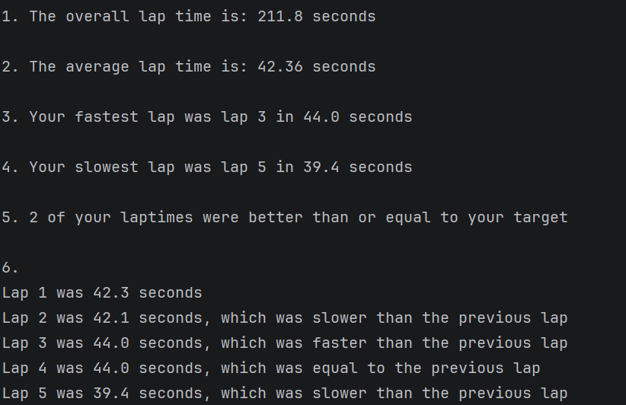
Result: Did the programme behave as expected ie syntactically and logically correct?
NO
If NO, what went wrong and why? Suggest how things could be improved
Statistic 1,2 5 and 6 work correctly however 3 and 4 were mixed up so slowest is fastest time and vice versa

Test:
Using own lap times

Screenshot(s) of output:
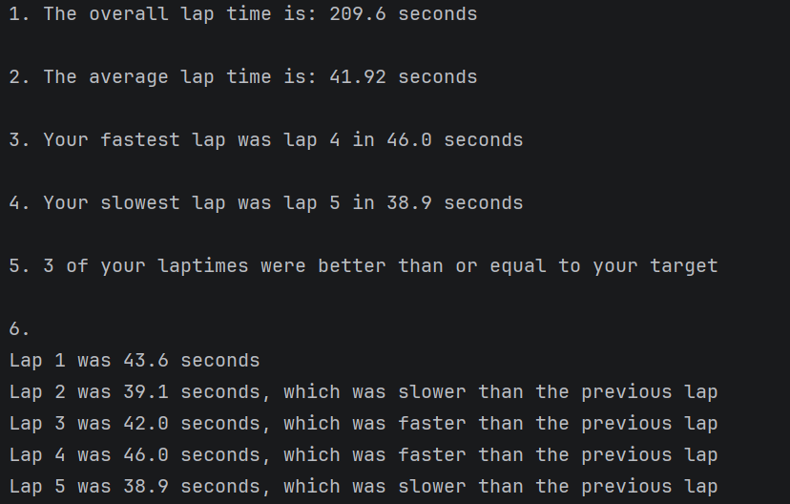
Result: Did the programme behave as expected ie syntactically and logically correct?
NO
If NO, what went wrong and why? Suggest how things could be improved
Statistic 1,2 5 and 6 work correctly however 3 and 4 were mixed up so slowest is fastest time and vice versa

Test:
Using own lap times 2nd time
Screenshot(s) of output:
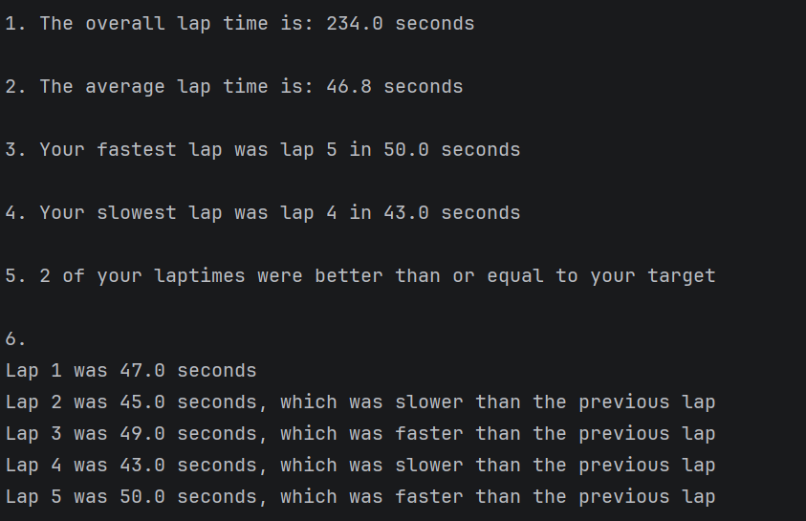
Result: Did the programme behave as expected ie syntactically and logically correct?
NO
If NO, what went wrong and why? Suggest how things could be improved
Statistic 1,2 5 and 6 work correctly however 3 and 4 were mixed up so slowest is fastest time and vice versa

- Consider the results of the above tests and revisit your original code in order to address any tests that failed and/or improve code efficiency.

(Note: you may not be able to solve all of the problems that were encountered, but solve as many as you can.)

Paste your full revised code here :

lapTime = []
for counter in range(5):
flag = 0
while flag == 0:
try:
time = float(input("Please enter the lap times "))
if time <= 30 or time > 85: #given 10 seconds above target time for headroom
print("Give a realistic time")
else:
lapTime.append(time)
flag = 1
except ValueError:
print("Please enter an appropriate time in seconds")
flag = 0
while flag == 0:
try:
targetTime = float(input("What is your target lap time"))
if targetTime < 30 or targetTime > 75:
print("Give a realistic lap time")
else:
flag = 1
except ValueError:
print("Please enter a valid time in seconds")
overallTime = sum(lapTime)
averageTime = overallTime / len(lapTime)
fastestTime = min(lapTime)
fastestLap = lapTime.index(fastestTime) + 1
slowestTime = max(lapTime)
slowestLap = lapTime.index(slowestTime) + 1
fasterTime = 0
for counter in range(len(lapTime)):
if lapTime[counter] >= targetTime:
fasterTime = fasterTime + 1
print("Your statistics .... \n")
print(f"1. The overall lap time is: {overallTime} seconds \n")
print(f"2. The average lap time is: {averageTime} seconds\n")
print(f"3. Your fastest lap was lap {fastestLap} in {fastestTime} seconds \n")
print(f"4. Your slowest lap was lap {slowestLap} in {slowestTime} seconds \n")
print(f"5. {fasterTime} of your laptimes were better than or equal to your target \n")
print("6.")
for counter in range(0,5):
if counter == 0:
print(f"Lap {counter + 1} was {lapTime[counter]} seconds")
elif lapTime[counter] > lapTime[counter - 1]:
print(f"Lap {counter + 1} was {lapTime[counter]} seconds, which was faster than the previous lap")
elif lapTime[counter] < lapTime[counter - 1] :
print(f"Lap {counter + 1} was {lapTime[counter]} seconds, which was slower than the previous lap")
elif lapTime[counter] == lapTime[counter - 1]:
print(f"Lap {counter + 1} was {lapTime[counter]} seconds, which was equal to the previous lap")

