

Project Management Plan: Reconstruction of the Coquihalla Corridor, British Columbia

Student Name: Raluca Mihaela Popa
Student Number: 2332370

Lecturer’s Name: Navid Nasirpourosgoei

Table of Contents
Pat A: Project Proposal Poster 3
Part B: Reflection 4
Introduction 4
1. Description 4
2. Feelings 4
3. Evaluation 5
4. Analysis 5
5. Conclusion 6
6. Action Plan 7
Part C: Project Management Report 8
1. Introduction 8
2. Project Description 8
Project Aim 8
Objectives 8
Key Deliverables 9
3. Project Scope 9
4. Work Breakdown Structure (WBS) 10
5. Quad Chart 11
6. Gantt Chart 12
7. Stakeholders’ Involvement 12
Key Stakeholders 13
8. Allocation of Resources 14
Human Resources 14
Financial Resources 14
Material and Equipment 14
Technology 14
9. Risk Analysis 14
10. Conclusion 15
Reference List 15

Pat A: Project Proposal Poster

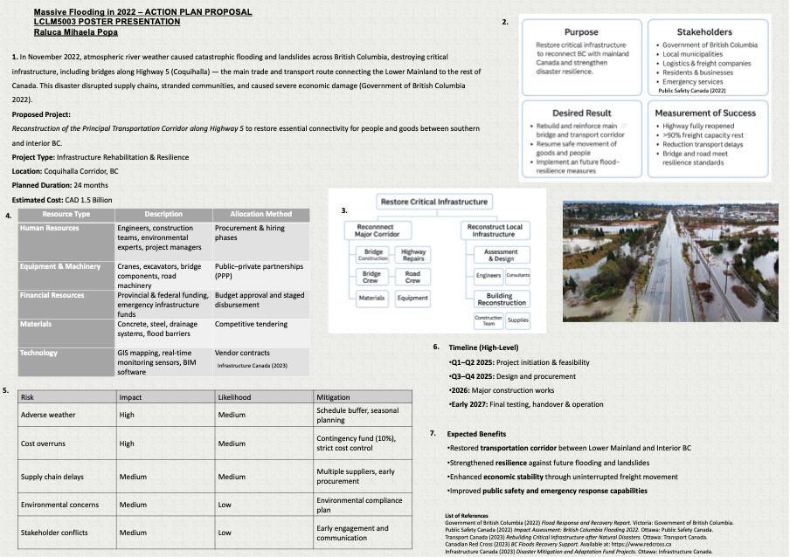

Part B: Reflection

Introduction
This reflective essay discusses my learning experience during the development of two academic works the poster presentation and the Project Management Plan (PMP) for the Coquihalla Corridor Reconstruction Project. Both tasks required not only research and analysis but also the practical application of project management principles such as stakeholder engagement, risk analysis, and scope definition. Using Gibbs’ Reflective Cycle (1988), this reflection explores the challenges I faced, the skills I strengthened, and the professional insights I gained throughout the process.

1. Description
The first task, the poster presentation, involved condensing a large and complex infrastructure proposal into a visually engaging and academically rigorous summary. It required identifying a real-world scenario in this case, the reconstruction of British Columbia’s Highway 5 after catastrophic flooding and communicating the project’s objectives, scope, and expected benefits in a concise visual format.
The second task, the detailed Project Management Plan, built upon the same scenario but demanded a more structured and analytical approach. It required producing a 2,500-word report incorporating key project management elements such as a Work Breakdown Structure (WBS), Gantt Chart, Quad Chart, and risk register, all underpinned by theories from PRINCE2, PMBOK, and stakeholder management literature. Together, these tasks simulated the full cycle of project conception and planning from visual proposal to formal documentation.

2. Feelings
At the beginning, I felt a mix of excitement and apprehension. I was confident in my research abilities but uncertain about how to translate complex project management frameworks into clear academic outputs. The poster, though creative, was challenging because it required visual clarity and precision, skills I had not extensively practiced in an academic context. The Project Management Plan, on the other hand, initially felt overwhelming due to its technical depth and the requirement to integrate multiple models such as Mendelow’s Matrix, PMBOK’s Scope Management, and ISO 31000 for risk analysis.
As I progressed, these feelings evolved. I began to appreciate the structure and logic that project management frameworks offer. While the workload was intensive, especially balancing report writing with graphical components, I gradually gained confidence in synthesising information and applying theory to practice.

3. Evaluation
The most significant challenge during the poster creation was selecting and simplifying key information. Academic writing typically values depth, but posters demand brevity and impact. I struggled initially with overcrowding content and had to refine my design multiple times to improve readability and coherence. However, this process strengthened my ability to communicate complex ideas visually and concisely, a skill essential for stakeholder presentations in professional contexts.
In contrast, the PMP tested my analytical and organisational capabilities. Developing the Work Breakdown Structure and Gantt Chart required breaking the project into logical, sequenced tasks while maintaining consistency with the defined scope and budget. One of the difficulties was ensuring that the report maintained academic rigour with in-text citations, Harvard referencing, and theory integration without losing its practical tone. Overcoming this balance taught me to write in a consultant-style voice, bridging academic and professional expectations.
Another challenge was time management. The iterative nature of research, drafting, and data visualisation made it difficult to meet deadlines at first. However, by adopting a disciplined project-style schedule setting milestones for drafting, editing, and proofreading I managed to complete both tasks systematically.

4. Analysis
Through these experiences, I realised that both tasks were not just academic exercises but simulations of real project environments. The poster represented the initiation and communication stage, while the PMP embodied planning and control. This understanding deepened my appreciation for project management as both an analytical and creative discipline.
From a theoretical perspective, applying Freeman’s (2010) Stakeholder Theory and Bourne and Walker’s (2018) stakeholder relationship model helped me recognise that successful projects depend on effective communication and trust, not just technical competence. Similarly, using Teece et al.’s (1997) Dynamic Capabilities Theory reinforced the importance of adaptability and learning both in organisations and in my own academic growth.
On a personal level, I strengthened several transferable skills:
- Analytical skills through risk identification and scope management.
- Visual and digital literacy through poster design and data presentation.
- Time and self-management by applying scheduling techniques to my academic workflow.
- Critical thinking by evaluating theories and selecting those most relevant to infrastructure resilience.
These skills align closely with professional project management competencies, suggesting that the module has had direct vocational value.

Part C: Project Management Report

1. Introduction
Natural disasters have a significant and often devastating impact on regional infrastructure, economies, and social systems. In November 2022, British Columbia (BC) experienced an unprecedented atmospheric river event that led to severe flooding and landslides, damaging over 200 sites and destroying major bridges along the Coquihalla Highway 5, the principal transport artery connecting the Lower Mainland with interior BC (Government of British Columbia, 2022). The resulting isolation of key communities exposed the vulnerability of Canada’s critical infrastructure to climate-related events.
The proposed project, Reconstruction of the Coquihalla Corridor, is a 24-month infrastructure rehabilitation and resilience programme designed to restore this vital transportation link while embedding adaptive and sustainable design principles. The project is valued at CAD 1.5 billion, funded jointly through the Disaster Mitigation and Adaptation Fund (DMAF) and provincial infrastructure budgets (Infrastructure Canada, 2023).
This Project Management Plan (PMP) applies structured project management frameworks to ensure timely, efficient, and resilient delivery. The plan integrates the PRINCE2 and PMBOK methodologies, emphasising governance, stakeholder engagement, and risk management.

2. Project Description
The Coquihalla Highway is a key strategic corridor that supports more than 35% of BC’s freight movement and connects Vancouver’s ports to the national highway network (Transport Canada, 2023). The 2022 flooding destroyed five bridges and caused slope instability across several sections, rendering the corridor impassable for months.

Project Aim
To reconstruct, strengthen, and future-proof the Coquihalla transportation corridor to ensure long-term resilience and reliability under extreme weather conditions.

Objectives
- Restore full connectivity between Lower Mainland and Interior BC by 2027.
- Design and construct flood- and landslide-resilient infrastructure using adaptive engineering.
- Integrate digital monitoring systems for predictive maintenance.
- Minimise environmental impact and support local economic recovery.

Key Deliverables
- Replacement of destroyed bridges with elevated, reinforced designs.
- Installation of advanced drainage and slope-stabilisation systems.
- Deployment of smart sensors for real-time condition monitoring.
- Implementation of environmental mitigation measures (revegetation, runoff control).
The project aligns with Canada’s National Adaptation Strategy (Public Safety Canada, 2022), promoting sustainable rebuilding after disasters and reinforcing public safety and economic continuity.

3. Project Scope
The project scope outlines all activities, deliverables, and limitations required to achieve the defined objectives and ensure the reconstruction of the Coquihalla Corridor remains focused, efficient, and free from scope creep. The project’s primary focus is on restoring critical infrastructure damaged during the 2022 floods and enhancing its long-term resilience to future climatic events.
The in-scope elements of the project include the complete reconstruction of five bridges and the associated damaged sections of the roadway. This encompasses the design and implementation of advanced resilience measures such as elevated bridge spans, reinforced embankments, and improved drainage systems to mitigate flood and landslide risks. The scope also involves the integration of smart monitoring technologies to enable real-time structural health tracking and predictive maintenance. In addition, close coordination with environmental regulators, local authorities, and Indigenous communities will ensure compliance with sustainability standards and community engagement requirements. Finally, the project will provide training for maintenance staff to ensure effective long-term operation and asset management after project completion.
Conversely, several activities are explicitly out of scope to maintain focus and cost control. These include any upgrades or expansions to sections of Highway 5 that were not directly affected by the floods, as well as broader capacity-increase projects that fall outside the current rehabilitation mandate. Compensation for private property damage will also remain outside the project’s remit, as these matters are managed under existing provincial disaster relief programmes.
The project’s scope is based on several assumptions that underpin planning and delivery. It assumes that stable funding will be available throughout the entire 24-month duration, that all necessary regulatory approvals will be secured within the planned timeframe, and that weather conditions will permit at least nine months of active construction work per year.
However, several constraints must be acknowledged. The construction window is significantly limited by BC’s harsh winter conditions, which restrict major fieldwork during colder months. Workforce availability in remote regions also presents a challenge, as skilled labour shortages could affect productivity. Furthermore, the project must adhere to stringent environmental regulations under the BC Water Sustainability Act, which may affect scheduling and material usage.
By clearly defining these parameters at the outset, the project establishes a robust foundation for governance and control. This clarity ensures that all stakeholders share a common understanding of the project’s scope and limitations, aligning with the PMBOK’s Scope Management principles (PMI, 2021), which emphasise the importance of scope definition, validation, and control in successful project delivery.

4. Work Breakdown Structure (WBS)
The WBS decomposes project work into manageable packages, supporting scheduling, budgeting, and accountability (Kerzner, 2022).

Project: Coquihalla Corridor Reconstruction
├── 1. Initiation & Feasibility (Q1–Q2 2025)
│ ├── 1.1 Feasibility and cost–benefit analysis
│ ├── 1.2 Environmental impact assessment
│ └── 1.3 Funding and stakeholder approval
│
├── 2. Design & Procurement (Q3–Q4 2025)
│ ├── 2.1 Bridge and road engineering design
│ ├── 2.2 Tender documentation and contractor selection
│ └── 2.3 Material and equipment procurement
│
├── 3. Construction Phase (2026)
│ ├── 3.1 Site preparation and temporary access roads
│ ├── 3.2 Bridge foundation and superstructure works
│ ├── 3.3 Drainage and slope-stabilisation systems
│ └── 3.4 Smart monitoring installation
│
└── 4. Testing & Handover (Early 2027)
├── 4.1 Structural load testing and safety audits
├── 4.2 Training for maintenance teams
└── 4.3 Final environmental remediation

The Work Breakdown Structure (WBS) for the Coquihalla Corridor Reconstruction Project provides a hierarchical decomposition of the total scope of work into manageable phases, tasks, and deliverables. It ensures all project components are clearly defined, scheduled, and assigned to responsible parties.
The WBS is structured into four main phases reflecting the project lifecycle:
- Initiation & Feasibility (Q1–Q2 2025): Involves feasibility studies, environmental assessments, and stakeholder approvals to confirm project viability.
- Design & Procurement (Q3–Q4 2025): Covers detailed engineering design, tendering, and procurement of materials and contractors.
- Construction Phase (2026): Encompasses on-site execution, including bridge reconstruction, roadway works, drainage systems, and smart monitoring installation.
- Testing & Handover (Early 2027): Focuses on load testing, safety verification, staff training, and final environmental remediation before project closure.
This WBS provides the foundation for resource allocation, scheduling, cost estimation, and performance monitoring, aligning with PMBOK (PMI, 2021) best practices to prevent scope creep and ensure project control.

5. Quad Chart
Element | Description
Objective | Restore and future-proof the Coquihalla transportation corridor following 2022 flood destruction.
Approach | Apply resilient design, adaptive engineering, and digital monitoring systems within PRINCE2 governance.
Benefits | Re-establish connectivity, enhance resilience to future floods, strengthen local economy, improve safety.
Resources/Timeline | CAD 1.5 billion budget; 24-month duration (2025–2027); multidisciplinary project team including engineers, environmental scientists, and local contractors.
The Quad Chart condenses strategic intent for senior decision-makers, reflecting best practice in project communication management (Turner, 2020).

6. Gantt Chart

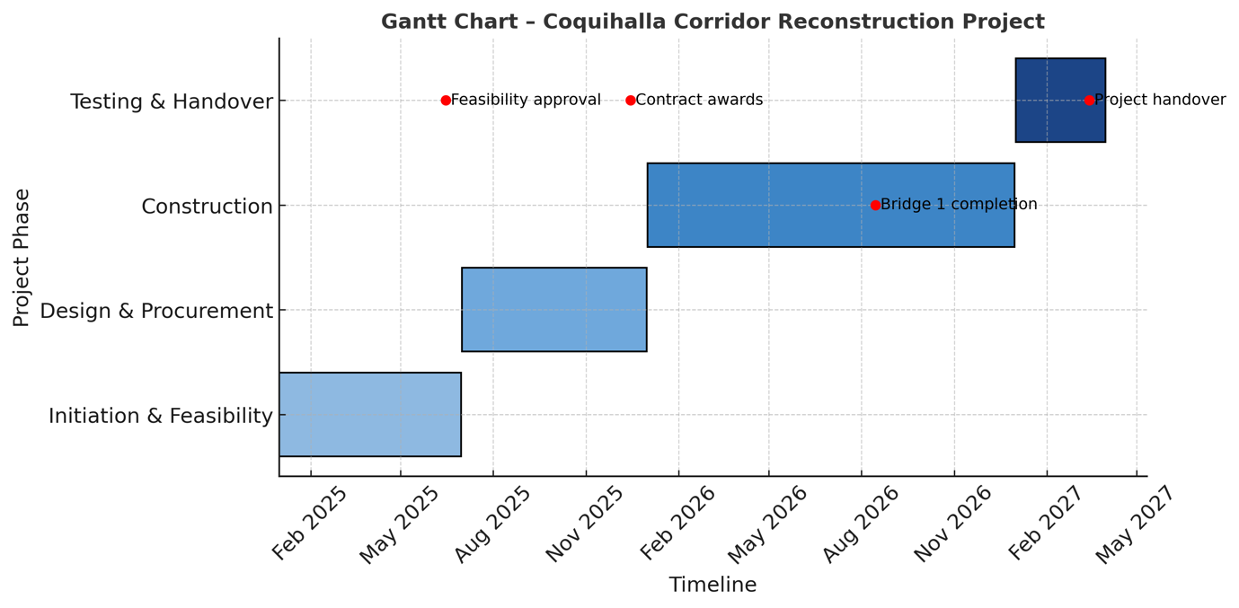
Phase | Key Activities | Timeline
Initiation & Feasibility | Environmental studies, stakeholder consultations, funding approval | Q1–Q2 2025
Design & Procurement | Engineering design, tendering, contractor selection | Q3–Q4 2025
Construction | Bridge reconstruction, slope stabilisation, drainage works | Q1–Q4 2026
Testing & Handover | Safety testing, staff training, project closure | Q1 2027
Milestones include:
- Feasibility approval (June 2025)
- Contract awards (December 2025)
- Bridge 1 completion (August 2026)
- Project handover (March 2027)
The Gantt schedule enables critical-path analysis, ensuring resource alignment and time control per PMI’s Schedule Management Process.

7. Stakeholders’ Involvement
In project management, stakeholders are defined as individuals, groups, or organisations that have an interest in, or are affected by, the outcomes of a project (PMI, 2021). They can either influence the project’s success or be directly impacted by its deliverables, operations, or consequences. In infrastructure development particularly in large-scale public projects like the Coquihalla Corridor Reconstruction stakeholders play a critical role in ensuring that the project aligns with community needs, regulatory expectations, environmental standards, and broader policy objectives.
Effective stakeholder engagement is, therefore, central to infrastructure delivery success (Freeman, 2010). It allows for early identification of concerns, effective resource alignment, and a smoother approval process. By fostering collaboration and transparency, the project can mitigate conflicts, improve decision-making, and build long-term trust with the affected communities. Moreover, successful stakeholder management enhances project legitimacy, ensures regulatory compliance, and helps maintain social licence to operate an increasingly important factor in public-sector initiatives (Bourne & Walker, 2018).

Key Stakeholders
Stakeholder | Interest/Influence | Engagement Strategy
Government of BC (Ministry of Transportation) | High influence; project owner | Weekly progress reports; decision meetings
Infrastructure Canada / DMAF | Funding oversight | Quarterly performance and financial audits
Local Municipalities | Community impacts | Regular public consultations
Indigenous Communities | Cultural and environmental stewardship | Collaborative design sessions and consent protocols
Contractors & Consultants | Delivery and quality | Clear contract KPIs and risk-sharing mechanisms
General Public & Road Users | Safety and accessibility | Continuous communication via media and project website
Understanding and managing stakeholder relationships effectively is essential because infrastructure projects often operate in politically, socially, and environmentally sensitive contexts. Failure to communicate transparently or manage expectations can lead to project delays, cost overruns, or even reputational damage. Applying Mendelow’s Matrix provides a strategic framework for stakeholder prioritisation manage closely for those with high power and high interest and keep informed for those with lower power but high interest.
In this project, the participative engagement approach not only strengthens collaboration but also fosters shared ownership of outcomes. Continuous dialogue with Indigenous communities and local authorities promotes cultural respect and environmental responsibility, while open communication with the public ensures accountability and support for construction disruptions. Ultimately, this collaborative model promotes transparency, trust, and smoother regulatory approvals, enhancing both project efficiency and long-term societal value (Bourne & Walker, 2018).
8. Allocation of Resources
Resource allocation balances human, financial, material, and technological inputs (Lock, 2020).

Human Resources
- Project Manager: Oversees PRINCE2 processes and governance.
- Engineering Lead: Supervises structural design and compliance.
- Environmental Manager: Ensures mitigation measures and regulatory adherence.
- Procurement Officer: Manages supplier contracts.
- Construction Teams: Skilled labour, operators, surveyors.

Financial Resources
The CAD 1.5 billion budget will be distributed as follows:
- Feasibility & design – 5%
- Procurement – 10%
- Construction – 70%
- Testing & handover – 10%
- Contingency – 5%

Material and Equipment
Locally sourced aggregates, steel, and concrete to support regional supply chains. Equipment includes cranes, GPS surveying tools, and automated monitoring sensors.

Technology
Integration of Building Information Modelling (BIM) for 3-D coordination and clash detection, enabling efficient communication and version control.
Efficient resource deployment aligns with the triple constraint model time, cost, and quality and supports performance tracking through EVM metrics (Kerzner, 2022).

9. Risk Analysis
Infrastructure projects of this scale involve significant uncertainties. The risk management process follows ISO 31000 (2018): identify, assess, respond, and monitor.
Risk | Likelihood | Impact | Mitigation/Response
Extreme weather delays | High | High | Schedule buffer; modular construction; winter shutdown contingency
Cost overruns | Medium | High | Strict EVM tracking; escalation protocols; contingency 5%
Supply chain disruption | Medium | Medium | Local supplier prioritisation; framework agreements
Regulatory approval delays | Medium | Medium | Early engagement; dedicated compliance team
Labour shortages | High | Medium | Workforce training incentives; partnership with local colleges
Environmental non-compliance | Low | High | Ongoing audits; adaptive environmental plan
Community opposition | Low | Medium | Transparent communication; consultation workshops
Continuous risk monitoring and lessons-learned reviews during phase gates reinforce adaptive capacity a central concept of Dynamic Capabilities Theory (Teece et al., 1997) applied to public projects.
A Monte Carlo simulation could be used to quantify cost-schedule interactions, offering probabilistic forecasts to inform decision-making.

10. Conclusion
The Coquihalla Corridor Reconstruction represents more than a physical rebuilding effort; it is a strategic resilience project integrating sustainable design, stakeholder inclusivity, and adaptive management. By applying structured methodologies (PRINCE2 and PMBOK), the project ensures rigorous control over scope, time, cost, and quality. The plan demonstrates how post-disaster reconstruction can act as a catalyst for modernisation, embedding climate-resilient practices into critical infrastructure. Stakeholder collaboration, risk responsiveness, and resource discipline will underpin the project’s success, enabling BC to restore not only its transport link but also its economic and social lifeline.

Reference List
Bourne, L. and Walker, D.H.T. (2018) Stakeholder Relationship Management: A Maturity Model for Organisational Implementation. 2nd ed. Abingdon: Routledge.
Chinyio, E. and Olomolaiye, P. (2010) Construction Stakeholder Management. Oxford: Wiley-Blackwell.

Coppola, D.P. (2020) Introduction to International Disaster Management. 4th ed. Burlington, MA: Butterworth-Heinemann.
Freeman, R.E. (2010) Strategic Management: A Stakeholder Approach. Cambridge: Cambridge University Press.
Flannery, T. (2021) ‘Building resilience into infrastructure systems: adapting to extreme climate events’, Journal of Infrastructure Systems, 27(4), pp. 1–12.
Government of British Columbia (2022) Flood Response and Recovery Report. Victoria: Government of British Columbia.
Infrastructure Canada (2023) Disaster Mitigation and Adaptation Fund Projects. Ottawa: Government of Canada.
Kerzner, H. (2022) Project Management: A Systems Approach to Planning, Scheduling, and Controlling. 13th ed. Hoboken, NJ: John Wiley & Sons.
Lock, D. (2020) Project Management. 11th ed. Farnham: Gower Publishing.
PMI (Project Management Institute) (2021) A Guide to the Project Management Body of Knowledge (PMBOK Guide) – Seventh Edition. Newtown Square, PA: Project Management Institute.
Public Safety Canada (2022) Impact Assessment: British Columbia Flooding 2022. Ottawa: Government of Canada.
Teece, D.J., Pisano, G. and Shuen, A. (1997) ‘Dynamic capabilities and strategic management’, Strategic Management Journal, 18(7), pp. 509–533.
Transport Canada (2023) Rebuilding Critical Infrastructure after Natural Disasters. Ottawa: Transport Canada.
Turner, R. (2020) Gower Handbook of Project Management. 6th ed. Abingdon: Routledge.
ISO (International Organization for Standardization) (2018) ISO 31000: Risk Management – Guidelines. Geneva: ISOi.

