Assignment 2 : Written Document

Student name : Ancuta Daniela Tofan
Student id : 2026253
Programme : BSc Health and Social Care
Module : Changemakers : Building your Personal Brand for Sustainable Employment
Module code : BMHP5015
Lecturer : Kennedy Obohwemu

Table of content
Table of content………………………………………………………………………….2
Introduction…………………………………………………………………………….…3
Unit 1 – Topic 1-Ambition is critical …………………………………………….…..…3
Unit 2-Topic 2 – Network Society……………………………………………….….....4
Unit 3- topic 2- Identifying career opportunities……………………………….……..4
Unit 4-Topic 1- Future me ………………………………………………………....….5
Conclusions………………………………………………………………………..….…6
Personal Development Plan……………………………………………………..….…7
References……………………………………………………………………………....10

Introduction
In this written assignment which reflects the learned outcomes from this module I will describe the learned key points through the module and explain what the module impact towards me was. Some of the topics had a real impact towards me . In the reflection I need to speak about four Units and choose a topic from each Unit.
My choices are Unit 1-Topic 1-Ambition is Critical
Unit 2-Topic 3 - Network Society
Unit 3-Topic 3 - Identifying Career Opportunities
Unit 4-Topic 1 --Future Me
Every single Unit and Topic will be related to me personally and expose my future aspirations after graduation. Personal convictions have shaped who I am today and who I will become in the future. This self-reflection work will be ended with my personal conclusions about the whole course Personal convictions have shaped who I am today and who I will become in the future..

Unit 1-Topic 1-Ambition is Critical
Pretension, aspiration, and arousal all refer to a strong desire for advancement ( Ewumi, Oyenuga, and Owoyele, 2014) .
The term "ambitiation" refers to the desire for one's own advancement or favour, and it can refer to either a worthy or excessive desire. (Merriam-webster.com, 2019). According to Moses, ( 2009 ) ,ambition is something which drive you through live to achieve your aspirations and your goals .I am agree with the author ,because with ought ambition you can not achieve nothing in your live or in your career . My personal ambition is to get my degree ,to have a better job ,better paid and to be a real model for my daughters. I have set a goal ,to get my degree with a Merrit or a Distinction on my degree and I am working hard to prove with hard work and with a high ambition I can achieve my desires.
The very concept of "moral ambition" may give the impression of connecting two concepts that are in complete conflict with one another ( Pettigrove, and Meyer, 2009 ) This could be due to the fact that the goals of ambition, such as power or honour ,lack the necessary moral credentials, or that the outcomes of ambition and moral intent, such as elitism or pride, are unethical not appropriate for the life of a moral person (Pettigrove, and Meyer, 2009 ) . On the additional hand, while a dressed person might have a modest plan for ethical self-improvement, the truthfully respectable person might be characteristically ambitious when it comes to self-improvement (Pettigrove and Meyer, 2009 ).In my case ,my moral ambition is to be the best in my courses ,that will give me a bigger trust in myself and it’s keeping me on a continuous improvement .

Unit 2- Topic 3-Network Society
Human portability and movement are firmly connected with and correspondingly impacted by globalization ( Niemandt, 2013 ) . An emerging new "global" culture is evident when you add the unending connectivity made possible adding social media's rise and the increase in mobile communications to this mix ( Niemandt , 2013 ). Not only are people moving to new areas and cultures, but they're also moving to new places ( Niemandt , 2013 ). From the real world to the virtual one, we are witnessing the greatest human migration ever( Niemandt , 2013 ). It’s a change from sharing space to sharing interests. The existence that migratory groups are a convergence of some of the greatest The analogy of a flood-ravaged river has been used to symbolise the major difficulties facing the religion and culture: hyper diversity, interconnection, a Google culture, and postmodern tribalism are all mentioned ( Aneesh, 2006 ). The church serves as a link between people trying to make sense of life, culture, and the tradition that has been passed down through the centuries. Culture flows like a river ( Aneesh, 2006 ).. To bring the gospel to life in this new culture will be one of the missionary difficulties ( Aneesh, 2006 ).Now a days ,everyone is a part of a network society : in work ,families ,at Uni.
Almost all businesses employ well-known managerial procedures like planning, budgeting, staffing, and measuring alongside this hierarchy (Kotter, 2011). We've all seen so many hierarchical organisation charts with their huge boxes of writings and arrows and inverted hierarchies and been to so many budget, planning, and problem-solving meetings that we take it all for granted, as if it had already been there (Kotter, 2011).Hierarchy is important in schools , companies , at home. Hierarchy must be respected everywhere (Kotter, 2011).

Unit 3-Topic 2 -Identifying career opportunities
A career conversation is an open, frank talk between someone manager and employee that helps the person set career goals and plans for achieving things that are both good for them and good for the company (O'Neill, and Adya ,2007 ) . By assisting employees develop them can improve their results and expand their capacity .Managers have more time to make improvements their own skills and effectiveness (O'Neill and Adya ,2007 ) . Moreover, managers can improve their reputations by cultivating a culture of employee development opportunities for advancement (O'Neill and Adya ,2007 ) .At my work I had my appraisal and my manager proposed me to have training for Senior Carer Manager .
Young employees will respond with energy and enthusiasm when given opportunity, which can spread and uplift everyone's spirits ( Achor,2011 ). Every member of the team performs better because of this energy ( Achor , 2011 ).. By allowing young employees to participate in your business's sustainability programme, you build their trust and foster an environment where they aspire to deliver better work ( Achor,2011 ).. They can transform from common employees into assets and ambassadors with the help and chances offered ( Achor,2011 ) .
According to the Merriam-Webster Dictionary, prioritisation means "to arrange (things) such that the most important thing is done or dealt with first" (Priority Matrix Productivity, 2020). It is often necessary to rank a group of tasks or other items that need to be completed to organise them. Such as how important each task is, whether it is time-sensitive, and how long it will take to finish each one (Priority Matrix Productivity, 2020). This enables us to decide what needs to be ordered to increase efficiency and accomplish additional (Priority Matrix Productivity, 2020) . For me to have the prioritizing skill is crucial in my future career of Social Worker . Some cases can be more urgent than others.

Unit 4- Topic 1 -Future Me
To get kids to concentrate on their education, adults often ask kids what they want to be when they grow up (Nurra , and Oyserman , 2018 ). However, this does not always happen (Nurra , and Oyserman , 2018 ) . According to identity-based motivation theory, one approach to improve the chances is for kids to have a connection to their future selves as adults (Nurra , and Oyserman , 2018) . Youngsters can be encouraged to feel a link between their present selves and their adult selves, according to our research (Nurra , and Oyserman , 2018 ) . Compared to kids who are taught to experience low connection, strong connection kids work more and do better in school (Nurra , and Oyserman , 2018) . By reducing the impact of viewing school as the route to one's adult young self, experiencing attachment works (Nurra , and Oyserman , 2018) .Me, when I will absolve University I want to become Social Worker to give support (emotional ,financial ) for those in need .
A limiting belief is a thinking or emotional state that prevents you from acting in a certain way because you believe it to be the absolute truth (Peirce, 1905 ). Additionally, these convictions don't always have to pertain to you (James, 2020).. They might deal with concepts, interpersonal dynamics, and how the world functions (James, 2020 ) . Pragmatism sometimes is constant in my life .I always encountering peoples who have different opinions regarding my future career, and I need to explain them my point of view for the chosen career.
By adopting plenty and allowing possibility into your life, Benjamin Zander explores the idea of keeping an open door in the back of your mind for possibilities, life-changing events, and more of the good things in life (Quinn, 2004).In my career I have a back-up plan ,which is a career as a Chef.
Conclusions
In this self-reflecting assignment, it reflect all my personal aspirations and beliefs achieved into this course. During lessons from the module, I discovered that sometimes I underestimate myself and I have doubts regarding the decisions made it, I have some retains due to my language barrier, but I guess that that makes part of human being, and everyone have these doubts. I learned that always in the life if a door is closing maybe a new window is opening. You need to have a back-up plan when you set a goal, but I never think about the back-up plan ,because that will make me look back and failing from what I desire to achieve. To conclude this piece of work ,I am proud of what I am ,and I still working to improve myself to be a better person, a better employee, and a better student.

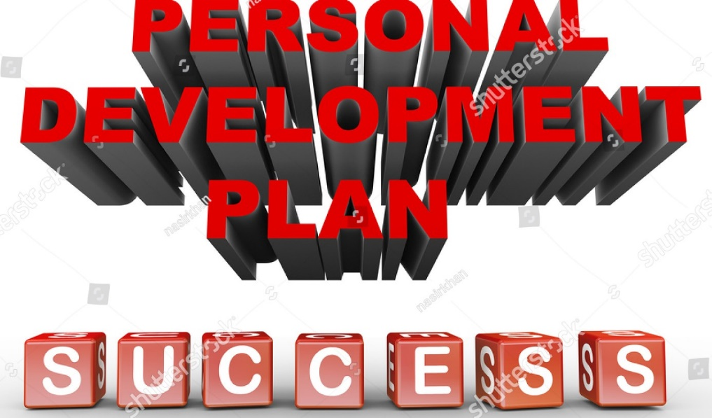
Image : www. (Shutterstock, 2022) .

Personal Development Plan
A PDP is a tool for self-evaluation and self-reflection in both higher education and the workplace (Putter, 2021). But it might also be a good habit to get into for your personal life (Putter, 2021). A PDP can help you accomplish your objectives, like learning a new language before an international trip. (Putter, 2021).
Test of personality
A personality test is a tool for evaluating a person's personality traits. This exam is intended to reveal details about a person's motives, preferences, interests, and manner of relating to others and challenging situations.
We took a personality test in one of the weeks in the course to better understand the types of people we were. My personality, according to this test, is a Logistician. I am forceful, introverted (69%) and observant (58%) as well as thinking (53%) and judging (100%) (58 percent ). I am a person of integrity, am well-organized, and love taking ownership of my actions. Law firms, army employment, or organisations with strict rules and standards are a good fit for my mentality. I am good in leading positions ,I am the Course Rep at Uni ,and I am a good advisor .

My long-time goals | My specific career goals | Key skills needed | Weaknesses | Actions taken to achieve my goal | Training time
Promotion to the area Social Worker manager | Absolve University  Get the BIA certificate | Leadership skills, Communications skills, IT skills | Communications skills , | Online CPD Leadership course  Companies Leadership course  Absolve UWTSD | 6 Months
 | Become a team manager | Leadership skills, project management skills, presentations skills, digital skills, management skills | Presentation’s skills ,improving my language skills | Online CPD project management training course  Lead companies’ meetings to build my Presentations skills | 12 Months
 | Become area manager | Management skills ,networking skills ,strategic thinking skills ,decision making skills , Prioritizing skills | Networking skills ,Strategic thinking skills ,Self-management skills ,decisions making skills, | Online CPD strategic-thinking training course  Networking meetings with departments managers | 24 Months

To achieve my goal still have a continuous work ,still need to get my driving licence ,get my degree . Some of the criteria needed to become a Social Worker Manager I started already to work on it ,so by the time is approaching to have all the above trainings ,so that I can start working .At the moment I am working as a Residential Support Worker because I need experience in Care for when I will work as Social Worker .I am planning to buy my own car and start driving so that I can have my practical exam by May next year .I am hoping that in the future to progress more at my workplace to made my family proud of me .I have my family support which give me strength to achieve what I want.
References
Achor, S.(, 2011). The happiness advantage: The seven principles of positive psychology that fuel success and performance at work. Random House.
Aneesh, A., (2006). Virtual migration: The programming of globalization. Duke University Press.
Ewumi, A.M., Oyenuga, A.O. and Owoyele, J.W., (2014). Entrepreneurship Education as 0Panacea For Youth Unemployment: Implication Of Vocational Counselling For Sustainable National Development. COUNSELLING AND BEHAVIOURAL STUDIES, p.89.
James, W.,( 2020). Pragmatism. In Pragmatism (pp. 53-75). Routledge.
Kotter, J.P. (2011). Hierarchy and Network: Two Structures, One Organization. [online]
Harvard Business Review. Available at: https://hbr.org/2011/05/two-structures-one-organizatio.‌

Merriam-webster.com. (2019). Definition of AMBITION. [online] Available at: https://www.merriam-webster.com/dictionary/ambition.

Moses, D.N., (2009). The promise of progress: The life and work of Lewis Henry Morgan. University of Missouri Press.

Niemandt, C.J.,( 2013). A network society, social media, migration and mission. Missionalia: Southern African Journal of Mission Studies, 41(1), pp.22-39.

Nurra, C. and Oyserman, D.,( 2018). From future self to current action: An identity-based motivation perspective. Self and identity, 17(3), pp.343-364.

O'Neill, B.S. and Adya, M.,( 2007). Knowledge sharing and the psychological contract: Managing knowledge workers across different stages of employment. Journal of managerial psychology.

Peirce, C.S., ( 1905). What pragmatism is. The monist, 15(2), pp.161-181.
‌ Pettigrove, G.A. and Meyer, M.J., (2009). Moral ambition. Australasian Journal of Philosophy, 87(2), pp.285-299.
Putter, M. (2021). What is a personal development plan? [online] CPD Online College. Available at: https://cpdonline.co.uk/knowledge-base/business/what-are-personal-development-plans/.

Priority Matrix Productivity. (2020). Prioritization - What is prioritization and why it’s important. [online] Available at:
https://appfluence.com/productivity/prioritization-what-is-prioritization-and-why-its-important/.

Shutterstock. (2022). 3d Illustration Phrase Personal Development Plan Stock Illustration 146073848. [online] Available at: https://www.shutterstock.com/image-illustration/3d-illustration-phrase-personal-development-plan-146073848 [Accessed 14 Nov. 2022].

Quinn, R.E.,( 2004 ). Building the bridge as you walk on it: A guide for leading change (Vol. 204). John Wiley & Sons.

‌

