

University of Wales
Trinity Saint David
Eduardo Aguilar

Emissions Diagnosis and systems
Data Collection
Contents
1. Introduction 2
2. Research 3
2.1 Emissions control 4
2.1.1 Engine Design procedures 4
3. Tasks 5
3.1 Catalytic converter 5
3.2 EVAP 7
3.3 EGR 9
3.4 SAIR 10
3.5 PCV 11
3.6 The importance of the Air/Fuel Ratio 11

Introduction
‘Every animal is naturally made for the use of pure, natural and free air’ [Test of the effects of the air in the human body, John Arburnoth]. In the fifth and six century BC, some philosophers knew about the influence of different and the relation in the health in the human. Also Pliny the Elder died in 79 BC due to the pollution caused by the eruption of Mount Vesivius [ R. Leygonie (1988), Pollution Atmospherique]. The English doctor John Evelyn wrote a thesis about the negative effects in the air of London due to the pollution, caused by the burning of coal and chimneys.
In thirteen-century, the king and the queen of England took measurements to restrict the burning of coal in homes, due the prejudicial characteristic of the smoke. Furthermore in previous centuries, most rural and urban populations breathed the smoke contained emission from burned wood, peat or coal. [P. Goubert, 1982]
The nineteenth century brought the first transport vehicles powered by mechanical energy. The concern was raised about the risk of the potential of the automobile exhaust. On September of 1967 the Council of Europe provided a new definition of air pollution showing the risks of the pollution and a concern not only as harmful chemical compounds, also includes nuisances to the human senses as a bad odours, reduce visibility and other similar problems. [P. Chovin, 1979, La pollution atmosperique].
The following assignment will discuss the effects of the air pollution resultant of the emission of the vehicles and the different methods to reduce the emissions of a combustion engine due to the importance to the environment of these emissions. The potential climatic consequences of these effects could affect to the environment drastically, being the plants and animal species also vulnerable to these effects. Acid rain and the acification of lakes, the degeneration of plants, are examples of that. Analytical methods applicable to the exhaust pollutants will be described along this assignment, which are either regulated or detected but not systematically measured. The influence of fuel on emissions will also be considered in the following paragraphs, also the relationship between the performance, fuel consumption and pollutants it will be a critical point to analyse along the assignment. To meet the level of the European restrictions, chemical reactors must be addedto the engine exhaust systems, those reactors are designed to reduce the emissions achieved by the combustion process by the engine, catalytic converters and other methods as particle filters and evaporation system will be described along the assignment. [Paul Degobert, Automobiles and Pollution]
For that, a test was carried out of 3 different ECU and injection systems to verify the working or the malfunction of the anti-pollution system implied in those systems.
The final part of this assignment will describe the economic factors related to the vehicle pollution control, detailing the costs of the system involved to control the emissions and the positive repercussion of this knowledge to improve and save cost of the new Euro laws to control the pollution on each country.

Research
The following paragraphs will explain how the gases absorbed from the atmosphere are converted by the combustion process in the engine and the importance of the air pollution in relation with the atmosphere and the environment. The principal components of the atmosphere are:
Nitrogen N₂ ₍78.09%): non-toxic, but high concentrations could be bad for the healthy. Nitrogen is a non-combustible, colourless and odourless gas; it is an essential component of the air that the people breathe. And feeds the combustion process together with the intake air. Most of the aspirated nitrogen comes out pure again in the exhaust gases; only a small part is combined with oxygen O2 (NOx nitric oxides). [T. Alsberg (1985), Chemical and biological characterization of organic material from gasoline particles]
Oxygen O₂ (20.95%): It's a colourless, odourless, and tasteless gas. It is the most important component of the air we breathe. It is essential for the combustion process, with an ideal mixture the fuel consumption should be total, but in the case of incomplete combustion, the remaining oxygen is expelled by the exhaust system. [T. Alsberg (1985), Chemical and biological characterization of organic material from gasoline particles]
Water (H2O): It is partly aspirated by the engine (air humidity) or is produced due to the "cold" combustion (engine heating phase). It is a by-product of combustion and is expelled by the exhaust system of the vehicle, it can be visualized especially on colder days, such as white smoke that escapes from the exhaust, or in the case of condensation along the pipe , a drip occurs. It is a harmless component of the exhaust gases.
Carbon dioxide (CO2): This occurs when fuels containing carbon are burned (gasoline, diesel). The carbon is combined during this operation with the oxygen aspirated. It is a colourless gas, not combustible. Carbon dioxide CO2, despite being a non-toxic gas, reduces the stratum of the earth's atmosphere that usually serves as protection against the penetration of UV rays (the earth is heated). The general discussions about the climatological alterations ("greenhouse effect"), the issue of CO2 emissions has become conscious in the public opinion. [D.J. Ball (1987), Vehicle emissions and their impact on European Air quality]
Carbon monoxide (CO): It is produced due to incomplete combustion of fuels containing carbon. It is a colourless, odourless, explosive and highly toxic gas. It blocks the transport of oxygen by the red blood cells. It is deadly, even in a low concentration in the air we breathe. At a normal concentration in the ambient air it oxidizes in a short time, forming carbon dioxide CO2. Vehicles caused the 47% of the CO of the atmosphere. [ Source of CO in winter in Oregon]
Nitric oxides (NOx): These are combinations of nitrogen N2 and oxygen O2 ( NO, NO2, N2O, ...). Nitrogen oxides are produced by high pressure, high temperature and excess oxygen during combustion in the engine. Nitrogen monoxide (NO) is a colourless, odourless and tasteless gas. When combined with oxygen from the air, it is transformed into nitrogen dioxide (NO2), a reddish brown colour with a very penetrating door, causing a strong irritation of the respiratory organs. Measures to reduce fuel consumption often lead to a rise in nitric oxide concentrations in exhaust gases, because more efficient combustion produces higher temperatures. These high temperatures in turn generate a higher emission of nitric oxides. [D.J. Ball (1987), Vehicle emissions and their impact on European Air quality]
Sulphur dioxide (SO2): Sulphur dioxide or sulphur dioxide promotes respiratory disease, but only to a very limited extent in the exhaust gases. It is a colourless gas, with a pungent odour, not combustible. If the sulphur content in the fuel is reduced, it is possible to reduce sulphur dioxide emissions. [D.J. Ball (1987), Vehicle emissions and their impact on European Air quality]
Lead (Pb): It has completely disappeared in the exhaust gases of vehicles. In 1985, 3,000 t, due to the combustion of fuels with lead, were still emitted into the atmosphere. The lead in the fuel prevented the combustion detonating due to auto ignition and acted as a buffer substance in the seats of the valves. With the use of ecological additives in the unleaded fuel, the antiknock characteristics have been kept almost identical.
HC – Hydrocarbons: They are unburned fuel residues, which arise in the exhaust gases after incomplete combustion. Bad combustion can be due to the lack of oxygen during combustion (rich mixture) or also due to a low rate of ignition (poor mix), so it is convenient to adjust the richness of the mixture. HC hydrocarbons are manifested in different combinations (C6H6, C8H18) and act in different ways in the body. Some of them irritate the sensory organs, while others are carcinogenic (benzene). [ A. B Dash (1983) Polynuclear aromatic hydrocarbons formation, metabolism and concentration in the urban air]
Particles PM (mass of particles) are generated mostly by diesel engines, are presented in the form of soot or ash. The effects they exert on the human organism are not yet fully clarified.

Emissions control
But how can the automotive industry control these emissions? There are basically two basic categories that are divided in different methods. Engine design and the measures after the exhaust occur in the SI. Each nation create his own emissions restrictive law and along the years has become more and more important due to the importance and the real damage capable to the environment and the atmosphere.

Engine Design procedures
Air fuel ratio and Mixture will explain in section 3.6
Valve timing
Early valve opened increase the internal gas recirculation due to the timing that the valve is opened. That can reduce the NO_{x} emissions. But, since the EGR linked fresh air into de air fuel ratio, early opening of the inlet valve reduce the torque of the engine. Also excessive gas recirculation could create a lead mixture which increases the Hydrocarbons of the mixture. [Automotive Handbook]
Compression ratio
High compression ratio result better thermal efficiency and can improve the fuel economy, however increasing the temperature in the chamber can increase the emissions of the NO_{x.} [Automotive Handbook]
Chamber design
A compact combustion chamber will generates low HC emissions. A centrally spark plug with short flame produces also a good combustion and a low HC emissions. [Automotive Handbook]
Ignition system
The design of the position of the spark plug, and the position on the combustion chamber and also the duration and the energy required provides different characteristic to the combustion and therefore to the emissions caused by the chamber. [Automotive Handbook]
Crankcase ventilation
A lot of HC are usually concentrated in the crankcase, a system which could put this exceeds of this HC in the exhaust system could burn these HC and raise the amount of these. [Automotive Handbook]
The exhaust gas treatment will be explained along the assignment.

Tasks
To understand the different exhaust treatments and different systems to reduce the emissions and the actual laws implied in these inventions, a serial of task has carried out and will be analyse the different parts of these systems.

Catalytic converter
Also called 3 ways catalytic converter, is an aftermarket treatment devices, located between the exhaust manifold and the silencer ( the nearer the engine the better due to need to operate a very high temperature). Made by a ceramic material in a honeycomb shape. The catalytic materials can added to it due to are made inside by Palladium, Platinum and Rhodium. [A. Gibson Catalytic converter Lecture] Its name indicates "three ways", this ceramic monolith located in the exhaust attacking the three main pollutants that emanates said engine. CO (Carbon monoxide) HC (Hydrocarbon) NOx (Nitrogen oxides) producing the following chemical reactions inside it. [http://www.blogmecanicos.com/2015/11/como-comprobar-la-eficiencia-del.html]
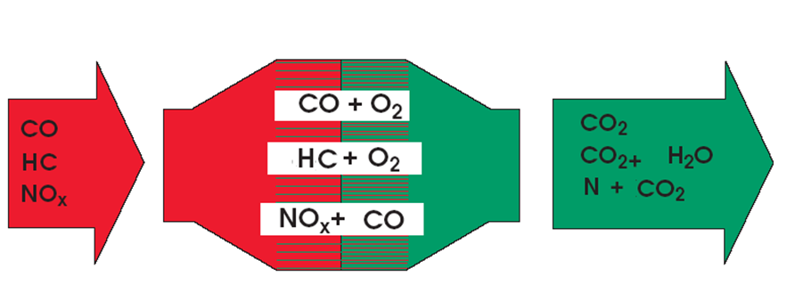
Figure 1; Reactions inside the catalytic converter [http://www.blogmecanicos.com/2015/11/como-comprobar-la-eficiencia-del.html]
Due to the noble metals contained in the catalyst monolith, two chemical reactions occur:
Oxidation: addition of oxygen to the components of the exhaust gases.

CO + O₂ = CO₂

The CO composed of 1 Carbon atom + 1 Oxygen is oxidized, that is, it gains an oxygen atom. Therefore it becomes CO₂.

HC + O₂ = H₂O and CO₂

The HC composed of 1 Hydrogen + 1 carbon atom is oxidized. On the one hand 2 H (H₂) + 1 O are combined, the result is H₂O. On the other hand the C is combined with 2 O and the product is again CO₂.
Reduction: extraction of oxygen from the components of the exhaust gases.

NOx + CO = N and CO₂

The oxygen is extracted from the NOx (1 atom of Nitrogen + x oxygen atoms Ox = NOx) and the nitrogen N is released alone, the excess oxygen is added to the CO and CO₂ is obtained.
In conclusion, neither appears nor disappear atoms, but combine differently generating a compound different from the initial. [https://www.ro-des.com/mecanica/catalizador-que-es-y-como-saber-si-falla/].
Catalytic converters must work correctly. Between 260 and 300 degrees becomes to be effective and between 480 and 870 degrees are fully effective. [A. Gibson, Catalytic Converters Lecture]. They stay still hot when the engine is turned off. Cat are monitored by the lambda sensors located before and after the Cat. Each oxygen sensor send a signal to the ECU measured in voltage, these voltages are interpreted by the ECU as a measured of Oxygen by the sensor. [E. Aguilar]
There are different ways to check the operatively od the Cat:
Diagnosis with gas analyzer
Looking at three magnitudes:

CO: the value must be low, less than 0.2%.
HC: it must also be low, less than 100 ppm.
O₂: as seen if the catalyst works well it uses oxygen and reconverts it. So the value of O₂ at the exit of the catalyst must be very low, less than 0.2%. If there is a noticeable presence of oxygen at the outlet it indicates that the catalyst is not working properly.

Table 1: Reading before and after cat
 | Reading Pre-Cat | Reading Post-Cat
CO | Between 0,4 and 0,8 % | Less de 0,2 %
CO₂ | Higher than de 13, % | Higher than 13,5 %
HC | Less than 250 ppm | Less de 100 ppm
O₂ | Less than de 1,5 % | Less than de 0,2 %
LAMBDA | Between 0.99 and 1.02 | Between 0.99 and 1.01

It is also useful to measure the values before and after the catalyst, if there is a dysfunction, we will see that the values are not corrected.
Inserting the probe before the catalyst to take the reading can be difficult. In these cases we take advantage of the fact that the catalyst does not work until it reaches 300ºC. So we insert the probe to the output, start the engine and for a few minutes we will read the untreated gases. Gradually the temperature increases and the gases are corrected.

Diagnostic by temperature
The chemical reactions generated in the catalyst increase the temperature of the same. So, if the reactions are carried out successfully, the temperature at the outlet of the catalyst is higher than at the inlet. Approximately a temperature difference between 20 and 50ºC. [ Bosch Automotive Hanbook]
Testing the pressure
With a pressure gauge, check the back pressure at idle and should be less than 1.5 PSI and less than 2.5 PSI at 2500 RPM. With a vacuum gauge when the engine is at constant RPM, the manifold vacuum will drop if there is a restriction on the exhaust. [A. Gibson]
Tapping test
Tapping the Cat with a mallet and listen for a rattling of the particles. If its rattling, the cat must be changed. [A. Gibson]

EVAP
EVAP is an evaporation emission control system, the function of the EVAP system is to allow proper ventilation of the fuel system and to prevent evaporations and Hydrocarbons from being discharged to the atmosphere, that is, the vapours must be retained and stored during the engine is turned off, which is when the greatest amount of evaporation occurs, droping the amount of Hydrocarbons and reducing petrol reaction expulsing the gases to the atmosphere. When the engine is started, the vapours must be "unburned" and burned in the cylinders. In most systems, storage occurs in an activated carbon deposit, commonly called Canister.[ http://www.mailxmail.com/curso-emision-gases/sistema-control-evaporaciones-gases-evap]

Components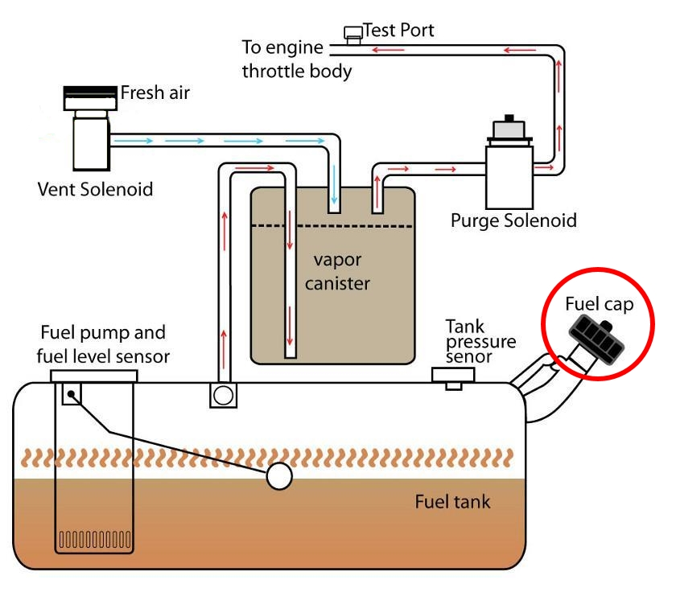

Figure 2: EVAP components [https://www.troublecodes.net/pcodes/p0440/]
Fuel cap: The tank is directly vented are no longer used. All current tank plugs are sealed. Most of them, besides being sealed, are equipped with a pressure and vacuum relief valve. These valves prevent damage to the tank in case the tank's ventilation system fails. [A. Gibson & A. Summerfield]
Fuel tank: Prior to 1970, vehicles released excess fuel vapours through the filler cap and vent tube in the fuel tank. The vent pipe allowed air to enter as the fuel was consumed, which compensated for the internal vapour pressure at high temperatures. With the sealed filler cap, all venting of the tank is done through the vent pipe and to avoid excessive pressures, the tanks have been redesigned. The two methods of redesign are:
1) Install an additional thermal expansion tank, inside the tank.
2) Change in tank shape, which allows only 10-12% of air space with full tank.
Vapour Canister: A charcoal tank is added to the petrol system to hold the gases due to the petrol reactions with the air. A vent line is connected the tank to the canister. Is controlled via vacuum by a solenoid controlled by the ECU o the vehicle. [A. Gibson]
Vent valve: Developed since 1996, the introduction of the OBD2 diagnosis system provide to the vehicle to detect a purge or a leakage of the system. The vent valve is normally open allowing the air to enter to the tank. [A. Gibson]
Purge valve: Is normally closed and during the purging allows the engine vacuum to suck the vapours. [A. Gibson]

EGR
Also called Exhaust Gas Recirculation, used in some cars since the 70s, especially in the United States, where anti-pollution standards were more severe. In Europe it is mandatory to equip it from the entry into force of Euro 2 in 1996.
The function of the EGR valve is to recirculate part of the gases that exit through the exhaust to the intake. Reintroduce the combustion smoke of the engine into the cylinders in order to reduce the emissions of nitrogen oxides (NOx). The EGR valve connects the exhaust manifolds with the intake manifolds and its opening depends on various parameters that will explained in the following paragraphs The key to the reduction of nitrogen oxides is the reduction of the temperature in the combustion chamber by recirculating the exhaust gases towards it. NO_{x} formation increases dramatically for combustion temperatures over 1370 degrees [A Gibson] [M.P Walsh, Vehicle pollution control in Europe]
In the most modern engines, the operation of the EGR is governed by the signal from the temperature sensors of the engine, engine speed and acceleration load. Depending on these the car's ECU will command the EGR, opening it or closing it. As a general rule, EGRs are open (putting burnt gases into the engine) when the engine hot, at low load and at low engine speeds.
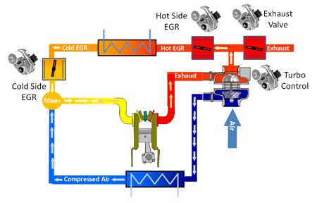
Figure 3; How a EGR works [http://roosystems.com.au/egrs/]
If the parameters for the opening of the EGR are met, it will see that it is activated in two ways, according to its nature. It can be by a vacuum actuator or by an electric actuator. The second ones are the most effective and those that now equip almost all vehicles, since they allow to better controlling the degree of opening of the valve. Some vehicles equipped EGR valves cooled by a heat exchanger that uses engine coolant. In this way, the temperature of the gases is reduced when they are introduced into the cylinders and the production of NOx emissions is even lower.
When the EGR valve is open in the combustion chamber, the recirculate gases are mixed with the fresh gases from the intake. In this case the seconds are smaller than if the valve were closed and therefore in the explosions less heat is generated, hence the reduction of NOx emissions. As it is not difficult to intuit, the operation of the EGR valve reduces the power to the engine. The colder the air entering the engine and the more oxygen it has, the more power the explosions will have and therefore, the better the vehicle's performance will be. For that reason, when the engine demands a lot of acceleration, the EGR remains closed, to have all the benefits of the engine. [A. Gibson].

SAIR
In a SI most harmful substances (HN and CO) are produced during the cold start process. The insufflation of secondary air is an accredited method for the reduction of these emissions of cold start. For the cold start of an engine, a "grease mixture" (λ <1) is necessary, that is, a mixture with excess fuel. Until the catalyst has reached its operating temperature and the lambda regulation is applied, large amounts of carbon monoxide and unburned hydrocarbons are thus produced. For the reduction of these harmful substances during the cold start phase, oxygen-rich ambient air ("secondary air") is blown directly behind the exhaust valves in the exhaust manifold. This is why oxidation occurs Subsequent ("subsequent combustion") of the harmful substances in carbon dioxide and water. When the SAI is open when the engine is cold, the air is supplied to the exhaust manifold to contribute to oxide the HN and the CO, however, when the engine is running hot, the solenoid close the valve and the air is recirculating to the catalytic converter. [A. Gibson] [ Anonymous, Volatile organic compound emissions in Western Europe, Control Options for gasoline]
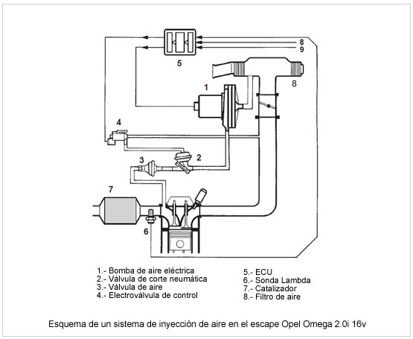
Figure 4: Air Injection secondary system schem [https://www.taringa.net/posts/autos-motos/16136338/Gases-de-Escape-y-Sistemas-Anticontaminacion-2da-Parte.html]

PCV
Positive Crankcase Ventilation valves are designed to reduce the CO and HC emissions of the vehicle. [A. Gibson]. PCV valve is responsible for extracting the gases from the crankcase; these gases are caused by small air leaks in the piston rings. When these are made, they produce small air leaks towards the lower part of the engine (CÁRTER). If this air does not go outside, the oil leaks through the joints and even in some cases the pressurized air will take out the oil rod, expelling the gases and oil outwards. [T.C Austin, A comparation of emissions controls with on board and stage II systems].
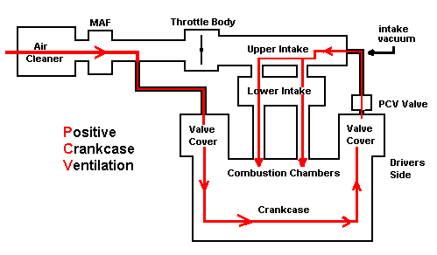
Figure 5; PCV system [https://motores.com.py/foro/index.php?threads/varilla-de-medidor-de-aceite-salta-sospechoso-valvula-de-respiradero-pcv.58118/]
When the PCV is blocked and remains always it can know why at idle there is a suction of the engine on the crankcase, and sometimes, the RPM of the idle is altered because there is suction putting the hand where the oil plug. That's also why an extra suction on the crankcase, because of the PCV always open generates high oil consumption via intake manifold. The opposite fault, the ventilation of the crankcase is always interrupted by PCV is always closed, leads to the accumulation of gases (coming from the cylinders) inside the crankcase and this overpressure causes oil leaks making pressure to the oil seals. The PCV could be blocked by accumulation of oil, making cream due to oil mixed with the acids of combustion becomes mayonnaise and this mass that is no longer liquid clogs inside the PCV and blocks it, in addition to that, the spring loses it calibration factory allowing opening and closing the valve. [L. B. Lave, Controlling emissions from motor vehicles]

The importance of the Air/Fuel Ratio
As variations in the air-fuel ratio affect the power output and fuel consumption, they also affect exhaust emissions. It also affects the temperature of combustion which turn affects the formation of pollutants. A mixture too rich (air low), and therefore fuel will not be completely burned, that unburned fuel will enter the atmosphere as CO and HC. A very poor mixture (too much air) increases the temperature of the combustion and therefore the NOx. Adjusting the air-fuel ratio to make sure that the combustion in the chamber is complete and also and minimize the production of HC and CO has the unwanted side-effect of increasing NOx. Similarly, enriching the mixture to minimize the temperature of combustion and NOx formation brings unacceptable increases in HC and CO. So, the manipulation of the air-fuel ratio is not enough to adequately control the three most harmful pollutants, especially when faced with regulations for the control of increasingly harsh emissions. The control of the air-fuel ratio to optimize emissions is a first step, which must be followed by the treatment of the gases after they leave the engine. [http://www.fullmecanica.com/definiciones/r/956-relacion-aire-combustible-y-contaminantes]
Finally, the quality of the mixture formed in the combustion chamber is also very important to control the emissions. If the fuel mixture is homogenous and the temperature of the ignition is optimum, the consequent effects of the emissions will be affecting raising the CO components as the product of a better combustion. [Automotive Handbook]

Euro 6
The development of the automotive industry has grown by leaps and bounds over the last 150 years. From Karl Benz and Henry Ford machines to autonomous driving, cars have gained speed, power and performance over the decades. However, behind this progress that many judge unstoppable, lies the degradation of the environment and the concern of companies and governments to mitigate the consequences of the motor industry in the atmosphere. [Chevallier, J.Econometric analysis of carbon markets]
The first major change in this field came from the side of electronic injection, replacing carburetion. Through the latter, the cars did not take full advantage of the fuel, and its efficiency was very poor. A car of 800 Kg and 50 CV consumed around 10 l / 100km, with the aggravating circumstance that the price of naphtha was fluctuating and the vehicle fleet grew exponentially. The arrival of the electronic injection immediately served to intelligently dose consumption, laying the foundations for future measures in favor of the environment. [Bosch Automotive Handbook]
In 1988, however, would arrive one of the most famous and efficient regulations in this battle against pollution. We are talking about the EURO standard, which in its first edition urged all European manufacturers to reduce emissions. For this, the ideal ally was a catalyst in the intermediate section of the exhaust pipe that reduced and oxidized (REDOX) the exhaust gases. First, nitrogen dioxide was converted to molecular nitrogen (reduction), and in the second part the unburned hydrocarbons and carbon monoxide were converted to CO2 and water (oxidation). [https://www.quadis.es/articulos/aspectos-basicos-de-la-normativa-de-emisiones-euro-6/131709]
The Euro 6 regulation concerning the emissions of motor vehicles entered into force in Europe on September 1, 2014 for new engine approvals, and on September 1, 2015 all new registrations (sales) will have to comply with Euro 6 regulations. The Euro 6 regulation marks a drastic reduction of polluting gases, especially nitrous oxides or NOx. The previous Euro 5 regulation contemplated emissions of 180 mg / km of NOx, while Euro 6 reduces it to 80 mg / km. In addition, it includes an average emission quota for the entire range offered by a manufacturer, set at 130mg / km. The combined emissions of hydrocarbons and nitrogen oxides must be reduced to 170 mg / km, compared to 230 mg / km of the regulations still in force. [https://www.rac.co.uk/drive/advice/emissions/euro-emissions-standards/]. The Euro 6 regulation requires manufacturers to apply multiple cooled EGR particle filters with greater recirculation in diesel engines, and higher pressures in the fuel pump and turbo blower. Gasoline vehicles must incorporate air baffles in the basses and piloted water and oil pumps to control the force that the motor exerts on them (more force more consumption). Manufacturers must ensure the live of these anti-pollution systems of at least 160,000 kilometres. In addition, systems should be checked every 100,000 kilometres or five years. In order to reduce these levels of NOx emissions, manufacturers have two options: a NOx storage catalyst or an SCR catalyst with an AdBlue additive tank. AdBlue is a water-based liquid and urea that causes the transformation of NOx to water vapor and hydrogen at the exit of vehicles. Most manufacturers already offer Euro 6 diesel engines equipped with diesel particulate filter (DPF), which traps and burns solid particles. [http://www.autoexpress.co.uk/car-news/consumer-news/90816/euro-6-emissions-standards-what-do-they-mean-for-you]

Analysis

4.1 PIN 21 Ford
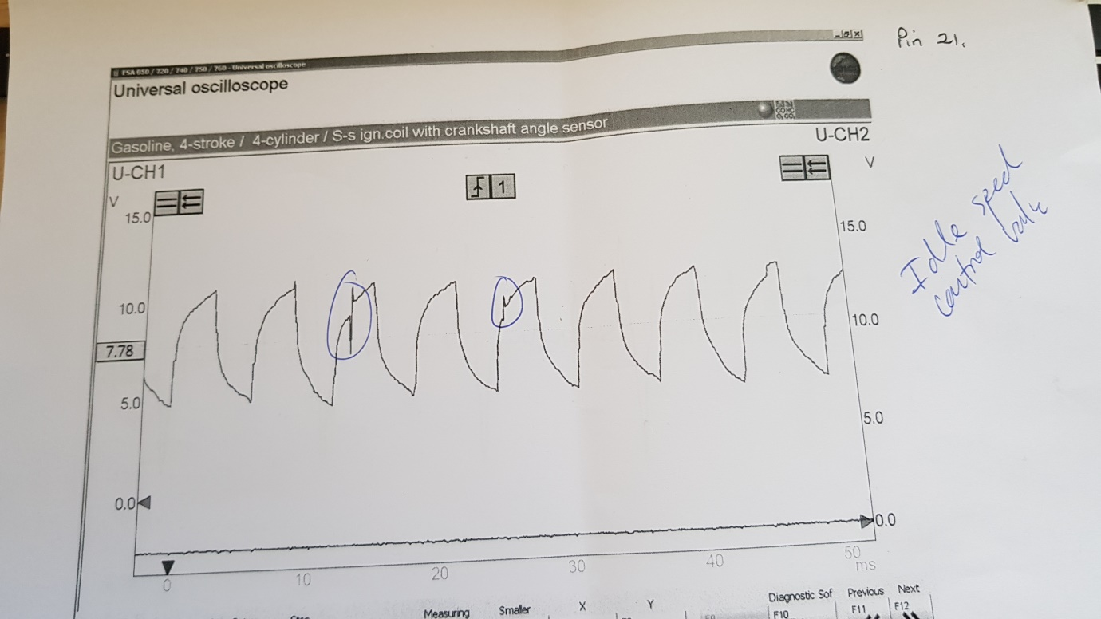
The image shows the idle control valve on a Ford EECV1 ECU, is connected to the PIN number 21 of the ECU and is supplied by 12V, the reading of the waveforms it’s between 12 and 6V. If the lights or any electronically devices are working, the amplitude of the waveform it would be bigger. Also it can see in the waveform a diphase in the 3rd and 5th form. Its due to a non-established idle and could be made by a emissions sensor or EGR fault.

4.2 PIN 24 Ford
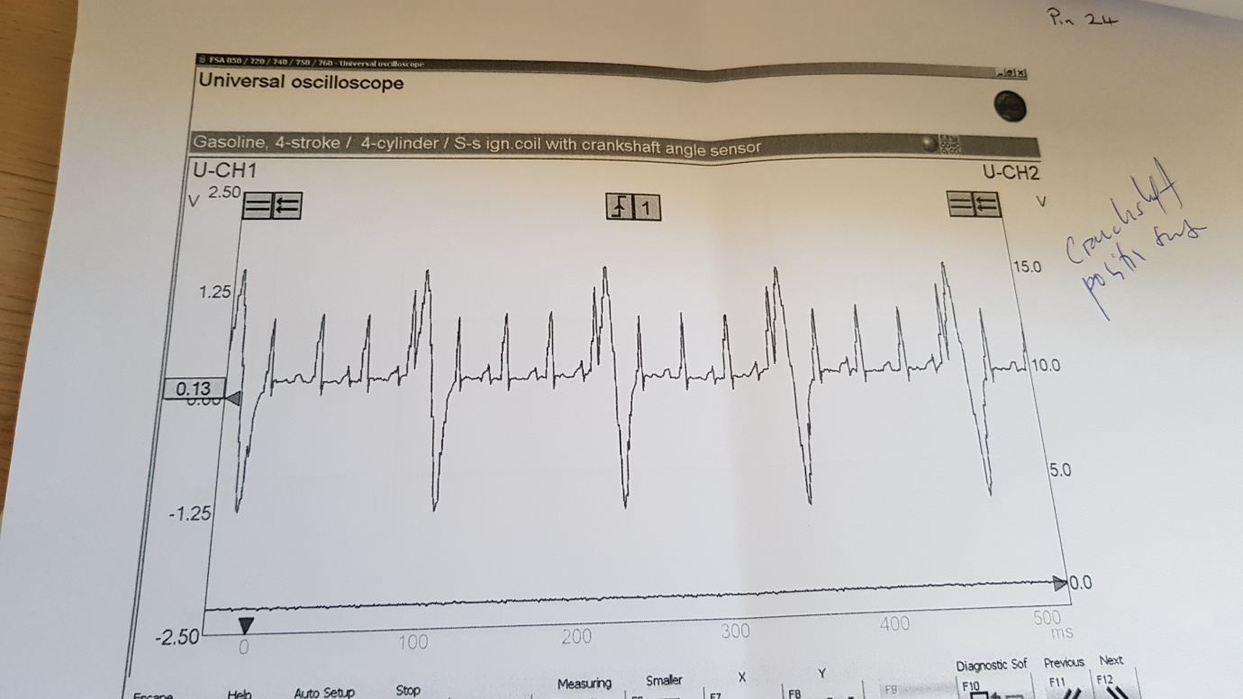
This waveform shows the position of the crankshaft sensor,

Conclusion
Throughout the assignment it has been possible to buy the different types of gases that expel an internal combustion engine, as well as the importance and relevance of these gases towards the environment. To do this and to avoid all the possible reduction of emission of gases into the atmosphere over the years, the anti-polluting systems of the vehicles have been improved, thus implementing new emissions reduction systems in the exhaust system and improving the efficiency of the engines creating new compressions, mixing with the gasoline mixture, and perfecting each part of the engine to reduce the amount of particles and gases emitted to the environment.
Each system has been analysed separately explaining the operation of each and the best way to diagnostique either by OBD2 port or physically the correct functioning of these systems. The components of these systems have also been shown and how an error in the system can alter the number of emissions and the environmental impact caused.
In turn, a series of sensors whose readings have been able to demote and explain the functioning of these sensors through the readings of the vehicle's ECU have been analysed through the oscilloscope. These readings are quite useful when diagnosing a vehicle since each sensor is communicated with the ECU of the car and this in turn with each module in charge of anti-pollution systems. Knowing how to read these oscilloscopic curves we can know more closely what is happening to the vehicle or if there is a system that is operating incorrectly.
Lastly, the restrictive emission laws of the European Union have been reviewed, as well as the latest law in force in 2014 and 2015. This law has created radical changes in vehicles, giving way to the creation of new anti-pollution systems and forcing the automotive industry to their engineers every time invest more time in the department of emissions.

6 Bibliography
References were added on each paragraphs, but also has been used the following references:
Catalyst emissions. (1996). Maidenhead: Autodata.
Chevallier, J. (2012). Econometric analysis of carbon markets. Dordrecht: Springer.
Davis, D. and Onishi, G. (1962). Catalytic converter development problems. New York, N.Y.: Society of Automotive Engineers.
European environment outlook. (2005). Copenhagen: European Environment Agency.
John, J. (1974). Consultant report to the Committee on Motor Vehicle Emissions, Commission on Sociotechnical Systems, National Research Council on emissions control of engine systems. Washington: U.S. Environmental Protection Agency, Office of Air and Waste Management, Office of Mobile Source Air Pollution Control.
Robert Bosch Gmbh. (2013). Automotive handbook. [Place of publication not identified]: John Wiley & Sons
Stubblefield, M. and Haynes, J. (2005). The Haynes emissions control manual. Sparkford Nr Yeovil, Somerset, England: Haynes Publishing Group.
Thornton, M. (2004). Fuel sulfur effects on a medium-duty diesel pick-up with a NOx adsorber, diesel particle filter emissions control system. [Golden, Colo.]: [National Renewable Energy Laboratory].

