


Network & Data Centre Management

Tutorial 4

Faculty of Architecture, Computing & Engineering
School of Applied Computing
I.Q Building, Room 205
Swansea
SA1 8EW

- INTRODUCTION AND OBJECTIVES OF THE Exercises
In the lecture, you learnt about Managing Site-to-Site Connectivity, which is an essential factor in successfully operating a network. Apply your understanding and knowledge from what you learnt in the lecture about the topic and the previous lectures to do the following tasks:

Use your lecture notes and/or the Internet to answer the questions.

- What are the Benefits of VPNs

- Name and discuss the types of VPN

- Discuss two types of tunneling include their function and characteristics.

- What is the purpose of these commands issued on R1?

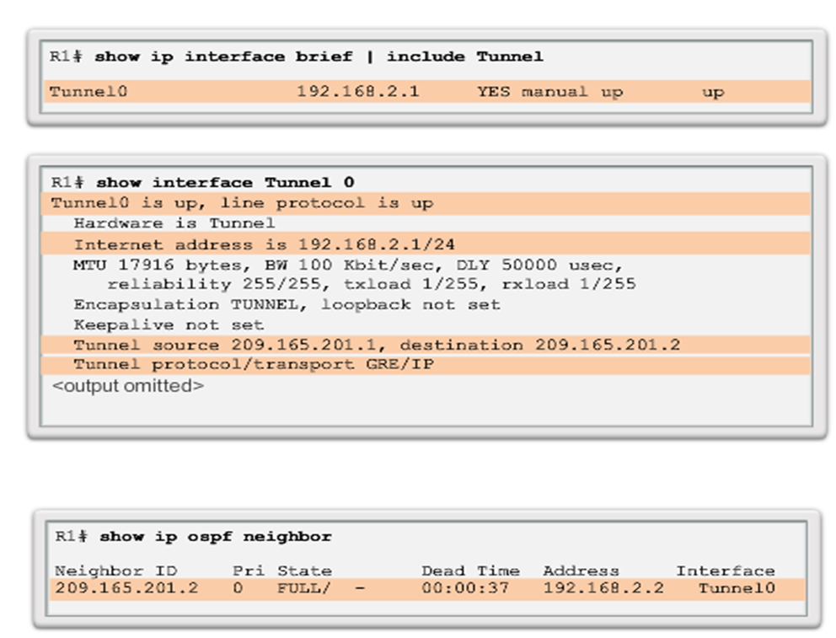

- Explain the following encryption algorithms:
  - Symmetric Encryption
  - Asymmetric Encryption

- Describe the process of Diffie-Hellman (DH) key exchange.

- What are the two common HMAC algorithms?

- What is the differene between Pre-shared Key (PSK) and Rivest, Shamir and Adleman (RSA) signatures?

- With the aid of a diagram explain the four basic building block of the IPsec framework?

- What does the figure below illustrating?

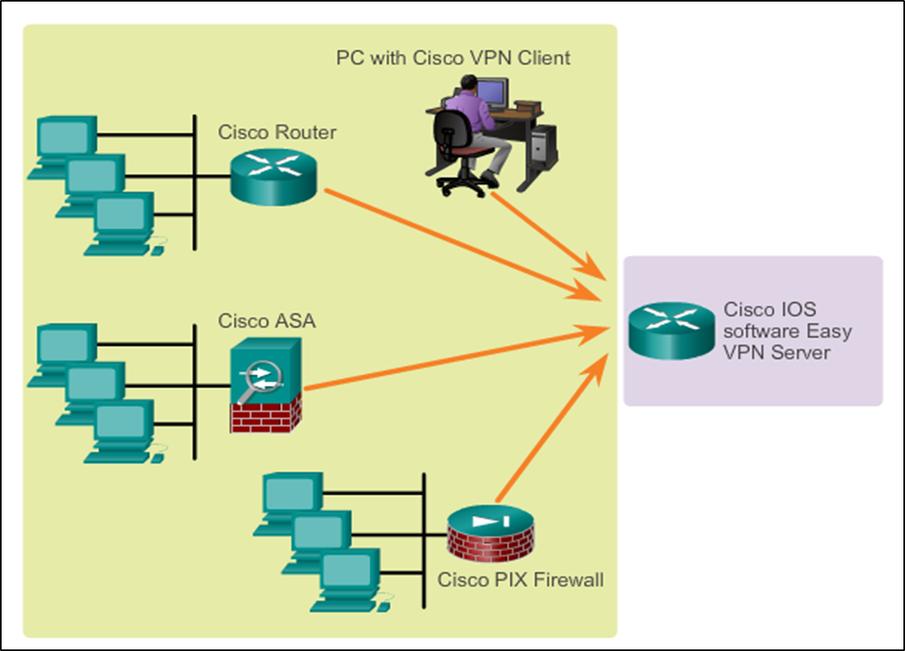

- Using a table format compare IPsec and SSL

- In reference to the below Figure on Integrity with Hash Algorithms,
  - Describe hash-based message authentication code (HMAC) process in order for the message to correctly receive. HMAC is a mechanism for message authentication using hash functions.

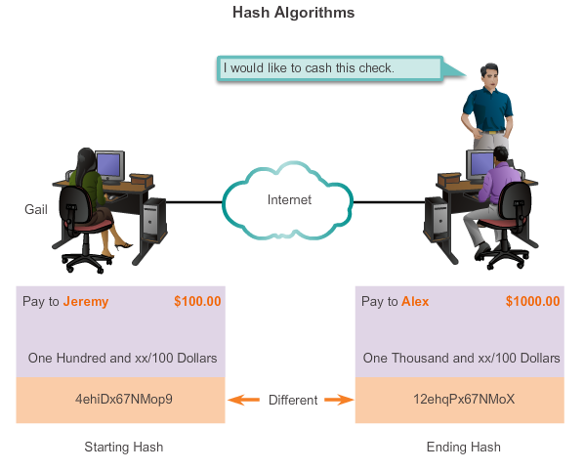

  - Name and explain the two main HMAC algorithms

  - Complete the table below in comparing IPsec and SSL



