University of Wales Trinity Saint David

Group Project Portfolio
ACDA 5022: Work Based Group Project

Name - Luke Brown (ID-2309075)
Course – Ordnance, Munitions and Explosives (OME)
Lecturer – Dave Holley
Submission Deadline – 4th May 2026

Table of Contents:

Section 1 – Introduction

  - Purpose of the reflection ……………………………………………………………………………… (Page 1)
  - Project context and scope ……………………………………………………………………………. (Page 1)
  - Approach to reflective analysis …………………………………………………………………….. (Page 1)

Section 2 – Research and contextual understanding

  - Role of systems engineering in complex design ……………………………………………. (Page 1)
  - Relevance to test and evaluation practices …………………………………………………… (Page 2)
  - Integration of theory into project work ………………………………………………………… (Page 2)

Section 3 – Understanding of role within the team

  - Responsibilities of the test and evaluation function ……………………………………… (Page 2)
  - Contribution to design, verification and validation ………………………………………. (Page 3)
  - Integration with other engineering disciplines ……………………………………………… (Page 3)

Section 4 – Team communication and collaboration

  - Communication methods and tools used …………………………………………………….. (Page 3)
  - Effectiveness of team coordination and information sharing ………………………… (Page 4)
  - Reflection on group decision-making and collaboration ………………………………. (Page 4)

Section 5 – Reflection of requirements and design decisions

  - Role of requirements in guiding decisions ……………………………………………….. (Pages 4-5)
  - Trade-off decisions and justifications ……………………………………………………………. (Page 5)
  - Risk and safety considerations in design ………………………………………………….. (Pages 6-7)

Section 6 – Analysis of contribution to team outputs

  - Development of a test and evaluation strategy ……………………………………….. (Pages 7-8)
  - Contribution to system validation and performance metrics ………………………… (Page 9)
  - Influence on design decisions and outcomes …………………………………………. (Pages 9-10)
  - Evaluation of effectiveness of outputs ……………………………………………………….. (Page 10)

Section 7 – Practical application and deployment

  - Reflection on the final design solution ………………………………………………… (Pages 10-11)
  - Consideration of real-world implementation ……………………………………………… (Page 11)
  - Reflection on presentation and communication of results …………………………. (Page 11)

Section 8 – Conclusions and recommendations

  - Key findings from the project …………………………………………………………………….. (Page 12)
  - Identified limitations in approach ………………………………………………………………. (Page 12)
  - Recommendations for future improvement ……………………………………………….. (Page 12)

Section 9 – Development of professional skills

  - Reflection on personal learning and development ……………………………………… (Page 13)
  - Development of systems thinking ………………………………………………………………. (Page 13)
  - Improvement in communication and teamworking skills ……………………………. (Page 13)

Section 10 – References

  - All referenced citations ……………………………………………………………………….. (Pages 14-15)

List of Figures and Tables:

Figures:

Figure 1 – T&E bowtie diagram ……………………………………………………………………………….. (Page 7)
Figure 2 – Testing phases presentation slide …………………………………………………………… (Page 7)
Figure 3 – Environmental conditions presentation slide ………………………………………….. (Page 8)
Figure 4 – Vibration testing presentation slide ………………………………………………………… (Page 8)
Figure 5 – Decision criteria presentation slide …………………………………………………………. (Page 9)
Figure 6 – Design feedback presentation slide ………………………………………………………. (Page 10)

Tables:

Table 1 – Generic requirements set …………………………………………………………………………. (Page 4)
Table 2 – T&E requirements set ………………………………………………………………………………. (Page 5)
Table 3 – Generic system Pugh matrix …………………………………………………………………….. (Page 5)
Table 4 – Generic system FMEA ………………………………………………………………………………. (Page 6)
Table 5 – T&E hazard identification …………………………………………………………………………. (Page 6)

Section 1 - Introduction:

1.1- Purpose of the reflection:

This report primarily analyses team collaboration in applying systems engineering to develop a solution to an OME problem. From a test and evaluation (T&E) perspective, it reflects on promoting testing considerations, influencing concept development and shaping engineering outputs, alongside evaluating communication and the integration and delivery of the final presentation. It also identifies key learning outcomes and their relevance to future engineering practice.

1.2- Project context and scope:

The project involved developing a systems engineering solution to a humanitarian mine clearance problem under operational constraints. This report focuses on the design process rather than detailed technical outcomes, with emphasis on team collaboration, decision-making and the contribution of T&E in moulding and validating the proposed solution.

1.3- Approach to reflective analysis:

This reflection adopts a critical evaluation of the project, assessing both effective and ineffective aspects of the approach. It focuses on how each role interacted within the team, how communication was managed and how decisions were reached, demonstrating the importance of effective teamwork and communication in contributing to overall project success.

Section 2 - Research and contextual understanding:

2.1- Role of systems engineering in complex design:

Systems engineering played a key role in ensuring the design was structured, coherent and fully considered, particularly in managing complexity and maintaining alignment across requirements, functions and outcomes. It supported a clear and traceable development process, improving confidence in the final solution. While it could be time consuming and occasionally felt overly procedural, these drawbacks were minor compared to its overall value. The structured approach it provided was essential in ensuring that all aspects of the system were addressed effectively and consistently, as supported in the literature [1], [2].

2.2- Relevance to test and evaluation practices:

T&E played an important role in verifying the system was designed with performance, safety and reliability in mind, encouraging the use of measurable requirements and clear validation criteria. It helped identify potential issues early and provided confidence in the proposed solution. However, incorporating T&E as a core function could be time intensive and sometimes constrained design flexibility due to strict criteria. Despite this, its inclusion was highly beneficial, as it ensured decisions were grounded in verifiable performance and aligned with real engineering practice, as further emphasised in [3].

2.3- Integration of theory into project work:

The project demonstrated that systems engineering tools were not only understood in theory but actively applied to support decision-making. Methods such as QFD, FMEA and Pugh matrices were used to structure analysis, prioritise requirements and justify concept selection. This helped provide a logical and traceable basis for design choices. However, the effectiveness of these tools was sometimes limited by assumptions and subjective inputs, particularly when real data was unavailable. While they improved organisation and clarity, it became clear that their value depends on how critically their outputs are interpreted rather than applied directly, as cited in [4].

Section 3 - Understanding of role within the team:

3.1- Responsibilities of the test and evaluation function:

The T&E function was responsible for ensuring system integrity across multiple areas, consistent with established defence lifecycle management practices [5], including:

- Assuring safety, reliability and survivability throughout the system lifecycle.
- Measuring performance against defined requirements and acceptance criteria.
- Reducing technical and operational risk through structured testing.
- Validating system requirements and design compliance.
- Supporting optimisation of future capabilities.
- Enabling continuous improvement through structured feedback from test results.

3.2- Contribution to design, verification and validation:

The T&E role contributed by embedding testing considerations within requirements, design and verification activities. Survivability and safety were incorporated through measurable requirements, including environmental parameters and prequalification trials. T&E specific metrics were developed and prioritised through pairwise comparison and QFD, promoting functions such as environmental survivability and range testing. During concept selection, solutions with proven testability and robustness were supported. A structured four-phase verification strategy, progressing from component to field testing, was established to ensure the system met performance and safety requirements.

3.3- Integration with other engineering disciplines:

The T&E function interacted closely with R&D, safety, manufacturing and disposal, ensuring testing considerations were embedded throughout. Within R&D, emphasis was placed on designs with established testing methods and proven reliability. For safety, inputs to FMEA and P diagrams focused on realistic, testable failure modes, while also supporting risk assessment through identification of hazards and their potential impact. In manufacturing, attention was given to quality and compliance with qualification requirements, while disposal decisions were supported by T&E data. Integration was largely effective, though challenges arose when differing priorities led to conflicting viewpoints requiring resolution.

Section 4 - Team communication and collaboration:

4.1- Communication methods and tools used:

Communication was facilitated through group chats, shared documents and meetings. When working remotely, meetings were relatively infrequent, with group chats used more for coordination and updates. When together, meetings became the primary method, although group chats were still used consistently. Discussions were initially informal, becoming more structured as work progressed and tasks were defined.

4.2- Effectiveness of team coordination and information sharing:

Team coordination was generally effective, despite roles such as leadership and task management not being formally assigned. Responsibility developed naturally, with the T&E individual informally taking on aspects of coordination and task organisation. There was some back and forth when defining functions, which occasionally slowed progress but encouraged discussion. Minor communication issues arose when meetings were missed, though these were mitigated through group chats. Overall, efficiency and output quality remained strong, with limited impact on the final outcome.

4.3- Reflection on group decision-making and collaboration:

Decisions were generally made collaboratively, combining data driven approaches with group discussion, although task specific decisions were handled individually. As the project progressed, smaller groups were formed to improve efficiency, with final reviews ensuring alignment. Overall, this approach was effective, though greater consistency in attendance and more regular structured check-ins would have further strengthened coordination.

Section 5 - Reflection of requirements and design decisions:

5.1- Role of requirements in guiding decisions:

Requirements formed the foundation of the design, guiding all key decisions. Table 1 presents the generic requirements and Table 2 the T&E specific set, both prioritised using must, should and could classifications. Measurable criteria were primarily defined within the T&E requirements, supporting evaluation. However, assumptions regarding cost, time and reusability introduced uncertainty and prompted debate over requirement accuracy and influence.

Table 1 - Generic requirements set
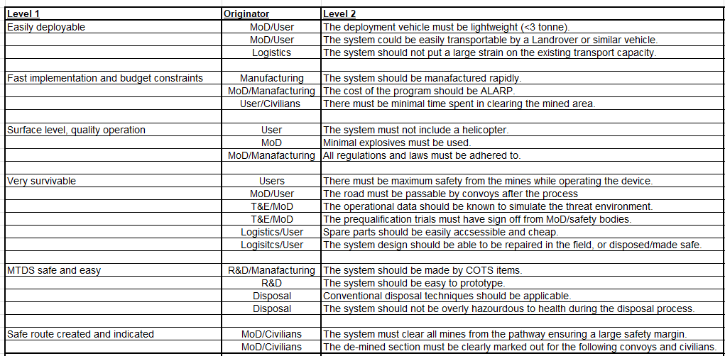
Table 2 - T&E requirements set
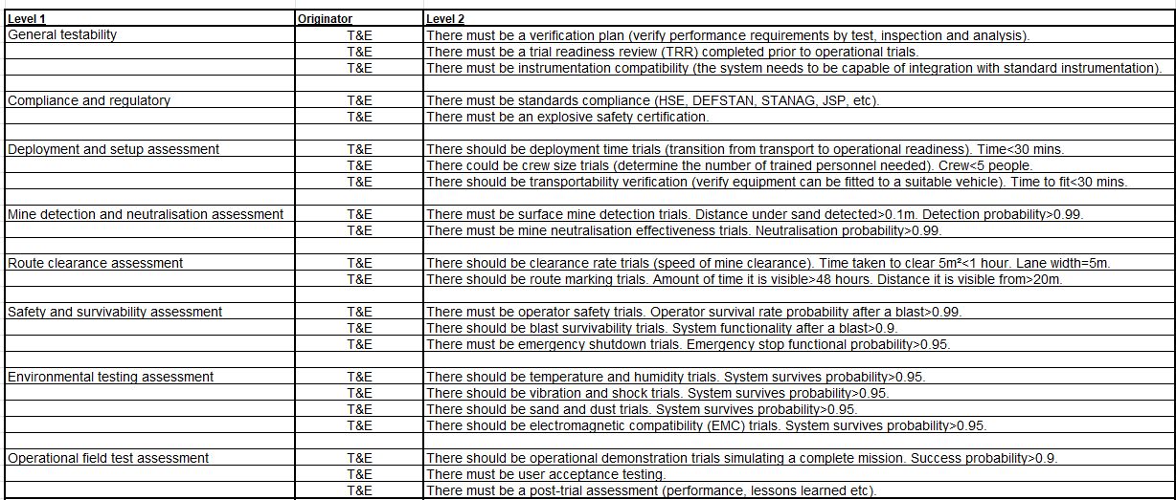

5.2- Trade-off decisions and justifications:

Trade-off decisions, such as selecting drones over alternative concepts, were supported using the Pugh matrix (Table 3). From a T&E perspective, drones offered improved safety and survivability by removing operators and equipment from hazardous areas. Decisions balanced performance, cost and safety, with T&E favouring solutions that were testable and reliable. While the drone concept was ultimately selected, the tools used served to guide and support the decision rather than determine it outright.

Table 3 - Generic system Pugh matrix
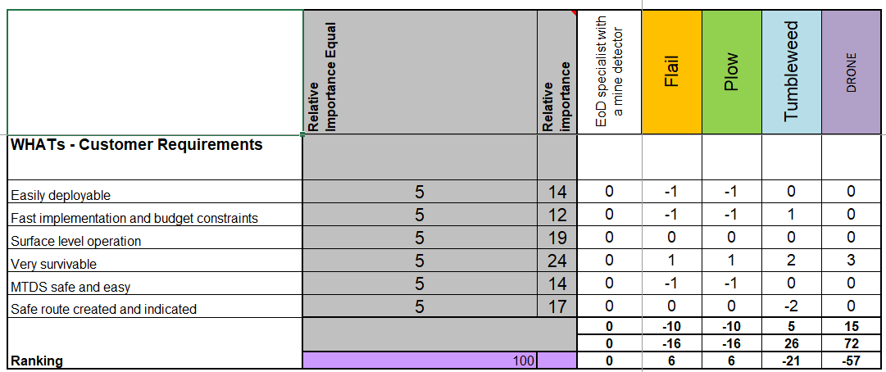

5.3- Risk and safety considerations in design:

Risk and safety were central to the design, supported by tools such as the generic FMEA (Table 4), T&E hazard identification (Table 5) and the bowtie diagram (Figure 1). These approaches informed both design decisions and testing priorities, reflecting the importance of structured risk assessment within safety critical engineering.

Table 4 - Generic system FMEA
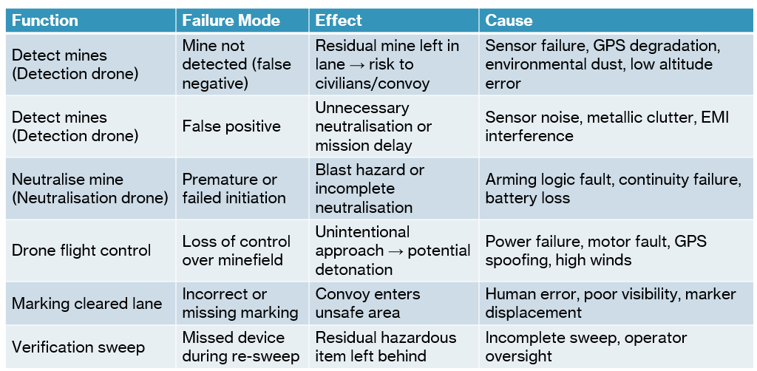

Table 5 - T&E hazard identification
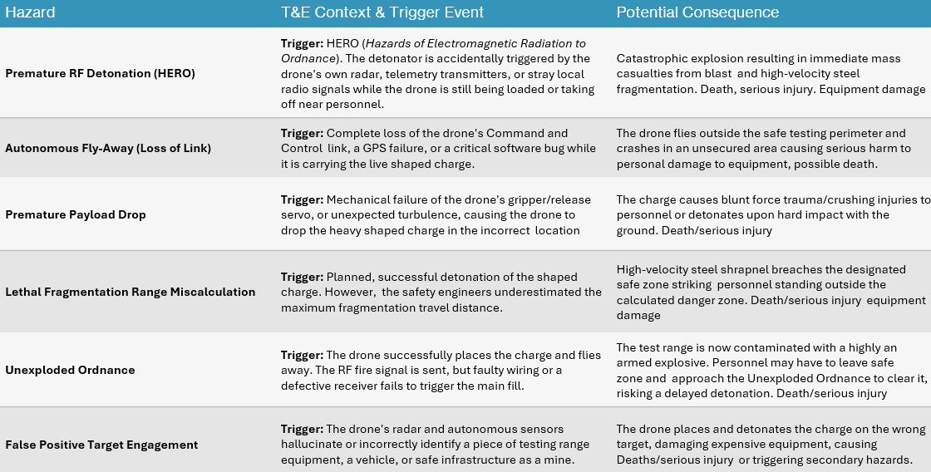

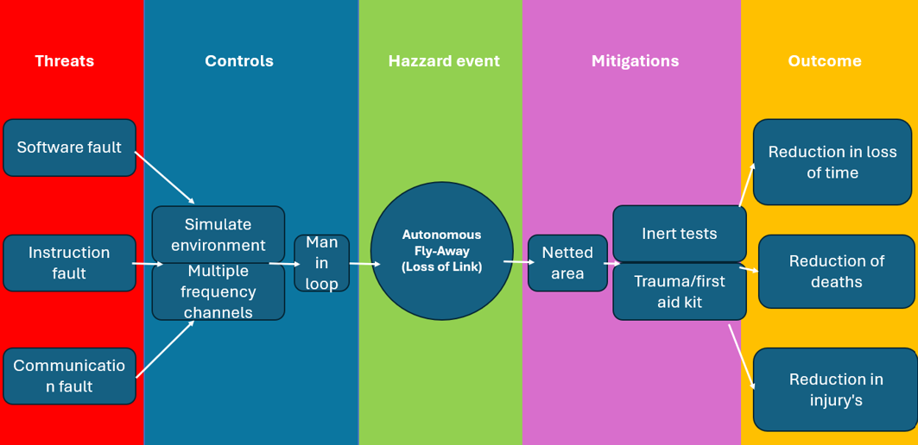
Figure 1 - T&E bowtie diagram

Section 6 - Analysis of contribution to team outputs:

6.1- Development of a test and evaluation strategy:

The T&E strategy was developed around a structured, phased approach, as shown in Figure 2, progressing from component level testing through subsystem and integration to controlled system and field validation. This staged progression allowed increasing system complexity to be assessed in a controlled manner, reducing the likelihood of late-stage failures.

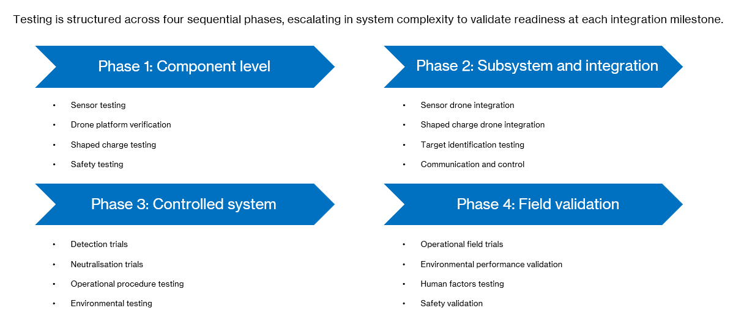
Figure 2 - Testing phases presentation slide

As the strategy developed, there was a shift from a broad testing perspective to a more focused consideration of environmental conditions, as illustrated in Figure 3. Lifecycle phases such as transport, storage, deployment and operation highlighted the range of environmental stresses the system would encounter.

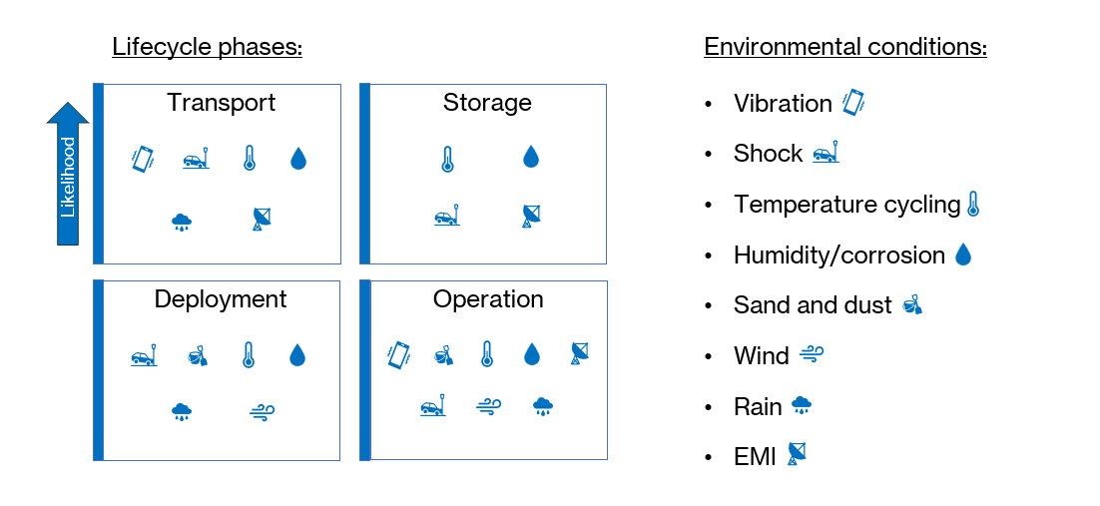
Figure 3 - Environmental conditions presentation slide

This led to a more detailed focus on specific test conditions, with vibration testing, as seen in Figure 4, identified as particularly critical due to its impact on structural integrity and system reliability [6]. This progression reflects how the T&E approach evolved from high-level planning to targeted testing. By refining focus in this way, the strategy ensured that key risks were addressed in greater detail, improving confidence in system performance while maintaining a structured and traceable testing framework.

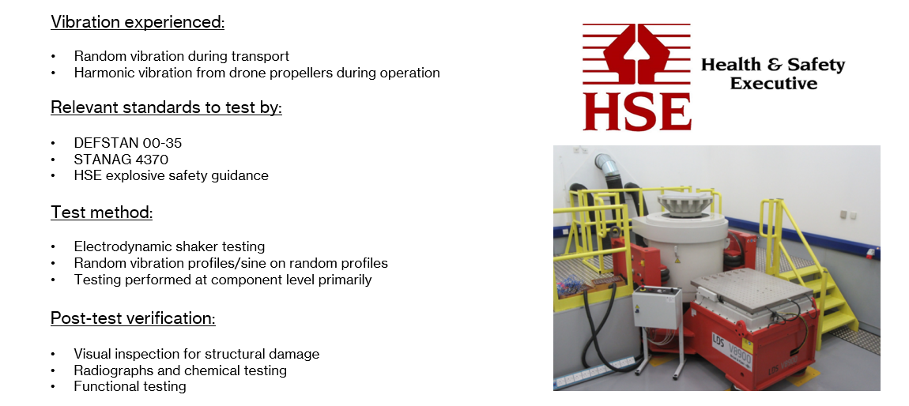
Figure 4 - Vibration testing presentation slide
6.2- Contribution to system validation and performance metrics:

The T&E function contributed to system validation by defining clear, measurable performance metrics, including detection rate, reliability, deployment time and survivability, as outlined in Figure 5. Establishing pass/fail criteria ensured that system performance could be objectively assessed against predefined thresholds. This approach enabled key aspects such as structural integrity, functional performance and safety compliance to be quantified. By making performance measurable, the T&E input strengthened design credibility, ensuring that the proposed solution was not only conceptually viable but also demonstrably capable of meeting operational and safety requirements in line with established testing standards [7].

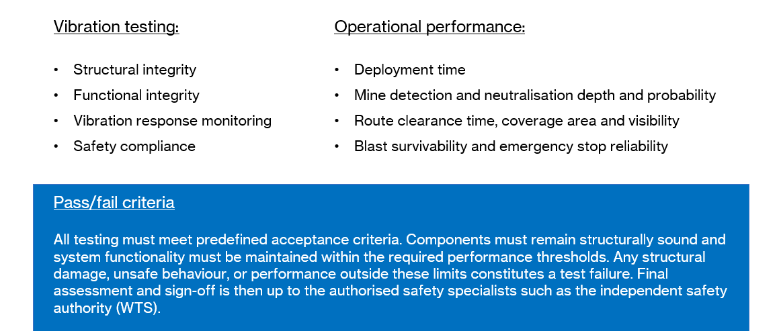
Figure 5 - Decision criteria presentation slide

6.3- Influence on design decisions and outcomes:

The T&E function was intended to influence design decisions by identifying performance gaps and informing targeted improvements, as illustrated in Figure 6. Feedback from testing would highlight areas such as sensor effectiveness, safety features and system reliability, leading to design refinements. Through processes such as anomaly detection and iterative validation, T&E would ensure issues are addressed rather than overlooked. This demonstrates that T&E was not a passive activity, but a driving factor in shaping the final solution, ensuring that design choices were supported by evidence and aligned with performance and safety requirements.

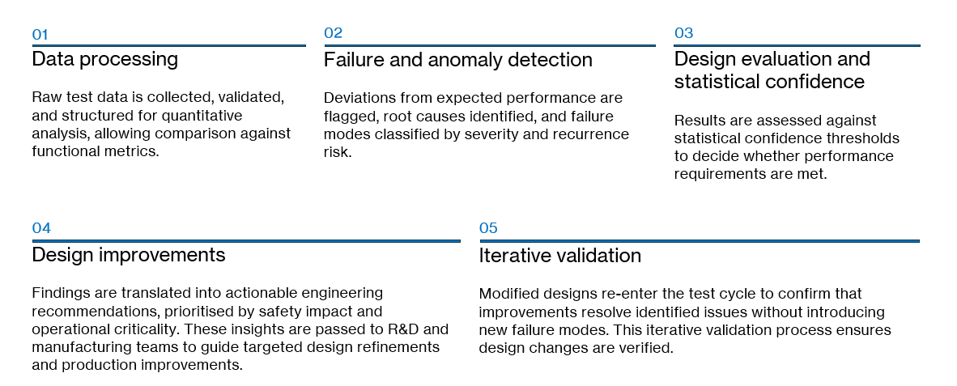
Figure 6 - Design feedback presentation slide

6.4- Evaluation of effectiveness of outputs:

The T&E contributions were effective in ensuring the system was operationally capable, safe and survivable, while also addressing human factors and reducing the likelihood of oversight. This improved overall system quality, particularly in terms of reliability and survivability. However, limitations existed due to reliance on assumptions and potential differences between controlled trial conditions and real operations. Additionally, the time and cost associated with comprehensive testing may reduce practicality in rapid deployment scenarios, highlighting a balance between thorough validation and operational urgency.

Section 7 - Practical application and deployment:

7.1- Reflection on the final design solution:

The proposed solution uses a pickup mounted system deploying drones equipped with sensors to detect subsurface mines and relay their locations. Smaller drones then place shaped charges with trailing firing lines onto identified targets for controlled neutralisation, followed by route marking using GPS and biodegradable spray foam.

This approach offers several advantages. It significantly improves operator safety by removing personnel from the minefield and reducing exposure to threats such as mines and potential hostile fire. The use of targeted shaped charges limits the quantity of explosives required, reducing collateral damage and preserving the surrounding terrain. The system is also scalable and repeatable, allowing rapid clearance over larger areas, while aerial deployment improves accessibility in difficult environments.
However, several uncertainties remain, particularly around detection reliability in varying environmental conditions and the precision of GPS-based targeting. There is also uncertainty regarding the ability of shaped charges to consistently achieve deflagration rather than detonation. In addition, the durability and effectiveness of the spray foam marking system have yet to be fully proven. These uncertainties reinforce the importance of T&E in validating assumptions and ensuring the system performs reliably under realistic operational conditions.

7.2- Consideration of real-world implementation:

In real-world application, the system would present relatively moderate costs for a reusable platform, with the primary expense being the sensor equipped drone (≈£35,000), while smaller drones and shaped charges remain comparatively low-cost. Trained drone operators and sensor data analysts would also be required. Logistically, deployment is manageable due to system portability, though transport and storage of explosive charges would require strict control. Regulatory compliance would be essential, particularly under standards such as IMAS for humanitarian mine action [8] and JSP 520 for explosive safety management [9]. Airworthiness and operational approval would also need to align with standards such as STANAG 4671 [10].

7.3- Reflection on presentation and communication of results:

The presentation was delivered in a clear and professional manner, with each team member communicating their sections concisely and following a logical structure. Overall, the content was well organised and easy to follow, contributing to a coherent and joined up delivery. However, a minor communication breakdown resulted in one member arriving late, highlighting the need for more robust coordination. Feedback was generally positive, with useful questions raised around operational aspects, such as defining minimum detection depth from a T&E perspective, with mine action standards typically indicating clearance depths to be no less than 130mm [11, p. 2]. Some areas for improvement were identified, including reducing slide text, strengthening referencing and expanding on test factors beyond simple prioritisation. Additionally, incorporating more advanced methods such as a T&E specific FMEA and STAMP analysis could have strengthened the technical depth [12]. From a delivery perspective, minor improvements such as avoiding hands in pockets and engaging more directly with the audience would have enhanced professionalism.

Section 8 - Conclusions and recommendations:

8.1- Key findings from the project:

The project demonstrated that systems engineering was highly effective in structuring the progression of the design, providing a clear framework to move from requirements through to a coherent solution. T&E played a key role in validating decisions and ensuring performance, safety and reliability were considered. Equally, the contributions from other engineering functions were essential, and the process of aligning differing priorities and perspectives was particularly valuable. Bringing these elements together to form a balanced and functional system highlighted the importance of integration and collaboration in successful engineering outcomes.

8.2- Identified limitations in approach:

The approach was subject to several limitations, primarily due to reliance on assumptions regarding environmental conditions, detection accuracy and GPS precision, which reduced confidence in the final outcome. Validation remained entirely conceptual, with no opportunity to physically test a prototype system under realistic conditions. Additionally, the use of systems engineering tools introduced subjectivity and potential gaps in analysis. Time constraints also limited the depth of exploration, particularly in more advanced methods, highlighting areas for further development and refinement.

8.3- Recommendations for future improvement:

Future work should begin with R&D developing a prototype to move the concept beyond a theoretical stage. This would enable preliminary testing to be conducted, providing valuable feedback to refine the design before progressing to manufacturing. Early test results could inform design for manufacture and assembly considerations, improving efficiency and reliability. Further work should also focus on refining detection accuracy, system integration and operational procedures. In parallel, more detailed planning around cost, logistics and regulatory compliance would support a smoother transition towards real-world deployment.

Section 9 - Development of professional skills:

9.1- Reflection on personal learning and development:

This project supported significant development in both technical understanding and teamwork. Confidence was built in applying systems engineering tools and integrating T&E considerations into design decisions. Stronger communication and presentation skills were also developed, particularly through delivering technical content clearly to an audience. Working within a multidisciplinary team enhanced collaboration and adaptability, while active involvement in discussions strengthened final contribution. Overall, the project provided valuable experience in applying engineering principles within a team environment, supporting both technical growth and professional skill development.

9.2- Development of systems thinking:

This project supported a clear shift from focusing on individual components to understanding the system as a whole. Greater emphasis was placed on how different elements interact, ensuring integration across requirements, functions and design solutions. Consideration of the full lifecycle, including development, deployment and disposal, further strengthened this approach. Systems thinking enabled more informed decision-making by highlighting dependencies and trade-offs, ensuring that changes in one area were understood in the context of the wider system. Overall, this approach improved the coherence and effectiveness of the final design.

9.3- Improvement in communication and teamworking skills:

This project reinforced the importance of clear and effective communication within a team, particularly when coordinating tasks and aligning different engineering perspectives. Stronger communication supported smoother collaboration and reduced misunderstandings during decision-making. It also highlighted the value of more structured teamwork, including regular check-ins and clearer organisation of responsibilities to improve efficiency. These experiences reflect the expectations of real engineering environments, where effective teamwork and communication are essential to delivering successful outcomes and maintaining project cohesion across multiple disciplines.

Section 10 - References:

10.1- All referenced citations

[1] | A. Kirkels, V. Evers and M. Gerrit, “Systems Engineering for the Energy Transition: Potential Contributions and Limitations,” Sustainability, vol. 13, no. 10, 2021. [Online]. Available: Link. [Accessed 29th April 2026].
[2] | L. Bretz, L. Kaiser and R. Dumitrescua, “An analysis of barriers for the introduction of Systems Engineering,” Procedia CIRP, vol. 84, pp. 783-789, 2019. [Online]. Available: Link. [Accessed 29th April 2026].
[3] | Ministry of Defence, “Test and Evaluation (T&E): Future Advantage Through Evaluation (FATE),” GOV.UK, 30 January 2026. [Online]. Available: Link. [Accessed 29th April 2026].
[4] | I. Van de Poel, “Methodological problems in QFD and directions for future development,” Research in Engineering Design, vol. 18, pp. 21-36, 2007. [Online]. Available: Link. [Accessed 29th April 2026].
[5] | North Atlantic Treaty Organisation (NATO), “NATO Programme Management Framework (AAP-20),” The NATO Standardization Office (NSO), Brussels, 2015. [Online]. Available: Link. [Accessed 29th April 2026].
[6] | Ministry of Defence, “Defence Standard 00-35, Part 3: Environmental Test Methods (Issue 7),” Defence Equipment and Support, Glasgow, 2025. [Online]. Available: Link. [Accessed 30th April 2026].
[7] | North Atlantic Treaty Orgnisation (NATO), “STANAG 4370: Environmental Testing,” The NATO Standardization Office (NSO), Brussels, 2019. [Online]. Available: Link. [Accessed 30th April 2026].
[8] | International Mine Action Standards (IMAS), “Explosive ordnance disposal 09.30,” United Nations Mine Action Service (UNMAS) , New York, 2022. [Online]. Available: Link. [Accessed 30th April 2026].
[9] | Ministry of Defence, “JSP 520 Safety and Environmental Management of Ordnance, Munitions and Explosives over the Equipment Acquistion Cycle, Part 1: Directive,” Defence Safety Authority (DSA), Bristol, 2015. [Online]. Available: Link. [Accessed 30th April 2026].
[10] | North Atlantic Treaty Orgnisation (NATO), “STANAG 4671: Unmanned Aircraft Systems Airworthiness Requirements (USAR),” The NATO Standardization Office (NSO), Brussels, 2019. [Online]. Available: Link. [Accessed 30th April 2026].
[11] | International Mine Action Standards (IMAS), “Clearance requirements 09.10,” United Nations Mine Action Service (UNMAS), New York, 2020. [Online]. Available: Link. [Accessed 30th April 2026].
[12] | P. S. Nelson, “A STAMP Analysis of the LEX Comair 5191 Accident,” Lund University, Lund, 2008. [Online]. Available: Link. [Accessed 30th April 2026].

