INDEPENDENT PROJECT PRACTICAL PORTFOLIO

Pre-module expectations
Before beginning the module, I was more than a little nervous about having to create and plan a project entirely independently. Most of my fear at the time revolved around the planning and organisation aspect, but I was also incredibly excited about getting to create something I had a passion for and wanted to explore creatively- I was eager to begin this module.

Creating our first ideas
Prior to our first meeting as a class, I wanted to have a few ideas that I could already start planning out and solidifying, as I knew it would be vital to manage my time effectively as we progressed- and if I had a strong idea coming into it, I could save myself some of the work later. I realised that I was struggling with having very little boundaries or parameters in relation to what we were allowed to create, finding that when there was so much choice and open opportunity it felt impossible to think of any potential ideas. However, my first idea arose partially from this struggle when my family suggested I could use my own life experiences as a person with undiagnosed ADD, on the topic of what the world is like from my perspective, which I found to be an idea that resonated with me due to the impact this has had on certain events in my life and my personal experiences. It was something I would be able to use my own point of view with, and take inspiration from. Once I’d began drafting the basic idea, I worked on expanding on it in my notes over the final weeks of our summer break.
For my second idea, I had debated for a long time on doing a piece relating to immersive theatre, as I had found a deep love and passion for the style from the first visit I had to ‘Doctor Who: Time Fracture’ when I had the opportunity to step into a world I had been invested in to be part of my own adventure. However, at that point I was unsure if our project was something we needed to create alone or if we could include others, so I was hesitant to move forward with this idea until I had confirmation.
As both of these were only rough drafts for the moment, I had no real ideas on what theme I would use for the immersive theatre or what theatre style I would like to explore for the idea relating to ADD, but I resolved to figure out the answer to those questions further along the line when I had more information and had settled on a particular idea.
When the first workshop as a class together about our ideas was held, I was mainly looking to answer the questions I held about what I had already begun considering as options and was wanting to create. We spent some time evolving and discussing our various ideas with each other- and though I still had no style for the ADD piece like I had hoped to find, there were other developments relating to it such as possibly including other’s own voices or their experiences with being undiagnosed as verbatim thanks to discussions with Jon. It was a difficult choice deciding between them since I had some experience with creating immersive theatre during my time in sixth form, yet I wanted to perform something personal to me, but I eventually settled on taking forwards the immersive because it was a definitive style I knew with pieces I’d seen that I could take inspiration from.

Developing ideas and preliminary research
Once we’d finalised which idea we’d be going with, I spent a while figuring out the specifics of my idea, as immersive theatre is broad in the ways it could be presented and I didn’t have any sort of specific theme I was hoping to use at that point. However I recalled another passion of mine that other immersive productions, like Punchdrunk theatre company, have used for theirs: mythology and folklore, and combining the two would mean I would have a story that I could follow or use as a starting point as well as include another subject I have a passion for.
I originally considered using Greek mythology, as I had already gathered several books and research for my own personal interests, but I felt like that was too easy of a path for me to explore, and I wanted to discover something fully new to me so that I could expand my knowledge of culture and other mythologies. I was hoping to ultimately discover something specifically local to Carmarthen during my exploration so that I could use a local link to where I’m studying- as someone with an outside perspective on Wales and its individual culture, I thought it important that I dedicate my efforts to learning about the history and the folklore of the country I made the active choice to study in, which meant that I would need to find some more specific research to discover anything local.
During my search I had looked into multiple stories and tales from Welsh mythology, such as the Mabinogion and various Arthurian myths, but ultimately nothing stood out to me as something that I could adapt. The National Trust (n.d.) details the myth of the red and white dragons and their battle above the walls of Dinas Emrys- stating “The tale goes that a Celtic king was building a castle on Dinas Emrys but each night the walls crumbled. Merlin the wizard revealed that this was because of two dragons who slept in the mountain beneath. The dragons were woken and they fought a fierce battle until the white dragon fled and the red dragon returned to its lair”, and I was looking at adapting due to its significance and the red dragon’s link to the Welsh flag, but there were some issues that came up when I wanted to work with it.
My main concern was that I couldn’t figure out a way to create multiple storylines that could take place in separate locations all at once. As my inspirations were that of Punchdrunk’s ‘The Burnt City’ and, as mentioned previously, ‘Time Fracture’, I was thinking of having scenes occurring at the same time in different locations in order for the audience to craft their own unique version of the story and immerse themselves further within the world created. Without the possible storylines, however, this wouldn’t have been possible.
There were also locations and plot points that I would need to either plan around or adapt, such as the dragons’ fight in the sky or Vortigern digging to release them first. Perhaps with some brainstorming I may have found a solution to this issue, but I wanted to find something both easily adaptable and- as stated prior- local to Carmarthen.
Often with what I investigated, there was far too much to cover in one piece, or the myth was so complicated that there was no way to easily adapt it into a simpler shorter story. Because of this, my search did eventually lead me to Merlin’s oak- which I learned of from a conversation with a friend. After some surface research to get a basic overview and the prophecy itself, I had fully settled on using the story of the oak. Its history was vague enough for me to script something original, but specific enough for me to include enough historical facts and create a full piece of theatre centred around it as a theme.
While I was still developing the project, I debated whether to include some form of theatre in education somehow. Scene Flair (2025) mentioned that “Participation heightens engagement. When senses are activated and agency is offered, emotional investment deepens. Audiences often report stronger memory retention and a sense of personal connection to the material.” which I felt was useful in the avenue of research I wanted to explore. It meant that I could experiment with the immersive style and creating a piece that was factual and yet engaging for audiences.
My thinking was inspired by living history events, which have been something I’ve loved attending in the past for the immersive way they teach history for any age. I was already aware others that don’t take information in from the particular ways that schools use are sometimes more invested in practical methods of learning, much like my own experiences with education and the ways in which I learn. I ultimately decided that I would work this into my piece, as I felt like I could take some small parts or inspiration from my other idea involving neurodivergence which would mean my project would have a more personal connection.
With the theatre in education and the myth of Merlin’s oak, I wanted to have themes that could be relevant to the modern day, even with a story that wasn’t. From this, I decided to use nature and its importance, the loss of heritage and history, and why a sense of community is needed, because of climate change and destruction of the environment in things such as deforestation and the loss of green spaces being an incredibly important issue that still isn’t being properly addressed, and the disconnect between each other as a population meaning that the sense of community and the connection between humans as a whole is disappearing due to multiple factors. Doing such would mean that I could maintain the purpose of what myths and folk tales were actually for when they were first told- they were used to give warnings, explanations, morals and messages. These stories spanned from explaining why the seasons changed- like with Hades and Persephone in Greek mythology, to scaring children away from water that they could drown in with the tale of the hag-like monster Jenny Greenteeth.
Within their ‘priorities for culture’ document, GOV.WALES (2025) details that “Communities have their own cultural identities, often linked to landscapes, place names, local history, buildings, objects, documentary heritage, migration, traditions, and stories. Culture and heritage can be seen in our landscapes and townscapes, and in countless historic buildings and ancient monuments all around us […] Getting people actively involved in identifying and supporting the conservation of their local cultural assets develops a sense of belonging and of pride in their community, creates a sense of stewardship, connects communities and supports community well-being.” Carmarthen’s link to the tree was a part of its culture, the removal erasing something of significance within the town’s community and history. Telling its historical past through methods like this means that a more personal connection is built through investment in the story being told, and perhaps could forge a closer relationship with Welsh heritage in Carmarthen and a sense of belonging that is discussed within this document.

Preparation and planning
Finishing the major project during this module was incredibly beneficial to me, because the style that was chosen was immersive and worked well with a relatively minimal set, which is what I was intending to do. The interaction style was also what I was looking at using as well- I wanted to have the scenes happen around the audience, with small elements of connection with the audience going on rather than full improvised conversations.
The Space (2014) mentioned that “In an immersive theatre production, the audience in some way plays a role, whether that is the role of witness or the role of an actual character. They may be allowed to roam and explore the performance space as the performance happens around them, allowing them to decide what they see and what they skip. They might be herded from room to room so they see the key scenes. They might even be invited to become a more active part of the performance”, which helped me in part figure out the exact way I wanted to format the performance. I wanted to let them explore on their own without the guidance from actors, similar to the approach that Punchdrunk takes, but have certain large key events within a central space so that even if every perspective wasn’t explored by the audience the main story could still be understood.
During my deeper research, I made the decision to email the Carmarthenshire museum (Appendix 1) about the oak and see if they had any further information on the prophecy or the oak itself as I had already visited many websites in an attempt to find other facts about it and found nothing new. On my visit, though, I couldn’t find anything specific on the origin of the prophecy or where exactly the link to Merlin had begun from the information given (Appendix 2), but I realised I could potentially use that within my piece as there’s an air of ambiguity and magic that is created from having such a vague source.
I also did consider that it most likely would have begun as something oral, which most folk tales and myths were at their beginnings. Because I wasn’t able to discover anything about its beginning other than some secondary sources mentioning that the myth was attributed to the tree since the 19th century- long after Merlin was said to exist, I suspected that it was possibly never written down, which meant that I would have to find other sources that held possible details in other places.
I also thought it worthwhile to visit the site on Priory Street where the oak used to be, and found a notice board (Appendix 3) with slightly more detailed information that aligned with the other pieces I had already explored, mentioning more on the history of the tree and a summary of the legend attached to it. Again, there was nothing new with this particular source, so instead I moved onto drafting the beginnings of the script that I would be eventually using for the performance.
Attempting to create a solidified plot using Merlin’s Oak as a base was more difficult than I had expected it to be, as I had wanted at first to craft around the poisoning of the tree due to there being a relatively clear motive for doing so which I could use as a starting point, but I decided on the latter half of the tree’s history when it was finally fully removed instead due to being able to potentially utilise some mantle of the expert techniques and include the audience’s interaction in the story far more than I could have if I’d kept my initial idea going forward.
Mantle of the Expert (2017) summarises it as “Mantle of the Expert works by the teacher planning a fictional context where the students take on the responsibilities of an expert team. As the team, they are commissioned by a client to work on an assignment, which has been planned to generate tasks and activities that will involve them in studying and developing wide areas of the curriculum”, and while I wouldn’t be generating tasks or activities for the audience- thus branching more into a full theatre in education piece, I felt that the general premise would be useful for what I was looking to do. As the technique was made specifically with such a genre of theatre in mind, it would mean that plan around the concept of involving the audience as a part of the council, thus increasing the immersion and allowing them a sense of being part of the final decision.

The writing and creation process
While I was unable to write due to an extensive writer’s block where I couldn’t make any further progress on the plot for a few weeks, I decided to find something else to work on instead and finally moved onto drafting both the introduction and final scene of the piece since the ideas for those I had already solidified- along with an attempt at a plan, which had me far less optimistic as I am not entirely the best with being organised nor with reaching out to people for any reason- but this gave me an opportunity to improve on those and learn to finally work on becoming more organised.
While I worked on these, I also contacted the council via email about if they had any documents about any sort of meeting they had about the tree, to which they replied with various points of information (Appendix 4). They mentioned that the archive could have some more specific details that might interest me, which hopefully would help me further write the script or find some new inspiration in what I could find there. Following this, I booked an archive appointment for the first week back after the Christmas break.
My search overall was exactly what I needed to progress my writing, as the staff present in the archive helped me to search for any possibly relevant documents- beginning with the council minutes of the years in which the final decision took place. While they were less helpful than I’d imagined for revealing anything new about said decision or what was brought up within meetings, as I continued searching I found that the news articles held in the archive’s online collection were incredibly useful and contained much more new information and dates that discussed the events surrounding the tree and the decision to remove it than I had expected (Appendix 5). I had even discovered dates and events relating to the situation that I wasn’t aware of, since I couldn’t find anything online or in any of the physical sources I’d previously explored.
Certain articles from these newspapers contained opinions expressed by the real council, which meant that I could actually gain more insight on the thoughts that were expressed on the matter, rather than having to rely on just the BBC documentary for them. This also meant I was able to possibly work some verbatim into the script, which I’d been wanting to finish as soon as I was able to.

My struggles with the project
When starting the initial idea for this piece, I had already known that this project would be ambitious and I might struggle with creating a full performance by myself. However, I believed I could manage it at the time. It occurred to me very quickly while mid-creation that I had taken on a much larger task than I’d imagined, and I was beginning to struggle with it- which in turn was putting my mental health under stress and keeping me stuck in a cycle of inactivity.
However, I realised that I might be able to adjust my plans in order to produce something far more manageable, as it had become far too much for me to handle alone and the last time I had done something immersive I’d had four other people also writing and creating alongside me. I had wanted to find someone else within the class to collaborate with, but I felt that my project differed too much to find anything mutually beneficial.
Another struggle of mine that I believe contributed to the overall issue was that I had become too used to a performance being the end goal, and I feel that I focused too much on that without remembering there were other creative options that were far more achievable for me.
When I discussed with Jon about the fears I had with my project and what I planned to do, it was suggested to me that I didn’t need to put all the pressure on a performance, and there were other options available for me to create. The subject of multimedia was brought up in this conversation, which I was already somewhat familiar with although only in relation to film studies. As part of my research into what exactly multimedia was in terms of theatre, I came across a summary by Ephratamain (2025) who phrased it as “Multimedia techniques in modern theatre refer to the integration of various media forms into theatrical productions. These techniques often include video projections, digital soundscapes, and interactive elements. Video projections can enhance storytelling by providing visual context or creating immersive environments. Digital soundscapes contribute to the atmosphere and emotional impact of a scene. Interactive elements engage the audience, blurring the lines between performers and viewers”.
What interested me the most with this was that I didn’t realise this was classed as multimedia- I had always thought of it as general theatre design choices, but this summary gave me a good idea on what it was and how I could use it to my benefit. I thought it to be a good alternative plan, as it still has some relevance to what my original project would’ve been in terms of storytelling and practical methods of education, and it meant I would be creating something far smaller and more manageable by a long way. In terms of immersive theatre, having multiple different pieces of media involved as extra additions to explore makes the experience more immersive for audiences. There was much more out there for me to investigate and produce rather than just a performance. From there, it was decided that I should create three podcasts lasting around two or three minutes each (Appendix 6), and a map of the area that the oak resided. (Appendix 7)
Having such a conversation and being reminded that there were other options out there renewed my motivation and energy, now that I was aware that something at least was possible to produce. I set finishing my script to the side for now, aiming to have finishing the podcasts first as my main focus so that I had something already done and out there to show.

Further exploration
Although I believed it to be initially unrelated and an event I attended more for personal enjoyment, I gained some surprisingly relevant insight from a wassail held by Global Gardens in Cardiff.
Wassails are an old British folk tradition that has roots in paganism, being a celebration of apple trees and giving thanks to nature for providing a good harvest- scaring off bad luck and spirits for another year with loud noise so that the trees could continue to provide. The event usually takes place around the yuletide, which is around the earlier end of January.
This particular wassail that I attended included an introduction done by a Mari Lwyd, storytelling and music while outdoors around a campfire, that told tales of apple trees and magic which encouraged audience participation through sounds and actions. I observed that many of the participants brought children along to take part as well, which I was pleasantly surprised by. Seeing others teaching their children about traditional beliefs and practices, reconnecting the next generation with their heritage and educating them on folk celebrations, was encouraging to see in modern day when we’re losing a connection with the outdoors and each other.
Sally-Anne Huxtable (n.d.) covers this in the National Trust’s ‘discover and learn’ page detailing wassails, stating that “In a world where many of us live lives that are, for the most part, divorced from the land that sustains us, it always pays to be reminded that we are still subject to the vagaries of nature and its cycles. Wassailing reminds us of the ways people in Britain have looked to the land to see that good health, good community relations and good harvest are maintained in the year ahead”, which is exactly the message I have attempted to put across in my own work. This is relevant to my project because the topics that they’re discussing in relevance to wassailing are linked directly to the themes I was hoping to channel through my practical work- such the importance of nature, as well as the community it creates. Seeing such a celebration of the past and the feeling of close community it fostered in a world where there is such a disconnect inspired me to take inspiration from the experience and attempt to create something with that same feeling within my own work.
Another thing that I happened to observe was that most of the celebration- aside from the giving to the trees- was related to the arts or something more practical. I was inspired by the way that this tradition is being kept alive by practices, songs and stories. The storytelling was created to engage and entertain, and although it seemed more geared towards children with the style I was still invested, involved and enjoying myself. I wanted to capture this feeling within my own work, as although my project wasn’t specifically for children, I wanted all ages to enjoy the story of the oak and the history behind it.
While I aimed to keep the themes mentioned as a key part within my project, my main objective and priority was ultimately to use the arts and creative means to tell historical events and bring parts of folklore to life, much like this wassail had done. I find being immersed into such a story far more engaging for me personally than reading a book or a website, as it creates a strong personal connection to the story being told and means that there’s a stronger motivation to follow along and participate.
While I was writing the scripts for the podcasts, my intentions remained the same as they did when I was creating my original project. I wanted to educate others on the folklore of Merlin’s Oak, while including most of the thematic elements I would’ve had in the performance in here to link them together and still communicate the themes I felt were important to feature. One of the most prevalent themes was the idea of the loss of culture and community. Jo Clifford (2008) makes an excellent comment on this, saying that “…This is something denied to most of us, growing up in this age, this place, and this time. The industrial revolution has almost completely erased our folk heritage, and severed our connection with it. […] …folk culture, if it still lives at all, is mostly preserved in museums or in those festivals in which middle-aged people rather self-consciously dress up as Morris dancers, clog dancers, or dancers round the maypole.” The foreword to the play, although its point is in relation to Spain, mentions a loss of heritage that appears to be incredibly common as of the modern day. While there are still some traditions celebrated like the Mari Lwyd and certain days dedicated to patron saints, there are so many local myths and pieces of folklore that feel unexplored and unknown in comparison. My aim with this piece was to bring light to at least one, especially to the Oak with its connection to Merlin and Carmarthen being known as his town.
I had some insights about the process and what differences I noticed between this and my original plan. I found it far easier to write each of these podcast entries as opposed to the first script due to a different format, a different theme, and a much shorter goal that was much more achievable. In my writing outside of this project, I am far more used to writing more fantastical stories and other short pieces more based within fiction, which I believed carried over into my work which is why I feel that I enjoyed writing them more.
I had also made the decision at first to discard the inclusion of Merlin within the first script, but I was presented with an opportunity to place this role back within my new work- as such, I could use the point of view of Merlin to channel the more fantastical and mystical element to the folklore surrounding the oak.
During my writing, I also made the observation that I had writer’s block far less often. However, much like with the full original script, I did still find myself struggling sometimes with it. Although this time I was able to avoid the long periods of making little progress on anything. To make sure I didn’t repeat the same issues I had with the prior script, I set myself a somewhat loose goal for the end of February to have everything done and make sure I could have something to present.

Recording and filming
As soon as I had finished writing all three podcasts, I scheduled in a date with Kim- a student of the digital media course- about recording them in the Teaching & Learning building when the two of us were free. I wanted to have something physical to show as soon as I could, due to the majority of my time having been spent on the previous script. My goal was to have them finished by that day, but I was unsure of the time that they would take. As I had little to no experience or knowledge of that kind of equipment, I was following along with what Kim had booked. It was far simpler than I’d expected however, and something that I found interesting about this process was how relatively easy it was to use and operate the equipment needed. I had no prior reference for recording anything in this way, so when it came to the controls being explained and what needed to be done, I found that while I wouldn’t be operating it, I still understood how it would be controlled and I thought that it was useful to know.
I was more than glad to be collaborating with Kim on these podcasts, as having a good friend with me who knew this area and that I was comfortable with put me at ease. It was far easier to focus and get into character for the narration when I knew that it wouldn’t feel awkward if something went wrong or I needed to record another take. Having fun with the process was something that I believe improved my overall voice performance as well, considering that I could let myself experiment with it and it didn’t feel too awkward to record what I’d written- which I was quite anxious about showing to others, even though that was what I intended to do with them.
There were quite a few differences between my usual experiences and how this particular creative output felt for me as someone more used to live theatre and acting on stage. Recording a podcast was strange at first, as I was unsure whether I was too close or too far away to the microphone, as well as hearing myself back through the headphones when testing the sound levels and if I was audible, but after a while I found that I began to settle into it. The first draft of the podcasts was more of a trial to understand exactly what we needed to change or experiment with. It took a try or two to get the sound as I had wanted it due to my inexperience with using a microphone and the sound levels taking a little time to adjust between each take, but it was easily fixed surprisingly quickly, and we had them recorded within that short session before my tutorial later that day.
As I hadn’t wanted to leave the screen fully empty since audio alone felt somewhat unfinished to me, I made the decision to take myself to the reservoir when I had enough time for a walk in order to collect some footage of nature during the rain. While I wasn’t too particular in what I could find, I was mainly aiming to gather trees that held interesting shapes so that the visuals had some sort of link to the oak, but I also filmed some short clips of various plants like ferns and ivy that looked to have some rich colour to them- I hoped that they would capture the lush atmosphere that I was picturing for the first two podcasts.
I decided that I should also collect footage of some rivers and streams due to the water being both calming and an important part of the final podcast with the flooding of Carmarthen. Similarly, I used the rain to my advantage and gathered clips that I thought useful, since rain and storms as a whole had the most relevance to what I was describing within the final narration and I wanted to make sure that I could make the tonal distinction between them and the previous entries. My experience filming was more relaxing and refreshing than I’d expected. Even with the rain, I felt a sense of playfulness in the outdoors I hadn’t had for a while, and I experienced the theme that I was wanting to convey- the power of nature. Once I felt that I had enough to fill the time of each podcast, I reached out to Kim for her help with organising the footage, and she helped me to layer the sound onto the video- which allowed me to finally complete my podcasts.
During my last tutorial session with Jon about it, I expressed my worries that my practical output wouldn’t be enough for me to feel satisfied with. However, I also mentioned that I was aware I was comparing myself against other projects that were different to mine, but it was still making me feel anxious about it since I wanted to still make something that I could feel satisfied with, and my plans had already changed from what I’d originally wanted to do. However, I was told that I’d already answered that question myself, as every project was different and there was enough room for each of them. After the tutorial, I still had my worries about it- considering the original scale of my project and what that had eventually become- but I was more reassured about it since I had gotten the podcasts recorded and the map was completed. From there, my next goal was to create the questionnaire that I would need to gather feedback and answers.

Sharing week
While with my original plan I had wanted to do a physical survey after the performance, I decided it’d be easier for me to instead digitalise it, since I could share the podcasts and the link in one rather than having to send each of them separately. (Appendix 8)
Due to the change in output, I had decided to update the questionnaire I had planned with new questions to work with what my project ended up being. The old project had the same objective, but some of the questions were more specific to the style of immersive theatre, and they wouldn’t have made any sense if I had kept them in. The difference of changing some of the questions to better suit the format, as well as having some be more open-ended, allowed me to gather more specific responses rather than vague yes-or-no answers that had no explanation to them. The majority of my questions revolved around whether the particular method was useful for education and if it was enjoyable. They related to the educational aspect of what I wanted to explore- which was on whether it was useful, whether it was entertaining, and so on. These are of importance to my study, as if my findings did prove to be useful then it means I could perhaps take the idea onwards further outside of university in later life and create around other myths that are local to new places. I sent the responses to both students in class and close friends outside of the university, so that I could gather specialist and non-specialist responses for my survey.

Evaluation/conclusion
When looking over my final findings, I believe that overall it worked the way I was hoping that it would, as I feel that I have succeeded in prioritising the main points that I’d wanted to, and my question about what specifically was interesting about the style of learning gave me some good responses that I wasn’t entirely expecting. The responses each were in agreement that having other subjects and topics taught this way would be useful or informative, and felt that the storyline of the Oak- from its planting to its removal- was clearly communicated and easily understood by those who knew nothing of the folklore behind it beforehand.
The themes I wanted to highlight were clear, as shown by the understanding that the responses given had- each answer made clear their comprehension of the importance and the loss of nature, the loss of community and our past, and the potential to reconnect with it. They also commented on the overarching idea of each of these themes feeding into a sense of hope that humanity could change and return to a positive relationship with nature and with each other.
Overall, the people that I reached out to for responses were interested in the folklore aspect of Merlin being involved with something as mundane as a tree rather than something grander like Arthurian legend is more known for, the history of it and the passage of time being narrated via Merlin’s perspective over so many years.
Having the tale of Merlin’s Oak told in such a way means that rather than using a more academic style of education that some may not be able to learn through the style is entertaining and holds the attention of people that are not necessarily aware of or do not engage with the folklore that exists in the area. The podcast style of narration and having something such as journal entries from a first-person point of view from someone- fictional or not- who experienced the event was effective. It felt personal, like the audience/listener was there alongside Merlin within the conversation and feeling what he was feeling- the loss of the tree was especially prevalent, the tone much darker and gloomier than the previous two podcast entries. This is where the visuals being tied into the story helped to create part of the atmosphere, which all responses commented on.
However, there were things that I believe could have been changed or improved. Reflecting back on my work and the project as a whole, I would aim to make the podcasts slightly longer or include more detail within the entries as I felt there was so much to the story that I missed or didn’t mention due to the goal of keeping them near two to three minutes each. As well as this, I feel that I could have tried a few more takes of the podcasts so that I could experiment further with voice acting and have more options to decide from. Due to the limited time left for recording, I aimed to just have them finished as soon as I could, but if I had another chance I’d take more time with it and play with various aspects of it. There was also feedback from a response to (turn down the rain sounds) which in hindsight I agreed with and would change if I had the opportunity to redo them. Aside from that, though, those that took part and watched or listened to the podcasts found them enjoyable.
Although I’m pleased with the amount of positive feedback on the podcasts alone, I’m far prouder that the process of this project has proved to myself that I can write something much more coherent and larger than usual where I most likely would’ve struggled previously. Having done so much work on the scripts makes me genuinely feel like I’ve achieved something for myself- although I didn’t perform my script (appendix 9) and create my project properly as I’d intended to. If I had done it again with the experience I have now, however, I’d aim my attention at another creative output that would be much more manageable from the beginning. My first plans were very ambitious, but even so I was still satisfied with the subject matter I’d chosen, and I have learned far more interesting information about both the folklore surrounding it and the history behind it than I had expected to. I’d assumed it would be simpler than it was, but it gave me an exciting challenge with my research that I was eager to dive deeper into.
From this, I believe that both the original project idea that I began with and the podcasts I eventually created would very much be excellent tools for those that don’t learn traditionally- whether it’s through an event like a wassail, or a piece of theatre that removes people from a more academic setting in which the subject might come across as uninteresting. Even with little to no participation from the audience, there’s still a way to educate through the use of practical means.
Ultimately, from the results of my exploration into how more practical methods can aid in education regarding mythology and folklore was successful, and I will keep these results in mind as a path to consider taking later in life.

BIBLIOGRAPHY:
National Trust (n.d.) Welsh myths and folklore | Wales (online) Available at: https://www.nationaltrust.org.uk/visit/wales/welsh-myths-and-folklore (Accessed 6 Nov. 2025)
Scene Flair (2025). The Rise of Immersive Theatre: How Audience Participation Is Redefining the Stage - Scene Flair. [online] Scene Flair. Available at: https://sceneflair.com/the-rise-of-immersive-theatre-how-audience-participation-is-redefining-the-stage/ (Accessed 15 Nov. 2025)
GOV.WALES. (2025). Priorities for Culture [HTML] | GOV.WALES. [online] Available at: https://www.gov.wales/priorities-culture-html. (Accessed 7 Nov. 2025)
‌The Space. (2014). What is Immersive Theatre? - The Space. [online] Available at: https://space.org.uk/2014/08/04/what-is-immersive-theatre/ (Accessed 3 Nov. 2025)
Mantle of the Expert (2017). Introduction to Mantle of the Expert | Mantle of the Expert. [online] Mantle of the Expert. Available at: https://www.mantleoftheexpert.com/what-is-moe/introduction-to-moe/ (Accessed 5 Nov. 2025)
Ephratamain. (2025). The Integration of Multimedia Techniques in Modern Theatre - ephratamain.com. [online] Available at: https://ephratamain.com/the-integration-of-multimedia-techniques-in-modern-theatre/
Huxtable, S.-A. (n.d.). Wassailing │ Twelfth Night traditions. [online] National Trust. Available at: https://www.nationaltrust.org.uk/discover/history/art-collections/wassailing-ritual-and-revelry (accessed 3 Jan. 2026)
Federico Garcia Lorca and Clifford, J. (2008) Blood Wedding (Drama Classics) London, UK: Nick Hern Books.
Visitwales.com. (2026). Traditions | VisitWales. [online] Available at: https://www.visitwales.com/traditions (Accessed 28 Jan. 2026)
Punchdrunk Enrichment. (2024). Punchdrunk Enrichment. (online) Available at: https://www.punchdrunkenrichment.org.uk/blog/what-is-immersive-theatre (Accessed 3 Nov. 2025)
Visit Caernarfon Ltd (2024). The Importance of Preserving the Welsh Language for future Generations to Speak. [online] Visit Caernarfon Ltd. Available at: https://www.visitcaernarfon.co.uk/post/the-importance-of-preserving-the-welsh-language-for-future-generations-to-speak (Accessed 7 Nov. 2025)
‌Landoflegends.wales. (2025). Land of Legends (en-GB). [online] Available at: https://www.landoflegends.wales/location/carmarthenshire-county-museum (Accessed 7 Nov. 2025)
‌Bbc.co.uk. (2025). BBC - A History of the World - Object: Part of The Old Oak. [online] Available at: https://www.bbc.co.uk/ahistoryoftheworld/objects/9uWeidYiSPGZv97UwpmofA (Accessed 7 Nov. 2025)
Davies, S. (2007) The Mabinogion. Oxford: Oxford University Press
Saunders, C. (2003) Into the dragon’s lair: a supernatural history of Wales. Llanrwst: Gwasg Carreg Gwalch
Hunter, E.B. and Magelssen, S. (2025). Enveloping Worlds: toward a discourse of immersive performance. 1st ed. Ann Arbor, Michigan: University of Michigan Press.
Jackson, A. and Vine, C. (2013) Learning through theatre: the changing face of theatre in education. 3rd edn. New York: Routledge, Taylor & Francis Group
Pearson, J., Smail, M. and Watts, P. (2013). Dramatherapy with myth and fairytale: the golden stories of Sesame. London: Jessica Kingsley Publishers
Aldhouse-Green, M.J. (2023) Enchanted Wales: myth and magic in Welsh storytelling. Cardiff: Calon
Hunter, E.B. and Hunter, E. (2025) Acting the Part: Audience Participation in Performance. Ann Arbor, University of Michigan Press
Machon, J. (2013). Immersive theatres: intimacy and immediacy in contemporary performance. London: Palgrave Macmillan

APPENDIX:
Appendix 1:
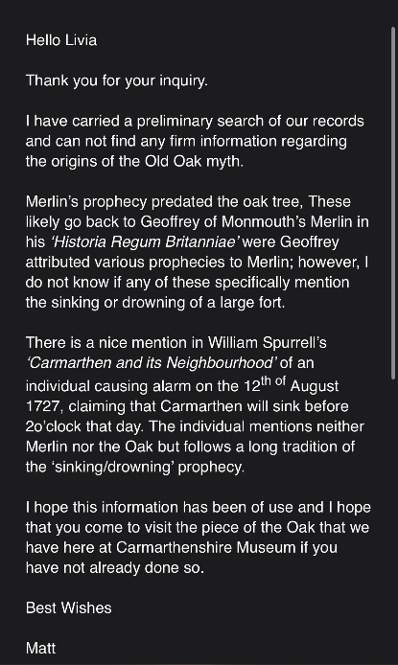
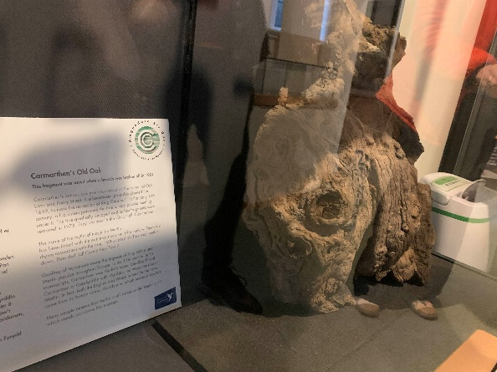
Appendix 2:
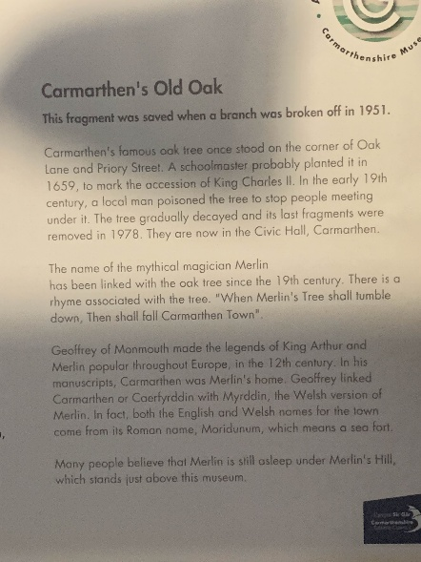
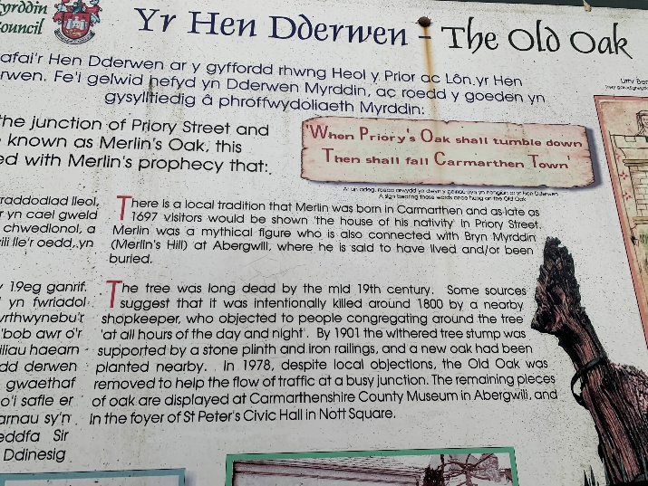
Appendix 3:

Appendix 4:
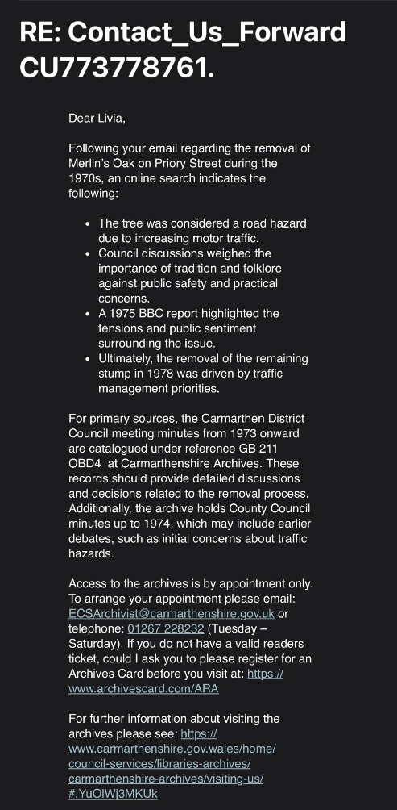
Appendix 5:
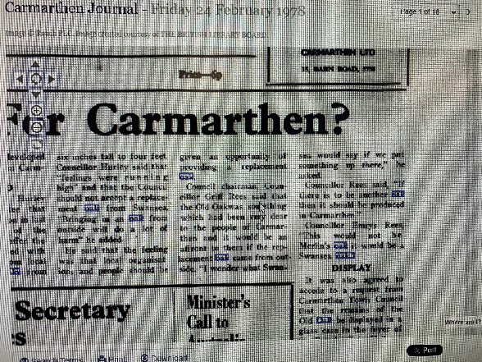
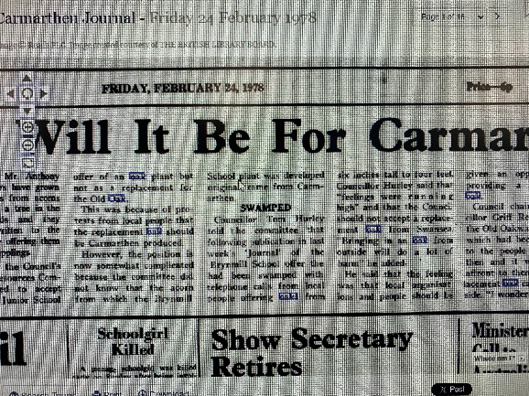
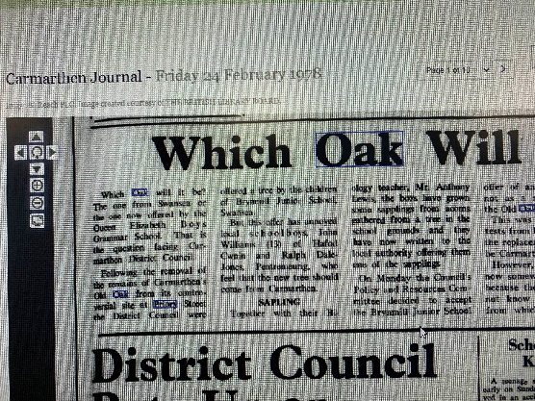
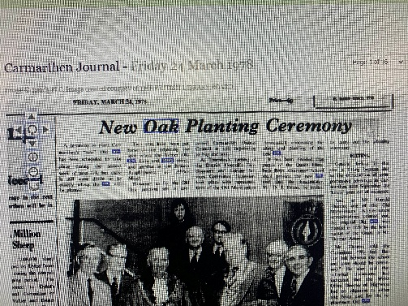
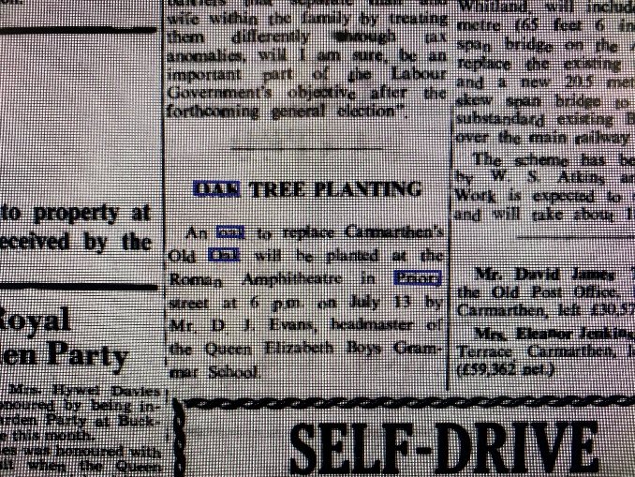
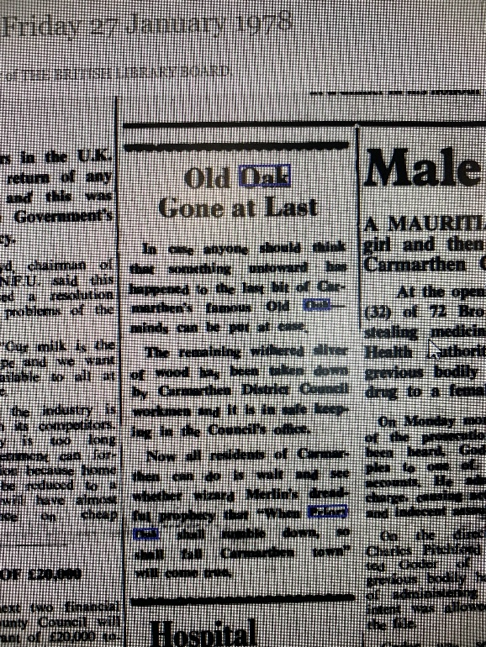
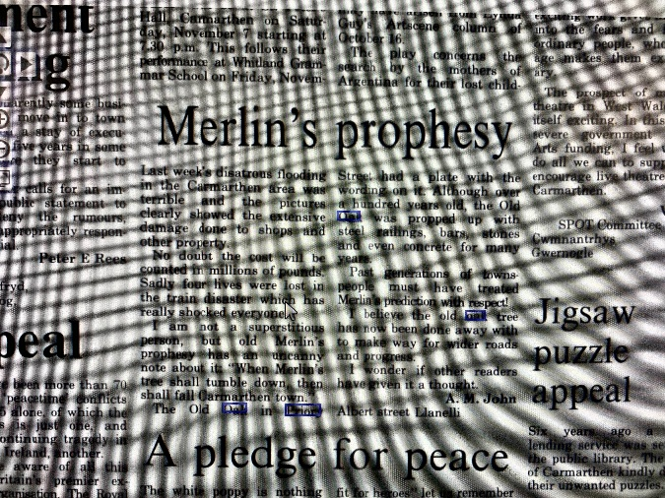
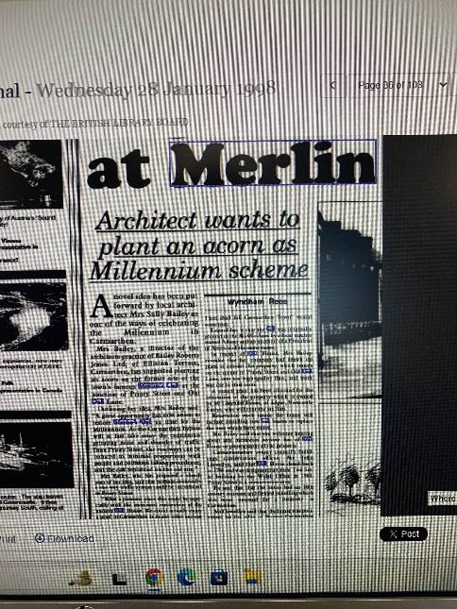
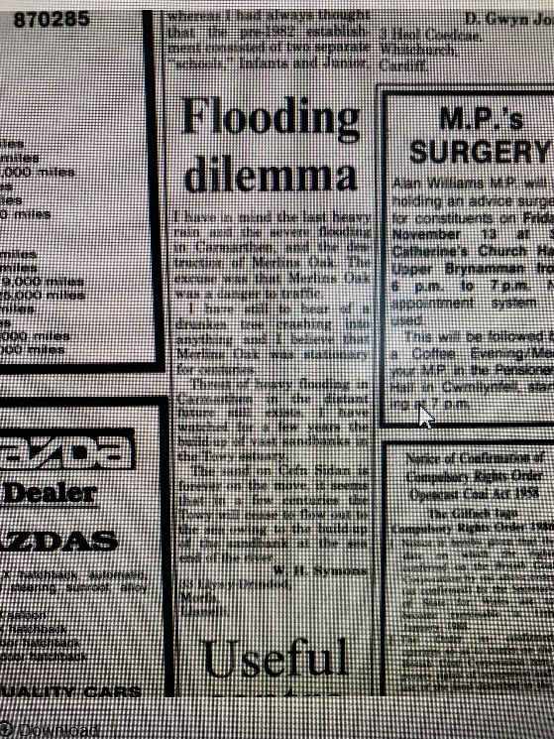
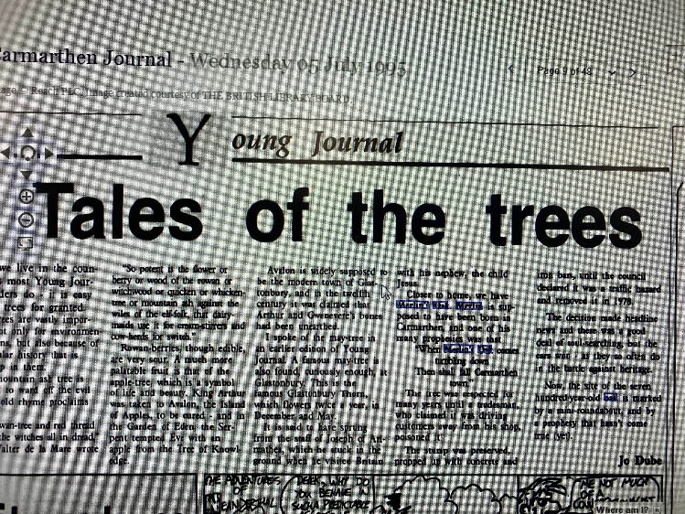
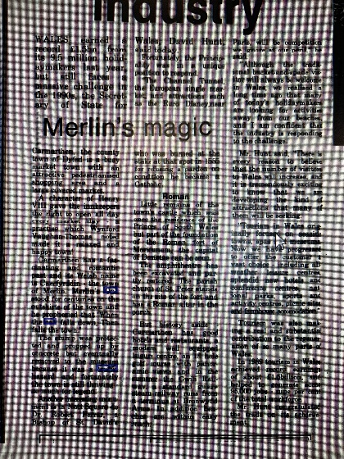

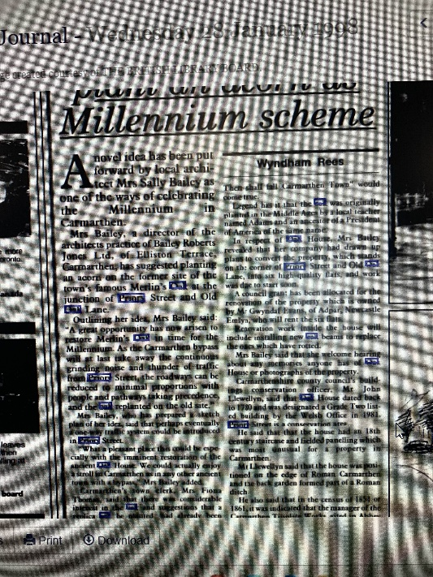
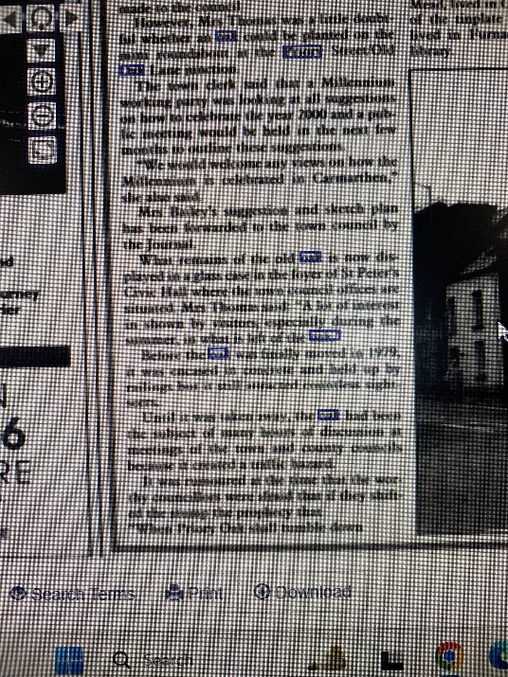
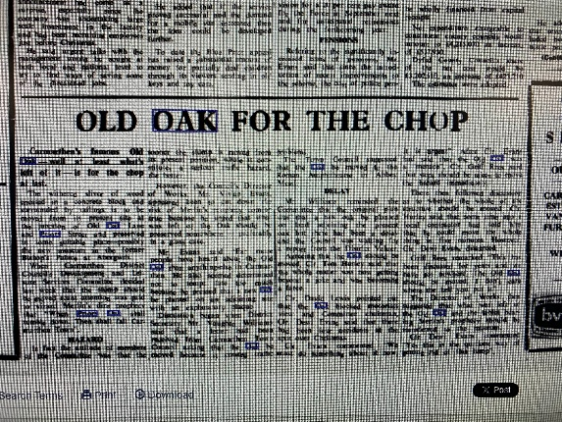

Appendix 6:
Podcast 1- https://youtu.be/deuETOYysN0?si=7cngOFjSMxVbCcMm
Podcast 2- https://youtu.be/o8xQTuxncBM?si=wIV_GEKBAHVztrJv
Podcast 3- https://youtu.be/HDyKzNYGm9s?si=y0VfaHqrpMb6GMYV

Appendix 7:
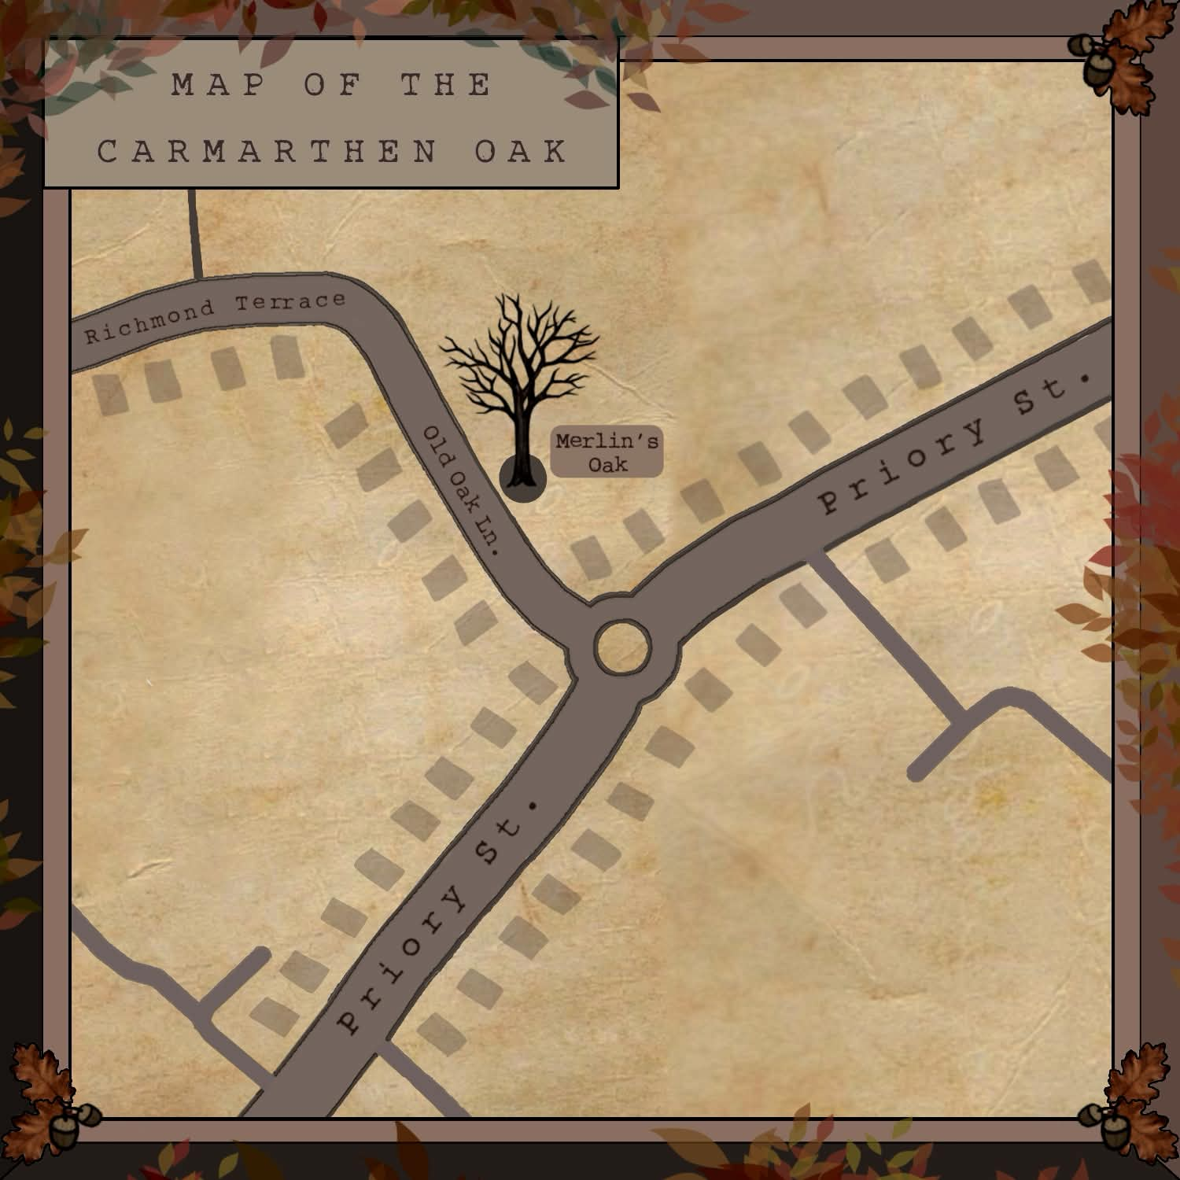

Appendix 8: https://docs.google.com/forms/d/e/1FAIpQLSfZNjfnBPNA22E0tjRA9MUMeMu_ATGLQJzNk2P0tqQaO0zDyA/viewform?usp=publish-editor
Appendix 9:
https://1drv.ms/w/c/68ab8bdaa4f8fa90/IQABFZFbHlveS7pJoBLD-eEgAThcKZTbNjnPpAxnSDFtxrU?e=XVbnzL

AI STATEMENT:
I confirm that I have not presented any AI generated text as my own work. I confirm I have copies of my drafts, notes, and other resources I used before, and after the use of AI tools which I may be asked to provide in evidence.


