L5 – Art Direction for the Animated Short (M5X02050)
Ben Hawker 2100301 – Submission

A Directors Journal
My name is Ben Hollywood, and I’m going to be the next big hit director. I’ll be like a mix of Tarantino, Nolan, and Spielberg all in one – but better. I even had my name changed appropriately. I just need to make a movie first. Here are some of my failed ideas and attempts:
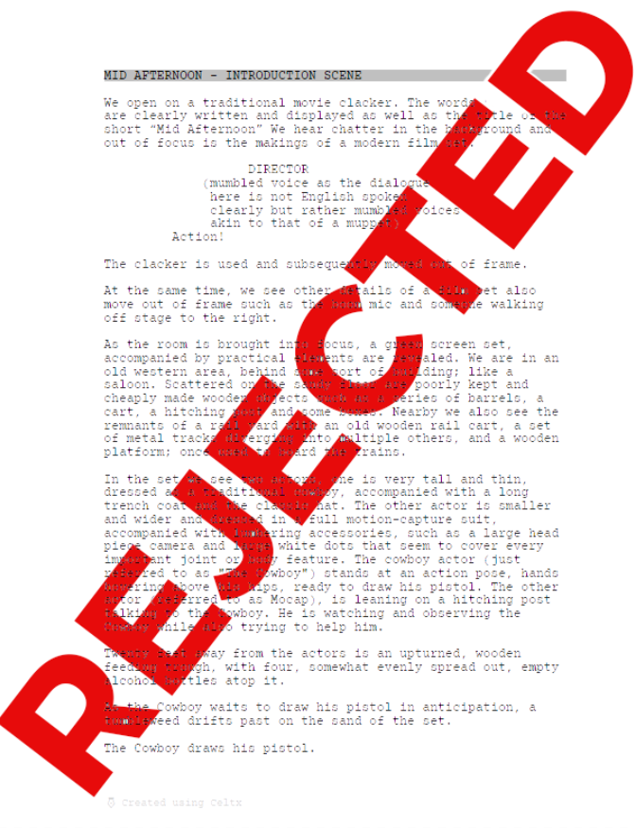
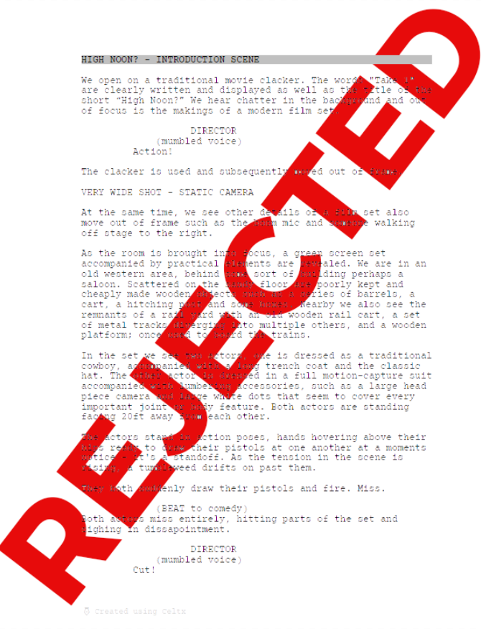

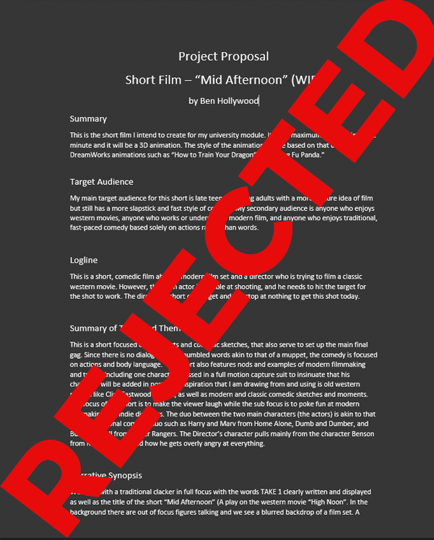
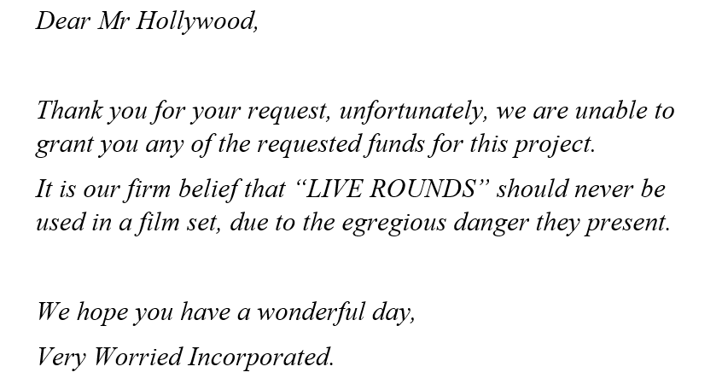
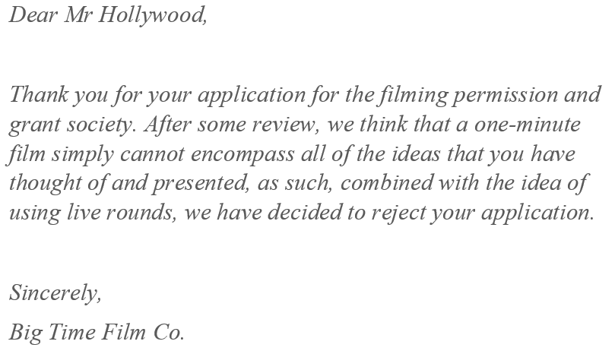
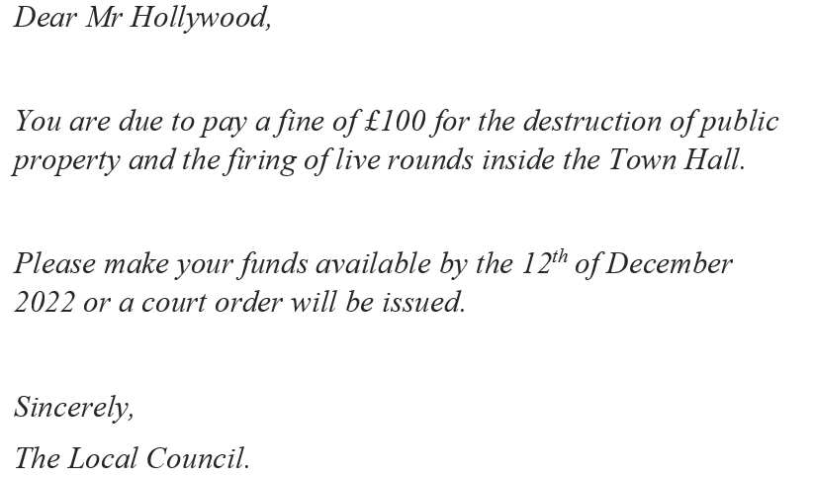
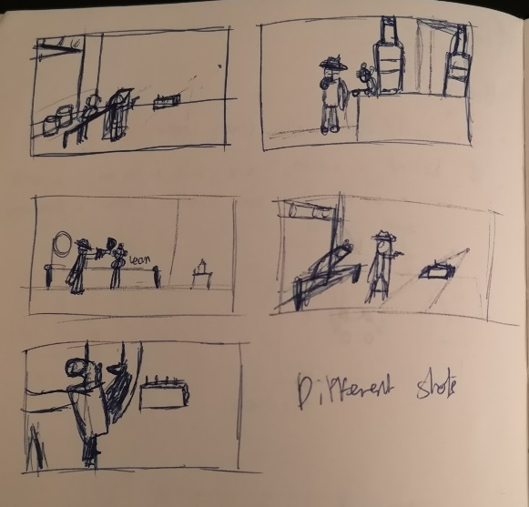
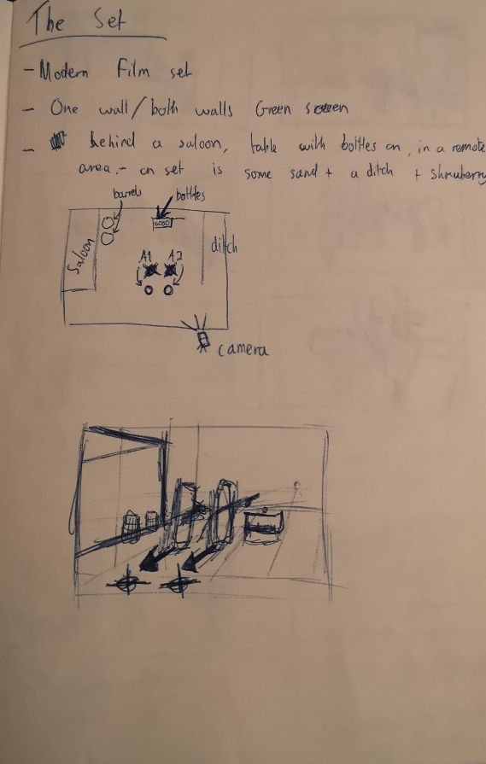
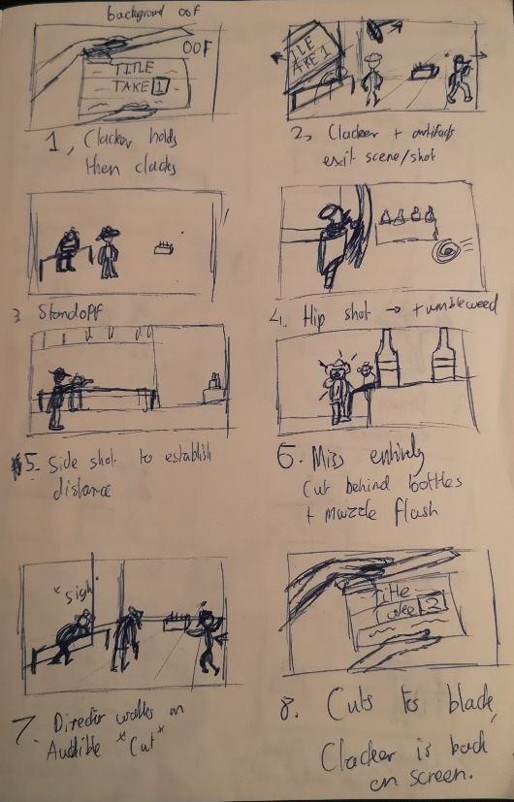

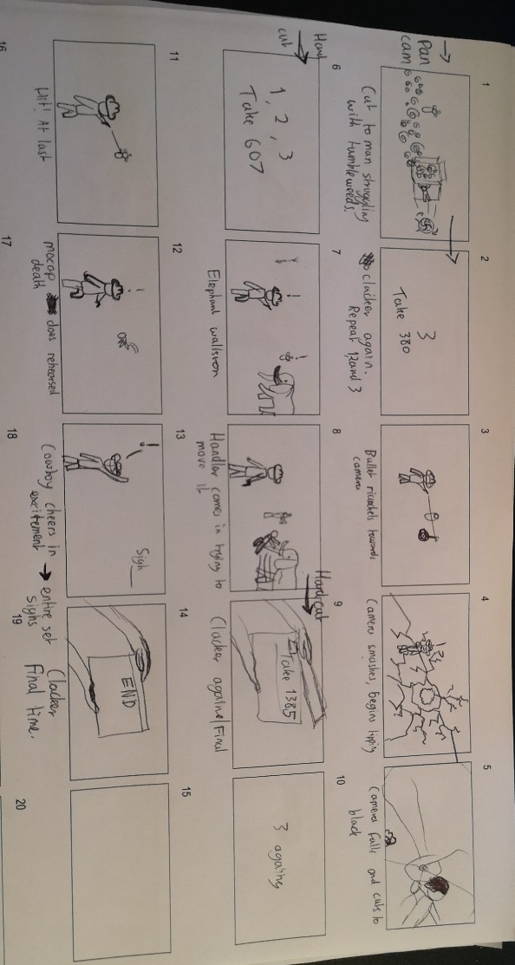
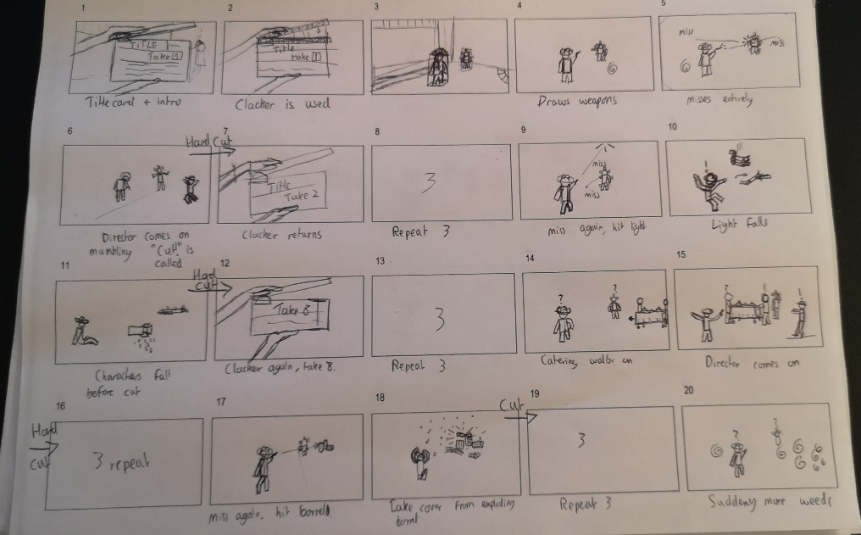
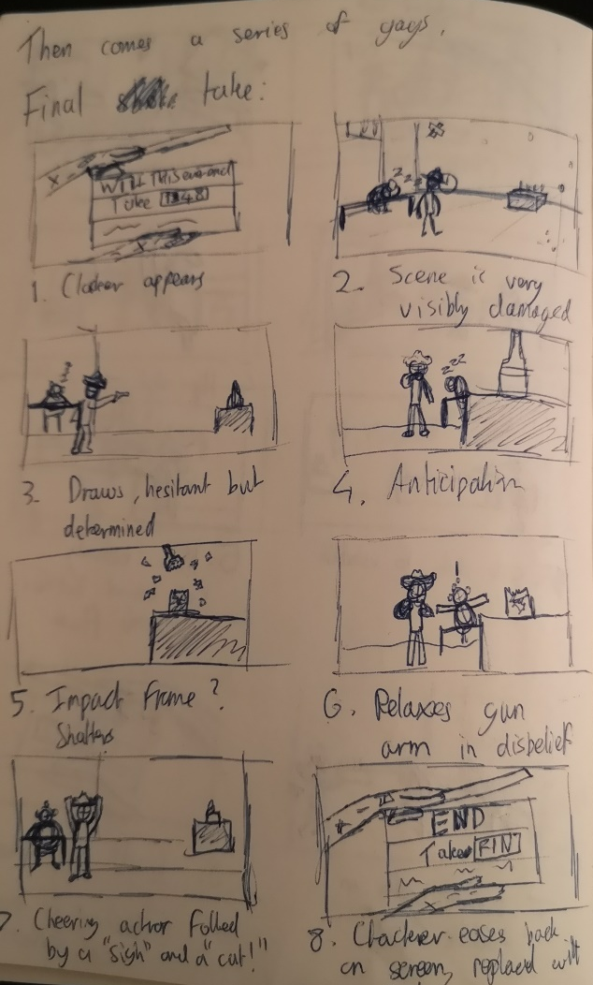
My New Idea
Finally, I found an idea that they would actually let me do.

Project Proposal
Short Film – “You’re on in 5”.
by Ben Hollywood
Summary
This is the short film I intend to create for my breakout directing piece. It has a maximum running time of 1 minute and it will be a 3D animation. The style of the animation will be based on that of DreamWorks animations such as “How to Train Your Dragon” and “Kung Fu Panda.”

Target Audience
My main target audience for this short is late teens to young adults with a more mature idea of film but still has a more slapstick and fast style of comedy. My secondary audience is anyone who enjoys western movies, anyone who works or understands modern film, and anyone who enjoys traditional, fast-paced comedy based solely on actions rather than words.

Logline
This is a short, comedic film about a modern film set and an actor who, whilst waiting for the call to film, sits on his chair fumbling around with his prop, blank-firing gun that production have given him to use for the scene. Numerous times he has the gun fall apart and he must try to repair it himself, before ultimately being called to film and having the gun explode in his face as a final gag.

Summary of Topic and Themes
This short is focused on the idea of physical comedy told without facial expressions and dialogue; akin to that of Mr. Bean or traditional comedy cartoons such as Tom and Jerry. The small gags and actions used in the initial fumbling of the prop are used to ultimately set up the final laugh at the end where the prop explodes. The short will also feature nods to modern filmmaking and tropes including modern equipment and a very fast paced and busy set, with people constantly walking past the camera to briefly interact with our character. The inspiration that I am drawing from and using is old western movies like Clint Eastwood movies, as well as modern and classic comedic sketches and moments. The primary aim of the short is to make the viewer laugh while the secondary focus is to poke fun at modern filmmaking. The main character himself will be based on very physical based comedic characters, such as animation Rowan Atkinson has played, Del-boy and characters from John Sullivan’s “Only Fools and Horses,” and cartoon characters such as Tom and Jerry, and Benson from J. G. Quintel’s “Regular Show.”

Tagline
“The film crew and the director are ready, but what about the lead actor?”

Narrative Synopsis
We open with our actor, slouching in his chair with his cowboy hat angled over his eyes – he appears to be asleep. He is sat amongst wires and various metal frames; we can see that he appears to be on a movie set. People are walking in the foreground as we see their shadows cast on the wall behind him. The title card then slowly fades in, and we see the words “You’re on in 5” in the centre of the screen in bold text. A sudden loud “BANG” is heard coming from the right side where it sounds as if something large had crashed in the background on set, this shatters the text as it quickly dissipates from the screen. It also causes our actor to wake up with a sudden jolt, throwing up his prop gun in the air. After fumbling and trying to catch it, the gun falls to the ground and breaks into multiple pieces. Panicked, the actor dives to the ground and quickly attempts to put the gun back together. After attempting to do so, he stands up triumphant but attempting to play it off as if nothing had happened. He leans on a nearby, unused light or piece of equipment and waves at people passing by. The piece of equipment then falls due to the force of him leaning and he is sent backward, almost completely rigid, and not breaking his pose, falling to the floor. Once again, his gun breaks, and he fumbles about attempting to repair it once more. After trying to repair it again and being satisfied with his attempt, he stands up again, attempting to play off what happened by tipping his hat to the people walking by, this time looking the other direction. He then quickly checks another piece of nearby equipment before leaning on it with his other arm and spinning the gun in his hand, attempting to look smooth and to pretend that nothing had happened, when suddenly the gun again breaks, this time in his hand, and the pieces fall back on the floor. The actor then looks annoyed before hearing a shouting voice from the right calling him to set, he then frantically tries to repair the gun once more, this time pulling duct tape from his back pocket and putting a large part over the gun before standing up again and walking over to the right. The camera then cuts to the film camera on set, we see a typical western set, accompanied by a sandy floor, multiple wooden props like barrels and a cart, and half a wooden building that looks to be a saloon or something similar, with the other half being cut off by a large green screen wall. The camera is situated behind the silhouette of another actor’s legs, with their hand eagerly waiting to draw the pistol that is sat in a holster around their waist. In the background of the shot, we see our actor who is also ready to draw his pistol. This is a Mexican standoff. A tumbleweed drifts over the set as the camera very slowly pans towards the other actor before coming to a stop. Both actors draw their pistols and fire, but our actor’s pistol explodes! A huge cloud of smoke is seen in front of our actor’s face before the camera shot freezes and the credits begin to play, accompanied by comedic music.

Status of Film
Currently, the film is in pre-production with planning and storyboarding almost coming to a finish. Soon it is expected to begin dealing with sound, colour, and modelling. As the writer, director, and producer, I have gone through many iterations and ideas for this film, all of which have been rejected. I am now turning to this idea to be the one that becomes successful. As I further develop the project, I intend to keep looking for inspiration and keep coming up with new ideas to really nail the timing and comedic value of each of the gags to make the short as funny as possible.

Total Budget in British Pounds
The estimated budget for completion is £50.
This estimate is solely from the cost of models and effects purchased just in case I need them and as much as I am willing to pay for them.
This is also how much I have left after my failed attempts and that one fine that we don’t talk about.

Line-item Budget
Pre-production - £30.
Production – £0.
Post-production – £20.
On a sidenote, I refuse to pay VFX artists any more than £10 per 20-hour shift.

Total Budget Acquired to Date
The total budget acquired to date is £0.
No one will fund my project, not even my mom believes in me.

New Script
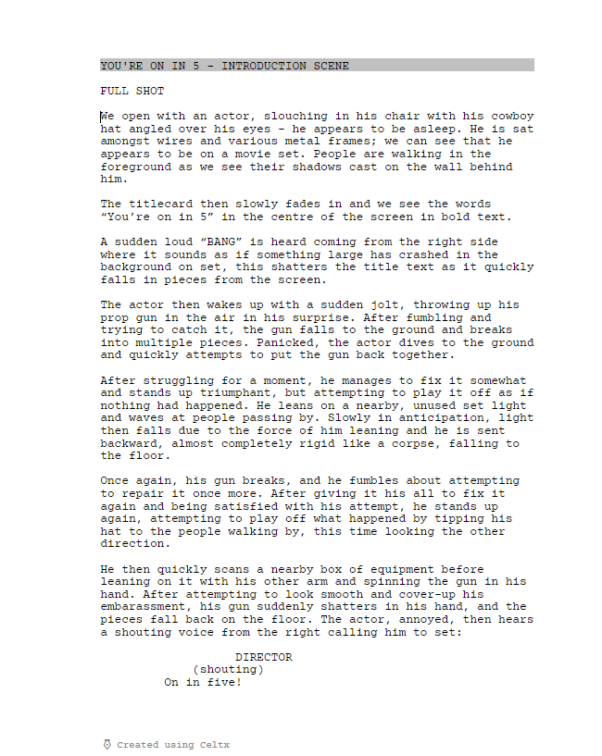

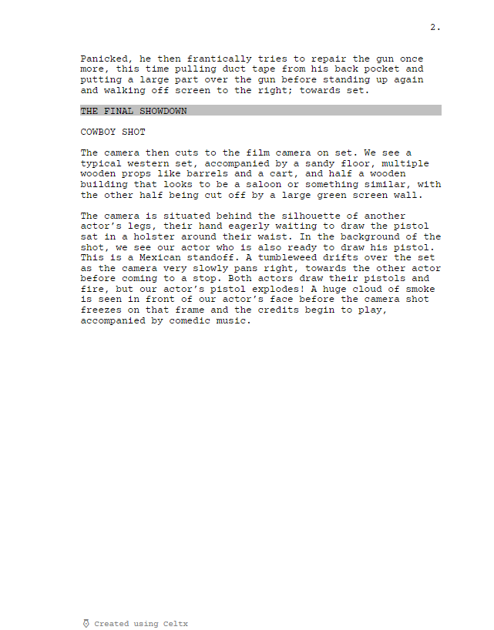

Research and Inspiration
For this short film, I am heavily inspired by the comedic genius that is Rowan Atkinson, and more specifically, his mastery of physical comedy. I also did lots of research into other media I find hilarious, such as cartoons and the show: “Only Fools and Horses.” I tried to note down the important factors of the comedy: why were they funny? What timing was used to heighten to comedy? Were other characters and props utilised? What can I use to make my film funnier? These were my findings:

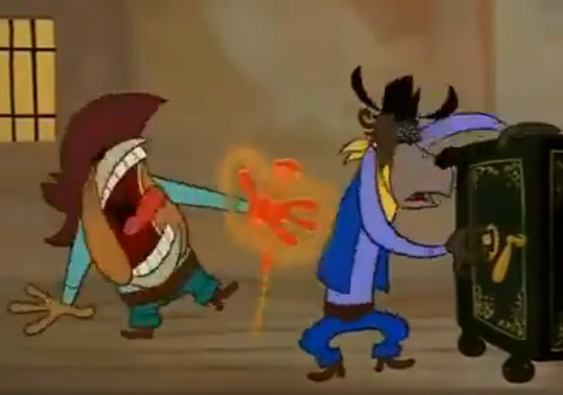
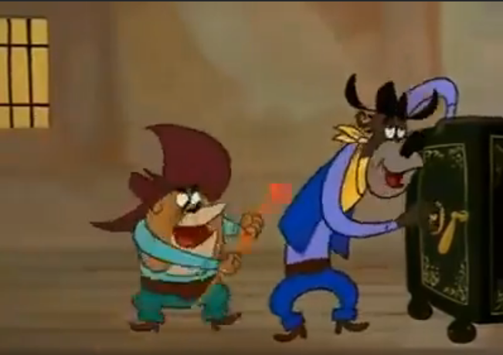
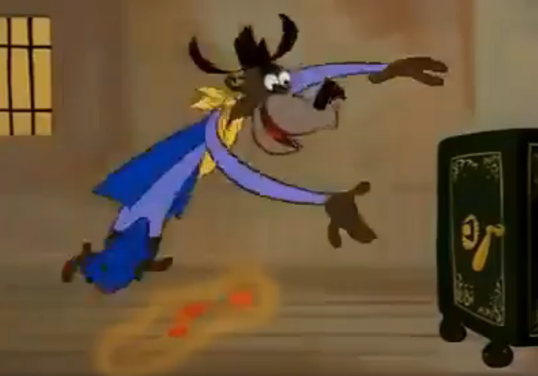
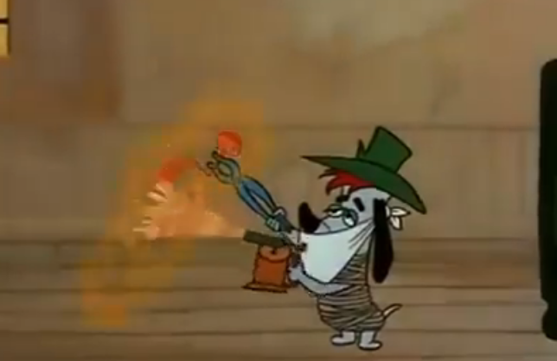
Anticipation - Droopy
I watched the cartoon “Droopy”, specifically the episode titled “Deputy Droopy” [1] from 1955. The episode is about two bandits that try to steal gold from a safe whilst trying to be silent so as not to wake the sheriff. Each gag they must run away to let out their cries before coming back to continue. This episode has an emphasis on minimal dialogue for the comedy to serve its purpose, but it also shows a great use of anticipation, something seen frequently in many cartoons.
In the episode, when the character of droopy heats up the safe-cracking device, there’s an anticipation between when the outlaws arrive excited to try to crack the safe and realising that the tool is extremely hot. This tells us that the outlaws aren’t the smartest characters, and also that their haste and excitement has cost them in a comedic way. When the second outlaw picks up the tool, there is a brief pause of about one second before the pain and realisation kicks in. This serves to heighten not only the animation, but also the comedy of the moment – keeping the viewer in brief suspense while they wait for the inevitable. This is a technique I could certainly utilise for the quick comedic moments such as when the gun breaks or when the cowboy falls over.
It is also used frequently in the movement of the characters and their actions too, a common technique in animation, this makes the movement feel much more fluid and a have more weight and momentum [2].
In my film, I will use this technique to heighten the comedy of the final bit, waiting in anticipation during the standoff, only for the pistol to backfire and explode.

Physical Comedy – Rowan Atkinson
“It is the attitude of the performer with which humour is told. That’s what I enjoy” – Rowan Atkinson [3]. When studying physical comedy, I need look no further than the master himself Rowan Atkinson. Watching one of my favourite sketches starring Rowan from the show “Not the Nine O’clock News” [4], I realised that the action and performance of the actor is crucial to what makes a moment funny.
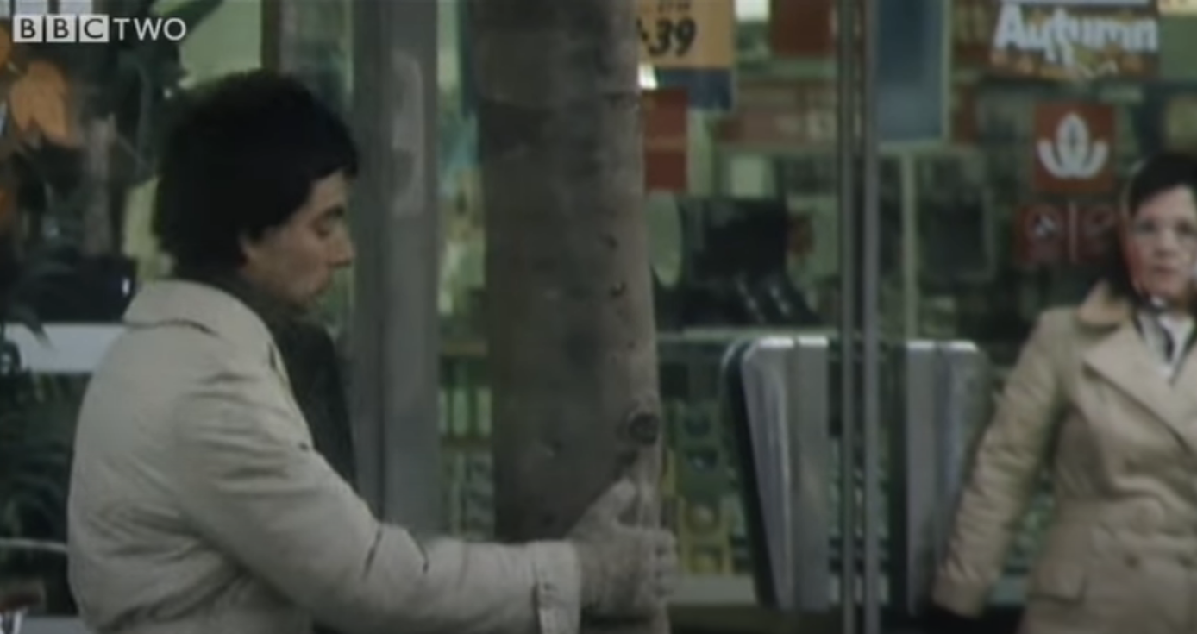
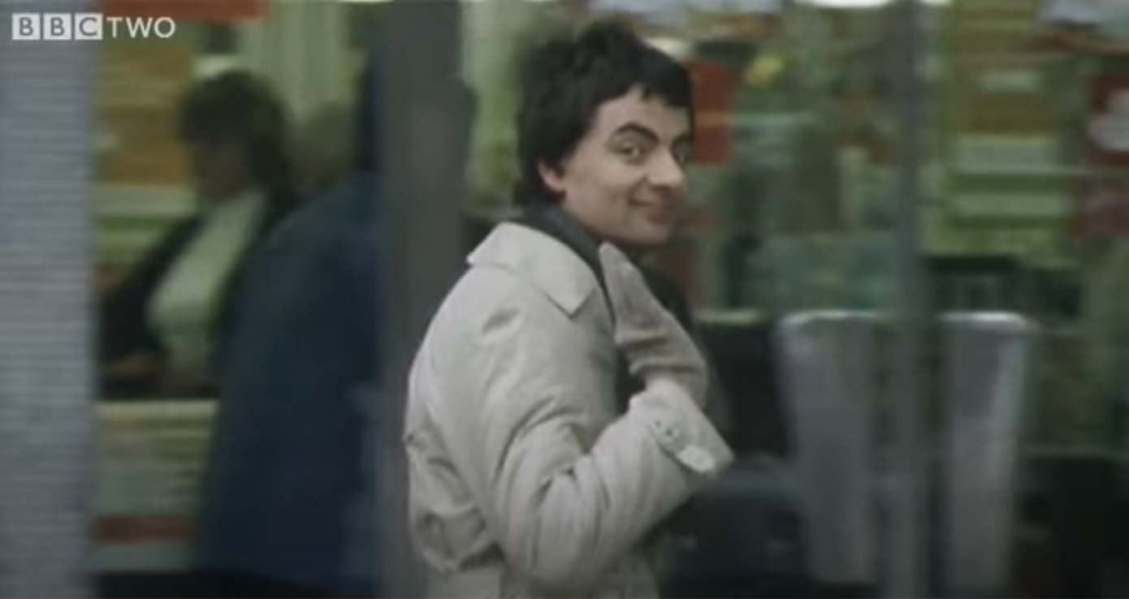

In this sketch, his character notices that he’s being filmed and pays attention to the camera, ultimately leading to him walking into a tree. The reason that this sketch is so funny is because of Rowan’s performance. It becomes less about the punchline of walking into the tree and more about the vanity of the character. Noticing that they are being filmed, they start posing and waving, which is what takes their attention away from the path in front of them and then leads to them hitting the tree. Without the performance, it would simply not be as funny.
The main reason I look at Rowan Atkinson and not the obvious choices like Charlie Chaplin and Buster Keaton is because I think Atkinson is funnier. Whilst Chaplin and Keaton used the fact that there was no option for audio and dialogue to portray their humour, Atkinson chose to portray his humour through physicality. He uses this physicality to “broadcast an attitude” [3], being able to completely convey a character’s motivations and emotions purely from physical actions. As paraphrased from an interview from 1993 [5], it is that humanity to his performance that always brings a relatable feel to his comedy, “even though it’s mad or it’s funny or it’s wacky or it’s rude or it's silly.”
Atkinson uses lots of exaggerated facial expressions, body movements and stances, often leaning or moving his arms in accordance with the moments and comedic timing. His comedy comes through best when playing a character with a specific attitude, whilst telling a joke or doing a comedic action.
In my short film, I intend to try and utilise these techniques inspired by Rowan Atkinson, to improve the comedy of my film. Since it is only a minute long, I hope to use this style to make each second comedic. Especially since the focus is on one character having a series of misfortunate events. Using the idea of characterisation whilst telling a joke, I intend to characterise my actor by having him be an eager but bumbling character as he waits on set for the call to action. Often clumsy whilst trying to play it off in embarrassment.

Comedic Timing – Only Fools and Horses
For comedic inspiration and research, I need look no further than the cult classic show “Only Fools and Horses,” [6] written by the late, great John Sullivan. For the moment in focus, in the episode titled “Yuppy Love” the main character Del Boy accidentally falls through a bar that gets lifted whilst preparing to walk over and talk to a woman.
The key to the comedy in this moment is the setup of the bar being lifted whilst Del comments to the character “Trigger”: “Just play it nice and cool son, nice and cool you know what I mean.” Which ultimately leads to the great moment of Del falling, almost corpse-like rigid, through the bar. Trigger then looks around trying to find Del before he pops back up and tries desperately to play it off before they both leave the bar abruptly. The timing here is perfect, the lead up into the payoff flows very naturally and the fact that the characters are trying to act cool and suave before ultimately embarrassing themselves.
In my film, I am going to incorporate a focus on timing like this, in order for each comedic bit to have as much impact and flow as possible. As well making sure to have plenty of anticipation and build-up, so the audience know what is about to go wrong just before it happens. Such as when the actor falls over after leaning on a non-stable bit of equipment – which was a moment directly inspired from this “Only Fools and Horses” moment.
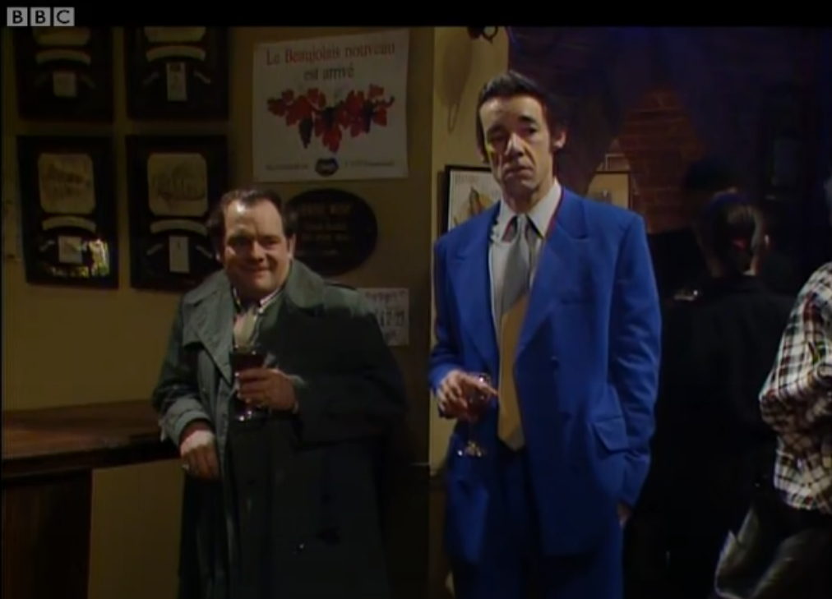
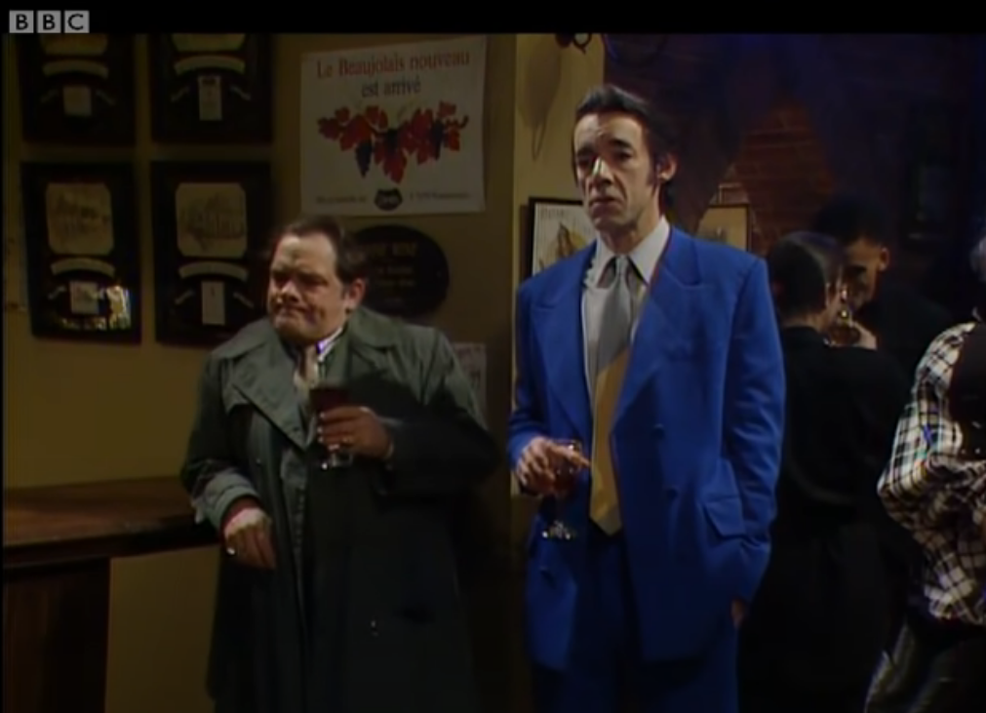
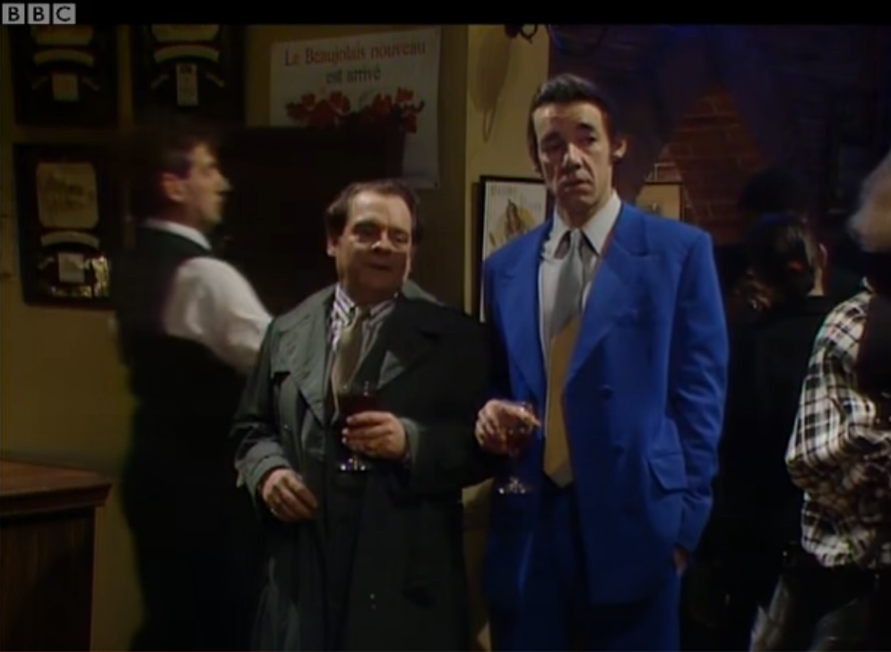
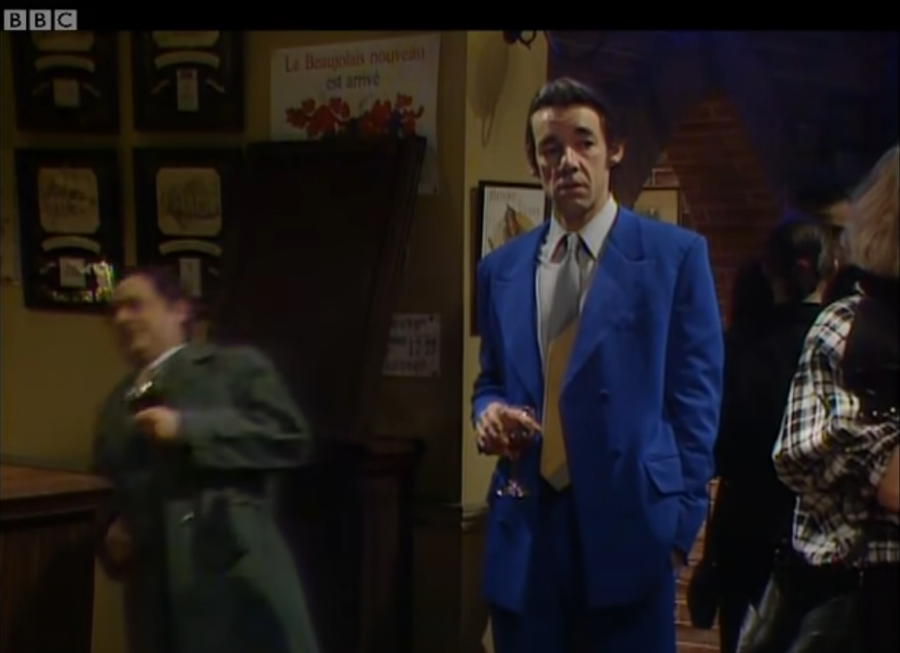

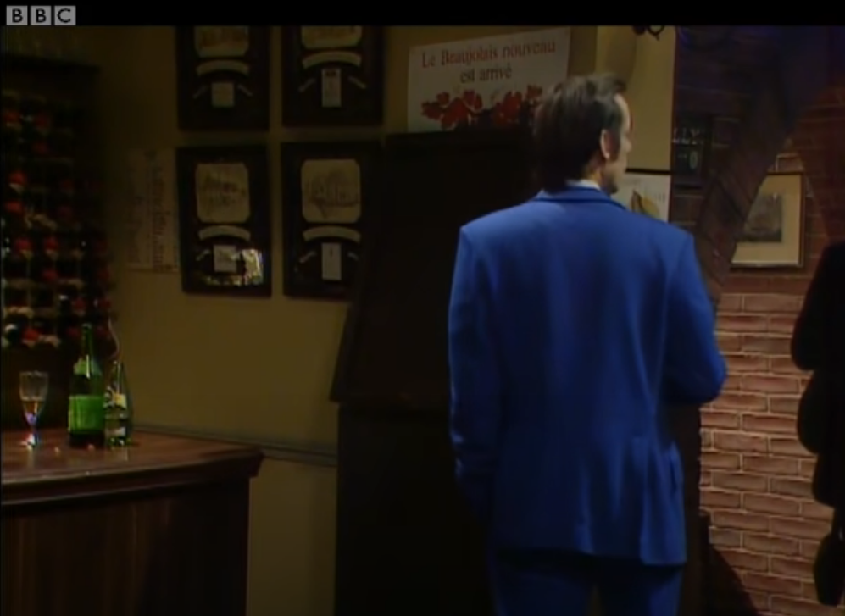

Character Design
My inspiration for my actor is that of a Dreamworks character. Their idea of conveying a character through proportions and exaggerated features is something I think would work well for my design. Here I have included some mood boards and research into the character, accompanied with some thumbnail sketches of the kind of costume and environment the character is in.
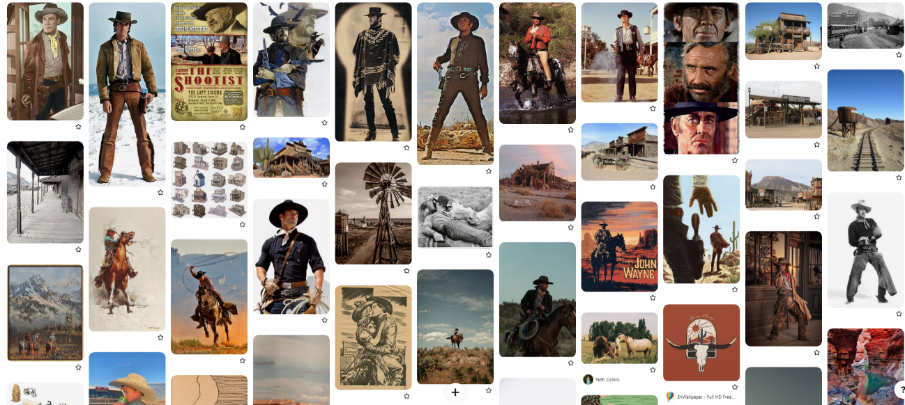
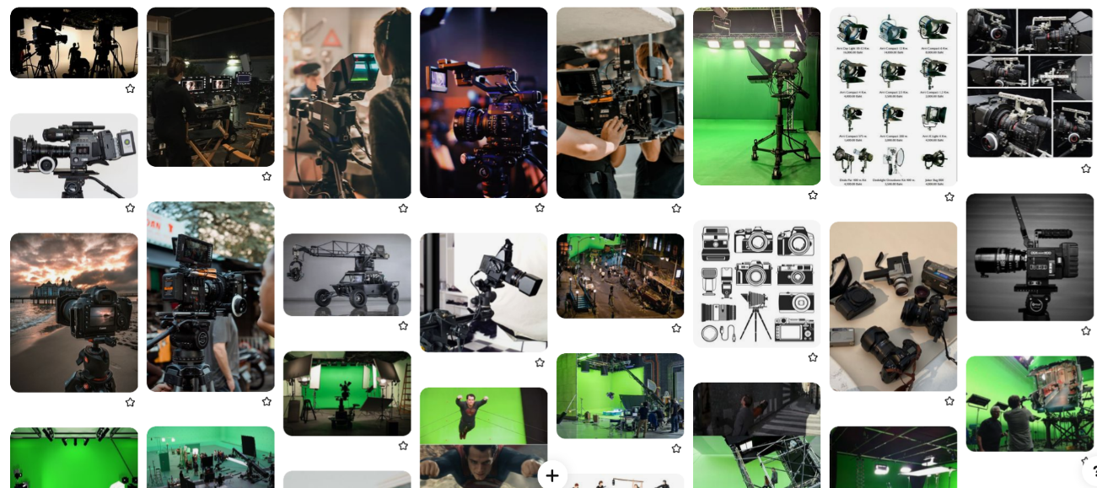
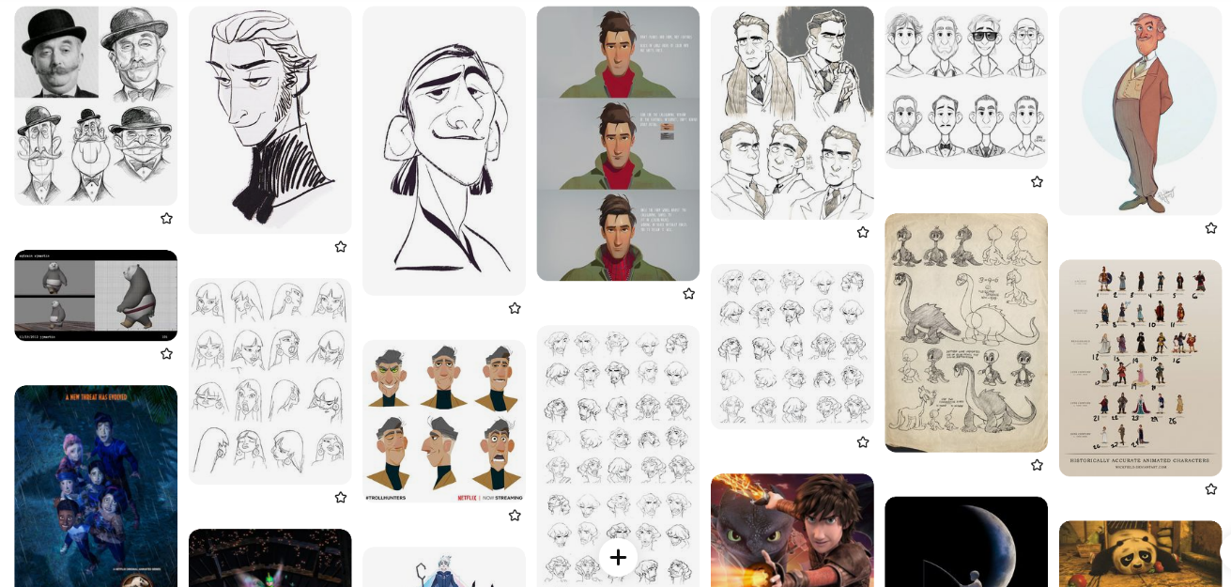
Western Themes
Character Design
Modern Day Film Set
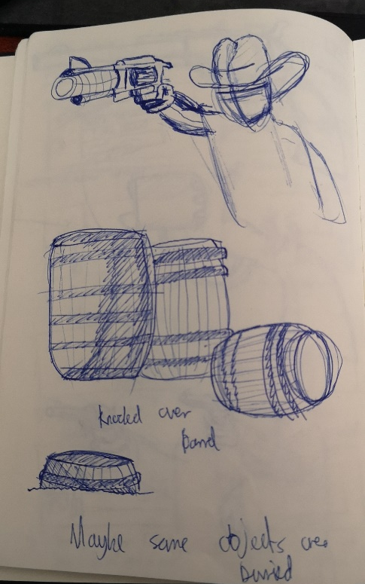
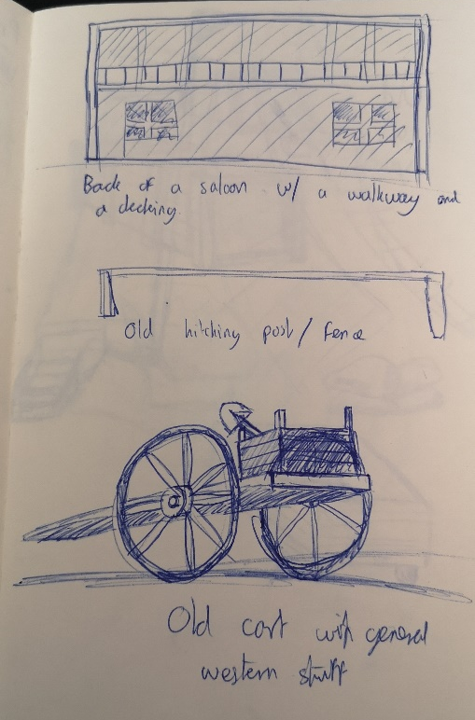
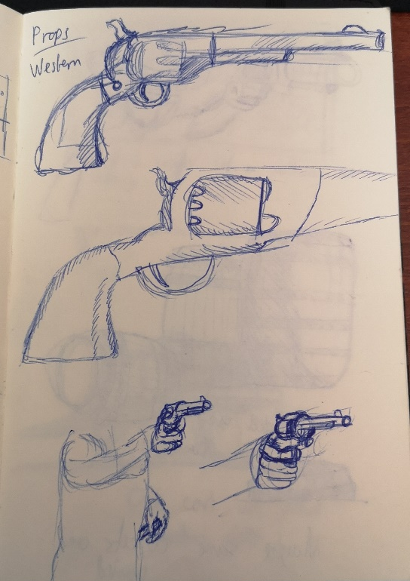
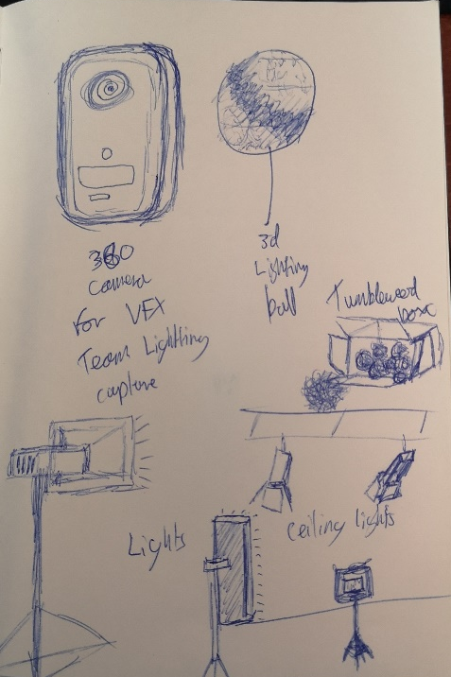
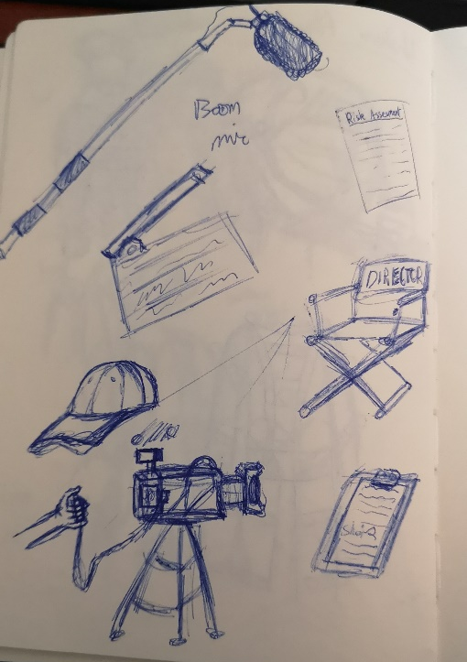
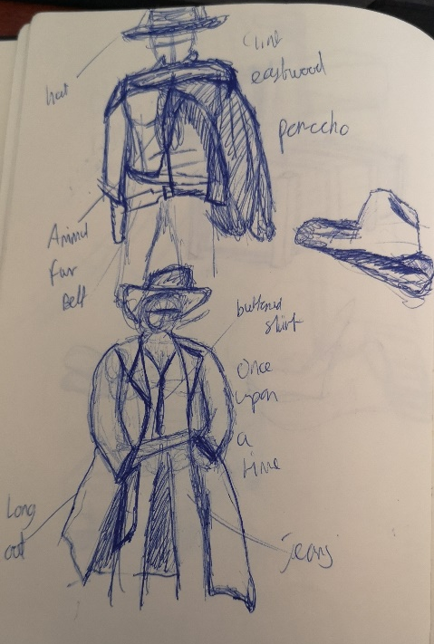
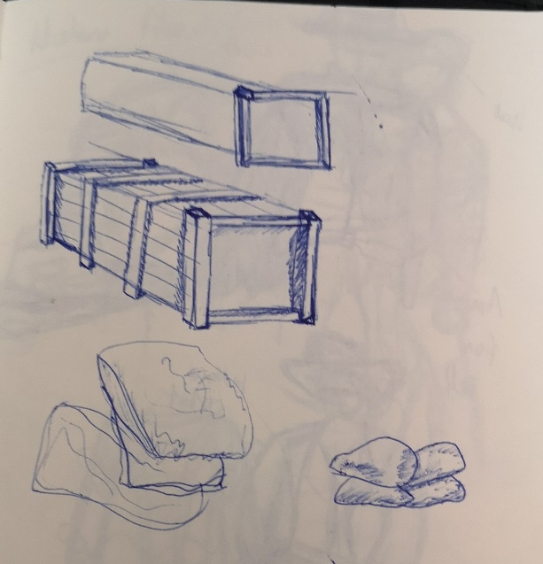
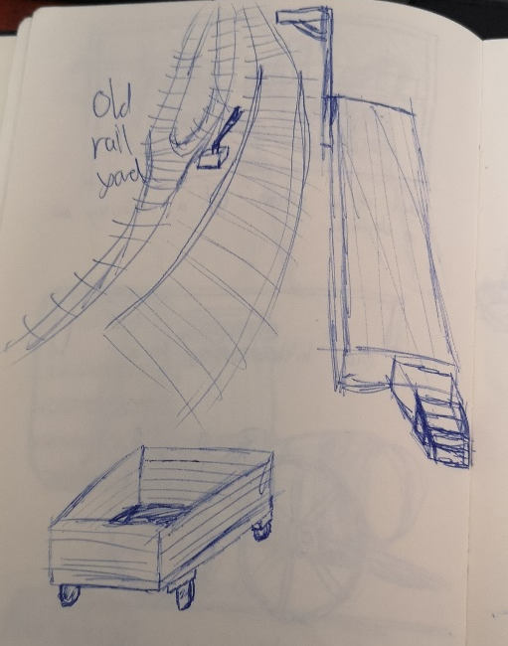
Below are some thumbnail sketches of props, clothing, and scene design.
Based on the idea of British comedy and comedic icons such as David Jason and Rowan Atkinson, I had the idea to make my character tall and thin, akin to a bumbling and clumsy British gentleman actor but playing a serious and cool cowboy. Here are some initial character design sketches I made with the idea of proportion:
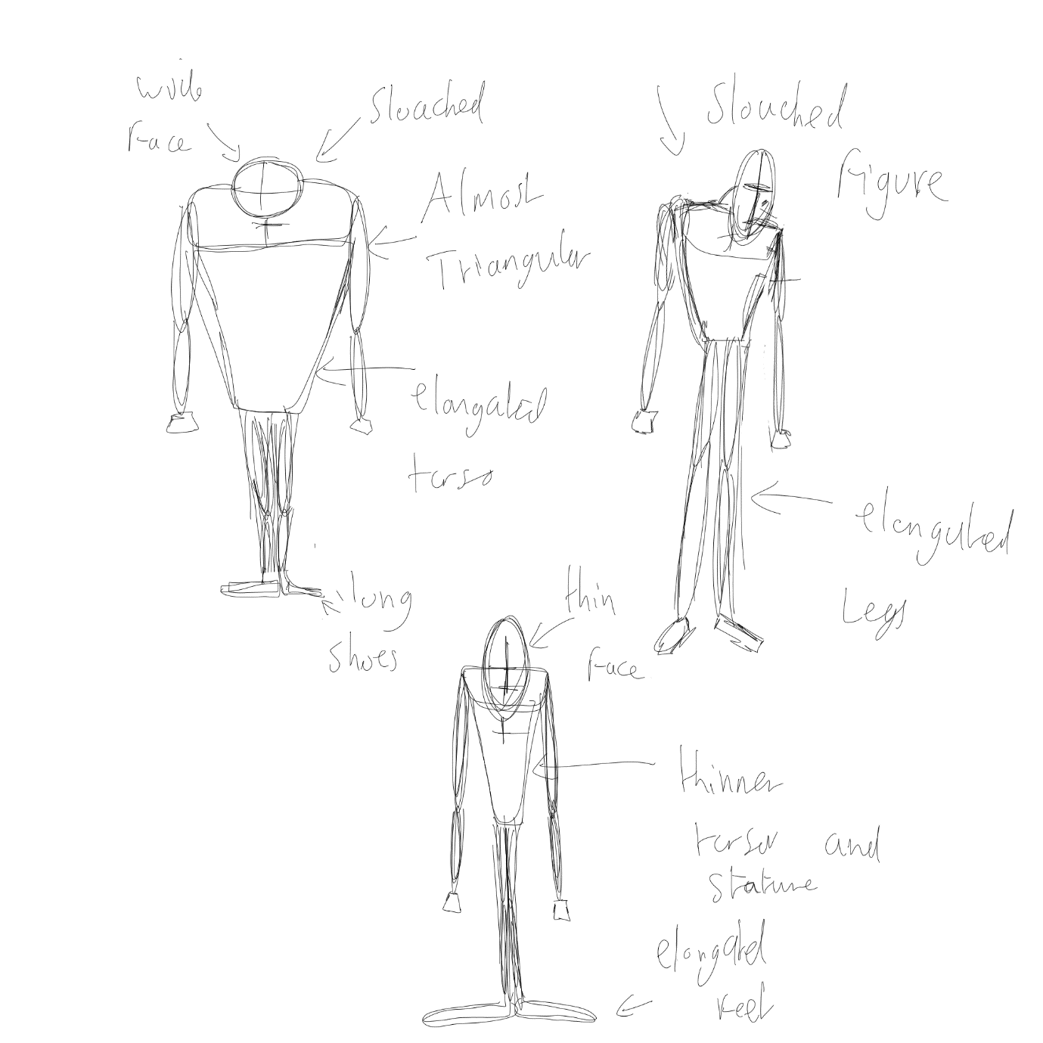

I then chose my favourite idea of these and started to experiment with clothing based on my mood board and my research that I did on traditional western movie wardrobe and clothing. Taking inspiration from things like “The Good, The Bad and The Ugly” [6] and “Once Upon a Time in The West” [7].
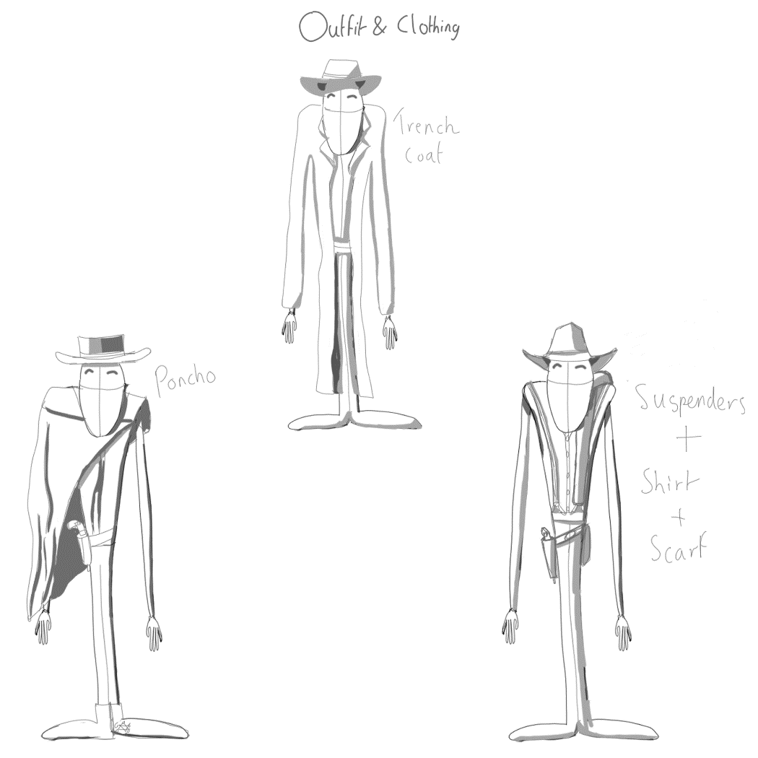
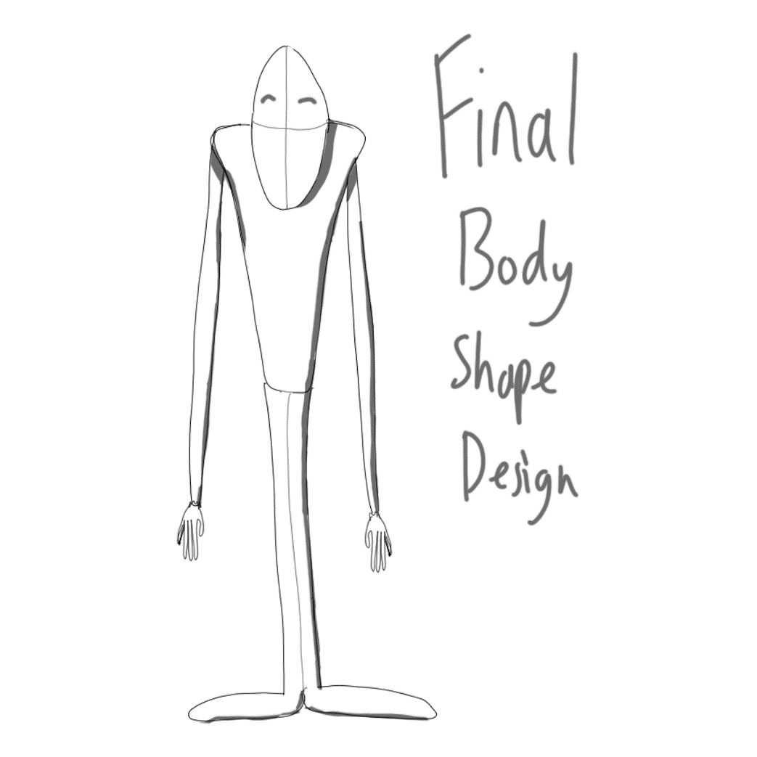
I then chose this as my final design and added some appropriate colour. Such as the traditional western browns combined with a striped, blue shirt and suspenders, to show the element of the working man and to add some sophistication to the idea of the comedic British gentleman.
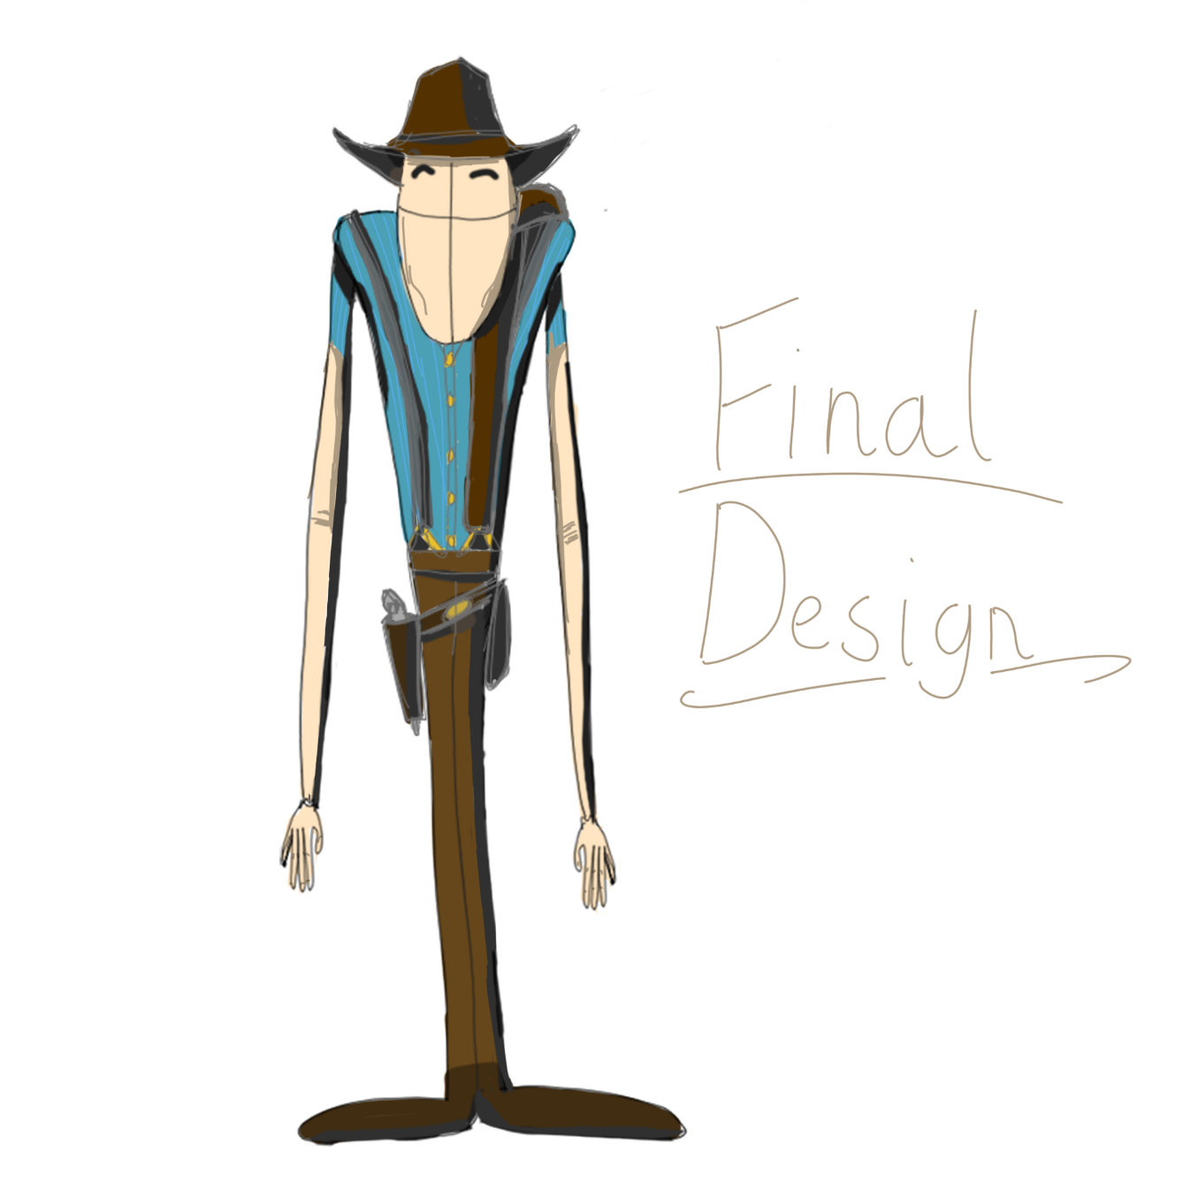
Storyboard
Here I drew a storyboard for the film, based on the script. Doing this, allows me to quickly prepare and block out my animation, as well as being able to present my ideas well [12]. Later, when it comes to the main animation, I can refer to my storyboard to check my keys and keep me on track with my original idea and plan.
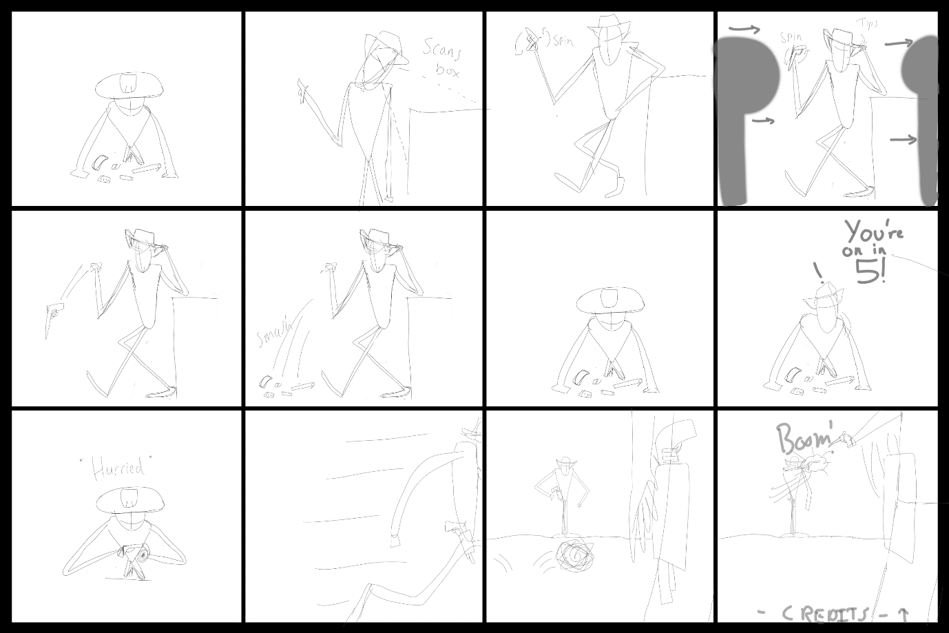
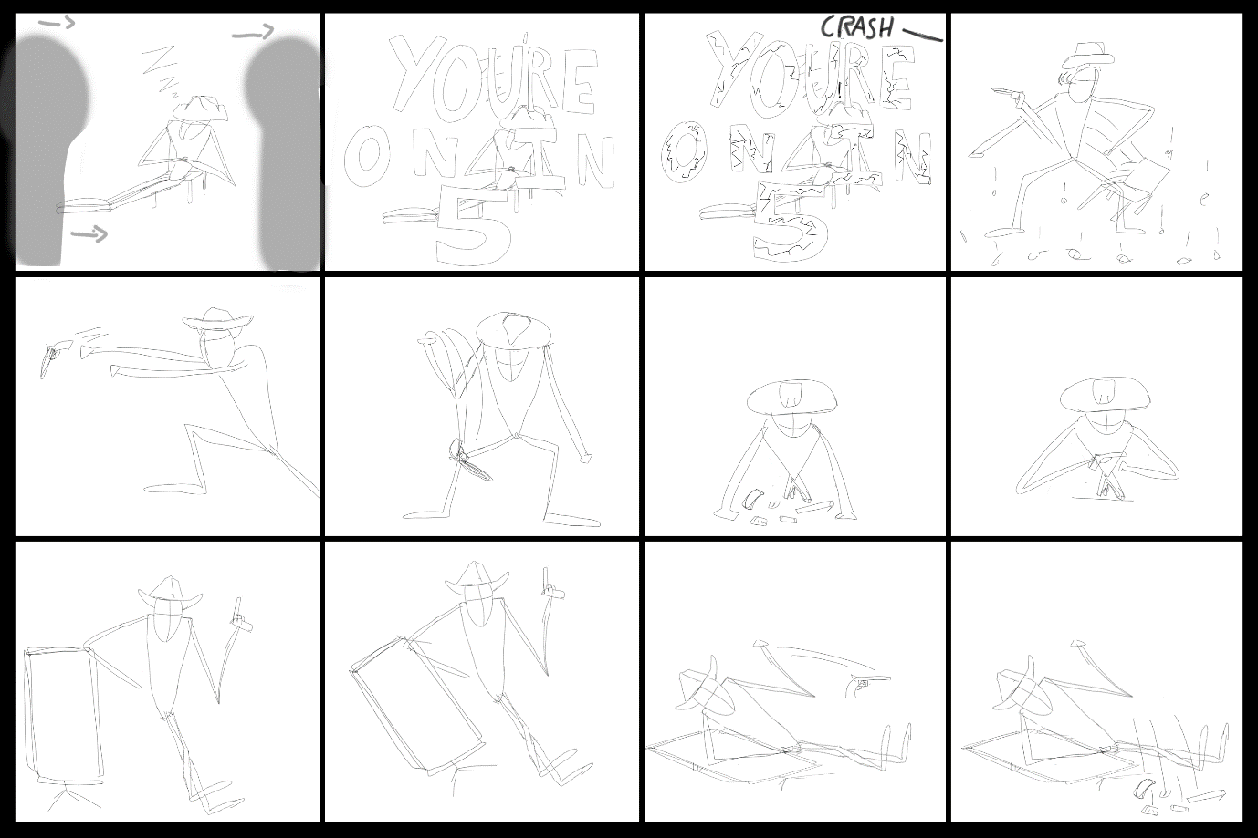
Animatic
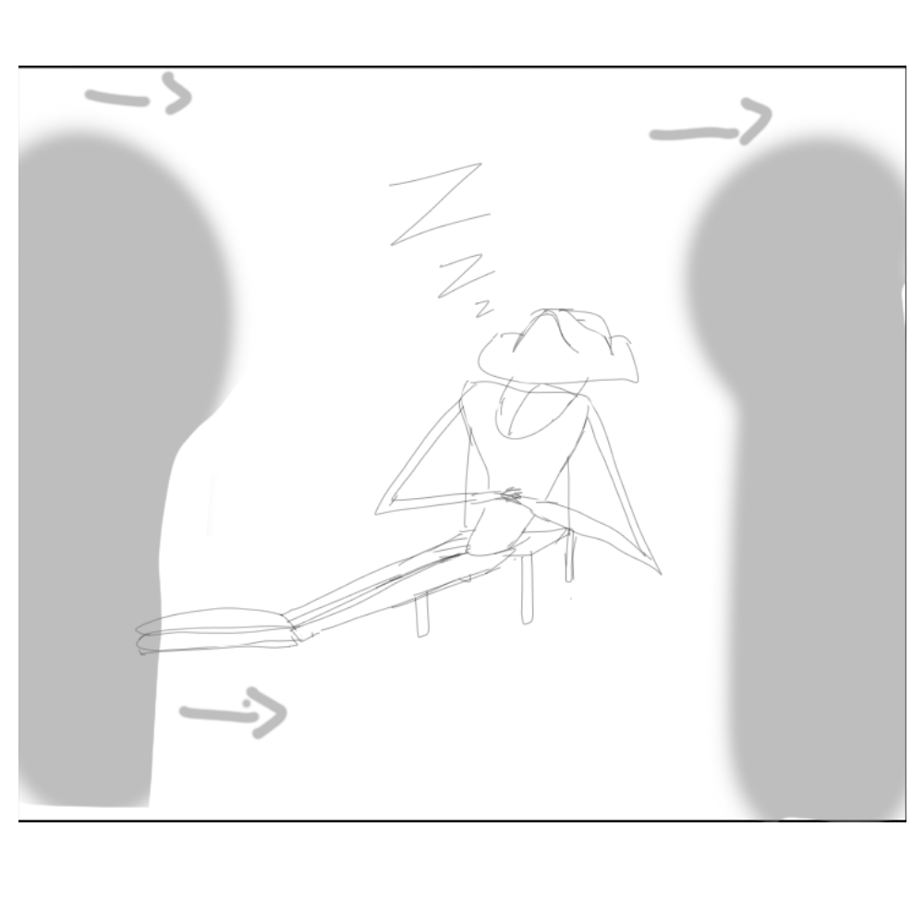
I created an animated gif of my storyboard, and using photoshop, I timed it out into a frame animation. What this allowed me to do was play around and test the length of each key moment. I could therefore fine tune and check my plan to make sure it aligned with my previous research into comedic timing and anticipation. Throughout, right before the big comedic moments, I often held the key for a longer time, building suspense for the upcoming moment.
Having made this animatic will make it easier and more streamlined when it comes to animating later on, as I can make sure my keys are timed correctly. [13]

Colour
After doing some research into colour theory and techniques [14], I concluded the colour palette I would need to use to get across the ideas of comedy and the atmospheres like the Western set.
Using simple swatches and low opacity brushes, below I have coloured the scene of the Western film set, with the ideas of browns and sand colours. Showing poverty and the Great Depression era that many Western stories are based in. Such as the rail or the use of wooden cards and barrels. I have also included the stark contrast between the set and the green screen, making it evident that it is on a film set.
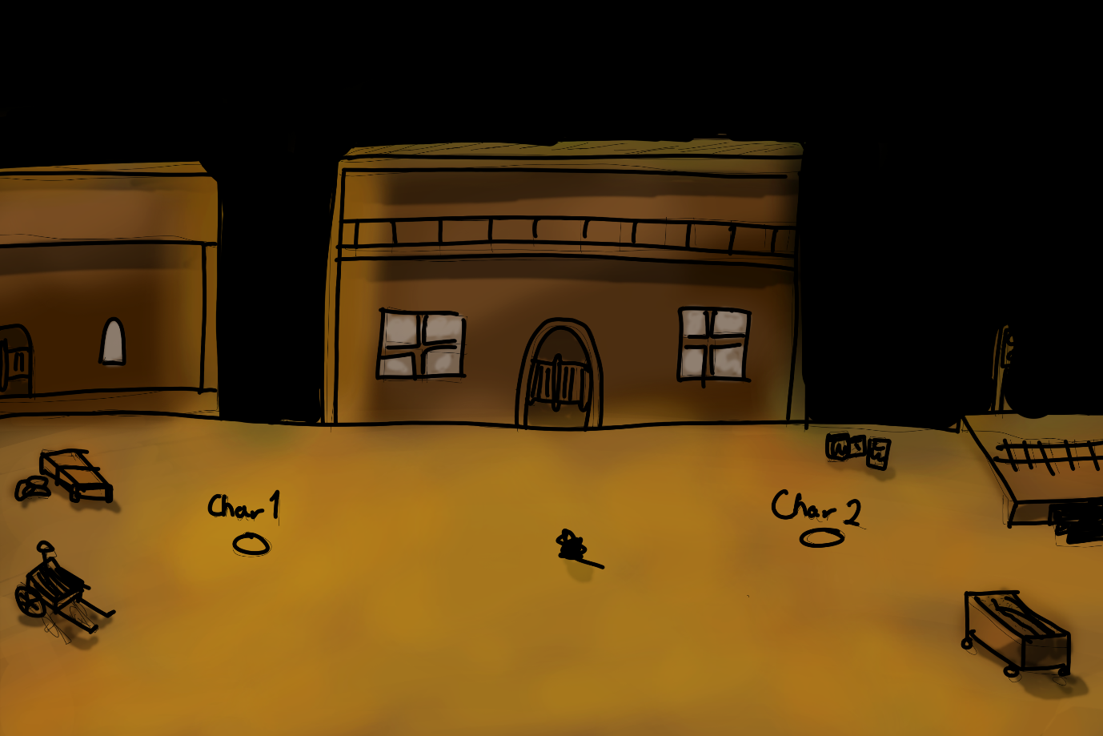

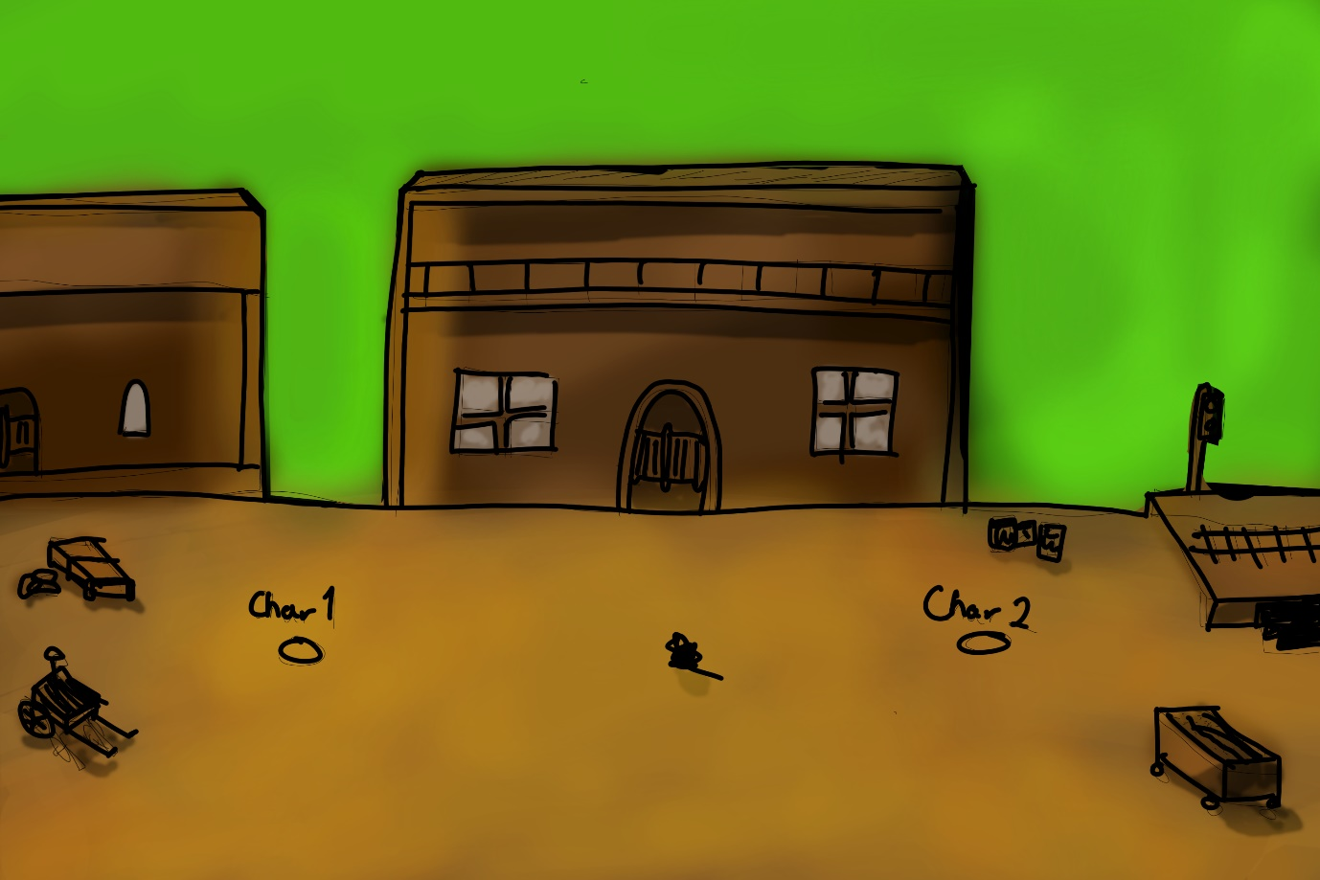

In the film set area of the start of the film, I have tried to use many greys and blacks to give the impression of lots of equipment and a busy room. Accompanied with the strewn bits of equipment and the mess of wires, this is meant to convey a very busy and full area, away from the cameras. Clearly backstage. Accompanied with the green screen again for stark contrast and to show that this is supposed to be a very modern film set.
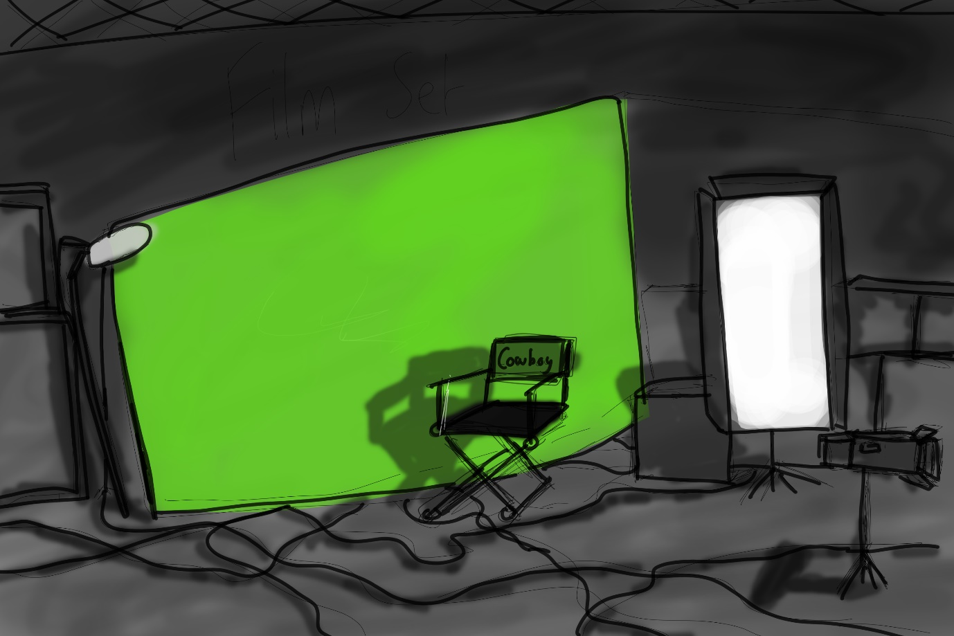

Blocking Out the Scene
Using Maya, I have laid out the rough scenes and objects in Maya using primitives. I did this to see what kind of scale I would need to be looking at, and how many objects and props would need to be modelled and included.
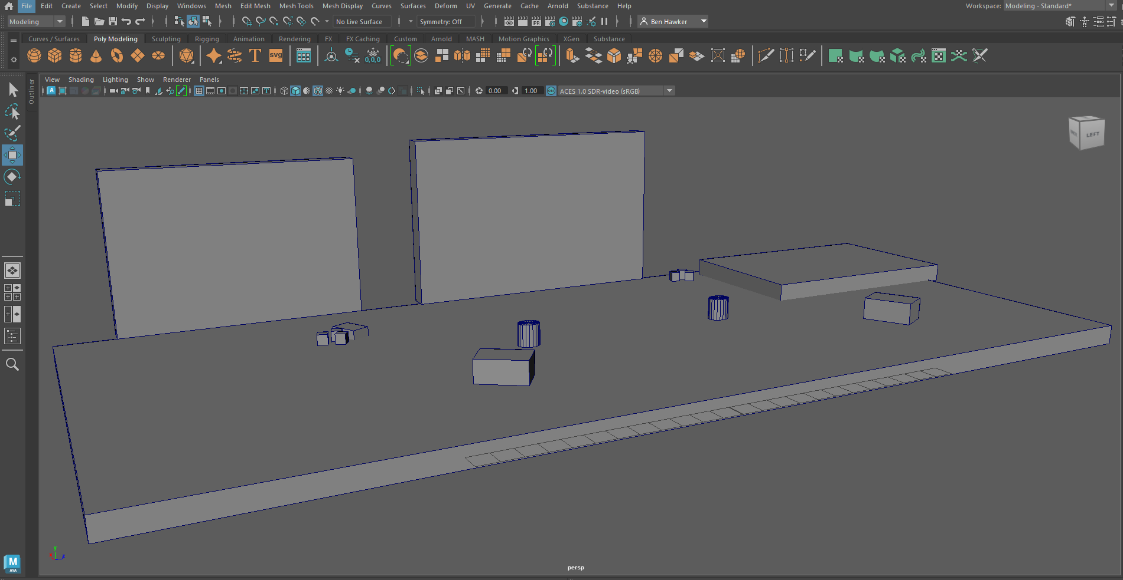

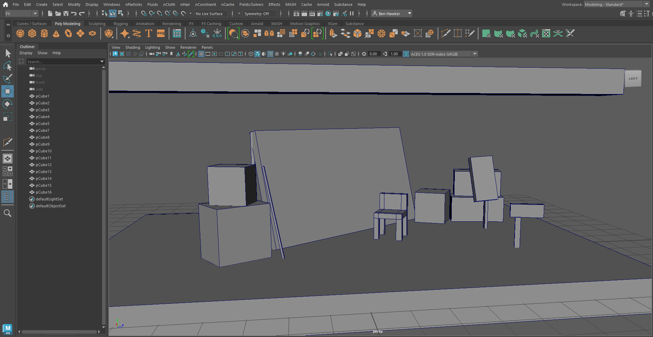

Current Status and Future Plan
Currently, the film is about to enter the final phase of pre-production: modelling and rigging. Once completed, production can be started.
A list of required props, characters and VFX shots is as follows:
Props
- A gun,
- Barrels,
- A movie set,
- 2 green screens,
- 2 cameras,
- 3 extras,
- A VFX artist,
- A stage light,
- Some random equipment boxes,
- A bunch of wires,
- A cheeseburger (IMPORTANT),
- Costume,
- Wooden cart and western accessories,
- A chair,
- A boom mic.
Characters
- The Cowboy,
- The director actor,
- The opponent.
VFX Shots
- An explosion cloud of smoke from the gun,
- Sand and dust particles in the air,
- Chroma keying the wall and adding a Western background,
- Sound effects from the prop guns.

Final Statement
I hope I can count on your approval for this project. My future Oscars depend on you.

Reference List
[1] M. Lah, T Avery, Directors, Droopy: Deputy Droop, [DVD], MGM Cartoons, 1955
[2] R. Reid, “Understanding the Principles of Anticipation,” School of Motion, Dec. 16, 2022. [Online] Available: https://www.schoolofmotion.com/blog/understanding-the-principles-of-anticipation#:~:text=Anticipation%20adds%20life%20to%20your,animate%20moves%20with%20a%20purpose. [Accessed Dec. 16, 2022]
[3] Nerdwriter1, “Mr. Bean Is A Master Of Physical Comedy,” YouTube, Jan. 31, 2018. [Online] Available: https://www.youtube.com/watch?v=uBUnmdd5-iA&ab_channel=Nerdwriter1 [Accessed Dec. 16, 2022]
[4]
Not the Nine O’clock News, Unsuspecting Man Walks into a Tree
[5] CigarsOnMars, “Rowan Atkinson in-depth interview 1993,” YouTube, Apr. 15, 2013. [Online] Available: https://www.youtube.com/watch?v=1mdpz6lvZc0&ab_channel=CigarsOnMars [Accessed Dec. 16, 2022]
[6]
Good bad and ugly
[7] J. Fechter, “How to Format a Screenplay,” Squibbler, Dec. 09, 2022. [Online] Available: https://www.squibler.io/blog/how-to-format-a-screenplay/. [Accessed Dec. 09, 2022]

[8] R. Hilder, “27 Expert Character Design Tips,” CreativeBloq, Jan. 12, 2023. [Online] Available: https://www.creativebloq.com/character-design/tips-5132643. [Accessed Jan. 12, 2023]

[9] J. Straub, “7 of Pixar’s Best Storyboard Examples and the Stories Behind Them,” Boords, Aug. 11, 2022. [Online] Available: https://boords.com/blog/7-of-pixars-best-storyboard-examples-and-the-stories-behind-them. [Accessed Dec. 16, 2022]

[10] A. Maio, “What is The Three Act Structure? No Formulas Necessary,” StudioBinder, Dec. 09, 2019. [Online] Available: https://www.studiobinder.com/blog/three-act-structure/. [Accessed Dec. 16, 2022]

[11] F. Englander, “Define your art with Mood Boards,” AnimatorIsland, Feb. 10, 2014. [Online] Available: http://www.animatorisland.com/define-your-art-with-mood-boards/. [Accessed Dec. 03, 2022]

[12] BarkingSquirrelMedia, “What to Know About Why Using Storyboards Are So Important,” BarkingSquirrelMedia, Mar. 17, 2022. [Online] Available: https://barkingsquirrelmedia.com/video-production-blog/what-to-know-about-why-using-storyboards-are-so-important/#:~:text=%E2%80%9CStoryboarding%2C%E2%80%9D%20as%20it's%20called,to%20quickly%20describe%20your%20video. [Accessed Dec. 16, 2022]
[13] J. Bartlett, “What Are Animatics, and Why Are They Important?” School Of Motion, Dec. 16, 2022. [Online] Available: https://www.schoolofmotion.com/blog/what-are-animatics-and-why-are-they-important [Accessed Dec. 16, 2022]
[14] K. Ferguson, “A color analysis of Western films,” FlowingData, June. 08, 2015. [Online] Available: https://flowingdata.com/2015/06/08/a-color-analysis-of-western-films/ [Accessed Dec. 16, 2022]

