The name is “Organic Preservation”. I aim to curate an exhibition focused on pieces of work made by two different artists. I intend to hold this exhibition in Antiquarium in Regio VIII. Looking at the themes in preservation with natural and historical forms, I believe doing my exhibition in the Antiquarium will corollate with the theme and support me in what I plan to curate. I think the setting being related to one of the pieces that is based in the area Pompeii adds a better setting for spectators to view the idea of preservation. I have selected pieces of work that I believe will support my thoughts and concepts in exploring preservation in a way that shows the historical and natural corelation.
Basing my idea on the original plan of the Antiquarium, I plan to place my artefact Mostly central of the room to be the focal point to my exhibition with the contemporary artists surrounding them to hopefully bring more focus towards them. As Amedeo states,
“Yet Pompeii, today more than ever, has need of its Antiquarium. The gradual expansion of the excavations, the preciousness and uniqueness of certain discoveries, the duty, the inescapable duty, to defend all that cannot be kept outside from atmospheric agents and dangers, if not from the ill-will of men, and finally the usefulness of presenting materials grouped together and categorised, which are not to be found in the houses …” (Amedeo Maiuri, 1967)
This explains the significance of the Antiquarium being in Pompeii due to the backstory and meanings hence I felt it would be best to keep them in the original locations.
The artefact, preserved in Pompeii after a volcanic eruption scattering volcanic debris, pumice stones and lapilli across the area, collapsing roofs, trapping people and engulfing the area killing many people. This left a lot of bodies under the layer of debris and other volcanic materials that kept their forms even after decomposing. With a method perfected by Giuseppe Fiorelli, from the time of 1863 a little over a hundred casts have been made and displayed in the Museum of Pompeii. Unfortunately, due to a bombing that happened in 1943, a lot of the casts were destroyed or badly damaged. After that, Maiuri and his collaborators attempted to restore some of survived casts, but after the Great Pompeii Project, an inspection happened that found some casts that were thought to be lost. To keep the authenticity, the casts are kept in the Antiquarium to be put up for display as unique evidence of the tragedy that happened with copies made to be loaned to other areas for temporary exhibitions.

As part of my exhibition, I will include eight pieces of work as I would like the space to be filled with artwork to show my theme and idea more clearly. For my first artist, It will be Adam Buick. This artist is based in Pembrokeshire, and his work shows his journey around Wales. He works with natural clay and stones that are made into moon jars to be fired showing how each natural element has affected the jars appearance. Using the land around to make glazes and inclusions to create a unique spin to his journey around Wales. As Adam states, “My strongest influences stem from the archaeological and anthropological theory... Ultimately my work is about being present within a landscape.”, this tells me where his inspiration came from as it shown through his work. His use of the land and using all forms within his surroundings to capture a landscape frozen in time as its fired and turned into a beautiful ceramic.
My next artist is Marcin Rusak. This artist is based in Poland, and his work focuses on using natural elements in various decomposition and degradable materials to combine with more durable materials like metals and resin to create, preserved objects, sculptures and installations. With the variety of his work ranging from sculptures to installations that can be used as tabletops or wardrobe doors, he is able to create elegant, rugged forms that show the decomposition and organic materials preserved forever.
With the theme on organic preservation, I aim to link the collaborating artists’ works to the artefact. To do this, I looked at Walter Benjamins concept on aura and how objects carry a unique presence that represents its position in time and space. This connects to my theme of organic preservation as this contributes between the natural processes and human intervention, where life is not simply remembered but materially suspended. The presence that follows between the artefact that is formed from the real bodies to Adams jars that give that historic presence indicating from another time and then Marcins works that preserves the organic matters but alters it via turning into designed objects thus linking back to the artefact. As Walter argues, “Even the most perfect reproduction of a work of art is lacking in one element... its unique existence at the place where it happens to be.” (Walter Benjamin, 1936, p. 3). Walters’s idea in preserving time and space supports my idea on organic preservation and its meaning on preserving the ‘presence’ of life. With the Pompeii incident preserving actual human presence, adams work recreates it through the materials and form and Marcins work captures it through suspension of organic matter which together shows how presence can be both preserved and reconstructed.
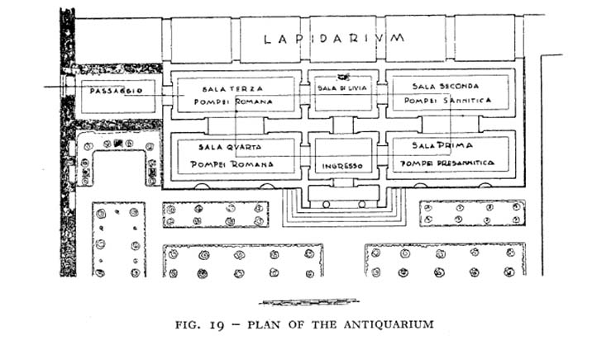
Fig 1, Maiuri, 1978, p.102
With my mapping for the exhibition, I plan on using the floor plan found by Maiuri for the Antiquarium in 1978 and my primary research from the Glynn Vivian gallery.
From looking at this, I gather the symmetrical look and would like to continue this with my work arrangement. I also feel it would be necessary to have some empty spaces to give people the opportunity to slow down and think. As Obrist states, “The exhibition is a space of encounters” (Obrist, 2008), This suggests that exhibitions with empty areas allows spectators a chance to slow down and reflect reinforcing the focus on time and space.
For the entrance I aim to create an introductory room that will allow the viewer to shift the mentality for the exhibition through means such as dimmer lighting and a simpler atmosphere to allow for more focus on the concept of aura

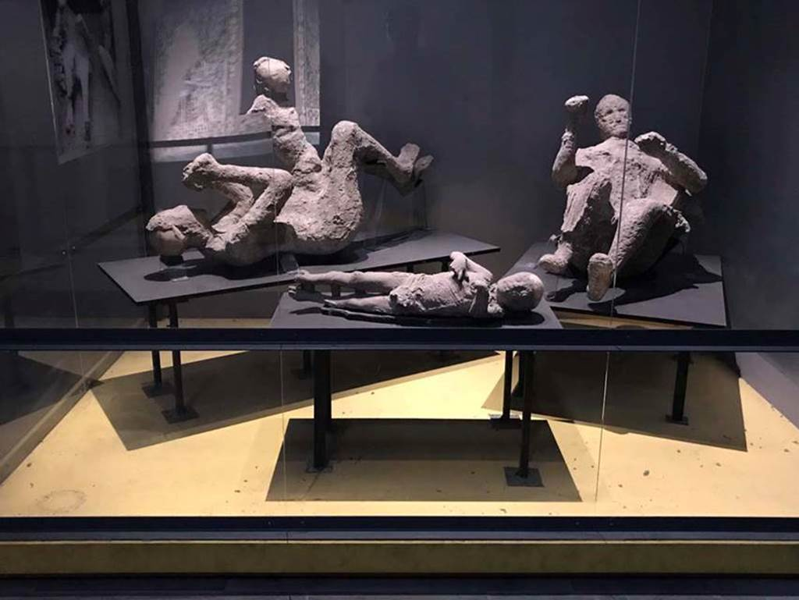
Fig 2, VI.17.42 Pompeii. Victims 50 to 53. April 2019, Rick Bauer
As you walk through from the entrance into the middle, I plan to place the Pompeii artefact as the centre piece to allow this to be focal point. This further empathises the concept of aura with its position in space. I chose this to be the centre point in hopes to emphasize the preserved moment of catastrophe and anchor the exhibition around the historic context. As it was a major tragedy where many people were lost, I tried to limit it to something that would set the scene and therefore chose the ‘suggested family of four’. With the casts being the centre point, I'm able to surround it with works from the other two artists as relations to the casts suggesting the material formation and decay as interconnected processes.
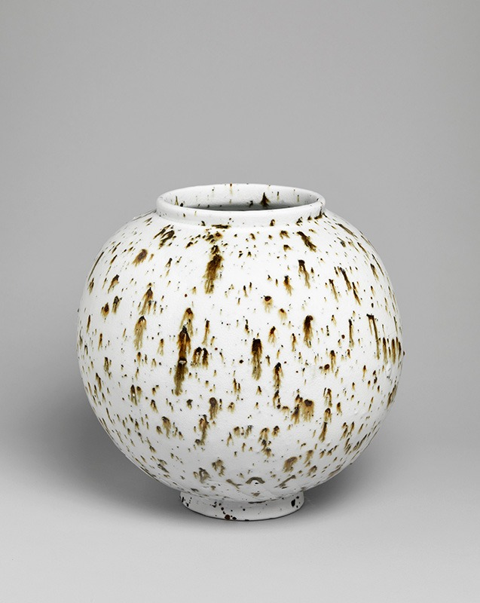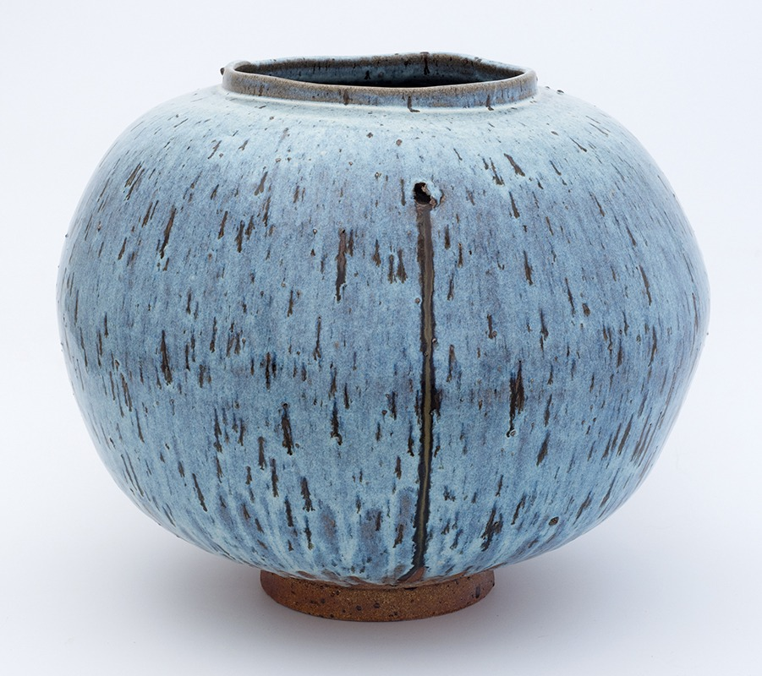Fig 3 & 4, Untitled 2012, porcelain with landscape inclusions, Abereiddi Jar 2011, stoneware with stone inclusions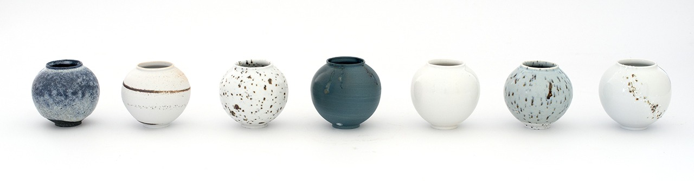Fig 5, Miniature moon jars 2014, Mixed ceramic media with landscape inclusions.
On the left two rooms from the middle, I aim to spread the moon jars created by Adam Buick. The jars represent the intensions behind his work in using the earth and how it affected as he dries and fires them. I aim to arrange the jars between two rooms with one big jar and two mini jars each. The work of adams deeply relates to the Pompeii casts as they both emerge from the ground. As the casts were preserved through the volcanic ash solidifying the catastrophe, adams work use a slower formation to preserve the earths materials through forming, drying and firing. These link to the theme of preservation as it demonstrates the preservation through its means of transforming the material.
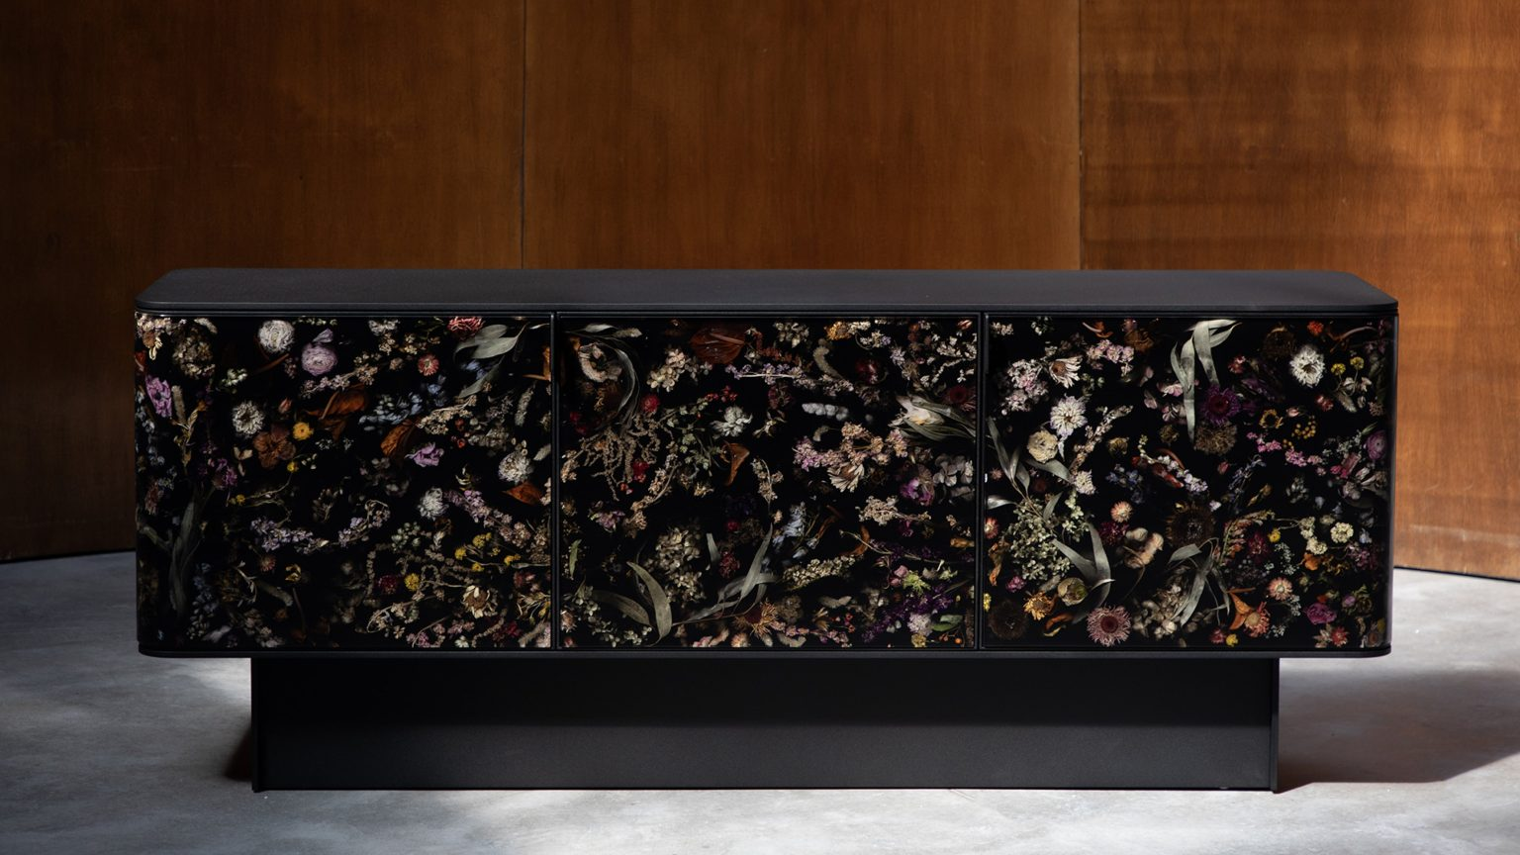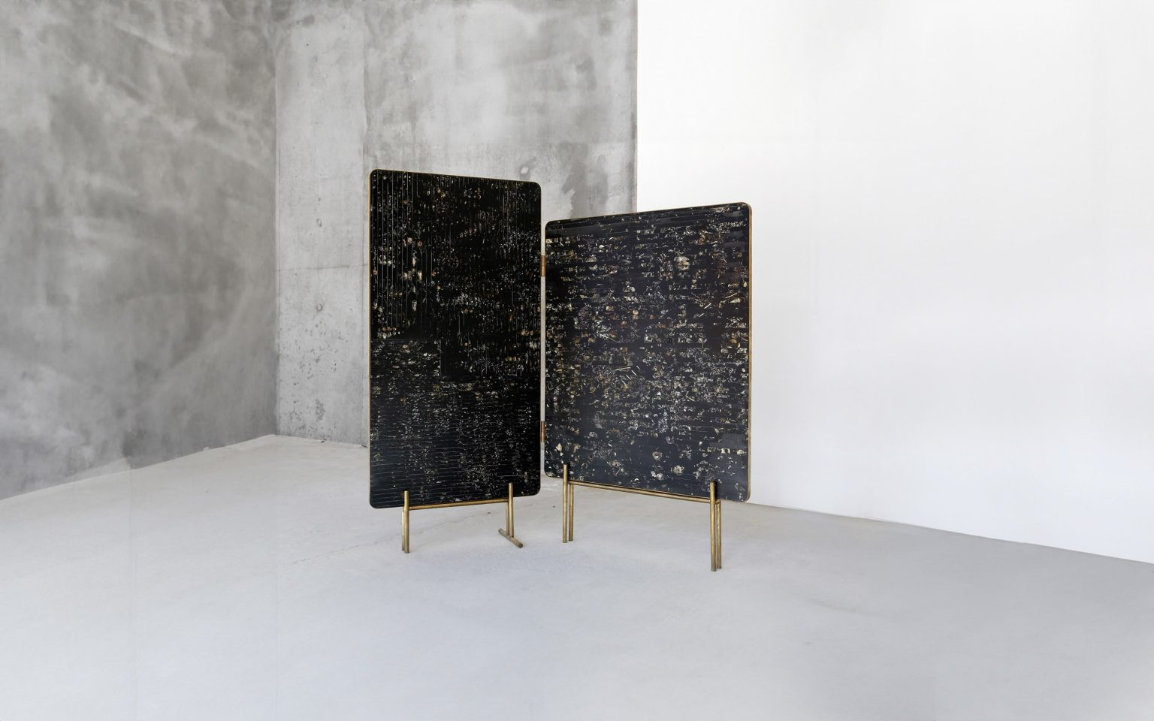
Fig 6 & 7, Flora Credenza 200, Flora Screen
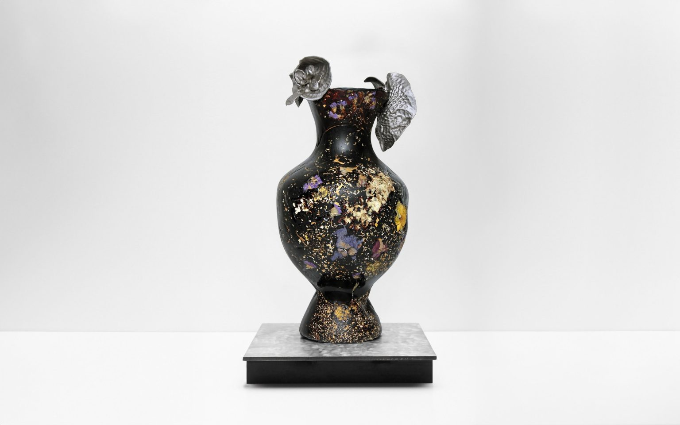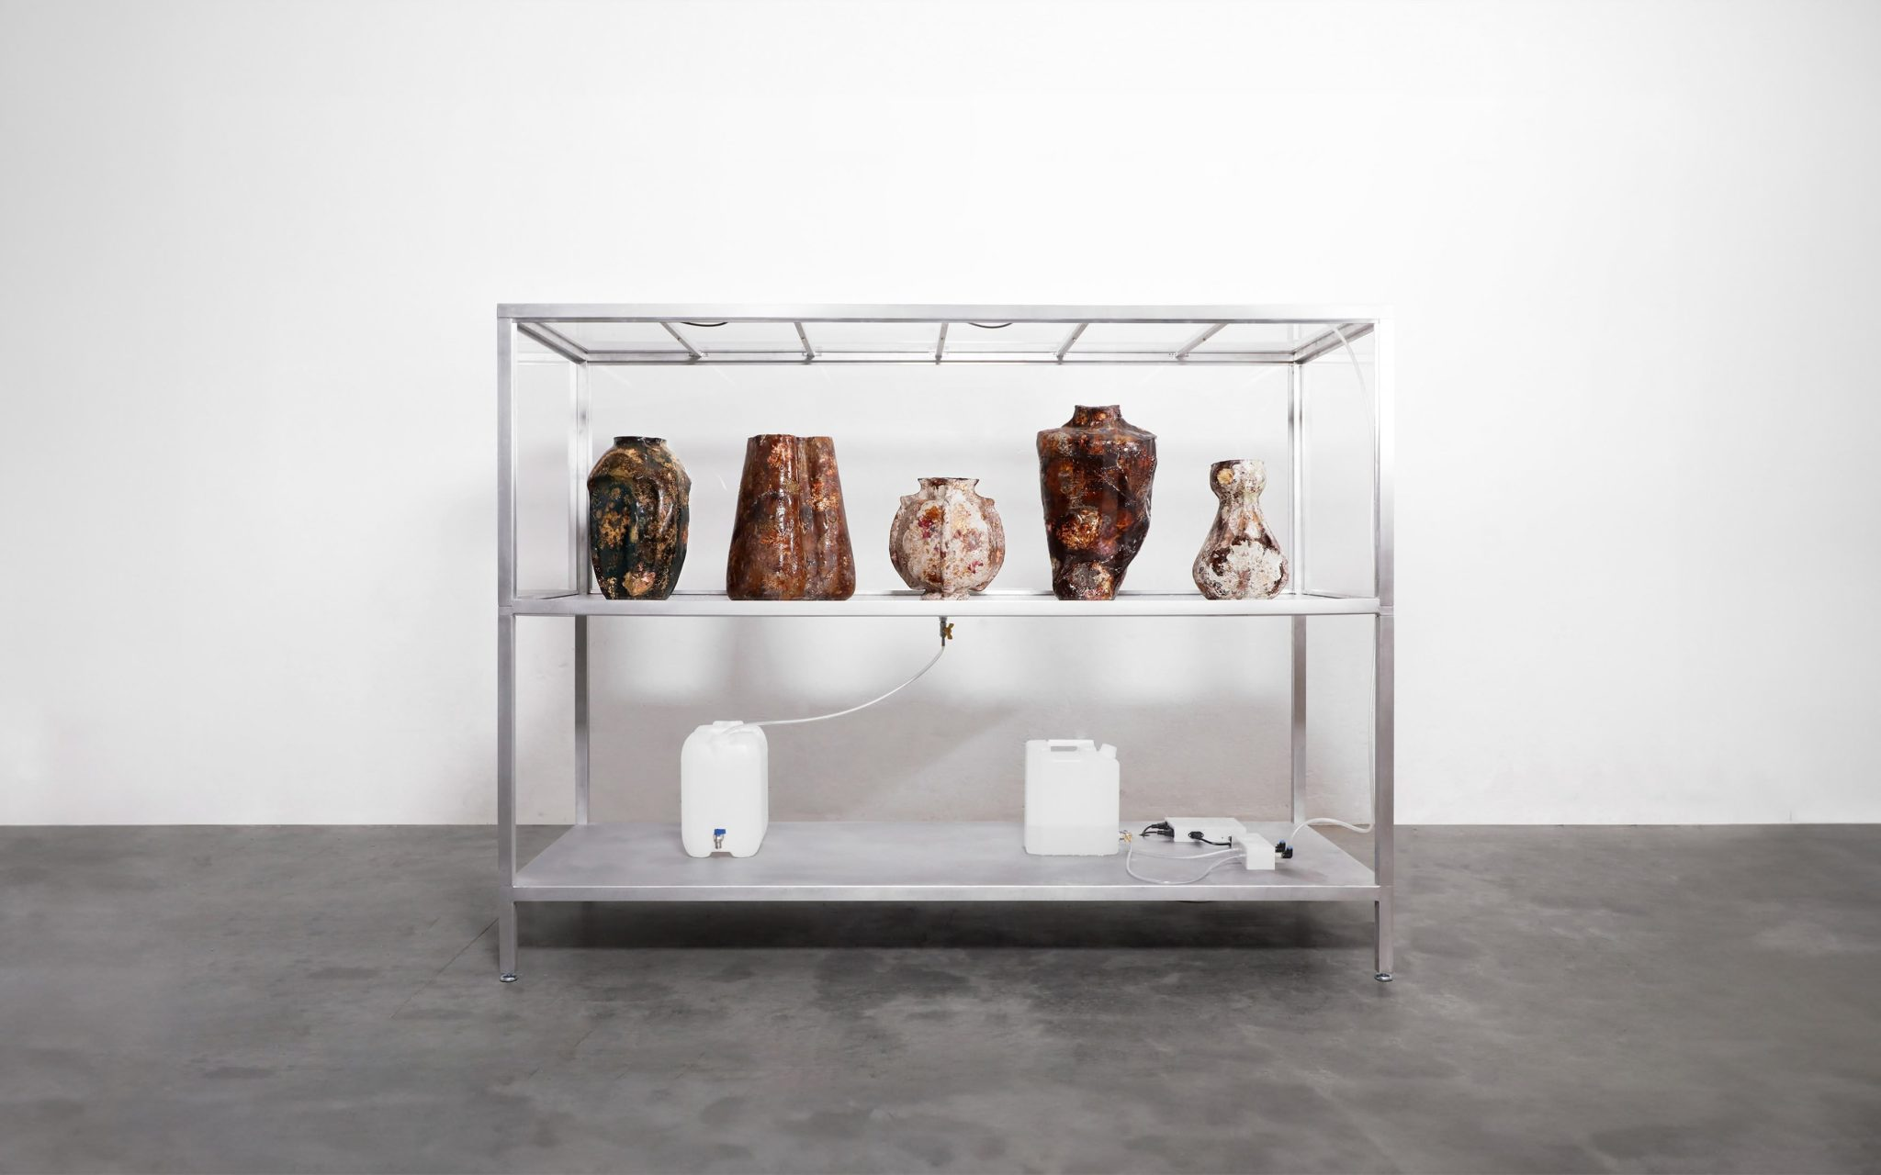Fig 8 & 9, Unique Piecee 2015, Unique 2018
On the right two rooms from the middle, I aim to position his work as a final destination, to end the journey of this exhibition. Therefore, I want to make this room different from the rest by changing its atmosphere. Using lights and arranging them unsymmetrically, I want the viewers to feel the unstable atmosphere with a sense of decay as Marcins work focuses on preserving the decayed flowers. The work being placed scattered gives the room no indication of stability without seeming cluttered which gives more relation to decay and preservation through his work. With his work on the ‘Flora’ series, you see the organic matter being encased in resin that gives an almost fossil like approach, but with time, the organic matter will still decay. This suggests that preservation isn’t permanent, but instead it is temporary and always changes due to time.

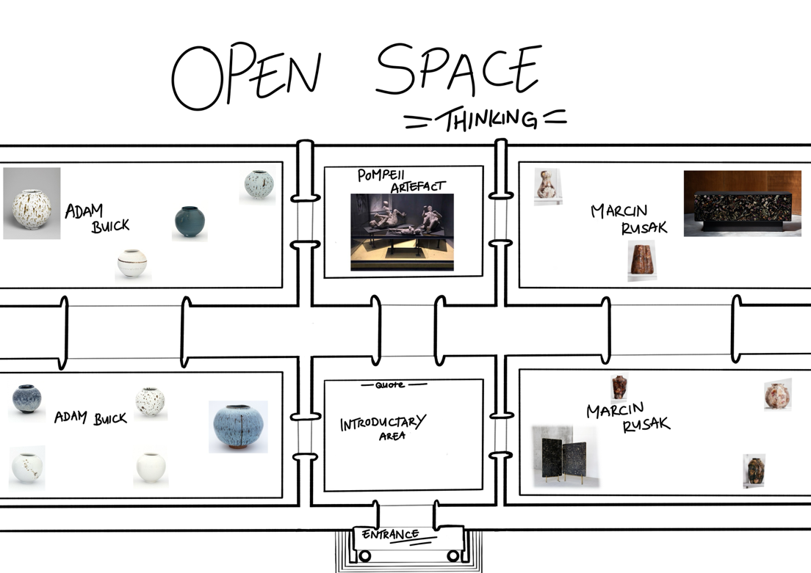
Fig 10, exhibition map, own image, 2026
As seen in Fig 9, my intent for this layout is to show the sequence of transformation through materials reflecting the theme on organic preservation. This shows a journey through the fixed state of preservation with the casts to Buicks works on moon jars that show the slow processes and then leading to the work of Marcin that shifts the focus onto the fragility and decay which disrupt the idea of permanence in preservation. The spaces that have little to nothing allow for pause and time for reflection as it allows them to process the ideas and concepts shown.
As you look at them individually, they each indicate a form of preservation that includes some form of organic matter. This shows the correlation between the artists and artefact whilst also seeing the contrast between each use of preservation as the casts were preserved in a fixed position in time. In contrast, Buicks work shows preservation on a slower, gradual process with materials changing over time. Rusaks work differs further by showing that although the organic materials are being preserved, they still decay with time. Together, these differences show that preservation can be formed with different speeds and change with time meaning they aren't ever stable. This links back to the Walters concept of ‘aura’ as it is presented throughout all works, but this aura isn’t simply maintained by the preservation, but by the ongoing process of the materials transforming with time.
My intention for this exhibition is to highlight the importance of preservation from a contemporary context. As environmental issues show that nature cannot be controlled, I aim to showcase preservation as a process of change rather than permanence. Using the works of Adam Buick and Marcin Rusak to raise awareness on the fragility of organic materials, my intention is to encourage people to find a more sustainable way in understanding the natural world.
References
Antiquarium of Pompeii (2016) - https://pompeiisites.org/en/pompeii-map/antiquarium/ (Accessed 29th March 2026)
Pompeii casts: where they are found and what they are - https://pompeiiinpictures.com/pompeiiinpictures/R8/8%2001%2004%20p3.htm
The casts - https://pompeiisites.org/en/pompeii-map/analysis/the-casts/
Masterclass with Adam Buick (30th Jan 2026) - https://www.ceramicreview.com/videos/masterclass-with-adam-buick/
Adam Buick About page (2019) - https://www.adambuick.com/about/
Marcin Rusak Artist Biography - https://carpentersworkshopgallery.com/artists/marcin-rusak
The Work of Art in the Age of Mechanical Reproduction New York: edited by Hannah Arendt (1969) - https://web.mit.edu/allanmc/www/benjamin.pdf
Obrist, H.U. (2008) A Brief History of Curating. Zurich: JRP|Ringier.

Figures
Fig 1 - VIII.1.4 Pompeii Antiquarium. 1978. https://pompeiiinpictures.com/pompeiiinpictures/R8/8%2001%2004%20p3.htm
Fig 2 – VI.17.42 Pompeii. Victims 50 to 53. April 2019, Rick Bauer https://pompeiiinpictures.com/pompeiiinpictures/Casts/victims%20bracciale.htm
Fig 3 - Untitled 2012, Porcelain with landscape inclusions. https://www.orieltir.com/gallery/
Fig 4 - Abereiddi Jar 2011, Stoneware with stone inclusions. https://www.orieltir.com/gallery/
Fig 5 - Miniature Moon Jars 2014, Mixed ceramic media with landscape inclusions. https://www.orieltir.com/gallery/
Fig 6 – FL2514, Flora Credenza 200, Selected and processed real flowers and leaves, resin, blackened steel. https://marcinrusak.com/objects/fl2514/
Fig 7 – FL1503, Flora Screen, Selected and processed real flowers and leaves, resin, brass. https://marcinrusak.com/objects/fl1503/
Fig 8 – PV1501, Perishable Pieces, Edition: Unique Piecee, 2015 https://marcinrusak.com/objects/pv1501/
Fig 9 – NOT1800, Perishable Vases, Edition: Unique, 2018 https://marcinrusak.com/objects/not1800/
Fig 10 – own image, drawn on procreate, 2026

Bibliography
Antiquarium of Pompeii (2016) - https://pompeiisites.org/en/pompeii-map/antiquarium/ (Accessed 29th March 2026)
Pompeii Tickets & Tours by Headout (2014-2026) https://www.pompeii-tickets.com/antiquarium/ (Accessed 29th March 2026)
Pompeii casts: where they are found and what they are - https://pompeiiinpictures.com/pompeiiinpictures/R8/8%2001%2004%20p3.htm
The casts - https://pompeiisites.org/en/pompeii-map/analysis/the-casts/
Masterclass with Adam Buick (30th Jan 2026) - https://www.ceramicreview.com/videos/masterclass-with-adam-buick/
Adam Buick About page (2019) - https://www.adambuick.com/about/
Contemporary Ceramics, Adam Buick - https://www.contemporaryceramics.uk/makers/adam-buick/
Marcin Rusak Artist Biography - https://carpentersworkshopgallery.com/artists/marcin-rusak
The Work of Art in the Age of Mechanical Reproduction New York: edited by Hannah Arendt (1969) - https://web.mit.edu/allanmc/www/benjamin.pdf
Obrist, H.U. (2008) A Brief History of Curating. Zurich: JRP|Ringier.

