[Date]
Student name Ralph Saramaduo-Hart
Student ID number 2411210
Programme: BSc Applied Computing
Module: Database and Application Development
Module code: ACCA 5026
Lecturer: Dr Fahad Ahmed
Assignment title: ` Database Design & Implementation

Table of Contents
I. Introduction 4
2. Database Design 5
2.1 Entity and Relationship Design 5
Figure 1: 6
Figure 2 7
Patient 8
Department 9
Doctor 9
Appointment 10
Treatment 10
Feedback 11
2.2 Entity relationships 11
2.3 Data-integrity constraints 12
2.4 Normalization 13
3. Database Implementation and Validation 14
3.1 Sample Data and Constraint Testing 14
Figure 3 Patients Table 14
Figure 4 Department Table 14
Figure 5 Doctors Table 15
Figure 6 Appointment Table 15
Figure 7 Treatment Table 16
Figure 8 Feedback Table 16
Figure 9 All Tables 17
3. Database Implementation and Validation 18
3.1 Validating the populated database 18
Query 1 Verify registered patients 18
Figure 11 18
Query 2 Retrieve a patients complete appointment and treatment history 19
Figure 12 19
Query 3 Produce a patient activity Summary 19
Query 4 Verify doctor – to – department assignments 20
Figure 14 20
Query 5 Count doctors within each department 21
Figure 15 21
Query 6 Measure each doctor’s appointment workload 21
Figure 16 21
Query 7 Shows the patients managed by each doctor 22
Figure 17 22
Query 8 Display the complete appointment schedule 23
Figure 18 23
Query 9 Retrieve an individual doctors diary. For example, retrieve Dr. Amelia Patel’s appointments. 23
Figure 19 23
Query 10 Find doctors available for a requested appointment 24
Figure 20 a 24
Figure 20b 24
Query 11 Defect overlapping appointments 25
Figure 21 25
Query 12. Retrieve consultation and treatment records 26
Figure 22 26
Query 13 Check treatment integrity 26
Figure 23 26
Query 14 Display complete patient feedback information 27
Figure 24 27
Query 15 Produce a feedback review dashboard 28
Figure 25 28
Query 16 Detect invalid feedback records 28
Figure 26 28
Query 17 Test a successful transaction and COMMIT 29
Figure 27 a 29
Figure 27b 29
Figure 27b 30
Figure 27d 30
Query 18 Test a failed transaction and Rollback 31
Figure 28a 31
Figure 28b 31
Figure 28c 32
Figure 28d 32
Create Patient 33
Testing the Create Patient 34
Read Patient 35
Update Patient 36
Delete Patient 36
3.3 Transactional Scenario and Transaction Control 37
3.4 Triggers, Functions and Auditing 38
4. Performance Tuning and Query Optimization 39
5. Conclusion and Reflection 41
PART B 42
CRUD Operations 43
Query 1: Create a patient 43
Query 2: Retrieve the test patient 44
Query 3: Modify the patient record 44
Query 4: Delete: Remove the test patient 46
SQL Injection: Overview, Risks and Examples 47
Conclusion 50
References 51

I. Introduction

MedAssist Clinic is a private outpatient healthcare provider located in the UK, delivering general consultations, diagnostic tests, and specialized care. As the clinic expands, manually curated or disjointed records become progressively inadequate for overseeing patient data, clinical schedules, treatment histories, and service evaluations. The suggested resolution is a centralized relational database designed to facilitate the clinic's fundamental administrative and therapeutic operations while ensuring consistent links among records.

The relational model is suitable as MedAssist's data is primarily organized and may be depicted as interconnected entities. Codd's relational model introduced the concept of depicting data via relations, minimizing superfluous reliance between application programs and the actual arrangement of data This is pertinent to the current design as the data concerning patients, doctors, departments, appointments, treatments, and feedback exhibit distinctly recognizable interconnections and integrity prerequisites.

The database prototype was created in MySQL with phpMyAdmin utilizing six business entities: Patient, Department, Doctor, Appointment, Treatment, and Feedback. The execution includes main and foreign keys, unique and check constraints, realistic test data, stored procedures, explicit transaction management, auditing triggers, a stored function, and secondary indexes. Significant importance is attributed to preserving precise clinical interactions, as healthcare data necessitates robust protections for confidentiality, integrity, and accountability [5]..

2. Database Design

2.1 Entity and Relationship Design
The six entities were derived directly from the MedAssist business processes.
Patient stores demographic and contact information including PatientID, PatientNumber, FirstName, LastName, DateOfBirth, email, telephone, address details, registration time and active status. PatientID is a surrogate primary key, while PatientNumber is a unique business key. A surrogate identifier was preferred because contact information can change, whereas relational references should remain stable.
Department stores DepartmentID, DepartmentName, DepartmentDescription and IsActive. Separating department information prevents department names and descriptions being repeatedly stored against individual doctors.
Doctor contains DoctorID, DepartmentID, RegistrationNumber, title, name, contact information and active status. DepartmentID establishes the relationship with Department, while RegistrationNumber is unique.
Appointment represents the principal transactional entity. Its attributes include AppointmentID, PatientID, DoctorID, start and end times, reason for attendance, appointment status, booking user and timestamps. It resolves the conceptual many-to-many relationship between doctors and patients: a patient may consult many doctors and a doctor may see many patients, but each appointment relates one patient to one doctor.
Treatment records the clinical outcome of an appointment through TreatmentID, AppointmentID, diagnosis, clinical notes, treatment plan, follow-up requirement and recording date. AppointmentID is unique in this table, meaning an appointment can have zero or one treatment.
Feedback records the patient's experience using FeedbackID, AppointmentID, rating, comments, review status and timestamps. An appointment may receive zero or one feedback record.
The resulting relationships are therefore: Department 1:N Doctor, Patient 1:N Appointment, Doctor 1:N Appointment, Appointment 1:0..1 Treatment and Appointment 1:0..1 Feedback.

Figure 1: Logical ERD showing the six entities, attributes, keys and cardinalities.
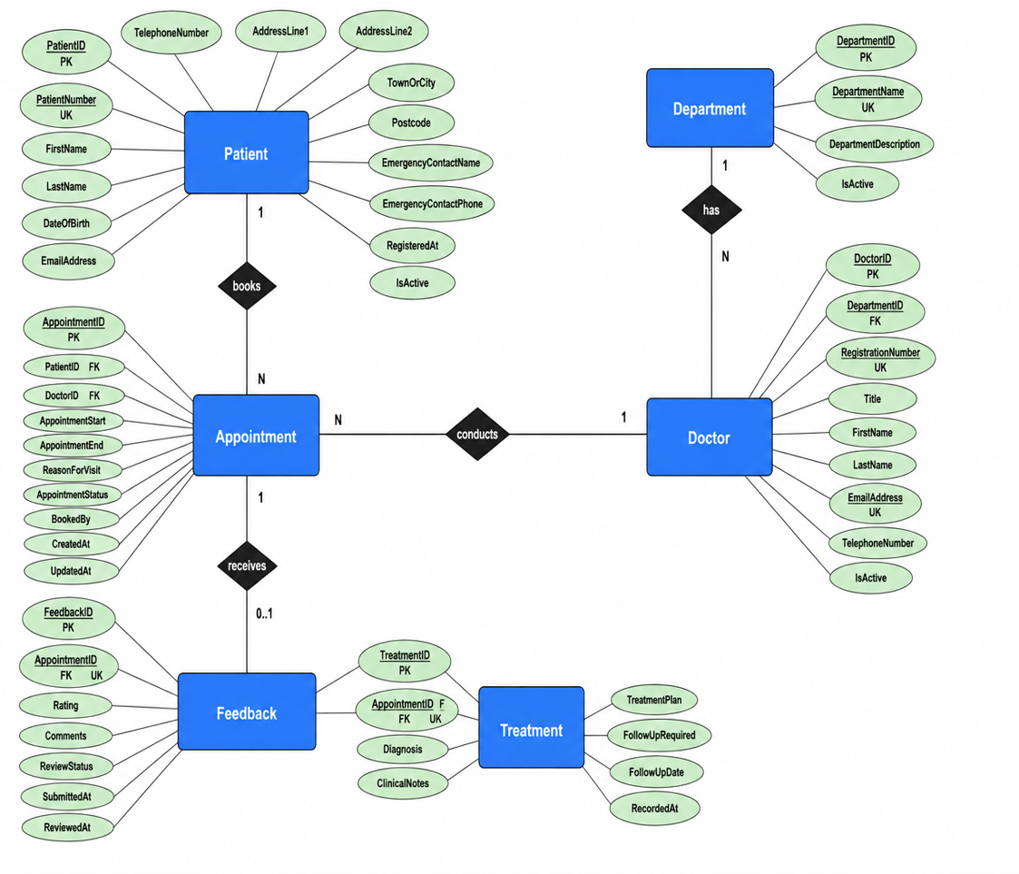

Figure 2: Physical Relational Schema showing Primary Keys, Foreign Keys and Unique Keys
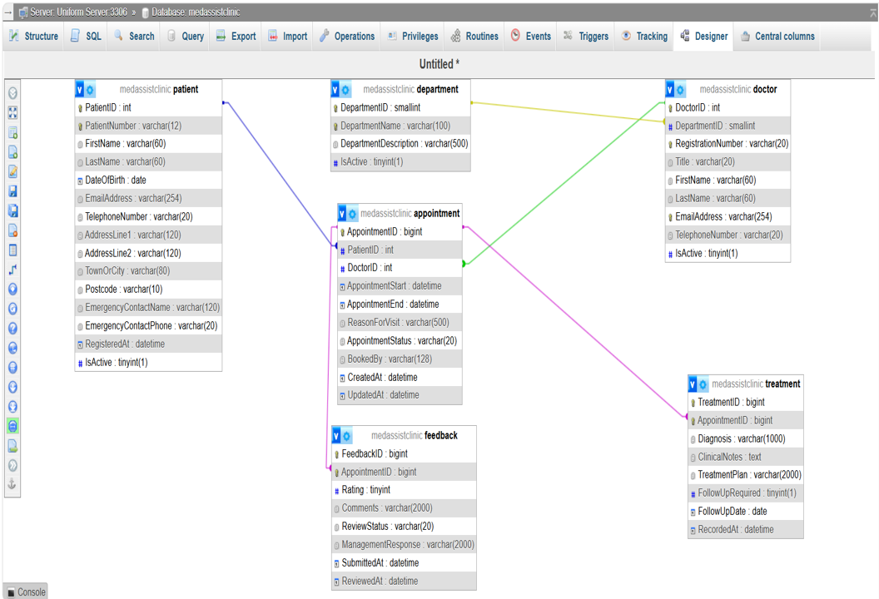

Patient
The Patient entity stores the personal and contact information of every registered patient.
Its principal attributes are:
Attribute | Character
•PatientID | INT | PRIMARY KEY
PatientNumber | VARCHAR(12) | UNIQUE KEY
FirstName | VARCHAR(60) | NOT NULL
LastName | VARCHAR(60) | NOT NULL
DateofBirth | DATE | NOT NULL
EmailAddress | VARCHAR(254) | NULL
TelephoneNumber | VARCHAR(20) | NOT NULL
AddressLine1 | VARCHAR(120) | NOT NULL
AddressLine2 | VARCHAR(120) | NULL
TownorCity | VARCHAR(80) | NOT NULL
Postcode | VARCHAR(10)
EmergencyContactName | VARCHAR(120)
EmergencyContactPhone | VARCHAR(20)
RegisteredAt | DATETIME  DEFAULT CURRENT | NOT NULL  TIMESTAMP
IsActive. | TINYINT(1) | NOT NULL  DEFAULT

A surrogate key named PatientID is used because personal information such as telephone numbers and
email addresses may change. PatientNumber is retained as a unique business identifier used by clinic
staff.

Department
The Department entity stores the clinic’s clinical divisions, such as General Medicine, Dermatology and
Physiotherapy. Its attributes are:
Attribute
DepartmentID | SMALLINT | PRIMARY KEY
DepartmentName | VARCHAR(120) | UNIQUE KEY  NOT NULL
DepartmentDescription | VARCHAR(100) | NULL
IsActive | TINYINT(1) | NOT NULL  DEFAULT 1

Department information is stored once and referenced by doctors, preventing inconsistent department
names from being repeated throughout the database.

Doctor
The Doctor entity stores information about the clinic’s medical professionals. Its attributes include:
Attributes
DoctorID | INT | PRIMARY KEY
DepartmentID | SMALLINT | FOREIGN KEY  NOT NULL
RegistrationNumber | VARCHAR(20) | UNIQUE KEY  NOT NULL
Title | VARCHAR(20) | NULL
FirstName | VARCHAR(80) | NOT NULL
LastName | VARCHAR(80) | NOT NULL
EmailAddress | VARCHAR(254) | UNIQUE KEY NOT NULL
TelephoneNumber | VARCHAR(20)
IsActive | TINYINT(1) | NOT NULL DEFAULT1

Each doctor is assigned to one principal department. However, one department may contain several
doctors.

Appointment
The Appointment entity records a scheduled consultation between one patient and one doctor. Its
attributes include:
Attribute
AppointmentID | BIGINT | PRIMARY KEY
PatientID | INT | FOREIGN KEY
DoctorID | INT | FOREIGN KEY
AppointmentStart | DATETIME
AppointmentEnd | DATETIME
ReasonForVisit | VARCHAR(500)
AppointmentStatus | VARCHAR(20)  DEFAULT ‘Scheduled’
BookedBy | VARCHAR(128)
CreatedAt | DATETIME  DEFAULT CURRENT_TIMESTAMP
UpdatedAt | DATETIME  ON UPDATE CURRENT_TIMESTAMP | NULL

The appointment table resolves the many-to-many relationship between patients and doctors. A patient
may consult several doctors, and a doctor may consult several patients, but each appointment records one
specific patient-doctor interaction.

Treatment

The Treatment entity stores the outcome of a completed consultation. Its attributes are:
Attributes
TreatmentID | BIGINT | PRIMARY KEY
AppointmentID | BIGINT | UNIQUE KEY  NOT NULL
Diagnosis | VARCHAR(1000) | NOT NULL
ClinicalNotes | TEXT | NOT NULL
TreatmentPlan | VARCHAR(2000) | NULL
FollowUpRequired | DATE | NULL
RecordedAt | DATETIME  DEFAULT CURRENT_TIMESTAMP | NOT NULL

The unique constraint on AppointmentID ensures that one appointment cannot have more than one
treatment record.

Feedback
The Feedback entity stores a patient’s evaluation of a completed appointment. Its main attributes are:
FeedbackID | BIGINT | PRIMARY KEY
AppointmentID | BIGINT | FOREIGN KEY  UNIQUE KEY  NOT NULL
Rating | TINYINT | NOT NULL
Comments | VARCHAR(2000) | NULL
ReviewStatus | VARCHAR(20)  DEFAULT ‘Submitted’ | NOT NULL
SubmittedAt | DATETIME  DEFAULT CURRENT_TIMESTAMP | NOT NULL
ReviewedAt | DATETIME | NULL

The rating will be restricted to values between 1 and 5. A unique constraint on AppointmentID ensures that
an appointment cannot receive duplicate feedback records.

2.2 Entity relationships
The principal relationships are:
- one patient may have many medical-history records;
- one department may contain many doctors;
- one doctor may have many availability periods;
- one patient may book many appointments;
- one doctor may conduct many appointments;
- one appointment may produce zero or one treatment;
- one prescription contains one or more prescription items;
- one appointment may receive zero or one feedback record.

This relatively focused six-entity design deliberately avoids introducing entities not explicitly required by the case study. For example, prescriptions are currently represented within the treatment plan rather than through separate medication tables. This simplifies the prototype but is also a recognized limitation: a production implementation should separate prescriptions and medication items if MedAssist requires structured prescribing, interaction checking or medication-level reporting.

2.3 Data-integrity constraints
Data integrity is enforced at several levels. Every table has a primary key, ensuring entity integrity by preventing duplicate or null identifiers. Business identifiers are additionally protected with unique constraints, including PatientNumber, DepartmentName, RegistrationNumber and doctor email address.

Foreign keys enforce referential integrity. Doctor.DepartmentID references Department.DepartmentID; Appointment.PatientID and Appointment.DoctorID reference their parent records; and Treatment.AppointmentID and Feedback.AppointmentID reference an existing appointment. This prevents orphan records such as a treatment belonging to a non-existent consultation.

Check constraints enforce domain validity. Appointment end time must be later than appointment start time, feedback ratings are restricted to 1–5, and appointment status is limited to recognized values such as Scheduled, CheckedIn, Completed, Cancelled and DidNotAttend. Boolean-style fields are limited to 0 or 1.

Deletion is deliberately restrictive. Automatically cascading deletion from a patient to appointments and treatments could remove important clinical history. The implementation therefore favours ON DELETE RESTRICT and logical deactivation through IsActive. This decision prioritizes historical integrity over deletion convenience and is particularly appropriate where records have operational or compliance value. Research on database compliance similarly emphasizes that operational mechanisms must be considered together with retention and governance requirements rather than purely from a convenience perspective [6].

2.4 Normalization

The schema was normalized to Third Normal Form (3NF). Normalization is intended to reduce redundancy and associated insertion, update and deletion anomalies. Codd's relational work introduced normal forms as a means of reducing undesirable dependency and inconsistency, while more recent database research continues to connect structured storage design with efficient retrieval and maintainability [1], [2].

First Normal Form is satisfied because each table has a primary key, fields contain atomic values and there are no repeating column groups. For example, the database does not contain Doctor1, Doctor2 or Appointment1 fields within Patient.

Second Normal Form is satisfied because every non-key attribute depends on the complete primary key. The six core tables use single-column surrogate primary keys, eliminating partial dependency on composite identifiers.

Third Normal Form removes transitive dependencies between non-key attributes. DepartmentName exists only in Department; it is not repeated in Doctor or Appointment. Doctor contact information exists only in Doctor; Appointment stores DoctorID. Similarly, patient demographic data exists only in Patient and is retrieved through the foreign key when appointment information is displayed.

This structure means that changing a doctor's email address requires one update rather than changes to every historical appointment. Normalization does increase the number of joins needed to reconstruct complete clinical information, but this trade-off is preferable to inconsistent duplicated data. Where joins become performance-critical, indexing and query optimization provide a more controlled response than premature denormalization [2].

3. Database Implementation and Validation

3.1 Sample Data and Constraint Testing
The six tables were populated with realistic test records representing patients, doctors, ten clinical departments, scheduled and completed appointments, treatment outcomes and patient feedback. The dataset was deliberately varied so that both successful and unsuccessful database operations could be tested.

Figure 3 Patients Table
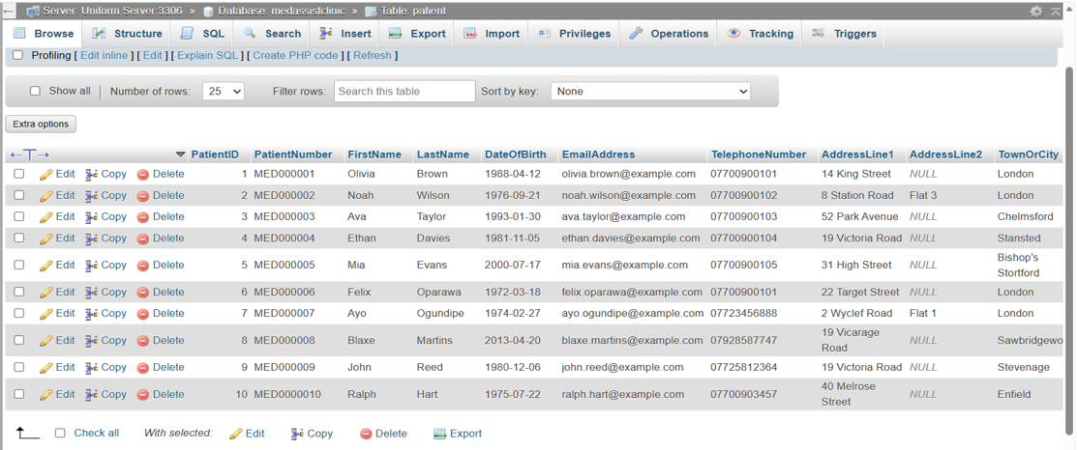

Figure 4 Department Table

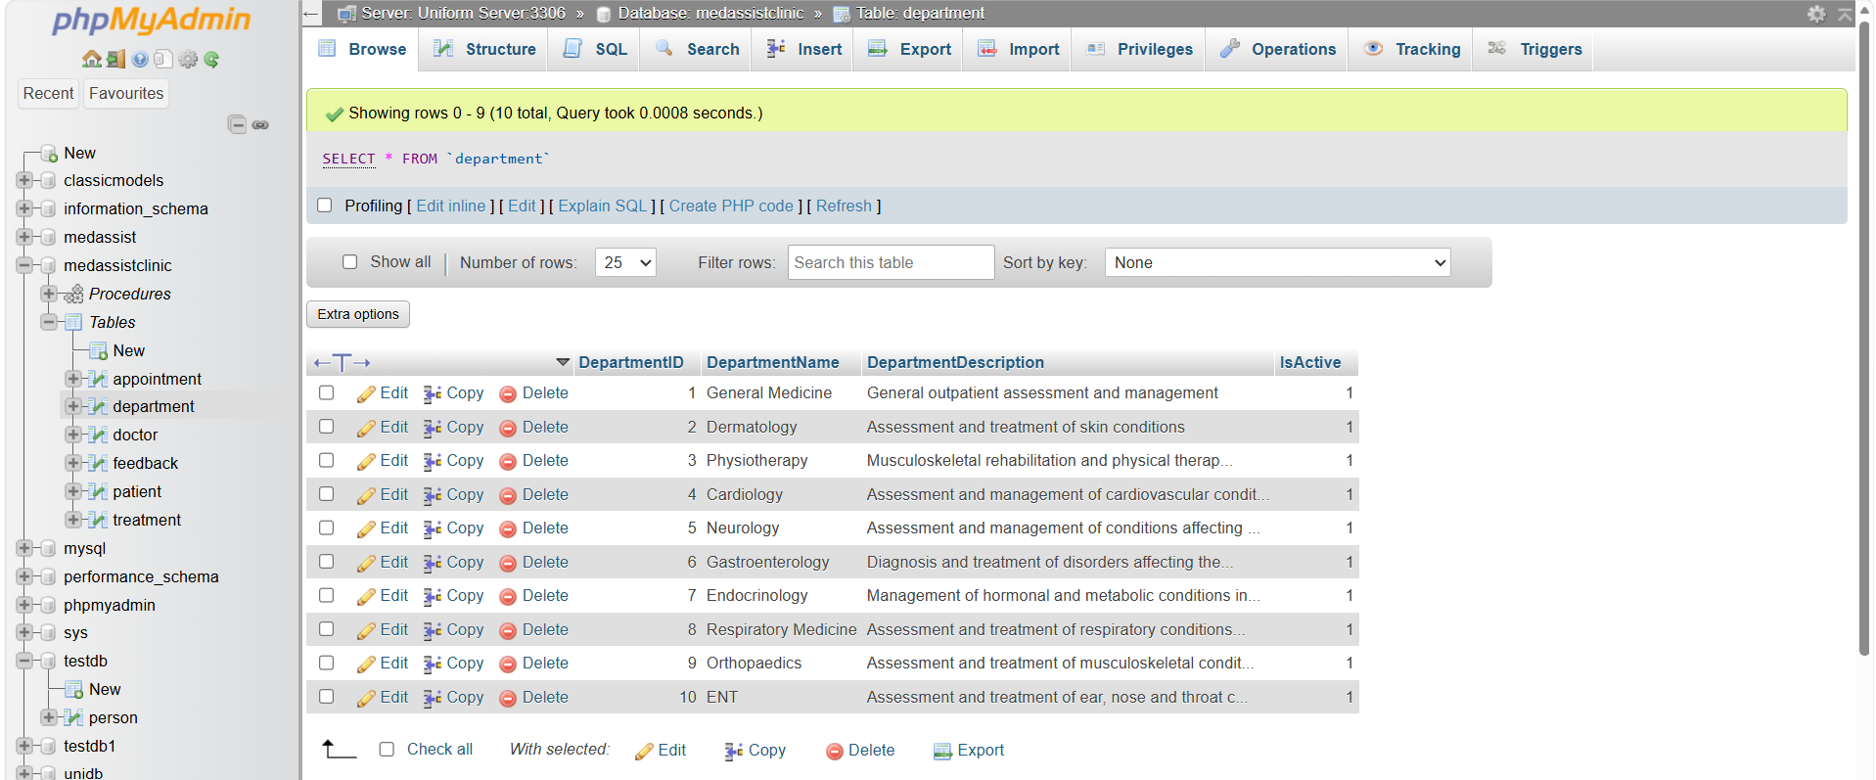

Figure 5 Doctors Table

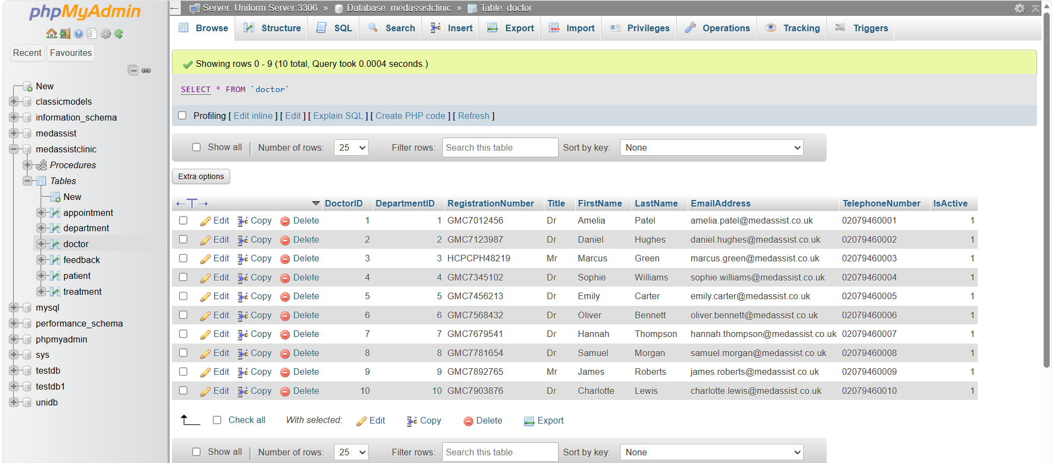

Figure 6 Appointment Table

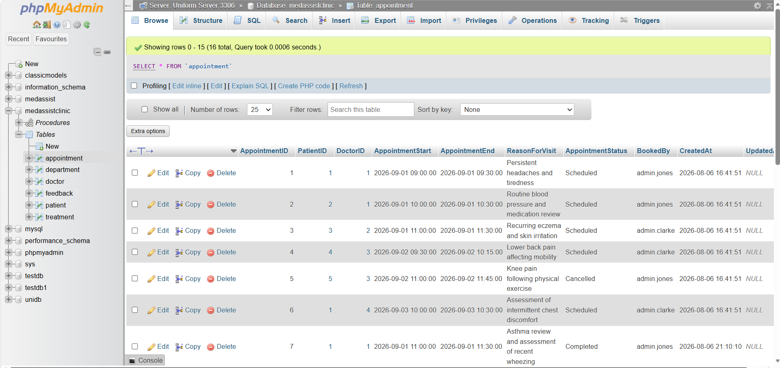

Figure 7 Treatment Table

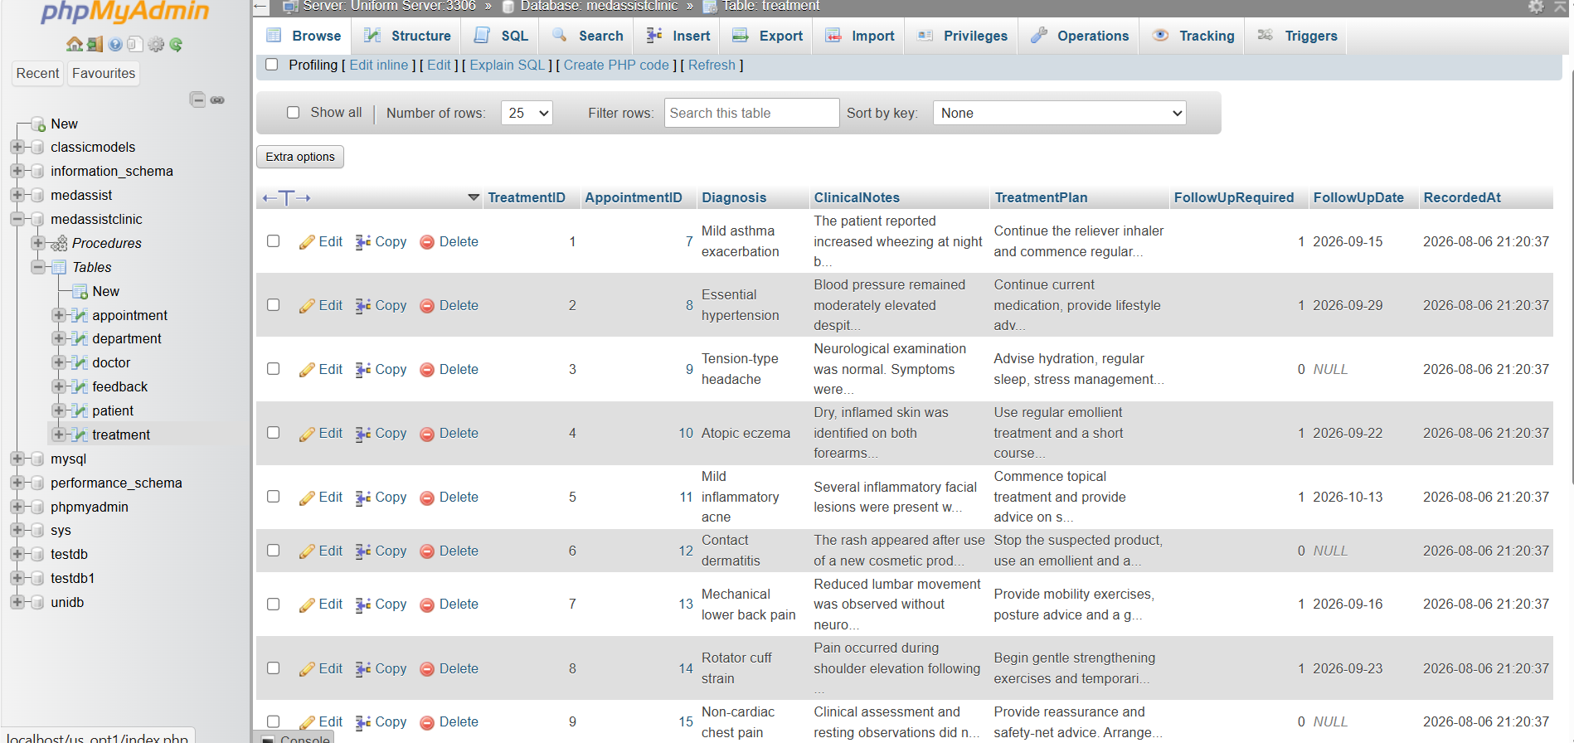

Figure 8 Feedback Table

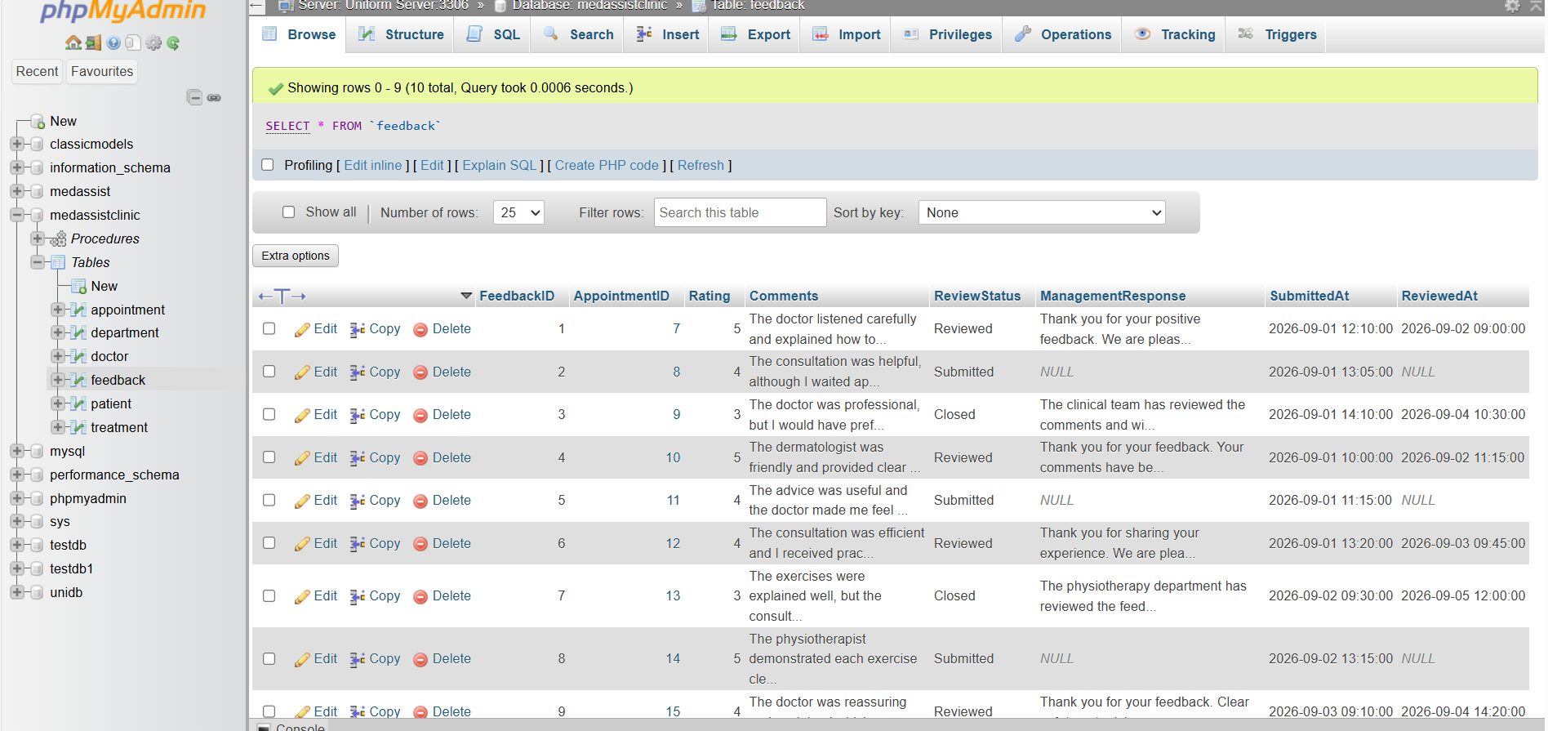

Figure 9 All Tables

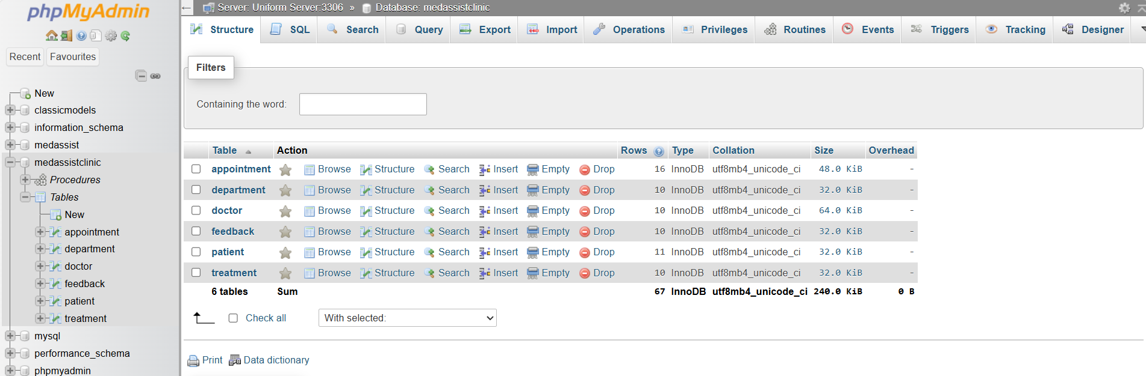

3. Database Implementation and Validation

3.1 Validating the populated database

Here we test the processes to see if our database is robust to handle all enquiries.

Query 1 Verify registered patients

Figure 11

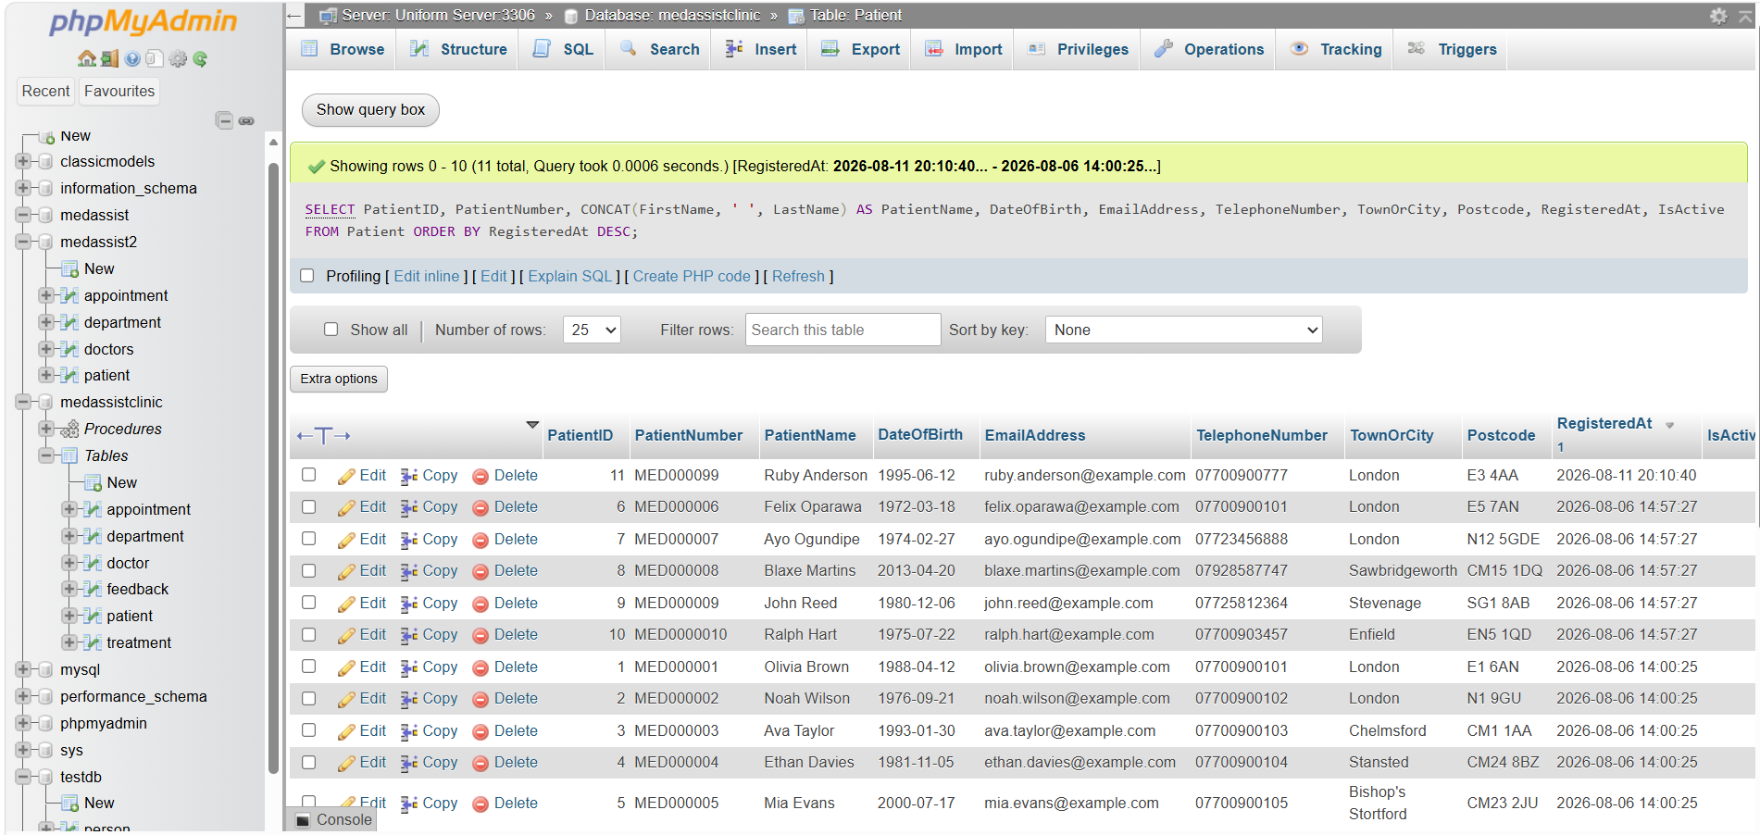

This confirms that patient registration records are stored correctly and allows the most recently registered patients to be identified.

Query 2 Retrieve a patients complete appointment and treatment history

Figure 12

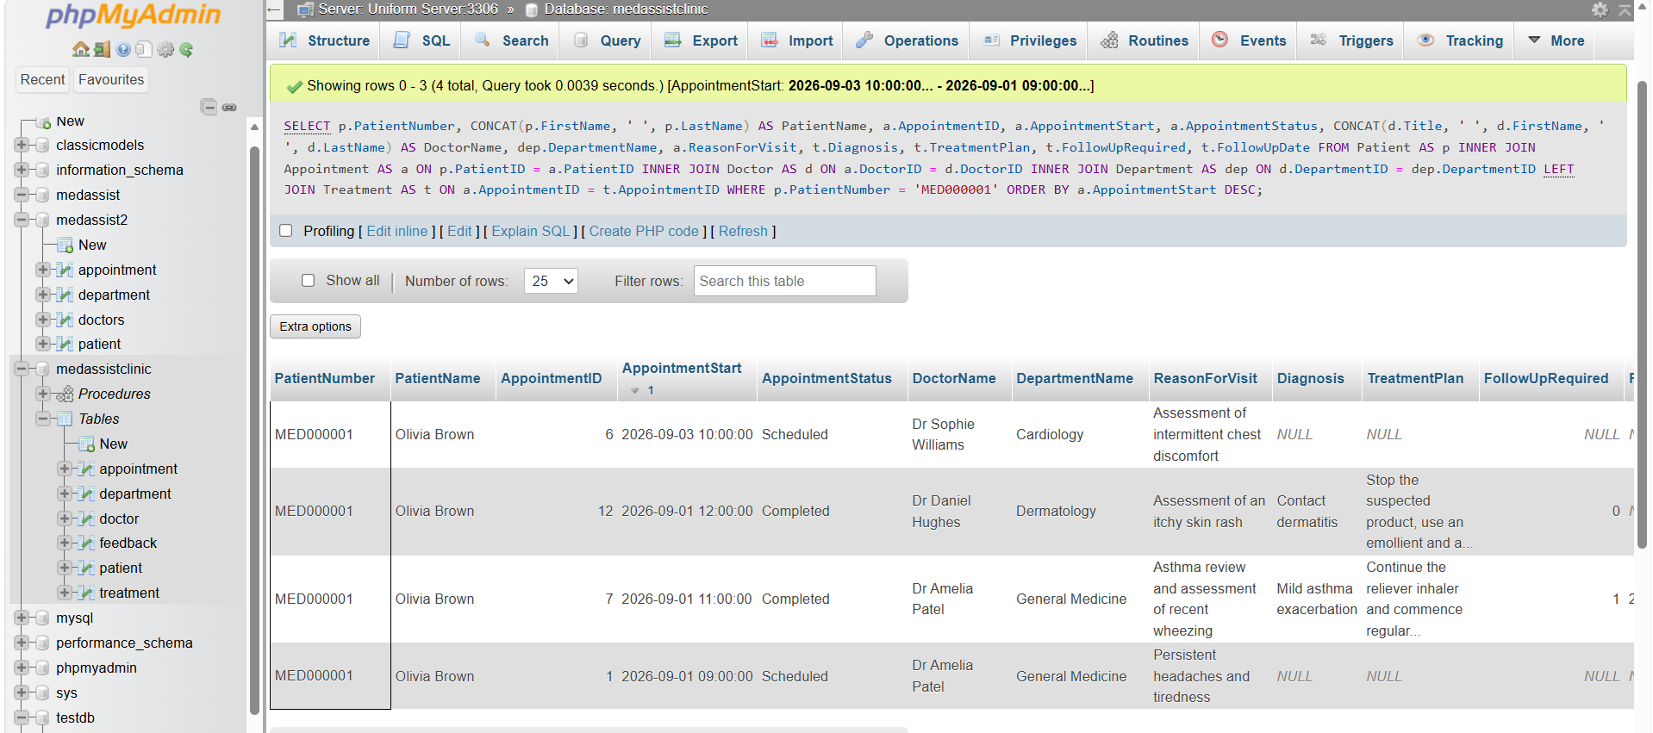

This is one of the strongest relationship tests because it joins Patients, Appointment, Doctor, Department and Treatment. This query demonstrates that a patient can have multiple appointments and treatment records while avoiding duplicated demographic information.

Query 3 Produce a patient activity Summary

Figure 13

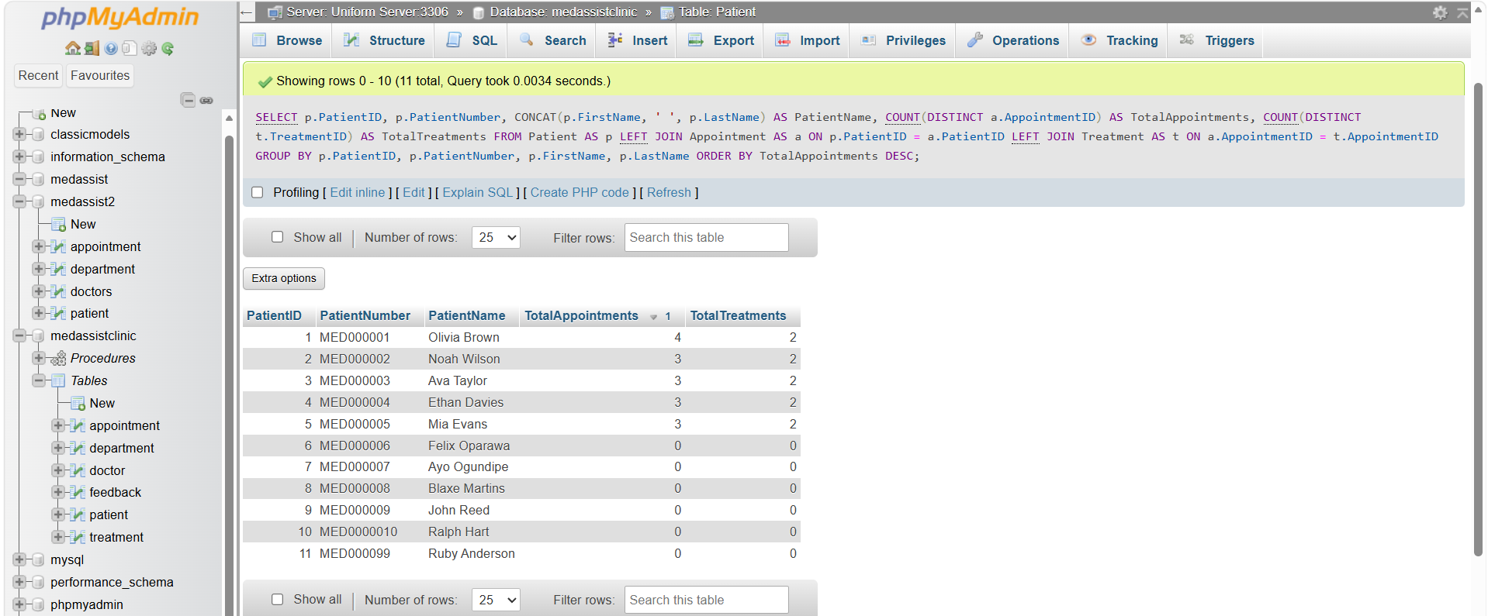
This provides a management – level view of how many appointments and treatments each patient has. The use of LEFT JOIN is deliberate because registered patients should still appear even if they have not yet attended an appointment.

Query 4 Verify doctor – to – department assignments

Figure 14
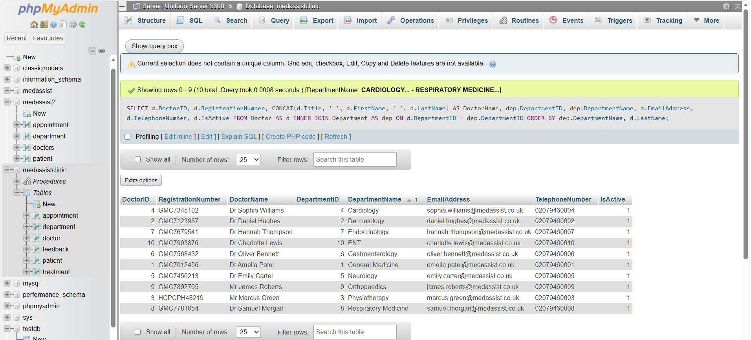

This demonstrates the business rule that every doctor is assigned to a valid department.

Query 5 Count doctors within each department

Figure 15

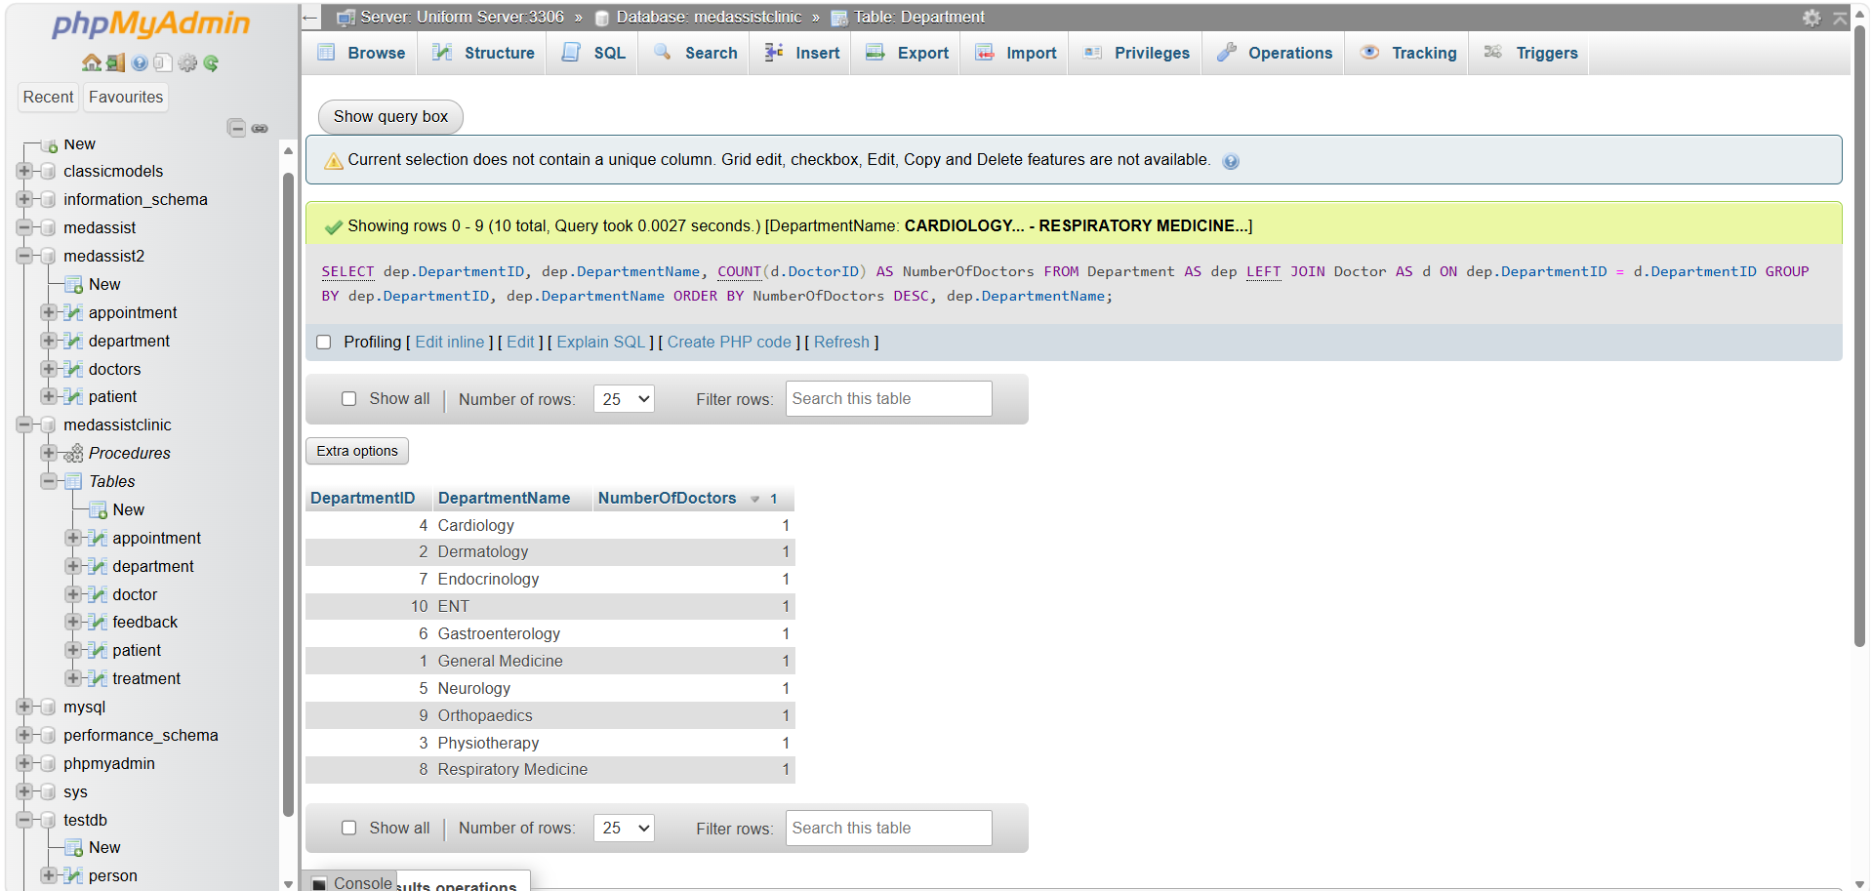

A left join is appropriate because it also identifies departments that currently have no doctors assigned.

Query 6 Measure each doctor’s appointment workload

Figure 16

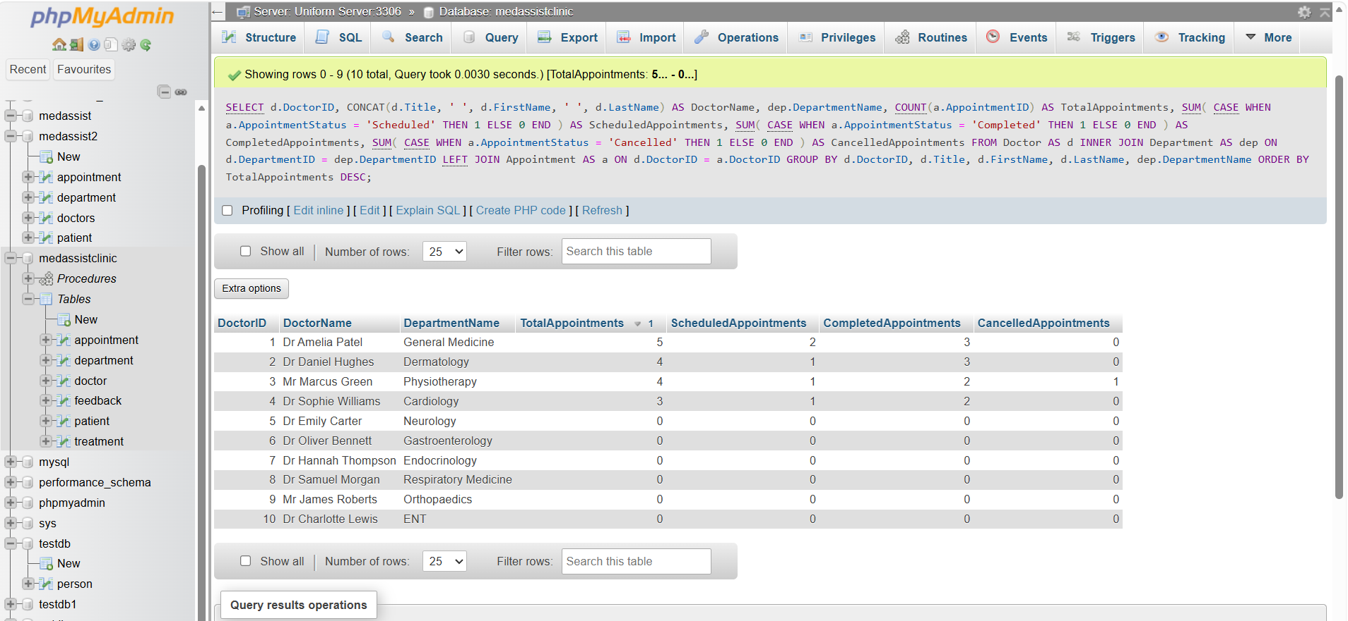
This demonstrates that a doctor can conduct many appointments and supports workload monitoring.

Query 7 Shows the patients managed by each doctor

Figure 17

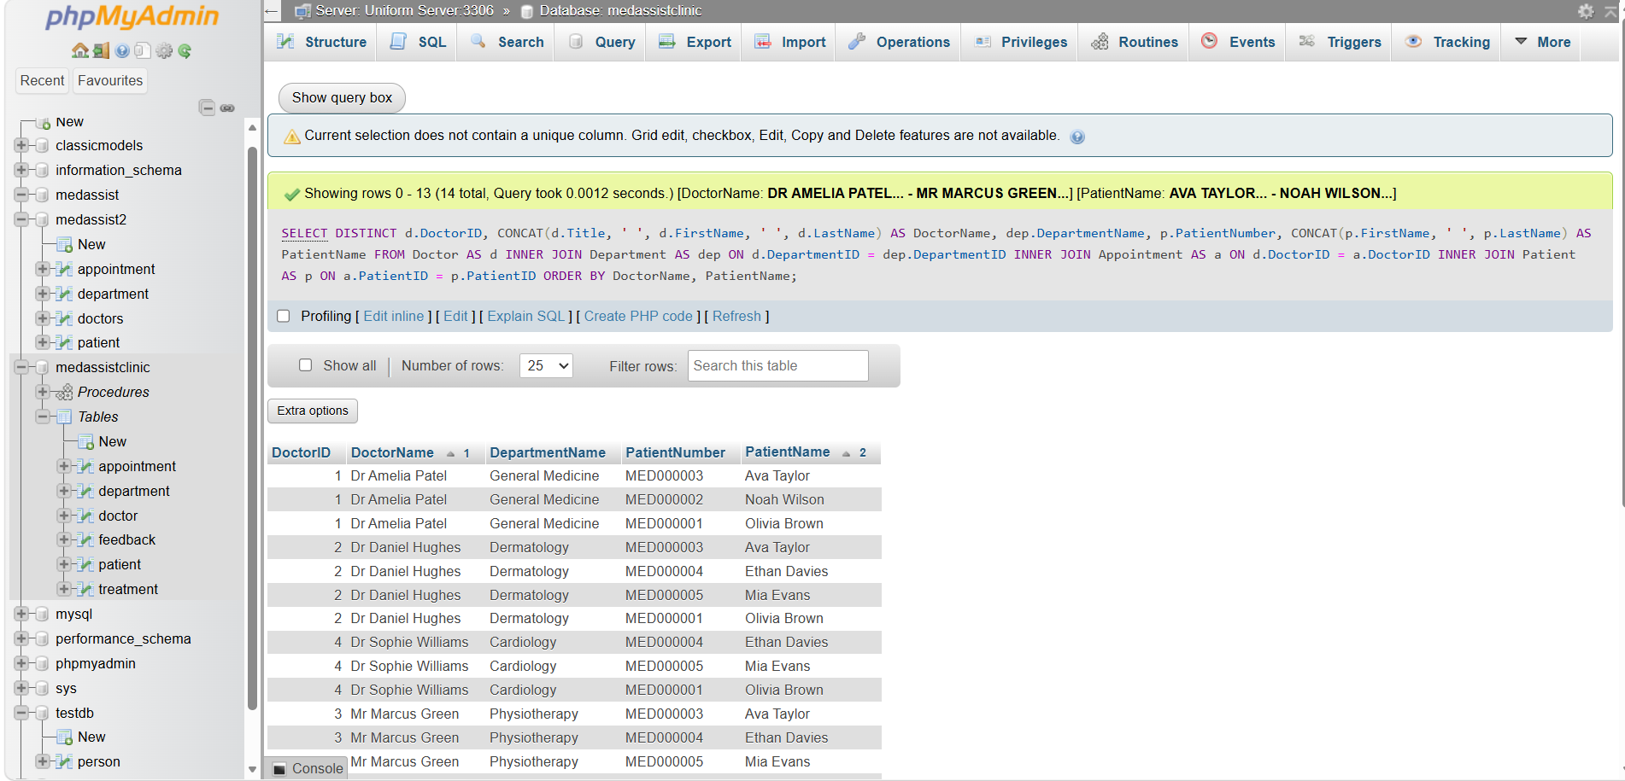

This is useful evidence of the conceptual many to many relationships between patients and doctors being resolved through Appointment.

Query 8 Display the complete appointment schedule

Figure 18

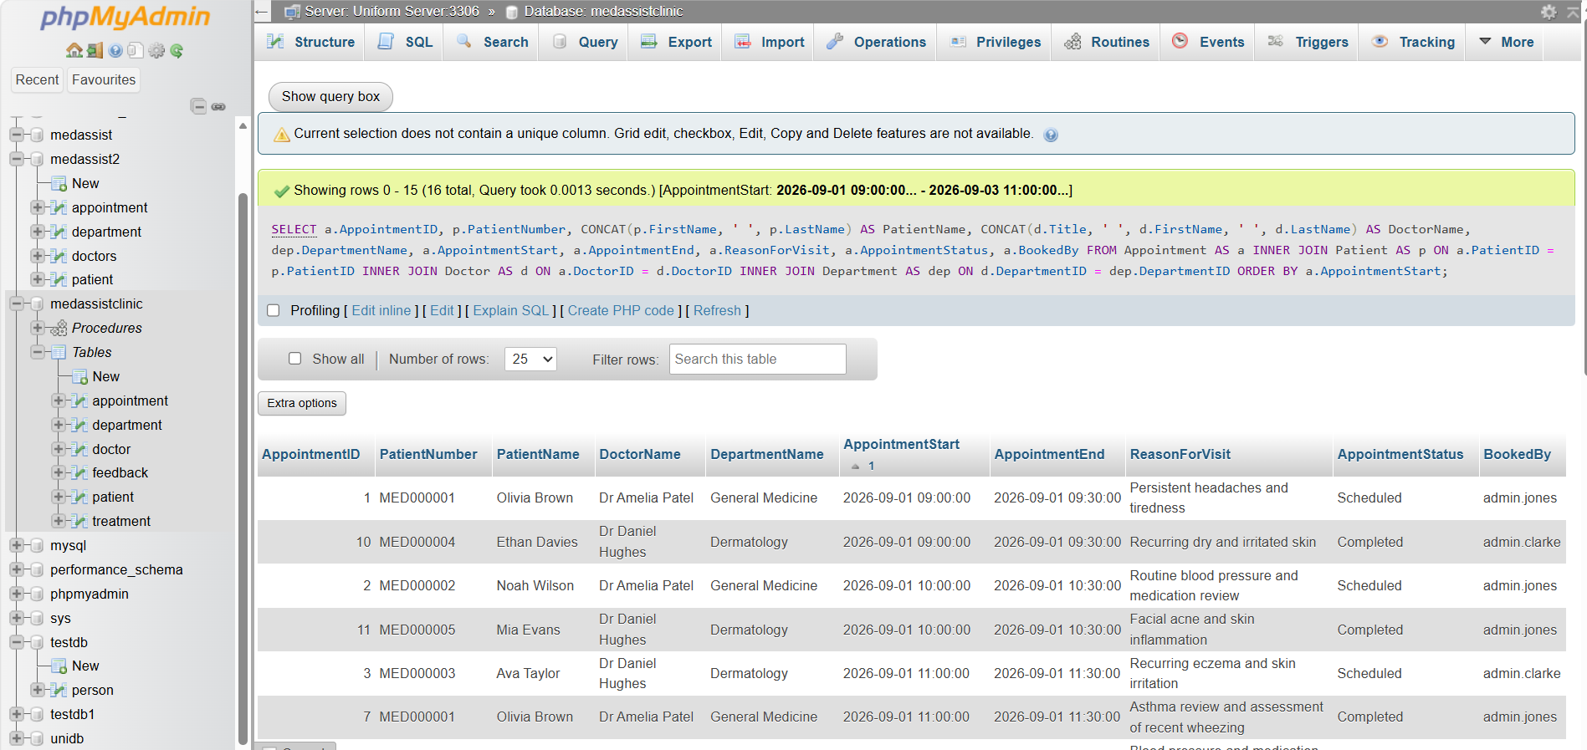

This demonstrates the entire Appointment Booking relationship in one query

Query 9 Retrieve an individual doctors diary. For example, retrieve Dr. Amelia Patel’s appointments.

Figure 19

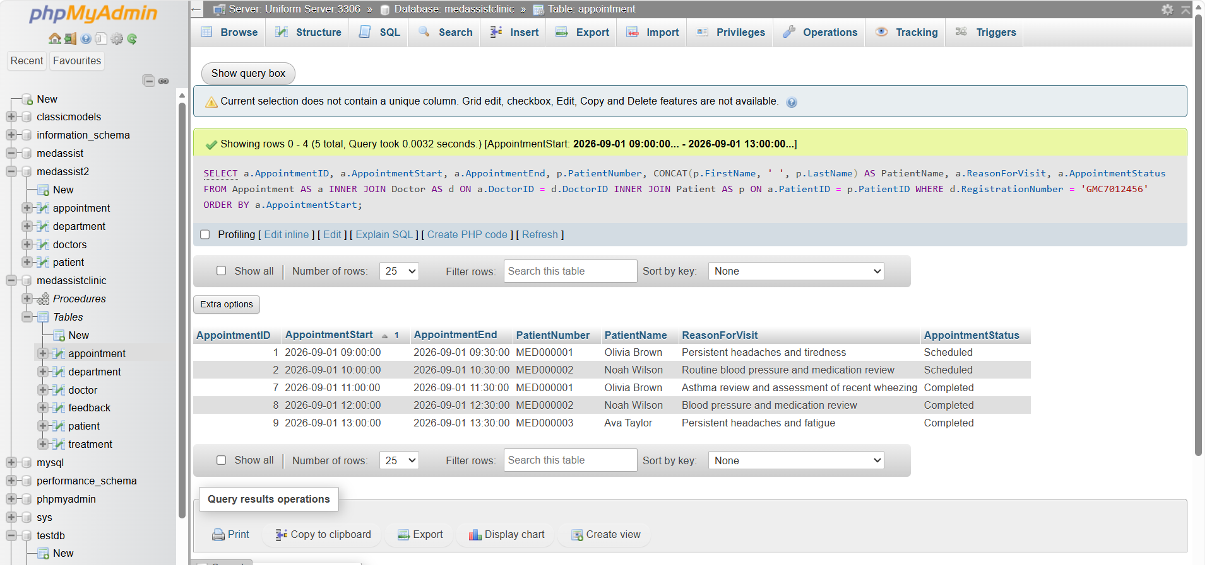
This reflects how administrative staff could retrieve a doctors clinic scheudule.

Query 10 Find doctors available for a requested appointment

Figure 20 a

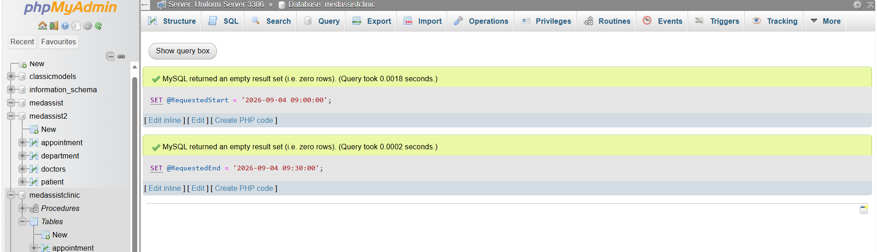

Then

Figure 20b
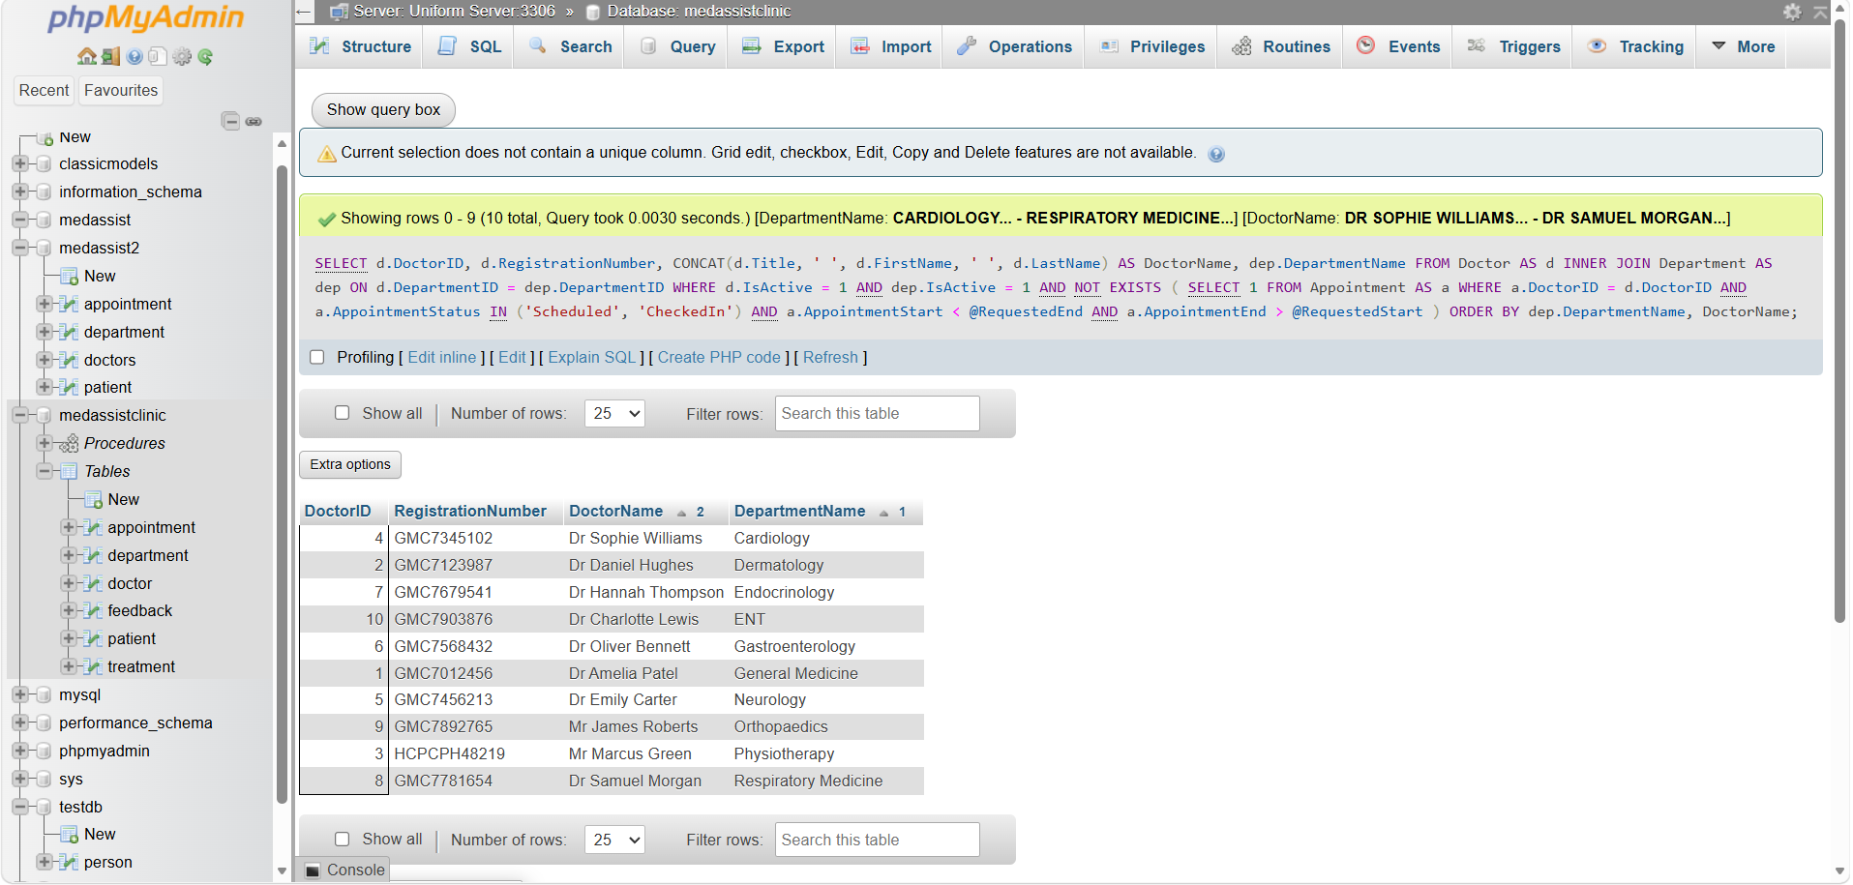
This demonstrates practical appointment scheduling by finding doctors who are free from conflicting active bookings.

Query 11 Defect overlapping appointments

A robust scheduling database should be capable of detecting accidental double bookings

Figure 21

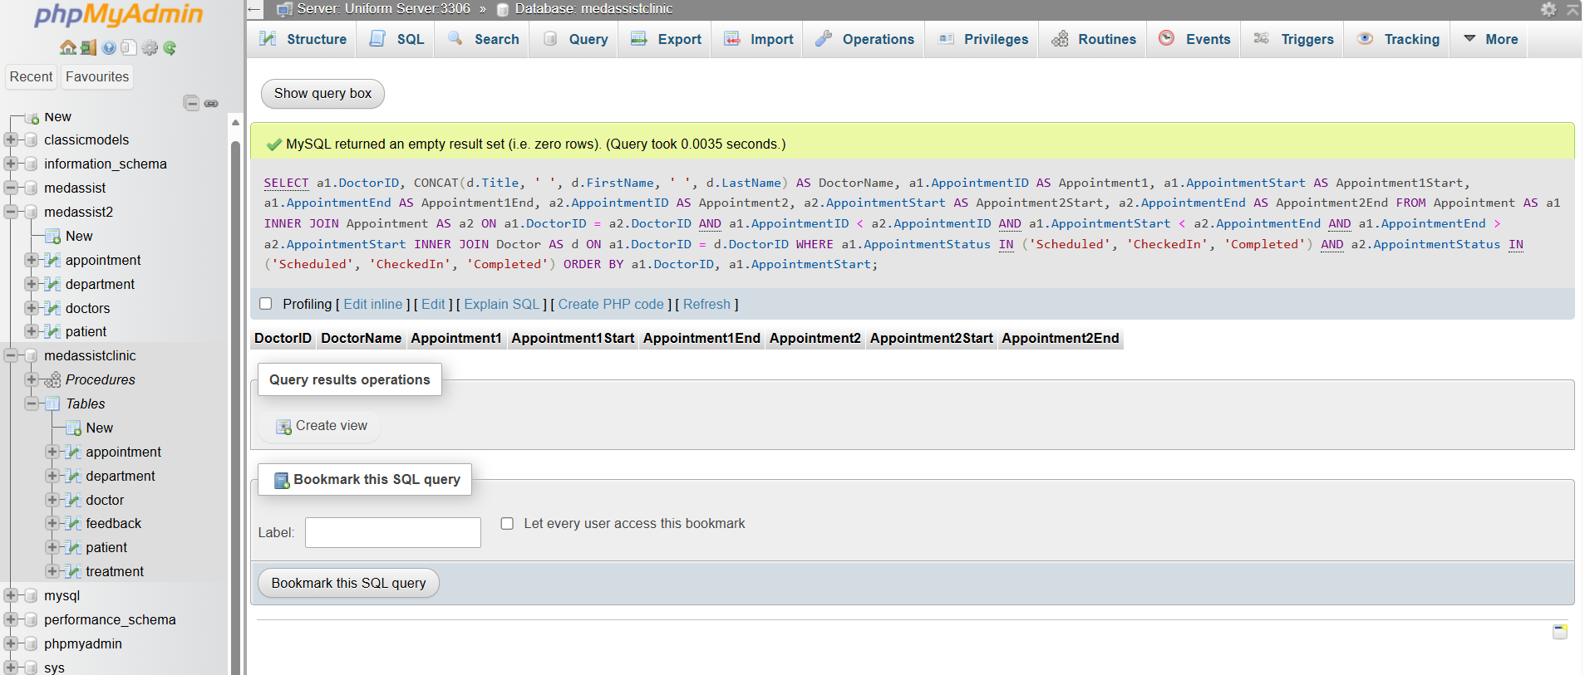

For properly prepared data, this should ideally return
0 rows

Query 12. Retrieve consultation and treatment records

Figure 22

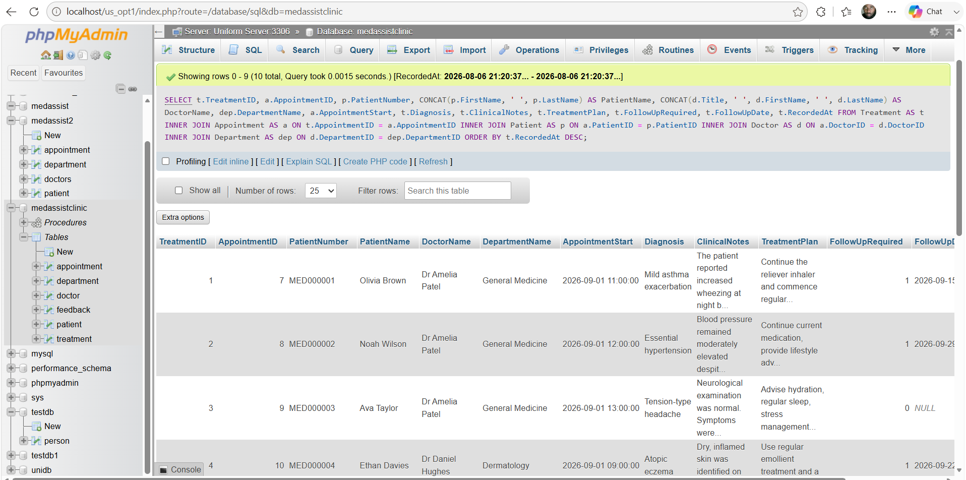
This directly demonstrates consultation and treatment recordings

Query 13 Check treatment integrity

Figure 23

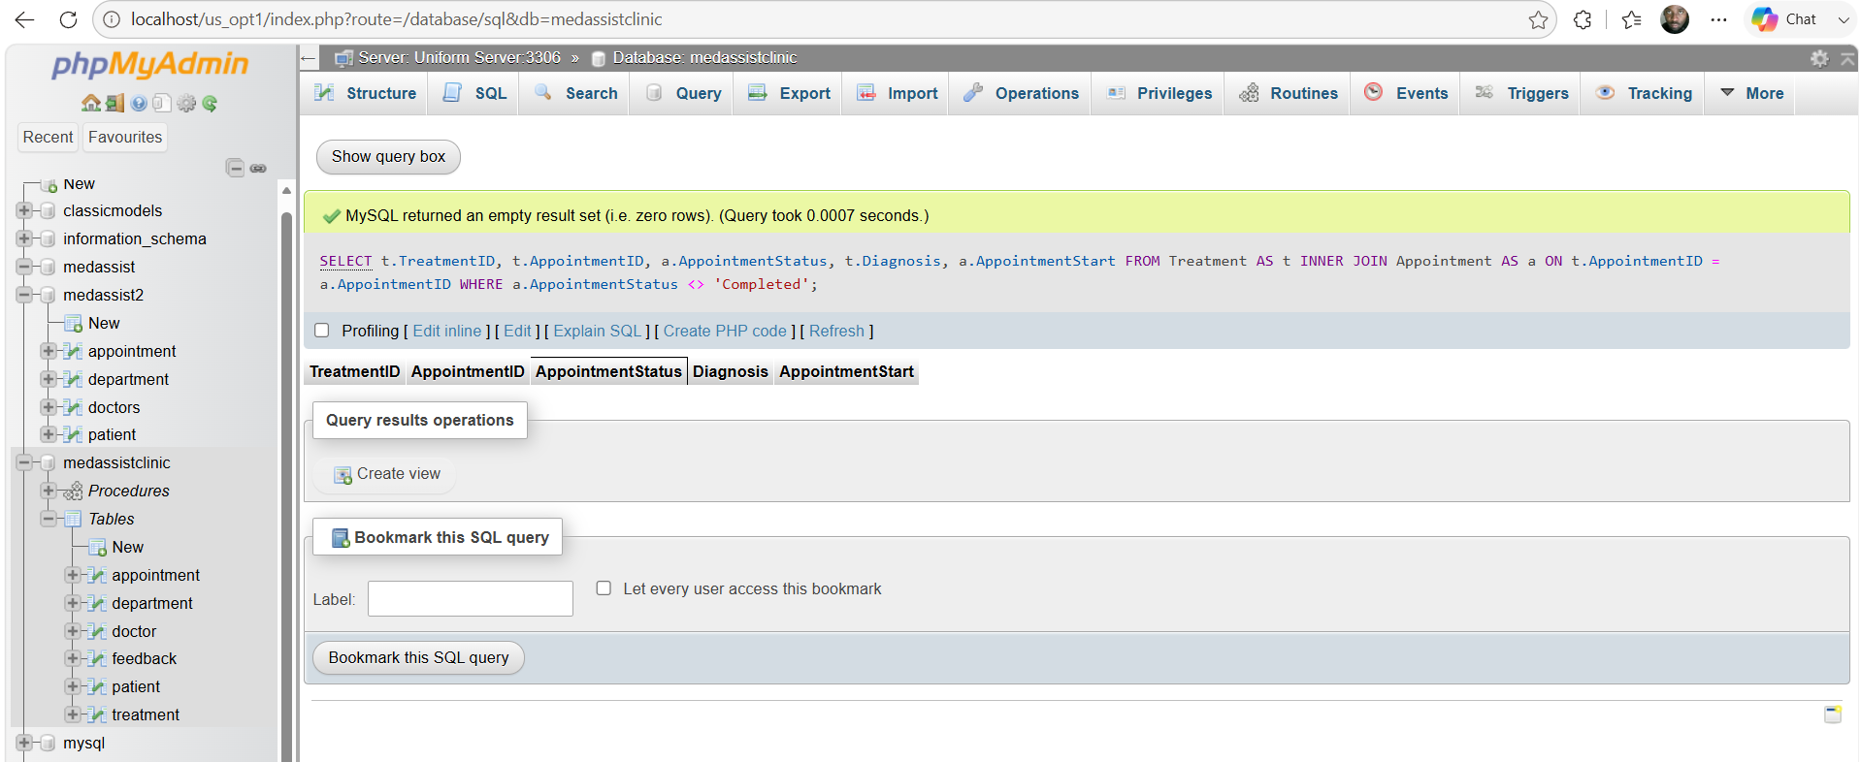
Expected result for a fully consistent dataset:
0 rows

Query 14 Display complete patient feedback information

Figure 24

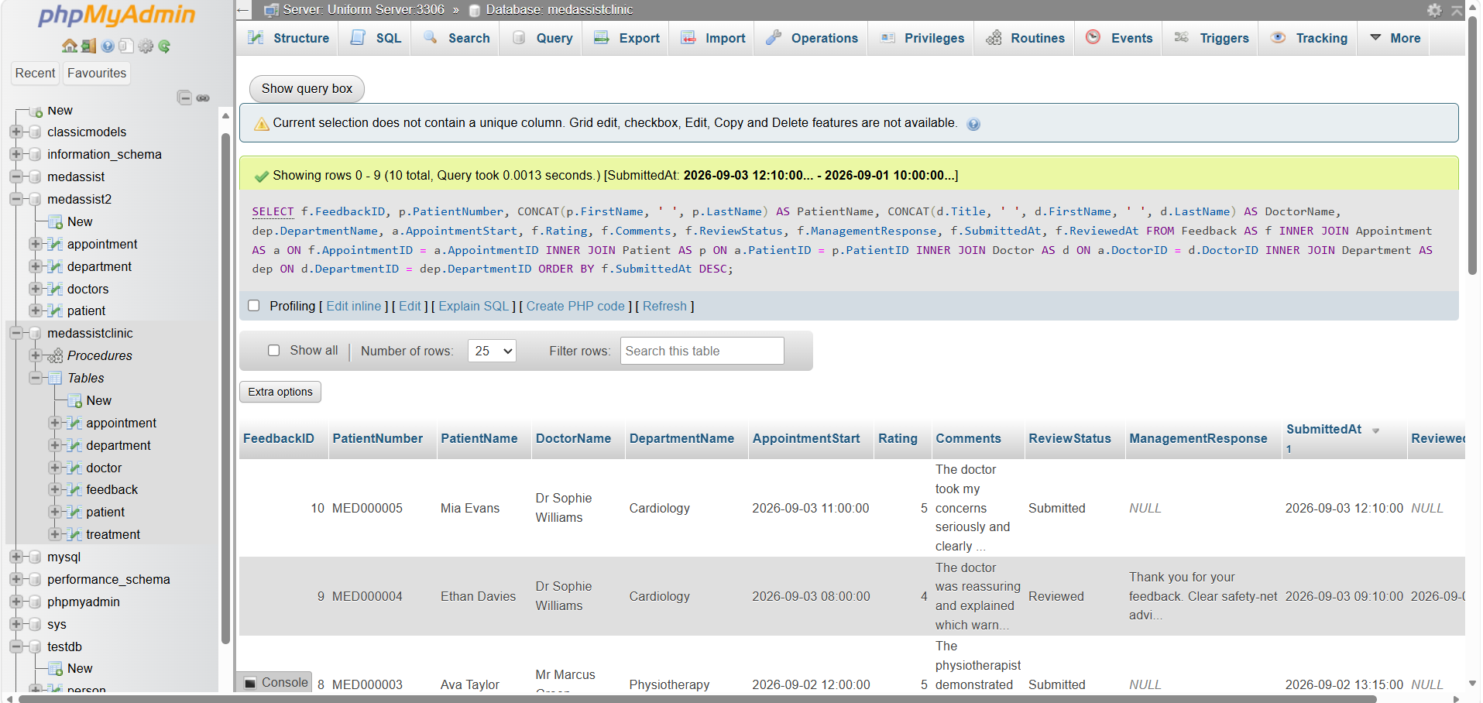
This joins five of six core entities

Query 15 Produce a feedback review dashboard

Figure 25

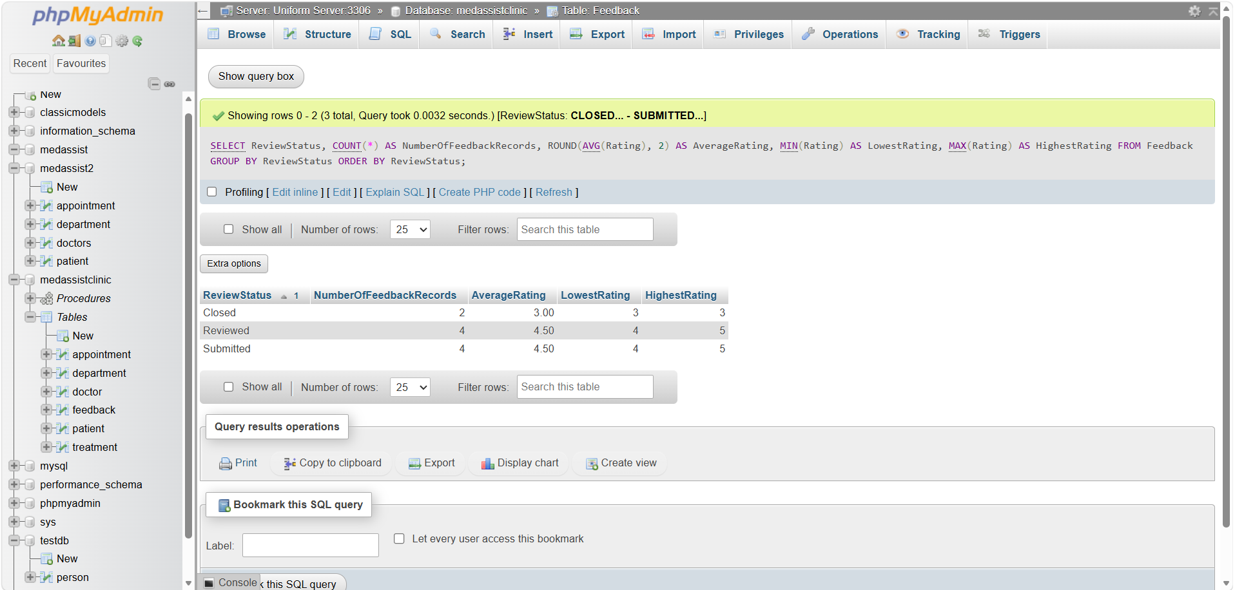

This demonstrates that the system supports both feedback collection and management review, rather that merely storing comments

Query 16 Detect invalid feedback records

Figure 26
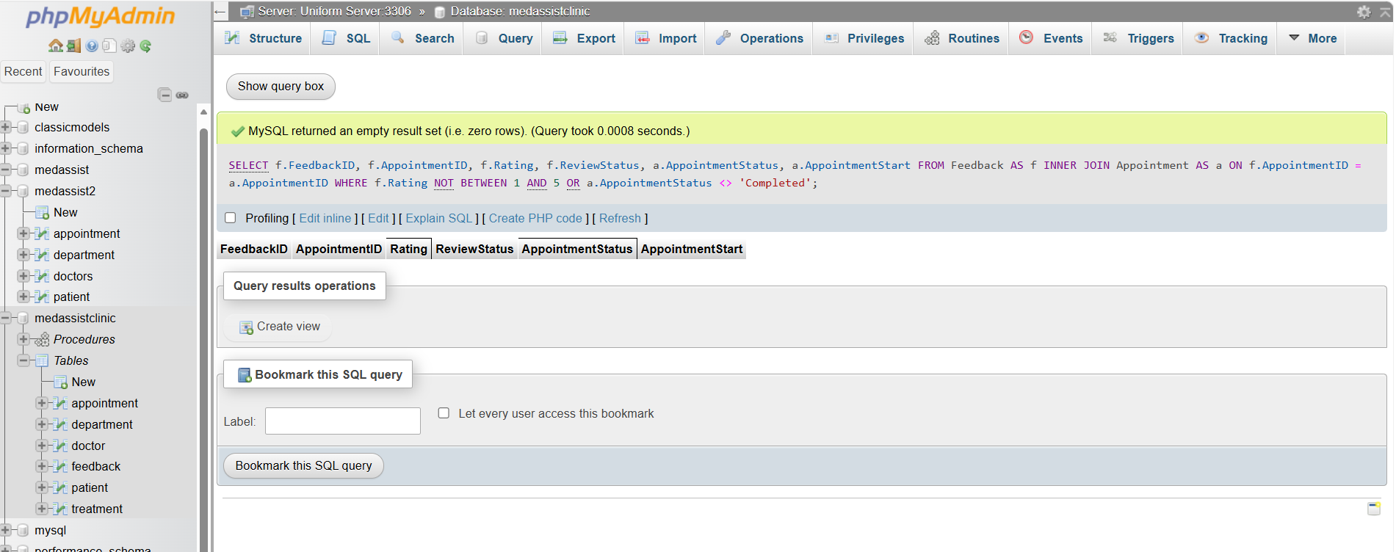

This shows that the test data follows the business rules, the expected results is 0 rows.
This provides evidence that the check constraint and relational workflow are producing consistent data.

Query 17 Test a successful transaction and COMMIT

Figure 27 a

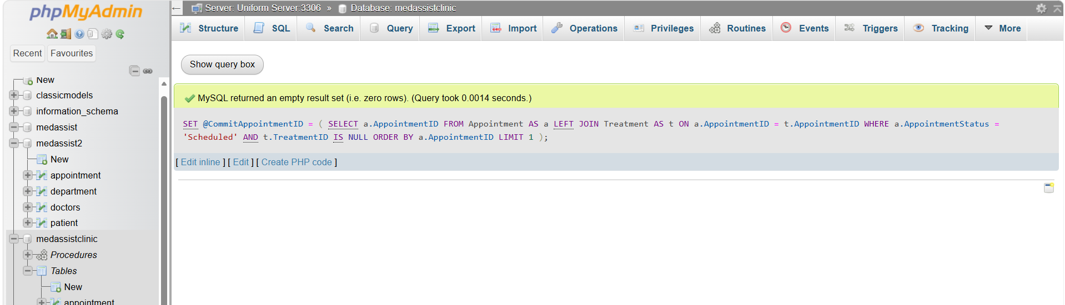

Check which appointment was selected

Figure 27b
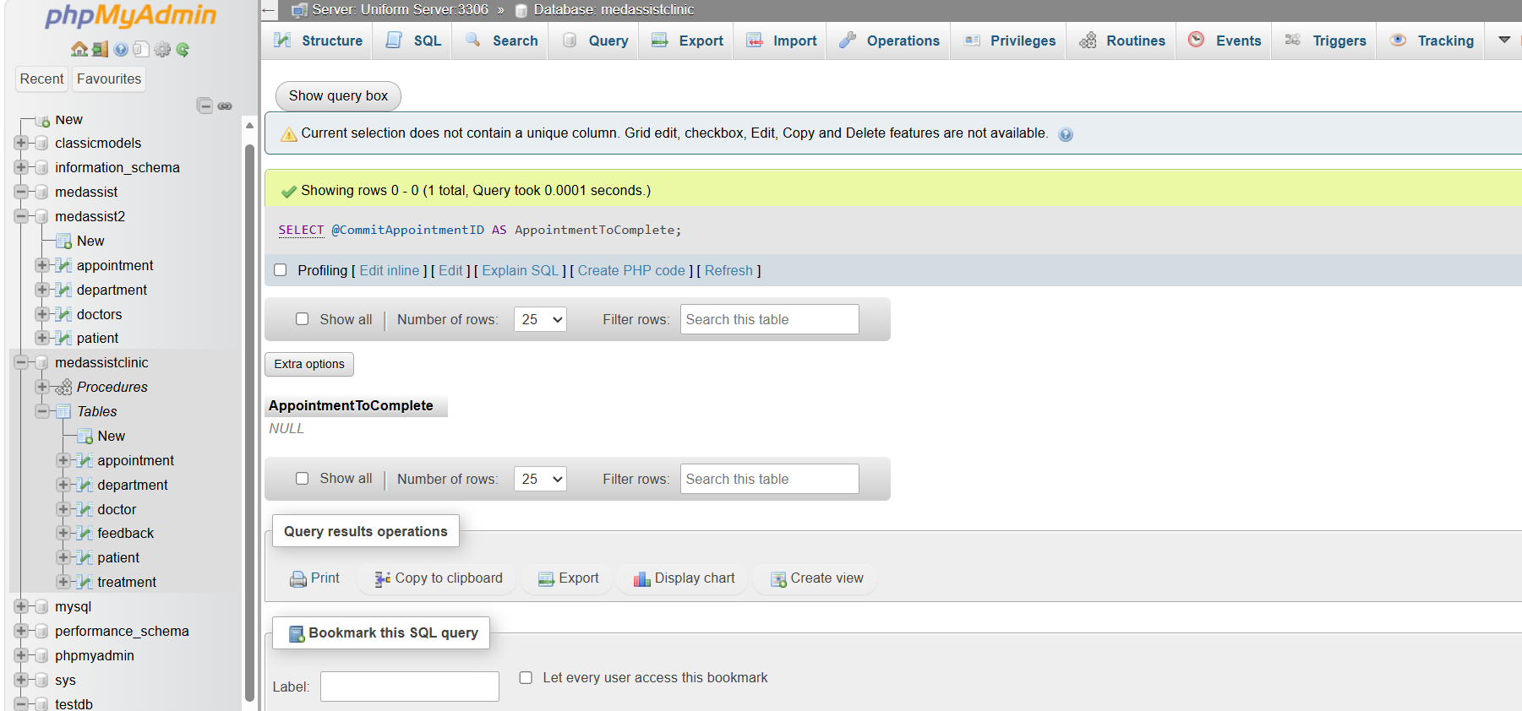

Now we would execute the transaction controlled procedure:

Figure 27b

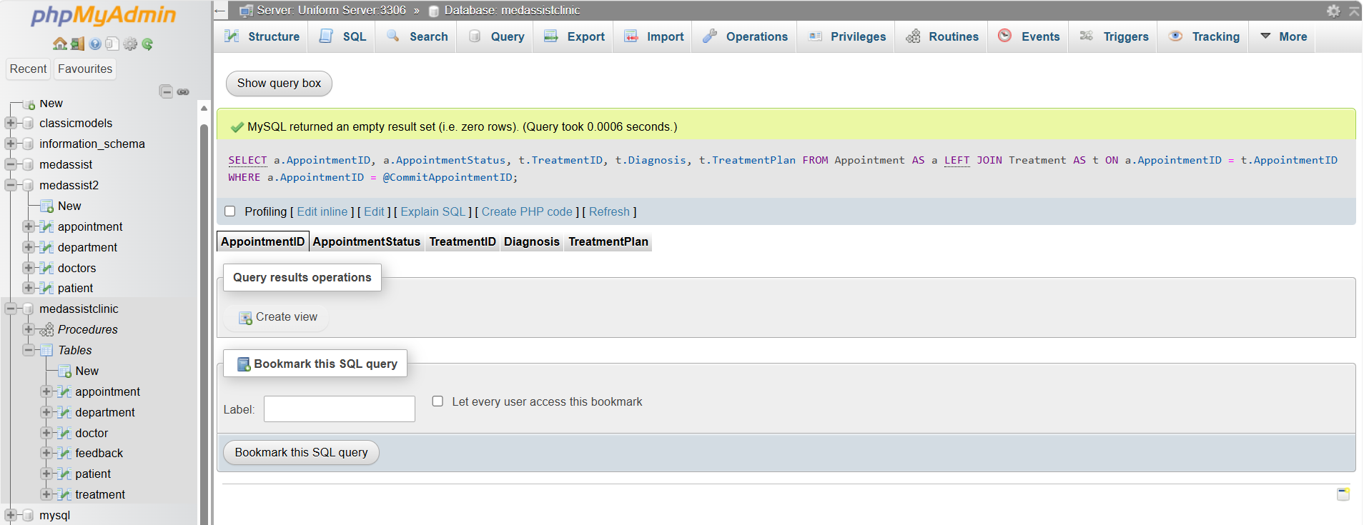
Verify the result

Figure 27d

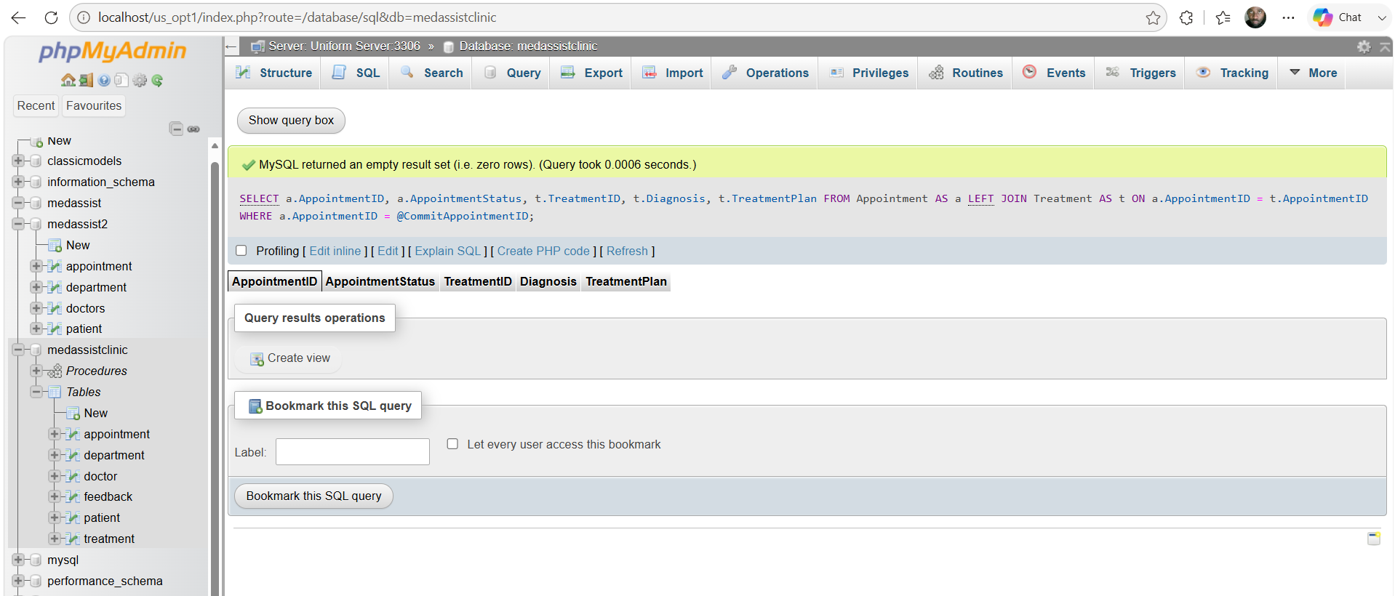
Expected

AppointmentStatus = Completed
TreatmentID = populated
Diagnosis = populated

Query 18 Test a failed transaction and Rollback
Select another scheduled appointment without treatment

Figure 28a
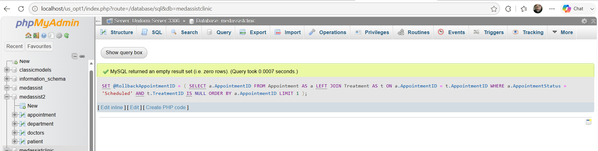
Check the appointment before the test

Figure 28b
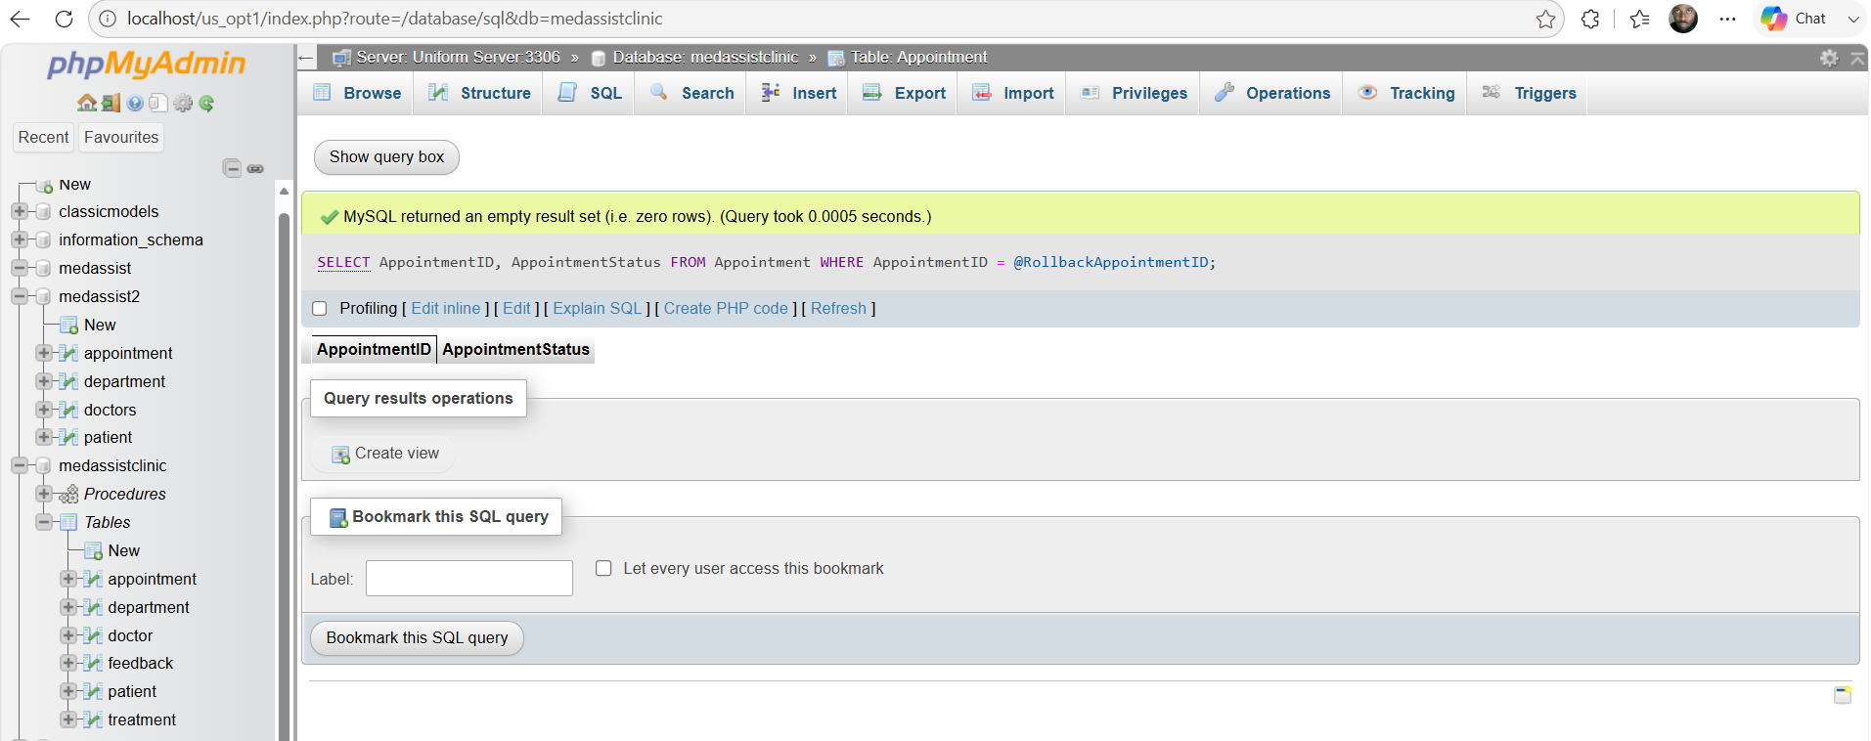

Now I would deliberately submit an invalid treatment

Figure 28c
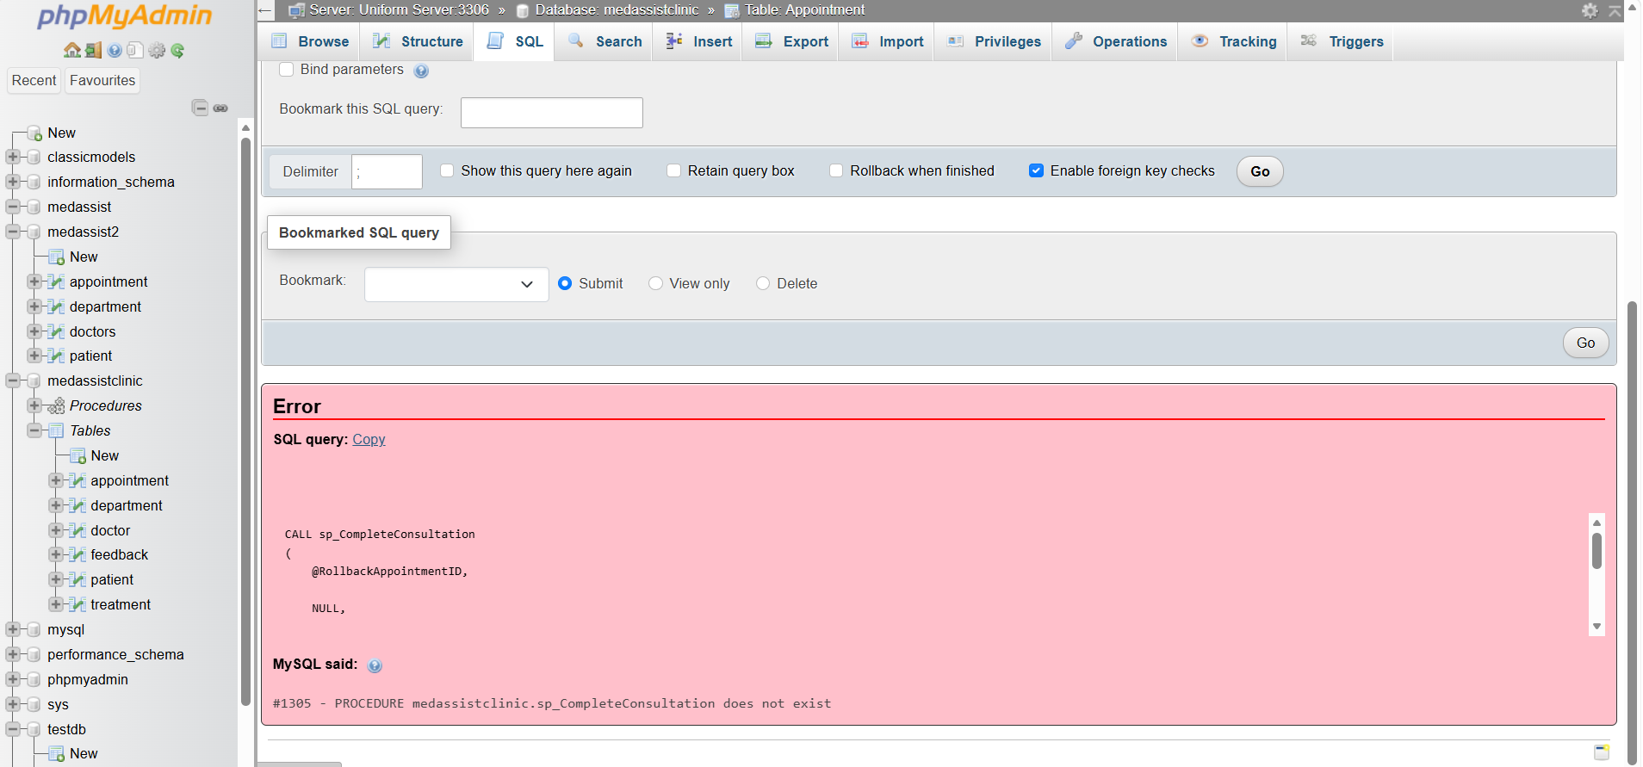
Because Treatment,Diagnosis is defined as NOT NULL, this should produce an error
After the error, I would run,

Figure 28d
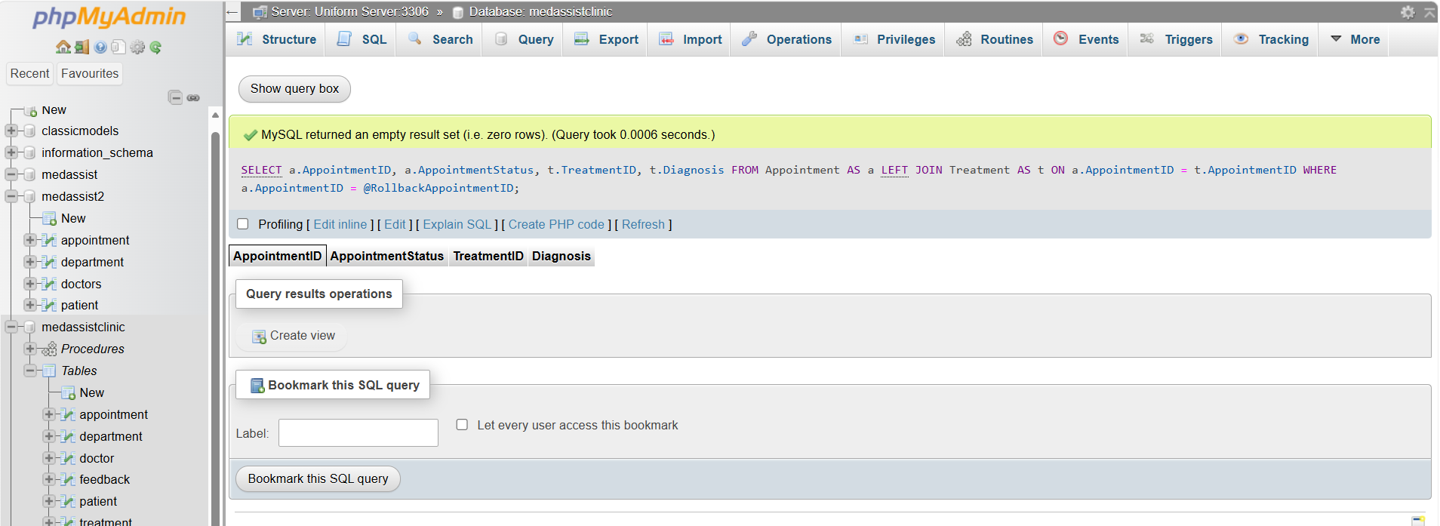
The expected result should be
AppointmentStatus = Scheduled
TreatmentID = NULL
Diagnosis = NULL
3.2 CRUD stored procedures

Create Patient

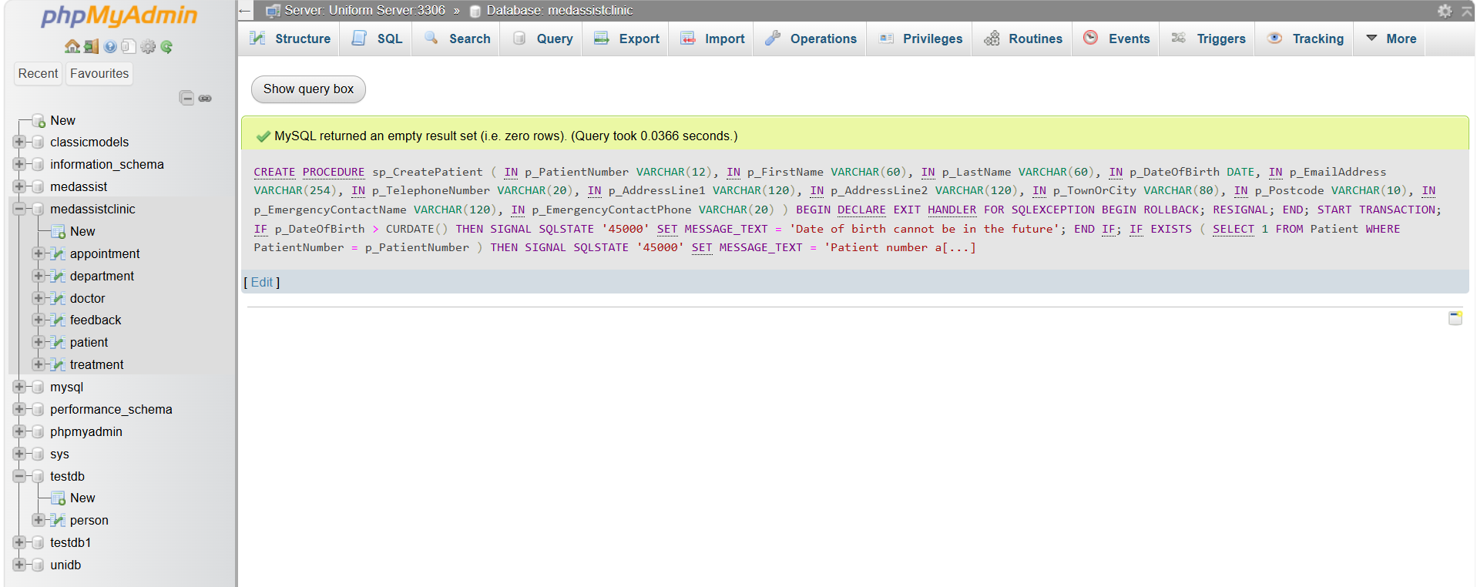

Testing the Create Patient

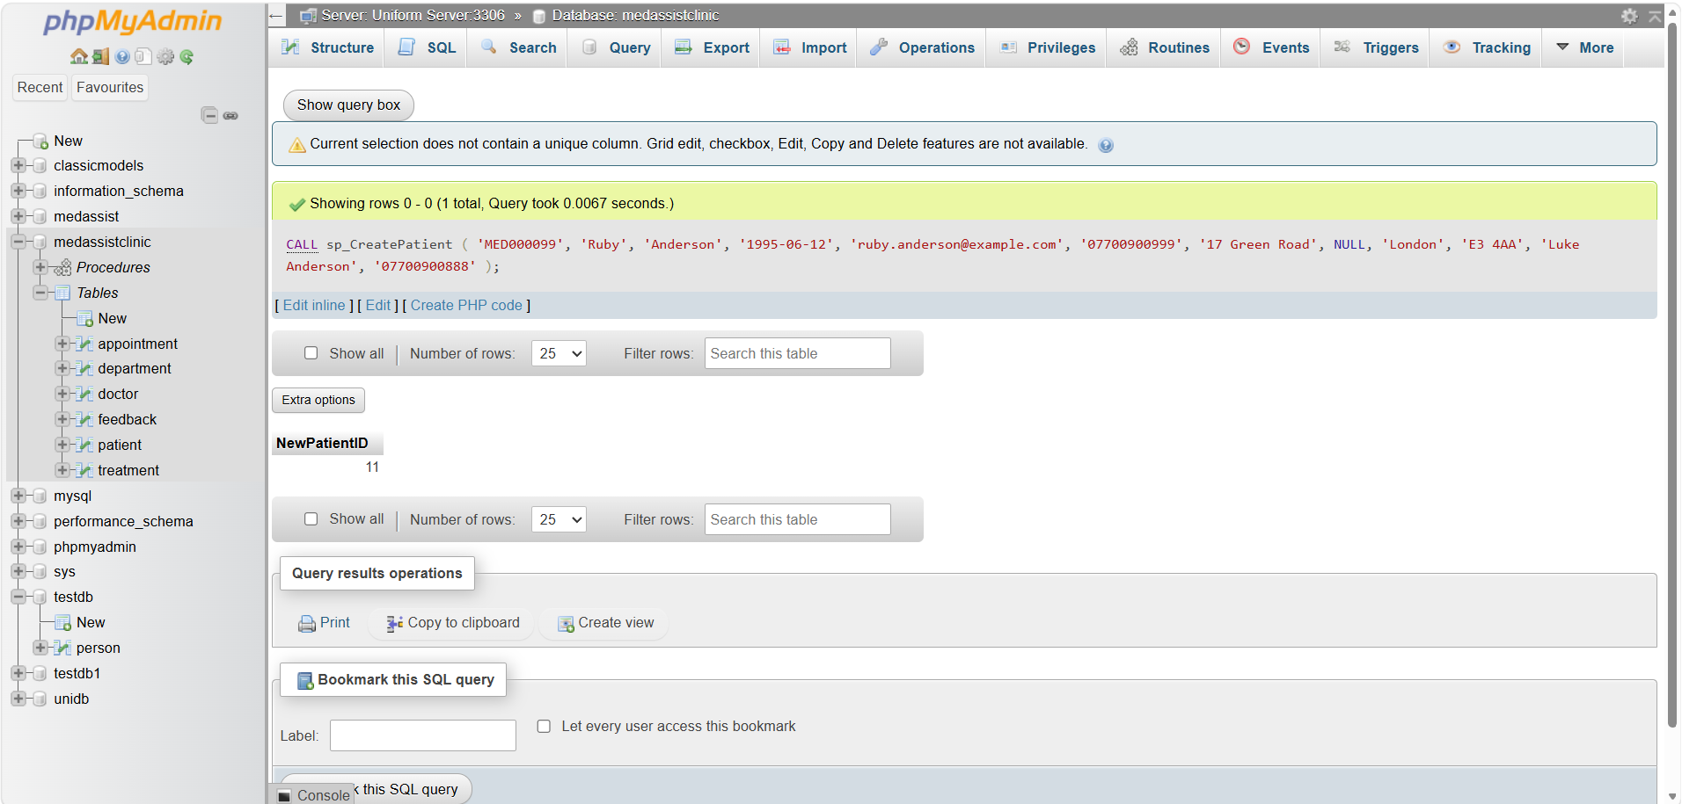

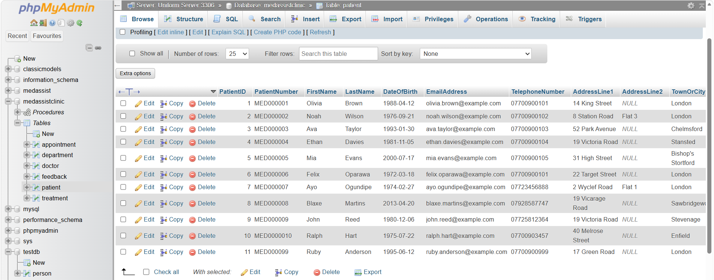

We can see from the table that Ruby Andersson has been added.

Read Patient

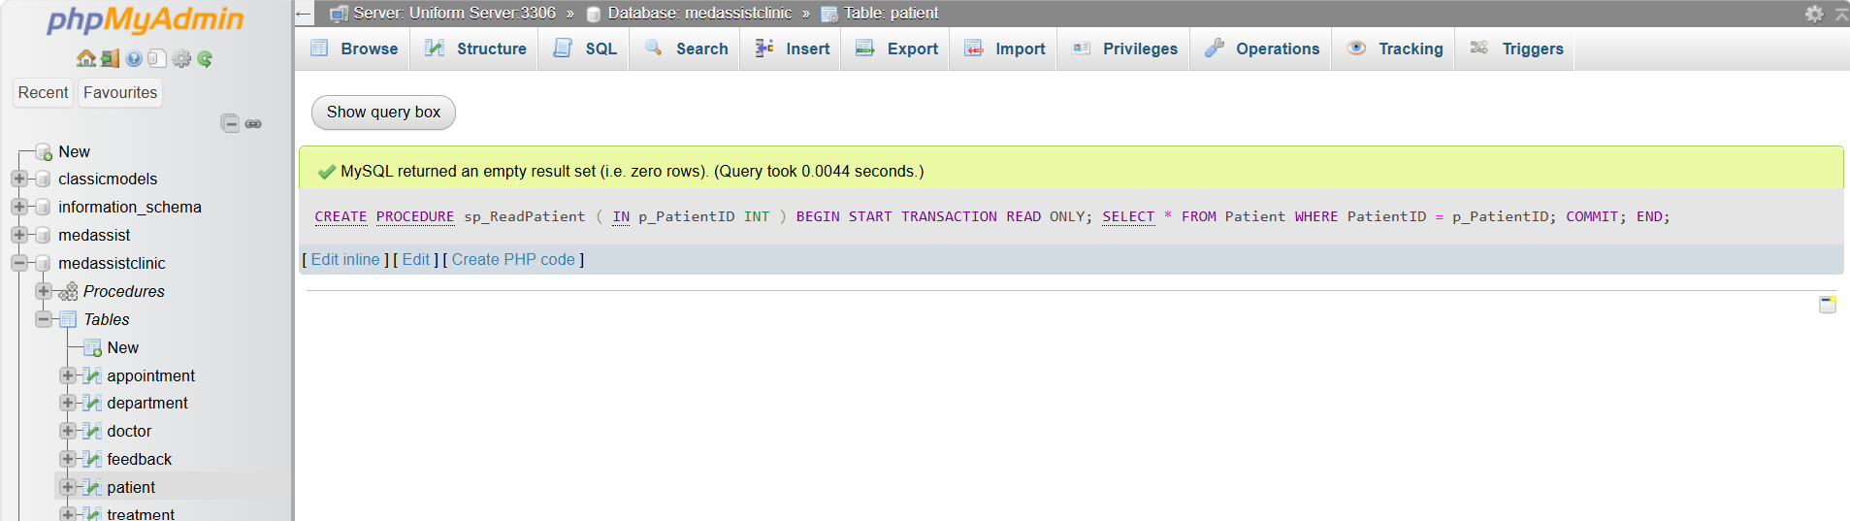

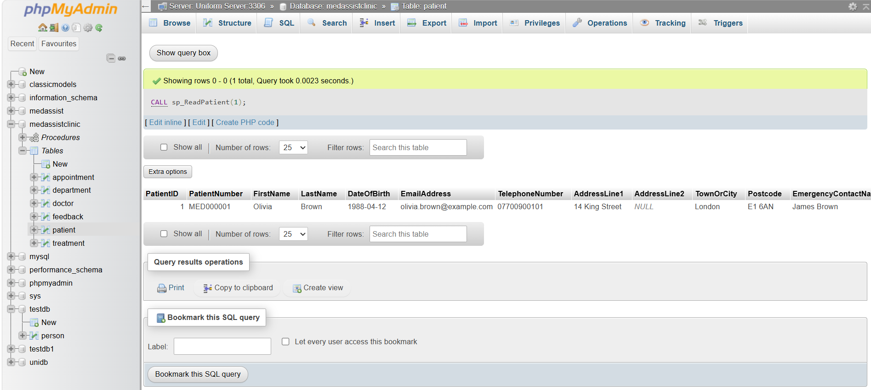

Update Patient

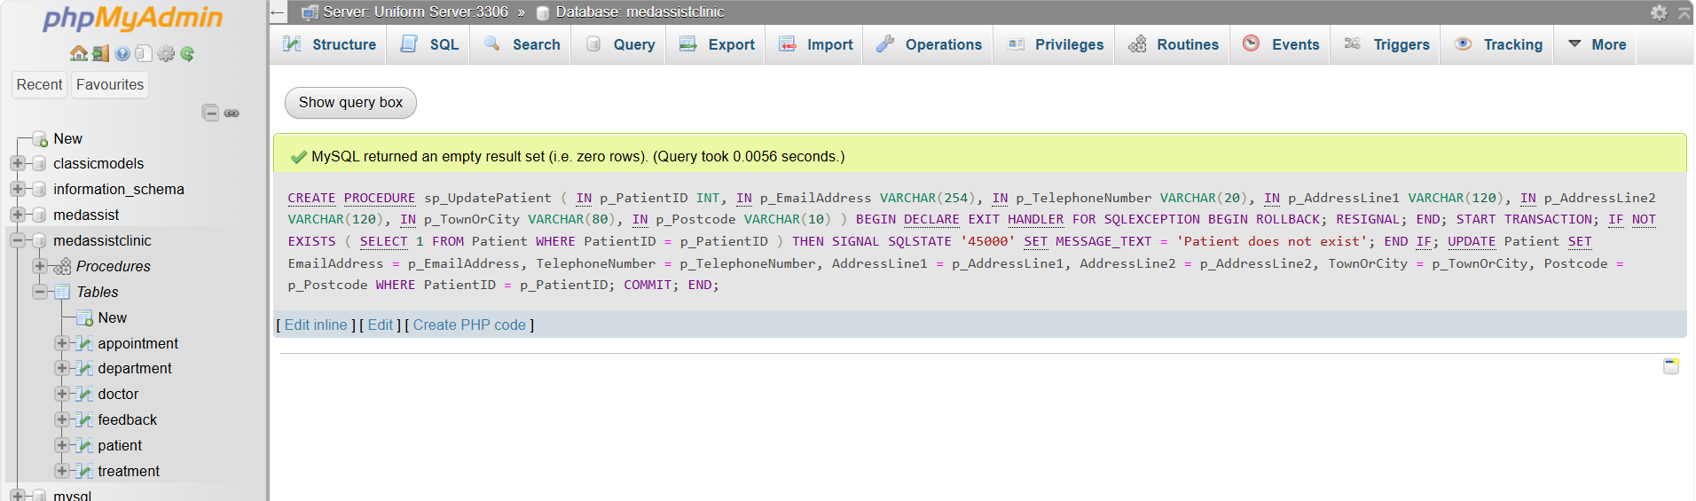

Delete Patient
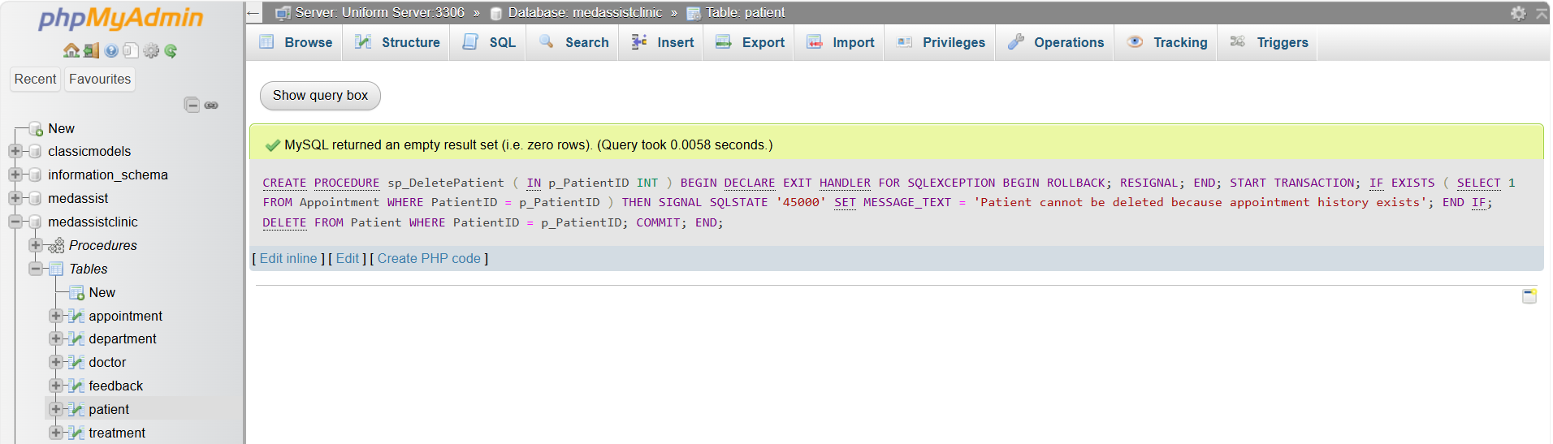
Clinical records should not be deleted casually. Therefore, the delete procedure should reject deletion where appointment history exists.
This is substantially stronger than allowing unrestricted deletion because it protects historical clinical relationships.
Stored procedures were implemented for Create, Read, Update and Delete operations, principally for Patient and Appointment. MySQL stored routines allow a set of SQL statements to be stored on the server and reused by client applications, improving consistency where several applications must perform the same business operation [7].

For example, sp_CreatePatient validates the patient's date of birth and checks that the patient number does not already exist before inserting the record. sp_UpdatePatient first confirms that the requested patient exists. sp_DeletePatient is deliberately more restrictive: deletion is rejected if the patient has appointment history. This is preferable to unrestricted CRUD because clinical information should not disappear solely because a user executes a delete operation.
Appointment procedures apply further business logic. sp_CreateAppointment validates patient and doctor status and rejects overlapping appointments using:
ExistingStart < ProposedEnd AND ExistingEnd > ProposedStart.
This is stronger than a simple unique constraint on doctor and appointment start time because it detects partial overlaps such as 10:00–10:30 and 10:15–10:45.
Each modifying procedure uses a transaction and an SQL exception handler. The repeated logic ensures that either the procedure completes successfully or its changes are rolled back.
[Insert Figure 5: Successful stored-procedure execution and returned patient/appointment record.]

3.3 Transactional Scenario and Transaction Control
Transactions are essential where several database changes represent one logical operation. Contemporary database literature continues to distinguish relational systems by their strong transactional guarantees, particularly ACID properties—atomicity, consistency, isolation and durability [4].
The MedAssist scenario uses sp_CompleteConsultation. The procedure performs two related operations:
changes the appointment status to Completed; and
inserts the corresponding treatment record.
These operations must not become permanently separated. A completed appointment without treatment documentation would represent an inconsistent clinical state.
Although the assignment refers to BEGIN, MySQL correctly uses START TRANSACTION inside stored procedures because BEGIN is interpreted as the beginning of a compound stored-program block. MySQL documents START TRANSACTION, COMMIT and ROLLBACK as the transaction-control statements, and explicitly distinguishes transaction initiation from the BEGIN ... END stored-program syntax [8].
A successful call updates the appointment, inserts the treatment and executes COMMIT, making both operations permanent.
Rollback was tested deliberately by passing a null diagnosis to a NOT NULL treatment column. The appointment status had already been changed within the transaction, but the treatment insertion failed. The exception handler executed ROLLBACK, which reversed the earlier update. Subsequent querying showed the appointment remained Scheduled and no treatment record existed.
This provides direct evidence of atomicity: the database cannot retain a partially completed consultation. COMMIT is therefore justified only after every dependent operation succeeds, whereas ROLLBACK is necessary whenever an error would otherwise leave related tables inconsistent.

3.4 Triggers, Functions and Auditing
A supporting Audit Log table was introduced as a technical implementation object rather than a seventh business entity. It records table name, record identifier, action type, old values, new values, user and timestamp.
Three Appointment triggers execute automatically after insert, update and delete events. MySQL triggers are table-associated objects activated by specified events, and the OLD and NEW row aliases make it possible to access values before and after a change [9].
The update trigger serializes the previous and new appointment values as JSON and stores them in Audit Log. This approach centralizes auditing at database level, meaning changes remain traceable regardless of whether they originate from phpMyAdmin or an application interface. Auditability is particularly valuable in health information systems, where recent literature stresses accountability, privacy controls and regular auditing as important safeguards for electronic health information [5].
A stored function, fn_AuditCount, returns the number of audit events for a specified record. Functions were used only for retrieval-style logic; transaction control remains within procedures because MySQL restricts explicit transaction statements inside triggers and stored functions.
Triggers have a trade-off: they provide automatic enforcement but may hide processing from application developers. For this reason, the prototype uses triggers specifically for cross-cutting audit functionality, while major clinical workflows remain explicit in stored procedures.

4. Performance Tuning and Query Optimization
Four frequent operations were identified: retrieving a doctor's diary, retrieving a patient's appointment history, locating feedback awaiting review and retrieving recent treatment records. Secondary indexes were therefore created on:
Appointment(DoctorID, AppointmentStart),
Appointment(PatientID, AppointmentStart),
Feedback(ReviewStatus, SubmittedAt), and
Treatment(RecordedAt).
The first two indexes reflect common equality-plus-date-range access patterns. Their column order is deliberate: a doctor or patient is selected first and appointment time is then used for range filtering or ordering. Indexing should be workload-driven rather than indiscriminate because every additional index consumes storage and introduces maintenance work during inserts and updates. Recent research continues to identify indexing and query tuning as major components of database performance optimization [2], [3].
The design therefore avoids creating isolated indexes on low-selectivity Boolean fields such as IsActive. Although such a column may appear in predicates, an index containing only two possible values may provide little benefit in a small operational database.
MySQL's EXPLAIN command was used to inspect query execution plans and determine whether indexes were considered by the optimizer. MySQL describes EXPLAIN as a mechanism for displaying how statements will be processed, including access paths and join order [10].
The prototype dataset is intentionally small, so execution-time improvements should not be exaggerated. On a small table MySQL may legitimately choose a full scan because scanning a few rows can be cheaper than index traversal. The more defensible conclusion is that the indexes provide scalable access paths for the clinic's predicted workload; their benefit should become more visible as appointment and treatment volumes grow. This limitation demonstrates why performance conclusions should be based on execution plans and representative data rather than unsupported timing claims.
Four frequent operations were identified: retrieving a doctor's diary, retrieving a patient's appointment history, locating feedback awaiting review and retrieving recent treatment records. Secondary indexes were therefore created on:
Appointment(DoctorID, AppointmentStart),
Appointment(PatientID, AppointmentStart),
Feedback(ReviewStatus, SubmittedAt), and
Treatment(RecordedAt).
The first two indexes reflect common equality-plus-date-range access patterns. Their column order is deliberate: a doctor or patient is selected first and appointment time is then used for range filtering or ordering. Indexing should be workload-driven rather than indiscriminate because every additional index consumes storage and introduces maintenance work during inserts and updates. Recent research continues to identify indexing and query tuning as major components of database performance optimization [2], [3].
The design therefore avoids creating isolated indexes on low-selectivity Boolean fields such as IsActive. Although such a column may appear in predicates, an index containing only two possible values may provide little benefit in a small operational database.
MySQL's EXPLAIN command was used to inspect query execution plans and determine whether indexes were considered by the optimizer. MySQL describes EXPLAIN as a mechanism for displaying how statements will be processed, including access paths and join order [10].
The prototype dataset is intentionally small, so execution-time improvements should not be exaggerated. On a small table MySQL may legitimately choose a full scan because scanning a few rows can be cheaper than index traversal. The more defensible conclusion is that the indexes provide scalable access paths for the clinic's predicted workload; their benefit should become more visible as appointment and treatment volumes grow. This limitation demonstrates why performance conclusions should be based on execution plans and representative data rather than unsupported timing claims.

5. Conclusion and Reflection
The completed MedAssist Clinic prototype demonstrates how relational database principles can be applied to a realistic healthcare scenario. Six core entities represent patients, departments, doctors, appointments, treatments and feedback, with primary, foreign, unique and check constraints protecting the relationships between them. Normalization to 3NF reduces duplication while maintaining a clear separation between demographic, organizational, transactional and clinical information.
The implementation extends the schema beyond simple storage. CRUD procedures centralize validation, transactions ensure multi-step operations remain atomic, and the deliberate rollback test demonstrates protection against partial clinical updates. Automatic triggers and the audit function provide traceability, while workload-specific secondary indexes support appointment, treatment and feedback retrieval.
Several limitations remain. Doctor availability is currently handled primarily through appointment-overlap logic rather than a dedicated availability entity. Prescription information is embedded in treatment documentation rather than structured separately. The prototype also does not implement a complete production security model with role-based database accounts, encryption, backup policies or application-level authentication. Given the sensitivity of e-health information, these should be priorities for future development [5].
Overall, the project demonstrates that effective database development involves more than creating tables. Integrity constraints, transactions, auditing and indexing must be selected according to the operational consequences of failure. The resulting prototype therefore provides MedAssist Clinic with a coherent and extensible foundation for secure and consistent outpatient information management

PART B
Part B of this project focuses on the development of MedAssist2 Clinic, a database-driven website designed to demonstrate the practical application of PHP, MySQL, HTML and CSS within a realistic healthcare management scenario. The system builds upon the database concepts explored in Part A but uses a simplified relational database specifically designed to support the functionality required for the web application. The medassist2 database consists of four related tables: patient, department, doctors and appointment. Primary and foreign keys are used to establish appropriate relationships between these tables and to maintain referential integrity.
The main aim of the website is to demonstrate how server-side PHP programming can be integrated with a MySQL database to retrieve, display, search and manipulate dynamic information. The application therefore includes facilities for displaying database records, searching for patient information and performing Create, Read, Update and Delete (CRUD) operations. Particular attention has been given to the patient-management functionality, where administrators can add new patient records, review existing information, update patient details and delete records where relational constraints permit.
In addition to functionality, consideration has been given to usability, presentation and security. The website uses a consistent professional visual design appropriate to a private outpatient clinic, while PHP validation, HTML output escaping and parameterized SQL statements are used to reduce common security risks. Particular emphasis is placed on SQL injection, as this represents one of the most significant threats to applications that accept user input and interact directly with relational databases. The report therefore evaluates the potential SQL-injection vulnerabilities within the application and demonstrates the measures implemented to mitigate them.

The updated view_patients.php now includes an Actions column with Edit and Delete buttons for each patient. The Edit page loads the selected patient into a pre-populated form and updates the database using a prepared UPDATE statement. The Delete page first asks for confirmation and then uses a prepared DELETE statement.
One useful feature is that the delete process respects the existing foreign-key relationship with appointment. If a patient is linked to an appointment, the website explains that the record cannot be deleted because referential integrity would be broken. To demonstrate a successful delete for your assignment screenshots, add a temporary patient with no appointment, then delete that record.

CRUD Operations

Query 1: Create a patient
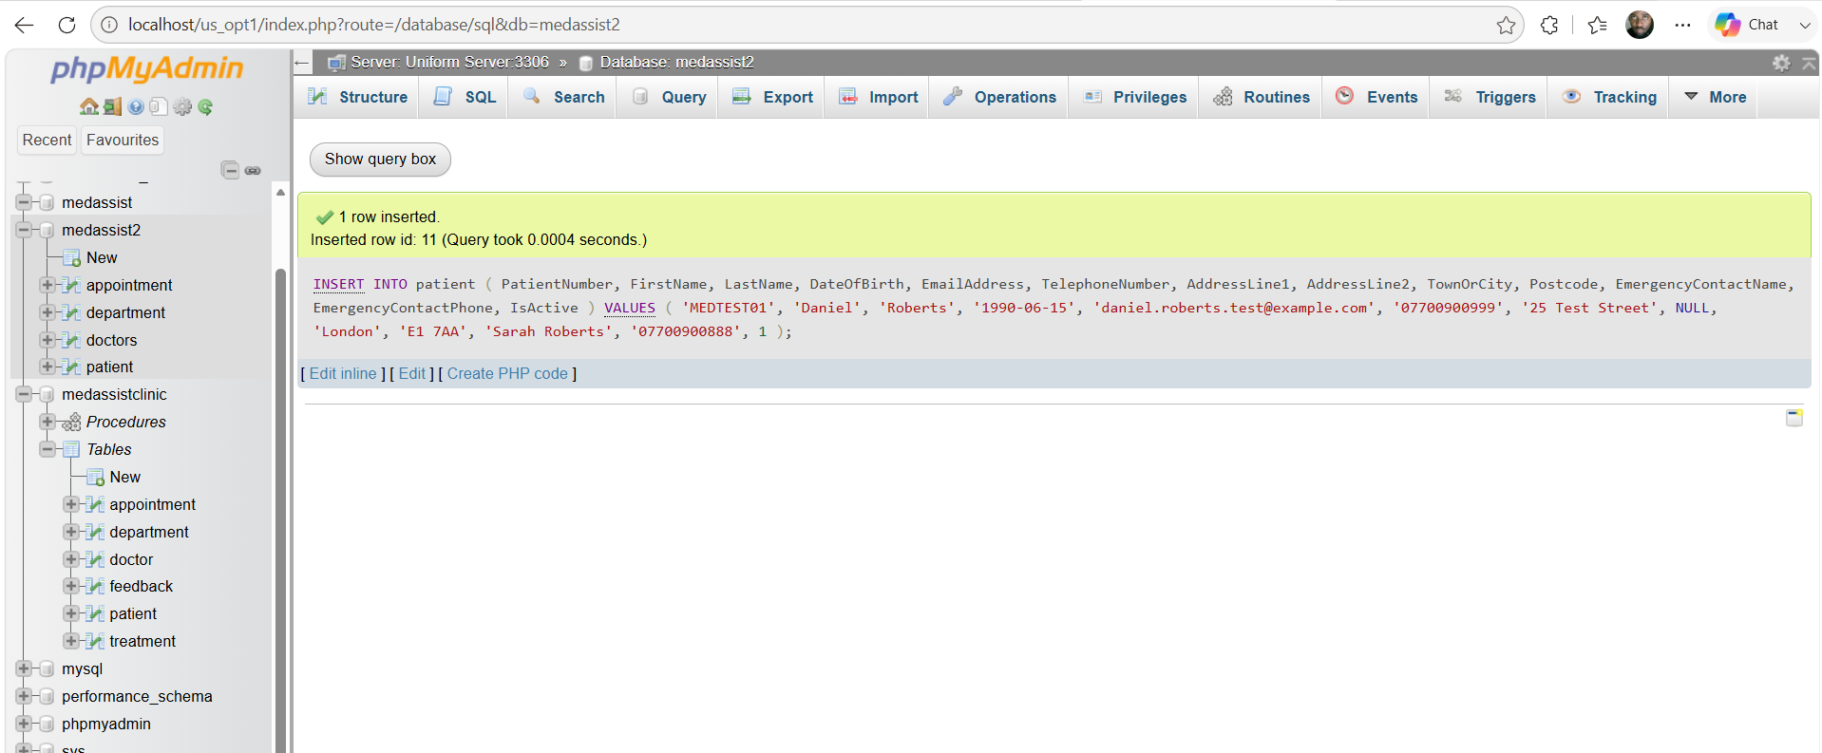
Expected result: one new patient should be inserted and MySQL should automatically generate the PatientID.

This tests AUTO_INCREMENT, required fields, unique fields and valid data insertion.

Query 2: Retrieve the test patient

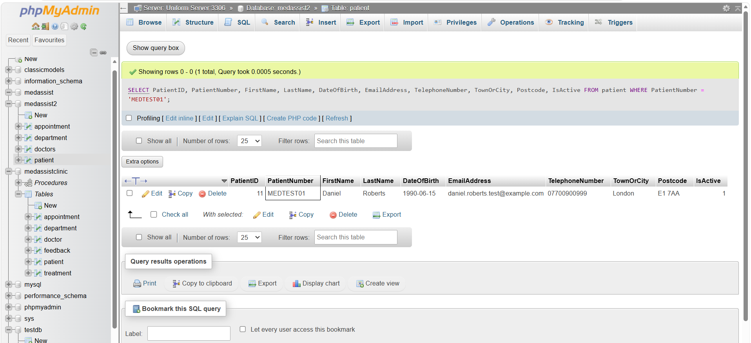
Expected output should resemble:

PatientNumber FirstName LastName TownOrCity IsActive
MEDTEST01 Daniel Roberts London 1

This verifies that the newly created record can be correctly retrieved from the database.

Query 3: Modify the patient record
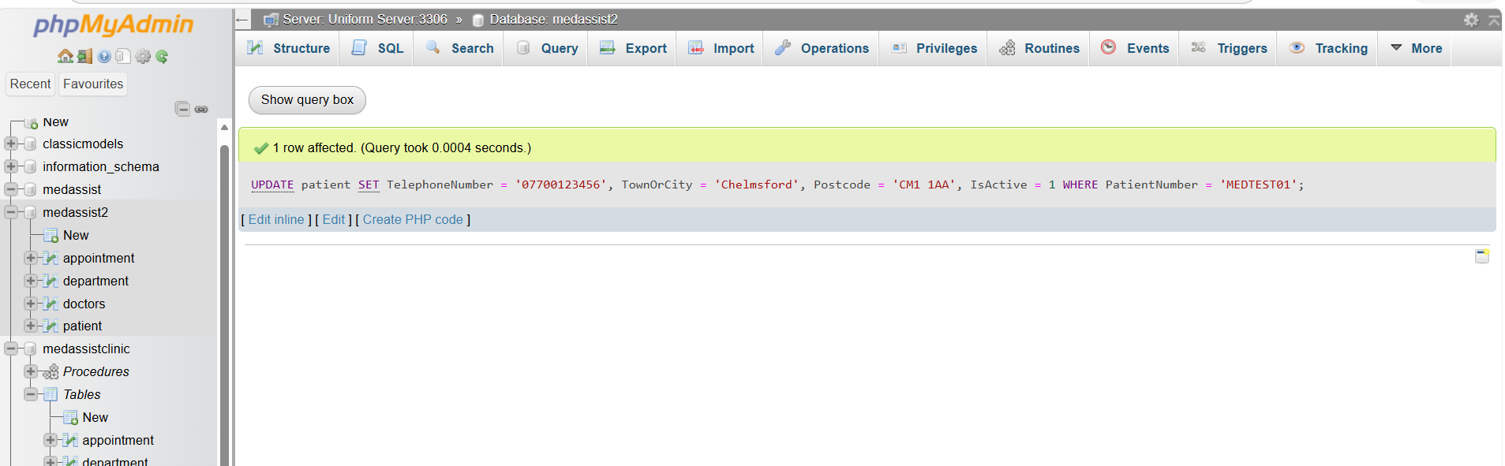

Then verify the update with
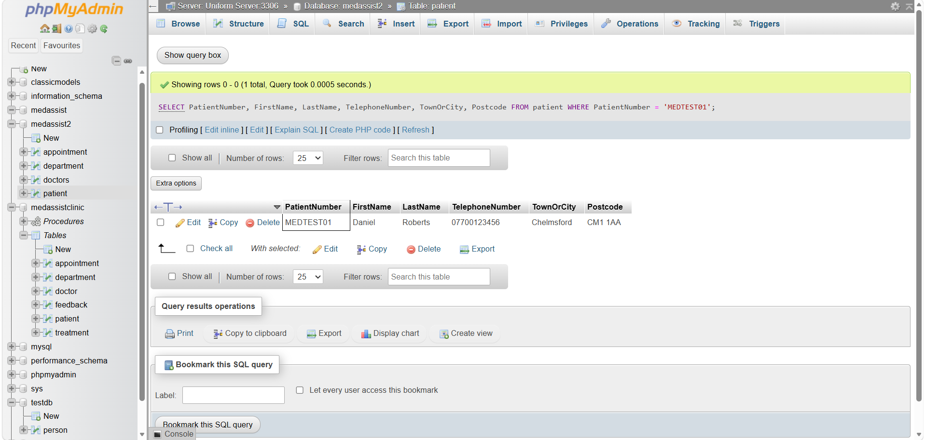
We should now see
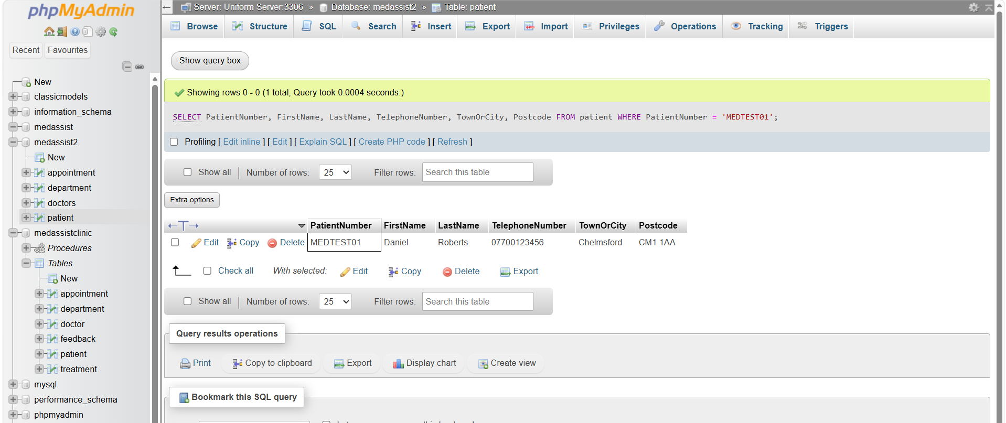
TelephoneNumber: 07700123456
TownOrCity: Chelmsford
Postcode: CM1 1AA
This demonstrates that an existing database record can be modified without creating duplicate information.

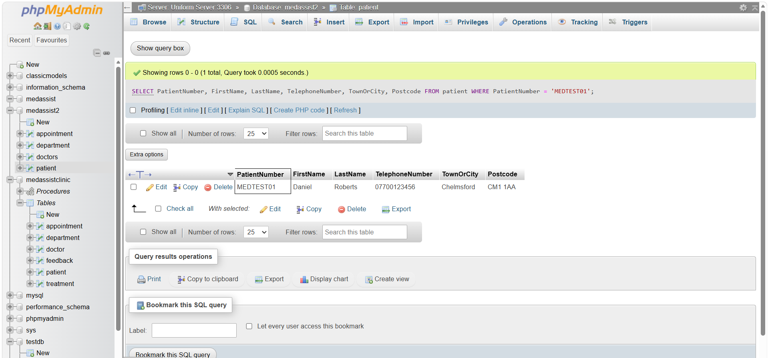

Query 4: Delete: Remove the test patient
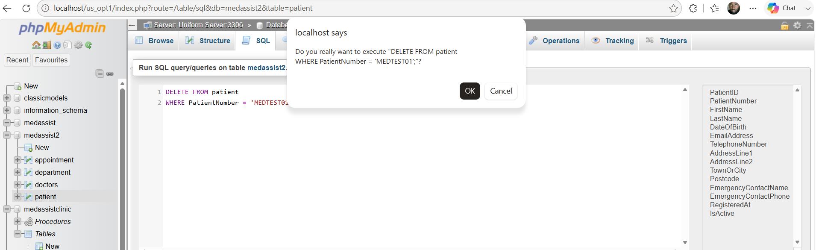
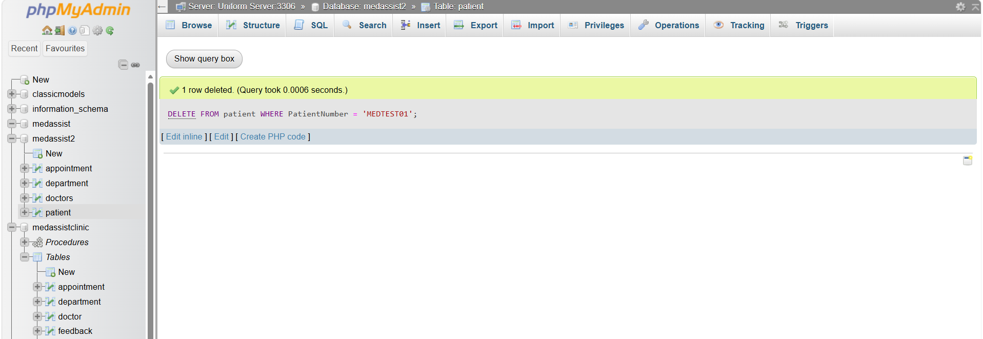

Confirming the deletion worked
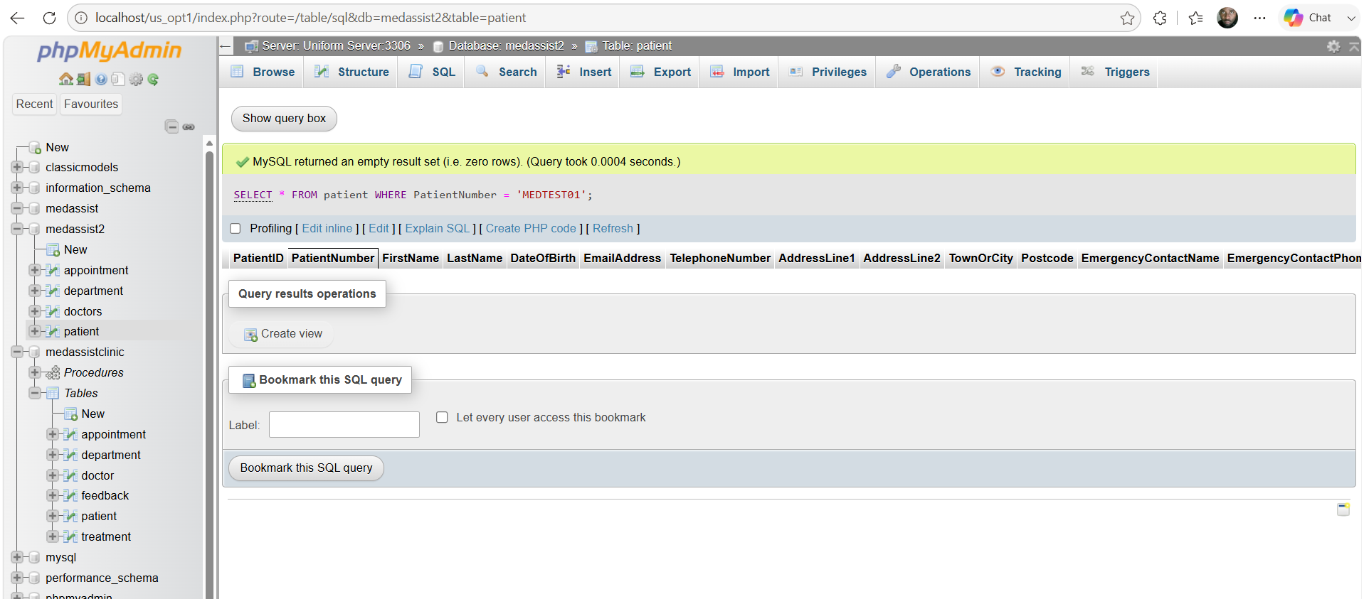
This demonstrates successful deletion while preserving the original MedAssist2 sample data.

A particularly strong additional robustness test would be to attempt to delete one of the original 10 patients who already has an appointment
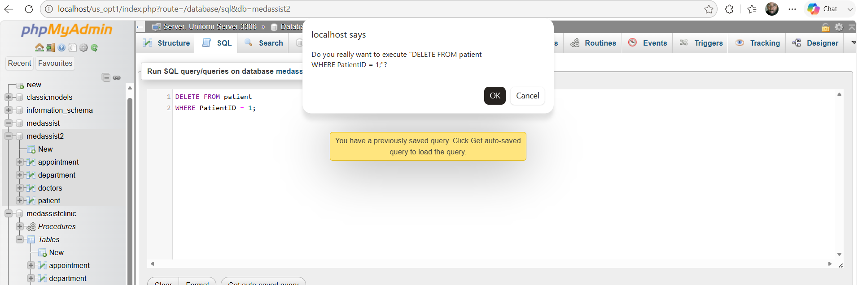

DELETE FROM patient
WHERE PatientID = 1;

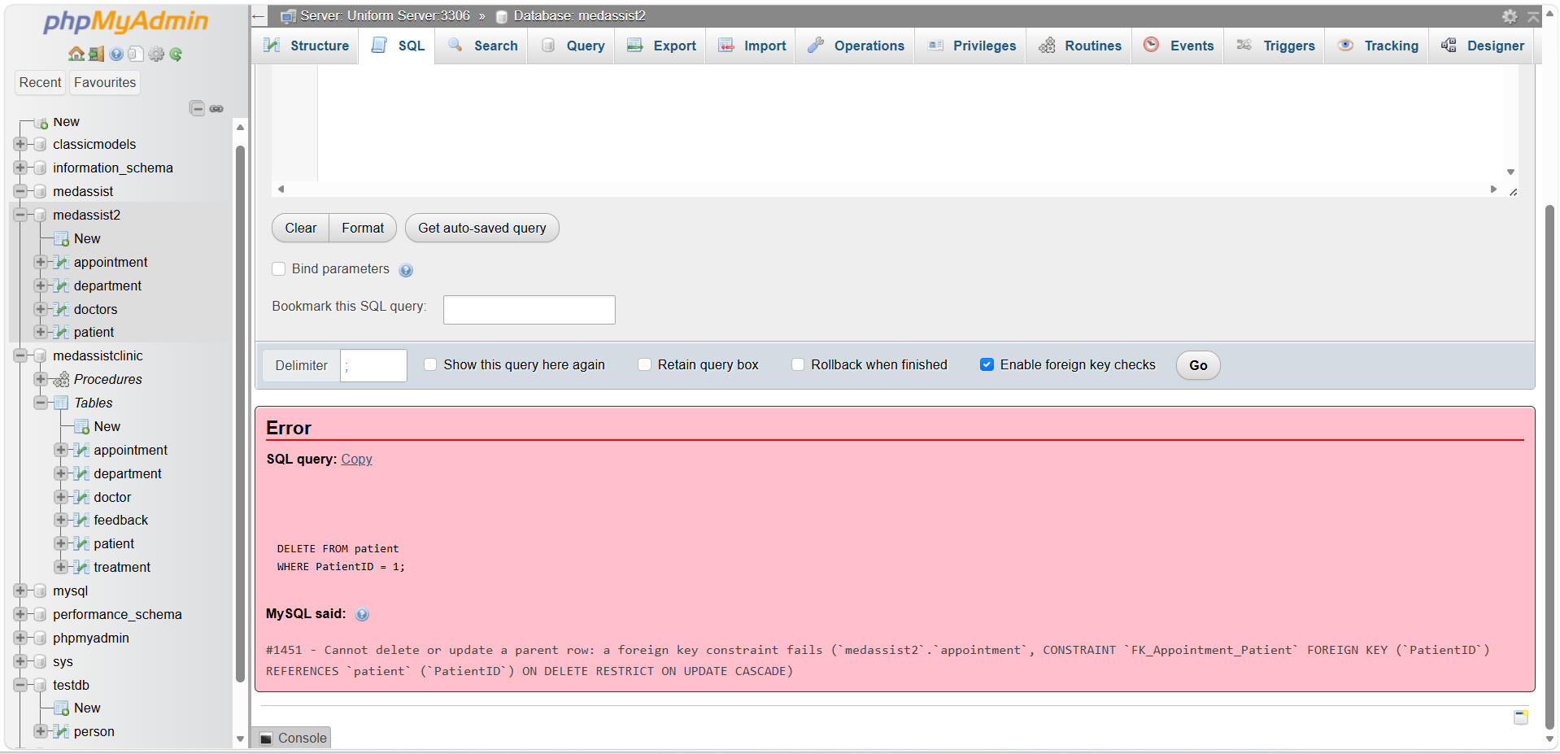
MySQL should reject the operation because appointment.PatientID references that patient through a foreign key. Do not disable the foreign-key check. The rejection is evidence that your database protects referential integrity rather than allowing an appointment to become orphaned.
The MedAssist2 patient section now demonstrates the full CRUD cycle:
- Create — add_patient.html → insert_patient.php
- Read — view_patients.php
- Update — edit_patient.php
- Delete — delete_patient.php
The main visible change is that the Patient Records table now has an Actions column:
Patient ID | Patient No. | Name | DOB | ... | Active | Actions
------------------------------------------------------------------------------------------------------------------------------
1 | MED000001 | .......... | ……..| | Yes | Edit Delete

Clicking edit opens a pre-populated form containing the existing patient details. The update is then performed using a prepared UPDATE statement:

SQL Injection: Overview, Risks and Examples

SQL Injection (SQLi) is a web application security vulnerability that occurs when untrusted user input is incorporated into a Structured Query Language (SQL) statement in a way that allows the input to alter the intended structure or behaviour of the database query. MITRE formally classifies this weakness as CWE-89: Improper Neutralization of Special Elements used in an SQL Command, while the Open Worldwide Application Security Project (OWASP) identifies injection as an important category of web application security risk. SQL injection remains particularly significant: MITRE ranked CWE-89 as the second most dangerous software weakness in its 2025 CWE Top 25, demonstrating that the vulnerability continues to have substantial practical relevance.
SQL injection normally becomes possible when an application constructs an SQL statement by directly concatenating data supplied by a user. Consider a website that searches the MedAssist2 patient table using a surname. An insecure PHP implementation could construct the following query:
$sql = "SELECT * FROM patient
WHERE LastName = '" . $_GET['surname'] . "'";
If the legitimate input is Brown, the resulting SQL statement would be:
SELECT * FROM patient
WHERE LastName = 'Brown';
The database interprets Brown purely as data and returns matching patient records. However, if the application does not safely separate user input from SQL syntax, an attacker may provide specially constructed input. A classic example is:
' OR '1'='1' --
This may transform the intended query into one whose condition is always true. Consequently, instead of returning one patient's details, a vulnerable application could return every record in the table. OWASP similarly illustrates injection using conditions such as OR 1=1, where attacker-controlled input changes the meaning of a query rather than simply supplying a value to it.
SQL injection can affect more than search functionality. Authentication forms are another common example. An insecure login system might execute:
SELECT * FROM users
WHERE username = '$username'
AND password = '$password';
If attacker-controlled values are concatenated directly into the statement, malicious SQL syntax may manipulate the WHERE condition and potentially bypass the intended authentication check. Other SQL injection techniques may attempt to combine an application's legitimate query with additional database queries, infer information through differences in application responses, or manipulate INSERT, UPDATE and DELETE operations. OWASP notes that successful SQL injection may permit unauthorized reading or modification of database information and, depending on the database configuration and privileges available to the application, may have wider consequences.
The impact of SQL injection can therefore be considered in terms of the fundamental principles of information security. Confidentiality may be compromised if unauthorized users retrieve sensitive records. Integrity may be affected if an attacker modifies or deletes legitimate information, while availability may be disrupted if database contents or services are damaged. This would be particularly serious in a healthcare-related system such as MedAssist2. Although the database developed for this project contains fictional information, a real clinic database could hold names, contact information, appointments and medical information. Unauthorised disclosure or modification of such records could therefore have consequences extending beyond technical system failure to privacy, organizational reputation and patient safety.
SQL injection is especially dangerous because the vulnerable website effectively becomes an intermediary through which attacker-controlled input reaches a trusted database. Recent research continues to investigate improved SQL-injection detection techniques, illustrating that SQLi remains an active cybersecurity problem rather than a purely historical vulnerability (Alghawazi et al., 2022). Nevertheless, secure application design should primarily prevent the vulnerability from arising. OWASP recommends keeping SQL commands separate from user-supplied data, particularly through parameterized queries or prepared statements, rather than attempting to identify and remove individual malicious characters. This principle is particularly relevant to MedAssist2 and forms the basis of the SQL-injection defences implemented within its PHP database operations.

Conclusion

The development of the MedAssist2 Clinic website demonstrates how relational database principles can be applied within a functional PHP-based web application. By integrating PHP, MySQL, HTML and CSS, the project moves beyond a standalone database and shows how stored information can be retrieved and manipulated through an interactive user interface. The use of four related tables provides an appropriate relational structure while remaining sufficiently focused for the requirements of the application.
The implemented patient-management functionality demonstrates the complete CRUD lifecycle. New records can be inserted into the database, existing patient information can be retrieved and displayed, records can be updated through pre-populated forms, and appropriate records can be deleted. The implementation also demonstrates the importance of referential integrity. For example, patients linked to existing appointments cannot simply be removed because the foreign-key relationship protects related data from becoming inconsistent. This illustrates how database-level constraints and application-level logic can operate together to preserve data integrity.
Security has also been an important consideration throughout development. Prepared statements separate user-supplied values from SQL commands, reducing the risk that malicious input will alter the intended structure of a query. Server-side validation and output escaping provide additional protection and demonstrate a defence-in-depth approach rather than reliance on a single control.
Overall, MedAssist2 provides a functional and extensible prototype of a database-driven healthcare information system. Although a production healthcare application would require substantially stronger authentication, authorization, auditing, encryption and regulatory controls, the project successfully demonstrates the core principles of relational database integration, dynamic PHP programming, CRUD processing, data validation and SQL-injection prevention required for this assessment.

References
[1] E. F. Codd, “A relational model of data for large shared data banks,” Communications of the ACM, vol. 13, no. 6, pp. 377–387, 1970, doi: 10.1145/362384.362685.
[2] D. Wang, L. Liu and Y. Liu, “Normalized storage model construction and query optimization of book multi-source heterogeneous massive data,” IEEE Access, vol. 11, pp. 96543–96553, 2023, doi: 10.1109/ACCESS.2023.3301134.
[3] Q. Cai, C. Cui, Y. Xiong, W. Wang, Z. Xie and M. Zhang, “A survey on deep reinforcement learning for data processing and analytics,” IEEE Transactions on Knowledge and Data Engineering, vol. 35, no. 5, pp. 4446–4465, 2023, doi: 10.1109/TKDE.2022.3155196.
[4] E. Dritsas and M. Trigka, “Database systems in the big data era: Architectures, performance, and open challenges,” IEEE Access, vol. 13, pp. 95068–95084, 2025, doi: 10.1109/ACCESS.2025.3572059.
[5] M. Nankya, A. Mugisa, Y. Usman, A. Upadhyay and R. Chataut, “Security and privacy in E-health systems: A review of AI and machine learning techniques,” IEEE Access, vol. 12, pp. 148796–148816, 2024, doi: 10.1109/ACCESS.2024.3469215.
[6] B. Lenard, A. Rasin, N. Scope and T. Al Johani, “The intersection of compliance, databases, and IT operations,” in Proc. 36th International Conference on Scientific and Statistical Database Management (SSDBM 2024), 2024, Art. no. 2, doi: 10.1145/3676288.3676297.
[7] Oracle, “Using Stored Routines,” MySQL 8.4 Reference Manual, 2026.
[8] Oracle, “START TRANSACTION, COMMIT, and ROLLBACK Statements,” MySQL 8.4 Reference Manual, 2026.
[9] Oracle, “CREATE TRIGGER Statement,” MySQL 8.4 Reference Manual, 2026.
[10] Oracle, “EXPLAIN Statement,” MySQL 8.4 Reference Manual, 2026..3 Appointment booking procedure
{[11] Alghawazi, M., Alsaeed, D., Alharbi, S. and Alsaqour, R. (2022) ‘Detection of SQL Injection Attack Using Machine Learning Techniques: A Systematic Literature Review’, Journal of Cybersecurity and Privacy, 2(4).
[12] MITRE (2025) CWE-89: Improper Neutralization of Special Elements used in an SQL Command (‘SQL Injection’). Common Weakness Enumeration.
[13] MITRE (2025) 2025 CWE Top 25 Most Dangerous Software Weaknesses. Common Weakness Enumeration.
[14] OWASP (2025) A05:2025 Injection. OWASP Top 10.
[15] OWASP (n.d.) SQL Injection Prevention Cheat Sheet. OWASP Cheat Sheet Series.
[16] OWASP (n.d.) Testing for SQL Injection. Web Security Testing Guide.

