Business Plan Template
Next Level Sports Camps

Business Plan
[May 2026 - May 2029]

1. Executive Summary
The Performance Sports Day Camp is a multi-sport development programme designed to provide high-quality coaching and structured athletic development for children aged 8–14 across South Wales. The camp aims to bridge the gap between recreational holiday provision and elite performance pathways by offering a professional, multi-sport training environment led by qualified coaches.
The business responds to a clear market demand for structured youth sport provision, particularly during school holidays, where participation often declines despite strong interest in sport. Research indicates that a high percentage of young people in Wales are already engaged in sport but seek further opportunities to develop their skills, highlighting a strong opportunity for a performance-focused camp.
The camp will run across several locations, using a travelling delivery model, allowing greater access to different communities and reducing geographical barriers. Every camp will deliver the same model; a full day programme, that runs from 8:30 to 16:30 consisting of structured rotating sessions which include skill development, strength and conditioning, speed and agility sessions, and tactical evaluation. This approach will ensure that there is a comprehensive athlete development experience.
This business has a clear staffing structure, including a camp director and head coach, a selection of qualified coaching staff, and qualified first aiders. Safeguarding procedures will be in place, alongside risk assessments, and structured athlete management plans, completed by qualified staff with IOSH managing safely and the UK Coaching Safeguarding and Protecting Young People qualifications.
Financially, the camp is designed to be sustainable and valuable for the service we will offer, with revenue generated through participant fees at £50 a day and will be supported by potential funding from Sport Wales and local sponsorships to cover any additional costs such as equipment. Our Break-even analysis shows that we will need 165 participants per week to cover operational costs, with the potential to generate profit if capacity is reached and the opportunities to grow as business if we hit consistent numbers in our camps.
Marketing will merge both digital and physical face to face strategies, including social media platforms (TikTok, Instagram, Facebook), school engagement and community outreach campaigns. This combined approach will be designed to build brand awareness, set up trust with communities, and rive consistent sales.
Overall, the next level sports camp presents practical and scalable sport development business that lines up with current involvement trends, addresses gaps in the local market and delivers a structured high-quality experience of coaching for young athletes.

2. Introduction and Company Overview
(Provide a brief description of what your business is, who is involved, what you want to achieve and how you will measure success. Include a description of your product or service and explain your USP.)

The Performance Sports Day Camp offers children aged between 8-14 opportunities to access to multi-sport high level coaching through a travelling delivering model throughout different areas in South Wales. The camps are an opportunity for participants to access both fun sporting activities and high-level performance-based coaching. This business differs to others of a similar nature due to its underlying theme of allowing children aged 8-14 to experience their first taste of high-level performance-based coaching, compared to other camps such as Spanish Soccer Schools that offer multi sports camps with the aim of children “staying active and making new friends”. (Spanish Soccer Schools, 2026) The aims of our camp are to:
- Allow participants to develop skills a multitude of differing sports
- Provide participants with access to high level performance-based coaching (many for the first time)
- Provide a space where participants can socialise and make new friends
- Provide a space where participants can have fun in a controlled and safe environment

Throughout the camps, each session will have one main head coach to oversee the sessions, with an added ratio of coaches of 1 coach for every 8-12 participants. We expect around 20 participants per session so an estimated number of between 3-4 coaches per session including head coach.

For this camp to be a success, participants would have enjoyed the experience, learned something new every session, and leave the programme with more connections and friends than they started with. To measure how much enjoyment the participants get from the sessions we will be observing them throughout the process and use visual analysis to see if children are showing physical signs of enjoyment or boredom throughout the sessions. Moreover, to measure how successful each athlete has developed in each sport they will have opportunities to show off their development in either game-based drills or actual sports games (football, rugby, netball etc..). We will be using visual recognition to infer whether participants have made new connections within the camp or not.

3. Market and Competitors
(Provide an overview of the market you are working in, including a competitor analysis, and explain how you plan to compete. Give details about your target markets, your customers’ needs and how you match those needs.)
Market Overview
The Performance Sports Day Camp operates in the youth sport sector in Wales, where demand is strong due to increasing focus on health, wellbeing, and physical activity. Sport Wales reports that 97% of pupils participate in sport at least once a year, and 93% want to do more sport (Sport Wales, 2022), showing clear demand for additional opportunities.
Swansea has around 30,600 children aged 5-15, making it a strong youth market. Participation levels are high, but activity often drops during school holidays, increasing demand for structured holiday programmes.
Target Market and Customer Needs
The main target group is children aged 8-14 in Swansea and surrounding areas, supported by parents seeking safe and structured holiday activities.
Key customer needs include:
- Safe and supervised environment
- Structured sport sessions
- Skill and performance development
- Social interaction and confidence building
- Reliable holiday childcare
Current provision often focuses on either basic childcare or single-sport coaching, creating a gap in the market.
Market Opportunity
There is a clear gap between low-cost holiday camps and elite single-sport academies. Many children already involved in sport want further development during holidays, while parents want high-quality, structured provision.
The camp fills this gap by offering:
- Multi-sport performance coaching
- Strength and conditioning sessions
- Structured daily development programme
- Professional coaching environment
Competitor Analysis
Key competitors in Swansea include:
Swansea City AFC Soccer Schools - football-only, £25 per day, strong brand but single-sport focus
Freedom Leisure camps - £15-£25 per day, low-cost childcare-focused provision
Local clubs/academies - sport-specific but limited holiday availability
Overall, competitors mainly offer either low-cost childcare or single-sport programmes.
Competitive Advantage
The Performance Sports Day Camp is positioned as a premium multi-sport development programme with a higher price (£50-£52 per day) justified by quality delivery.
Key advantages:
- Small coach-to-athlete ratios (1:8-12)
- Qualified performance coaches and specialists
- Structured development programme (skills, fitness, education)
- Multi-sport approach
- Strong safeguarding and professional delivery
This positions the camp as a development-focused alternative, not childcare.
Summary
The Swansea youth sport market has strong participation but limited high-quality multi-sport development options. The Performance Sports Day Camp fills this gap by offering a premium, structured, and performance-focused service, targeting both young athletes and parents seeking quality holiday provision.

4. Sales and Marketing Strategy
(Explain your marketing strategies and how you cut through the competition. Give details of where your customers are and how you plan to reach them. Include your pricing strategy and a detailed sales forecast.)

Our sales and marketing strategy is built to ensure we cut through competitors by merging high impact digital promotional and physical community engagement, creating both demand and trust. We will use TikTok and Instagram to grab attention and drive excitement with younger audiences through engaging content. Although, we will also use Facebook to target parents with clear informative messaging and community-based communications. This trio platform approach will aggressively influence both the choice maker and the end users, increasing conversion rates. Social proof, involving testimonials and visible success stories, will reinforce credibility and position the programme as premium yet an accessible choice. Next to this, physical marketing, and face to face engagement such as school visits, events and partnerships will create direct interaction with our audience, creating a strong brand presence and giving the service a trusting, personal feel that some competitors often do not have.
Our pricing strategy Is set at £52 per day, strategically positioned to reflect a high-quality experience while being still competitive within the market. This price highlights value without undervaluing the service, helping to maximise both uptake and revenue. From a sales perspective, we project a string performance, with a conservative estimate of 20 participants per day creating £1,040 in daily income. This results to £5,200 per week and approximately £31,200 across a 6-week holiday period. With effective marketing execution and increased brand recognition, reaching 30 children per day as a realistic aim, driving weekly revenue to £7,800 and total of £46,800. This conveys clear scalability and revenue growth possibilities, positioning the business not only to compete, but to lead within the market through a mix of strategic pricing, targeted promotion, and continuous customer engagement.

5. Operations
Operations and Business Delivery
Performance Sports Day Camp provides quality coaching in a safe and professional setting. Athlete safety and good organization are our top priorities, so we make sure the camp runs smoothly every day.
Location, Premises and Facilities
- Olchfa Sports Hall
- All Weather Pitch at Phoenix Centre
- CCYD Astroturf Pitch
- CCYD Sports Hall
- Bae Baglan 4G Pitch
- Bae Baglan Sports Hall
To be considered, a venue must have at least one of the following features:
- A sports hall or outdoor pitch for physical-based sessions
- A classroom space for tactical workshops and athlete education
- A space suitable for registration and check-in
- Basic amenities like changing areas and toilets
Equipment and Resources
All equipment should help with performance training or general camp activities, from sport-specific equipment like balls, cones, and agility ladders, to strength and conditioning tools like dumbbells, resistance bands, and plyometric boxes. Other areas of the business will also need equipment, including registers, medical forms, and incident forms. Health and safety will involve stocked first aid kits, PPE, and emergency contact systems.
Production and Service Delivery Plan
As the service being provided is a day camp experience running from 8:30 to 16:30 with rotating sessions focusing on performance, the daily schedule is built to keep athletes active and involved.
The daily schedule and delivery plan includes:
- Warm-ups and movement mechanics
- Skill development blocks
- Strength and conditioning sessions
- Speed and agility testing
- Tactical workshops and performance education
Athletes will change groups every 45 to 60 minutes, so every participant is involved in every part of the training. This will allow the camp to remain organised, interesting, and fair.
Supplier Base
Due to the nature of the business, we will work with:
- Facility Providers
- Equipment Suppliers
- Funding Bodies
- Local Sponsors
By working with different suppliers, we avoid relying on just one. This helps keep our finances stable.

Delivery Strategy:
We will provide our service directly to customers in the following ways:
- On-site camp delivery at local facilities
- Online booking systems for easy access and registration
- School and community partnerships to promote and host camps

Staffing Structure
Our staffing plan ensures we have quality sessions and enough staff to supervise properly:
- Camp Director/Operations Manager (1): Overall responsibility, safeguarding lead, and operational control
- Head Coach (1): Oversees coaching quality and session delivery
- Coaches: Recommended ratio of 1:8–12 athletes
- Specialist staff: Strength & conditioning coach and skill-specific coach
- Support staff: Registration/admin and designated first aider
This staffing setup helps us run smoothly and follow all safeguarding rules.
Systems and Procedures
We will use clear systems to keep our operations safe and professional:
Athlete Management Systems
- Controlled sign-in/sign-out procedures
- Colour-coded group allocation
- Attendance tracking and headcounts
Health and Safety Procedures
- Full pre-event risk assessments (IOSH, n.d.)
- Emergency action plans and injury protocols
- Compliance with UK legislation (Health and Safety at Work Act 1974, RIDDOR 2013)
- Safeguarding policies aligned with UK Coaching guidance (UK Coaching, n.d.)
Operational Procedures
- Daily staff briefings and debriefings
- Equipment audits and safety checks
- Incident reporting and documentation
These systems help us provide a reliable service, lower risks, and keep everyone safe.
Risk Assessments
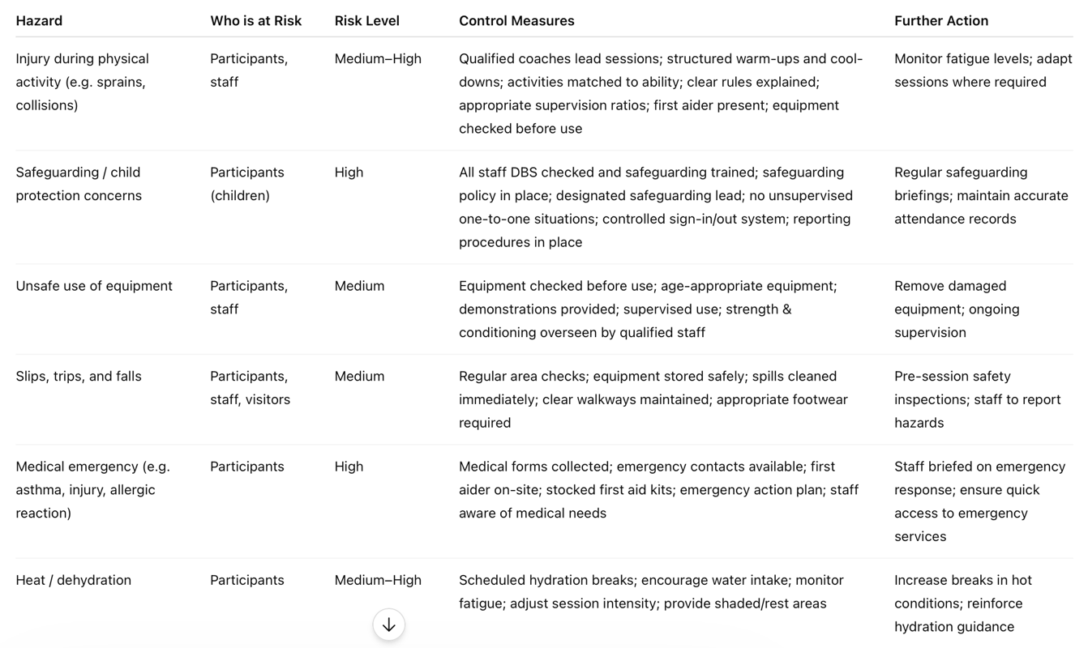

6. Financial Information
(Provide a month-by-month cashflow forecast for the first year, together with a profit and loss statement for years 2 and 3, and a calculation of how much you need to break-even.)

On our original pitch we were looking to charge £50 a day for children to attend our camps with 20 spaces, with the first 5 spaces having a discounted price at £45. Based on feedback and costings we decided to up the prices £52 a day with the discounted price being at £47. This price point will still be sustainable compared to our competitors, as the average price for camps in the UK are at £50 (United Education, 2022) and local competitors such as Swansea City charging £25 per day (£25 per day (Swansea City, 2026) and freedom leisure facilities charging between £15 to £25 (Freedom Leisure, 2025). Although our price point is a lot higher than local competitors, we are looking to offer a more premium service with sports specific coaches that have worked at a high level.
Funding
We would look to apply for a grant through the Be Active Wales fund, which can allow us to gain £50,000 to cover costs such as facilities and equipment (Sport Wales, 2026).
We will look for sponsorships to create extra funding for our camps. We will use the sponsorships on our social media posts when we promote our camps to gain attention.
Our sponsorships cost will range between £100 to £250.

Predicted incomings
3 locations x 20 children per session= 60 children per day x 3 days= 180 children per week.
- £47 x 45= £2115
- £52 x 135= £7020
- Total = £9135
Additional incomings can come from funding via the Be active Wales fund and sponsorships from local businesses.
Staff costings
- £130 x 3 days x = £390 x 3 locations= £1170 a week
- £85 x 3 days= £255 x 3 locations= £765 a week
- = £1935 a week on coaching (3 locations)
We decided the main coach price based on a study from Wage Wizard (2025) that suggested this a competitive price for a high-level coach which we are looking for.
We decided the assistant coach cost based on these rates based on Sports Society (2021), where they charged between £70 to £120 depending on qualifications. We would look at a young and enthusiastic assistant coach who would look to gain further insight to start their coaching career.
Facilities costings
- Olchfa sports Hall- £13.50hr x 9= £121.50 x 3days = £364.50 (Olchfa, 2026)
- All weather pitch at Phoenix Centre- £55hr x 9= £495 x 3days= £1485 (Phoenix Centre, 2025)
- CCYD Astro- £40hr x 9= £360 x 3days= £1080 (CCYD, 2025)
- CCYD sports hall- £36hrx 9= £324 x 3 days= £972 (CCYD, 2025)
- Bae Baglan 4G- £60hr x 9= £540 x 3days= £1620(Bae Baglan, 2017)
- Bae Baglan Sports Hall- £33 hr x 9= £297 x 3 days= £891 (Bae Baglan, 2017)
- Total= £6412.50 over 3 days at 3 locations
Equipment costings
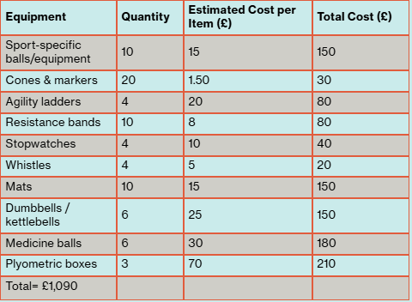
We would look to apply for the Be active Wales fund to cover the costs of the equipment needed in the sessions.
These costs were based on UK retailers such as Decathlon, which we could potentially use when buying the equipment (Decathlon).
Sustainability
- Weekly fixed costs: £8347.50 (Staffing-£1935 + Facilities-£6412.50)
- Weekly income: £9135 (if fully sold)
- Weekly profit: £787.50 (£9135-£8347.50)
- Revenue per child: £50.75 (£9135÷180)
- Break-even point: 165 children per week (£8347.50÷£50.75=164.5)
Predicted Year 1 Month-by-Month Cashflow Forecast
As the sessions will only be happening over the school holidays, we will be operating for 10 weeks a year.
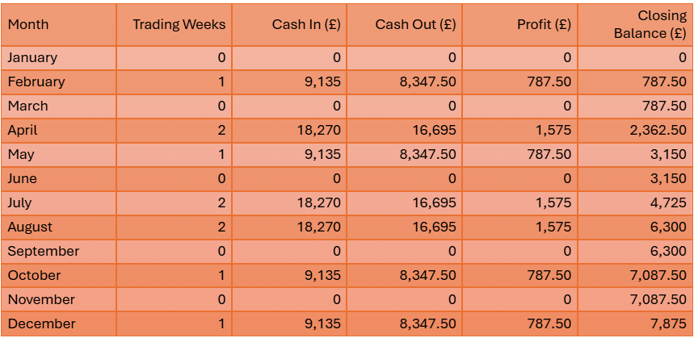
- Incomings = £91,350
- Outgoings = £83,475
- Net profit = £7,875
Year 2 and 3 financial forecasts
At year 2 and 3, we predict to have a 10% increase in revenue per year. This assumption is based on expansion opportunities for additional sessions or expanding to different age sections, customer retention from the first year and growing the brand by growing partnerships with local schools and clubs. We also predict an increase in costs of 5% based on wage inflation to retain our coaching staff and prudent forecasting to make sure that the business is sustainable long-term rather than assuming static outgoings.
Year 2 profit and loss (with the assumed forecasts)
- Incomings - £91,350 × 1.10 = £100,485
- Outgoings - £83,475 × 1.05 = £87,648.50
- Profit - £482,328 - £420,714 = £12,836.25

Year 3 profit and loss (with the assumed forecasts)

- Incomings - £100,485 × 1.10 = £110,533.50
- Outgoings - £87,648.75 × 1.05 = £92,031.19
- Profit - £110,533.50 - £92,031.19 = £18,502.31

7. Appendices
(Include all documents and evidence to support your plan. This may include market research, letters of intent and any firm orders you may have, references, portfolio of previous work, legal documents, price lists, CVs for key team members and sample promotional material. Make sure you cross reference the appendices to the appropriate section of the business plan.)

References:

Arne Güllich, Michael Barth, David Z. Hambrick, and Brooke N. Macnamara. “Recent Discoveries on the Acquisition of the Highest Levels of Human Performance.” Science 390, no. 6779 (2025): eadt7790. https://doi.org/10.1126/science.adt7790.
Bae Baglan (2017) Ysgol Bae Baglan Charging and Remissions Policy. Available at: http://d6vsczyu1rky0.cloudfront.net/36504_b/wp-content/uploads/2018/03/Charging-Policy.pdf (Accessed: 19 February 2026).
Callum. “Why Consistent Social Media Posting Is Crucial for Modern Marketing Success – All Advertising.” All Advertising, 16 Aug. 2024, www.alladvertising.co.uk/why-consistent-social-media-posting-is-crucial-for-modern-marketing-success/ (alladvertising.co.uk in Bing).
CCYD (2025) Facilities. Available at: https://ccyd.co.uk/facilities/ (Accessed: 19 February 2026).
Children’s Commissioner of Wales (2021) Publications. Available at: https://www.childcomwales.org.uk/publications/ (Accessed: 08 March 2026).
CIM. “Marketing Qualifications, Training and Membership | CIM.” CIM, 2023, www.cim.co.uk/.
Decathlon (n.d.) Football Coaching Equipment & Accessories. Available at: https://www.decathlon.co.uk/sports/football/football-coaching-equipment (Accessed: 08 March 2026).
Effective School Outreach Needs Employer Collaboration. Luminate, 2024, luminate.prospects.ac.uk/effective-school-outreach-needs-employer-collaboration. . Accessed 1 Mar. 2026.
Estyn (2024) Annual Report. Available at: https://estyn.gov.wales/annual-report/ (Accessed: 08 March 2026).
Freedom Leisure (2025) Holiday Activities. Available at: https://www.freedom-leisure.co.uk/centres/flash-leisure-centre/latest-news/holiday-activities/
How Great Marketing Drives Sales. Institute of Directors, 21 Mar. 2024, www.iod.com/resources/business-advice/marketing-and-sales/ (iod.com in Bing).
Health and Safety at Work Act (1974)
Management of Health and Safety at Work Regulations (1999)
Multi sports camps (2026) Spanish Soccer Schools. Available at: https://spanishsoccerschools.co.uk/multi-sports-camps/ (Accessed: 04 May 2026).
Olchfa (2026) Lettings. Available at: https://lettings.olchfa.org.uk/spaces (Accessed: 19 February 2026).
OpenStax. “1.2 The Marketing Mix and the 4Ps of Marketing – Principles of Marketing.” OpenStax, openstax.org/books/principles-marketing/pages/1-2-the-marketing-mix-and-the-4ps-of-marketing.
Phoenix Centre (2025) All-weather Pitch. Available at: https://thephoenixonthehill.com/all-weather-pitch/ (Accessed: 05 March 2026).
Principles of Marketing. Google Books, 2026, books.google.com/books?hl=en&lr=&id=UKyaBQAAQBAJ&oi=fnd&pg=PP1&dq=principles+of+marketing..
Reporting of Injuries, Diseases and Dangerous Occurrences Regulations 2013
Sport Wales (n.d.) 3. Active Nation. Available at: https://www.sport.wales/research-and-insight/school-sport-survey/active-nation/.
Sport Wales (2022) School Sport Survey. Available at: https://www.sport.wales/research-and-insight/school-sport-survey/.
Sport Wales (2026) Funding and Support. Available at: https://www.sport.wales/grants-and-funding/ (Accessed: 19 February 2026).
Sports Society (2021) Position of Sports Coach (Holiday Work). Available at: https://sportsociety.co.uk/jobs/position-of-sports-coach-holiday-work/ (Accessed: 05 March 2026).
Stonehouse Communications Ltd. Wicks, Iain. “Social Media Demographics: Know Your Platform’s Users.” 3 Feb. 2025, stonehousecomms.co.uk/one-pagers/social-media-audience-analysis-know-your-platforms-users..
Swansea City AFC (2026) Soccer Camps | Swansea. Available at: https://www.swanseacity.com/community/soccer-camps (Accessed: 5 March 2026).
Swansea Council (2024) Children and Young People – Swansea. Available at: https://www.swansea.gov.uk/article/6318/Children-and-Young-People.
Swansea Council (2025) Book Now – Lots of Affordable Sports Sessions for Young People This Half-Term. Available at: https://www.swansea.gov.uk/sportsfunfeb25
Swansea Council (2025) Recent Population Trends. Available at: https://www.swansea.gov.uk/article/10895/Recent-Population-Trends.
Taylor, Nigel. “Choosing between Social Media Platforms and Understanding the Markets They Reach.” Journal of Digital & Social Media Marketing, vol. 1, no. 3, 2013, pp. 283–291.
UK Coaching (N.D.) A Guide to Safeguarding. Available at: https://www.ukcoaching.org/ukc-club/duty-to-care/safeguarding/a-guide-to-safeguarding/
United Education (2022) Prices and Discounts: Holiday Camps. Available at: https://www.united-education.co.uk/school-holiday-camps/united-camps/dates-and-locations/prices-and-discounts/ (Accessed: 05 March 2026).
Wage Wizard (2025) Sports coaches, instructors and officials pay data UK 2025: Wage wizard, Sports coaches, instructors and officials Pay UK 2025 - Annual & Hourly Pay Data | Wage Wizard. Available at: https://wage-wizard.co.uk/pay/3432/sports-coaches-instructors-and-officials/ (Accessed: 20 April 2026).
Wales Government (2024) Sport and Active Recreation. Available at: https://www.gov.wales/healthy-weight-healthy-wales-delivery-plan-2025-2027-html
Youth Sport Trust (no date) Building a Brighter Future for Every Child. Available at: https://www.youthsporttrust.org/ (Accessed: 08 March 2026).

