Innovation Strategy for Business Advantage

Farzana Hussen 1709301
7th July 2020
Abbreviation
R&D – research and development
FFA – Force Field Analysis
PEST – political, economic, social, technological
BMI – Business model Innovation
IO – Innovation Opportunity

Executive Summary
This report has been compiled by Spice takeaway employee: 1709301, this report has been requested by Management at Spice. To develop a business strategy for innovation opportunity for business advantage. The research has found that Spice has the opportunity to innovate, this is in the result of the economic factors of the present business environment. The employee has identified the area of the business that require implementation. Assessment of effectiveness has been undertaken and it has been found that the IO is regarded as effective, it has been identified that the IO comes with limitations. However, the forces for change deems superior. To successfully implement the IO, the employee has made recommendations to Spice management to choose appropriate leadership and management style. The employee has completed the steps of the innovation process, and the 4P’s to be aligned with the recommendations.
Contents Page
Executive Summary 2
Term of Reference 4
1.0 Introduction 5
1.3 Compare and Contrast Innovation and Creativity 6
1.3.1 Differences see appendix 1 6
1.3.2 Similarities 6
2.0 Main Findings 7
2.1 PEST External Analysis 7
2.2 Innovation Matrix 8
2.3 Models of Innovation 9
2.3.1 Open VS Closed Innovation 9
2.3.2 The innovation Process – developed in 2018 by John Bessant & Joe Tidd 10
2.4 Assessment of Effectiveness 11
2.4.1 FFA – Kurt Lewin 11
2.4.2 Barriers and Risks 11
3.0 Conclusion 12
4.0 Recommendation 13
5.0 Appendix 14
1. Innovation and creativity Difference 14
2. PEST Analysis of Spice 15
3. Innovation Matrix 15
5. Spice innovation Process 17
6. Innovation space 4Ps 18
6A). Spice 4P’s 18
7. Force field analysis 19
6.0 Reference List 20

Term of Reference
The researcher has used books, journals and websites to compile this report.

1.0 Introduction
This report has been compiled to analyse innovation and creativity for business advantage. As illustrated by Majdar et al (2011) that due to global competition and economic pressures, organisations are empowering and motivating employees to be creative as a possible resource for change, innovation and survival. The article stated that employees are nurtured and encouraged to the initiative, innovative to developing creative solutions to the workplace or work-related issues, this enables organisations to be cost-effective, such as product development for profit. This report will analyse Innovation and creativity and its presence in the organisational context. Analyse the benefits and limitations of Innovation models and theories. Apply the models/theories to a local organisation. Conclude and make recommendations for the organisation for competitive advantage.

The local business chosen to critically analyse is Spice Indian Takeaway. The business is recently established, founded in October 2019. The business offers traditional Indian cuisine, which is ordered and made in the takeaway. Spice is located in West Cross, it is a suburban area of Swansea, near the attractions of Mumbles area, which has top sights of Swansea and tourist attraction. Spice offers order in-store, telephone/online order and collect and/or home delivery. Spice has a basic website for online orders, advertised on Swansea Biz, active on Facebook page and recently partnered with Just-Eat. Just-Eat is the UK’s delivering platform, it acts as an intermediary between independent takeaways and customers. Spice has trialist, client and supporter customers. Just-Eat rating: 5.5. Google rating: 4.9. Food hygiene inspection awaiting.

1.1 Definition of Creativity
Kim & Lee (2019) define creativity as a divine flash of inspiration, and newness is a prerequisite to creativity. It has been found that creativity is the ability to imagine and invent something new, it is defined as generating or recognising new ideas, alternatives, or possibilities that may accompany in problem-solving (Franken, 1994). Open Learn (2020) suggests ideas with Kim and Lee (2019) that creativity is strongly associated with imagination, innovation, originality and genius and believes that creativity needs to be fostered, stimulated and expressed.

1.2 Definition of Innovation
It has been found that The Telegraph (2017) defines innovation as means of creating value from ideas, with no limitations of where innovation comes from, innovation can be from within the organisation, or competitors of the market. Forbes (2011) explains that in business innovation is a process of applying knowledge to the creation of new processes, products, and services that has value for stakeholders. The researcher has found that from a business perspective that innovation supports the growth of an organisation, it is a process of implementing changes to something established by introducing features or something new, which can be radical or incremental change (O’Sullivan & Dooley, 2009). The researcher agrees with Kremer et al (2019) that innovation is the implementation of creative ideas, which is one of the most important factors of competitive advantage of the 21st century in organisations.

1.3 Compare and Contrast Innovation and Creativity

1.3.1 Differences see appendix 1

1.3.2 Similarities
- These elements are related to developing new knowledge
- Both elements contribute towards the organisation’s efficiency
- Both elements are included in the creative process

However, Kremer et al (2019) argue that innovation is dependent on creativity, this is because innovation does not take place in the absence of creativity, therefore management must promote and encourage creativity in the workplace. It has been found that Sarkar (2015) also argues that without creativity there is no innovation because for an organisation to innovate they would need to stimulate creative thinking throughout the workforce.

2.0 Main Findings

2.1 PEST External Analysis
The researcher believes that to support IO, businesses must identify and assess the micro and macro-economic factors. It is important to apply the analytical tool: PEST analysis, this tool has been found in 1964 by possibly American professor: Francis J. Aguilar. the tool is primarily used for strategic planning, it supports businesses to understand how external factors can impact the business situations. The analysis helps businesses to determine how these factors will affect the performance and activities for longevity. It can be used in collaboration with other analytical tools likes Porters five forces and SWOT analysis to analyse both internal and external factors (Pestle Analysis, 2013, 2017, Birsan et al, 2016).

As illustrated in appendix 2, the researcher has identified that the economic factors have impacted and influenced the innovation opportunity. Covid-19 an economic crisis has impacted Spice; this is due to the lockdown restrictions and social distancing. Public being furloughed with less disposable income to take-out. By partnering with Just-Eat has supported Spice to be recognised by local customers and wider target market which has supported in increases in sales since the setup. The researcher believes that Spice cannot solely depend on Just-Eat to promote the business and requires a permanent promotional and marketing solution. With inflation rates unstable causing supplies and ingredients to increase in price, and due to decrease of imports has trigger Spice to look at re-pricing its menu. Disposable income has impacted Spice, that has triggered to reach out to new target segment through online platform.

2.2 Innovation Matrix
It has been found that Al-Tameemi et al (2018) points out the innovation matrix developed in 2006 by Davila et al, the matrix classifies the types of innovation based on how it will impact the organisation’s existing capabilities. The matrix has technology, Business model, radical and incremental innovations. The research demonstrates the Technology and BMI:

Technology Innovation – Davila et al (2012) emphasise that technology is a critical source of innovation, technology has a role of bringing creativity to people, such as; Nanotechnology contribution towards cancer therapies. The BBC (2020) reported that Microsoft is replacing its contracted journalists with robots this is a radical change of the MSN site by implementing AI.

BMI – is the development of new, unique concepts that supports the organisation's financial capabilities and profits. To recognise new revenue sources through improving product value and customer experience (BCG, 2020). It has been found that HBR (2014) argues that BMI is not a new creation of a brand-new market, it is about delivering the existing products that are produced by existing technologies in the existing market. Apple has had many successful BMI by launching iPhone, iPad, Mac and other devices that are enhanced, updated or modified by features, capabilities, compatibility, size and price (Forbes, 2016).

The research has illustrated Spice on appendix 3 of the matrix. Spice IO is BMI, to make incremental changes in areas for improvement that will contribute to the growth of profit and customer experience. Innovation increases the customer value or lowers an organisations cost creating competitive advantage. Business Model Spice initiated that they need to make enhancements, brainstorming ideas, integrated within the business process and implemented. Initiation, ideation, integration, implementation. BMI identifies through the dimensions of who, what, value and profit. who is the target customers, what is does the business offer to customers, how to create the value of the proposition and how to generate revenues.

2.3 Models of Innovation

2.3.1 Open VS Closed Innovation
As illustrated in appendix 4, the researcher has found that a closed innovation process is within the organisational R&D department, where new concepts emerged in a closed environment. For organisations, closed innovation is about the safekeeping of the organisation's knowledge and experience that are the greatest assets that are only exclusive to the organisation to enable and expand the business activities. However, open Innovation developed by Business school professor: Henry Chesbrough, the innovation takes place internally and externally. Exchanging knowledge and ideas between business partners, customers, competitors and public institutes of its intellectual assets (Mapping Awareness Campaign, 2018). The research indicates that Google applies the open innovation process, with 233 partners and subsidiary acquisition, Google exchange knowledge and data analytics to support their innovation. Google mission statement is to organise the world’s information and make it universally accessible and useful (Google, 2020).

It has been found that Vanhaverbeke et al (2008) claim that closed internal centralised approach to R&D had become obsolete in many industries and that knowledge requires to be disseminated and ideas must be used or should be distributed or sold to other organisations this is because R&D has become expensive and the return of the knowledge is not sufficient due to increasing of competition in the market and short product life cycles. Many professionals have expressed that open innovation is the possible way of achieving goals. Therefore, it has been found according to Felin & Zenger (2014) research suggests knowledge that flows from various external partners, have generated improved innovation outcomes. Tidd & Bessant (2013) point out that open innovation is universally positive, however, has challenges and needs to be managed such as; identifying the relevant knowledge sources or how to disseminate and codify tacit knowledge or the fact that R&D from external sources are open to competitors, which means that it can be obsolete as soon as it is acquired.

2.3.2 The innovation Process – developed in 2018 by John Bessant & Joe Tidd
The innovation process is a description of the path of converting new ideas or existing knowledge into marketable solutions (Lead Innovation, 2020). Bessant (2015) demonstrates that this model is to see innovation as a journey, travelling from the start to the end through different landscapes. Each stage of the model poses different challenges, as an innovation manager, it is relevant to focus on key stages of the process identifying risk and limitations. Innovation Masters (2014) points out that that innovation needs to be measured and the model will manage and support the innovation strategies, it is to structure the application of innovation in real organisations. On the other hand, Bessant (2015) expresses that the process has limitations, the innovation process can be helpful, however, it is only a model and in reality, there will be many risk factors, barriers and blocks that can stop the process. This can be due to the type of sector, business size, KMS, financial resources, industry life-cycle and more. The researcher argues that innovation managers should not highly depend on the framework, this is because the framework is a simple pathway that does not illustrate the complex and uncertain events that can arise during each phase.

Please refer to appendix 5 for Spice Innovation Process
It has been found that at the search stage Spice will search internal and external environments for factors. At the select stage, Spice will use resources to recruit a marketing and sales advisor, the marketing specialist will be able to use their skills to market the business on social media. At the implementation stage Spice will complete risk analysis, this will support the business to mitigate risks before implementing the innovation. Marketing advisor will set up social media accounts, schedule photoshoot of dishes that can be trademark. Print updated menus with social media accounts. The Capture stage will create valuable information for the business such as sale numbers/profits, how many new customers, reviews, and whether the market segment is attracted such as other Swansea areas and not just the local area customers.

2.3.3 Innovation Space – 4P’s developed by John Bessant & Joe Tidd
As illustrated in appendix 6, the innovation mix paradigm has been developed by Bessant and Tidd to enable organisations to discover what each process can improve and bring to the business. The model is used for planning the processes to support organisations to understand where they currently are and how it can innovate to improve the 4P’s. The 4P’s gives an indication of which area of the business needs innovating, the tool supports in generating ideas and incubating new ideas.

Spice 4P’S
As illustrated in appendix 6A, the researcher has identified that Spice is not using social media platform to promote and market the business to a wider market segment. The researcher analysed Facebook page is obsolete and not used to its capabilities. Due to the current economic crisis of COVID-19, the number of sales had decreased; this is the reason why Spice partnered with Just-Eat. This implementation has shown improvements in sales per weeks. Spice wants to make further enhancement by marketing the business to wider areas than just the local areas. The researcher has found this as the purpose of the innovation opportunity.

2.4 Assessment of Effectiveness

2.4.1 FFA – Kurt Lewin
It has been found that FFA was developed in 1951 by Kurt Lewin, a social psychologist and expert of leadership style. FFA is often used in management that influences and drives change. The researcher has found that the purpose of the framework is to identify factors and pathways that contribute and hinder the success of an innovative implementation and transformational effort. FFA encapsulates the benefit of identifying factors, and then ranking the factors by importance and changeability, this then is evaluated to understand whether the innovation will be effective (Toves et al, 2016).

The research has illustrated on appendix 7, Spice will have to invest financial resources and recruitment of new staff for different skills and roles. Therefore, although there are forces against change, such as minimum wage increasing annually, or the fees and commission prices of using other online ordering takeaway foods; UberEATS, hungry House, Deliveroo and many more. The forces for change have more priority and it has found to be an effective opportunity.

2.4.2 Barriers and Risks
It has been found that although the IO illustrates to be effective, Spice needs to be aware of the risks. The potential profit that could be achieved from this proposal may not outweigh the financial resources used to recruit skilled staff. The new recruits may not be as productive, such as staff for checkout and packing may require training to be familiar with the menu and the packing process. New chefs or whether supporting in the development in upgrading existing employees to a chef role will require food hygiene/ food safety accreditation, Spice will require to cover the fees for the courses. When recruiting new delivery drivers, Spice needs to ensure that they are trained in the contactless delivery due to the recent pandemic impact, also need to ensure that background checks are made of the driver such as driving permit, and/or health conditions.

3.0 Conclusion
This report has been compiled by the employee of Spice Takeaway, that has been requested by the management of the company. The request is to present a business report of a successful innovation strategy, this is to support the management to understand the importance of innovation and how capitalising on innovation opportunity will contribute to business advantage.

The research has found that the IO is effective, however, does come with limitations and financial expenditures. The innovation has been influenced by the economic factors; the external factors have impacted many SME during this unprecedented time. There is no evaluation of micro-economic factors, employee did not conduct SWOT analysis. The innovation models have been applied to Spice; the application shows that the opportunity proposed by the employee is an incremental business model innovation. Spice currently apply open innovation; this supports the business to monitor and evaluate competitors. However, open innovation poses a threat to the company please refer to appendix 4 for discussion. It has been found that the innovation process model is mainly used to manage the implementation of change, and organisation should be prepared to be challenged during each stage of the innovation process, by mitigating risk factors. The research has found that the 4P’S model had supported the employee to monitor and evaluated the areas that lack innovation. Therefore, the model has supported the employee to propose new ideas, of eCRM and actively marketing on SM platform, please refer to appendix 6A. The FFA has demonstrated that financial investments are required the effectiveness of the opportunity is superior with risks stated on 2.4.1 & 2.4.2. The IO will develop valuable creation such as; CRM however, in the longevity it cannot guarantee sustainability of profit, therefore Spice will need to continually innovate to remain in the competitive business environment.

4.0 Recommendation
To support Spice takeaway, the employee has made recommendations, which the employee believes that will make the IO effective.

- Refer to appendix 5, this is a proposed innovation process developed by the employee, this can be used by the manager as an action plan of each stage of the process.
- The research has found that Kesting et al (2015) state that transformational leadership style is the most favourable choice in many kinds of literature for innovation, however, indicate that different innovation phases and types raise different demands on the leadership style. Therefore, Spice should apply suitable leadership style and management theory to the innovation strategy.
- Spice should complete both external/internal environment analysis to ensure that there are no threats or weaknesses within the company that could impact the opportunity.
- Firstly, Acquire the financial resources to make it happen.
- The employee has proposed innovation strategies demonstrated on appendix 6A.
- The researcher recommends that Spice should apply closed innovation – this is because competitors can acquire knowledge of the business and can predict business strategies and it will be giving competitors an advantage.
- FFA analysis should be conducted, proceed forward if the forces for change is higher.
- The 4P’s should be applied during the strategic planning this tool will support to find gaps in the process and to improve them.
- When applying The Innovation Process model, Spice should monitor and measure the efficiency, although this is the journey, there will be challenges at each stage of the process, this is when risk analysis should be conducted.
- Capture data of how the innovation has benefited the business and continually monitor the business environment and review the BMI frequently.

5.0 Appendix

Innovation and creativity Difference

Innovation | Creativity
- Innovation is a process that transforms creative unique ideas into new realities such as; products, service, procedures that deliver value (Harmeyer, 2015).  - Innovation is the actual implementation and execution of creative ideas (Kremer, Villamor, & Aguinis, 2019).  - Innovation is measurable - by introducing change into stable systems  - Innovation has 4 types, these are: Technology, Business Model, Incremental and radical innovation | - Creativity is a useful idea or solutions to problems  - Creativity is the mental ability to conceptualise new unusual ideas or the ability to recognise new connections between things that are unrelated (Harmeyer, 2015).  - Creativity is subjective – it is difficult to measure the mind to conceive new ideas (Business Insider, 2013).  - Creativity has 2 types: Incremental and radical

PEST Analysis of Spice
Political  - Tax reforms  - Health and safety regulations  - Food hygiene accreditation  - Adhering to the guidance for food businesses during COVID-19  - Competition & Markets authority | Economic  - Inflation rate – increased prices of supplies and ingredients, as a result menu prices will increase  - Disposable income – less take-out, which means targeting another segment  - Minimum wage – need to consider how many employees the business can afford
Social  - healthy lifestyle  - increased awareness of organic food  - Vegan demand  - Halal demand | Technology  - Apps to monitor efficiency  - Management and accounting software to monitor the flow of profitability  - Card payment systems – accepting payment contactless from mobiles

Innovation Matrix

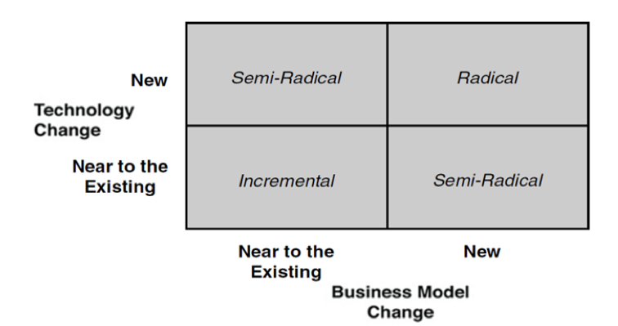
Spice

- Spice Open Innovation
Spice applies open innovation for its strategic goals, Spice has researched competitors within the area to offer customers competitive meal options and offers of delivery service to entice and attract prospective customers. Customer ratings and reviews, menu and delivery prices are shared publicly. It has been found that there are many challenges and limitations of open innovation that can impact Spice, these are;
  - Open strategy gives competitors an advantage by revealing intellectual data
  - Can expose strategic thinking to competitors
  - Competitors can access menu, dishes, prices and exploit the knowledge acquired by offering competitive menu and promotional offers that will entice prospect customers
  - Therefore, Spice losing to the competitors

Spice innovation Process

Search – how can we find opportunities for innovation?

- Spice will search for triggers by analysing internal and external factors by completing SWOT and PEST analysis.

Select – What are we going to do and why?

- Spice have the financial resources to implement.
- Spice do not have the skill and will require to hire external agency.
- Marketing professional will promote and engage with new prospect customers on social media platforms.
Capture – How are we going to get the benefits from it?

- Generate more sales
- New customer relationship
- Successfully entice new market segment
- Positive reviews and feedback to continually improve
- Customer engagement
- Rise in revenue
- Reflection for improvement
Implement – How are we going to make it happen?

- Spice will complete a risk analysis- this will support to void or mitigate risk that could impact the innovation.
- Documenting the social media T&C’s.
- Spice to acquire knowledge from monitoring and evaluating competitors and how they interact with consumers.
- Set up a market segment.
- Hire photographer for photoshoots of dishes.
- Order new menu’s with social media page links
- Add social media icon stockers on the displays

Innovation space 4Ps

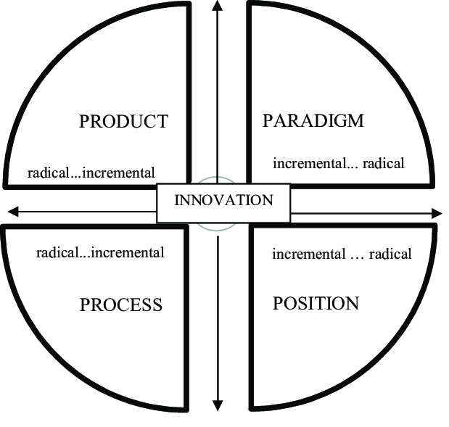

6A). Spice 4P’s
Paradigm  The researcher suggests that Spice to focus on their image, brand, and marketing techniques. Spice need to take full advantage of the social media platform and how it influences people. SM can instantly connect with the audience and interact to create customer relationships. As well as eCRM marketing by emailing existing customers with promotional offers. Spice has repeat customers, this purpose of interacting with locals is to acquire new customers. | Product  The researcher has found the opportunity to implement Spice recruit marketing agency or candidate who has marketing and CR skills. This will support the business to set-up, update, enhance, improve existing SM accounts and set up new accounts on Instagram and Twitter where followers/customers can use hashtags to promote, share contents of orders and recommend to friends and families. The risk factor of this technique is that customers will give reviews and feedbacks, where customer dissatisfaction is broadcasted, and it is important that Spice resolve customer dissatisfaction effortlessly with integrity.
Process  Recruit staff or agency for the role, set-up the pages and use third parties to target consumers how to get followers on Instagram, edit the page with menu, posts, dishes, live cooking videos, share reviews. Share best times to order, promote the vegetarian/halal menu to attract diverse cultures, collaboration opportunities with competitors, use the viewing analytics to understand how often customers are engaging in social media | Position  Communicate with audience/ customers on social media, discuss best seller items and dishes, live cooking or update on stories. Communicate open and close times. Participate in local events by hiring stalls, such as Air roadshow, Xmas parade, Eid in the park, contribute to community cultural and tourism events. Contact local B&B and hotel for collaboration. Supporting key workers offering discounts.

Force field analysis

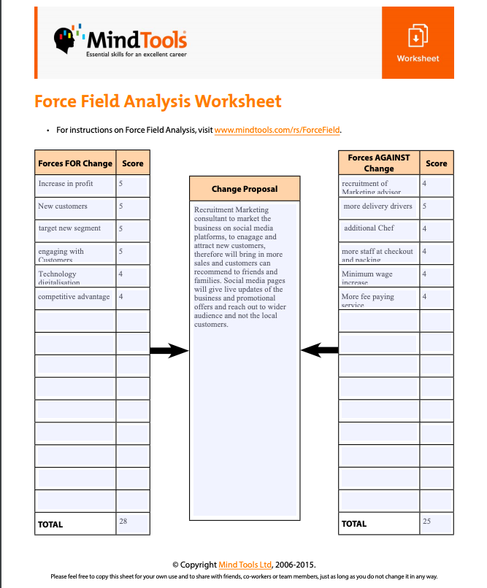

6.0 Reference List
Al-Tameemi, K., Aishawi, M., & Ahmed, V. (2018) Integrating Business Improvement and Innovation Models: a Step Change Approach for Organisational Performance Improvement, International Journal of Engineering & Technology, 7(4.20), pp.608-617.

BCG, (2020) Business Model Innovation Delivers Competitive Advantage
Available at: https://www.bcg.com/capabilities/innovation-strategy-delivery/business-model-innovation.aspx
(Accessed: 30th May 2020)

Bessant, J. (2015) Strategic Innovation Management – Chapter 5
Available at: https://johnrbessant.files.wordpress.com/2015/03/sim-chapter-5.pdf
(Accessed: 3rd June 2020)

Bîrsan, A. Shuleski, D. & Cristea, C, V. (2016) Practical Approach of the PEST Analysis from the Perspective of the Territorial Intelligence. Ovidius University Annals: Economic Sciences Series, XVI (2), pp.169–174.

Business Insider (2013) There’s A Critical difference between creativity and innovation
Available at: https://www.businessinsider.com/difference-between-creativity-and-innovation-2013-4?r=US&IR=T
(accessed: 27th May 2020)

Davila, T., Epstein, M. & Shelton, R. (2012) Making Innovation Work: How to Manage It, Measure It, and Profit from It, Updated Edition FT Press

Felin, T. & Zenger, T, R. (2014) Closed or open innovation? Problem solving and the governance choice. Research Policy, 43(5), pp.914-925.
DOI: https://doi.org/10.1016/j.respol.2013.09.006

Franken, R.E. (1994) Human Motivation, 3rd ED, California: Brooks/Cole

Google (2020) About
Available at: https://about.google/?fg=1&utm_source=google-GB&utm_medium=referral&utm_campaign=hp-header
(accessed: 3rd June 2020)

Harmeyer, K. (2015) Linkedin: The Relationship between Creativity and Innovation
Available at: https://www.linkedin.com/pulse/relationship-between-creativity-innovation-keith-harmeyer
(Accessed: 28th May 2020)

Innovation Master (2014) Developing an innovation process
Available at: https://www.youtube.com/watch?v=l9sNGnxMEXE
(accessed: 3rd June 2020)

Kesting, P., Song, J.L., Ulhoi,J.P, & Niu, H. (2015) The impact of leadership styles in innovation management – a review and a synthesis. Journal of Innovation Management, 3(4), pp22-41
Kim, K. & Lee, J. (2019) Creative and Gifted Education in Korea; Using the CATs model to illustrate how creativity can grow into innovation. Handbook of Giftedness and Talent Development in the Asia-Pacific. Pp.1-35.

Kremer, H., Villamor, I. & Aguinis, H. (2019) Innovation Leadership: Best-Practice recommendations for promoting employee creativity, voice, and knowledge sharing, Business Horizons, 62(1), pp 65-74.

Lead Innovation (2020) Defining the innovation Process
Available at: https://www.lead-innovation.com/en/innovation-process#:~:text=The%20innovation%20process%20describes%20the,through%20development%2C%20to%20market%20entry.
(accessed: 3rd June 2020)

Majdar, N., Greenberg, E., & Chen, Z. (2011) Factors for radical creativity, and routine, non-creative performance. Journal of Applied Psychology, 96(4), pp. 730-743.

Mapping Awareness Campaign (2018) What is Open Innovation?
Available at: https://www.youtube.com/watch?v=GD2wCS2xwWQ
(Accessed: 3rd June 2020)

Open Learn (2020) Language and Creativity: Defining creativity
Available at: https://www.open.edu/openlearn/languages/language-and-creativity/content-section-1
(accessed: 27th May 2020)

O’Sullivan, D. & Dooley, L. (2009) Apply Innovation, Thousand Oaks: SAGE publication

Pestle Analysis (2013) PEST Analysis Definitions and examples in the business world
Available at: https://pestleanalysis.com/pest-analysis/
(accessed:5th June 2020)

Pestle Analysis (2017) Who Invented PEST Analysis and why it matters
Available at: https://pestleanalysis.com/who-invented-pest-analysis/
(Accessed: 5th June 2020)

Sarkar, P. (2015) Creativity: Generic definition, tests, factors and methods. International Journal of Design Sciences and Technology. 21(1), pp. 7-38.

Toves, P.R, Graf, L. & Gould, D.A. (2016) Innovative Use of Force Field Analysis: Factors Influencing Technology-Enabled Change. Journal of Behavioral & Applied Management, 17(2), pp.85–103.

Tidd, J. & Bessant, J. (2013) Managing Innovation: Integrating Technological, Market and Organizational Change, 5th ed, Chichester: John Wiley & Sons

Vanhaverbeke, W., Vrande, V., & Chesbrough, H. (2008) Understand the Advantages of Open Innovation practices in corporate venturing in terms of real Options. Creativity and innovation management, 17(4), pp. 249-338.

