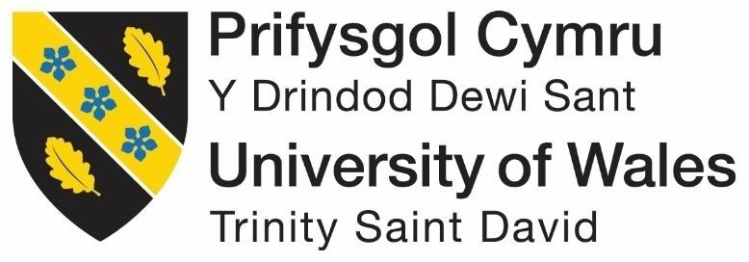
MODULE CODE/ COD Y MODIWL: BMSW4001
ACADEMIC AND EMPLOYABILITY SKILLS
RESIT ASSESSMENT: 1&2
Name: Tahmina Sharmin
ID: 1816429
Teacher’s Name: SHAO-LAN YEN
Resubmission Date: 23/08/20

Contents
Essay from Term-1 3
Personal Skills Analysis 3
References 8
Essay from Term-2 10
Reflective Essay 10
References 14
Appendix-1: Class Activities from Term-1 16
Appendix-2: Class Activities from Term-2 18

Essay from Term-1

Personal Skills Analysis
Introduction
Readiness for your career revolves around major academic and employability skills which are very important for success in your career or the job you are doing are planning to do. These skills have been emphasized by many literatures and researches and allow students to be successful in their careers. Academic skills are the skills which students learn in class and are required for them to succeed in their academic work in relation to graduation attributes such as innovation, problem solving and others. Employability skills on the other hand are the skills required for success in the place of work in this century such as teamwork, creativity, problem solving and many others (Olsen, 2018). In this essay, I will analyze my academic skills as well as my employability skills basing on published literature, exercises done in class as well as my working at Tesco.
Academic skills
Literature Related to Academic Skills
Anne (2018) states that students struggle to cope with systems which they don’t understand every year and most of the students who do not adapt in these systems who does not have does not have the relevant academic skills needed for success in these environments. Once students are aware of the skills such as time management, note taking, writing skills, academic writing, referencing and others, they can understand their areas of focus and well end up doing much better in class. .
Academic skills are the skills which are majorly applied in the process of learning and boosts the student’s process of acquiring and retaining knowledge and play a great role towards academic success, getting good grades as well as learning throughout the lifespan of every individual (Strangl, 2015). According to Skills you need (2016), academic skills are the skills which are required for one to efficiently learn such as being organized, managing your time, writing styles, citing sources, note taking, reading effectively and others throughout my learning, I have acquired so many skills in which have contributed to my academic success and are very important for my future academic success too. The skills are described below.
Academic writing
Academic writing has been defined as the form of expression in writing in which students or researchers use to clearly, concisely, well structured, focused while backed up by evidence with a major aim of making it easier for the reader to read and understand. It is easier, makes use of a formal tone with a short sentence structure (Library, 2019). I am very good in academic writing; a skill which I haves mastered throughout my studies with a great contribution of my good grasp of language. I make use of this skill every day in my studies since we do a lot of writing in class. It has enabled me to do well in my academic work such as doing assignments, doing examinations, carrying out research, writing reports and many other aspects of class work through the use of the right tone, simple language, the right punctuation, use evidence in my writing while using the right language.
Presentation writing
Presentation writing is a form of academic skill which is used to present an idea or a topic to the audience. Writing presentations can be a daunting experience since you are supposed to move your ideas and thoughts from your head to writing and later presenting the it to an audience. With much learning and practice, I have been able to master the skill of writing presentations especially for academic work right from the start of preparing for the presentation by gathering information, organizing these information, structuring of the presentation, using PowerPoint, making my presentations interesting and the best way to end the presentation (Skillsyouneed, 2018).
Analytical skills
Analytical skills are the skills needed for collecting information and analyzing them towards solving problems and making the right decisions. This skill allows one to break down information into smaller pieces which are easy to understand and draw conclusions from it through logical reasoning. It is the use of clear cut and creative techniques to acquire solutions to a problem (Alison, 2020). I have great analytical skills through my ability to logically reason, brainstorm, interpret data and apply creative techniques while solving problems in my academic work. Through analytical skills I can review information from varying sources, come up with new integration and make the best decision based on this observation.
Reflective writing
Reflective writing is a form of academic writing in which students write essays or reports basing on an experience and it makes use of mental reflection. Students write about the experiences with an exploration of how the experience went, how the experience have changed their personalities or improved their performance (Yancey, 1998). With an understanding of how beneficial reflective writing can be, I have learned on the best ways to write my reflections and obtain maximum learning from it towards improving my learning in class and performing the best in class work by learning out of an experience. While writing my reflections, I always ensure that I understand why I am writing, whether it is understandable, my feelings towards my writing, my emotions when writing and my abilities towards reflective writing.
Summarizing
Summarizing is a very important academic skill which allows one to extract important information from a text or document, rewriting them under own words in a shortened manner (MIT, 2018). In most of our academic work, we read other people’s ideas on the various topic, this skill allows me to break down large units from other people and come up with my own ideas which are more condensed. Sometimes, I just summarize a text as part of my class assessment which may include or may not include my own ideas. While summarizing, I always ensure that I identify the original text, I then synthesize the main ideas from the original text and present the ideas in my understanding on a neutral stand.
The skills I have
I have learnt various academic and employment skills in my life, as explained above, some of the academic skills which I have include language skills such as being able to listen well, being able to speak well, I am able to read and understand very effectively and also write in a simple manner which is easily understandable, in a formal tone using the right punctuations. Besides that, I have great presentation skills whether writing presentations or presenting them to an audience. I also have great analytical skills which has helped me solve many academic problems and perform well academically, besides that, I am very good in summarising and paraphrasing notes.
The skills which I need
Besides having much of the employability and academic skills, there are some other skills which I need in order to do much better in my career from academic work all the way to employment. One of the academic skills in which I need to learn more about it is referencing and citation since I am not well versed with it. I also need to learn on note taking from reading or when listening to verbal speeches. I also need to learn on how to revise very well for my assignments or exams towards my academic success.

Employability skills
Literature Related to Employability skills
Academic qualifications may allow one to get a very good job, but employability skills will allow you to be productive in the job. The most important skills for employment revolve around the areas which allows one to work well with other people such as communication skills, team work, problem solving, trustworthiness and others, the skills which makes you dependable and reliable and your willingness towards learning new skills (Carey, 2015). The most critical skills to the 21st century workplaces are the employability skills such as problem solving, critical thinking, communication skills, technological skills, ethics, professionalism, creativity and others. Students must therefore be provided with opportunities to learn, develop and practice these skills and to put them into practice in the real-world scenarios, these skills are also important towards college readiness (Development Services Group, 2000). According to SHRM (2008), the places of work are changing rapidly, and employee skills must be in line with the expectations of the employers. The skills need by the employers should therefore be taken into consideration by the education system towards producing the right quality of graduates and learning of employability skills should be a continuous process.
Success in my academic work is not enough to guarantee me with my dream job since the job market has become so competitive due to the high number of graduates joining the job market every year. The employers’ currently look for the employability skills above the academic qualifications to sift the high number of graduates. The employers also need these skills to ensure that the employees they are recruiting improves the performance of the firm (GT Scholars, 2017). Some of the employability skills include;
Communication skills
Every work involves interaction with the people whether interacting with the clients or colleagues. Communication is the passing of information from one person to the other. Communication is a very important skill which allows one to work effectively with other people (Marsha, 2001). Being good in both spoken and written communication has always allowed me to put across my points and ideas clearly which can be easily understood by my employer. I have enhanced my communication skills through regular practice and through the public speaking forum which I joined.
Time management
Time management is the practice of exercising control over the time that one spends on daily activities towards improving the effectiveness, productivity and efficiency. Being able to manage your time allows you to accomplish a lot under less time (Stella, 2013). Time management is a great skill which is very important to my life since I do a lot of work every day which I able to accomplish them by managing my time very well which allow me to accomplish my tasks at Tesco and get time for my studies too. I always ensure that I arrive at work in time, work on my assigned tasks within the required timeframe which has earned me with a lot of praise at work.
Problem solving
Problem solving is the process in which a problem is defined, its cause identified, coming up with alternative solutions and implementing the solution to the problem (Charles, 2019). having great analytical skills has allowed me to handle problems with much ease. I able to analyse the various information around a problem and come up with the best solution to the problem. Being good in communication skills and decision making besides the analysis skills has been the major contribution towards being good in solving problems.
Teamwork
In our daily duties at work, we always interact with colleagues. Even though one might be working alone, one must interact with other people to effectively complete the tasks, every organization in one way or another work as a team and one needs to have teamwork skills in order to achieve its objectives (Stella, 2013). I have been a great team worker right form my class work to my work at Tesco. In everything that I do, I always ensure that I work in collaboration with my colleagues at Tesco, I always set my goals in line with the goals of Tesco team while ensuring that I am flexible so that I accommodate others.
Motivation
Motivation is a force which drives us to act towards achieving or doing something such as a goal, they are the emotional, the cognitive, biological and social forces which drives our behaviours (GT Scholars, 2017). I am a self-motivated person who sets goals and goes for them no matter what. In everything that I do, I never give up in the face of setbacks, I take on new opportunities and I always committed to achieving the best. I believe by doing so, others will get motivated too. I always remain positive and cheerful in every situation while avoiding negative talk to keep my colleagues motivated.
The skills I have
I have various employability skills which are very important towards my success at my place of work such as time management, I also have great problem-solving skills and communication skills as well. I am also very good in time management, self-motivation, motivating others. Besides that, I am a great team worker. In everything I do, I am always able to be relied upon. While being accommodative towards other people, I always try to be
The employability skills I need
There are some skills which I have little or no knowledge about, yet they are very important for my employment success. Some of the employability skills in which I need to learn on basing on my current work performance at Tesco and feedback include networking skills towards making my network better, also need to learn on my technological skills such as computer skills.
Conclusion
Career success and career readiness depends on the grasp of both academic skills as well as the employability skills since they work hand in hand. Acquiring of all these skills is not possible from the class work and one should acquire additional training as well as development so that they can acquire some of the specialized skills towards academic and employment success. It also important to start the process of skills development earlier. In this report, I analyzed my academic skills as well as my employability skills basing on published literature, exercises done in class as well as my working at Tesco.

References
- Alison Doyle. 2020. Analytical skills [Online] Available at: https://www.thebalancecareers.com/analytical-skills-list-2063729#:~:text=Analytical%20skills%20refer%20to%20the,skills%20and%20how%20they%20work. [Accessed 22nd August 2020]
- Anne Bolender. 2018. Academic skills every student needs [Online] Available at: https://www.youniversitytv.com/college-tips/6-academic-skills-every-successful-student-needs/ [Accessed 22nd August 2020]
- Carey Benedict. 2015. The Surprising Truth About How We Learn And Why It Happens. New York. Random House
- Charles Conn. 2019. Bulletproof Problem Solving: The One Skill That Changes Everything. Hoboken. Wiley
- GT Scholars. 2017. Skills needed to improve your performance in employment [Online] Available at: https://gtscholars.org/7-effective-skills-to-improve-your-employability/ [Accessed 21st August 2020]
- Library. 2019. Academic writing [Online] Available at: https://library.leeds.ac.uk/info/14011/writing/106/academic_writing [Accessed 20th August 2020]
- Marsha J. Ludden. 2001. Effective Communication Skills: Essential Skills for Success in Work and Life 2nd Edition. Bloomberg. Jist Works
- MIT. 2018. Summarising [Online] Available at: https://integrity.mit.edu/handbook/academic-writing/summarizing [Accessed 21st August 2020]
- Olsen Lynn, 2018. "What Does 'Ready' Mean?" Education Week [Online] Available at: <www. educationalliance.org/StateScholars/Downloads/ WhatDoesReadyMean.pdf> [Accessed 19th August 2020
- SHRM. 2008. A study by the Society for Human Resource Management and WSJ.com/ Careers [Online] Available at: https://www.octech.edu/wp-content/uploads/2019/01/Critical-Skills-Needs-and-Resources-for-the-Changing-Workforce-Survey-Report.pdf [Accessed 21st August 2020]
- Skills you need. 2016. Academic skills [Online] Available at; https://www.skillsyouneed.com/learn/study-skills.html [Accessed 23rd August 2020]
- Skillsyouneed. 2018. Writing you presentation [Online] Available at: https://www.skillsyouneed.com/present/writing-your-presentation.html [Accessed 21st August 2020]
- Stangl Werner.2015. The PQRST method of studying , stand-taller. Effective study. New York. Harper & Row
- Stella Cottrell .2013. The study skills Handbook. London. Palgrave Macmillan
- Yancey Kathleen Blake. 1998. Reflection in the Writing Classroom. Logan, UT. Utah State University Press

Essay from Term-2

Reflective Essay
For an employee to perform this/her duties well, he/she is required to have the basic necessary skills required for them to acquire employment or succeed in the academic world. These skills are known as academic and employability skills. These skills may include making presentations, CV writing, public speaking, academic writing and many others. Being knowledgeable about these skills can help one well prepared to achieve their career goals in future (Cottrell, 2013). This report will describe my experience while learning these academic and employability skills. It will also give a highlight of the skills I had before my understanding of these skills, my feelings while learning these topics, what I learned after completing the study of these skills, how to best apply these skills upon employment and how to improve on my weak areas. Some of the skills that I learned and will be discussed in this report include Paraphrasing, referencing, CV writing and cover letter writing. I will apply Gibbs Reflective Cycle developed by Graham Gibbs in the year 1988 to reflect on my experience in learning these skills. Gibbs reflective cycle offers a structure to learning from a previous experience (Gibbs, 1988).
Description
In this module I learned how to write a good CV, paraphrasing, referencing and writing a cover letter. A CV is a document which focuses on explaining to an employer who you are as a person, the skills and qualifications you have and explaining your previous employments for them to give a chance to work with them (Morgan, 2017). In this topic, I learned how to create my personal brand before writing the CV, how to write the perfect CV using the correct format and presentation which included my personal contact details, personal statement, my qualifications and education, previous and current work experience, additional responsibilities and activities, hobbies and interests and how to write references on a CV. I learned that while writing and presenting a CV, it is important to write a cover letter as well. Borchardt (2014) state that a cover letter is an executive employment letter which offers the employer a preamble to an accompanying CV. In this topic, I learned what should be included in a cover letter, like how to introduce myself, sell myself through my skills and abilities, stating what I can do for the company I am applying to and how to finalize a cover letter. I had very good feedback from my tutor during my cover letter writing class exercise.
The other topic I learned in this module was paraphrasing. According to Bailey, (2011) paraphrasing involves writing the concepts and views of another writer in your own words to support your own objectives. In this topic, I learned the different techniques used in paraphrasing. These include making appropriate use of synonyms, changing word class and word order. I learned how to make a list of the key ideas and retaining the original meaning of the paragraph or sentence. I also learned how to change the structure of a paragraph. I learned the topic of referencing which is important when paraphrasing some else’s ideas to avoid plagiarism. According to Cite them rite (2020), referencing is the act of offering a book or article with citations of sources of information when using another writer’s ideas to give credit to their work. In this topic, I learned about plagiarism and how I can avoid it through successful paraphrasing, I learned how to write list of references and bibliography through the use if Harvard referencing style.
Feelings
The main emotion I felt while learning this module was excitement. I realized that I needed to do a lot of research and practice on the topics and this made the module enjoyable. Before studying this module, I thought I had all the skills I needed to be employed and upon understanding the various topics in this module, I realized that I had a lot of studying to do in order to prepare myself for employment. Some of my fellow classmates felt anxious to learn this module as they also realized they did not have the basic skills required for the employment world especially skills like CV writing and cover letter writing which were two of the most essential requirements needed for employment. This module has given me a chance to improve on my paraphrasing and refencing skills which were my weak skills.
Evaluation
During this module, I had a difficult time learning and doing practice on paraphrasing and referencing. My work resulted in high percentages of plagiarism and I was often asked to rewrite my list of references. Not all resources were accessible both in the library and on the internet and this made referencing hard to practice. It was hard being consistent while using multiple resources from different locations. The process of research was time consuming and made me miss some deadlines. My CV and cover letters were good but not good enough to sell myself for employment. After a lot of tutoring from my lecturers and doing more research and studies during my free periods, I learned to write attractive skills and qualifications on my CV which was a good way to sell myself for employment. This made me more confident to teach my classmates on how to improve their CV writing skills. The tutor also helped me exercise my paraphrasing skills by frequently giving me paragraphs to work on. Doing a lot of exercises on paraphrasing also improved my grammar and spellings mistakes that occurred while changing word class and word order. I made use of the resources at the library like using books, articles and the internet to practice my refencing skills. Our lecturer made sure that I had improved on the various topics and gave me enough time and assignments to practice.
Analysis
The hard work and determination I had during this module has greatly affected my learning and understanding of the topics. Putting this extra effort was frustrating for some people but it was important to realize that one could not succeed in their careers without these skills. Upon completing this module, I noticed that my skills had improved and I could now face the employment world without fear. Academic and employability skills make one reliable and willing to learn (Subjectguides, 2020). I have established my CV writing skills to prepare for the job seeking procedure. Learning this module encouraged me to improve and enjoy writing a CV and cover letter. I had the chance to portray all my interpersonal skills that I am proud of and allowed me to recognize my weakest areas which I would improve on through an established structure. The module has enabled me to acknowledge the importance of paraphrasing by making use of synonyms to replace the original words and phrases with alternative words. Paraphrasing has taught me to change the structure of a sentences and paragraphs to achieve a successful paraphrasing (Berant and Liang, 2014). After a successful paraphrasing, I have learned to use Harvard referencing style to acknowledge the work of other writers I use while doing my research and further study. Through referencing, I learned the different kinds of plagiarism and how they can be avoided. I learned that while referencing another author’s work, the reference should be in the text or paragraph and another on the list of reference which comes after the work. I also learned the difference between list of references which only covers the sources used on my work and a bibliography which all the other sources that I have used for my work and is therefore longer than the list of references. Having these skills will be an added benefit in the employment world.

Conclusion
Upon completing this module, I have learned that working together with the lecturers and my fellow classmates has greatly improved my academic and employability skills. Having made maximum use of the online and library articles, journals and books has improved my referencing and paraphrasing skills. Understanding the academic and employability skills has also improved my spelling and grammar while exercising my paraphrasing skills. Through this, I can now write the perfect articles and essays through researching other books and better expressing my ideas. During my studies and observations, I learned the different versions of paraphrasing which also helped me learn the paraphrasing in academic writing. Thanks to this module, I can now write the best CV and cover letter that will help me get employed in future. I have been able to do much practice on the CV format and present myself well on my skills which can guarantee employment as the employer will be fully satisfied with the information displayed on my CV.
Action Plan
In order to succeed in my future career, I have to often put these skills into practice both in and out of the academic world. To improve on my paraphrasing skills, I need to frequently proofread my work and idea against the original work and fully understand the full objective behind the original author’s work. Plagiarism has been a big problem with most students at the university and the only way to avoid this issue is by use of references. I should study more on the Harvard style of referencing to better indicate my sources to the readers and lecturers looking at my work. Using quotes on my work will also help my research more effective with the use of in-text citation. In order to be consistent in my refencing, I write down the sources as I work so as to successfully have a list of references (Cite them rite, 2020). Though I have improved on my CV and cover letter writing skills, I should do more research on grammar and sentence structure so as to write the best CV and cover letter that can win me a job in my future. I have to take an advantage of every assignment regarding CV writing and cover letter writing to boost my skills. I need to greatly improve on my study and research skills so as to improve on the academic and employability skills.
To conclude, this report has carefully examined the academic and employability skills module. It has explored my experience I had while learning the various skills like CV writing, cover letter writing, paraphrasing and referencing. This report has displayed the importance of learning academic and employability skills both at the university and the employment world. These skills can make us valuable at the workplace and boost our performances at the academic life. Having these skills at the academic world establishes a good foundation to being successful in future and overcoming the competitions that one faces while trying to apply for a job in the outside world. I now have the adequate skills needed to courageously face the employment world. I am now assured that I can write a good CV and cover letter to acquire the most aggressive jobs out in the employment world but still practice on them for a more efficient and effective performance at work.

References
- Bailey, S., 2011. Academic writing for international business students. London: Routledge.
- Borchardt, J., 2014. Writing a winning cover letter. Science.
- Cite them rite, 2020. Elements you may need to include in your references. [Online] Available at:<https://www.citethemrightonline.com/> Accessed 15/08/20
- Cottrell, S., 2013. The study skills handbook. Basingstoke: Palgrave Macmillan
- Gibbs, G., 1988. Learning by doing: a guide to teaching and learning methods. [London]: FEU.
- Morgan, P., 2017. The Business Student’s Guide to Employability. London: Sage.
- Smith, Linda S. 2016. "Writing A Perfect Cover Letter". Nursing, vol 46.
- Subjectguides, 2020, "Subject Guides: Skills Guides: Reflective Writing: Employability Skills". Available at: https://subjectguides.york.ac.uk/skills/reflective-writing. Accessed 10/8/2020.
- Berant, J. and Liang, P., 2014. Semantic parsing via paraphrasing. In Proceedings of the 52nd Annual Meeting of the Association for Computational Linguistics (Volume 1: Long Papers) (pp. 1415-1425).

Appendix-1: Class Activities from Term-1

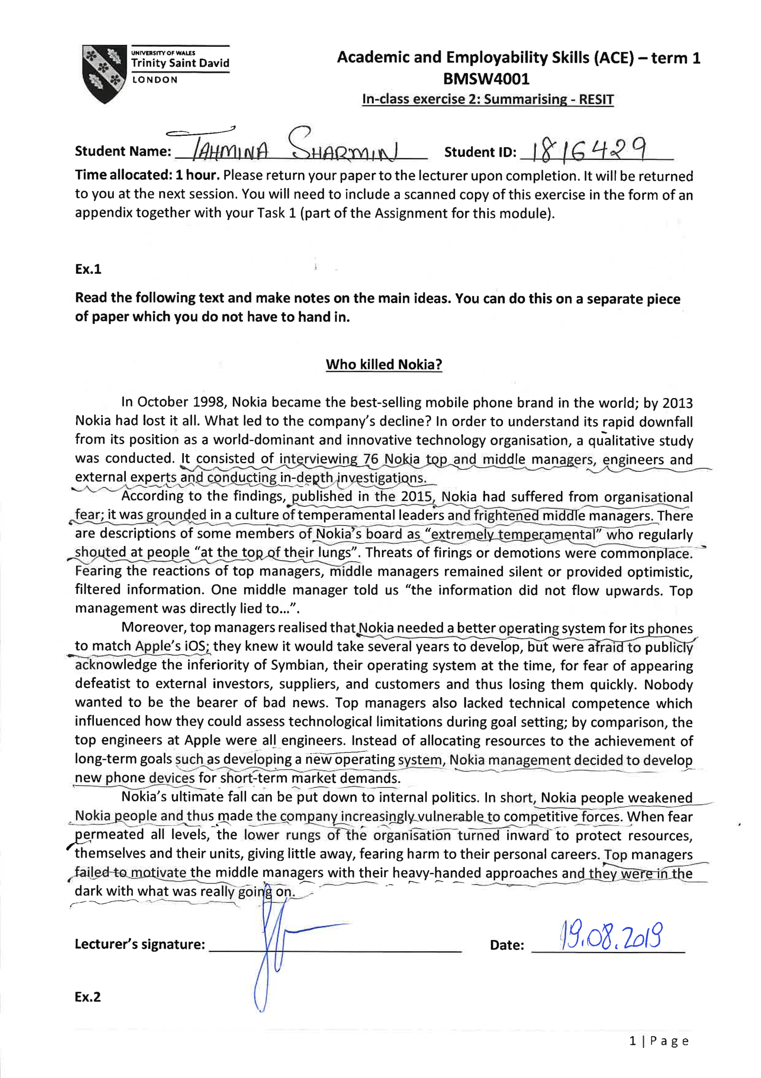

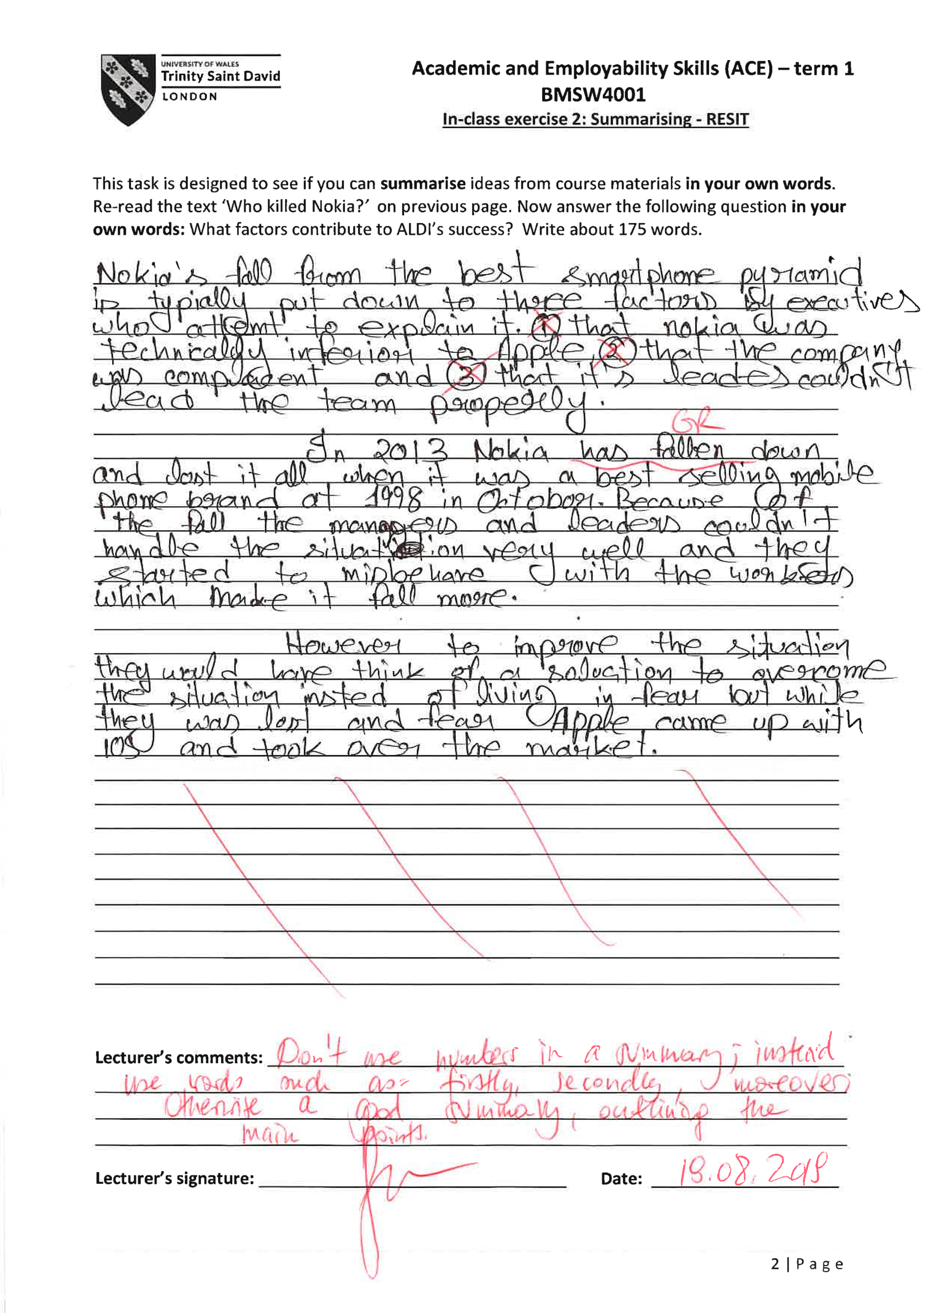

Appendix-2: Class Activities from Term-2


