

Module name: Effective Team Working and Communication (BMSW4009)
Lecturer name: Melanie Squire
Student name: Evelinne Alice Dicu (2422448)

Contents page
- Introduction…………………………………………………………...page 2
- Findings……………………………………………………………….page 2
  - Belbin`s Team roles……………………………………………. page 2
  - Tuckman`s Stages of Group development…………………...page 3
  - Thomas – Kilmann Conflict model……………………………..page 4
  - Communication and Emotional Awareness…………………. page 5
- Conclusion…………………………………………………………....page 5
- Reference list………………………………………………………...page 6

- Introduction
Teamwork is the collaborative effort of individuals working together towards a shared goal. Mullins & Christy, (2016). In a strong team, people support one another, share idea, and combine their different strengths to get the best results. It is not about dividing tasks-it is about trusting each other, communicating well, and building a sense of unity. When everyone feels valued and works together with respect and purpose, the team becomes more motivated, productive, and resilient. Teamwork helps create a positive environment where people feel encourage to grow and succeed together. This report is based on my experience working as assistant manager at OMV in Romania. Through this reflection, I draw upon Belbin`s Team Roles, Tuckman`s Stages of group development, Thomas-Kilmann Conflict Model, Communication and Emotional Awareness to analyse how these theories shaped my team interactions.

- Findings
  - Belbin`s Team Roles
Belbin`s model outlines nine team roles and show that people take on different parts in a team. Belbin, (2010). After doing the Belbin`s self-perception inventory in class, I found out that I am mostly a “Shaper” and a “Team Worker”. I like to get things done but also, I care about the people I work with, and I try to make everyone feels welcome, listened to, and included. I believe everyone in a team matter, even if their role is small. At OMV, I helped with things like setting up the meeting room, prepare agendas, ordering meals, checking if others needed support, including also our hard-working security staff and make sure everything ran smoothly. I saw the value in everyone`s role and tried to include everybody in the team. I also tried to include quieter team members because I know how it feels to be left out and I wanted to remind others that their work matters too. Rice, M (2009). These experiences showed me how important teamwork, communication, care, really are.

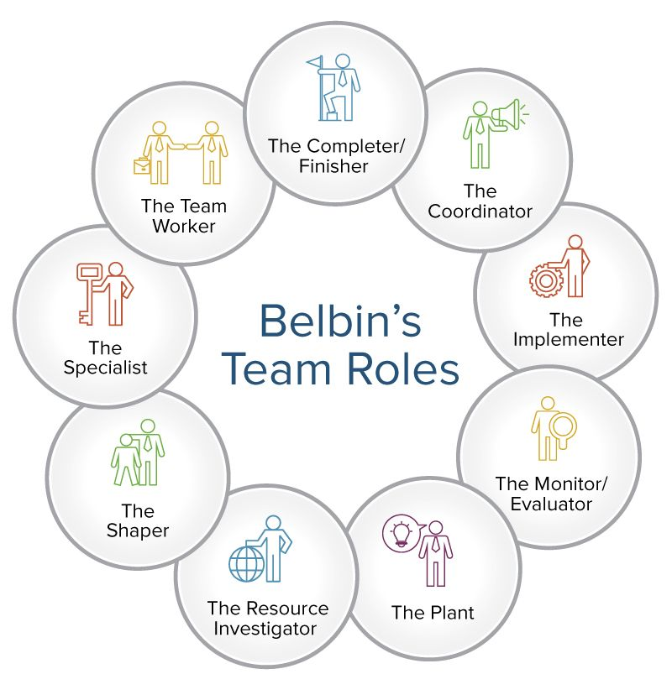

  - Tuckman`s Stages of Group Development
At the beginning, our team was in the “forming” stage of Tuckman`s model. Seck, M.M. and Helton, L. (2014). Everyone was polite, but unsure of their roles, and people were still getting to know each other. As we moved into the “storming” stage, we faced some challenges. There was a moment when two colleagues disagreed on how to handle a customer service issue. It felt a bit tense at the time, but it encouraged the team to become more honest and open. We took the time to listen to each other, and after a few more meetings and shared tasks, we moved into the 'norming' and 'performing' stages. Trust between us grew, and we started working better together. I felt more confident to suggest new ideas without being judge, help others, and give feedback. The whole team became more relaxed and motivated, and our work felt smoother and more organised.

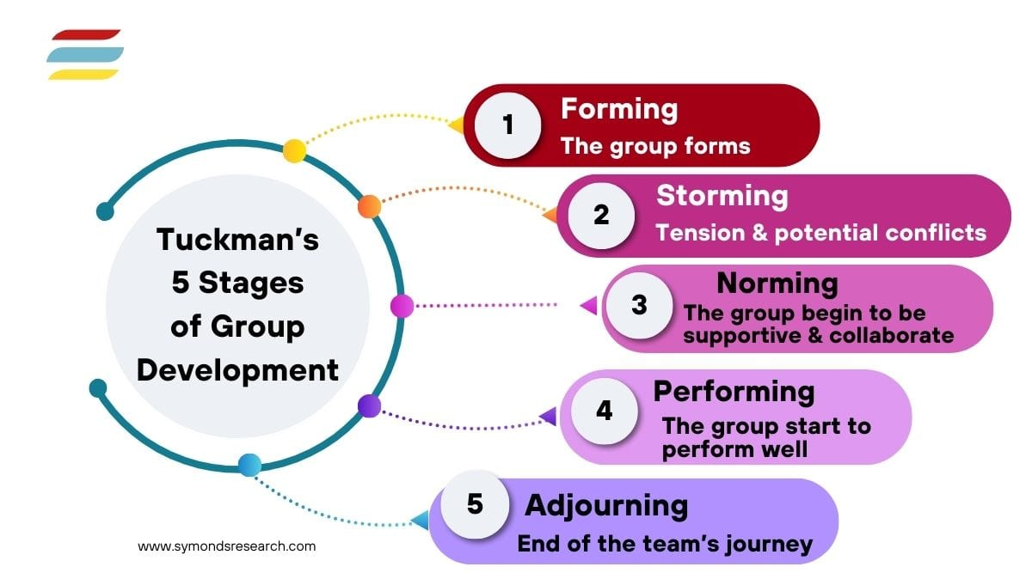

  - Thomas – Kilmann Conflict Model
Using the Thomas – Kilmann Conflict Mode Instrument. Jones, John E. (1976), helped me understand my own behaviour during conflict. Womack, D.F. (1988). We completed a conflict mode questionnaire in class and my results showed that I scored highest in compromising and avoiding (both 8 points), followed by withdrawing (7), competing (5), and collaborating (4). This showed me that I often try to keep things peacefully because I don’t like fights or arguments, and I try to avoid making anyone upset. That’s why I compromise, even if it sometimes means I don’t fully say what I think and keeping inside is not the right thing to do. Avoiding conflict, Stadler, (2019) can help when emotions are high or when a pause is needed, but I also learned that avoiding too much can lead to problems being ignored and not resolved. I try to make others feel comfortable, but I understand it is also important to speak up and work together to solve the problem. Collaborating, where both sides work together to find a solution, is something I want to practise more. Heffeman, (2012).
By learning more about these styles, I now try to balance my need for peace with being more honest and clearer. I see how emotional intelligence, like understanding myself and others, is very important in teamwork. Goleman, (1998).

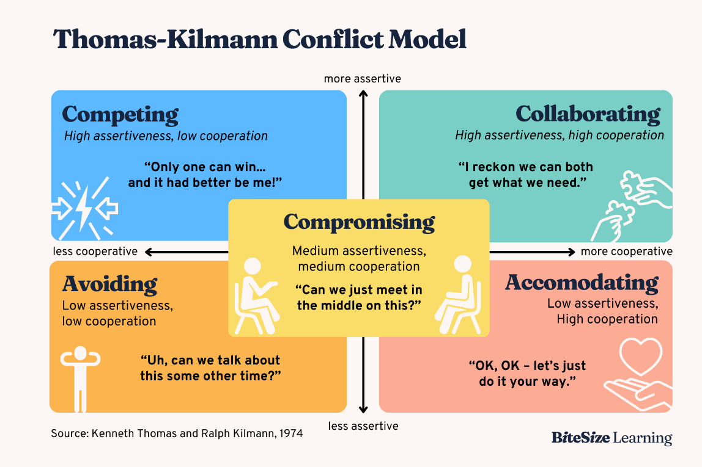

  - Communication and Emotional Awareness
From my work experience at OMV, I learned that good communication is more than just giving instructions or passing on messages. It is also being clear, respectful and listening carefully. When our team communicated well, everything felt easier and smoother. Zimmerman, (2021) I often made sure that everyone knew was happening – this included sending update, reminding people about meetings, or checking in if someone was unsure about their tasks.
I also learned that emotions play a big role in a teamwork. There were times when people were tired, stressed, ill, or upset, and I realised that how we speak to each other in those moment matters a lot. Trust and care build a strong relationship in a teamwork.

- Conclusion
This module and my work at OMV helped me to understand what make teamwork effective.
The models that helped me most were: Tuckman`s, Belbin`s and Thomas – Kilmann.
Tuckman `s – taught me how teams grow and how to face changes and challenges.
Belbin`s – helped me see the value of every role and how I can support others while staying focus.
Thomas – Kilmann – showed that I avoid conflict, but I need to speak up and work things out kindly.
I have learned that teamwork needs care, honesty, and communication. I want to keep growing and help others feel included.
I will specifically do the following:
- Speak up respectfully and clearly so my team understands my ideas.
- Take part in honest and calm discussions to solve problems together.
- Set personal boundaries to manage stress and look after my emotional well-being.

- Reference List

- Belbin, R. M., (2010). Team roles at work (2nd edition). London: Routledge.
- Goleman, D. (1998). Working with emotional intelligence. London: Bloomsbury Publishing.
- Heffernan, M. (2012). Dare To Disagree. [online] TED. Available at: https://www.ted.com/talks/margaret_heffernan_dare_to_disagree [Accessed 20 June 2025].
- jones, john e. (1976). Thomas-Kilmann Conflict Mode Instrument. ProQuest Central. 1(1), p.249–251. [Online]. Available at: https://doi.org/10.1177/105960117600100214. [Accessed 25 June 2025]
- Mullins, L.J. & Christy, G., (2016). Management & organisational behaviour (11th edition). Harlow: Pearson.
- Rice, M. (2009) ‘Time to think: listening to ignite the human mind by Nancy Kline: Recommended reading’, Nursing management (Harrow, London, England), 16(2), pp. 9–9. Available at: https://doi.org/10.7748/nm.16.2.9.s16.
- Seck, M.M. and Helton, L. (2014) Faculty Development of a Joint MSW Program Utilizing Tuckman’s Model of Stages of Group Development’, Social work with groups (New York. 1978), 37(2), pp. 158–168. Available at: https://doi.org/10.1080/01609513.2013.828908.
- Stadler, S., (2019). Conflict, Culture and Communication. Milton: Routledge.
- Zimmerman, D.P., Roussin, J.L. and Garmston, R.J. (2021) ‘Transforming Teamwork: Cultivating Collaborative Cultures’, Families systems & health. American Psychological Association, Inc, pp. 401-. Available at: https://doi.org/10.1037/fsh0000603.
- Womack, D.F. (1988) ‘Assessing the Thomas-Kilmann Conflict Mode Survey’, Management communication quarterly, 1(3), pp. 321–349. Available at: https://doi.org/10.1177/0893318988001003004.

