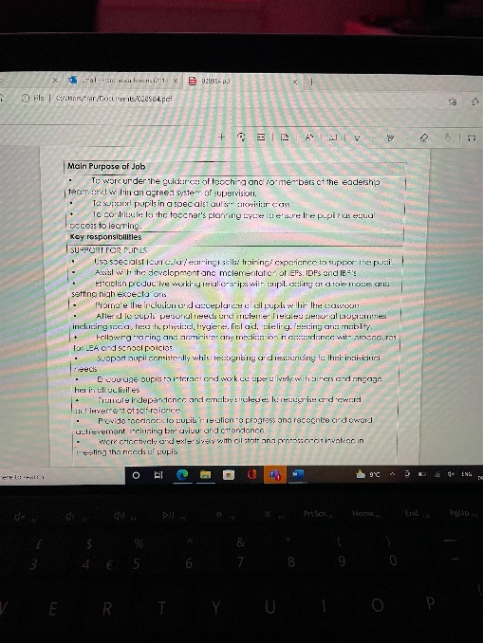
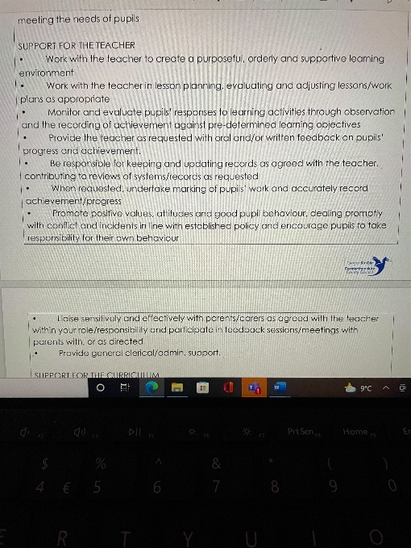
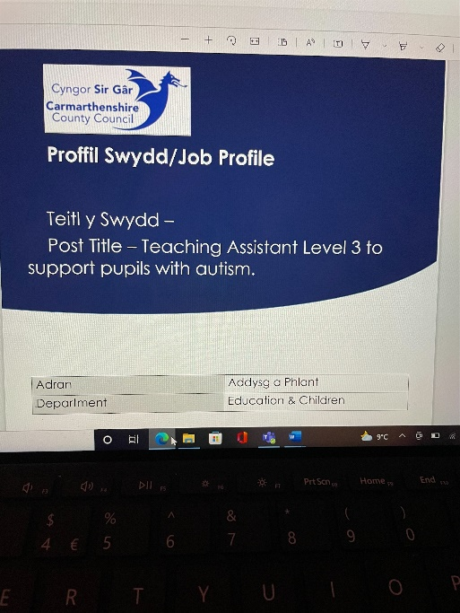

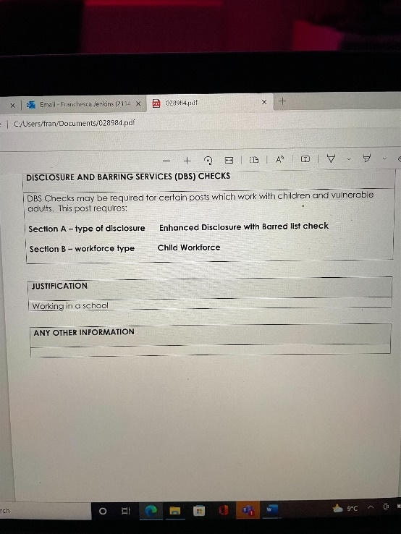
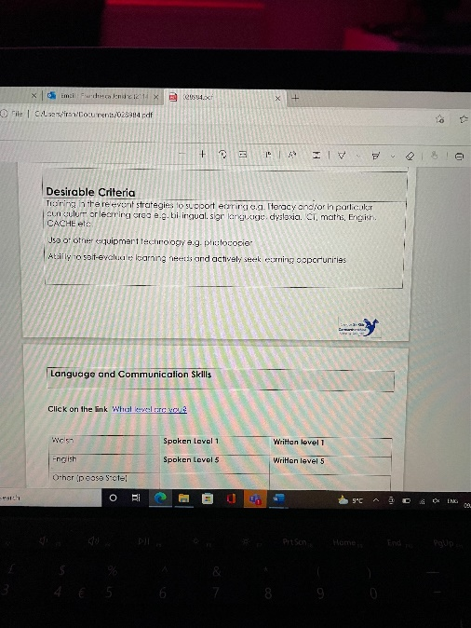
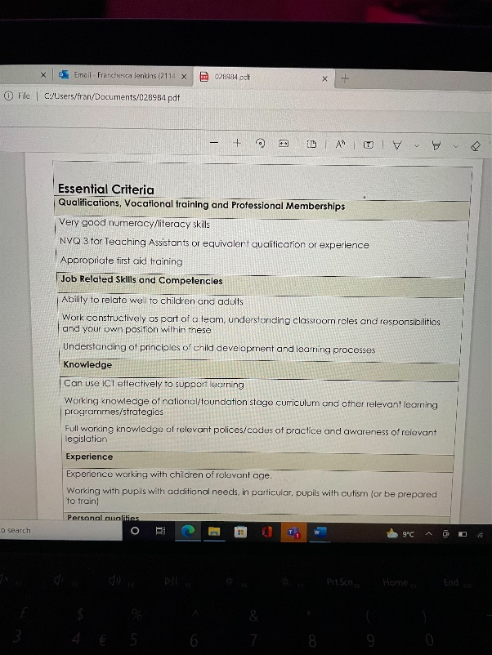
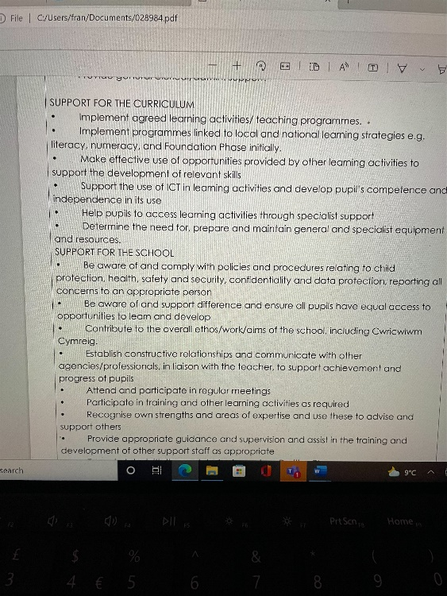

Franchesca Jenkins
franchescaann@hotmail.co.uk | 07419343283 | 21 downing street, Llanelli, Carmarthenshire sa15 2ua

Professional summary  Dedicated to enhancing physical, educational, social and emotional health of children.  Dependable Nursery Nurse enthusiastically delivering exceptional levels of care to children in line with regulations, Providing warmth and encouragement to every child for continued happiness, progress and development.  Motivated with deep passion for helping students excel by supporting teachers and enhancing classroom environments.  Work history  sun moon Chinese. Llanelli, Carmarthenshire  Takeaway Assistant | 08/2018 – Current  - Coordinate efficient running of the business  - Taking care of customer inquiries  - Arranging deliveries  - Prep and storage of food and deliveries  Llanelli. Llanelli, Carmarthenshire  Administrative Assistant | 03/2014 - 03/2016  - I Professionally represented Llanelli women's Aid in front of house role by maintaining a safe space.  - I Managed external queries by engaging with clients face to face, by phone and through email.  - Support and address queries by providing a specialist service for venerable women.  - Received and routed business correspondence to correct department or staff member.  Play king. llanelli, Carmarthenshire  Receptionist | 03/2013 - 09/2014  - Using my ICT skills, coordinated and set up systems to ensure a smooth delivery of services.  - Provided general admin support to customers and employees ensuring and efficient running of office  - I Answered telephone calls, compiling detailed notes and promptly forwarding as required.  twizzle lodge Day nursery. Swansea, City and County of Swansea  Nursery Nurse | 12/2012 - 06/2013  - I Wrote up daily reports to monitor children's progress and development for parents.  - I Regularly utilized multi-tasking expertise to ensure multiple children's needs were effectively met, I have experience of working with children by using multitasking expertise to ensure multiple children’s needs were effectively met.  - I Provided a kind, encouraging environment for children to learn and explore through play.  - Maintained comprehensive child learning records, sharing growth and improvement with key caregivers.  - Utilized skills in behavior management to aid positive, productive nursery environments for optimal child development.  - Built positive, professional relationships with children and family members, providing a safe, trusting care environment.  Aunty Ivys day nursery. Gowerton, City and County of Swansea  Nursery Nurse | 05/2011 - 07/2012  - Developed games and activities using arts and crafts to support learning and verbal skills.  - Kept areas clean, organized and stocked, and sanitized surfaces and toys each day.  - Promoted language development skills through reading and storytelling.  - Selected appropriate stories based on ages of children and teachable moments, read to groups and promoted discussions based on content.  - Set and enforced rules to maintain children's safety and created welcoming, caring environments for all children.  - Instructed children in crafts and other activities to promote gross and fine motor skills, including creating paintings, drawings, paper crafts and decorations.  camau bach day nursery. Llanelli, Carmarthenshire  Nursery Nurse | 02/2010 - 11/2010  - Regularly utilized multi-tasking expertise to ensure multiple children's needs were effectively met.  - Provided a kind, encouraging environment for children to learn and explore through play  - Initiated and led creative art activities, aiding positive child development and enjoyment.  - Built positive, professional relationships with children and family members, providing a safe, trusting care environment.  - Promoted language development skills through reading and storytelling.  top totz day nursery. Llanelli, Carmarthenshire  Nursery Nurse | 07/2009 - 12/2009  - Provided outstanding levels of care, receiving continued praise for children's happiness and development.  - Utilized in-depth knowledge of safeguarding to ensure relevant guidelines were implemented and adhered to.  - Created caring bonds with children to ensure their feeling of comfort and safety whilst at nursery  - Built positive, professional relationships with children and family members, providing a safe, trusting care environment.  - Maintained comprehensive child learning records, sharing growth and improvement with key caregivers.  - Acted as a positive role model to children, careers and colleagues. | Skills  - Effective communicator  - Compassionate early-years care  - Child development  - Educational support  - Information Security  - Greeting Visitors  - Special needs  - Active listening  - Early childhood education  - Proactive learner  - Effective communication  - Well organized  - Classroom support  Education  Gorseinon College  Swansea, City and County of Swansea  06/2009  NVQ Level 3: children’s care learning and development  St John Lloyds Comprehensive School  Llanelli, Carmarthenshire  06/2007  GCSE  ST Mary’s Primary school  Llanelli, Carmarthenshire  07/2002  References  Available on request.

component 2
Shelha- professional career development

Interview Questions and Answers

- Do you have any experience in working with children with additional needs?
yes, I have a variety of experience in working with children with additional needs such as ADHD, Autism and varies other additional needs, I completed my training while I was attending college doing my Level 3 in childcare. I have previously worked with young children along the autistic spectrum and have personally helped family members children with additional needs out of a school setting.
I currently have been looking after my niece who is on the autistic spectrum, and it has given me a bit more insight in how to care and attend to children that have these needs, I am passionate about giving these children the best possible experience of being in a mainstream school.
I ensure that I interact with the child/ren that need the support, I would ask the teacher how the child that needs support likes to communicate and get as much information as possible in order to establish a good relationship with the child from day one of me supporting them. For example, I would introduce myself to the class teacher and discuss the needs of the child/ren I am supporting and get as much information as possible, then use this information to introduce myself to the child and establish a relationship with that child.
I can provide a stimulating environment for children depending on their needs. I can work inside the classroom or outside the classroom and adapt things according to children’s needs. I can do this by ensuring I know as much as possible about the child I will be supporting.
I also have experience in preparing learning materials under supervision of the teacher. ]

- What characteristics do you believe you have or that are important for being a teacher assistant?
This varies depending on the age and type of children you are dealing with, in this job it will of course be primary school age and children with additional needs, but in general a learning support assistant will have great communication skills and experience in helping the children she supports, sensitivity and patience is a must in this line of work even more so with children that require that extra support. I did this when one child I was supporting needed to have extra time to complete a task I waited with them and allowed them the time they needed, gave support to them when needed to complete the task.
Being patient and positive is important in supporting children that have the additional needs because they may not be able to communicate with you the way you’d expect so they may just act out and it is my job to find out as much as possible to help the child as best as possible, so they are able to learn and get the best out of school life.

- What specific responsibilities did you have as a learning support assistant?
Learning support assistants generally help maintain order in class and during break times, they are there to try and promote good student behavior. In order to this I would build a rapport with the child/ren I am supporting, showing them a good role model and promoting positive behavior rather than negative this helps a child understand that negative behavior will not get attention but positive will.
As a Learning support assistant, I was there to assure help to the class alongside the main teacher but also to mainly support those children that required it the most, other duties included establishing positive working relationships with the children acting as a role model and setting high expectations.
I worked with the main class teacher to create a purposeful, orderly, and supportive learning environment for children regardless of their abilities, I was responsible for keeping and updating records as agreed with the teacher contributing to reviews of current systems or records as requested.
I was there to support pupil consistently whilst recognizing and responding to their individual needs, promoting the inclusion and acceptance of all pupils within the classroom.
Monitor and evaluate children’s responses to activities within the classroom through observation and recording achievement against pre-determined learning objectives

- How would you handle behaviour management?
This is a large part of a learning support assistant in aiding the teacher with managing behavior in the classroom.
I would help make sure that the children that I am supporting are on task during class time and during lessons ensuring that disruptions are kept to a minimum, in order to do this, I will adhere to the school’s behavioral policy.
In order to help the children of the classroom and the child that I am there to support I will use the following strategies:
- Turning negatives into positive’s, information with children seems to work better when they are told what to do rather than what they shouldn’t do.
- Be a positive role model and show behaviour that you expect to be shown.
- Communicating well with the child/ren ensuring that I communicate consistently, and ensure they are phrased to for the age group I am working with.
- Recognize good behaviour and achievement and make a big fuss of the child/ren if they do well this will encourage children that this is the way forward to get praise.
- Promote a quiet area where children can go when they are displaying challenging behaviour this will enable the child to calm themselves alongside you and it will cause less disruption to the class.
Lastly communicating with parents alongside the main class teacher its essential for managing challenging behavior this will ensure that all parties are on the same page in order to help the child.

- Why did you decide to become a teaching assistant?
I decided to become a teaching assistant because I have always wanted to work with children and it was something I was so passionate about, for me assisting in the education and care of children is dead Centre of what I care about. I want to help children make the best of their time at school and help make a teacher’s life a little bit easier so that the teacher can focus on teaching and the children can focus on learning.
In my opinion a teaching assistant is the glue that holds a class together and I want to be able to help provide encouragement and support to the teachers I work with as well as help children with additional needs.
The joy on a child’s face when they solve a problem unassisted is priceless, it is my job to get them children there by giving them the help and support they need to stay in line with their peers and not to fall behind their classmates.
I enjoy that every day is different, variety is the best part of being a teaching assistant boredom doesn’t happen, I love that I can use my hobby of crafting and bring it in to the classroom for the children to experience the joy I get from it but also so they can try new things.
The best part of being a teaching assistant is the children without a doubt, being part of a pupil’s life on a day-to-day basis is to me a position of privilege, and comes with so many rewards, it makes my day when I see a child able to get the most out of something.
I like to make a difference in a child’s life making them feel valued and safe is something I can do as a teaching assistant. It is the most rewarding career decision I ever made.

