
Developing Workplace Critical Thinking
BMSW5101

How do organisational beliefs, attitudes, and value systems affect workplace behaviour? Also, how will tailoring workplace changes for the post-changes for the post-COVID mindset tackle the challenges we face now, and create more resilient businesses in the future?

Student name: Diana-Lidia Bejan
Student ID: 1914605

Lecture’s Name: Gregory Cowan

Executive summary

This report is about Novotel Blackfriars, which is a five-star hotel located near Southwark Underground and Waterloo Station. However, this report will show how Novotel Blackfriars is managing beliefs, attitudes, and workplace performance applying critical thinking, evaluating models helping the hotel industry grow and face the COVID-19 pandemic. Furthermore, at the end of the report the reader can see that having a critical thinking can help face more challenges in a business. In addition, reading more and understanding that this report can help the hotel industry reach a point where can resolve the problems with shortage of staff or help the management critically thinking how to face a pandemic and still make the hotel attract more customers.
Table of Contents

Introduction 4
1. Novotel Background 4
2. Critical Thinking Models 5
2.1. The RED Model 5
2.1.1. Recognize assumptions 6
2.1.2. Evaluate arguments 6
2.1.3. Draw conclusions 6
Applying the RED Model analysing critical thinking 6
2.2. The T.H.I.N.K. Model 6
Applying the T.H.I.N.K. Model analysing critical thinking 7
2.3. De Bono’s Six Thinking Hats Model 8
2.3.1. White hat: FACTS 9
2.3.2. Green hat: CREATIVITY 9
2.3.3. Yellow hat: BENEFITS 9
2.3.4. Black hat: CAUTIONS 9
2.3.5. Red hat: FEELINGS 10
2.3.6. Blue hat: PROCESS 10
Applying De Bono’s Six Thinking Hats Model 10
3. Evaluating beliefs, attitudes, and workplace performance 11
3.1. Beliefs 11
3.2. Attitudes 11
3.3. Workplace performance 11
3.4. Novotel SWOT Analysis 11
Recommendations 13
Conclusion 13
References 14

Introduction

This report will show how Novotel is evaluating their beliefs, attitudes, and workplace performance within the organisation. London having eleven Novotel’s, this report is more about Novotel London Blackfriars, which is a five-star hotel located near Southwark Underground and Waterloo Station, being easy to travel all around London (Accor All Limitless, 2019). Novotel is offering to any guests a spacious room with a comfortable bed and a shower with opaque glass. In addition, having the luxury to relax to a drink at the Jamboree restaurant and bar, or enjoying a relaxing day with the family in the swimming pool and gym. The purpose for choosing this organisation is because the hospitality industry is facing more problems than any company because of COVID-19, and a lot has changed in these pandemic years, affecting all companies, and changing people’s life. However, after one year being in this pandemic of COVID-19, the hotel closed from March 2020 until August 2020, some of the employees being furloughed, or some of them being made redundance, however, when opened, the COVID rules were implemented, stickers with 2m distance were placed on the floor along with the signs, every corner having a disinfection point, and the rules for the employers and employees to wear a face mask and gloves.
All the departments, from housekeeping to food and beverage implemented the COVID-19 health and safety rules, by wearing the masks and using gloves along with washing the hands regularly and using the disinfected every time before and after, or during work. The government rules applied in hospitality were that all the guests who wants to stay in a hotel has to be a key worker or at least have the contract and reason why they are staying overnight, otherwise with all the boarders closed nobody could travel anywhere and after opening them they implemented the isolation for fourteen days if traveling to United Kingdom or out. Hospitality industry is changing, being difficult to attract more customers. Working along with every department, I will apply critical thinking and try to help the management attract more customers, by evaluating their beliefs, attitudes, and workplace performance, implementing a plan by making guests choose our hotel.

1. Novotel Background

Novotel is a four-star hotel, first economy hotel being opened in 1974, Bordeaux, France. Accor being the story of Gerard Pelisson and Paul Dubrule, who opened the first hotel in 1967 when nobody believed in this new industry hotel in France. Having over five thousand addresses in over one hundred countries, with two hundred six thousand people invented into the hospitality of tomorrow bringing to life their enthusiasm for the visitors. According to Accor (2021), which Accor is the world leading hospitality group, from 1967 opening the first Novotel hotel in Lile Lesquin, France until 2001 accomplishing more openings and campaigns, opening the first Novotel property in Africa, in Cameroon, in 1975 and by 1984 the first Novotel stone is laid in Beijing, China. All the way from 2001 through 2021, Accor launching campaigns, taking ownerships, and winning prizes, making Accor a group of hospitality known and changing the brand to Accor Hotels, being a COP21 partner and an Official Paris 2024 Partner. From 2011 until 2020, developing one thousand two hundred thirty-three hotels with one hundred fifty-six thousand one hundred forty-nine rooms.

2. Critical Thinking Models

2.1. The RED Model

The RED Model helps critical thinking develop and make everyone see and understand any situation and information from different points of view splitting facts from opinions and assumptions. In order to apply critical thinking, one must thing logically carefully in Recognising assumptions, Evaluate arguments using an objective approach and Draw conclusions (Wulandari et. al, 2021).

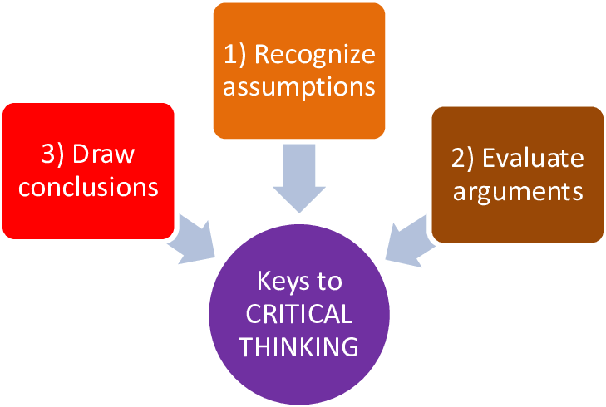
Source: (Enriquez, 2018)

2.1.1. Recognize assumptions
An assumption is a belief that is true despite not having proof, having the capacity to detect assumptions is necessary for developing critical thinking abilities. Assumptions must also be addressed from various perspectives and questioning assumptions aids in the separations of data from irrational thinking, being critical to distinguish between assumptions, facts, and opinions.

2.1.2. Evaluate arguments
Being able to evaluate arguments is crucial, in order to enhance and clarify the truth of an argument, an objective examination of information and views is required as well as evidence analysis.

2.1.3. Draw conclusions
In order to be met with precision, drawing conclusion is a final aim. After the process of recognising the assumption and analysing the arguments we finalised in a conclusion accompanied by evidence.
(Wulandari et. al, 2021)

Applying the RED Model analysing critical thinking

In order for Novotel Blackfriars to recognize the assumption by attracting customers needs to make sure that everything they advertise is true without any proof taking in consideration the feedbacks from other guests who had the pleasure to stay at Novotel, those cannot consider proof because you do not know if it is a real feedback or just someone who can help the hotel grow or look bad for others. However, evaluating the arguments, analysing, and investigating if the feedbacks are real or not by searching the names in the hotels bookings and finding the real dates when those people were guests at Novotel, that way the evidence is found. After recognising the assumption and evaluating the arguments making sure that the people’s feedbacks are real having proof the conclusion is being drawn.

2.2. The T.H.I.N.K. Model

The T.H.I.N.K. Model is composed from five levels. Starting to level one which is Think, it has in his essence to engage and question, remember acknowledging, understand, and characterize, and examine and empathize. The second level which is starting by Having a plan, set goals, organize, and arrange, compare, and contrast. Level three, which is to Investigate, analyse and explore, induct plus deduct, break into parts, possibility thinking and make connections. Moving forward, to level four, which includes New ideas, create, generate, solve problems, chare ideas and consider why or interpret. Furthermore, at level five which is to Know, reason with evidence, self-evaluate self-reflect, deep understanding. The processes can sometimes fold back on themselves or work in unison.
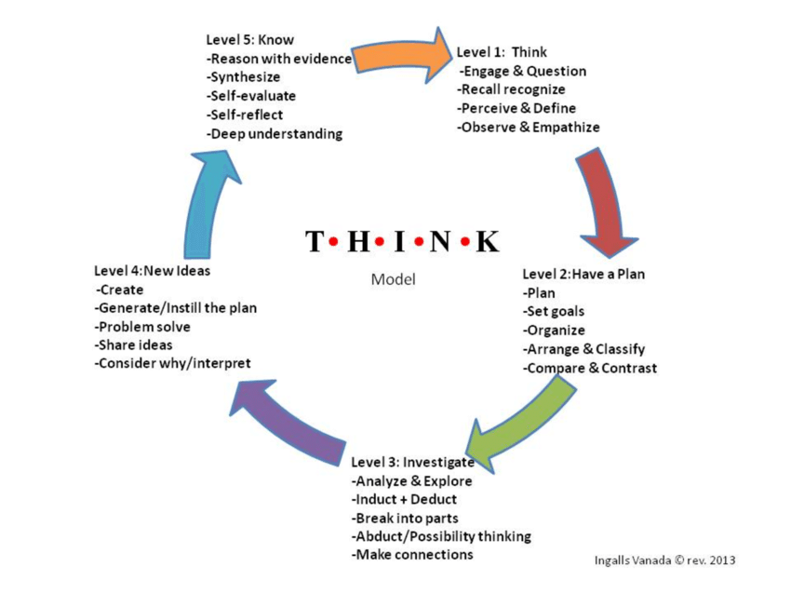
Source: (Ingalls Vanada, 2015)

Applying the T.H.I.N.K. Model analysing critical thinking

In the first part of applying the T.H.I.N.K. Model, Novotel Blackfriars needs to make sure that every question is being asked and observe everything that is going on and off in the company. Starting with the COVID-19 rules, Novotel is facing more than one problem at the time, and the T.H.I.N.K. Model can be identified because at level two of the model Novotel has to come with a plan, set goals for the future, organise all the rules of COVID-19, arrange and train the staff to comply with the rules and make sure that every guest who is staying at Novotel are following the rules as well. However, at the level three of the model is saying that it needs to investigate, which it doesn’t apply with the COVID-19 rules because is nothing to investigate, maybe just to make sure that everyone is following the rules. Furthermore, at level four where is more about the new ideas, implementing the rules, sharing the ideas from the managers of the departments all the way through the employees, solving any problems the guests are having according to the COVID-19, making they stay easier. At level five already everyone knows about the COVID-19 rules and have a deep understanding that they have to wear a mask, use the disinfected points, keep a 2-meter distance from anyone and use gloves if applicable.

2.3. De Bono’s Six Thinking Hats Model

De Bono’s has designed the Six Thinking Hats Model which when is properly implemented, can enhance critical thinking, and provide changes for fixing any difficulties that may arise. He also stated that when someone is trying practical thinking, they confront three basic difficulties, while describing the six coloured hats thinking model, he pinpoints the problems and explain them as follow: 1. Emotions, which we have a propensity to not think at all, instead relying on gut instinct, emotion, and bias to guide our actions; 2. Helplessness, when we may feel inadequate and say things like, “I do not know how to think about this, I do not know what to do next.”; 3. Confusion, where we struggle to remember everything at once, which results in a disaster.
In addition, De Bono’s concept of wearing six distinct thinking hats is helping people by overcoming these three challenges. The hat wearer’s capacity to take off one colour hat after they’ve done with it and put on another is the great power of De Bono’s colourful hats metaphor in resolving these issues. Coming up with different solutions, allowing them to think critically about it by wearing a different coloured hat allows the user to approach a situation from a new viewpoint.
(Kivunja, 2015)


Source: (Douglas, 2016)

2.3.1. White hat: FACTS
The white hat thinking adds demands for information to critical thinking and problem-solving process to aid the solution of the problem at hand, it focuses on three questions: “what information do we have and how do we know what information we have?”, “What information do we need?” and “What information do we need to expand our knowledge base, and where do we acquire the data, we require?”. Allowing for the collection of that information, the white hat thinking follows the identification of the information required, the viewpoint includes both individual and group information searches.

2.3.2. Green hat: CREATIVITY
The green hat thinking is for creative critical thinking and problem-solving, the colour green conjures up thoughts of nature and plants, therefore it is easy to see how it may represent the productive ability and energy contained in natural resources. As a result, it reflects inventive and creative thinking, introducing fresh ideas, options, recommendations, and proposals to the critical thinking and problem-solving process. Creativity can be seen from two perspectives, one of them being producing something that was not there and the second one by having new ideas and fresh ideas that nobody has used before.

2.3.3. Yellow hat: BENEFITS
The yellow hat thinking drive to achieve to the critical thinking and problem-solving process by providing a sense of optimism. It searches for our strengths as well as the opportunities presented by the scenario. In order to reach greater heights of success, it aims to build on current strengths and accomplishments. A current achievement instils confidence in the ability to achieve even greater success in the future. Other alternatives that can lead to improve performance are indicated with this hat. This optimistic approach to problem solving to the colour yellow is associated by the author because for him yellow means optimism and sunshine, looking every time from the bright side of thinks.

2.3.4. Black hat: CAUTIONS
The black hat thinking was chosen by the author as cautions because the word critical is originated from Greek where it means judge and in many countries the judges wear black, and this colour is chosen for this way of thinking because it denotes a thorough examination of difficulties or problems to be resolved. Furthermore, being a black hat, it does not mean that is a bad hat. By wearing the hat, critical thinking and problem-solving allow us to analyse the probable repercussions of our actions, starting on disastrous courses of action or saving us money by avoiding the expenses of implementing ineffective tactics.

2.3.5. Red hat: FEELINGS
The red hat thinking brings to the problem solving and critical thinking procedure chances to express personal feelings, these are spoken without fear of being criticised or needing to justify themselves. Without having to explain or justify their feelings, participants are allowed to express their feelings regarding a specific method being taken in an attempt to address an issue at any given time. Emotions, sentiments, hunches, and intuitive thoughts are all shared in a save environment. Participants are free to express their feelings without having to find rationale or rationalisation for them since they have freedom of speech and no need for justification. As a result, this hat allows participants to be humanly real, rather than constantly needing to be objective, and to be free to hold on to what they value and think without fear of being challenged.

2.3.6. Blue hat: PROCESS
The blue hat thinking provides an organisational critical thinking and metacognition viewpoint, which distinguishes blue hat thinking from the other hats because the other hats are concerned with determining how to solve a specific problem, blue hat thinking is concerned with determining how to think about thinking that will lead to a solution. As a result, the blue hat thinking adds higher order thinking to the critical thinking and problem-solving process, which requires active control over the cognitive processes involved in finding an acceptable solution to a problem. Planning of actions that may be used to solved an issue; it helps in the identification of methods. The author identifies the colour blue with a sky which is above everything, being up in the sky and looking down people can see what is happening down.
(Kivunja, 2015)

Applying De Bono’s Six Thinking Hats Model

The white thinking hat is helping Novotel asking what information it has and how it knows that information, what information is needed and how that information is helping grow the knowledge and how that information is being purchased in order to resolve the problems thinking critically. However, the green hat is more about creativity, helping Novotel to come with new ideas that nobody used before solving a problem. The yellow hat is giving Novotel the hopes to resolve the problems, using the opportunities and strengths to reach a bigger success with optimists and looking every time at the part where is always positiveness. Furthermore, the black hat is the one where Novotel is applying a critical thinking and problem solving analysing the consequences in order to save money and avoid costs executing different methods. The fifth hat which is the red hat, is more about the feelings where Novotel is critically thinking expressing the emotions without having to explain why is choosing that way and not another and being free to choose what is best for the company without any fear that anyone can make a bad feedback about being too sensitive. Finally, the blue hat provides an organisational critical thinking and helps Novotel to be more about thinking how to resolve a problem becoming with the solution than how to solve a problem

3. Evaluating beliefs, attitudes, and workplace performance

3.1. Beliefs
A belief is the acceptance of a statement or claim as true. Personal experience has a significant influence in what someone is thinking, beliefs can evolve rapidly or slowly, depending on the circumstances and the persons involved. Behavioural beliefs are those that are concerned with the outcomes of one’s actions. Control beliefs pertain to the presence of circumstances that may assist or impede behaviour performance, whereas normative beliefs refer to views about others acceptance or disapproval of a behaviour (Sullman et al, 2018).

3.2. Attitudes
Attitudes are defined through words and behaviour, the thinking and feeling a person is expressing applying their beliefs and values. Risk-taking attitudes and behaviours are essential components in human behaviour because they influence a variety of decision-making strategies and help individuals navigate a complicated, unpredictable, and dangerous environment (Chan et al, 2020).

3.3. Workplace performance
In any workplace the performance is an important factor because if the employees do not make a good job, applying critical thinking, solving problems, and making sure that the job is done properly the company cannot grow and have success. At Novotel Blackfriars the employees are the most valuable persons in there, because if they do not make a good job, in hospitality can affect the success of the business by making the guests choose another hotel. According to Leonard, K. in Chron (2019), the employee performance is crucial to the company’s overall success, therefore business owners need staff who can get the job done and establish consistent and objective procedures.

3.4. Novotel SWOT Analysis

As an overview of evaluating Novotel’s, beliefs, attitudes and workplace performance, a SWOT Analysis is implemented to show the critical thinking at the workplace.
- Strengths
Novotel’s strengths are the quests who choose to stay overnight every week, month, or year because they experience with the hotel is always pleasant. Novotel makes sure that everyone is welcome ensuring a fast check-in, a clean and comfortable room, breakfast included or free for kids, even an evening in the swimming pool or a sport morning in the gym. At Novotel the qualities which separates this hotel from other ones are that having the benefits to book a room for all the family, being just five minutes’ walk from two stations which can be time saving traveling all around London. Providing a safe environment accommodating people and making sure they have a good and relaxing day forgetting about work or problems. Another powerful strength is that a hotel can offer a lot of jobs, even after loosing a lot of money and staff because of the COVID-19 pandemic the hotel it remains one of the largest employments.
- Weaknesses
The weaknesses in this period of time, facing COVID-19 rules, are that a lot of people went back in their countries, and as we all know the jobs in London depend more on the Europeans to work, the hotel is now facing a shortage of staff which can be a big weakness because the check-in is slower than before, not having the rooms ready in time and all guests are waiting more hours to go in the room, hardening the restaurant staff job as well because they have to wait in the restaurant for the room to be ready and they cannot face a big flow of guests facing with the same problem, and that being shortage of staff. The weaknesses of a hotel industry are mostly because they can lose customers to competitions especially if they have less room rate. Another weakness that can affect the hospitality is that depends a lot of the number of visitors, the holidays, and the season, depending mostly on tourists. The COVID-19 pandemic has completely destroyed the tourism industry in 2020.
- Opportunities
Novotel London Blackfriars, being a well-located hotel gives a lot of opportunities to people around, especially in the summer when everyone is looking for traveling and enjoying a good holiday. At Novotel, the most important part are the guests, making sure that every event happening, investing in charities, employees running for the London marathon helping to raise in 2020 over £15 million for charity. The good news is that the hotel industry is a good business and is here to stay, the best part is that every public has its own set of sights and sites to see, if hotels put a little flare to them, people from all walks of like will travel great distance to enjoy their beauty. Hotels generally accommodate to local and foreign tourists during peak season, as well as local tourists during the off-season. And here is where the hotel industry's attraction is.
- Threats
Some of the threats for Novotel can be mostly another hotel locally or the Airbnb’s which is the first threat to a hotel industry. In certain foreign nations the civil conflicts can have a direct and indirect impact in the hotel business, and as the globe becomes increasingly globalised, more booking and travel alternatives become available. Customers can now enjoy vacations without having to travel as much thanks to augmented reality and virtual reality which can be a threat to the hotel industry. Another one who can be a threat to hospitality are pandemics, such us the recent one, COVID-19 pandemic who changed people life and businesses. According to Resolver (2021), the hotels could be bankrupt if they did not have visitors and travellers. Guests are the lifeblood of every hospitality business and might be one of the most significant risk to profitability, both directly and indirectly. One guests who can sue the hotel can harm the financial part because it was injured.

Recommendations

The recommendations helping hospitality guide their employees through the stages of the post-COVID are to provide enough information of how to deal with a pandemic. Businesses should have set up counselling hotlines and wellness workshops for employees and their families to assist them get through this difficult time. People respond differently to complexity and uncertainties, such as emotions of loss of control, concern for their well-being and financial instability assumptions. To effectively manage workforces in the near term, putting people first with a clear strategy and plan centred on survival is critical. Changes in business models, new methods of working, and the digital culture mentality that has evolved in reaction to the current circumstances are likely to persist after COVID-19, with the potential to become widespread (Deloitte, 2020).

Conclusion

After evaluating the beliefs, attitudes and workplace performance, this report is showing how the hospitality passed and manage the COVID-19 pandemic. Using some of the models learned, the RED Model demonstrates that in order to apply critical thinking some rules needs to be followed, using T.H.I.N.K. Model can help employees evolve, and the last model which is the Bono’s Six Hats Model helps the business apply critical thinking in different “colours” and moods. In addition, using a SWOT Analysis, Novotel has positive and negative values, mostly applying critical thinking in the workplace.

References

Accor (2021) Our History Reaching for the impossible [Online]. Available from: https://group.accor.com/en/group/who-we-are/our-history (Accessed: 08 August 2021).
All Accor Limitless (2019) Novotel London Blackfriars Hotel [Online]. Available from: https://all.accor.com/hotel/7942/index.en.shtml?dateIn=&nights=&compositions=1&stayplus=false (Accessed: 12 August 2021).
Chan, H.F., Skali, A., Savage, D.A., Stadelmann, D. and Torgler, B. (2020) “Risk attitudes and human mobility during the COVID-19 pandemic” [Online]. Available from: https://www.nature.com/articles/s41598-020-76763-2.pdf (Accessed: 20 August 2021).
D., Ingalls Vanada. (2015) “Practically creative: The role of design thinking as an improved paradigm for 21st century art education”, Techne Series: Research in Sloyd Education and Craft Science, A (21), pp. 21-33. ResearchGate [Online]. Available from: https://www.researchgate.net/publication/319944563_Practically_creative_The_role_of_design_thinking_as_an_improved_paradigm_for_21st_century_art_education (Accessed: 21 July 2021).
D., Ingalls Vanada (2015) The T.H.I.N.K. Model [Online]. Available from: https://www.researchgate.net/figure/The-T-H-I-N-K-Model-Ingalls-Vanada-2011-revised-2013_fig4_319944563 (Accessed: 06 August 2021).
Deloitte (2020) Combating COVID-19 with an agile change management approach [Online]. Available from: https://www2.deloitte.com/content/dam/Deloitte/in/Documents/human-capital/in-hc-consulting-deloitte-change-management-pov-on-covid-noexp.pdf (Accessed: 20 August 2020).
E., Douglas (2016) The Six Thinking Hats [Online]. Available from: https://www.business2community.com/strategy/six-thinking-hats-01515213 (Accessed: 05 August 2021).
Enriquez, J. J. (2018) RED Model [Online]. Available from: https://www.researchgate.net/figure/Pearsons-RED-Model-Adapted-from-Chartrand-et-al-2009_fig1_325951721 (Accessed: 08 August 2021).
Kivunja, C. (2015) Using De Bono’s Six Thinking Hats Model to Teach Critical Thinking and Problem-Solving Skills Essential for Success in the 21st Century Economy. Creative Education, 6, pp. 380-391. Scientific Research [Online]. Available from: https://www.scirp.org/html/12-6302477_54681.htm (Accessed: 16 July 2021).
Leonard, K. (2019) Importance of employee performance in business organizations [Online] Available from: https://smallbusiness.chron.com/importance-employee-performance-business-organizations-1967.html (Accessed: 27 August 2021).
Resolver (2021) Top 4 Risks Facing the Hospitality Industry [Online]. Available from: https://www.resolver.com/blog/top-risks-facing-the-hospitality-industry/ (Accessed: 19 August 2021).
Sullman, M.J.J., Przepiorka A. M., Prat, F., and Blachnio, A.P. (2018) “The role of beliefs in the use of hands-free and handheld mobile phones while driving”, Journal of Transport & Health, 9, pp 187-194, Elsvier [Online]. Available from: https://reader.elsevier.com/reader/sd/pii/S2214140516303577?token=040C6FE4399D416BFA0ABDF546428000245D06A818B9277171FF4E82A7CC08FA99556FFF5B6B5EBED4A6F0FC9A6BA9FA&originRegion=eu-west-1&originCreation=20210826194001 (Accessed: 26 August 2021).
Wulandari, R., Baedhowi & Hindrayani, A. (2021) "Measuring Critical Thinking Skills with the RED Model", Journal of Physics: Conference Series, 1808 (1), pp. 4-6. ProQuest [Online]. Available from: https://www-proquest-com.ezproxy.uwtsd.ac.uk/docview/2512915219/10F8503FCBEF40EAPQ/1?accountid=130472 (Accessed: 01 August 2021).

