NAME: Nunzia Lomonaco
STUDENT NUMBER: 2123363
MODULE: LCMB7000
LECTURER: Gladius David Kulothungan
COURSE: Master’s in business administration
SUBMISSION DATE: 25/04/2022
Title:
The labour market in the post-Covid and post-Brexit environment in the UK. New HR strategies.

TABLE OF CONTENTS

- INTRODUCTION 3
- DEFINITION OF LABOUR MARKET 3
- COVID AND LABOUR MARKET 4
- STATISTICS NUMBER 4
- WHO ARE THE WORKERS MOST AFFECTED BY THE PANDEMIC IN UK 5

- LABOUR MARKET POST-BREXIT IN THE UK 6
- HUMAN RESOURCES MANAGEMENT 7
- EMPLOYEE RETENTION MANAGEMENT 7
- RETENTION STRATEGIES FOR NEW ENTRANTS EMPLOYEES 8
- RETENTION STRATEGIES FOR EXISTING EMPLOYEES 8

- CONCLUSION 10
- REFERENCES 11

INTRODUCTION
Our society is struggling between wars, health pandemics, and global market changes. Looking at the situation in the UK, the economy has experienced tremendous shocks in the last three years, including not only the pandemic emergency but also the effects of Brexit. The labour market has radically transformed, and it is the manager's responsibility to rethink new strategies to manage those new conditions. This report examines the concept of the labour market, as well as the effects of the Covid pandemic and Brexit on the labour market in the UK and emphasizes the importance of new human resource management strategies for retention and incentivisation of the employees for a company.

DEFINITION OF LABOUR MARKET
The term labour market is synonymous with ‘manpower market’, it is the place where the supply and the demand for manpower meet; it is the interaction between people in need of labour (employers), and people who can supply labour (employees) (Kotliar, 1998).
Each type of job has a different labour market; The labour market differs based on the type of work, skills and position. As there are different labour markets, they all operate in comparable ways like all markets: on the principles of demand and supply. From an economical perspective, the labour market is technically equivalent to any other market for goods based on the principles of demand and supply ( Greenlaw, et al., 2017). So, the labour market is constantly changing, as it responds to the needs of employers and the changes in market economies. Many forces affect a labour market:
- External business environment changes, such as increased consumer demand for an industry's goods or services, or lower-priced competition from abroad, resulting in job losses
- Changes in the internal environment of the company, such as the impact on the production processes, technological innovations, changes in the availability of employment, or business processes that result in employee shortages (for example, more specialized jobs, fewer unqualified jobs).
- Interventions by the government, such as recovery programmes that support education, training, and investment in specialized skills or geographic regions.
- New laws that impact jobs
- National and international laws include the introduction of National Minimum Wages and the free movement of labour within the European Union, to mention just few examples.
- Employment-related legislation (e.g., the Equal Pay Act, etc.) sets limits on how employers recruit. (The University of Warwick, 2007).

COVID AND LABOUR MARKET
STATISTICS NUMBER
The global COVID-19 pandemic started in January of 2020 and induced almost all governments around the world to enforce restrictive measures such as severe social isolation. To prevent the spread of the virus, many businesses have been temporarily closed, and many workers have been confined and isolated in their homes. The global healthcare crisis had a massive effect on the economy and labour market. Economic activity was stalled as a result of the lockdown and other sanitary measures. The consequences of this unexpected crisis on the labour market have been various: the loss of jobs for many workers (e.g., Hospitality employees due to the total closure of restaurants, hotels, pubs, etc.). Many workers have reduced their working hours, and people looking for employment suspended their search. Despite massive vaccination campaigns that began worldwide in 2021, which have improved many people's working conditions, the COVID-19 situation is far from certain because variants are still in circulation and governments continue to enforce restrictive measures (Eurostat Statistics, 2022).
In the UK, as it happened, the COVID-19 pandemic has inexorably affected the economy and the labour market:
- employers have adopted a variety of strategies to prevent redundancies, including freezing recruitment, redistribution and wage flexibility.
- The government has helped companies with important economic support: the Coronavirus Job Retention Scheme (CJRS), and the furlough. The program allowed companies to claim financial help for every worker, allowing them to better manage the effects of the coronavirus on their employees and reducing business demand. The CJRS has contributed to limiting the rise in unemployment (Davies, 2021). The economic activity and labour market have been slowed by the pandemic of COVID-19. It had a negative impact on employment, but it also changed the dynamics of workers in the labour market and provided new study prospects.

On 15 March 2022, the House of Commons has just published a report that tracks the evolving impact of the coronavirus on the labour market in the Uk. These statistics reveal that the UK labour market is continuing to improve, with some labour market indicators restoring to pre-pandemic levels. In recent months, employment has increased, and unemployment has fallen below pre-pandemic levels. Even so, economic lack of activity remains significantly higher than it was before the pandemic, and rising inflation means another drop in real salaries. The pandemic has had an increased impact on the labour market status of special populations.

- Workers between the ages of 18 and 24 and those over the age of 65 have been the most likely to lose their jobs.
- The number of people receiving unemployment benefits decreased by 48,000 in February 2022, although it is still 510,000 greater than it was in March 2020.

On September 30, 2021, the Coronavirus Job Retention Scheme (CJRS) came to an end. From the end of December, when 4.9 million workers were furloughed, the number of furloughed employments gradually decreased. The Self-Employment Income Support Scheme (SEISS) came to an end as well.

WHO ARE THE WORKERS MOST AFFECTED BY THE PANDEMIC IN THE UK?

The coronavirus pandemic has had a significantly negative impact on the economy of some workers. But workers from ethnic minority groups, young workers, low-wage workers, and disabled workers are those who have been severely impacted by the health crisis (Powell, et al., 2022).
Since the start of the epidemic, the youngest and oldest workers are more likely to have been suspended and to have left their employment. It is interesting to study the case of young people in the UK.
- Young workers were disproportionately affected at the start of the pandemic. At the beginning of July 2020, 41% of employees under the age of 18 and 28% of employees aged 18-24 were on furlough. This reflects the fact that young people were most affected at the beginning of the pandemic. The significant impact on young workers is because they mostly work in sectors like hospitality, retail and leisure, the sectors most affected by the health crisis. Since spring 2021 the scenario of the labour market for young workers has significantly improved. According to ONS (Office for National Statistics) statistics, the pandemic era has impacted the proportion of young workers across industries. The above figures show that the labour market situation in the UK has not been dramatically affected, thanks to government support, the situation has returned to pre-pandemic parameters in a short amount of time.

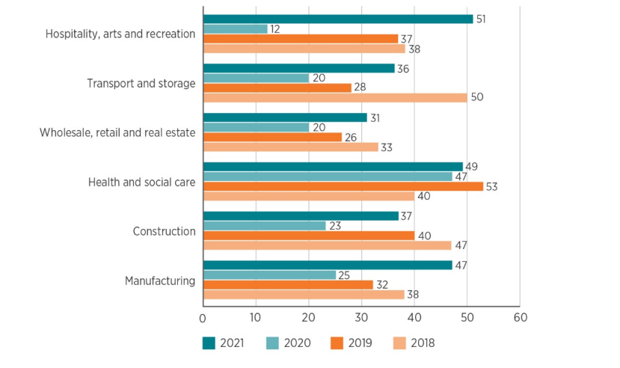

The proportion of organisations with hard-to-fill vacancies (%)
Source: (Chartered Institute of Personnel and Development, 2021)

LABOUR MARKET POST-BREXIT IN THE UK
On 1 January 2021, The UK officially left the European Union after the results of the referendum in 2016. After a year, it is now possible to evaluate the status of the UK labour market, considering the new laws governing immigration from Europe. According to this legislation, the workers from the EU must obtain a Visa with a point-based system, and employers must provide them with guarantees and a salary of at least 25.600 pounds per year for skilled workers (Government Uk, 2020).
- The last report of the Office for National statistics about the labour market in the Uk underlines that In December 2021, the UK had 29.5 million employees, more than the pre-Covid 19 February 2020 figure. All regions have now reached pre-coronavirus levels, with Scotland showing the greatest improvement. The report reveals that the labour market is constantly recovering, with an increase in the number of people employed and a decrease in the number of people unemployed (Office for national statistics, 2022). The employment rate in the United Kingdom improved by 0.2 percentage points and unemployment fell 0.4 percentage points. In the months October to December 2021, the number of job vacancies reached a new high of 1,247,000 (Office for national statistics, 2022).
- It can be observed that the new Visa rules for skilled workers have affected the lower-paid jobs because the workers from the EU are less likely to seek a job in the UK. The restrictions for the EU have opened new routes from extra Eu countries to the UK: e.g., from India and Pakistan for software development jobs, and nursing/health care jobs from Nigeria (Kennedy, 2021). Low paid sectors are considered: retail, transport and logistics, hospitality, food processing, health care, and construction. Hospitality (51%) is the hardest industry to recruit in, followed by health and social services (49%) and manufacturing (49%) respectively (47 per cent) (Chartered Institute of Personnel and Development, 2021).
This requires a reconsideration of recruitment techniques for some firms and recruiters. Cleaning, social care, distribution, childcare, food, and hospitality industries that traditionally relied on EU staff to support lower-paying jobs are likely to become more reliant on local candidates. Based on the historical reticence of local British people doing certain types of jobs and the fact that some jobs (for example, truck driving) require significant training periods, this could be a significant issue in some circumstances. If problems with recruiting persist, the solution is likely to include a reassessment of salary and conditions. Concerns about skill shortages in a variety of industries have mostly been dismissed by the administration, which has ignored demands for more flexibility. Employers should prioritise employing and training British workers, according to the Home Office. The current changes in the UK labour market demonstrate that Brexit is a tricky issue. Jobseekers have responded positively to the new immigration system, but British firms seeking to hire foreign workers will have an advantage or loss depending on the type of employment they provide. Some will have to think creatively in terms of how they respond, and seriously evaluate how they attract the personnel they need from sources of persons with diverse qualities than those they traditionally relied on (Kennedy, 2021).

HUMAN RESOURCES STRATEGIES
All employment practices that assure the organisation has the workforce it needs and manages employee issues are known as "people resourcing."
Workforce planning, recruitment and selection, employee retention, employee turnover management, and talent management are just a few examples of employment activities (Armstrong, 2014)
EMPLOYEE RETENTION MANAGEMENT
The loss of essential workers might have a severe negative influence on a company. People that organisations want to maintain are generally the ones who leave more than any other. Nowadays there is no such a thing as a job for life, and employees have no hesitation to change jobs. Employees are more inclined to stay voluntarily if they feel valued, and guaranteeing this is the most crucial goal for HR managers and the company if they want To keep talented people (Armstrong, 2014)
Employee retention strategies should be founded on a knowledge of the elements that influence whether or not people leave. These include the general quality of the employee experience:
- organization image;
- what the employer delivers in terms of employment terms and conditions;
- and employee experience: recruiting, selection, the ability to put people into jobs that suit them;
- learning and career chances; are social aspects as of how well people get along with their coworkers (Armstrong, 2020).

The propensity to stay or leave is also affected by the stage of employees’ career and their age.
Early-career employees (up to 30 ) look for new opportunities for promotion. Employees in their mid-career (ages 31–50) value their abilities to control their careers as much as their job fulfilment. Employees in their late careers (over 50) will be increasingly concerned about security.
A missed career progression, relationship issues with the line manager, economic and work dissatisfaction, and even discrimination are among the reasons why employees leave their jobs. To resolve this concern, the HR manager must first do an analysis to find which employees are leaving and then plan retention strategies (Maxwell, 2021). In addition to ensuring that each employee's financial remuneration is adequate, the HR manager has to consider the employee's psycho-physical well-being, that all employees are treated equally (sense of justice), that career growth opportunities are available, and that employees have a representation in the organization (Maxwell, 2021).
Many studies have suggested that employees who are more involved in the company's activities are more productive. The more satisfied a worker is, the more productive the company will be.
As a result, it is in the company's best interests to provide every opportunity for its employees to be happy (Torrington, 2020). According to those studies, there are 4 elements for the retention of employees:
- training opportunities,
- flexible work,
- good management organisation,
- fair salary (Torrington, 2020).
As an HR manager, to ensure the retention of employees, the most effective strategies are:
- first of all, to consider the salary in relation to the company's external and internal factors, and adjust the compensation if necessary (Hastings, 2022);
- periodic monitoring plan on the well-being of the employee,
- planning to involve the employees in the life of the company. It has been studied that if employees feel they’re part of the company, they work harder and willingly ( Tej, et al., 2021).
- In addition, it is important to give full recognition to the employees for their contributions to the company, especially during the pandemic and post-pandemic period when everyone worked in difficult and new situations, trying to adapt themselves to new conditions (Hastings, 2022).
- Another key factor is promotion, or career progression, to which practically all employees aspire. This must be planned ahead of time-based on the employee's characteristics and not developed when filling vacancies, or the risk is to have the wrong person in the wrong area (Rashidi, et al., 2018).
RETENTION STRATEGIES FOR NEW ENTRANTS EMPLOYEES:
As an HR manager, an effective method to attract new employees is to provide
- a compensation proportional to the duties and skills of the employee as well as a minimum wage proportional to the cost of living (for example, London has a minimum wage that does not correspond to a living wage).
- Working hours that allow employees to organize their life outside of work as well as their social life (Torrington, 2020).
- Another strategy could be to offer shares of the company to the employees as an incentive, this would increase involvement because the employee would feel part of a project and thus be more productive.
RETENTION STRATEGIES FOR EXISTING EMPLOYEES:
- Economic benefits as contributions for periods of sickness ( this would cover the government gap), a higher percentage of the pension contribution by the company.
- Salary increase during national holidays and bank holidays.
- Bonus for risk assessment compliance, paperwork compliance, financial risk, health and safety, etc.
- Training, is useful for career advancement in fact training its employees for key roles not only satisfies the worker but allows the company to have people ready to fill the vacancies left by people promoted to new positions.
- Flexible working hours which respect any personal and family needs of the worker (Torrington, 2020).
Below are some statistics that an HR manager should be aware of.
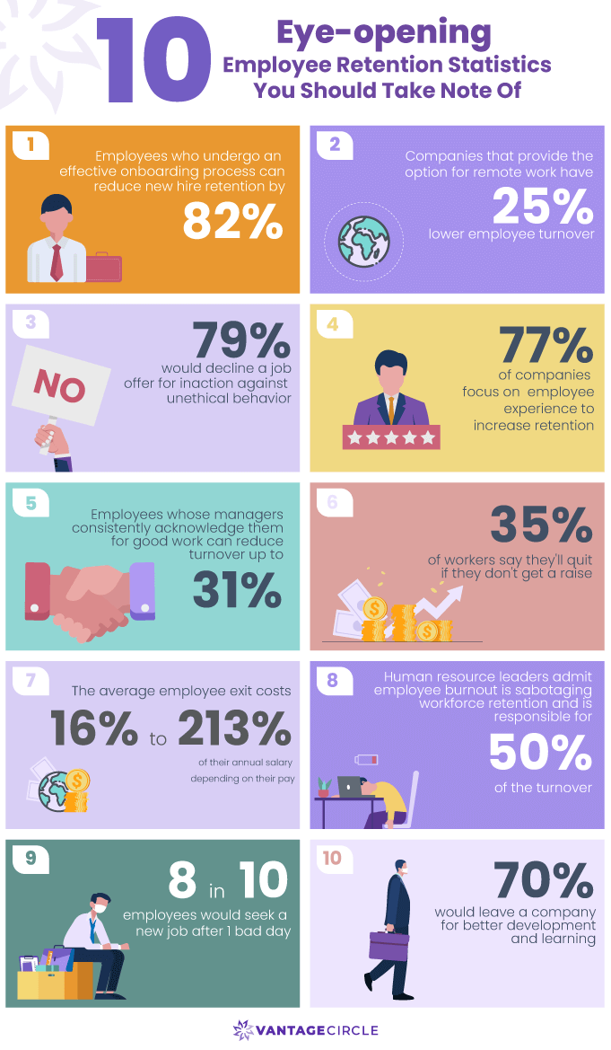
Source: (Vantagecircle, 2022)

CONCLUSION
This report highlighted, through the study of statistical data, government publications and expert analysis, that the labour market has inexorably changed in recent years due to external factors such as the Covid-19 pandemic and Brexit. Unemployment figures are not dramatic in the UK, so it needs to rethink new human resource management strategies. Today more than ever Hr manager has a fundamental role because is required to recruit qualified personnel ( the huge gap in the British labour market), consider how to integrate work in the presence and remotely, and above all develop new strategies to ensure that companies retain their staff. Recruiting new employees is expensive, time-consuming and complicated, so focusing on people who remain in the company is crucial. According to studies, there are several reasons why a worker stays with a company for a long time: adequate economic compensation, favourable working environment, career and learning opportunities but above all feeling part of the company and sharing its values.
It seems that Hr management in Uk is on the right track to cope with the external changes, and variables hitting the labour market.

References
Greenlaw, S., Tylor , T. & Shapiro, D., 2017. Principles of Economics 2e. 2 ed. s.l.:Openstax.
Tej, j. et al., 2021. Examining HRM Practices in Relation to the Retention and Commitment of Talented Employees. Sustainability.
Armstrong, M., 2014. Armstrong's handbook of human resource management practice. 13 ed. London: Kogan Page.
Armstrong, M., 2020. Armstrong's handbook of human resource management practice. 15 ed. london: Kogan Page.
Chartered Institute of Personnel and Development, 2021. Addressing skills and labour shortages post-Brexit, London: Chartered Institute of Personnel and Development.
Davies, G., 2021. Understanding the economy and labour market. [Online]
Available at: https://www.cipd.co.uk/knowledge/work/trends/economy-labour-market-factsheet
[Accessed 4 04 2022].
Davis, P. J., 2015. Implementing an employee career-development strategy. Human Resource Management International Digest, 23( 4), pp. 28-32.
Eurostat Statistics, 2022. Labour market in the light of the COVID 19 pandemic - quarterly statistics. [Online]
Available at: https://ec.europa.eu/eurostat/statistics-explained/index.php?title=Labour_market_in_the_light_of_the_COVID_19_pandemic_-_quarterly_statistics
[Accessed 02 04 2022].
Government Uk, 2020. Recruiting people from outside the UK. [Online]
Available at: https://www.gov.uk/guidance/recruiting-people-from-outside-the-uk
[Accessed 06 04 2022].
Hastings, R., 2022. 12 Employee Retention Strategies for Your Company. [Online]
Available at: https://emeritus.org/blog/strategies-for-employee-retention/
[Accessed 12 04 2022].
Kennedy, J., 2021. Brexit a double-edged sword for the UK labour market. [Online]
Available at: https://www.fenews.co.uk/fe-voices/brexit-a-double-edged-sword-for-the-uk-labour-market/
[Accessed 05 04 2022].
Kotliar, A., 1998. The Concept of the Labor Market. Problems of Economic Transition, 41(3), pp. 53-65.
Maxwell, G., 2021. Employee turnover and retention. [Online]
Available at: https://www.cipd.co.uk/knowledge/strategy/resourcing/turnover-retention-factsheet#gref
[Accessed 12 04 2022].
Office for national statistics, 2022. Labour market overview, UK: January 2022. [Online]
Available at: https://www.ons.gov.uk/employmentandlabourmarket/peopleinwork/employmentandemployeetypes/bulletins/uklabourmarket/january2022
[Accessed 06 04 2022].
Powell , A., Francis-Devine, B. & Clarck, H., 2022. Coronavirus: Impact on the labour market. [Online]
Available at: https://researchbriefings.files.parliament.uk/documents/CBP-8898/CBP-8898.pdf
[Accessed 31 03 2022].
Rashidi, Z., Qasim, S. & Rashidi, Z., 2018. How to Retain Employees? Commitment based Human Resource Practices as an Underpinning Trait that Promotes Job Embeddedness. Global Management Journal for Academic & Corporate Studies; Karachi Vol. 8, Iss. 2, (2018): 9-20., 8(2), pp. 9-20.
The University of Warwick, 2007. Understanding the labour market. [Online]
Available at: https://warwick.ac.uk/fac/soc/ier/ngrf/effectiveguidance/improvingpractice/lmi/understanding_the_labour_market_guide_for_teachers_2007.pdf
[Accessed 03 04 2022].
Torrington, D. e. a., 2020. Human Resource Management. 11 ed. Harlow: Pearson Education.
Vantagecircle, 2022. Top 30 Employee Retention Strategies for the “New” Work World!. [Online]
Available at: https://blog.vantagecircle.com/employee-retention-strategies/
[Accessed 20 04 2022].

